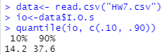

Therefore, the value **14 is the 10-percentile** and **38 is the 90-percentile**





The mean number of disk I/O’s per program is **26.91**





At 90% CI, $α=0.10$ and zp=1.645

n=33

A 90% confidence interval for the mean = 26.91 $±$ (1.645)(9.495)/ $\sqrt{33}$ = **(24.19, 29.63)**





The fraction of programs with <= 25 I/O’s = **0.485**

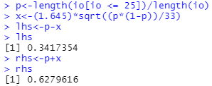

A 90% confidence interval for the fraction = **(0.342, 0.628)**



At 90% CI, $α=0.10$

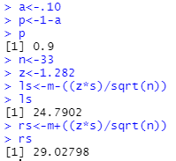

The 90% one-sided confidence interval for the mean = **(24.79, 26.91)** OR **(26.91, 29.03)**