



1. Give the coefficients of linear regression models for both the operating systems.

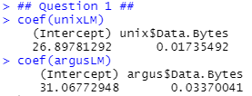

1. Draw the plot linear regression model and the data points for both the operating systems.



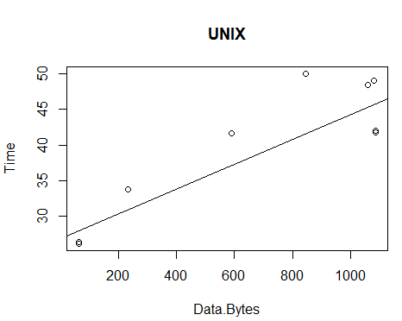



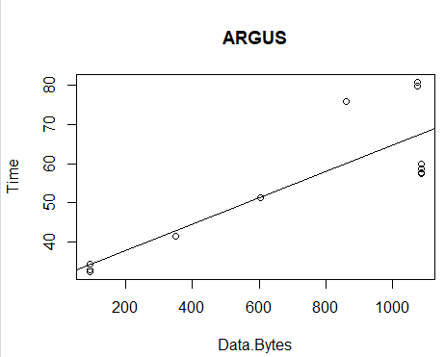

1. Write the equations of linear models for both the operating systems.

UNIX 🡪

ARGUS 🡪

1. Give the residual errors for both models.









1. Give R2 values for both the models. Which model is more accurate?

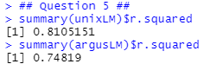

Since the R2 value for UNIX is higher, the UNIX model is more accurate

1. 
   1. Residual vs. fitted

UNIX:

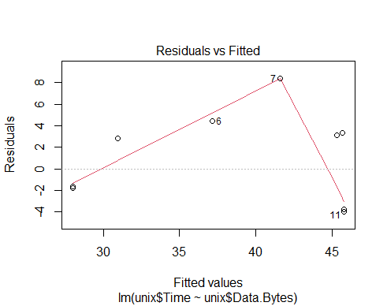

ARGUS:

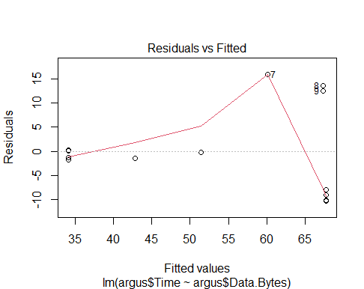

For both of these models, linearity is not met and variance increases as predictor values become larger.

* 1. Scale Location plots

UNIX:

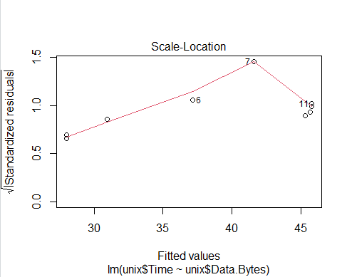

ARGUS:

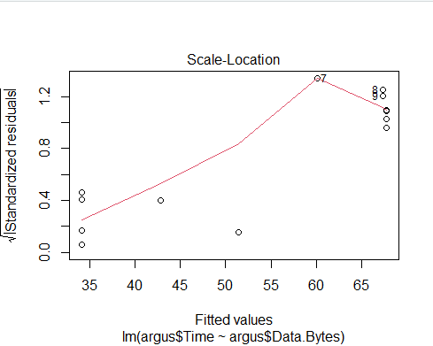

Both of these graphs show variation of data increasing as predictor values become larger. The residuals become more spread out as predicted values increase in the ARGUS graph than the UNIX model

* 1. Cook’s distance plot



UNIX:

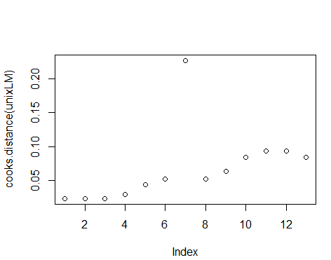

ARGUS:

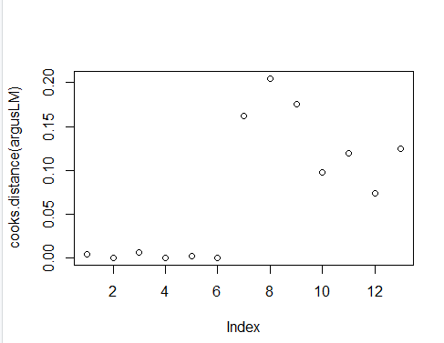

These graphs show that the removal of data points 7-13 in the ARGUS model would change the data more than removing those data points from the UNIX model

* 1. Q-Q plot

UNIX:

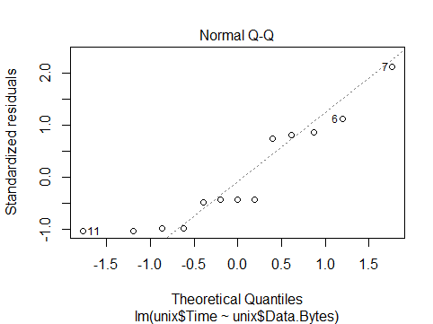

ARGUS:

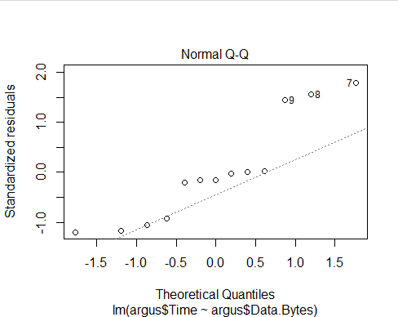

Both of these plots are not normally distributed, but the UNIX model is closer to normal distribution than the ARGUS model