1. 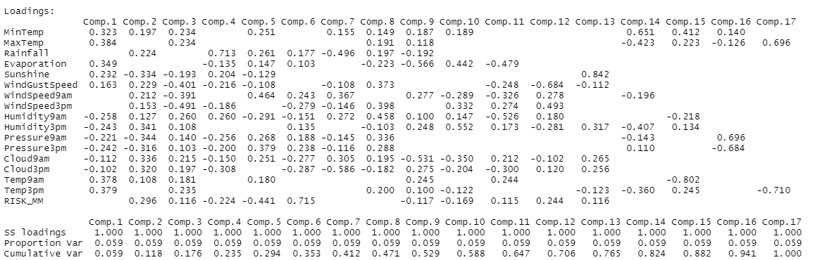



Weights are shown here

1. 



The portion of variance\*100 gives the amount of variation explained by each component

1. 

Cumulative proportion shows accumulated amount of explained variance. The first five components should be considered to account for around 80% of variation in the data

1. 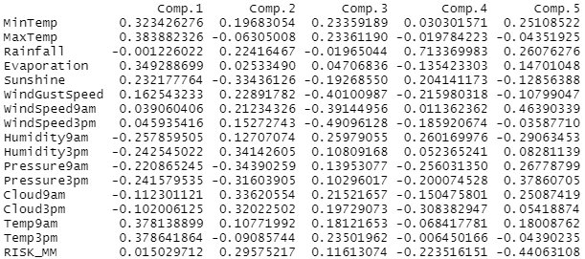

Output of original data that accounts for 80% of variation in the original data