Homework 2 - Exercise 2A

Weak Prompt: Explain regression
Improved Prompt:
Explain linear regression in simple terms for a beginner. Include a real-world example, key concepts like dependent and independent variables, and when it is used.
Why this is stronger:
This prompt is clearer, specifies the type of regression, the audience level, and asks for examples, making the response more useful and targeted.
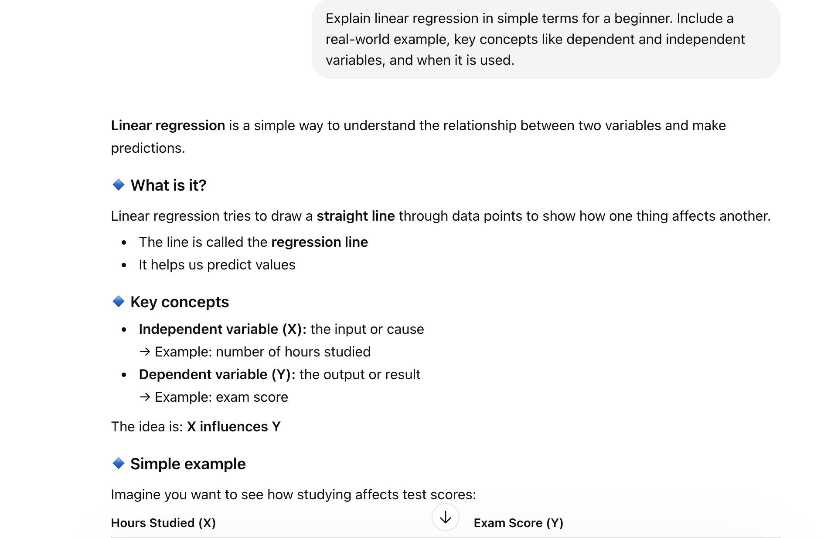
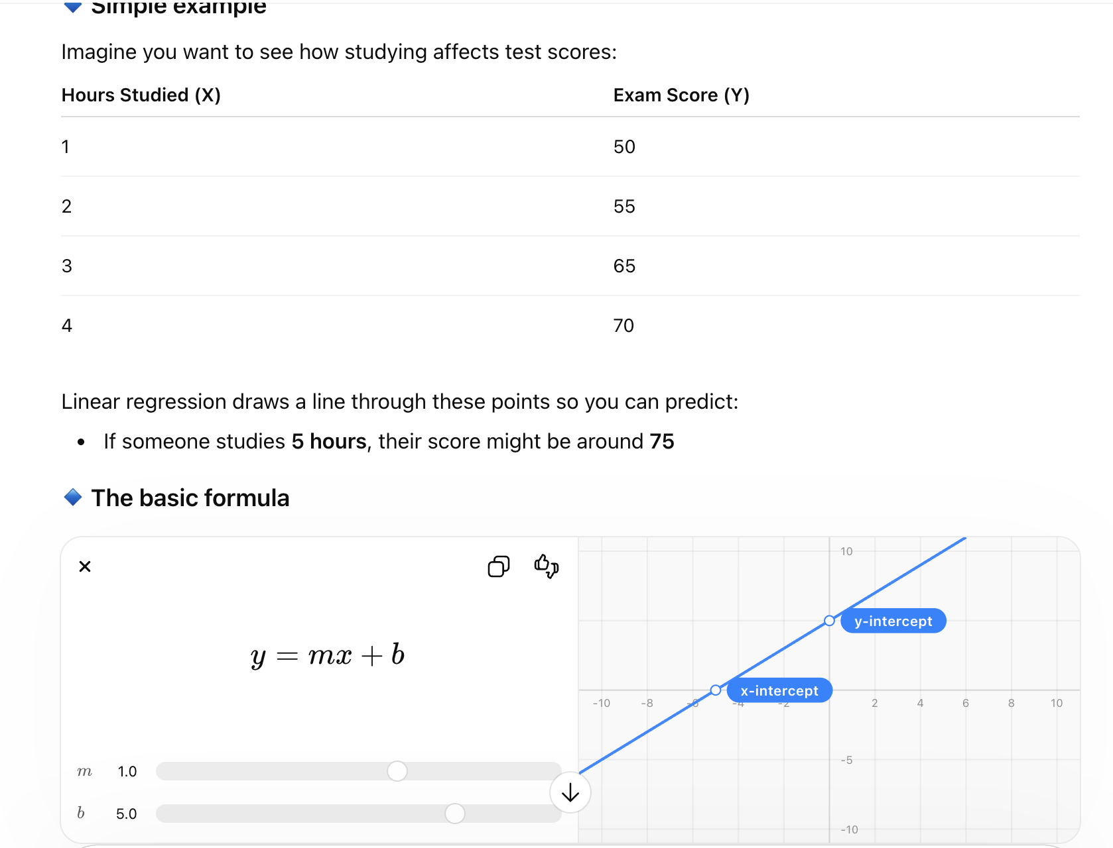
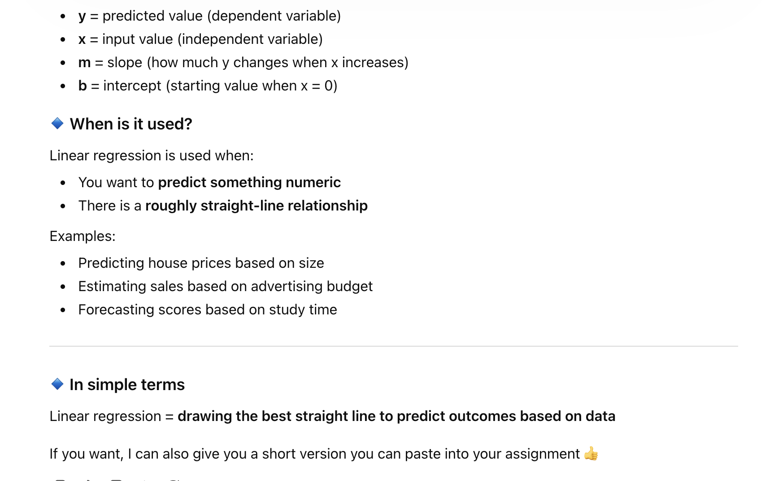

Weak Prompt: Help me understand SQL
Improved Prompt:
Teach me the basics of SQL for a beginner. Explain what SQL is, common commands (SELECT, INSERT, UPDATE, DELETE), and provide simple examples for each.
Why this is stronger:
This prompt defines the learning level, specific topics, and requests examples, resulting in a structured and practical explanation.
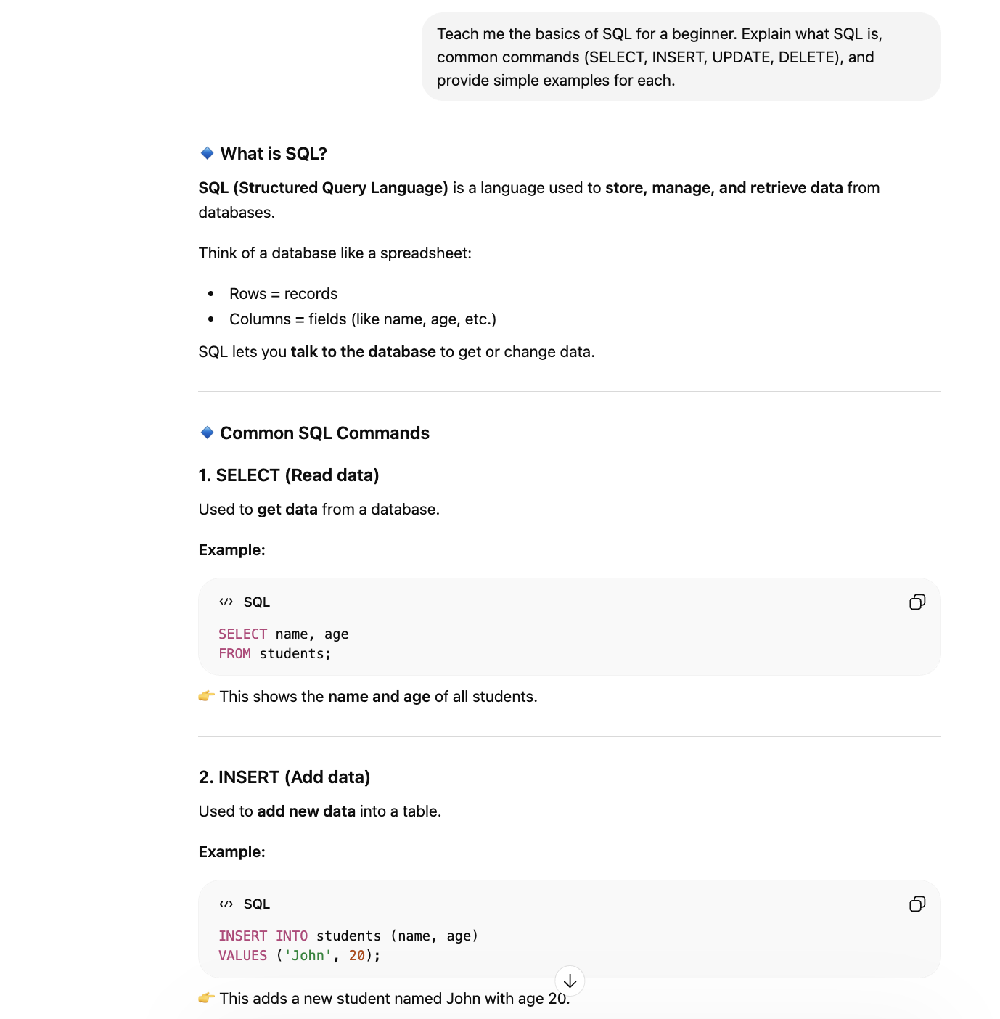
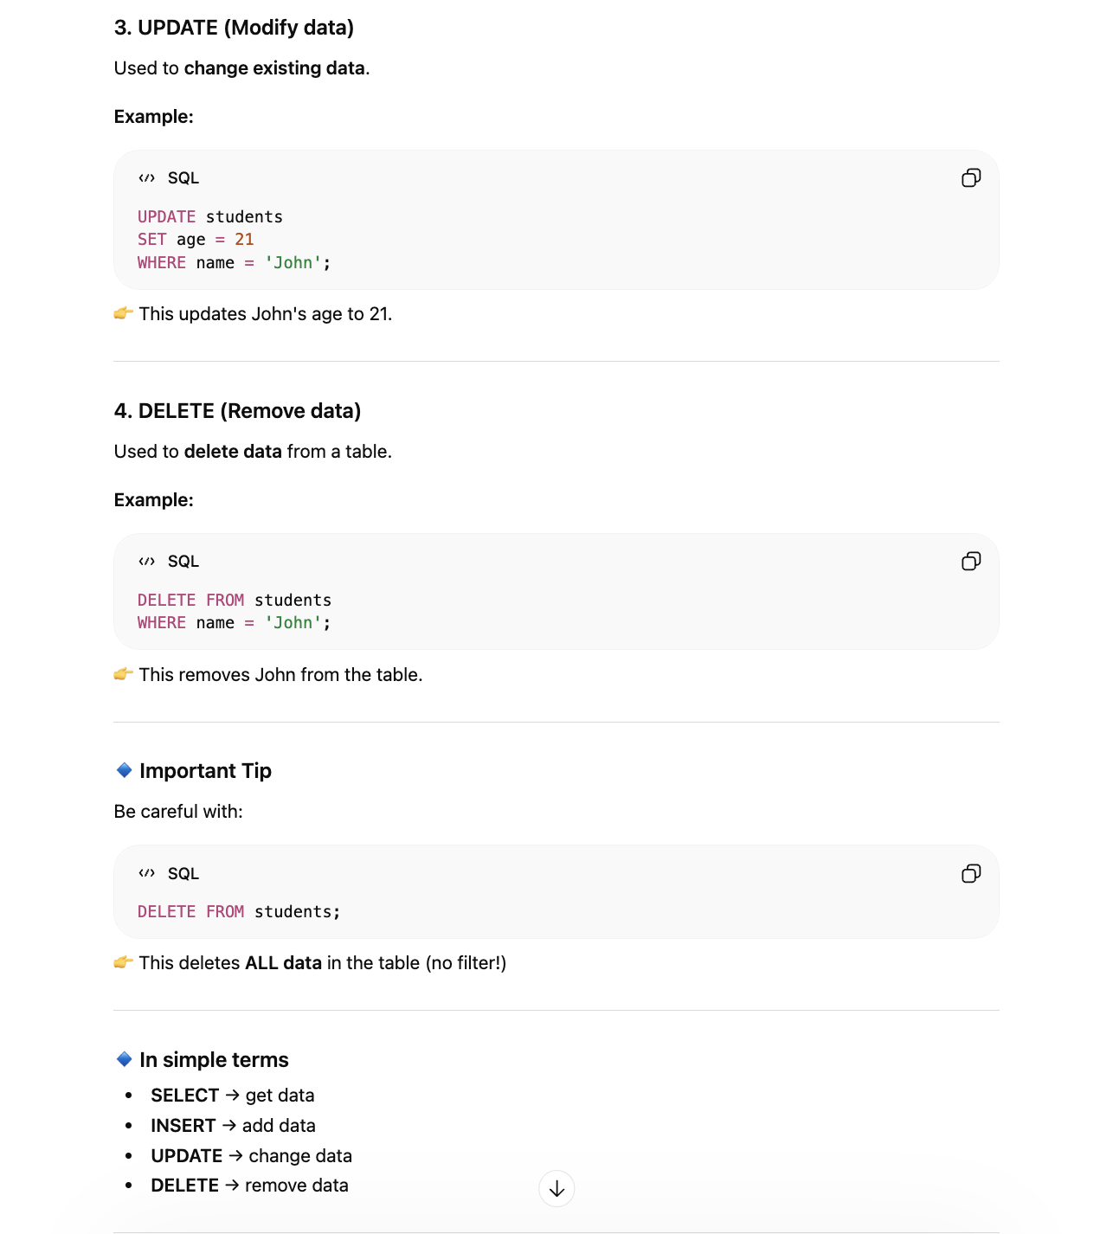

Weak Prompt: Create a dataset
Improved Prompt:
Create a dataset with 10 rows that includes columns for Product Name, Price, Quantity Sold, and Customer Rating. Ensure prices range from $10–$100 and ratings from 1–5.
Why this is stronger:
This prompt adds clear structure, constraints, and expectations, leading to a more precise and usable dataset.
