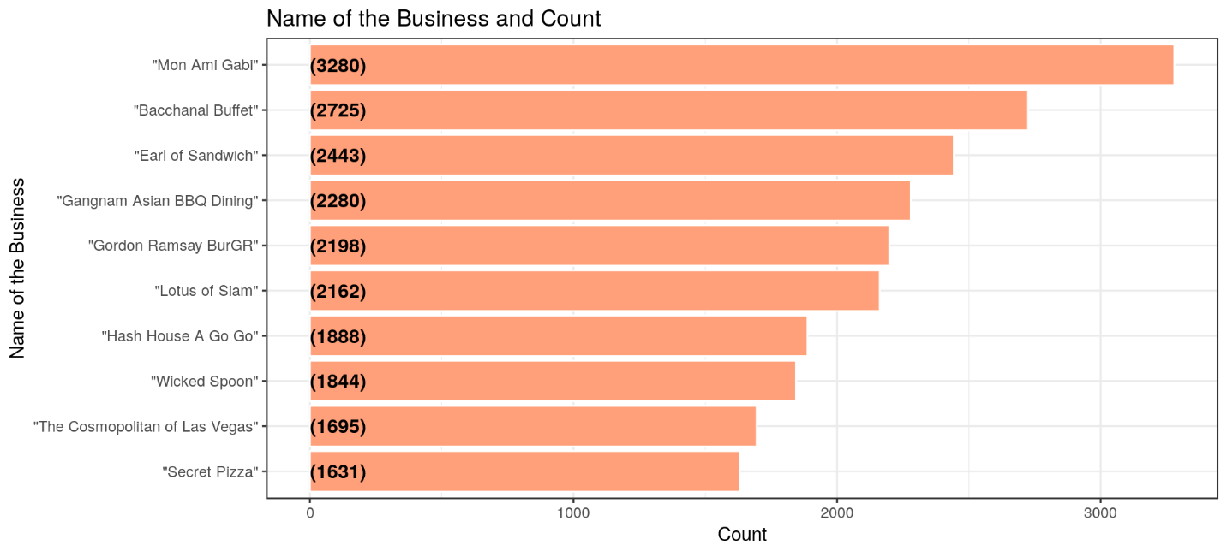

**Mon Ami Gabi**

## **Relationship among words**

### **Relationship of words with steak**

### **Relationship of words with steak**

### **Relationship of words with french**

# ****Bacchanal Buffet****

## **Relationship among words in Bacchanal Buffet**

### **Relationship of words with crab**

### **Relationship of words with food**

# Top Ten Business in Toronto

# ****Pai Northern Thai Kitchen****

## **Relationship among words in Pai Northern Thai Kitchen**

### **Relationship of words with thai**

# ****Chipotle business****

# Chipotle Business in Yonge Street Toronto

# Topic Modelling

Topic modeling is a method for **unsupervised classification of documents**, similar to clustering on numeric data, which finds natural groups of items even when we’re not sure what we’re looking for.

**Latent Dirichlet allocation (LDA)** is a particularly popular method for fitting a topic model. It treats each document as a mixture of topics, and each topic as a mixture of words. This allows documents to “overlap” each other in terms of content, rather than being separated into discrete groups, in a way that mirrors typical use of natural language.

## **Topic Modelling for Mon Ami Gabi**

## **Topic Modelling for Bacchanal Buffet**

## **Topic Modelling for Pai Northern Thai Kitchen**

# Phoenix City Analysis

## **Top Ten Business in Phoenix**

## **Topic Modelling for Phoenix City**

## **Top Ten most common Words of the business Phoenix City**

# ****Bobby Q****

## **Relationship among words in Bobby Q**

