**COL870: Assignment 1**

**A. GNN Details**

Hyperparameters used:

Results:

|  |  |  |  |
| --- | --- | --- | --- |
| Dataset | Train | Test | Val |
| Cora |  |  |  |
| Citeseer |  |  |  |

Macro-F1 scores on train, validation, and test data

The plots of epochs vs loss/macro-F1 score for both the datasets are given below.

***Cora***

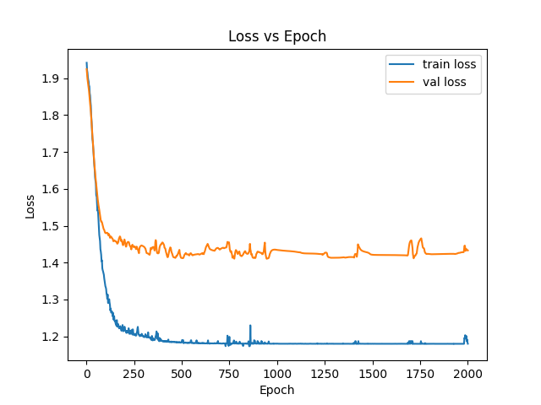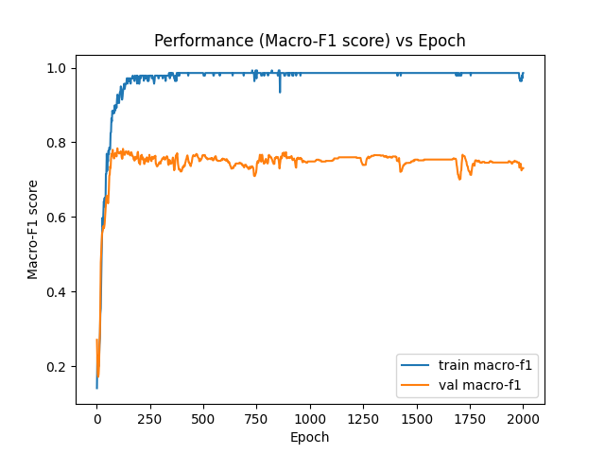

***Citeseer***

**B. Impact of Topology**

***Experiment 1:*** GNNs aggregate the messages from the neighbors of a given target node to compute its embeddings, and then uses them to make predictions, and that is where topology gets incorporated along with the features. MLPs on the other hand only use features to generate embeddings and not topology to make predictions. So we conduct an experiment where we present results

Results:

Observation:

***Experiment 2:*** To assess, how much topology should be incorporated while aggregating messages from the neighbors, we vary the number of layers of the GNN and plot the number of layers vs loss, and number of layers vs macro-F1 score. The number of GNN layers are directly proportional to the number of hops from which information is aggregated, thus it controls how much topology is being incorporated while making predictions for a given node on any given downstream task.

Results:

Observation:

***Conclusion:***