**Labsheet 03**

Name: Prarthana A.P.S

Student ID: IT22127228

Face Verification

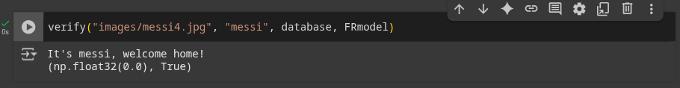

Face Recognition

