# Title: Organizational Management Database in Microsoft Access

Description: The Organizational Management Database is a comprehensive and efficient solution built in Microsoft Access to streamline and manage vital information within an organization. The database comprises three key tables: Banks, Departments, and Employees. It provides a user-friendly interface and two specialized forms to facilitate data entry, retrieval, and reporting. The system enables administrators to maintain, search, and export department-specific information effortlessly.

Tables: a. Banks Table: This table stores essential details about the banks associated with the organization, such as bank code, name, branch details, and contact information.

b. Departments Table: The Departments table contains information about various departments within the organization. Key fields include the Department Code (Dept_code), Department Name (Dept_name), and other department-specific attributes.

c. Employees Table: The Employees table is a comprehensive repository of employee information, including their Employee ID, name, contact details, job title, and department affiliation.

Query: The database features a powerful query that enables users to search the database by using the Department Code (Dept_code). Users can simply input the required Dept_code to retrieve specific information related to the corresponding department. The query simplifies data retrieval and enables swift access to pertinent departmental records.

Forms: a. Department Form: The Department Form allows users to export department-specific data by entering the Department Code (Dept_code) and Department Name (Dept_name). Upon inputting the relevant details, the form generates an export of the data in the required format. This feature ensures a seamless process of obtaining essential department-related information for analysis and reporting purposes.

b. Data Administrator Form: The Data Administrator Form is a versatile tool designed to empower data administrators with various functionalities to manage the organizational data efficiently. The form allows the data administrator to:

Add New Data: This feature facilitates the addition of new department and employee records into the database. By filling in relevant fields, the data administrator can ensure that accurate and up-to-date information is stored.

Read Data: The form provides a simple and intuitive interface to view department and employee details. The data administrator can easily access information by navigating through records.

Delete Data: This crucial functionality enables the data administrator to remove obsolete or redundant records from the database. The process is seamless and ensures data integrity.

The Organizational Management Database in Microsoft Access empowers the organization with a centralized and efficient data management solution. It offers quick and reliable access to department-specific information, enhances data integrity, and streamlines administrative tasks. By harnessing the power of this database, organizations can effectively manage their operations, enhance decision-making processes, and ensure optimal efficiency in day-to-day activities.

# In the Organizational Management Database, the three types of relationships between the tables (Banks, Departments, and Employees) are described below:

One-to-One (1:1) Relationship: In a one-to-one relationship, each record in one table is associated with exactly one record in another table, and vice versa. This means that for every row in the first table, there is only one matching row in the second table, and vice versa.

Example: One bank can have only one primary department, and one department can be associated with only one bank. This is represented by the relationship between the "Banks" table and the "Departments" table, where each bank is linked to its primary department.

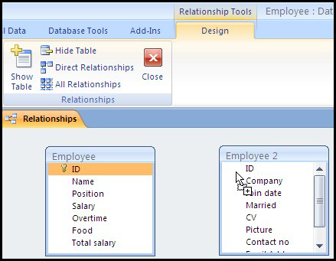

One-to-Many (1:N) Relationship: In a one-to-many relationship, each record in one table can be associated with multiple records in another table, but each record in the second table is linked to only one record in the first table. This is the most common type of relationship.

Examples:

One department can have many employees, but each employee is associated with only one department. This is represented by the relationship between the "Departments" table and the "Employees" table, where multiple employees can be assigned to a single department.

One bank can have multiple departments, but each department is associated with only one bank. This is represented by the relationship between the "Banks" table and the "Departments" table, where multiple departments can belong to the same bank.

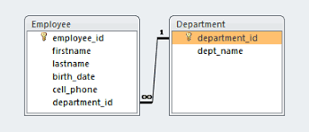

Many-to-Many (N:M) Relationship: In a many-to-many relationship, each record in one table can be associated with multiple records in another table, and vice versa. This relationship requires a junction table to link the two main tables.

Example:

Many employees can belong to multiple departments, and each department can have multiple employees. To represent this, a junction table called "Employee_Department" is created, which includes the Employee ID and Department Code, linking the "Employees" table and the "Departments" table.

