|  |  |  |  |  |  |  |
| --- | --- | --- | --- | --- | --- | --- |
| **Table Name** | **Field Order** | **Key Type** | **Column Name** | **Data Type** | **Nullable** | **Description** |
| notes | 1 | PK | id | integer(32) | NOT NULL | Unique ID for note |
| notes | 2 |  | note_title | character varying(255) | NOT NULL | Note title |
| notes | 3 |  | date_created | date(3) | NULL | Note Creation Date/Time |
| notes | 4 |  | date_edited | date(3) | NULL | Note Edit Date/Time |
| notes | 5 |  | size_bytes | integer(32) | NULL | Size of Note in bytes |
| notes | 6 |  | note_display | character varying(20) | NOT NULL | Shorter version of note_contents for display purposes |
| notes | 7 |  | note_contents | character varying(10485760) | NOT NULL | Note Content |
| users | 1 | PK | id | integer(32) | NOT NULL | Unique ID for User |
| users | 2 |  | username | character varying(255) | NOT NULL | N/a |
| users | 3 |  | password | character varying(255) | NOT NULL | N/a |
| users | 4 |  | role | integer(32) | NOT NULL | Is admin or Viewer Role |

Above is a data dictionary containing all the information about the fields within the tables of our database. Used to catalog the structure of the tables.

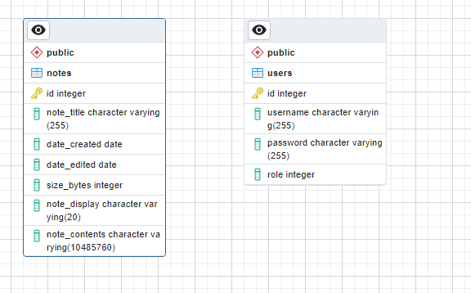

An ERD for showing the links between our tables. There are currently no links between either of these tables as at the point of this screenshot being taken there was no link at all between these two tables