HW #1 Solution
Deep Learning for Computer Vision (EN525.733.8VL)
Q.1: XOR Problem Analysis

Network 1 Analysis

Network Equations
From the network diagram:
h₁ = Step(x₁ + x₂ − 0.5)
h₂ = Step(x₁ + x₂ − 1.5)
out = Step(h₁ − h₂ − 0.5)

(a) Decision Regions
The hidden neurons create two parallel decision boundaries:
h₁ boundary: x₁ + x₂ = 0.5 (h₁ = 1 when x₁ + x₂ ≥ 0.5)
h₂ boundary: x₁ + x₂ = 1.5 (h₂ = 1 when x₁ + x₂ ≥ 1.5)
These create three regions with outputs:
Region A (x₁+x₂ < 0.5): h₁=0, h₂=0 → out = Step(-0.5) = 0 [contains (0,0)]
Region B (0.5 ≤ x₁+x₂ < 1.5): h₁=1, h₂=0 → out = Step(0.5) = 1 [contains (0,1), (1,0)]
Region C (x₁+x₂ ≥ 1.5): h₁=1, h₂=1 → out = Step(-0.5) = 0 [contains (1,1)]
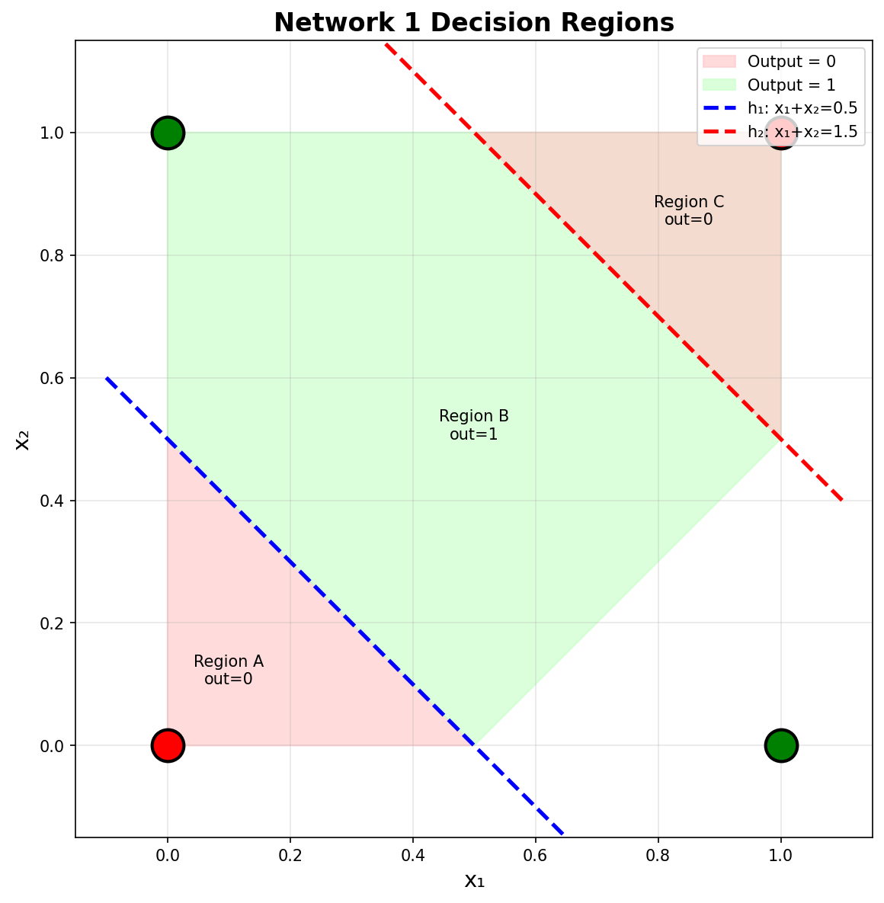

(b) Truth Table
x₁ | x₂ | h₁ net | h₁ | h₂ net | h₂ | out net | out | XOR | Match
0 | 0 | -0.5 | 0 | -1.5 | 0 | -0.5 | 0 | 0 | ✓
0 | 1 | 0.5 | 1 | -0.5 | 0 | 0.5 | 1 | 1 | ✓
1 | 0 | 0.5 | 1 | -0.5 | 0 | 0.5 | 1 | 1 | ✓
1 | 1 | 1.5 | 1 | 0.5 | 1 | -0.5 | 0 | 0 | ✓
Conclusion: Network 1 SOLVES the XOR problem. All outputs match the expected XOR values.

Network 2 Analysis

Network Equations
From the network diagram (note: connection lines cross in the middle):
h₁ = Step(−2.0x₁ + 9.2x₂ − 1.8)
h₂ = Step(4.3x₁ + 8.8x₂ − 0.1)
out = Step(−4.5h₁ + 5.3h₂ − 0.8)

(a) Decision Regions
The hidden layer decision boundaries:
h₁ boundary: −2.0x₁ + 9.2x₂ − 1.8 = 0 → x₂ = (2.0x₁ + 1.8)/9.2
h₂ boundary: 4.3x₁ + 8.8x₂ − 0.1 = 0 → x₂ = (0.1 − 4.3x₁)/8.8
Key observation: The hidden layer maps both (0,1) and (1,1) to the same representation (h₁=1, h₂=1), making them indistinguishable to the output layer.
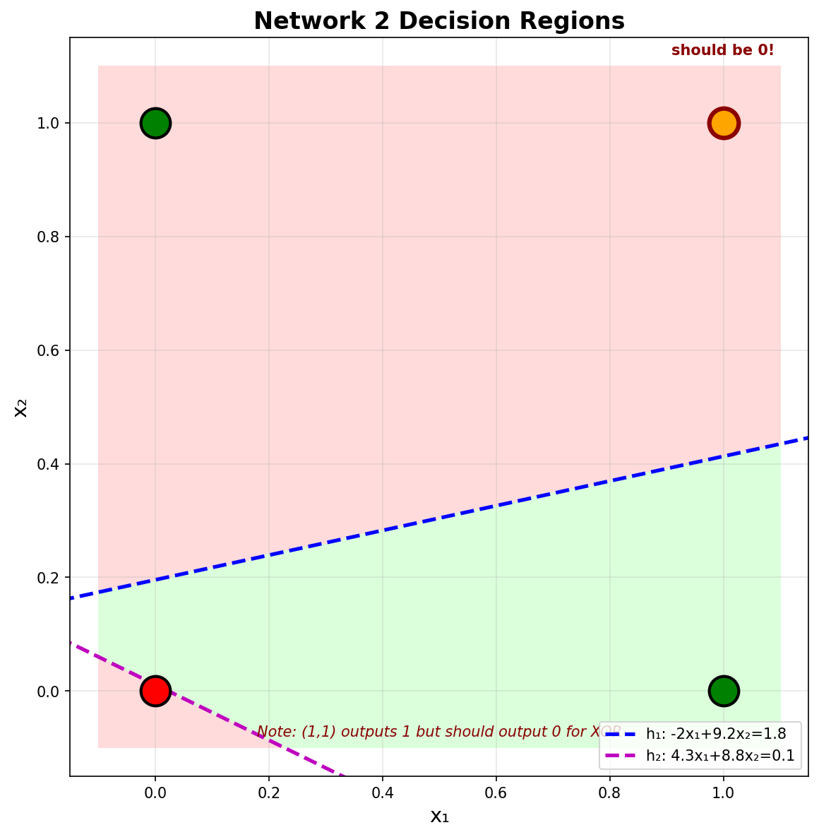

(b) Truth Table
x₁ | x₂ | h₁ net | h₁ | h₂ net | h₂ | out net | out | XOR | Match
0 | 0 | -1.8 | 0 | -0.1 | 0 | -0.8 | 0 | 0 | ✓
0 | 1 | 7.4 | 1 | 8.7 | 1 | -0.0 | 1 | 1 | ✓
1 | 0 | -3.8 | 0 | 4.2 | 1 | 4.5 | 1 | 1 | ✓
1 | 1 | 5.4 | 1 | 13.0 | 1 | -0.0 | 1 | 0 | ✗
Conclusion: Network 2 does NOT solve the XOR problem. Input (1,1) produces output 1 instead of expected 0.

Analysis of Network 2 Failure
The problem is that the hidden layer creates identical representations for inputs that require different outputs:
(0,1): h₁ = Step(7.4) = 1, h₂ = Step(8.7) = 1 → (h₁,h₂) = (1,1)
(1,1): h₁ = Step(5.4) = 1, h₂ = Step(13.0) = 1 → (h₁,h₂) = (1,1)
Since both inputs map to (1,1) in the hidden layer, the output neuron computes:
out = Step(−4.5(1) + 5.3(1) − 0.8) = Step(0) = 1 for both inputs
But XOR requires (0,1)→1 and (1,1)→0. Since both produce output 1, the network fails. Note: Even with Step defined as strictly greater than (>) instead of ≥, both would output 0, which also fails since (0,1) should be 1.

Summary
Network 1: Successfully solves XOR. The parallel decision boundaries correctly separate Class 0 {(0,0), (1,1)} from Class 1 {(0,1), (1,0)}.
Network 2: Does NOT solve XOR. The hidden layer fails to create distinct representations for (0,1) and (1,1), making it impossible for the output layer to produce different results for these inputs.

