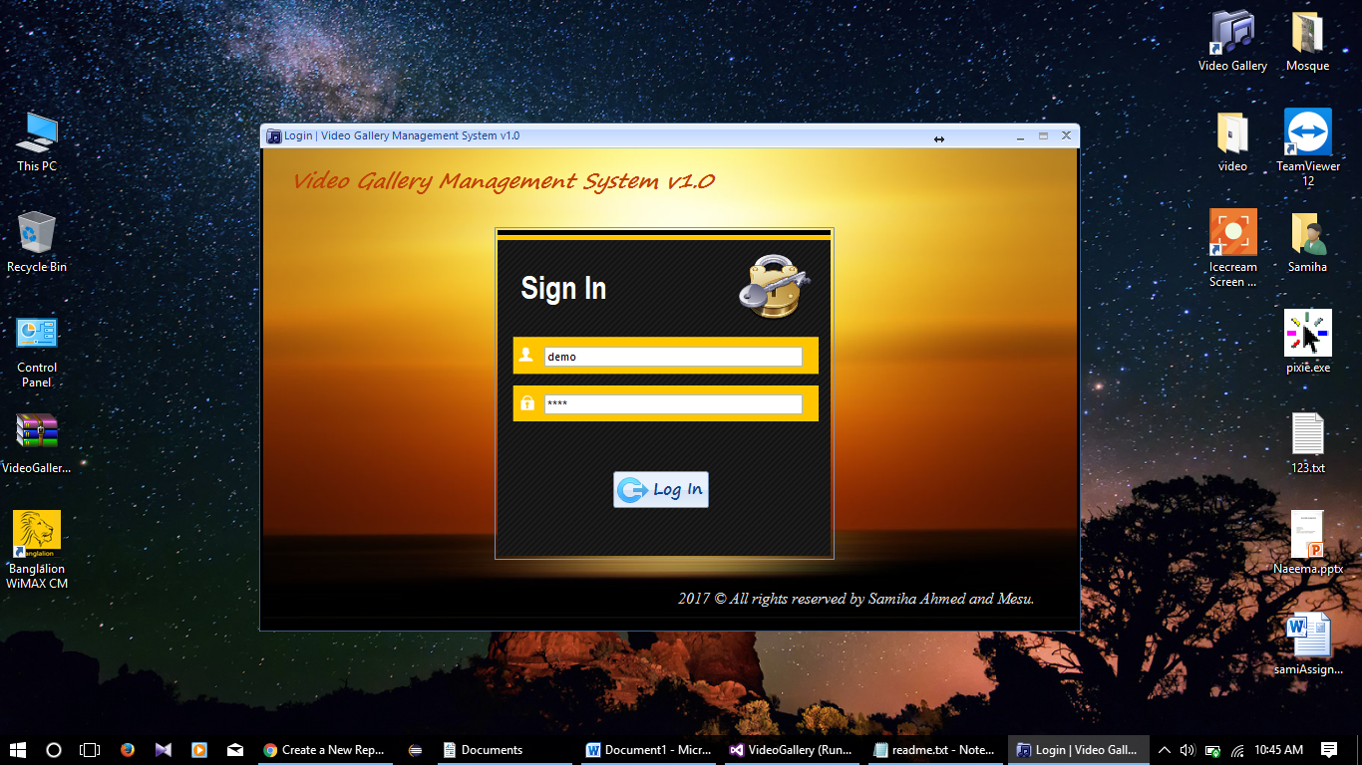

This is the Login form , at first user have to fill the username & password . (Sample Username : “demo” , Sample password : “demo” ). After click in “Log in” button “Main Form” will be open.

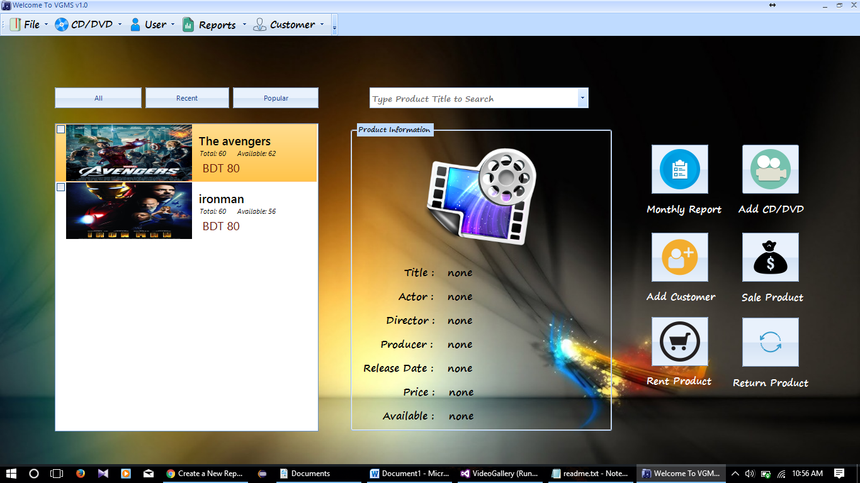

1) In the left list box all products are shown. This “All” button Shows all the products of the record , “Recent” button shows the recently added last 10 products , “Popular” button shows the most sold top 10 products. If user select any of the product of the list box then the details will be shown in the middle group box.

2) In the search box user can search any product & the selected product’s details will also be shown in the middle group box.

3) On the right side there some button as like , monthly report , sale product , rent product etc. for quick access .



4) On top there is a menu bar .

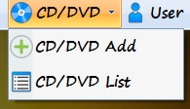

If User click the drop down button “CD/DVD Add” , then the CD-DVD add form will be opened & if click “CD/DVD List” ,then CD-DVD list will be opened.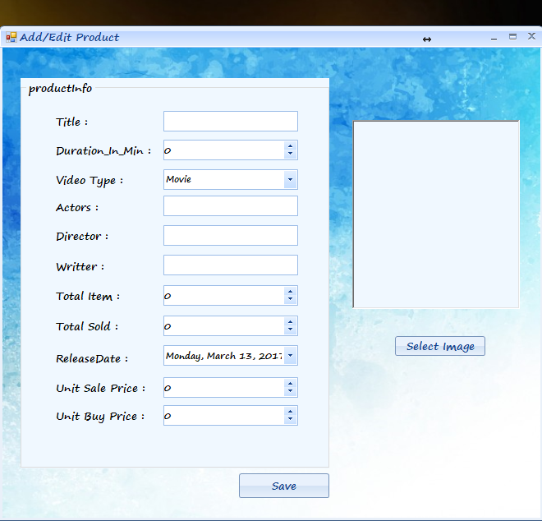

This is the CD/DVD add form . User have to fill the form completely , if user skip any field it will show an error message . After clicking save button the information will be saved.

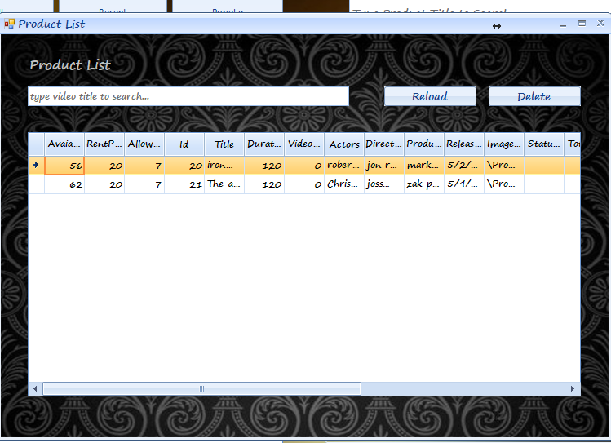

This is the CD/DVD list . User can view all the products & also edit from here by select a row and double clicking on it . But user can’t delete any item if that product is sold or rented .

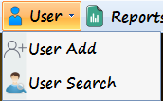

If User click the drop down button “User Add ” , then the User add form will be opened & if click “User Search ” ,then User list will be opened.

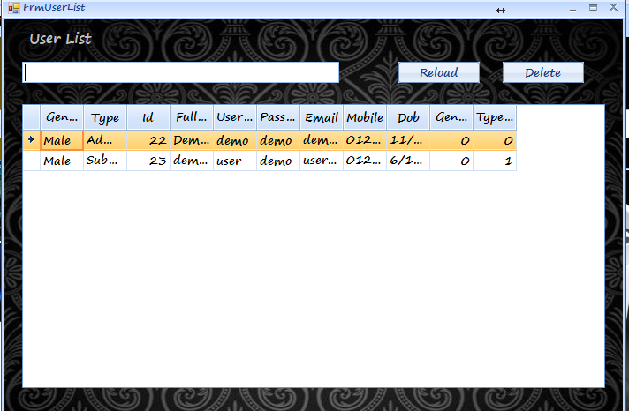

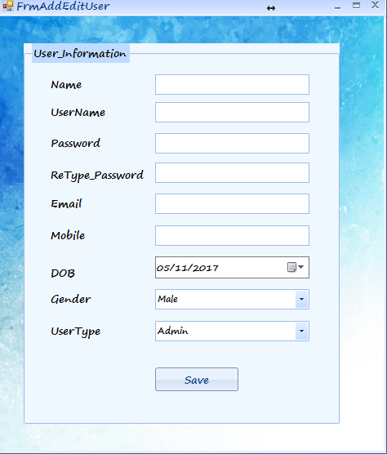

This two are “ User list “ & “User add” form . User can add user , view User list & edit list as like as Cd/DVD add & list .

\*\*\* In User form the type of user is very important . there can be 3 types of user :

(i) Admin : Admin can access all the features of the application .

(ii) Subadmin : Subadmin can access all the features except “User add” & see monthly report.

(iii) Salesman : Salesman can Add , sale & rent products but can not edit the existing list.

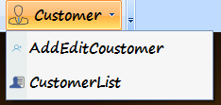

If User click the drop down button “Add Edit Customer” , then the Add Edit Customer form will be opened & if click “Customer List ” ,then Customer list will be opened.

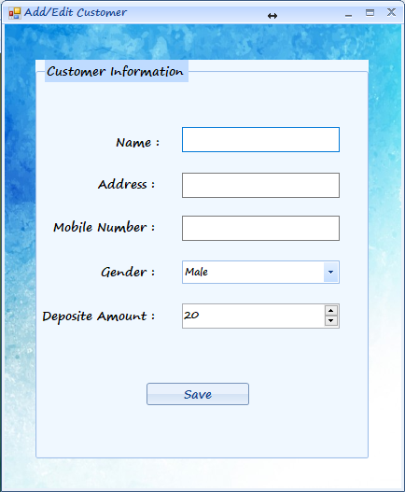

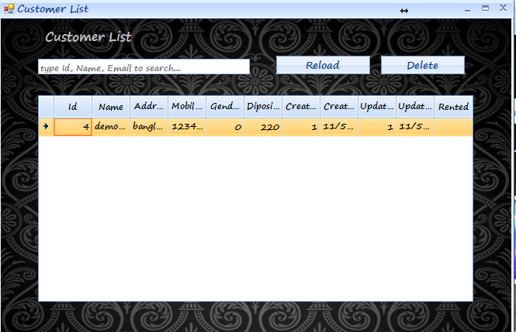

This two are “ Customer add “ & “Customer List” form . User can add customer , view Customer list & edit list as like as Cd/DVD add & list .

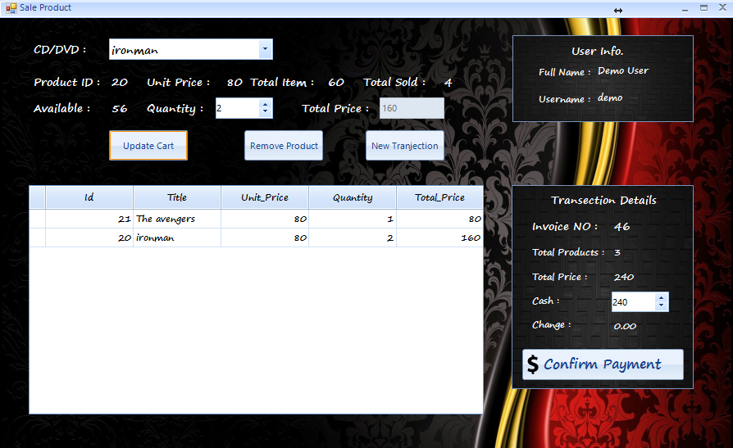

This is the sale form , user can select a product from search box and then select quantity and by clicking update cart ,then the selected product will be added in the cart . On the top right the information of user who logged in will be shown. User can also add multiple products . In the right there is transection details ,when user click conform payment the bill will be shown in a pdf viewer . And the form will be ready for new transection.

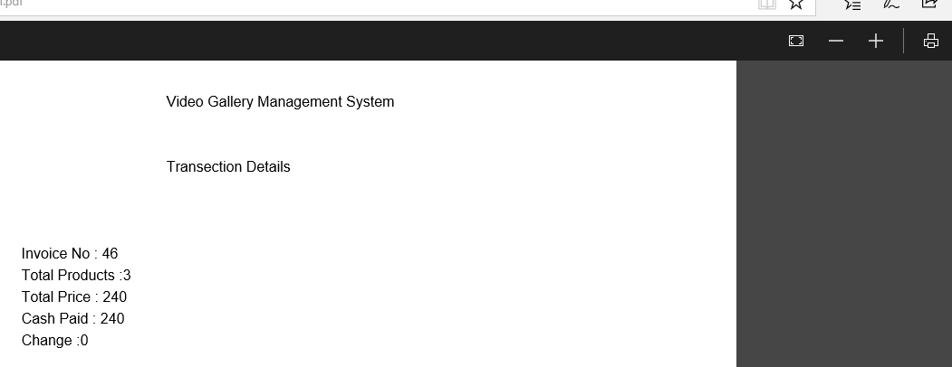

User can print the pdf from here.

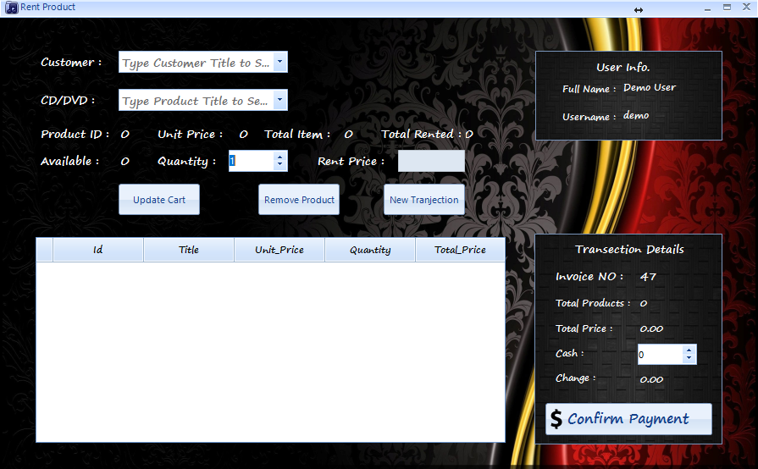

This is the rent form . A customer can rent a CD/DVD by the help of this form.

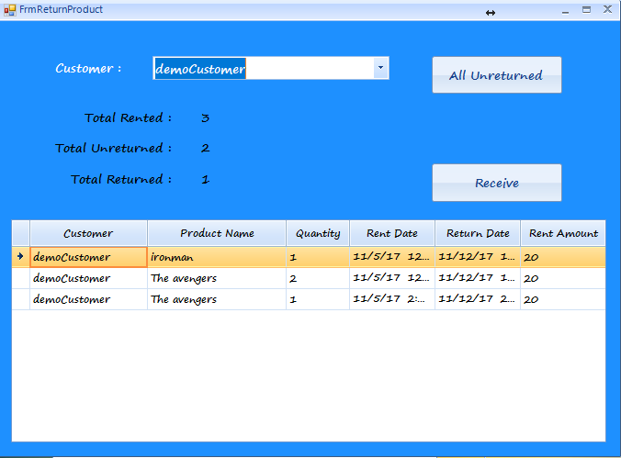

This is the rent return form. Customer can return his rented CD/DVD by the help of this form.

By selecting a row ,then click on the receive button the total unreturned calculation will be updated.

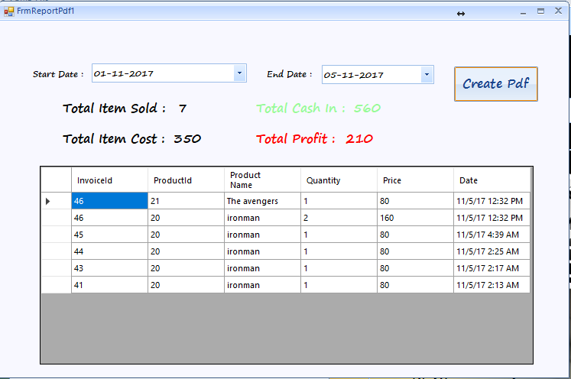

This is the monthly report form .This is the most important and main purpose of the application is to revenue and calculate the monthly income. User have to select startDate and endDate , and the sold products among this days will be shown in the gridview . And the profit will also calculate and shown in the report . After clicking the create pdf button the monthly report will be generated in a PDF viewer.

This is the generated pdf of the monthly report.

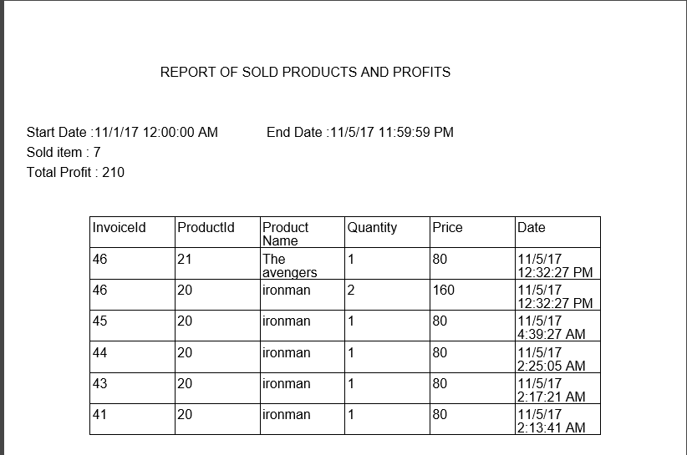

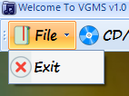

User can exit from the application by click on “Exit” button in file on menu bar.