Cloud Computing

Final Paper

M. Sami ur Rehman – CS191022

**1.**Upload your image on S3 Bucket and create a Resume HTML file in your AWS Instance (EC2) and add your image link in the

Link - http://13.55.136.117:8084/

Resume file and image uploaded on s3

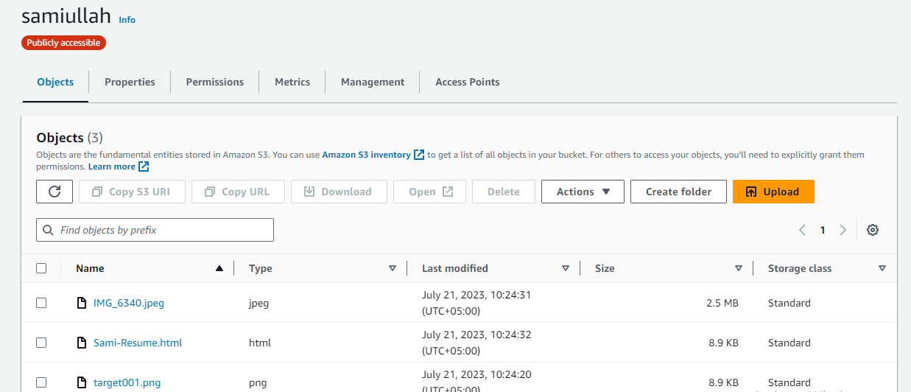

Termius

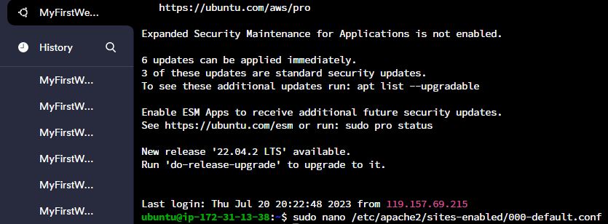

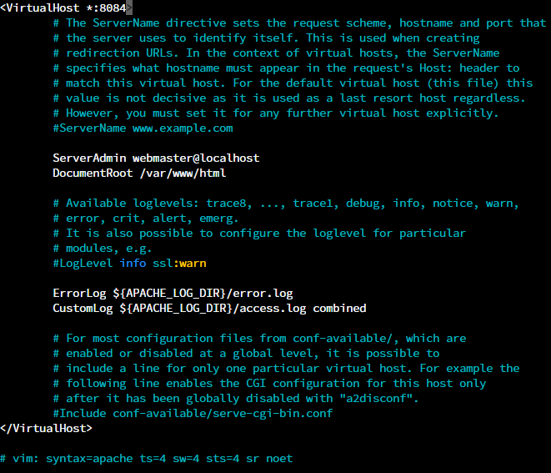

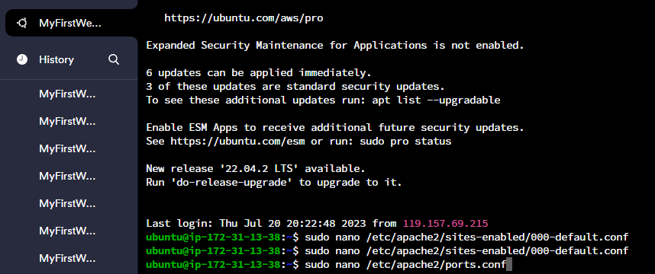

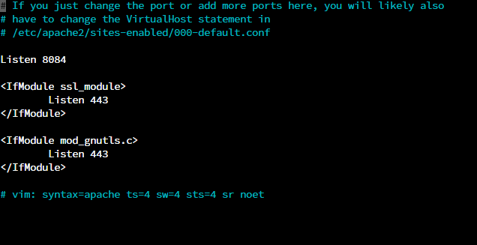

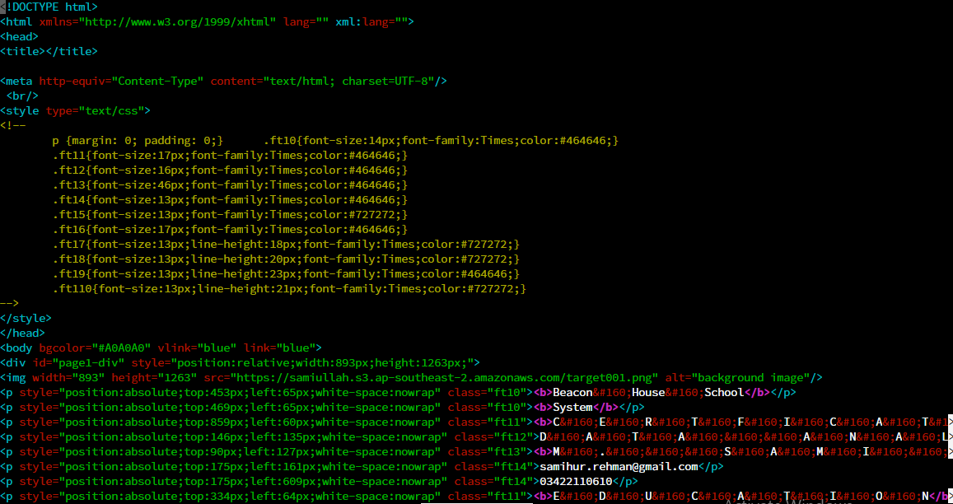

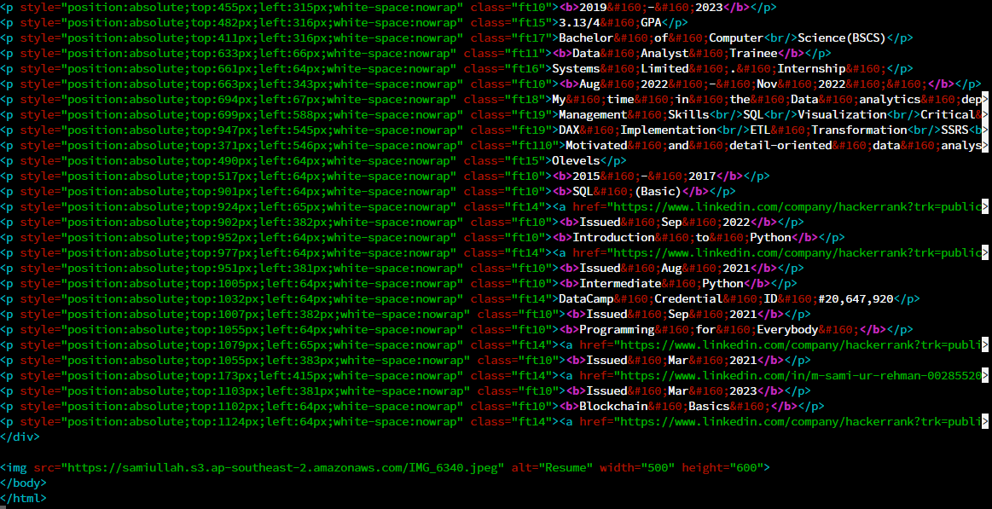

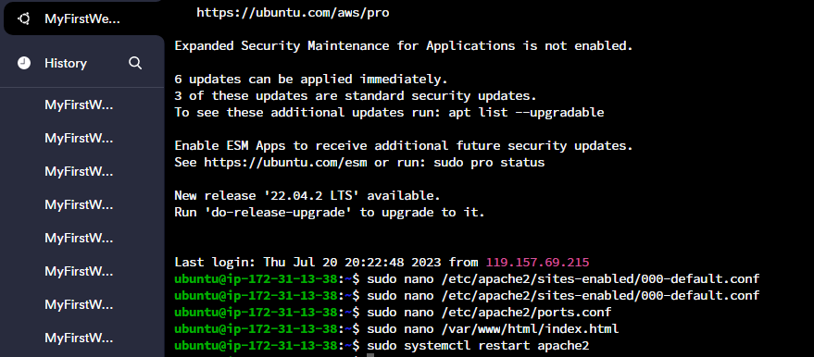

Webpage screenshot

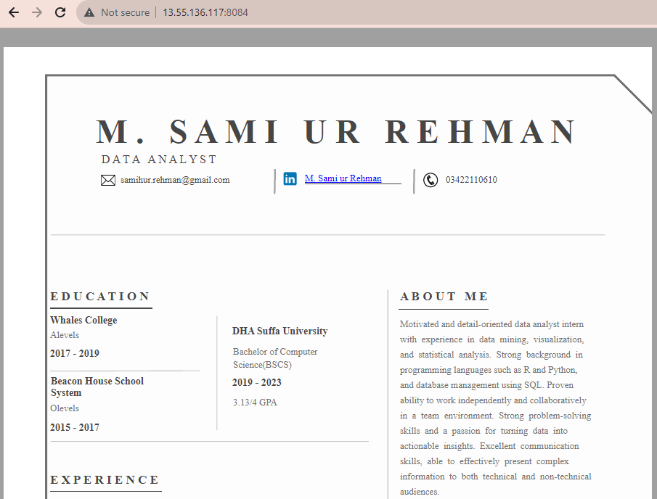

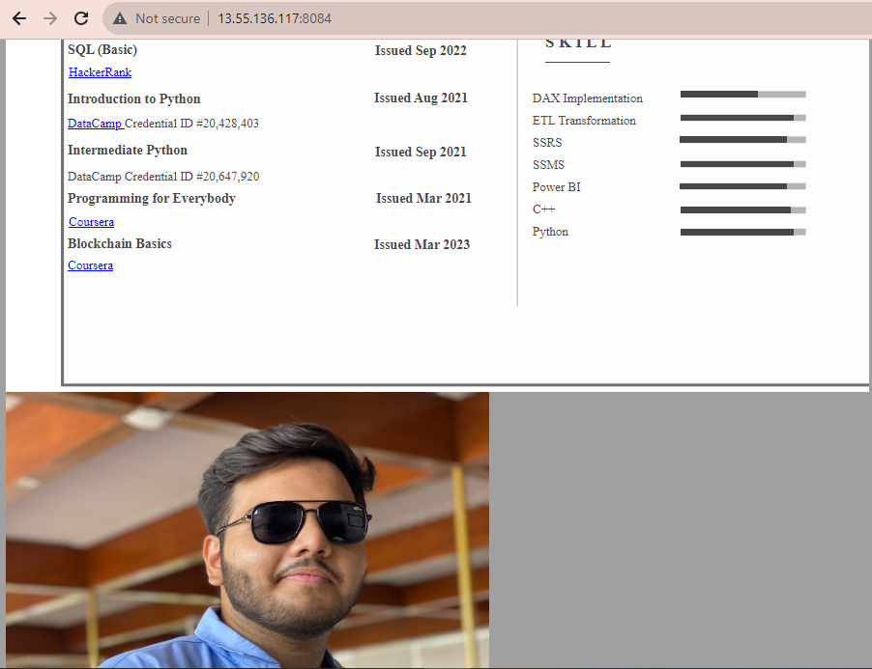

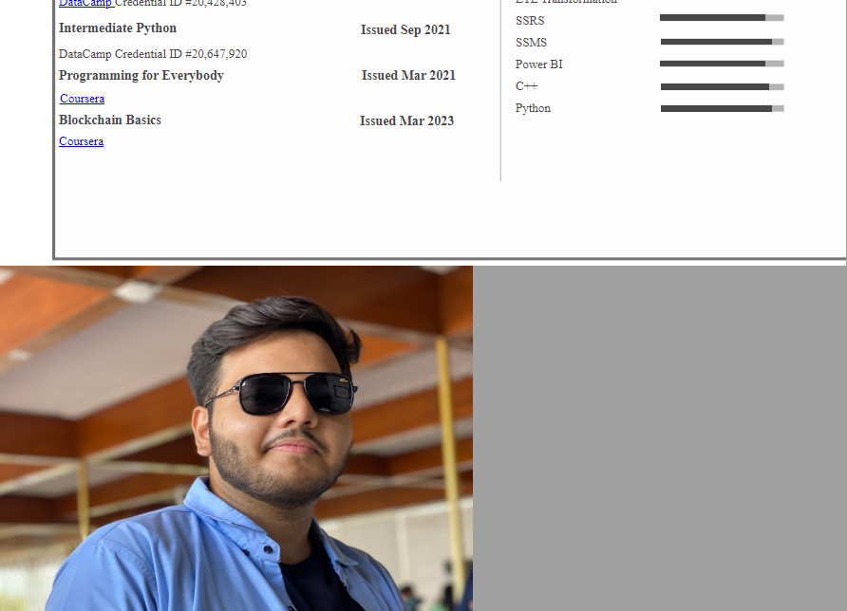

2. Git

* 1. Create a repository on git
  2. Upload html Resume file link in the repository.
  3. Create two branches
  4. Write different functions in each branch
  5. Merge branches
  6. Revert changes
  7. Merge only the first branch again