Project Report on

**Online Courier Management System**

Submitted to

**Department of Computer Science and Engineering Nepal Engineering College**

in Partial Fulfillment of the

Requirements for the Degree of B.E. in Computer

By

Samika Taja (020-380)

Supervised by: Sudarshan Subedi

Date: 07/10/20

**ABSTRACT**

The Online Courier Management System (OCMS) represents a pivotal advancement in logistics and delivery services, leveraging digital platforms to streamline operations and enhance customer satisfaction. This system provides a comprehensive solution for managing the entire courier process, from order placement to final delivery, through an intuitive and efficient online interface. Key features include real-time tracking of shipments, automated routing and scheduling, integrated payment gateways, and robust analytics for performance evaluation. Designed to cater to the needs of both courier service providers and end-users, OCMS aims to optimize resource utilization, minimize operational costs, and ensure timely delivery of parcels. This abstract explores the architecture, functionalities, benefits, and potential impacts of OCMS in revolutionizing the logistics industry towards greater efficiency and customer-centricity.

# **CHAPTER 1: INTRODUCTION**

In today’s world, delivering packages swiftly and accurately is crucial for businesses to satisfy their customers. Traditional methods of managing courier services often lead to delays, tracking errors, and poor communication, which can frustrate both businesses and customers.

To tackle these issues, the Online Courier Management System (OCMS) offers a modern solution. It uses digital technology to streamline how couriers are managed from the moment an order is placed to its delivery. The OCMS integrates advanced tracking features, automated scheduling, and instant updates, allowing businesses and customers to track shipments in real-time.

Furthermore, the OCMS improves communication among everyone involved couriers and customer by providing a central online platform accessible from anywhere. This not only increases transparency but also cuts down on costs and boosts efficiency.

This report delves into the features, advantages, and implementation of an Online Courier Management System. It explores how such a system can transform logistics operations, enhance customer satisfaction, and help businesses thrive in today's digital world. Embracing an OCMS enables organizations to navigate logistics challenges effectively and meet the growing expectations of a global market.

## **1.1 Problem Statement**

Traditional courier management methods suffer from delays, inaccurate tracking, and poor communication, leading to customer dissatisfaction and operational inefficiencies. Managing multiple shipments concurrently poses logistical challenges without a centralized system for oversight and coordination. These issues escalate costs and administrative complexities for businesses, hindering growth and customer retention. To address these challenges, an Online Courier Management System (OCMS) is crucial. It aims to revolutionize logistics by automating processes, enhancing tracking accuracy, and improving communication among stakeholders. This report examines how an OCMS can mitigate these problems, streamline operations, and elevate service standards in the competitive logistics industry.

## **1.2 Aim**

The primary aim of an Online Courier Management System (OCMS) is to streamline and optimize the process of managing courier services through digital automation. By integrating advanced tracking capabilities, automated scheduling, and real-time communication channels, the OCMS seeks to enhance operational efficiency, reduce costs, improve accuracy in delivery tracking, and ultimately elevate customer satisfaction levels. This system aims to provide businesses with a centralized platform for efficient logistics management, enabling them to handle shipments more effectively, mitigate logistical challenges, and maintain competitiveness in the modern marketplace.

**1.3 Objective**

* **Enhanced Efficiency:** Automate and streamline processes to ensure faster handling and dispatch of shipments, reducing turnaround times and operational bottlenecks.
* **Improved Tracking and Visibility:** Implement robust tracking mechanisms to provide real-time updates on shipment status to both businesses and customers, ensuring transparency and reliability.
* **Cost Optimization:** Minimize operational costs through efficient resource utilization, optimized route planning, and reduced administrative overhead associated with manual processes.
* **Enhanced Customer Experience:** Enhance overall service quality by providing accurate delivery estimates, proactive notifications, and responsive customer support, thereby improving satisfaction and loyalty.
* **Scalability and Adaptability:** Design a flexible system capable of accommodating varying shipment volumes, adapting to changing business needs, and integrating seamlessly with existing IT infrastructure to support long-term growth and competitiveness.

## **1.4 Scope**

An Online Courier Management System (OCMS) covers the digital transformation of logistics processes. It includes automating order handling, tracking shipments in real-time, optimizing delivery routes, and managing resources efficiently. The system improves communication between couriers, dispatchers, and customers through a centralized online platform. It also integrates with payment systems and customer support tools to enhance service quality. The OCMS is designed to handle different shipment volumes and support business growth while keeping operations smooth and cost-effective.

# **Chapter 2: Requirement Analysis**

**Functional requirements**

**User Management:**

* Registration of new users (customers, admins, delivery personnel).

**Order Management:**

* Ability for customers to place new orders, including specifying pickup and delivery details.
* Tracking of orders in real-time (status updates from pickup to delivery).

**Courier Assignment:**

* Automated assignment of delivery personnel based on location and workload.

**Payment:**

* Integration with payment gateways for secure transactions.

**Non Functional requirements**

**Performance:**

* Response time for key operations (e.g. order placement, tracking updates) should be under 2 seconds.

**Security:**

* Role-based access control to ensure only authorized personnel can perform specific actions.

# **CHAPTER 3: SYSTEM DESIGN**

**3.1 Use Case Diagram**

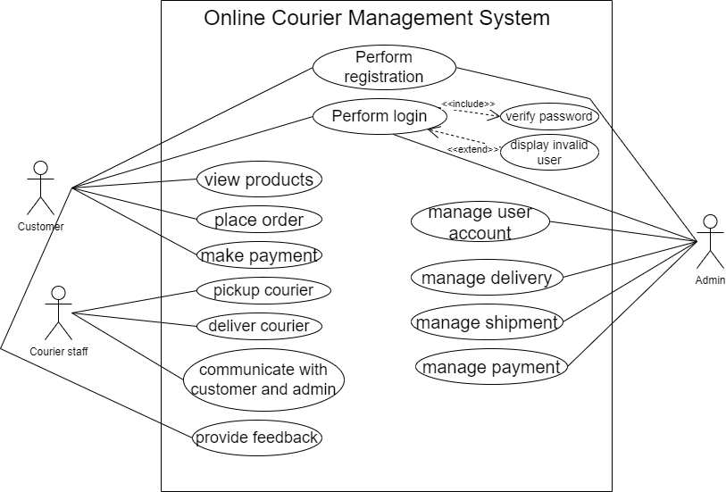

Figure 1 usecase diagram of online courier system

Top of Form

Bottom of Form

**3.2 System Sequence Diagram**

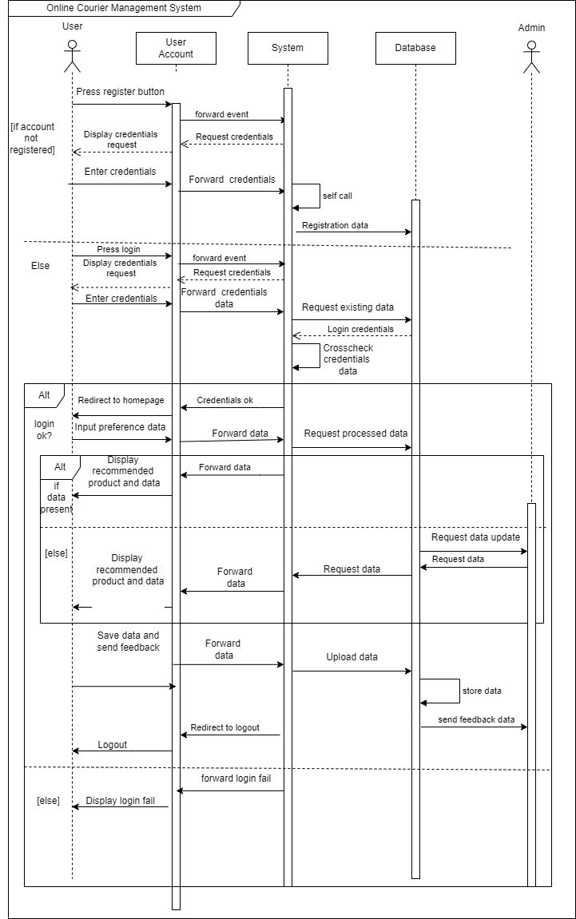

Figure 2 sequence diagram of OCMS

**3.3 Sequence Diagram for Major Use Cases**

**3.3.1 Sequence Diagram for searching data**

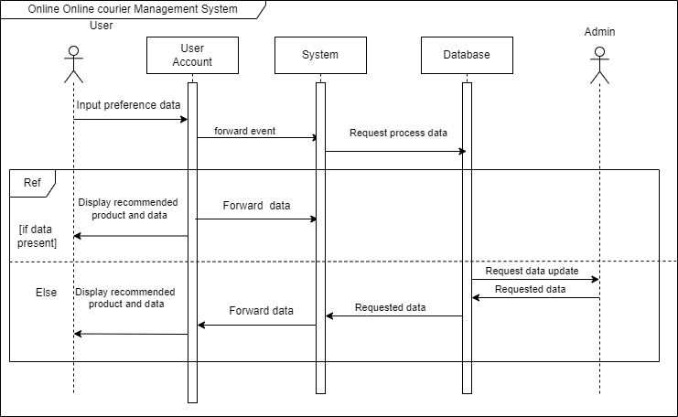

Figure 3 sequence diagram for searching data

**3.3.2 Sequence Diagram for verification**

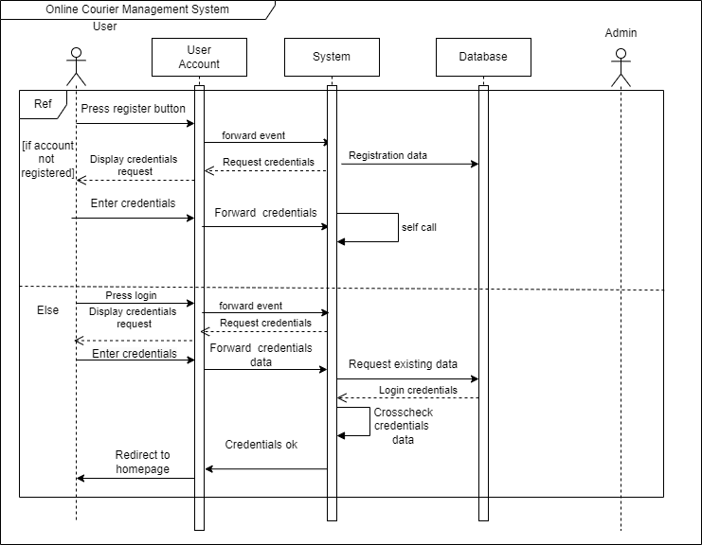

Figure 4 sequence diagram for verification

**3.3.3 Sequence Diagram for Feedback**

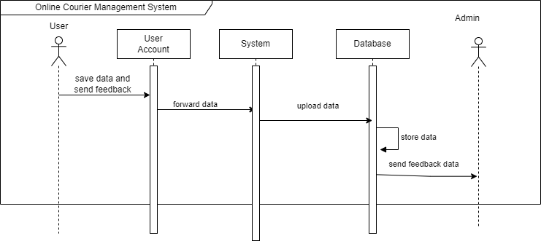

Figure 5 sequence diagram for feedback

**3.4 Activity Diagram for Major Use Cases**

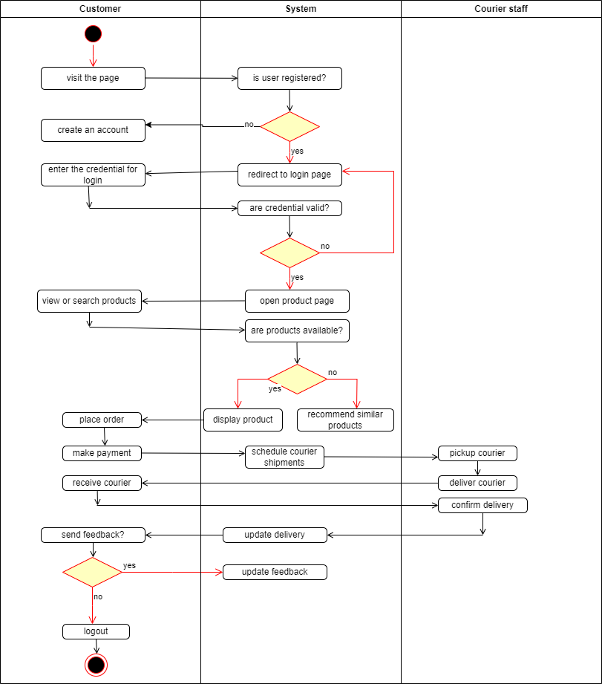

Figure 6 Activity diagram of OCMS

**3.5 Communication Diagram for Major Use Cases**

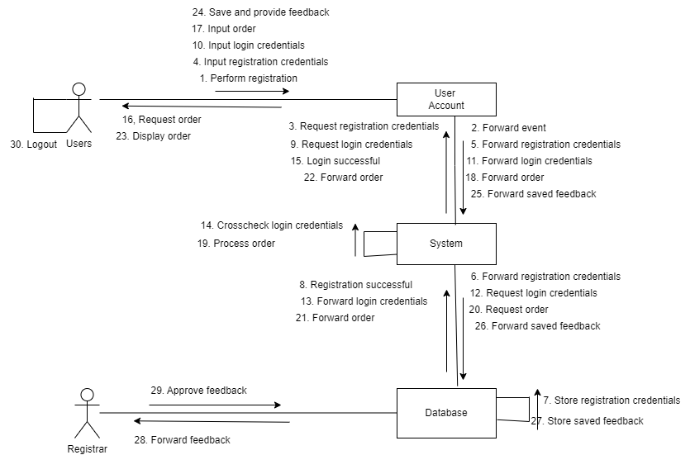

admin

Figure 7 Communication diagram for OCMS

**3.6 State Chart Diagram**

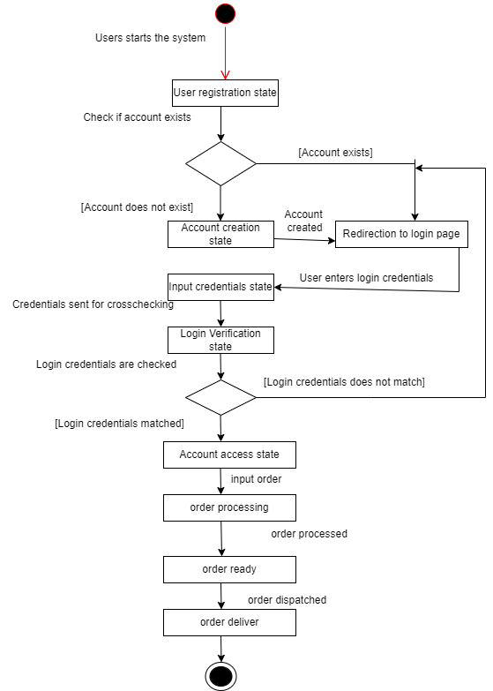

Figure 8 State chart diagram of OCMS

**3.7 Data Flow Diagram**

**3.7.1 DFD level 0**

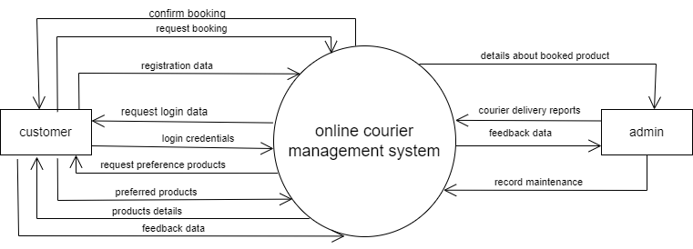

Figure 9 Data flow level 0 diagram of OCMS

**3.7.2 DFD level 1**

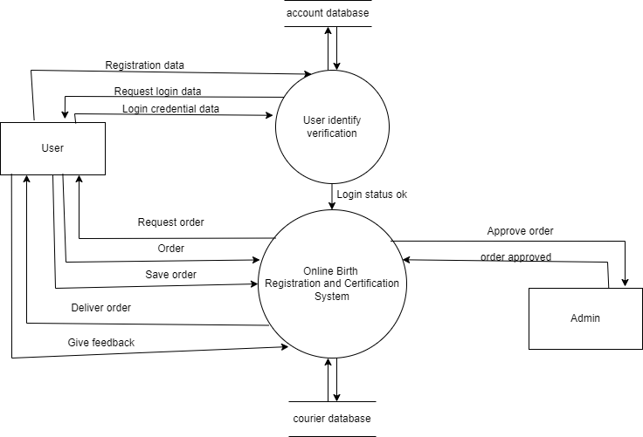

Figure 10 Data flow level 1 diagram of OCMS

**3.8 Component Diagram**

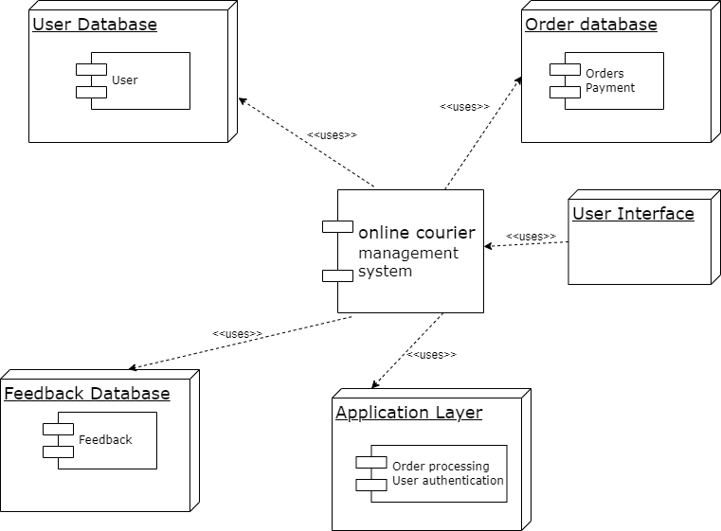

Figure 11 Component diagram of OCMS

**3.9 ER Diagram**

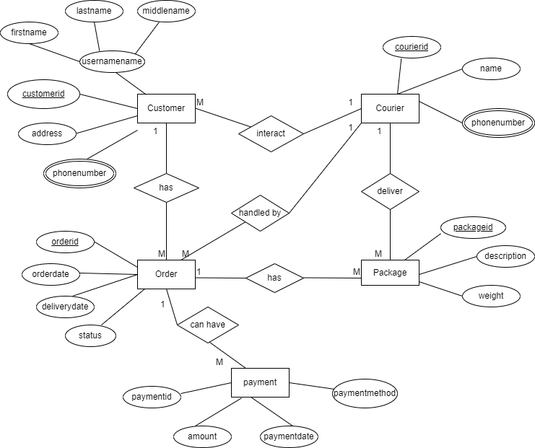

Figure 12 ER diagram of OCMS

**3.10 Class Diagram**

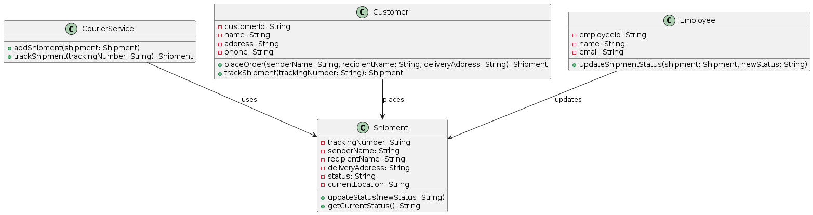

Figure 13 Class diagram of OCMS

# **CHAPTER 6: CONCLUSION**

In conclusion, our online courier management system marks a significant advancement in improving logistics and customer satisfaction in the courier industry. We've carefully designed the system to handle orders efficiently, allocate resources effectively, and keep everyone informed through features like real-time tracking and secure payments. By focusing on performance, security, reliability, usability, scalability, and compliance, we ensure a dependable platform that meets industry standards and regulatory requirements. As we move forward, our goal is to continually enhance the system to meet evolving needs, exceed user expectations, and set new standards for courier service excellence, ensuring long-term success for all stakeholders.