Report on

**Telephone System Simulation**

Submitted to

**Department of Computer Science and Engineering**

**Nepal Engineering College**

By

Samika Taja (020-380)

Submitted to: Sundar Kumar

Date: 07/18/2024

**OBJECTIVE**

To Simulate a Telephone System

**THEORY**

The System has a number of Telephone connecting to a switch board by lines. A switch has a number of links which can be used to connect any two lines subject to the condition that only one connecting at a time can be made to each line.

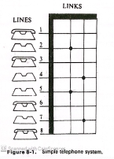

It assume that it lost call system. A call may be lost because no link is available it is called as a lost call. The object of the simulation is to process a given number of calls and determine what proportion are successfully completed block or busy. The current state of the system is that line-2 is connected to line-5 and a line-4 is connected to line-7.Each line is treated as an entity and it’s availability is an attribute a table of numbers is establish which show the current status of each line. A zero in the table means the line is free and where 1 means it is busy.

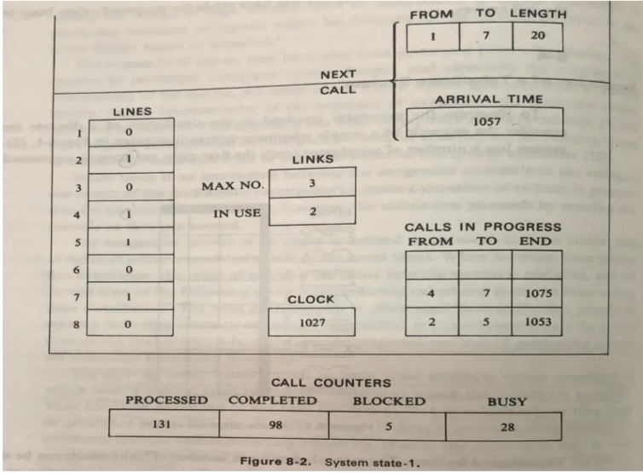

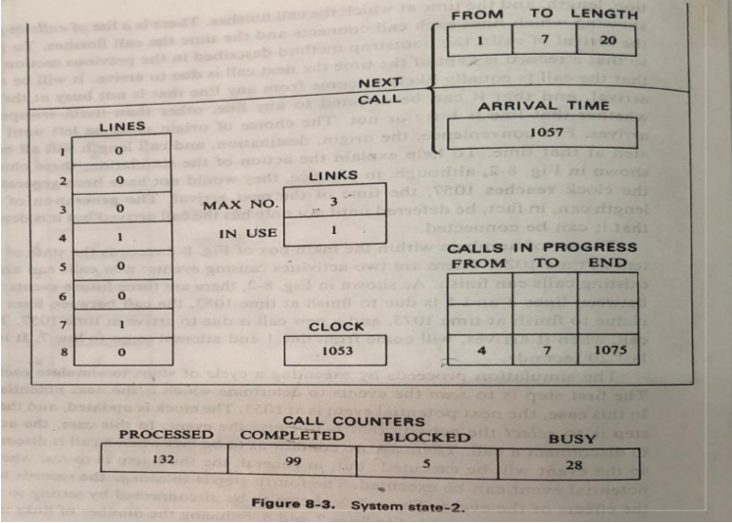

**PROGRAM**

package com.mycompany.telephonesystem;

import java.text.SimpleDateFormat;

import java.util.Calendar;

import java.util.Date;

public class Telephone extends javax.swing.JFrame implements Runnable{

int hour,second,minute;

int

telephone1=1,telephone2=8,link1,link2,link3,link4,link5,link6,duration1,duration2,duration3,due1=

5,due2=20;

public Telephone() {

initComponents();

//creating thread

Thread t=new Thread(this);

t.start(); // start thread go for run method for implementations

}

private void initComponents() {

jPanel1 = new javax.swing.JPanel();

jLabel1 = new javax.swing.JLabel();

jLabel2 = new javax.swing.JLabel();

jTextField1 = new javax.swing.JTextField();

jLabel3 = new javax.swing.JLabel();

jPanel3 = new javax.swing.JPanel();

jPanel4 = new javax.swing.JPanel();

jPanel5 = new javax.swing.JPanel();

jPanel6 = new javax.swing.JPanel();

jPanel7 = new javax.swing.JPanel();

jPanel8 = new javax.swing.JPanel();

jPanel9 = new javax.swing.JPanel();

jPanel10 = new javax.swing.JPanel();

jLabel4 = new javax.swing.JLabel();

jLabel5 = new javax.swing.JLabel();

jLabel6 = new javax.swing.JLabel();

jLabel7 = new javax.swing.JLabel();

jLabel8 = new javax.swing.JLabel();

jLabel9 = new javax.swing.JLabel();

jLabel10 = new javax.swing.JLabel();

jLabel11 = new javax.swing.JLabel();

jLabel12 = new javax.swing.JLabel();

jLabel13 = new javax.swing.JLabel();

jLabel14 = new javax.swing.JLabel();

jLabel15 = new javax.swing.JLabel();

jLabel16 = new javax.swing.JLabel();

jLabel17 = new javax.swing.JLabel();

jLabel18 = new javax.swing.JLabel();

jLabel19 = new javax.swing.JLabel();

jLabel20 = new javax.swing.JLabel();

jLabel21 = new javax.swing.JLabel();

jLabel22 = new javax.swing.JLabel();

jLabel23 = new javax.swing.JLabel();

jLabel24 = new javax.swing.JLabel();

jButton1 = new javax.swing.JButton();

jLabel25 = new javax.swing.JLabel();

jLabel26 = new javax.swing.JLabel();

jLabel27 = new javax.swing.JLabel();

jLabel28 = new javax.swing.JLabel();

jLabel29 = new javax.swing.JLabel();

jLabel30 = new javax.swing.JLabel();

jLabel31 = new javax.swing.JLabel();

jLabel32 = new javax.swing.JLabel();

jLabel33 = new javax.swing.JLabel();

jLabel34 = new javax.swing.JLabel();

jLabel35 = new javax.swing.JLabel();

jLabel36 = new javax.swing.JLabel();

jLabel37 = new javax.swing.JLabel();

jLabel38 = new javax.swing.JLabel();

jLabel39 = new javax.swing.JLabel();

jLabel40 = new javax.swing.JLabel();

jLabel41 = new javax.swing.JLabel();

jLabel42 = new javax.swing.JLabel();

jLabel43 = new javax.swing.JLabel();

jLabel44 = new javax.swing.JLabel();

jLabel45 = new javax.swing.JLabel();

setDefaultCloseOperation(javax.swing.WindowConstants.EXIT_ON_CLOSE);

setAutoRequestFocus(false);

setFocusable(false);

setFocusableWindowState(false);

jPanel1.setBackground(new java.awt.Color(0, 0, 0));

jPanel1.setBorder(javax.swing.BorderFactory.createBevelBorder(javax.swing.border.BevelBorder.

RAISED));

jPanel1.setForeground(new java.awt.Color(255, 0, 0));

jLabel1.setFont(new java.awt.Font("Liberation Sans", 1, 22)); // NOI18N

jLabel1.setForeground(new java.awt.Color(255, 0, 0));

jLabel1.setText("Simulation of Telephone System");

jLabel2.setFont(new java.awt.Font("Liberation Sans", 3, 20)); // NOI18N

jLabel2.setForeground(new java.awt.Color(51, 51, 255));

jLabel2.setText("CLOCK :");

jTextField1.setFont(new java.awt.Font("Liberation Sans", 2, 20)); // NOI18N

jTextField1.setForeground(new java.awt.Color(255, 0, 0));

jTextField1.addActionListener(new java.awt.event.ActionListener() {

public void actionPerformed(java.awt.event.ActionEvent evt) {

jTextField1ActionPerformed(evt);

}

});

jLabel3.setFont(new java.awt.Font("Liberation Sans", 3, 20)); // NOI18N

jLabel3.setForeground(new java.awt.Color(204, 0, 0));

jLabel3.setText("Telephones");

jPanel3.setPreferredSize(new java.awt.Dimension(34, 29));

javax.swing.GroupLayout jPanel3Layout = new javax.swing.GroupLayout(jPanel3);

jPanel3.setLayout(jPanel3Layout);

jPanel3Layout.setHorizontalGroup(

jPanel3Layout.createParallelGroup(javax.swing.GroupLayout.Alignment.LEADING)

.addGap(0, 34, Short.MAX_VALUE)

);

jPanel3Layout.setVerticalGroup(

jPanel3Layout.createParallelGroup(javax.swing.GroupLayout.Alignment.LEADING)

.addGap(0, 29, Short.MAX_VALUE)

);

jPanel4.setBackground(new java.awt.Color(255, 0, 255));

jPanel4.setPreferredSize(new java.awt.Dimension(34, 29));

javax.swing.GroupLayout jPanel4Layout = new javax.swing.GroupLayout(jPanel4);

jPanel4.setLayout(jPanel4Layout);

jPanel4Layout.setHorizontalGroup(

jPanel4Layout.createParallelGroup(javax.swing.GroupLayout.Alignment.LEADING)

.addGap(0, 40, Short.MAX_VALUE)

);

jPanel4Layout.setVerticalGroup(

jPanel4Layout.createParallelGroup(javax.swing.GroupLayout.Alignment.LEADING)

.addGap(0, 29, Short.MAX_VALUE)

);

jPanel5.setBackground(new java.awt.Color(255, 255, 0));

jPanel5.setPreferredSize(new java.awt.Dimension(34, 29));

javax.swing.GroupLayout jPanel5Layout = new javax.swing.GroupLayout(jPanel5);

jPanel5.setLayout(jPanel5Layout);

jPanel5Layout.setHorizontalGroup(

jPanel5Layout.createParallelGroup(javax.swing.GroupLayout.Alignment.LEADING)

.addGap(0, 34, Short.MAX_VALUE)

);

jPanel5Layout.setVerticalGroup(

jPanel5Layout.createParallelGroup(javax.swing.GroupLayout.Alignment.LEADING)

.addGap(0, 29, Short.MAX_VALUE)

);

jPanel6.setBackground(new java.awt.Color(0, 0, 255));

jPanel6.setPreferredSize(new java.awt.Dimension(34, 29));

javax.swing.GroupLayout jPanel6Layout = new javax.swing.GroupLayout(jPanel6);

jPanel6.setLayout(jPanel6Layout);

jPanel6Layout.setHorizontalGroup(

jPanel6Layout.createParallelGroup(javax.swing.GroupLayout.Alignment.LEADING)

.addGap(0, 34, Short.MAX_VALUE)

);

jPanel6Layout.setVerticalGroup(

jPanel6Layout.createParallelGroup(javax.swing.GroupLayout.Alignment.LEADING)

.addGap(0, 29, Short.MAX_VALUE)

);

jPanel7.setBackground(new java.awt.Color(255, 51, 0));

jPanel7.setPreferredSize(new java.awt.Dimension(34, 29));

javax.swing.GroupLayout jPanel7Layout = new javax.swing.GroupLayout(jPanel7);

jPanel7.setLayout(jPanel7Layout);

jPanel7Layout.setHorizontalGroup(

jPanel7Layout.createParallelGroup(javax.swing.GroupLayout.Alignment.LEADING)

.addGap(0, 34, Short.MAX_VALUE)

);

jPanel7Layout.setVerticalGroup(

jPanel7Layout.createParallelGroup(javax.swing.GroupLayout.Alignment.LEADING)

.addGap(0, 29, Short.MAX_VALUE)

);

jPanel8.setBackground(new java.awt.Color(0, 255, 0));

jPanel8.setPreferredSize(new java.awt.Dimension(34, 29));

javax.swing.GroupLayout jPanel8Layout = new javax.swing.GroupLayout(jPanel8);

jPanel8.setLayout(jPanel8Layout);

jPanel8Layout.setHorizontalGroup(

jPanel8Layout.createParallelGroup(javax.swing.GroupLayout.Alignment.LEADING)

.addGap(0, 34, Short.MAX_VALUE)

);

jPanel8Layout.setVerticalGroup(

jPanel8Layout.createParallelGroup(javax.swing.GroupLayout.Alignment.LEADING)

.addGap(0, 29, Short.MAX_VALUE)

);

jPanel9.setBackground(new java.awt.Color(0, 255, 204));

jPanel9.setPreferredSize(new java.awt.Dimension(34, 29));

javax.swing.GroupLayout jPanel9Layout = new javax.swing.GroupLayout(jPanel9);

jPanel9.setLayout(jPanel9Layout);

jPanel9Layout.setHorizontalGroup(

jPanel9Layout.createParallelGroup(javax.swing.GroupLayout.Alignment.LEADING)

.addGap(0, 34, Short.MAX_VALUE)

);

jPanel9Layout.setVerticalGroup(

jPanel9Layout.createParallelGroup(javax.swing.GroupLayout.Alignment.LEADING)

.addGap(0, 29, Short.MAX_VALUE)

);

jPanel10.setBackground(new java.awt.Color(255, 153, 0));

jPanel10.setPreferredSize(new java.awt.Dimension(34, 29));

javax.swing.GroupLayout jPanel10Layout = new javax.swing.GroupLayout(jPanel10);

jPanel10.setLayout(jPanel10Layout);

jPanel10Layout.setHorizontalGroup(

jPanel10Layout.createParallelGroup(javax.swing.GroupLayout.Alignment.LEADING)

.addGap(0, 34, Short.MAX_VALUE)

);

jPanel10Layout.setVerticalGroup(

jPanel10Layout.createParallelGroup(javax.swing.GroupLayout.Alignment.LEADING)

.addGap(0, 29, Short.MAX_VALUE)

);

jLabel4.setFont(new java.awt.Font("Liberation Sans", 1, 20)); // NOI18N

jLabel4.setForeground(new java.awt.Color(255, 255, 255));

jLabel4.setText("1");

jLabel5.setFont(new java.awt.Font("Liberation Sans", 1, 20)); // NOI18N

jLabel5.setForeground(new java.awt.Color(255, 255, 255));

jLabel5.setText("2");

jLabel6.setFont(new java.awt.Font("Liberation Sans", 1, 20)); // NOI18N

jLabel6.setForeground(new java.awt.Color(255, 255, 255));

jLabel6.setText("5");

jLabel7.setFont(new java.awt.Font("Liberation Sans", 1, 20)); // NOI18N

jLabel7.setForeground(new java.awt.Color(255, 255, 255));

jLabel7.setText("3");

jLabel8.setFont(new java.awt.Font("Liberation Sans", 1, 20)); // NOI18N

jLabel8.setForeground(new java.awt.Color(255, 255, 255));

jLabel8.setText("6");

jLabel9.setFont(new java.awt.Font("Liberation Sans", 1, 20)); // NOI18N

jLabel9.setForeground(new java.awt.Color(255, 255, 255));

jLabel9.setText("4");

jLabel10.setFont(new java.awt.Font("Liberation Sans", 1, 20)); // NOI18N

jLabel10.setForeground(new java.awt.Color(255, 255, 255));

jLabel10.setText("7");

jLabel11.setFont(new java.awt.Font("Liberation Sans", 1, 20)); // NOI18N

jLabel11.setForeground(new java.awt.Color(255, 255, 255));

jLabel11.setText("8");

jLabel12.setFont(new java.awt.Font("Liberation Sans", 3, 25)); // NOI18N

jLabel12.setForeground(new java.awt.Color(0, 0, 255));

jLabel12.setText("Link In use");

jLabel13.setFont(new java.awt.Font("Liberation Sans", 0, 25)); // NOI18N

jLabel13.setForeground(new java.awt.Color(255, 0, 0));

jLabel14.setFont(new java.awt.Font("Liberation Sans", 0, 25)); // NOI18N

jLabel14.setForeground(new java.awt.Color(51, 51, 255));

jLabel14.setText(":");

jLabel15.setFont(new java.awt.Font("Liberation Sans", 0, 25)); // NOI18N

jLabel15.setForeground(new java.awt.Color(255, 255, 255));

jLabel16.setFont(new java.awt.Font("Liberation Sans", 0, 15)); // NOI18N

jLabel16.setForeground(new java.awt.Color(255, 0, 0));

jLabel17.setFont(new java.awt.Font("Liberation Sans", 0, 25)); // NOI18N

jLabel17.setForeground(new java.awt.Color(255, 0, 51));

jLabel18.setFont(new java.awt.Font("Liberation Sans", 0, 25)); // NOI18N

jLabel18.setForeground(new java.awt.Color(0, 0, 255));

jLabel18.setText(":");

jLabel19.setFont(new java.awt.Font("Liberation Sans", 0, 25)); // NOI18N

jLabel19.setForeground(new java.awt.Color(255, 255, 255));

jLabel20.setFont(new java.awt.Font("Liberation Sans", 0, 15)); // NOI18N

jLabel20.setForeground(new java.awt.Color(255, 0, 51));

jLabel21.setFont(new java.awt.Font("Liberation Sans", 0, 25)); // NOI18N

jLabel21.setForeground(new java.awt.Color(255, 0, 51));

jLabel22.setFont(new java.awt.Font("Liberation Sans", 0, 25)); // NOI18N

jLabel22.setForeground(new java.awt.Color(0, 0, 255));

jLabel22.setText(":");

jLabel23.setFont(new java.awt.Font("Liberation Sans", 0, 25)); // NOI18N

jLabel23.setForeground(new java.awt.Color(255, 255, 255));

jLabel24.setFont(new java.awt.Font("Liberation Sans", 0, 15)); // NOI18N

jLabel24.setForeground(new java.awt.Color(255, 0, 0));

jButton1.setBackground(new java.awt.Color(0, 0, 255));

jButton1.setFont(new java.awt.Font("Liberation Sans", 0, 20)); // NOI18N

jButton1.setForeground(new java.awt.Color(255, 255, 255));

jButton1.setText("Make a Call");

jButton1.addActionListener(new java.awt.event.ActionListener() {

public void actionPerformed(java.awt.event.ActionEvent evt) {

jButton1ActionPerformed(evt);

}

});

jLabel25.setFont(new java.awt.Font("Liberation Sans", 0, 20)); // NOI18N

jLabel25.setForeground(new java.awt.Color(255, 0, 0));

jLabel25.setText("Next Call in Line");

jLabel26.setFont(new java.awt.Font("Liberation Sans", 0, 20)); // NOI18N

jLabel26.setForeground(new java.awt.Color(0, 0, 255));

jLabel26.setText("jLabel26");

jLabel27.setFont(new java.awt.Font("Liberation Sans", 0, 20)); // NOI18N

jLabel27.setForeground(new java.awt.Color(255, 0, 0));

jLabel27.setText(":");

jLabel28.setFont(new java.awt.Font("Liberation Sans", 0, 20)); // NOI18N

jLabel28.setForeground(new java.awt.Color(0, 0, 255));

jLabel28.setText("jLabel28");

jLabel29.setFont(new java.awt.Font("Liberation Sans", 2, 20)); // NOI18N

jLabel29.setForeground(new java.awt.Color(255, 0, 0));

jLabel29.setText("jLabel29");

jLabel30.setFont(new java.awt.Font("Liberation Sans", 0, 20)); // NOI18N

jLabel30.setForeground(new java.awt.Color(255, 0, 0));

jLabel30.setText("List of Calls in Progress");

jLabel31.setBackground(new java.awt.Color(0, 0, 153));

jLabel31.setFont(new java.awt.Font("Liberation Sans", 0, 20)); // NOI18N

jLabel31.setForeground(new java.awt.Color(255, 0, 0));

jLabel31.setText("jLabel31");

jLabel32.setBackground(new java.awt.Color(204, 153, 0));

jLabel32.setFont(new java.awt.Font("Liberation Sans", 0, 20)); // NOI18N

jLabel32.setForeground(new java.awt.Color(255, 0, 0));

jLabel32.setText("jLabel32");

jLabel33.setForeground(new java.awt.Color(0, 0, 204));

jLabel33.setText("jLabel33");

jLabel34.setFont(new java.awt.Font("Liberation Sans", 0, 20)); // NOI18N

jLabel34.setForeground(new java.awt.Color(255, 255, 255));

jLabel34.setText("From");

jLabel35.setFont(new java.awt.Font("Liberation Sans", 0, 20)); // NOI18N

jLabel35.setForeground(new java.awt.Color(255, 255, 255));

jLabel35.setText("To");

jLabel36.setFont(new java.awt.Font("Liberation Sans", 0, 20)); // NOI18N

jLabel36.setForeground(new java.awt.Color(255, 255, 255));

jLabel36.setText("Duration");

jLabel37.setFont(new java.awt.Font("Liberation Sans", 0, 20)); // NOI18N

jLabel37.setForeground(new java.awt.Color(255, 0, 51));

jLabel37.setText("jLabel37");

jLabel38.setFont(new java.awt.Font("Liberation Sans", 0, 20)); // NOI18N

jLabel38.setForeground(new java.awt.Color(255, 0, 0));

jLabel38.setText("jLabel38");

jLabel39.setFont(new java.awt.Font("Liberation Sans", 0, 20)); // NOI18N

jLabel39.setForeground(new java.awt.Color(0, 0, 255));

jLabel39.setText("jLabel39");

jLabel40.setFont(new java.awt.Font("Liberation Sans", 0, 20)); // NOI18N

jLabel40.setForeground(new java.awt.Color(255, 0, 0));

jLabel40.setText("jLabel40");

jLabel41.setFont(new java.awt.Font("Liberation Sans", 0, 20)); // NOI18N

jLabel41.setForeground(new java.awt.Color(255, 0, 0));

jLabel41.setText("jLabel41");

jLabel42.setFont(new java.awt.Font("Liberation Sans", 0, 20)); // NOI18N

jLabel42.setForeground(new java.awt.Color(0, 0, 204));

jLabel42.setText("jLabel42");

jLabel43.setFont(new java.awt.Font("Liberation Sans", 0, 20)); // NOI18N

jLabel43.setForeground(new java.awt.Color(255, 0, 0));

jLabel43.setText("jLabel43");

jLabel44.setFont(new java.awt.Font("Liberation Sans", 0, 20)); // NOI18N

jLabel44.setForeground(new java.awt.Color(255, 0, 0));

jLabel44.setText("jLabel44");

jLabel45.setFont(new java.awt.Font("Liberation Sans", 0, 20)); // NOI18N

jLabel45.setForeground(new java.awt.Color(0, 0, 204));

jLabel45.setText("jLabel45");

javax.swing.GroupLayout jPanel1Layout = new javax.swing.GroupLayout(jPanel1);

jPanel1.setLayout(jPanel1Layout);

jPanel1Layout.setHorizontalGroup(

jPanel1Layout.createParallelGroup(javax.swing.GroupLayout.Alignment.LEADING)

.addGroup(jPanel1Layout.createSequentialGroup()

.addGap(6, 6, 6)

.addGroup(jPanel1Layout.createParallelGroup(javax.swing.GroupLayout.Alignment.LEA

DING)

.addGroup(jPanel1Layout.createSequentialGroup()

.addGroup(jPanel1Layout.createParallelGroup(javax.swing.GroupLayout.Alignment

.LEADING)

.addGroup(jPanel1Layout.createSequentialGroup()

.addGap(6, 6, 6)

.addComponent(jLabel4)

.addGap(29, 29, 29))

.addGroup(javax.swing.GroupLayout.Alignment.TRAILING,

jPanel1Layout.createSequentialGroup()

.addComponent(jPanel3, javax.swing.GroupLayout.PREFERRED_SIZE,

javax.swing.GroupLayout.DEFAULT_SIZE, javax.swing.GroupLayout.PREFERRED_SIZE)

.addGap(18, 18, 18)))

.addGroup(jPanel1Layout.createParallelGroup(javax.swing.GroupLayout.Alignment

.LEADING)

.addComponent(jPanel4, javax.swing.GroupLayout.PREFERRED_SIZE, 40,

javax.swing.GroupLayout.PREFERRED_SIZE)

.addGroup(jPanel1Layout.createSequentialGroup()

.addGap(6, 6, 6)

.addComponent(jLabel5, javax.swing.GroupLayout.PREFERRED_SIZE, 25,

javax.swing.GroupLayout.PREFERRED_SIZE)))

.addPreferredGap(javax.swing.LayoutStyle.ComponentPlacement.UNRELATED)

.addGroup(jPanel1Layout.createParallelGroup(javax.swing.GroupLayout.Alignment

.TRAILING)

.addComponent(jPanel5, javax.swing.GroupLayout.PREFERRED_SIZE,

javax.swing.GroupLayout.DEFAULT_SIZE, javax.swing.GroupLayout.PREFERRED_SIZE)

.addComponent(jLabel7, javax.swing.GroupLayout.PREFERRED_SIZE, 25,

javax.swing.GroupLayout.PREFERRED_SIZE))

.addPreferredGap(javax.swing.LayoutStyle.ComponentPlacement.UNRELATED)

.addGroup(jPanel1Layout.createParallelGroup(javax.swing.GroupLayout.Alignment

.TRAILING)

.addComponent(jPanel6, javax.swing.GroupLayout.PREFERRED_SIZE,

javax.swing.GroupLayout.DEFAULT_SIZE, javax.swing.GroupLayout.PREFERRED_SIZE)

.addComponent(jLabel9, javax.swing.GroupLayout.PREFERRED_SIZE, 25,

javax.swing.GroupLayout.PREFERRED_SIZE))

.addGap(18, 18, 18)

.addGroup(jPanel1Layout.createParallelGroup(javax.swing.GroupLayout.Alignment

.LEADING)

.addComponent(jPanel7, javax.swing.GroupLayout.PREFERRED_SIZE,

javax.swing.GroupLayout.DEFAULT_SIZE, javax.swing.GroupLayout.PREFERRED_SIZE)

.addComponent(jLabel6, javax.swing.GroupLayout.PREFERRED_SIZE, 25,

javax.swing.GroupLayout.PREFERRED_SIZE))

.addGap(18, 18, 18)

.addGroup(jPanel1Layout.createParallelGroup(javax.swing.GroupLayout.Alignment

.LEADING)

.addComponent(jPanel8, javax.swing.GroupLayout.PREFERRED_SIZE,

javax.swing.GroupLayout.DEFAULT_SIZE, javax.swing.GroupLayout.PREFERRED_SIZE)

.addComponent(jLabel8, javax.swing.GroupLayout.Alignment.TRAILING,

javax.swing.GroupLayout.PREFERRED_SIZE, 25,

javax.swing.GroupLayout.PREFERRED_SIZE))

.addGap(18, 18, 18)

.addGroup(jPanel1Layout.createParallelGroup(javax.swing.GroupLayout.Alignment

.TRAILING)

.addComponent(jPanel9, javax.swing.GroupLayout.PREFERRED_SIZE,

javax.swing.GroupLayout.DEFAULT_SIZE, javax.swing.GroupLayout.PREFERRED_SIZE)

.addComponent(jLabel10, javax.swing.GroupLayout.PREFERRED_SIZE, 25,

javax.swing.GroupLayout.PREFERRED_SIZE))

.addPreferredGap(javax.swing.LayoutStyle.ComponentPlacement.UNRELATED)

.addGroup(jPanel1Layout.createParallelGroup(javax.swing.GroupLayout.Alignment

.LEADING)

.addGroup(jPanel1Layout.createSequentialGroup()

.addGap(6, 6, 6)

.addComponent(jLabel11, javax.swing.GroupLayout.PREFERRED_SIZE, 25,

javax.swing.GroupLayout.PREFERRED_SIZE)

.addGap(0, 0, Short.MAX_VALUE))

.addGroup(javax.swing.GroupLayout.Alignment.TRAILING,

jPanel1Layout.createSequentialGroup()

.addComponent(jPanel10, javax.swing.GroupLayout.PREFERRED_SIZE,

javax.swing.GroupLayout.DEFAULT_SIZE, javax.swing.GroupLayout.PREFERRED_SIZE)

.addPreferredGap(javax.swing.LayoutStyle.ComponentPlacement.RELATED,

javax.swing.GroupLayout.DEFAULT_SIZE, Short.MAX_VALUE)

.addComponent(jLabel21, javax.swing.GroupLayout.PREFERRED_SIZE, 17,

javax.swing.GroupLayout.PREFERRED_SIZE))

.addGroup(javax.swing.GroupLayout.Alignment.TRAILING,

jPanel1Layout.createSequentialGroup()

.addGap(0, 0, Short.MAX_VALUE)

.addComponent(jLabel17, javax.swing.GroupLayout.PREFERRED_SIZE, 17,

javax.swing.GroupLayout.PREFERRED_SIZE)))

.addGap(318, 318, 318))

.addGroup(javax.swing.GroupLayout.Alignment.TRAILING,

jPanel1Layout.createSequentialGroup()

.addGap(0, 0, Short.MAX_VALUE)

.addGroup(jPanel1Layout.createParallelGroup(javax.swing.GroupLayout.Alignment

.LEADING)

.addGroup(javax.swing.GroupLayout.Alignment.TRAILING,

jPanel1Layout.createSequentialGroup()

.addComponent(jLabel13, javax.swing.GroupLayout.PREFERRED_SIZE, 25,

javax.swing.GroupLayout.PREFERRED_SIZE)

.addPreferredGap(javax.swing.LayoutStyle.ComponentPlacement.RELATED)

.addGroup(jPanel1Layout.createParallelGroup(javax.swing.GroupLayout.Align

ment.LEADING)

.addComponent(jButton1)

.addGroup(jPanel1Layout.createSequentialGroup()

.addComponent(jLabel14, javax.swing.GroupLayout.PREFERRED_SIZE,

22, javax.swing.GroupLayout.PREFERRED_SIZE)

.addGap(6, 6, 6)

.addComponent(jLabel19, javax.swing.GroupLayout.PREFERRED_SIZE,

41, javax.swing.GroupLayout.PREFERRED_SIZE)

.addPreferredGap(javax.swing.LayoutStyle.ComponentPlacement.RELAT

ED)

.addComponent(jLabel20, javax.swing.GroupLayout.PREFERRED_SIZE,

214, javax.swing.GroupLayout.PREFERRED_SIZE))

.addGroup(jPanel1Layout.createSequentialGroup()

.addComponent(jLabel18, javax.swing.GroupLayout.PREFERRED_SIZE,

13, javax.swing.GroupLayout.PREFERRED_SIZE)

.addPreferredGap(javax.swing.LayoutStyle.ComponentPlacement.RELAT

ED)

.addComponent(jLabel15, javax.swing.GroupLayout.PREFERRED_SIZE,

22, javax.swing.GroupLayout.PREFERRED_SIZE)

.addGap(18, 18, 18)

.addComponent(jLabel16, javax.swing.GroupLayout.PREFERRED_SIZE,

202, javax.swing.GroupLayout.PREFERRED_SIZE))

.addGroup(jPanel1Layout.createSequentialGroup()

.addComponent(jLabel22, javax.swing.GroupLayout.PREFERRED_SIZE,

20, javax.swing.GroupLayout.PREFERRED_SIZE)

.addPreferredGap(javax.swing.LayoutStyle.ComponentPlacement.RELAT

ED)

.addComponent(jLabel23, javax.swing.GroupLayout.PREFERRED_SIZE,

16, javax.swing.GroupLayout.PREFERRED_SIZE)

.addGap(35, 35, 35)

.addComponent(jLabel24, javax.swing.GroupLayout.PREFERRED_SIZE,

229, javax.swing.GroupLayout.PREFERRED_SIZE))))

.addGroup(javax.swing.GroupLayout.Alignment.TRAILING,

jPanel1Layout.createSequentialGroup()

.addComponent(jLabel25, javax.swing.GroupLayout.PREFERRED_SIZE, 153,

javax.swing.GroupLayout.PREFERRED_SIZE)

.addGap(171, 171, 171)))))

.addGap(112, 112, 112))

.addGroup(jPanel1Layout.createSequentialGroup()

.addGap(18, 18, 18)

.addGroup(jPanel1Layout.createParallelGroup(javax.swing.GroupLayout.Alignment.LEA

DING)

.addGroup(jPanel1Layout.createSequentialGroup()

.addGroup(jPanel1Layout.createParallelGroup(javax.swing.GroupLayout.Alignment

.LEADING)

.addGroup(jPanel1Layout.createParallelGroup(javax.swing.GroupLayout.Alignm

ent.TRAILING)

.addComponent(jLabel40)

.addComponent(jLabel43)

.addComponent(jLabel37, javax.swing.GroupLayout.PREFERRED_SIZE, 74,

javax.swing.GroupLayout.PREFERRED_SIZE))

.addComponent(jLabel34))

.addGap(18, 18, 18)

.addGroup(jPanel1Layout.createParallelGroup(javax.swing.GroupLayout.Alignment

.LEADING)

.addGroup(jPanel1Layout.createSequentialGroup()

.addComponent(jLabel35)

.addGap(49, 49, 49)

.addComponent(jLabel36))

.addGroup(jPanel1Layout.createSequentialGroup()

.addComponent(jLabel44)

.addGap(18, 18, 18)

.addComponent(jLabel45))

.addGroup(jPanel1Layout.createSequentialGroup()

.addComponent(jLabel41)

.addPreferredGap(javax.swing.LayoutStyle.ComponentPlacement.UNRELATE

D)

.addComponent(jLabel42))

.addGroup(jPanel1Layout.createSequentialGroup()

.addComponent(jLabel38)

.addPreferredGap(javax.swing.LayoutStyle.ComponentPlacement.UNRELATE

D)

.addComponent(jLabel39))))

.addComponent(jLabel30))

.addPreferredGap(javax.swing.LayoutStyle.ComponentPlacement.RELATED,

javax.swing.GroupLayout.DEFAULT_SIZE, Short.MAX_VALUE)

.addComponent(jLabel26)

.addPreferredGap(javax.swing.LayoutStyle.ComponentPlacement.RELATED)

.addComponent(jLabel27, javax.swing.GroupLayout.PREFERRED_SIZE, 6,

javax.swing.GroupLayout.PREFERRED_SIZE)

.addPreferredGap(javax.swing.LayoutStyle.ComponentPlacement.RELATED)

.addComponent(jLabel28)

.addGap(18, 18, 18)

.addComponent(jLabel29)

.addGap(249, 249, 249))

.addGroup(jPanel1Layout.createSequentialGroup()

.addGroup(jPanel1Layout.createParallelGroup(javax.swing.GroupLayout.Alignment.LEA

DING)

.addGroup(jPanel1Layout.createSequentialGroup()

.addContainerGap()

.addComponent(jLabel3, javax.swing.GroupLayout.PREFERRED_SIZE, 113,

javax.swing.GroupLayout.PREFERRED_SIZE))

.addGroup(jPanel1Layout.createSequentialGroup()

.addGap(247, 247, 247)

.addComponent(jLabel33, javax.swing.GroupLayout.PREFERRED_SIZE, 354,

javax.swing.GroupLayout.PREFERRED_SIZE))

.addGroup(jPanel1Layout.createSequentialGroup()

.addGap(194, 194, 194)

.addComponent(jLabel32, javax.swing.GroupLayout.PREFERRED_SIZE, 535,

javax.swing.GroupLayout.PREFERRED_SIZE))

.addGroup(jPanel1Layout.createSequentialGroup()

.addGap(167, 167, 167)

.addComponent(jLabel31, javax.swing.GroupLayout.PREFERRED_SIZE, 693,

javax.swing.GroupLayout.PREFERRED_SIZE))

.addGroup(jPanel1Layout.createSequentialGroup()

.addGap(238, 238, 238)

.addGroup(jPanel1Layout.createParallelGroup(javax.swing.GroupLayout.Alignment

.LEADING)

.addComponent(jLabel1, javax.swing.GroupLayout.PREFERRED_SIZE, 450,

javax.swing.GroupLayout.PREFERRED_SIZE)

.addGroup(jPanel1Layout.createSequentialGroup()

.addComponent(jLabel2)

.addPreferredGap(javax.swing.LayoutStyle.ComponentPlacement.RELATED)

.addComponent(jTextField1, javax.swing.GroupLayout.PREFERRED_SIZE,

101, javax.swing.GroupLayout.PREFERRED_SIZE)

.addGap(84, 84, 84)

.addComponent(jLabel12, javax.swing.GroupLayout.PREFERRED_SIZE, 135,

javax.swing.GroupLayout.PREFERRED_SIZE)))))

.addContainerGap(88, Short.MAX_VALUE))

);

jPanel1Layout.setVerticalGroup(

jPanel1Layout.createParallelGroup(javax.swing.GroupLayout.Alignment.LEADING)

.addGroup(jPanel1Layout.createSequentialGroup()

.addGroup(jPanel1Layout.createParallelGroup(javax.swing.GroupLayout.Alignment.LEA

DING)

.addGroup(jPanel1Layout.createSequentialGroup()

.addGroup(jPanel1Layout.createParallelGroup(javax.swing.GroupLayout.Alignment

.LEADING)

.addGroup(jPanel1Layout.createSequentialGroup()

.addGroup(jPanel1Layout.createParallelGroup(javax.swing.GroupLayout.Align

ment.LEADING)

.addGroup(jPanel1Layout.createSequentialGroup()

.addGap(102, 102, 102)

.addComponent(jLabel3))

.addGroup(javax.swing.GroupLayout.Alignment.TRAILING,

jPanel1Layout.createSequentialGroup()

.addComponent(jLabel1)

.addPreferredGap(javax.swing.LayoutStyle.ComponentPlacement.RELAT

ED, 53, Short.MAX_VALUE)

.addGroup(jPanel1Layout.createParallelGroup(javax.swing.GroupLayout.

Alignment.LEADING)

.addGroup(javax.swing.GroupLayout.Alignment.TRAILING,

jPanel1Layout.createSequentialGroup()

.addGroup(jPanel1Layout.createParallelGroup(javax.swing.GroupLay

out.Alignment.BASELINE)

.addComponent(jLabel2)

.addComponent(jTextField1,

javax.swing.GroupLayout.PREFERRED_SIZE, javax.swing.GroupLayout.DEFAULT_SIZE,

javax.swing.GroupLayout.PREFERRED_SIZE)

.addComponent(jLabel12))

.addPreferredGap(javax.swing.LayoutStyle.ComponentPlacement.RE

LATED)

.addGroup(jPanel1Layout.createParallelGroup(javax.swing.GroupLay

out.Alignment.LEADING)

.addComponent(jLabel13,

javax.swing.GroupLayout.PREFERRED_SIZE, 30,

javax.swing.GroupLayout.PREFERRED_SIZE) .addComponent(jLabel18)

.addComponent(jLabel15,

javax.swing.GroupLayout.PREFERRED_SIZE, 30,

javax.swing.GroupLayout.PREFERRED_SIZE)))

.addComponent(jLabel16,

javax.swing.GroupLayout.Alignment.TRAILING, javax.swing.GroupLayout.PREFERRED_SIZE,

22, javax.swing.GroupLayout.PREFERRED_SIZE))

.addGroup(jPanel1Layout.createParallelGroup(javax.swing.GroupLayout.

Alignment.LEADING)

.addGroup(javax.swing.GroupLayout.Alignment.TRAILING,

jPanel1Layout.createSequentialGroup()

.addGap(20, 20, 20)

.addComponent(jLabel20,

javax.swing.GroupLayout.PREFERRED_SIZE, 22,

javax.swing.GroupLayout.PREFERRED_SIZE))

.addGroup(jPanel1Layout.createParallelGroup(javax.swing.GroupLayou

t.Alignment.LEADING)

.addGroup(jPanel1Layout.createSequentialGroup()

.addPreferredGap(javax.swing.LayoutStyle.ComponentPlacement.

UNRELATED)

.addGroup(jPanel1Layout.createParallelGroup(javax.swing.Group

Layout.Alignment.TRAILING)

.addComponent(jLabel14)

.addComponent(jLabel17,

javax.swing.GroupLayout.PREFERRED_SIZE, 30,

javax.swing.GroupLayout.PREFERRED_SIZE)))

.addGroup(javax.swing.GroupLayout.Alignment.TRAILING,

jPanel1Layout.createSequentialGroup()

.addGap(20, 20, 20)

.addComponent(jLabel19,

javax.swing.GroupLayout.PREFERRED_SIZE, 22,

javax.swing.GroupLayout.PREFERRED_SIZE))))

.addGap(10, 10, 10)))

.addGroup(jPanel1Layout.createParallelGroup(javax.swing.GroupLayout.Align

ment.LEADING)

.addGroup(jPanel1Layout.createSequentialGroup()

.addGap(9, 9, 9)

.addComponent(jLabel22))

.addComponent(jLabel24, javax.swing.GroupLayout.Alignment.TRAILING,

javax.swing.GroupLayout.PREFERRED_SIZE, 20,

javax.swing.GroupLayout.PREFERRED_SIZE)

.addComponent(jPanel5, javax.swing.GroupLayout.Alignment.TRAILING,

javax.swing.GroupLayout.PREFERRED_SIZE, javax.swing.GroupLayout.DEFAULT_SIZE,

javax.swing.GroupLayout.PREFERRED_SIZE)

.addComponent(jPanel3, javax.swing.GroupLayout.Alignment.TRAILING,

javax.swing.GroupLayout.PREFERRED_SIZE, javax.swing.GroupLayout.DEFAULT_SIZE,

javax.swing.GroupLayout.PREFERRED_SIZE)))

.addGroup(jPanel1Layout.createSequentialGroup()

.addGap(0, 0, Short.MAX_VALUE)

.addGroup(jPanel1Layout.createParallelGroup(javax.swing.GroupLayout.Align

ment.LEADING)

.addComponent(jPanel4, javax.swing.GroupLayout.Alignment.TRAILING,

javax.swing.GroupLayout.PREFERRED_SIZE, javax.swing.GroupLayout.DEFAULT_SIZE,

javax.swing.GroupLayout.PREFERRED_SIZE)

.addComponent(jPanel6, javax.swing.GroupLayout.Alignment.TRAILING,

javax.swing.GroupLayout.PREFERRED_SIZE, javax.swing.GroupLayout.DEFAULT_SIZE,

javax.swing.GroupLayout.PREFERRED_SIZE)

.addComponent(jPanel7, javax.swing.GroupLayout.Alignment.TRAILING,

javax.swing.GroupLayout.PREFERRED_SIZE, javax.swing.GroupLayout.DEFAULT_SIZE,

javax.swing.GroupLayout.PREFERRED_SIZE)

.addComponent(jPanel8, javax.swing.GroupLayout.Alignment.TRAILING,

javax.swing.GroupLayout.PREFERRED_SIZE, javax.swing.GroupLayout.DEFAULT_SIZE,

javax.swing.GroupLayout.PREFERRED_SIZE)

.addComponent(jPanel9, javax.swing.GroupLayout.Alignment.TRAILING,

javax.swing.GroupLayout.PREFERRED_SIZE, javax.swing.GroupLayout.DEFAULT_SIZE,

javax.swing.GroupLayout.PREFERRED_SIZE)

.addComponent(jPanel10, javax.swing.GroupLayout.Alignment.TRAILING,

javax.swing.GroupLayout.PREFERRED_SIZE, javax.swing.GroupLayout.DEFAULT_SIZE,

javax.swing.GroupLayout.PREFERRED_SIZE)

.addComponent(jLabel21, javax.swing.GroupLayout.Alignment.TRAILING,

javax.swing.GroupLayout.PREFERRED_SIZE, 20,

javax.swing.GroupLayout.PREFERRED_SIZE)

.addComponent(jLabel23, javax.swing.GroupLayout.Alignment.TRAILING,

javax.swing.GroupLayout.PREFERRED_SIZE, 30,

javax.swing.GroupLayout.PREFERRED_SIZE))))

.addPreferredGap(javax.swing.LayoutStyle.ComponentPlacement.UNRELATED)

.addGroup(jPanel1Layout.createParallelGroup(javax.swing.GroupLayout.Alignment

.LEADING)

.addGroup(jPanel1Layout.createSequentialGroup()

.addGroup(jPanel1Layout.createParallelGroup(javax.swing.GroupLayout.Align

ment.BASELINE)

.addComponent(jLabel4)

.addComponent(jLabel5)

.addComponent(jLabel6)

.addComponent(jLabel7)

.addComponent(jLabel9)

.addComponent(jLabel8)

.addComponent(jLabel10, javax.swing.GroupLayout.DEFAULT_SIZE,

javax.swing.GroupLayout.DEFAULT_SIZE, Short.MAX_VALUE)

.addComponent(jLabel11, javax.swing.GroupLayout.DEFAULT_SIZE,

javax.swing.GroupLayout.DEFAULT_SIZE, Short.MAX_VALUE))

.addGap(167, 167, 167))

.addGroup(jPanel1Layout.createSequentialGroup()

.addGap(59, 59, 59)

.addComponent(jButton1)

.addGap(56, 56, 56)

.addComponent(jLabel25)

.addGap(16, 16, 16)))

.addComponent(jLabel30)

.addGap(7, 7, 7)

.addGroup(jPanel1Layout.createParallelGroup(javax.swing.GroupLayout.Alignment

.BASELINE)

.addComponent(jLabel34)

.addComponent(jLabel35)

.addComponent(jLabel36))

.addGap(18, 18, 18))

.addGroup(javax.swing.GroupLayout.Alignment.TRAILING,

jPanel1Layout.createSequentialGroup()

.addGap(0, 0, Short.MAX_VALUE)

.addGroup(jPanel1Layout.createParallelGroup(javax.swing.GroupLayout.Alignment

.BASELINE)

.addComponent(jLabel29)

.addComponent(jLabel28)

.addComponent(jLabel27)

.addComponent(jLabel26))

.addGap(30, 30, 30)))

.addGroup(jPanel1Layout.createParallelGroup(javax.swing.GroupLayout.Alignment.BAS

ELINE)

.addComponent(jLabel38)

.addComponent(jLabel37)

.addComponent(jLabel39))

.addPreferredGap(javax.swing.LayoutStyle.ComponentPlacement.UNRELATED)

.addGroup(jPanel1Layout.createParallelGroup(javax.swing.GroupLayout.Alignment.BAS

ELINE)

.addComponent(jLabel40)

.addComponent(jLabel41)

.addComponent(jLabel42))

.addGap(18, 18, 18)

.addGroup(jPanel1Layout.createParallelGroup(javax.swing.GroupLayout.Alignment.BAS

ELINE)

.addComponent(jLabel43)

.addComponent(jLabel44)

.addComponent(jLabel45))

.addGap(90, 90, 90)

.addComponent(jLabel31, javax.swing.GroupLayout.PREFERRED_SIZE, 37,

javax.swing.GroupLayout.PREFERRED_SIZE)

.addPreferredGap(javax.swing.LayoutStyle.ComponentPlacement.RELATED)

.addComponent(jLabel32)

.addGap(18, 18, 18)

.addComponent(jLabel33)

.addGap(301, 301, 301))

);

javax.swing.GroupLayout layout = new javax.swing.GroupLayout(getContentPane());

getContentPane().setLayout(layout);

layout.setHorizontalGroup(

layout.createParallelGroup(javax.swing.GroupLayout.Alignment.LEADING)

.addGroup(layout.createSequentialGroup()

.addGap(468, 468, 468)

.addComponent(jPanel1, javax.swing.GroupLayout.DEFAULT_SIZE,

javax.swing.GroupLayout.DEFAULT_SIZE, Short.MAX_VALUE)

.addContainerGap())

);

layout.setVerticalGroup(

layout.createParallelGroup(javax.swing.GroupLayout.Alignment.LEADING)

.addComponent(jPanel1, javax.swing.GroupLayout.Alignment.TRAILING,

javax.swing.GroupLayout.DEFAULT_SIZE, javax.swing.GroupLayout.DEFAULT_SIZE,

Short.MAX_VALUE)

);

pack();

}// </editor-fold>

private void jButton1ActionPerformed(java.awt.event.ActionEvent evt) {

// TODO add your handling code here:

link1=(int) (Math.random()*(telephone2-telephone1+1)+telephone1);

link2=(int) (Math.random()*(telephone2-telephone1+1)+telephone1);

link3=(int) (Math.random()*(telephone2-telephone1+1)+telephone1);

link4=(int) (Math.random()*(telephone1-telephone1+1)+telephone1);

link5=(int) (Math.random()*(telephone2-telephone1+1)+telephone1);

link6=(int) (Math.random()*(telephone2-telephone1+1)+telephone1);

duration1=(int) (Math.random()*(due2-due1+1)+due1);

duration2=(int) (Math.random()*(due2-due1+1)+due1);

duration3=(int) (Math.random()*(due2-due1+1)+due1);

String s1=String.valueOf(link1);

String s2=String.valueOf(link2);

String s3=String.valueOf(link3);

String s4=String.valueOf(link4);

String s5=String.valueOf(link5);

String s6=String.valueOf(link6);

String s7=String.valueOf(duration1);

String s8=String.valueOf(duration2);

String s9=String.valueOf(duration3);

if(link1 != link2 && link3 != link4 && link5 != link6 && link4 != link1 && link3 != link2

&& link4 != link2 && link3 != link1 && link5 != link1 && link5 != 2 && link5 != link3 &&

link5 != link4 && link6 != link1 && link6 != link2 && link6 != link3 && link6!=link4){

jLabel13.setText(s1);

jLabel15.setText(s2);

jLabel16.setText("Connected Successfully...");

jLabel17.setText(s3);

jLabel19.setText(s4);

jLabel20.setText("Connected Successfully...");

jLabel21.setText(s5);

jLabel23.setText(s6);

jLabel24.setText("Connected Successfully...");

//for calls in progress

jLabel37.setText(s1);

jLabel38.setText(s2);

jLabel40.setText(s3);

jLabel41.setText(s4);

jLabel43.setText(s5);

jLabel44.setText(s6);

if(duration1!=duration2 && duration3!=duration2){

jLabel39.setText(s7);

jLabel42.setText(s7);

jLabel45.setText(s7);

}

}

else {

jLabel13.setText(s1);

jLabel15.setText(s2);

jLabel16.setText("Call is busy,Try again!!!");

jLabel17.setText(s3);

jLabel19.setText(s4);

jLabel20.setText("Call is busy,Try again!!!");

jLabel21.setText(s5);

jLabel23.setText(s6);

jLabel24.setText("Call is busy,Try again!!!!");

jLabel37.setText(s1);

jLabel38.setText(s2);

jLabel39.setText("Null");

jLabel40.setText(s3);

jLabel41.setText(s4);

jLabel42.setText("Null");

jLabel43.setText(s5);

jLabel44.setText(s6);

jLabel45.setText("NUll");

}

if(s6 == null ? s5 != null : !s6.equals(s5))

{

jLabel26.setText(s6);

jLabel28.setText(s5);

jLabel29.setText("Call is waiting to connect...");

}

else{

jLabel29.setText("Didn't make a call, Your call is lost");

}

jLabel31.setText("A special thanks to our Lecturer and guide Assoc.Prof. Sundar Kunwar");

jLabel32.setText("This program is written by Samika Taja 020-380");

jLabel33.setText("(A student of Nepal Engineering College)");

}

private void jTextField1ActionPerformed(java.awt.event.ActionEvent evt) {

// TODO add your handling code here:

//for line link

}

/**

* @param args the command line arguments

*/

public static void main(String args[]) {

/* Set the Nimbus look and feel */

//<editor-fold defaultstate="collapsed" desc=" Look and feel setting code (optional) ">

try {

for (javax.swing.UIManager.LookAndFeelInfo info :

javax.swing.UIManager.getInstalledLookAndFeels()) {

if ("Nimbus".equals(info.getName())) {

javax.swing.UIManager.setLookAndFeel(info.getClassName());

break;

}

}

} catch (ClassNotFoundException | InstantiationException | IllegalAccessException |

javax.swing.UnsupportedLookAndFeelException ex) {

java.util.logging.Logger.getLogger(Telephone.class.getName()).log(java.util.logging.Level.SEVER

E, null, ex);

}

//</editor-fold>

//</editor-fold>

/* Create and display the form */

java.awt.EventQueue.invokeLater(new Runnable() {

public void run() {

new Telephone().setVisible(true);

}

});

}

// Variables declaration - do not modify

private javax.swing.JButton jButton1;

private javax.swing.JLabel jLabel1;

private javax.swing.JLabel jLabel10;

private javax.swing.JLabel jLabel11;

private javax.swing.JLabel jLabel12;

private javax.swing.JLabel jLabel13;

private javax.swing.JLabel jLabel14;

private javax.swing.JLabel jLabel15;

private javax.swing.JLabel jLabel16;

private javax.swing.JLabel jLabel17;

private javax.swing.JLabel jLabel18;

private javax.swing.JLabel jLabel19;

private javax.swing.JLabel jLabel2;

private javax.swing.JLabel jLabel20;

private javax.swing.JLabel jLabel21;

private javax.swing.JLabel jLabel22;

private javax.swing.JLabel jLabel23;

private javax.swing.JLabel jLabel24;

private javax.swing.JLabel jLabel25;

private javax.swing.JLabel jLabel26;

private javax.swing.JLabel jLabel27;

private javax.swing.JLabel jLabel28;

private javax.swing.JLabel jLabel29;

private javax.swing.JLabel jLabel3;

private javax.swing.JLabel jLabel30;

private javax.swing.JLabel jLabel31;

private javax.swing.JLabel jLabel32;

private javax.swing.JLabel jLabel33;

private javax.swing.JLabel jLabel34;

private javax.swing.JLabel jLabel35;

private javax.swing.JLabel jLabel36;

private javax.swing.JLabel jLabel37;

private javax.swing.JLabel jLabel38;

private javax.swing.JLabel jLabel39;

private javax.swing.JLabel jLabel4;

private javax.swing.JLabel jLabel40;

private javax.swing.JLabel jLabel41;

private javax.swing.JLabel jLabel42;

private javax.swing.JLabel jLabel43;

private javax.swing.JLabel jLabel44;

private javax.swing.JLabel jLabel45;

private javax.swing.JLabel jLabel5;

private javax.swing.JLabel jLabel6;

private javax.swing.JLabel jLabel7;

private javax.swing.JLabel jLabel8;

private javax.swing.JLabel jLabel9;

private javax.swing.JPanel jPanel1;

private javax.swing.JPanel jPanel10;

private javax.swing.JPanel jPanel3;

private javax.swing.JPanel jPanel4;

private javax.swing.JPanel jPanel5;

private javax.swing.JPanel jPanel6;

private javax.swing.JPanel jPanel7;

private javax.swing.JPanel jPanel8;

private javax.swing.JPanel jPanel9;

private javax.swing.JTextField jTextField1;

// End of variables declaration

@Override

public void run() {

while(true){

Calendar cal= Calendar.getInstance();

//To get Current hour,minute and second.

hour=cal.get(Calendar.HOUR_OF_DAY);

minute=cal.get(Calendar.MINUTE);

second=cal.get(Calendar.SECOND);

// for 24 hour time

SimpleDateFormat sdf24= new SimpleDateFormat("hh:mm:ss");

Date dat=cal.getTime();

String time24=sdf24.format(dat);

//set to textfield

jTextField1.setText(time24);

}

}

}

**Output before Simulation**

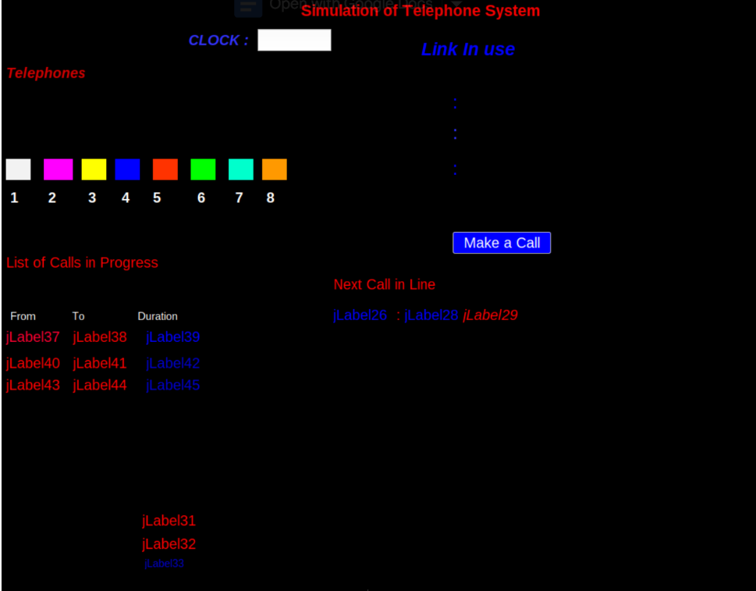

**Output after Simulation**

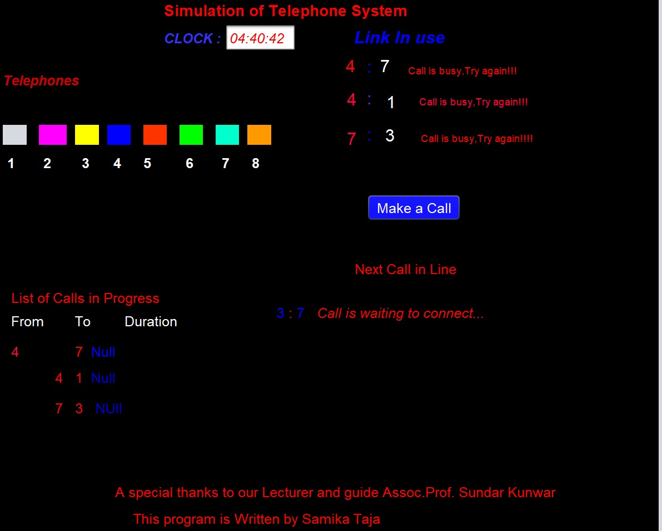

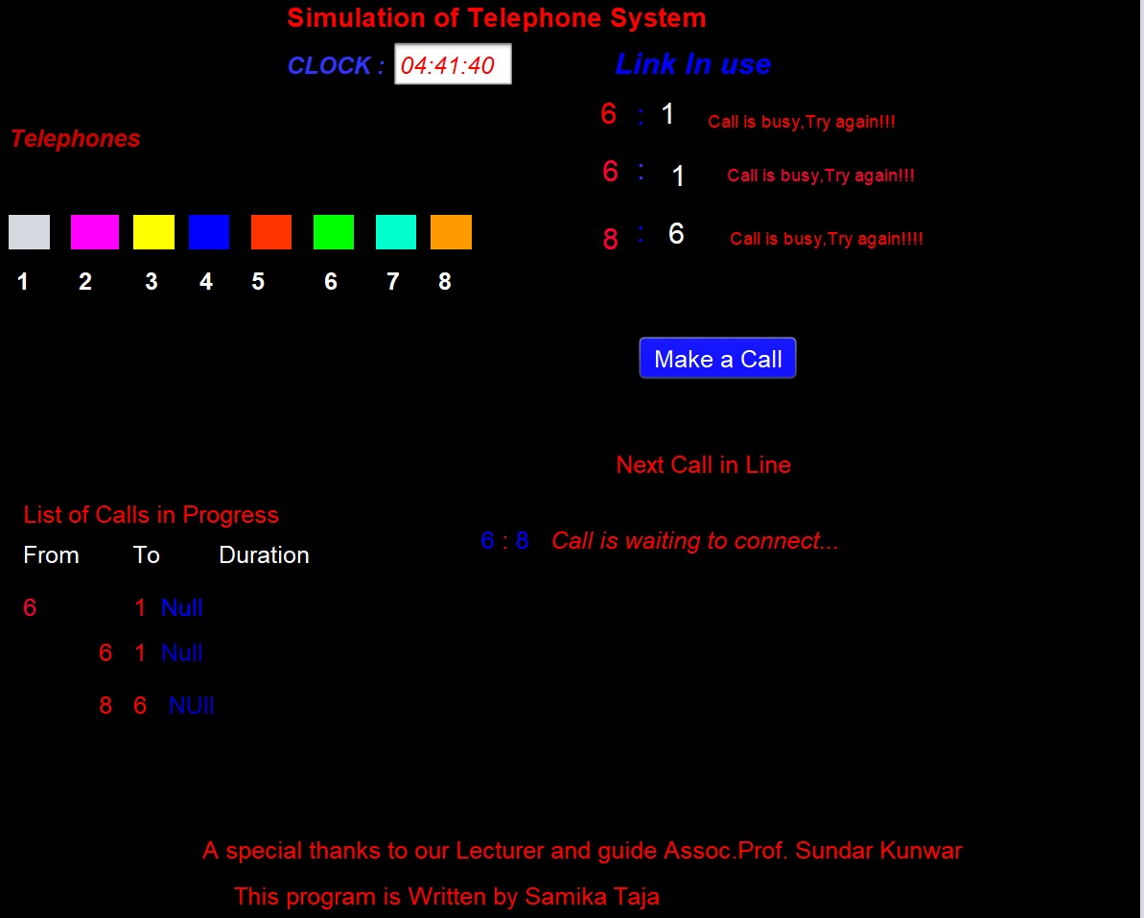

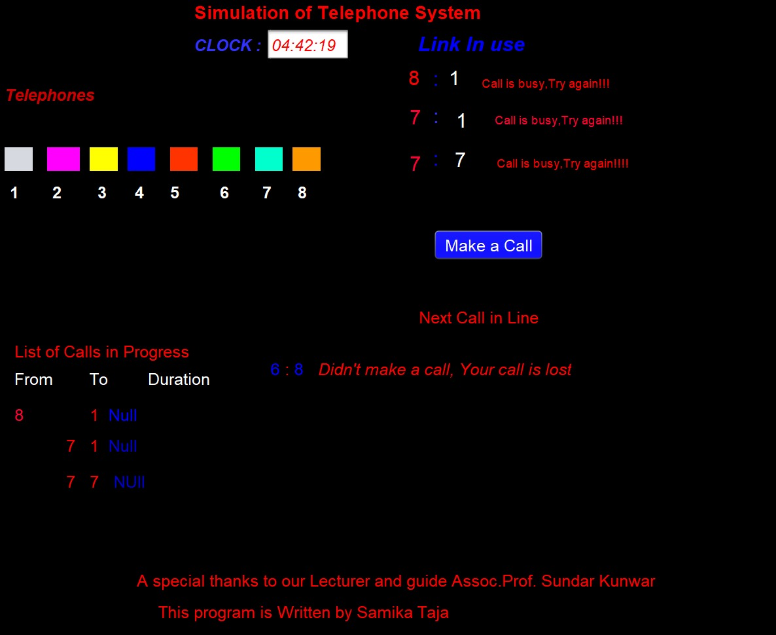

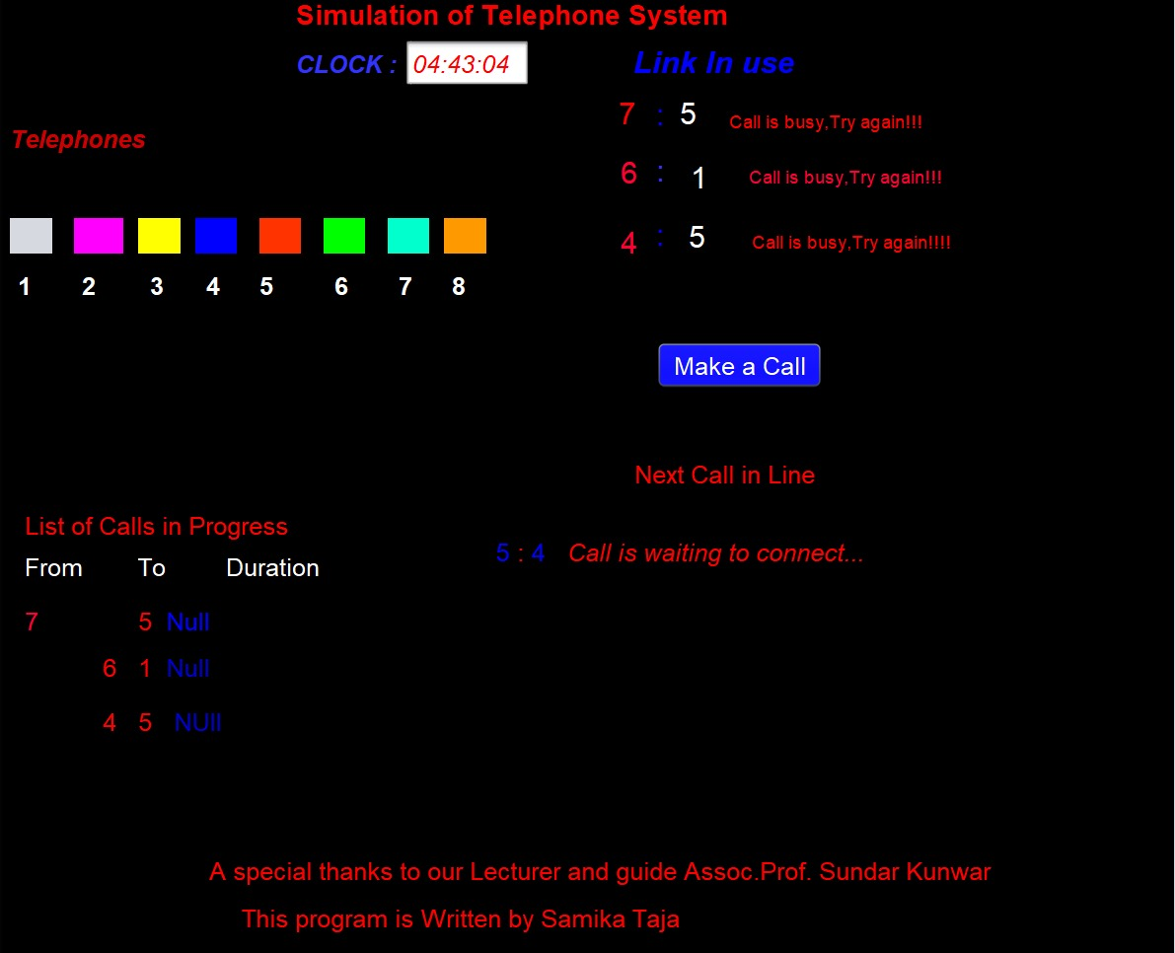

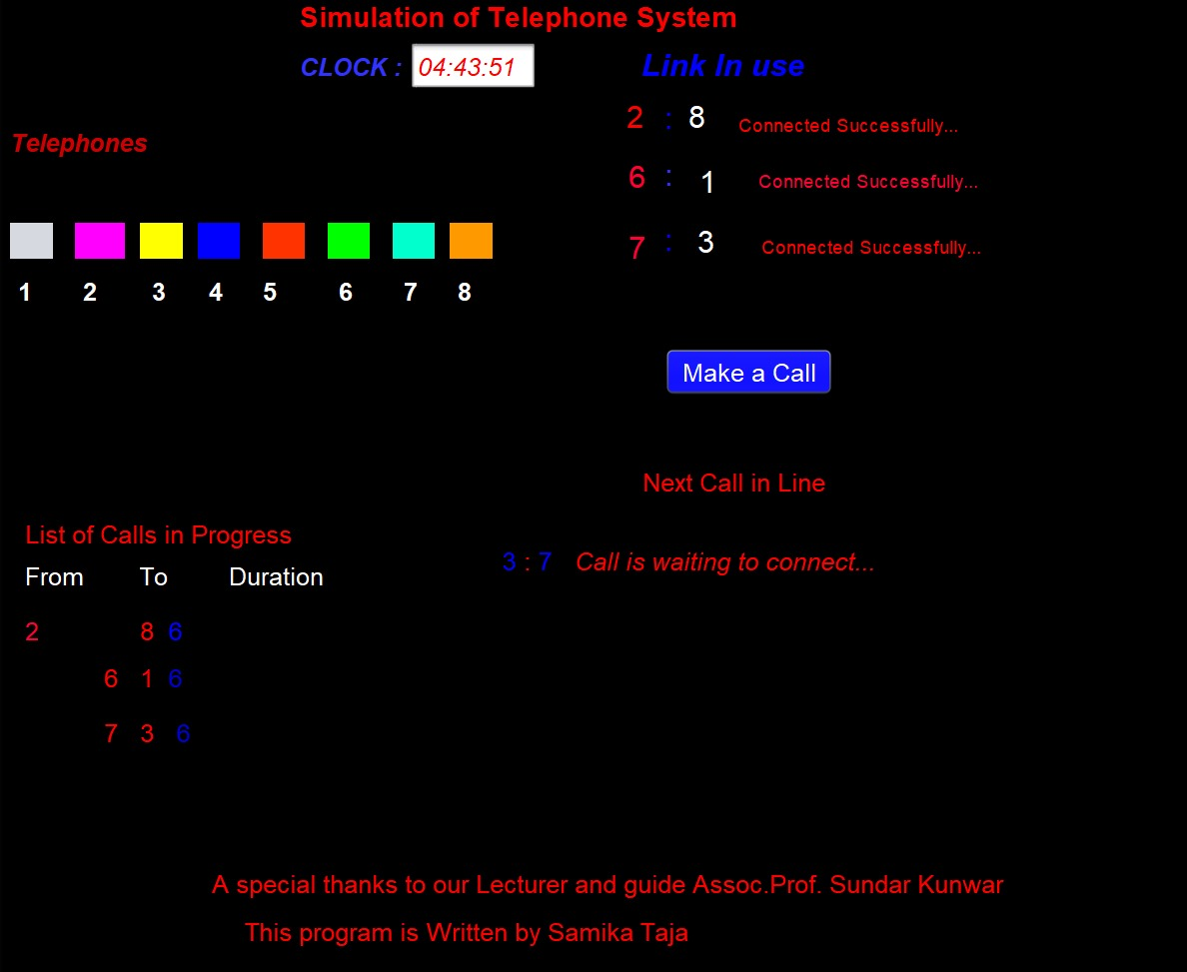

**Conclusion:**

In this way with the proper program, the simulation of the telephone system is done.