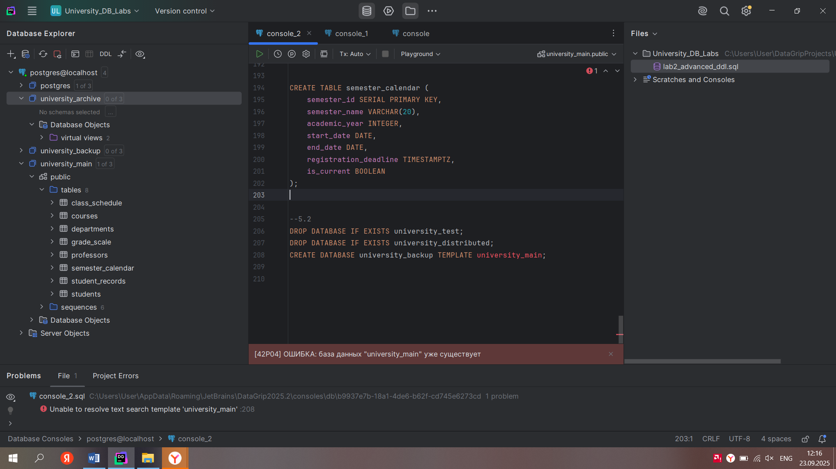

--1.1  
  
  
CREATE DATABASE university_main  
 TEMPLATE = template0  
 ENCODING 'UTF8';  
  
  
  
CREATE DATABASE = university_archive  
 CONNECTION LIMIT 50  
 TEMPLATE template0;  
  
  
  
CREATE DATABASE university_test  
 IS_TEMPLATE true  
 CONNECTION LIMIT 10;

--1.2  
  
CREATE TABLESPACE student_data LOCATION 'C:/temp/students';  
CREATE TABLESPACE course_data LOCATION 'C:/temp/courses';  
  
  
CREATE DATABASE university_distributed  
 TEMPLATE = template0  
 TABLESPACE = student_data  
 ENCODING = 'UTF8'  
 LC_CTYPE = 'ru_RU.UTF8'  
 LC_COLLATE = 'ru_RU.UTF8';  
  
--windows не поддерживает латин поэтому пришлось так сделать

--2.1  
  
\c university_main  
  
  
  
CREATE TABLE students (  
 student_id SERIAL PRIMARY KEY,  
 first_name VARCHAR(50) NOT NULL,  
 last_name VARCHAR(50) NOT NULL,  
 email VARCHAR(100),  
 phone CHAR(15),  
 date_of_birth DATE,  
 enrollment_date DATE,  
 gpa DECIMAL(3,2) DEFAULT 0.00,  
 is_active BOOLEAN DEFAULT TRUE,  
 graduation_year SMALLINT  
);  
  
  
CREATE TABLE professors (  
 professor_id SERIAL PRIMARY KEY,  
 first_name VARCHAR(50) NOT NULL,  
 last_name VARCHAR(50) NOT NULL,  
 email VARCHAR(100),  
 office_number VARCHAR(20),  
 hire_date DATE,  
 salary DECIMAL(10,2),  
 is_tenured BOOLEAN DEFAULT FALSE,  
 years_experience INTEGER  
);  
  
  
CREATE TABLE courses (  
 course_id SERIAL PRIMARY KEY,  
 course_code CHAR(8) NOT NULL,  
 course_title VARCHAR(100) NOT NULL,  
 description TEXT,  
 credits SMALLINT NOT NULL,  
 max_enrollment INTEGER,  
 course_fee DECIMAL(8,2),  
 is_online BOOLEAN DEFAULT FALSE,  
 created_at TIMESTAMP WITHOUT TIME ZONE DEFAULT *CURRENT_TIMESTAMP*);

--2.2  
  
CREATE TABLE class_schedule (  
 schedule_id SERIAL PRIMARY KEY,  
 course_id INTEGER,  
 professor_id INTEGER,  
 classroom VARCHAR(20),  
 class_date DATE,  
 start_time TIME,  
 end_time TIME,  
 duration INTERVAL  
);  
  
CREATE TABLE student_records (  
 record_id SERIAL PRIMARY KEY,  
 student_id INTEGER,  
 course_id INTEGER,  
 semester VARCHAR(20),  
 year INTEGER,  
 grade CHAR(2),  
 attendance_percentage DECIMAL(3,1),  
 submission_timestamp TIMESTAMPTZ,  
 last_updated TIMESTAMPTZ  
);  
  
  
--3.1  
  
ALTER TABLE students  
 ADD COLUMN middle_name VARCHAR(30),  
 ADD COLUMN student_status VARCHAR(20) DEFAULT 'ACTIVE',  
 ALTER COLUMN phone TYPE VARCHAR(20),  
 ALTER COLUMN gpa SET DEFAULT 0.00;  
  
ALTER TABLE professors  
 ADD COLUMN department_code CHAR(5),  
 ADD COLUMN research_area TEXT,  
 ALTER COLUMN years_experience TYPE SMALLINT,  
 ALTER COLUMN is_tenured SET DEFAULT false,  
 ADD COLUMN last_promotion_date DATE;  
  
  
  
ALTER TABLE courses  
 ADD COLUMN prerequisite_course_id INTEGER,  
 ADD COLUMN difficulty_level SMALLINT,  
 ALTER COLUMN course_code TYPE VARCHAR(10),  
 ALTER COLUMN credits SET DEFAULT 3,  
 ADD COLUMN lab_required BOOLEAN DEFAULT false;  
  
  
--3.2  
ALTER TABLE class_schedule  
 ADD COLUMN room_capacity INTEGER,  
 DROP COLUMN duration,  
 ADD COLUMN session_type VARCHAR(15),  
 ALTER COLUMN classroom TYPE VARCHAR(30),  
 ADD COLUMN equipment_needed TEXT;  
  
  
ALTER TABLE student_records  
 ADD COLUMN extra_credit_points DECIMAL(3,1) DEFAULT 0.0,  
 ALTER COLUMN grade TYPE VARCHAR(5),  
 ADD COLUMN final_exam_date DATE,  
 DROP COLUMN last_updated;  
  
  
--4.1  
CREATE TABLE departments (  
 department_id SERIAL PRIMARY KEY,  
 department_name VARCHAR(100),  
 department_code CHAR(5),  
 building VARCHAR(50),  
 phone VARCHAR(15),  
 budget DECIMAL(15,2),  
 established_year INTEGER  
);  
  
  
CREATE TABLE library_books (  
 book_id SERIAL PRIMARY KEY,  
 isbn CHAR(13),  
 title VARCHAR(200),  
 author VARCHAR(100),  
 publisher VARCHAR(100),  
 publication_date DATE,  
 price DECIMAL(8,2),  
 is_available BOOLEAN,  
 acquisition_timestamp TIMESTAMP  
);  
  
  
CREATE TABLE student_book_loans (  
 loan_id SERIAL PRIMARY KEY,  
 student_id INTEGER,  
 book_id INTEGER,  
 loan_date DATE,  
 due_date DATE,  
 return_date DATE,  
 fine_amount DECIMAL(8,2),  
 loan_status VARCHAR(20)  
);  
  
  
--4.2  
ALTER TABLE professors ADD COLUMN department_id INTEGER;  
ALTER TABLE students ADD COLUMN advisor_id INTEGER;  
ALTER TABLE courses ADD COLUMN department_id INTEGER;  
  
  
CREATE TABLE grade_scale (  
 grade_id SERIAL PRIMARY KEY,  
 letter_grade CHAR(2),  
 min_percentage DECIMAL(4,1),  
 max_percentage DECIMAL(4,1),  
 gpa_points DECIMAL(3,2)  
);  
  
CREATE TABLE semester_calendar (  
 semester_id SERIAL PRIMARY KEY,  
 semester_name VARCHAR(20),  
 academic_year INTEGER,  
 start_date DATE,  
 end_date DATE,  
 registration_deadline TIMESTAMPTZ,  
 is_current BOOLEAN  
);  
  
--5.1  
DROP TABLE IF EXISTS student_book_loans;  
DROP TABLE IF EXISTS library_books;  
DROP TABLE IF EXISTS grade_scale;  
  
CREATE TABLE grade_scale (  
 grade_id SERIAL PRIMARY KEY,  
 letter_grade CHAR(2),  
 min_percentage DECIMAL(4,1),  
 max_percentage DECIMAL(4,1),  
 gpa_points DECIMAL(3,2),  
 description TEXT  
);  
  
DROP TABLE semester_calendar CASCADE;  
  
  
CREATE TABLE semester_calendar (  
 semester_id SERIAL PRIMARY KEY,  
 semester_name VARCHAR(20),  
 academic_year INTEGER,  
 start_date DATE,  
 end_date DATE,  
 registration_deadline TIMESTAMPTZ,  
 is_current BOOLEAN  
);  
  
  
--5.2  
DROP DATABASE IF EXISTS university_test;  
DROP DATABASE IF EXISTS university_distributed;  
CREATE DATABASE university_backup TEMPLATE university_main;