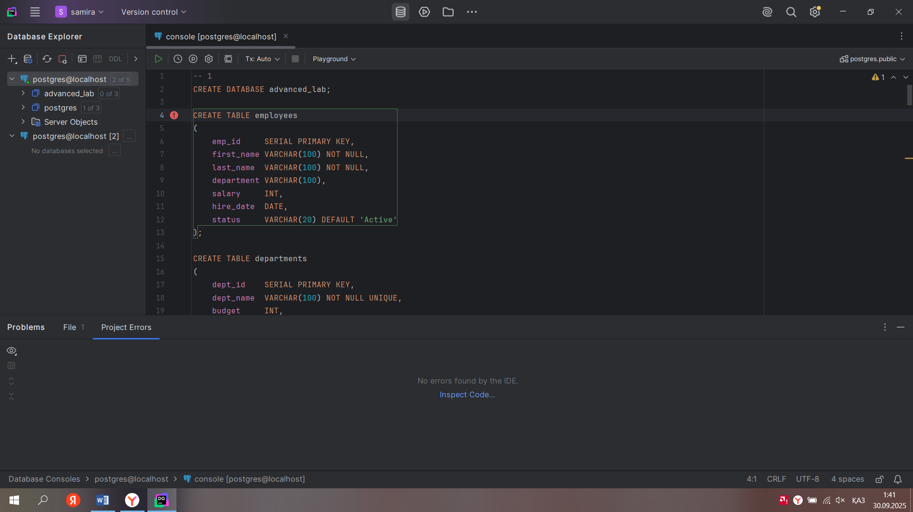

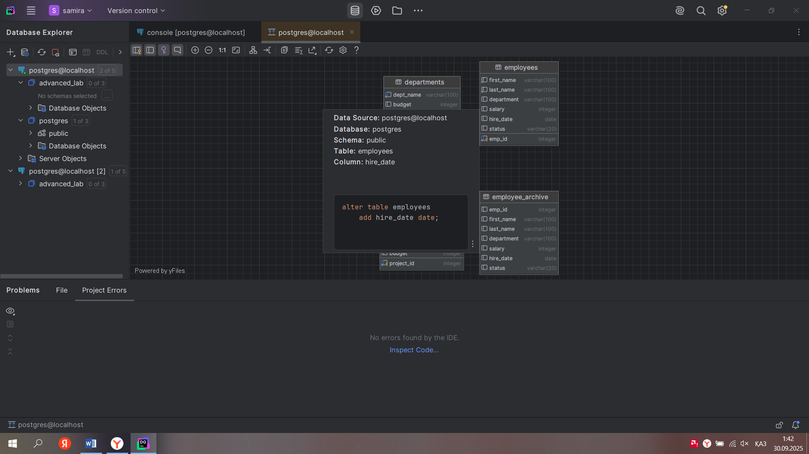

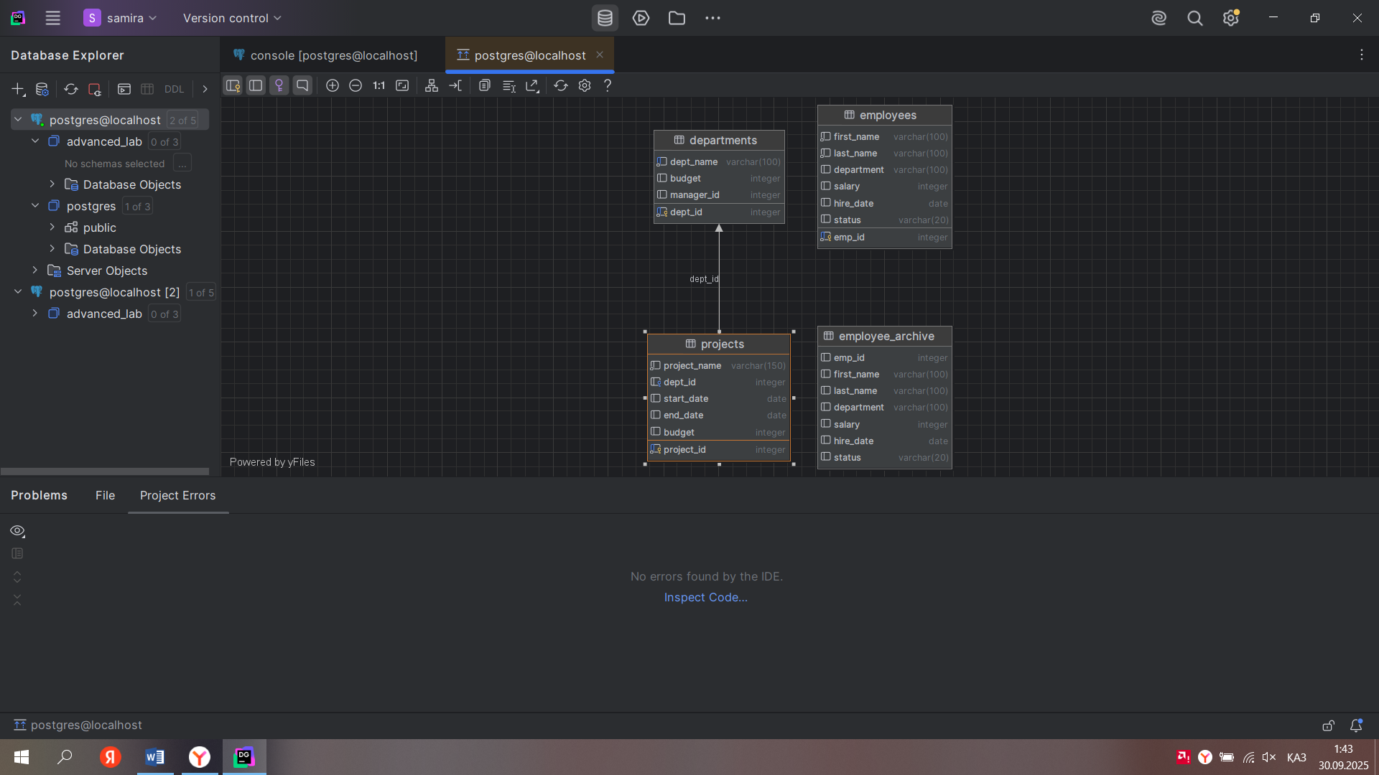

-- 1  
CREATE DATABASE advanced_lab;  
  
CREATE TABLE employees  
(  
 emp_id SERIAL PRIMARY KEY,  
 first_name VARCHAR(100) NOT NULL,  
 last_name VARCHAR(100) NOT NULL,  
 department VARCHAR(100),  
 salary INT,  
 hire_date DATE,  
 status VARCHAR(20) DEFAULT 'Active'  
);  
  
CREATE TABLE departments  
(  
 dept_id SERIAL PRIMARY KEY,  
 dept_name VARCHAR(100) NOT NULL UNIQUE,  
 budget INT,  
 manager_id INT  
);  
  
CREATE TABLE projects  
(  
 project_id SERIAL PRIMARY KEY,  
 project_name VARCHAR(150) NOT NULL,  
 dept_id INT REFERENCES departments (dept_id),  
 start_date DATE,  
 end_date DATE,  
 budget INT  
);  
  
INSERT INTO departments (dept_name, budget, manager_id) VALUES  
('IT', 150000, 101),  
('Sales', 120000, 102),  
('HR', 90000, 103);  
  
INSERT INTO employees (first_name, last_name, department, salary, hire_date, status) VALUES  
('Даулет', 'Қасымов', 'IT', 70000, '2019-05-10', 'Active'),  
('Санжар', 'Жүнісов', 'Sales', 60000, '2020-08-15', 'Active'),  
('Амина', 'Оразбаева', 'HR', 55000, '2021-01-20', 'Active');  
  
-- 2  
INSERT INTO employees (first_name, last_name, department)  
VALUES ('Сания', 'Ибраимова', 'IT');  
  
-- 3  
INSERT INTO employees (first_name, last_name, department, salary, hire_date, status)  
VALUES ('Айгерім', 'Тәжібаева', 'Sales', DEFAULT, *CURRENT_DATE*, DEFAULT);  
  
-- 4  
INSERT INTO departments (dept_name, budget, manager_id)  
VALUES  
 ('Finance', 130000, NULL),  
 ('Marketing', 95000, NULL),  
 ('Support', 80000, NULL);  
  
-- 5  
INSERT INTO employees (first_name, last_name, department, salary, hire_date)  
VALUES ('Қасым', 'Нұрмағамбетов', 'HR', 48000 * 1.1, *CURRENT_DATE*);  
  
-- 6  
CREATE TEMP TABLE temp_employees AS  
SELECT * FROM employees WHERE department = 'IT';  
  
-- 7  
UPDATE employees  
SET salary = salary * 1.10;  
  
-- 8  
UPDATE employees  
SET status = 'Senior'  
WHERE salary > 60000  
 AND hire_date < '2020-01-01';  
  
-- 9  
UPDATE employees  
SET department = CASE  
 WHEN salary > 80000 THEN 'Management'  
 WHEN salary BETWEEN 50000 AND 80000 THEN 'Senior'  
 ELSE 'Junior'  
 END;  
  
-- 10  
INSERT INTO employees (first_name, last_name, department, status)  
VALUES ('Бауыржан', 'Сәденов', 'IT', 'Inactive');  
  
UPDATE employees  
SET department = DEFAULT  
WHERE status = 'Inactive';  
  
-- 11  
UPDATE departments d  
SET budget = (  
 SELECT *AVG*(e.salary) * 1.20  
 FROM employees e  
 WHERE e.department = d.dept_name  
)  
WHERE *EXISTS* (  
 SELECT 1 FROM employees e WHERE e.department = d.dept_name  
);  
  
-- 12  
UPDATE employees  
SET salary = salary * 1.15,  
 status = 'Promoted'  
WHERE department = 'Sales';  
  
-- 13  
INSERT INTO employees (first_name, last_name, department, status)  
VALUES ('Ерлан', 'Қожаев', 'IT', 'Terminated');  
  
DELETE FROM employees  
WHERE status = 'Terminated';  
  
-- 14  
INSERT INTO employees (first_name, last_name, salary, hire_date, department)  
VALUES ('Мәдина', 'Әлімова', 35000, '2023-03-01', NULL);  
  
DELETE FROM employees  
WHERE salary < 40000  
 AND hire_date > '2023-01-01'  
 AND department IS NULL;  
  
-- 15  
DELETE FROM departments  
WHERE dept_id NOT IN (  
 SELECT DISTINCT d.dept_id  
 FROM departments d  
 JOIN employees e ON d.dept_name = e.department  
 WHERE e.department IS NOT NULL  
);  
  
-- 16  
INSERT INTO projects (project_name, dept_id, start_date, end_date, budget)  
VALUES ('Ескі жоба', 1, '2022-01-01', '2022-12-31', 50000);  
  
DELETE FROM projects  
WHERE end_date < '2023-01-01'  
RETURNING *;  
  
-- 17  
INSERT INTO employees (first_name, last_name, department, salary, hire_date, status)  
VALUES ('Нұрлан', 'Сапарбаев', NULL, NULL, *CURRENT_DATE*, 'Active');  
  
-- 18  
UPDATE employees  
SET department = 'Unassigned'  
WHERE department IS NULL;  
  
-- 19  
DELETE FROM employees  
WHERE salary IS NULL  
 OR department IS NULL;  
  
-- 20  
INSERT INTO employees (first_name, last_name, department, salary, hire_date)  
VALUES ('Гүлназ', 'Мұратова', 'IT', 58000, *CURRENT_DATE*)  
RETURNING emp_id, first_name || ' ' || last_name AS full_name;  
  
-- 21  
UPDATE employees  
SET salary = salary + 5000  
WHERE department = 'IT'  
RETURNING emp_id,  
 salary - 5000 AS old_salary,  
 salary AS new_salary;  
  
-- 22  
DELETE FROM employees  
WHERE hire_date < '2020-01-01'  
RETURNING *;  
  
-- 23  
INSERT INTO employees (first_name, last_name, department, salary, hire_date)  
SELECT 'Аслан', 'Бектаев', 'R&D', 62000, *CURRENT_DATE*WHERE NOT *EXISTS* (  
 SELECT 1 FROM employees  
 WHERE first_name = 'Аслан' AND last_name = 'Бектаев'  
);  
  
-- 24  
UPDATE employees e  
SET salary = salary * CASE  
 WHEN (SELECT d.budget FROM departments d WHERE d.dept_name = e.department) > 100000  
 THEN 1.10  
 ELSE 1.05  
 END;  
  
-- 25  
INSERT INTO employees (first_name, last_name, department, salary, hire_date)  
VALUES  
 ('Айбек', 'Шарипов', 'IT', 52000, *CURRENT_DATE*),  
 ('Динара', 'Құрманова', 'Sales', 50000, *CURRENT_DATE*),  
 ('Рауан', 'Темиргалиев', 'HR', 48000, *CURRENT_DATE*),  
 ('Жансая', 'Омарбекова', 'IT', 53000, *CURRENT_DATE*),  
 ('Марат', 'Искаков', 'Support', 47000, *CURRENT_DATE*);  
  
UPDATE employees  
SET salary = salary * 1.10  
WHERE first_name IN ('Айбек', 'Динара', 'Рауан', 'Жансая', 'Марат');  
  
-- 26  
CREATE TABLE IF NOT EXISTS employee_archive AS  
SELECT * FROM employees WHERE 1=0;  
  
INSERT INTO employee_archive  
SELECT * FROM employees WHERE status = 'Inactive';  
  
DELETE FROM employees  
WHERE status = 'Inactive';  
  
-- 27  
INSERT INTO employees (first_name, last_name, department, salary, hire_date) VALUES  
('Азамат', 'Кенжеев', 'IT', 65000, *CURRENT_DATE*),  
('Ботагоз', 'Сағиева', 'IT', 62000, *CURRENT_DATE*),  
('Ержан', 'Тулешев', 'IT', 68000, *CURRENT_DATE*);  
  
INSERT INTO projects (project_name, dept_id, start_date, end_date, budget)  
VALUES ('Үлкен жоба', 1, '2023-06-01', '2023-12-31', 60000);  
  
UPDATE projects p  
SET end_date = end_date + INTERVAL '30 days'  
WHERE budget > 50000  
 AND (  
 SELECT *COUNT*(*)  
 FROM employees e  
 WHERE e.department = (  
 SELECT d.dept_name  
 FROM departments d  
 WHERE d.dept_id = p.dept_id  
 )  
 ) > 3;