**1. Display the details of employee whose salary is >=100000 and designation is ‘Ceo’.**

mysql> select * from emp

-> where salary>=100000 and designation='Ceo';

**Output:**

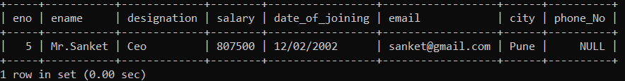

**2. Display the name of employee whose belongs to either ‘Pune’ or ‘Mumbai’.**

mysql> select ename from emp

-> where city='Pune' or city='Mumbai';

**Output:**

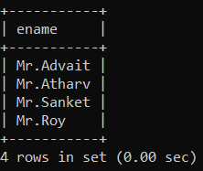

**3. Display the name of employee whose salary >= 50000 and having designation ‘Manager’ or ‘Ceo’.**

select ename from emp

-> where salary>=50000 and designation='Manager' or designation='Ceo';

**Output:**

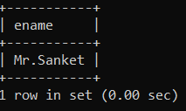

**4. Update salary of employee with 5% increment whose salary >= 50000 and phone_No is ‘1234567890’.**

mysql> update emp set salary=salary+(salary*0.05)

-> where salary>=50000 and phone_No='1234567890';

Query OK, 1 row affected (0.02 sec)

Rows matched: 1 Changed: 1 Warnings: 0

mysql> select * from emp

-> where phone_No='1234567890';

**Output:**

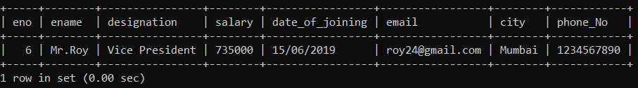

**5. Delete the details of employee whose eno=6.**

mysql> delete from emp

-> where eno=6;

Query OK, 1 row affected (0.02 sec)

**Output:**

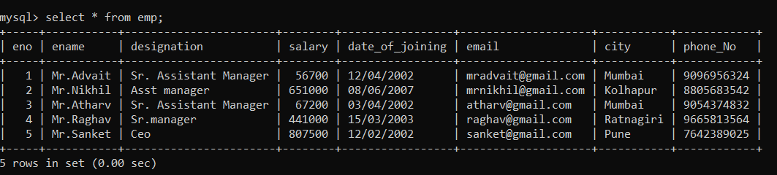

**6. Display unique city whose designation is Ceo.**

mysql> select city from emp

-> where designation='Ceo';

**Output:**

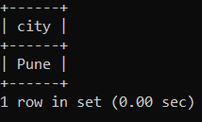

**7. Display the details of employee whose salary between 50000 to 100000 and city is Mumbai.**

mysql> select * from emp

-> where salary between 50000 and 100000 and city='Mumbai';

**Output:**

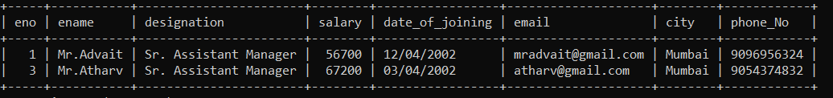

**8. Display details of employee where eno between 1 to 5 and his name is Mr.Advait.**

select * from emp

-> where eno between 1 and 5 and ename='Mr.Advait';

**Output:**

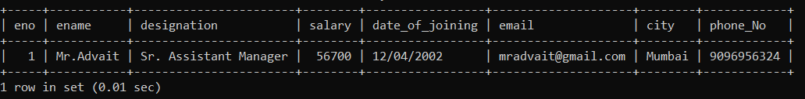

**9. Update city of employee to ‘Pune’ whose salary is between 50000 to 100000.**

mysql> update emp set city='Pune'

-> where salary between 50000 and 100000;

Query OK, 2 rows affected (0.03 sec)

Rows matched: 2 Changed: 2 Warnings: 0

**Output:**

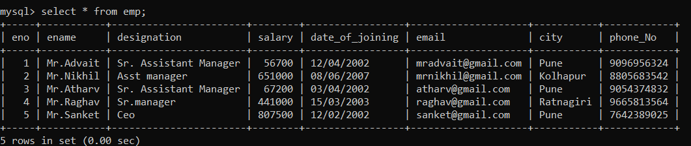

**10. Display ename of employees whose name start with ‘M’ and ends with ‘m’ & designation is Ceo & he/she belongs to Pune or Mumbai or Nagpur city.**

select ename

-> from emp

-> where ename like 'M%m' and designation='Ceo' and city in('Pune','Mumbai','Nagpur');

**Output:**

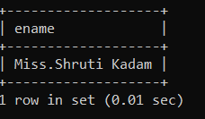

**11. Display the details of employee whose email contains ‘.’ character and salary between 10000 to 20000 or employee eno is either 1,12,31,49.**

mysql> select * from emp

-> where (email like '%.%') and (salary between 50000 and 70000) or (eno in(1,12,31,49));

**Output:**

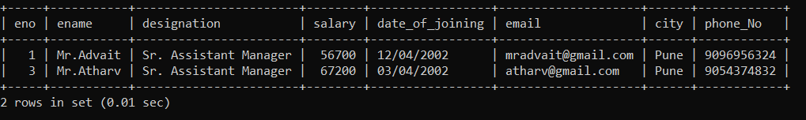

**12. Display ename, designation, and phone_No of employee whose name having fourth character is ‘r’ and ends with ‘v’ & also email having ‘@’ and ‘.’ character & phone_No >= 123456789.**

mysql> select ename,designation,phone_No from emp

-> where ename like '___r%v' and email like '%@%.%' and phone_No>='123456789';

**Output:**

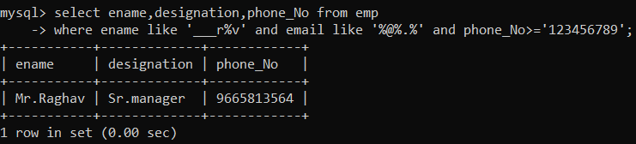

**13. Display the details of employee name in descending order whose name contains only nine characters.**

mysql> select * from emp

-> where ename like '_________'

-> order by ename desc;

**Output:**

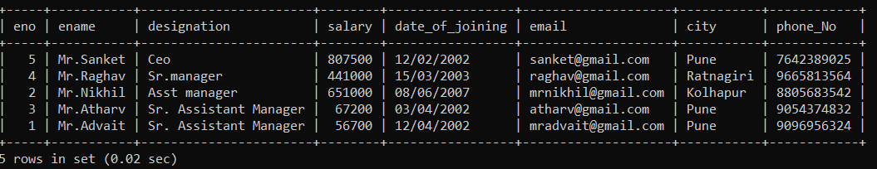

**14) Display maximum salary from an employee table whose name contain ‘m’ and date of joining between ‘12/02/2002’ (use alises).**

mysql> select max(salary) as SalaryMax

-> from emp as employees

-> where ename like 'm%' and date_of_joining='12/02/2002';

**Output:**

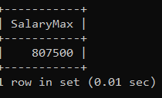

**15) Count the total no. of employees whose belongs to Pune or Nagpur city and designation is ‘Ceo’.**

mysql> select count(*) as Total

-> from emp as employee

-> where employee.city in('Pune','Nagpur') and employee.designation='Ceo';

**Output:**

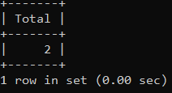

**16) Count total no. of employee designation wise.**

mysql> select count(*), designation

-> from emp

-> group by designation;

**Output:**

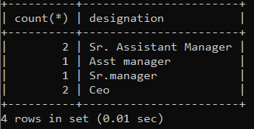

**17) Find maximum salary of an employee city wise.**

select max(salary) as salary,city

-> from emp

-> group by city;

**Output:**

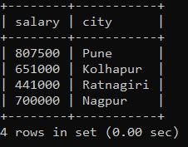

**18) To find total salary value of employee city wise having salary > 50000.**

mysql> select sum(salary) as salary,city

-> from emp

-> group by city

-> having salary > 50000;

**Output:**

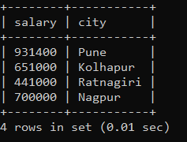

**19) Display the details of employee who having a maximum salary in table.**

mysql> select * from emp

-> where salary=(select max(salary) from emp);

**Output:**

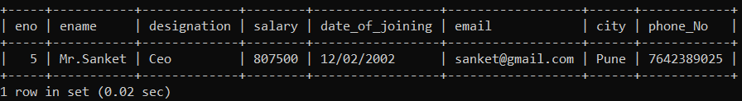

**20) Display the details of employee who having a minimum salary but he/she belongs to Pune or Mumbai city and he/she name contain ‘a’ or ‘i’ character.**

mysql> select * from emp

-> where salary=(select min(salary) from emp

-> where city in ('Pune','Ratnagiri')

-> and ename like '%a%' or ename like '%i%');

**Output:**

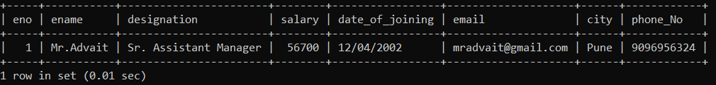

**21) Add dname column in employee table.**

mysql> alter table emp add column dname varchar(30);

Query OK, 0 rows affected (0.17 sec)

Records: 0 Duplicates: 0 Warnings: 0

**Output:**

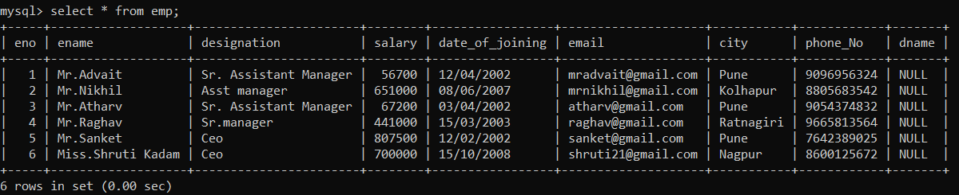

**22) Update dname column.**

mysql> update emp set dname='Computer' where eno=1;

Query OK, 1 row affected (0.02 sec)

Rows matched: 1 Changed: 1 Warnings: 0

mysql> update emp set dname='Statistics' where eno=2;

Query OK, 1 row affected (0.01 sec)

Rows matched: 1 Changed: 1 Warnings: 0

mysql> update emp set dname='Electronics' where eno=3;

Query OK, 1 row affected (0.04 sec)

Rows matched: 1 Changed: 1 Warnings: 0

mysql> update emp set dname='Electronics' where eno=4;

Query OK, 1 row affected (0.02 sec)

Rows matched: 1 Changed: 1 Warnings: 0

mysql> update emp set dname='Computer' where eno=5;

Query OK, 1 row affected (0.01 sec)

Rows matched: 1 Changed: 1 Warnings: 0

mysql> update emp set dname='Statistics' where eno=6;

Query OK, 1 row affected (0.01 sec)

Rows matched: 1 Changed: 1 Warnings: 0

**Output:**

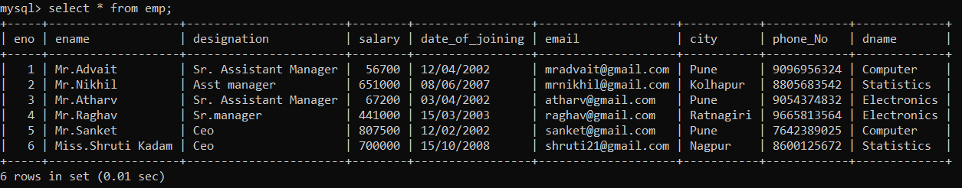

**23) Display department wise details of employee.**

mysql> select ename,dname

-> from emp

-> group by ename,dname;

**Output:**

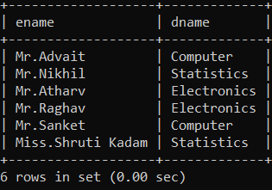

**24) Display total salary of employee of each department.**

mysql> select sum(salary) as salary,dname

-> from emp

-> group by dname;

**Output:**

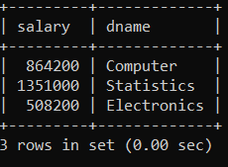

**25) Display average salary of employee of computer department.**

mysql> select avg(salary) as salary,dname

-> from emp

-> group by dname

-> having dname='Computer';

**Output:**

