**\*RDB Queries\***

**TASK-1**

**1) Add column phone_No into employees table with data type int.**

alter table employees add column phone_No int(15);

Query OK, 0 rows affected, 1 warning (0.04 sec)

Records: 0 Duplicates: 0 Warnings: 1

**Output:**

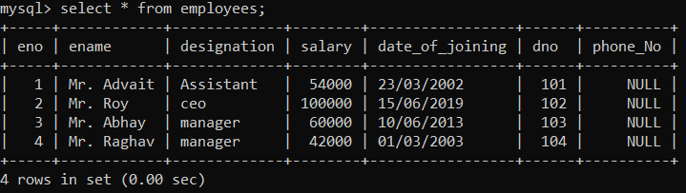

**2) Update phone_No.**

mysql> update employees set phone_No='9067680707' where eno=1;

Query OK, 1 row affected (0.01 sec)

Rows matched: 1 Changed: 1 Warnings: 0

mysql> update employees set phone_No='9665734389' where eno=2;

Query OK, 1 row affected (0.01 sec)

Rows matched: 1 Changed: 1 Warnings: 0

mysql> update employees set phone_No='8600118702' where eno=3;

Query OK, 1 row affected (0.02 sec)

Rows matched: 1 Changed: 1 Warnings: 0

mysql> update employees set phone_No='7853603412' where eno=4;

Query OK, 1 row affected (0.02 sec)

Rows matched: 1 Changed: 1 Warnings: 0

**Output:**

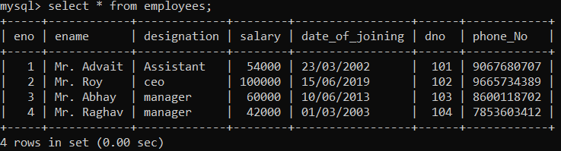

**3) Delete the details of Employee whose designation is ‘Manager’.**

mysql> delete from employees where designation='manager' and eno=3;

**Output:**

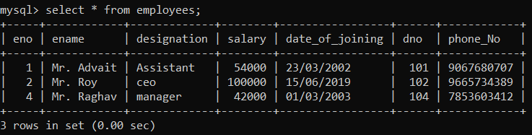

**4) Display the count of employees department wise.**

mysql> select count(eno),dname

-> from employees,dept

-> where employees.dno=dept.dno

-> group by dname;

**Output:**

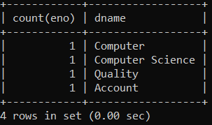

**5) Display the name of employee who is ‘Manager’ of ‘Account Department’.**

mysql> select ename,dname

-> from employees,dept

-> where employees.dno=dept.dno and designation='Manager' and dname='Account';

**Output:**

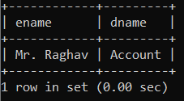

**6) Display the name of department whose location is ‘Pune’ and ‘Mr. Advait’ is working in it.**

mysql> select dname

-> from dept,employees

-> where dept.dno=employees.dno and location='Pune' and ename='Mr. Advait';

**Output:**

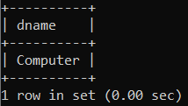

**7) Display the names of employees whose salary is greater than 50000 and department is ‘Quality’.**

mysql> select ename from employees

-> where salary>50000

-> And dno IN(select dno from dept where dname='Quality');

**Output:**

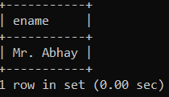

**8) Update date_of_joining of employee to ‘15/06/2019’ whose department is ‘computer science’ and name is ‘Mr. Roy’.**

mysql> update employees set date_of_joining='15/06/2019'

-> where ename='Mr. Roy'

-> and dno IN(select dno from dept where dname='Computer Science');

Query OK, 0 rows affected (0.01 sec)

Rows matched: 1 Changed: 0 Warnings: 0

**Output:**

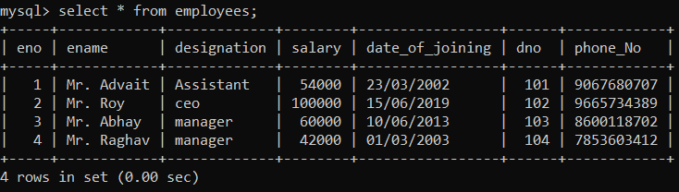

**TASK-2**

S**ales_order (ordNo, ordDate,Sales_order) Client (clientNo, ClientName, addr)**

**The relationship between Client & Sales_order is one-to-many.**

**Constraints: - Primary Key, ordDate should not be NULL**

**Client Table:**

create table client(clientNo varchar(10) primary key,ClientName varchar(20),address varchar(20));

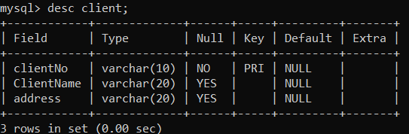

**Sales_order Table:**

mysql> create table Sales_order(ordNo int primary key,ordDate varchar(20) not null,clientNo varchar(10) references client(clientNo));

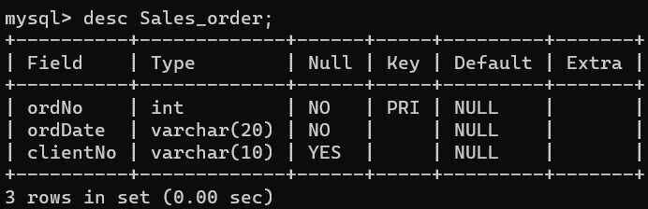

**1. Add column amount into sales_amt table with data type float.**

mysql> alter table Sales_order add column Sales_amt float;

Query OK, 0 rows affected (0.02 sec)

Records: 0 Duplicates: 0 Warnings: 0

**Output:**

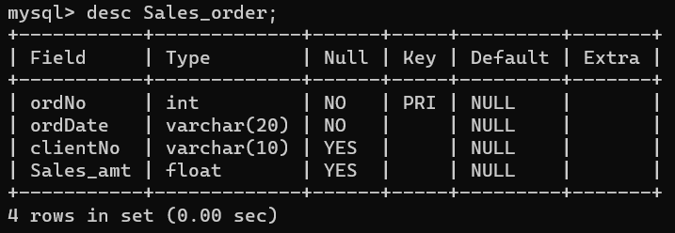

**2. Delete the details of the clients whose names contain ‘A’ character at fourth position.**

mysql> delete from client where ClientName like '____A%';

Query OK, 1 row affected (0.01 sec)

**Output:**

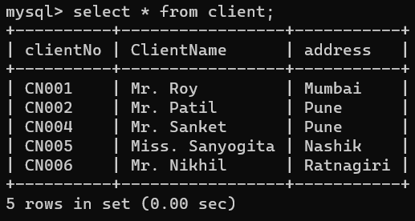

**3. Delete sales order details of client whose name is ‘Patil’ and order date is ‘09/08/2019’.**

mysql> delete from Sales_order

-> where ordDate='09/08/2019'

-> and clientNo in(select clientNo from client where ClientName='Mr. Patil');

**Output:**

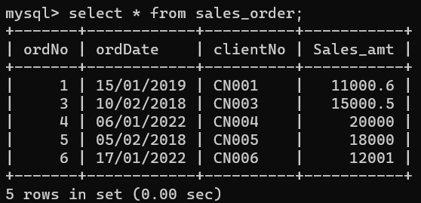

**4. Change order date of clientNo ‘CN001’ ‘18/03/2019’.**

mysql> update Sales_order

-> set ordDate='18/03/2019' where clientNo='CN001';

**Output:**

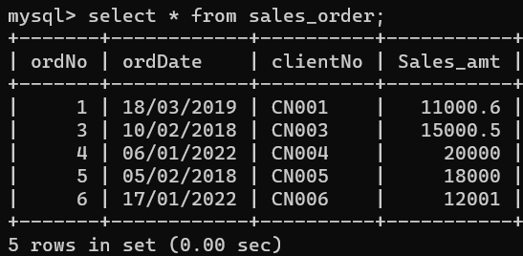

**5. Delete all sales record having order date is ‘10 /02/2018’.**

mysql> delete from Sales_order

-> where ordDate='10/02/2018';

Query OK, 1 row affected (0.02 sec)

**Output:**

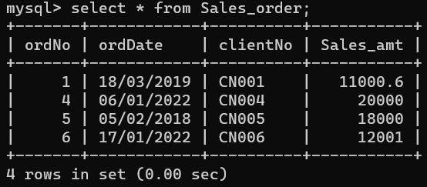

**6. Update the address of client to ‘Pimpri’ whose name is ‘Mr. Roy’.**

mysql> update client

-> set address='Pimpri' where ClientName='Mr. Roy';

Query OK, 1 row affected (0.02 sec)

Rows matched: 1 Changed: 1 Warnings: 0

**Output:**

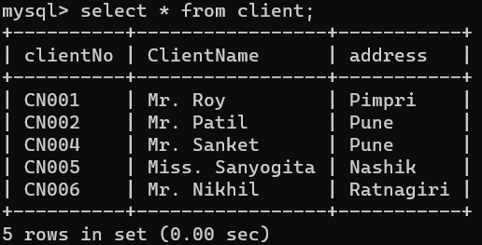

**7. Display total orders between '06/01/2022' to '17/01/2022'.**

mysql> select count(ordNo) as Total_orders

-> from Sales_order

-> where ordDate between '06/01/2022' and '17/01/2022';

**Output:**

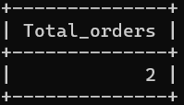

**8. Display total sale amount between '06/01/2022' to '17/01/2022'.**

mysql> select sum(Sales_amt) as Total_Sale_amt

-> from Sales_order

-> where ordDate between '06/01/2022' and '17/01/2022';

**Output:**

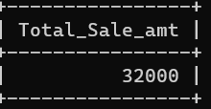

**9. Display details of client from Pune location.**

mysql> select * from client

-> where address='Pune';

**Output:**

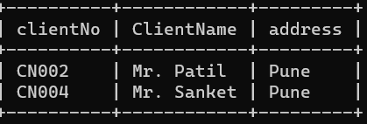

**TASK-3**

**Create a RDB in 3 NF with appropriate data types and Constraints.**

**Hospital (hno ,hname , city, Est_year, addr) Doctor (dno , dname , addr, Speciality,salary)**

**The relationship between Hospital and Doctor is one - to – Many**

**Constraints: - Primary Key, Est_year should be greater than 1990.**

**Hospital Table:**

mysql> create table doctors(hno int primary key,hname varchar(30),city varchar(20),Est_year int(10) check(Est_year>1990),address varchar(30));

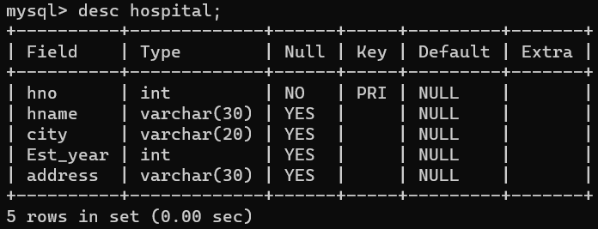

**Doctor Table:**

mysql> create table doctors(dno int primary key,dname varchar(30),address varchar(30),speciality varchar(20),salary varchar(10),hno int references hospital(hno));

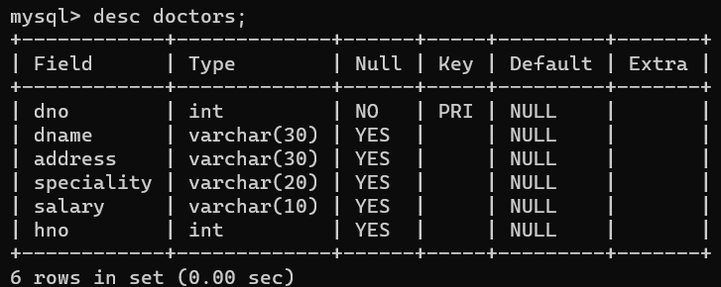

**1. Delete address column from Hospital table.**

mysql> alter table hospital drop column address;

Query OK, 0 rows affected (0.07 sec)

**Output:**

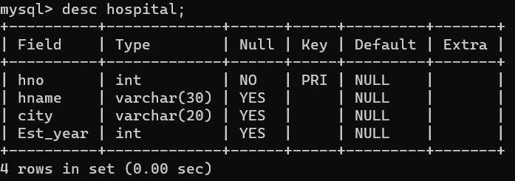

**2. Display doctor name, Hospital name and speciality of doctors from ‘Pune City’.**

mysql> select hname,dname,speciality from hospital,doctors

-> where doctors.hno=hospital.hno

-> and city='Pune';

**Output:**

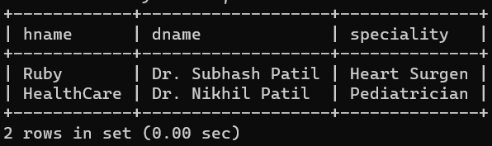

**3. Display the names of the hospitals which are located at ‘Pimpri’ city.**

mysql> select hname from hospital,doctors

-> where doctors.hno=hospital.hno

-> and city='Pimpri';

**Output:**

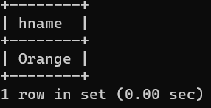

**4. Display the names of doctors who are working in ‘Birla’ Hospital and city name is ‘Chinchwad’.**

mysql> select dname from doctors,hospital

-> where doctors.hno=hospital.hno

-> and hname='Birla' and city='Chinchwad';

**Output:**

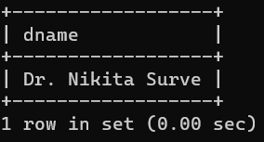

**5. Display the speciality of the doctors who are working in ‘Ruby’ hospital.**

mysql> select speciality from doctors,hospital

-> where doctors.hno=hospital.hno

-> and hname='Ruby';

**Output:**

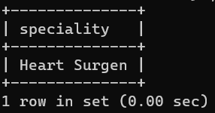

**6. Give the count of doctor’s hospital wise which are located at ‘Pimple Gurav’.**

mysql> select hname,count(dno) from doctors,hospital

-> where doctors.hno=hospital.hno and city='Pimple Gurav'

-> group by hname;

**Output:**

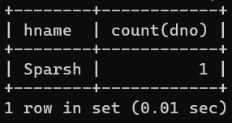

**7. Update an address of Doctor to ‘Pimpri’ whose hospital is ‘Ruby clinic’.**

mysql> update doctors set address='Pimpri'

-> where hno in(select hno from hospital where hname='Ruby');

Query OK, 1 row affected (0.03 sec)

Rows matched: 1 Changed: 1 Warnings: 0

**Output:**

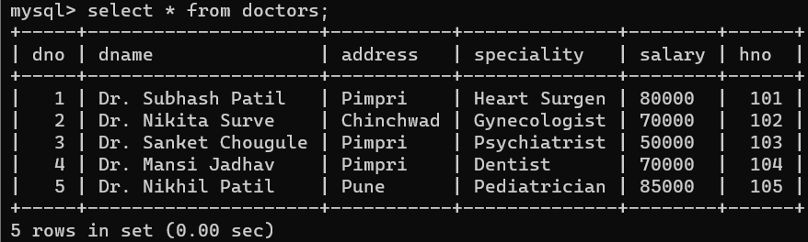

**8. Display doctor details whose speciality is ‘Heart Surgen’ and whole belong to hospital from ‘Pune’.**

mysql> select * from doctors,hospital

-> where doctors.hno=hospital.hno

-> and speciality='Heart Surgen' and city='Pune';

**Output:**

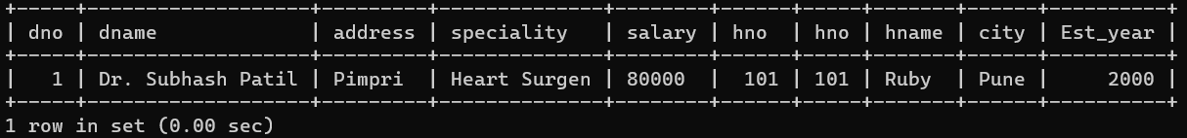

**9. Update an address of hospital to ‘Pimpri’ whose hospital is established in ‘2000’.**

mysql> update hospital set city='Pimpri' where Est_year='2000';

Query OK, 1 row affected (0.02 sec)

Rows matched: 1 Changed: 1 Warnings: 0

**Output:**

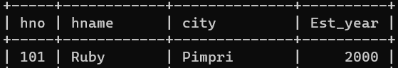

**10. Display Total salary of all doctor’s hospital wise.**

mysql> select sum(salary) as Total_salary,hname

-> from doctors,hospital

-> where doctors.hno=hospital.hno

-> group by hname;

**Output:**

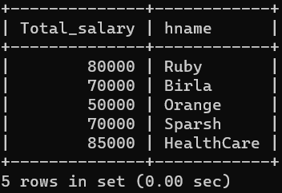

**11. Display annual salary of doctor who live in ‘Pune’.**

mysql> select salary from doctors

-> where address='Pune';

**Output:**

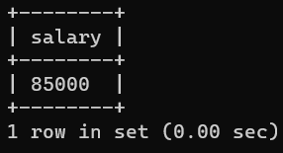

**TASK-4**

**Create a RDB in 3 NF with appropriate data types and Constraints.**

**Project (pno, pname, start_date, budget, status), Department (dno, dname, HOD, loc).**

**The relationship between Project and Department is Many to One.**

**Constraint: Primary key. Project Status Constraints: C – Completed, P - Progressive,**

**I – Incomplete.**

**Project Table:**

create table project(pno int primary key,pname varchar(20),start_date varchar(10),budget int,status varchar(20) check(status='Complete' or status='Progressive' or status='incomplete'));

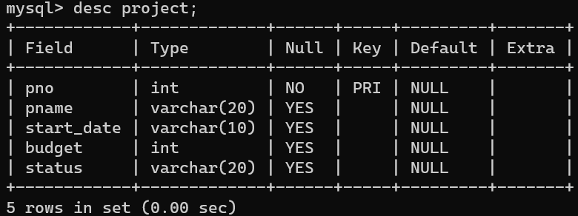

**Department Table:**

mysql> create table department(dno int primary key,dname varchar(20),HOD varchar(20),location varchar(20),pno int references project(pno));

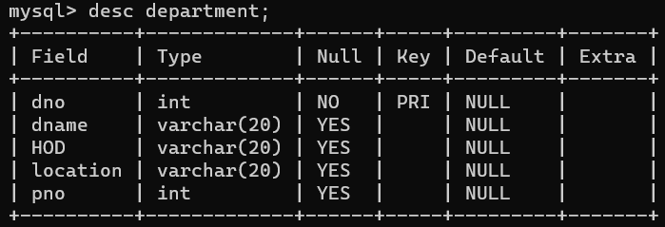

**1. Drop location column from department table.**

mysql> alter table department drop column location;

Query OK, 0 rows affected (0.06 sec)

**Output:**

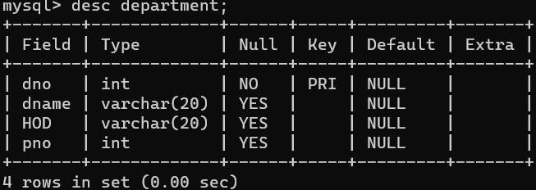

**2. Display the details of project whose start_date is before one month and status is ‘Progressive’.**

mysql> select * from project

-> where start_date>25/12/2023 and status='Progressive';

**Output:**

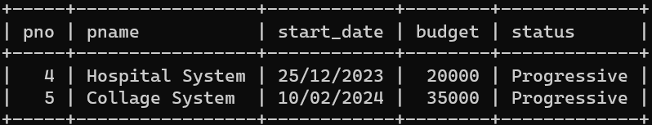

**3. Display the names of project and department who are worked on projects whose status is ‘Completed’.**

mysql> select pname,dname,HOD from project,department

-> where project.pno=department.pno

-> and status='Complete';

**Output:**

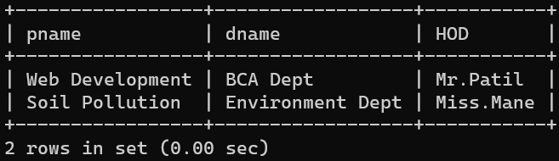

**4. Display total budget of each department.**

mysql> select sum(budget),dname from department,project

-> where department.pno=project.pno

-> group by dname;

**Output:**

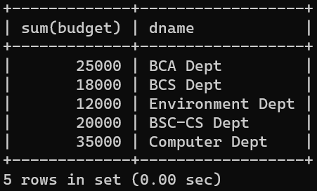

**5. Display incomplete project of each department.**

mysql> select pname,dname,status,count(department.dno) as count from department,project

-> where department.pno=project.pno

-> and status='Incomplete'

-> group by status,pname,dname;

**Output:**

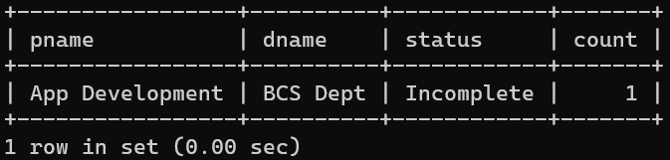

**6. Display all project working under 'Mr. Desai'.**

mysql> select pname from department,project

-> where department.pno=project.pno and HOD='Mr.Desai';

**Output:**

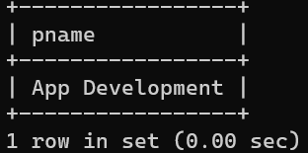

**7. Display department wise HOD.**

mysql> select dname,HOD from department,project

-> where department.pno=project.pno

-> order by dname;

**Output:**

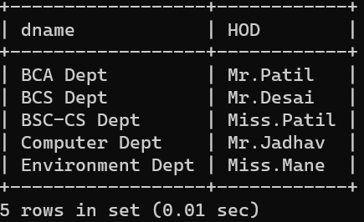

**8. Display project details where project name start with A and whose budget is >10000.**

mysql> select * from project

-> where pname like 'A%' and budget>10000;

**Output:**

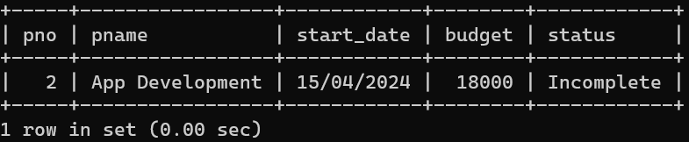

**9. Display the project details whose having highest budget.**

mysql> select * from project

-> where budget=(select max(budget) from project);

**Output:**

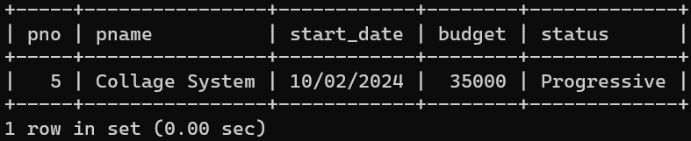

**TASK-5**

**Create a RDB in 3 NF with appropriate data types and Constraints.**

**Customer (cust_no, cust_name, city) Loan (loan_no, loan_amt)**

**The relationship between Customer and Loan is Many to Many.**

**Constraint: Primary key, loan_amt should be > 0.**

**Customer Table:**

mysql> create table customer(cust_no int primary key,cust_name varchar(20),city varchar(20));

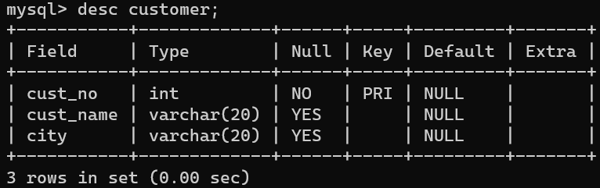

**Loan Table:**

create table loan(loan_no int primary key,loan_amt varchar(10) check(loan_amt>0),cust_no int references customer(cust_no));

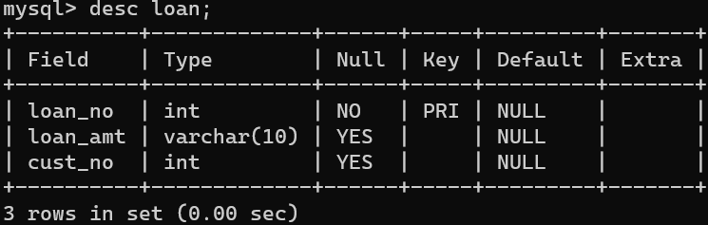

**Cust_Loan Table:**

mysql> create table cust_loan(cust_no int references customer(cust_no),loan_no int references loan(loan_no),loan_status varchar(20) check(loan_status='Complete' or loan_status='Process' or loan_status='Incomplete'));

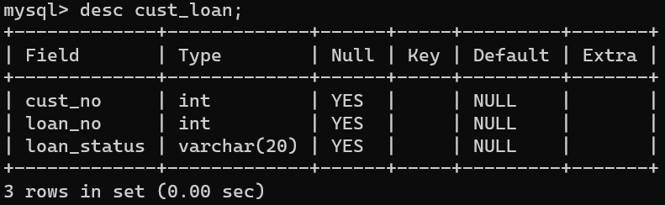

**1. Display the details of customer whose loan_amt<100000.**

mysql> select cust_name,city from customer,loan,cust_loan

-> where customer.cust_no=cust_loan.cust_no

-> and loan.loan_no=cust_loan.loan_no and loan_amt<100000;

**Output:**

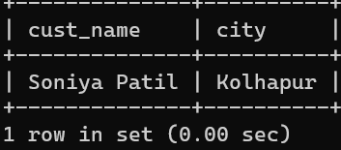

**2. List all customers whose name starts with 'D' character.**

mysql> select * from customer,cust_loan

-> where customer.cust_no=cust_loan.cust_no and cust_name like 'D%';

**Output:**

