Financial Performance Case Study: Revenue vs. Profitability
Prepared by: Samiksha Bansode
Date: September 22, 2026
Tools: Python, Power BI, SQL
1. Executive Summary
Over the 2013–2014 period, top-line sales performed exceptionally well, pulling in $19.61M in total revenue. However, looking under the hood reveals a significant issue: overall net profit ended up in the red at -$614.55K.
The main culprit behind this gap isn't a lack of demand it’s aggressive discounting and high manufacturing costs that are eating away at the margins, especially in large enterprise accounts.
2. Key Findings & Data Insights
A. Regional Performance
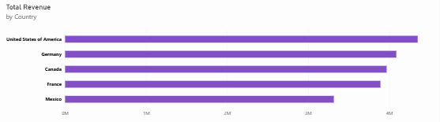
- Where the money is coming from: The United States is our strongest market by far, with Germany and Canada coming in as solid secondary drivers.
- Slower markets: France and Mexico lagged behind the rest of the group in overall sales volume.
B. Sales Growth vs. The Margin Problem
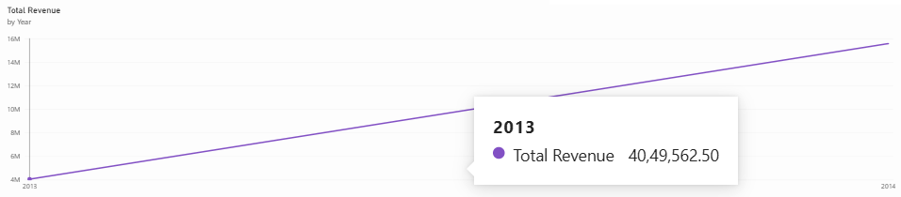
- Strong sales trajectory: Revenue grew consistently over the multi-quarter period, scaling from under $4M all the way up to nearly $16M.
- The profit disconnect: Even though sales volume kept rising, profits didn't follow. Heavy price discounts and high Cost of Goods Sold (COGS) kept pulling the bottom line negative.
3. Recommendations
- Fix the discount structure: We are giving away too much margin on large orders. Putting a stricter cap on discount bands particularly for enterprise buyers will immediately help recover profitability.
- Focus where demand is highest: Double down on sales and marketing efforts in the US and Germany. These regions already have proven demand and represent our best return on effort.

