SceneCraft
AI-Powered Interactive Story Analysis Platform
Turn Any Story Into an Explorable Workspace — Not Just a Summary
Document Type | Project Concept & Technical Blueprint
Version | v1.0 — August 2026
Target Audience | Portfolio Reviewers, Recruiters & Collaborators
Status | Concept / Pre-Development

TABLE OF CONTENTS
1. | The Problem — Why Story Analysis Tools Fall Short | 3
2. | Project Rationale & Portfolio Value | 3
3. | What is SceneCraft? | 4
4. | How SceneCraft Works — The Big Picture | 4
5. | Module 1: Scene Breakdown | 6
6. | Module 2: Character Profiles | 6
7. | Module 3: Relationship Graph | 7
8. | Module 4: Story Timeline | 8
9. | Module 5: Dialogue Summaries | 8
10. | Module 6: Mood & Emotion Analysis | 9
11. | Module 7: Story Arc Visualization | 9
12. | Module 8: Continuity Checker | 10
13. | Module 9: Semantic Search | 10
14. | System Architecture | 12
15. | Database Schema | 14
16. | Frontend Experience & UI Flow | 20
17. | Technology Stack | 20
18. | Implementation Roadmap | 22
19. | Why This Project Stands Out | 22

1. The Problem — Why Story Analysis Tools Fall Short
Writers, screenwriters, readers, and content teams who work closely with long-form stories currently rely on a single-prompt chatbot, or worse, their own memory and notes, to make sense of complex narratives. This produces flat, disposable text that has to be regenerated every time a new question comes up.

1.1 The Real Pain Points
Pain Point | What This Means for the User
Flat text summaries | A single wall of text loses character nuance and can't be revisited or filtered later.
No visual structure | Readers and writers must re-read the entire story to locate a specific detail or moment.
No relationship mapping | Complex casts become hard to track — who knows whom, and how that changes over the story.
No timeline view | Non-linear or multi-POV stories become confusing without a chronological view of events.
No continuity checking | Writers miss contradictions — eye colour changes, timeline clashes, forgotten subplots.
Single-prompt AI tools | One shot answers are shallow; there is no structured data to filter, search, or build on.
No searchable memory | Users can't ask "when did X happen" or "what did character Y say about Z" without re-reading.

Key Insight | Writers and story editors report spending hours manually building character sheets, timelines, and continuity notes — structured work that a multi-stage AI pipeline can generate automatically, in minutes, and keep interactive.

2. Project Rationale & Portfolio Value
SceneCraft is designed as a portfolio-defining project — one that demonstrates full-stack systems thinking rather than a single AI API call wrapped in a chat window.
Opportunity | Detail
Growth in AI reading/writing tools | Rising demand for AI-assisted writing, editing, and story analysis tools among indie authors, screenwriters, and students.
Existing tools are narrow | Most tools either summarize OR generate character sheets — none combine both into one connected, explorable system.
Underserved audience | Fiction writers, screenwriters, book clubs, students, editors, and story consultants currently improvise with spreadsheets and sticky notes.
Portfolio differentiation | Most AI portfolio projects are single-prompt wrappers; SceneCraft showcases multi-stage pipelines, background jobs, and real-time UX.
Recruiter appeal | Combines AI orchestration, distributed job processing, complex data modeling, and interactive visualization — a rare, hireable combination.

3. What is SceneCraft?
SceneCraft is an AI-powered platform that turns an uploaded story — a novel chapter, screenplay, or short story in PDF, DOCX, or TXT format — into a structured, interactive workspace. Instead of a single generated summary, the system runs the story through multiple specialized AI analysis stages and stores the output as structured, queryable data that powers an immersive, notebook-inspired interface.

3.1 Core Principles
Principle | What It Means
Structured, Not Just Text | Every insight is stored as structured data (scenes, characters, events) — not a disposable paragraph.
Multi-Stage Analysis | Nine specialized AI passes analyze the story instead of one generic prompt trying to do everything.
Real-Time Feedback | Background jobs stream live progress updates instead of a blank loading spinner.
Immersive by Design | The interface feels like opening a storybook — not like using a conventional AI dashboard.
Explorable Memory | Every analysis result is searchable and cross-referenced, so nothing has to be re-generated to be revisited.
Format-Flexible Input | Accepts PDF, DOCX, and TXT so it fits into a writer's existing workflow.

4. How SceneCraft Works — The Big Picture
A story moves through a connected processing pipeline: it is parsed and chunked, then fanned out to independent and dependent AI analysis stages, and finally persisted as structured records that power every interactive page. Progress is streamed to the client in real time as each stage completes, so the workspace unlocks incrementally rather than all at once.
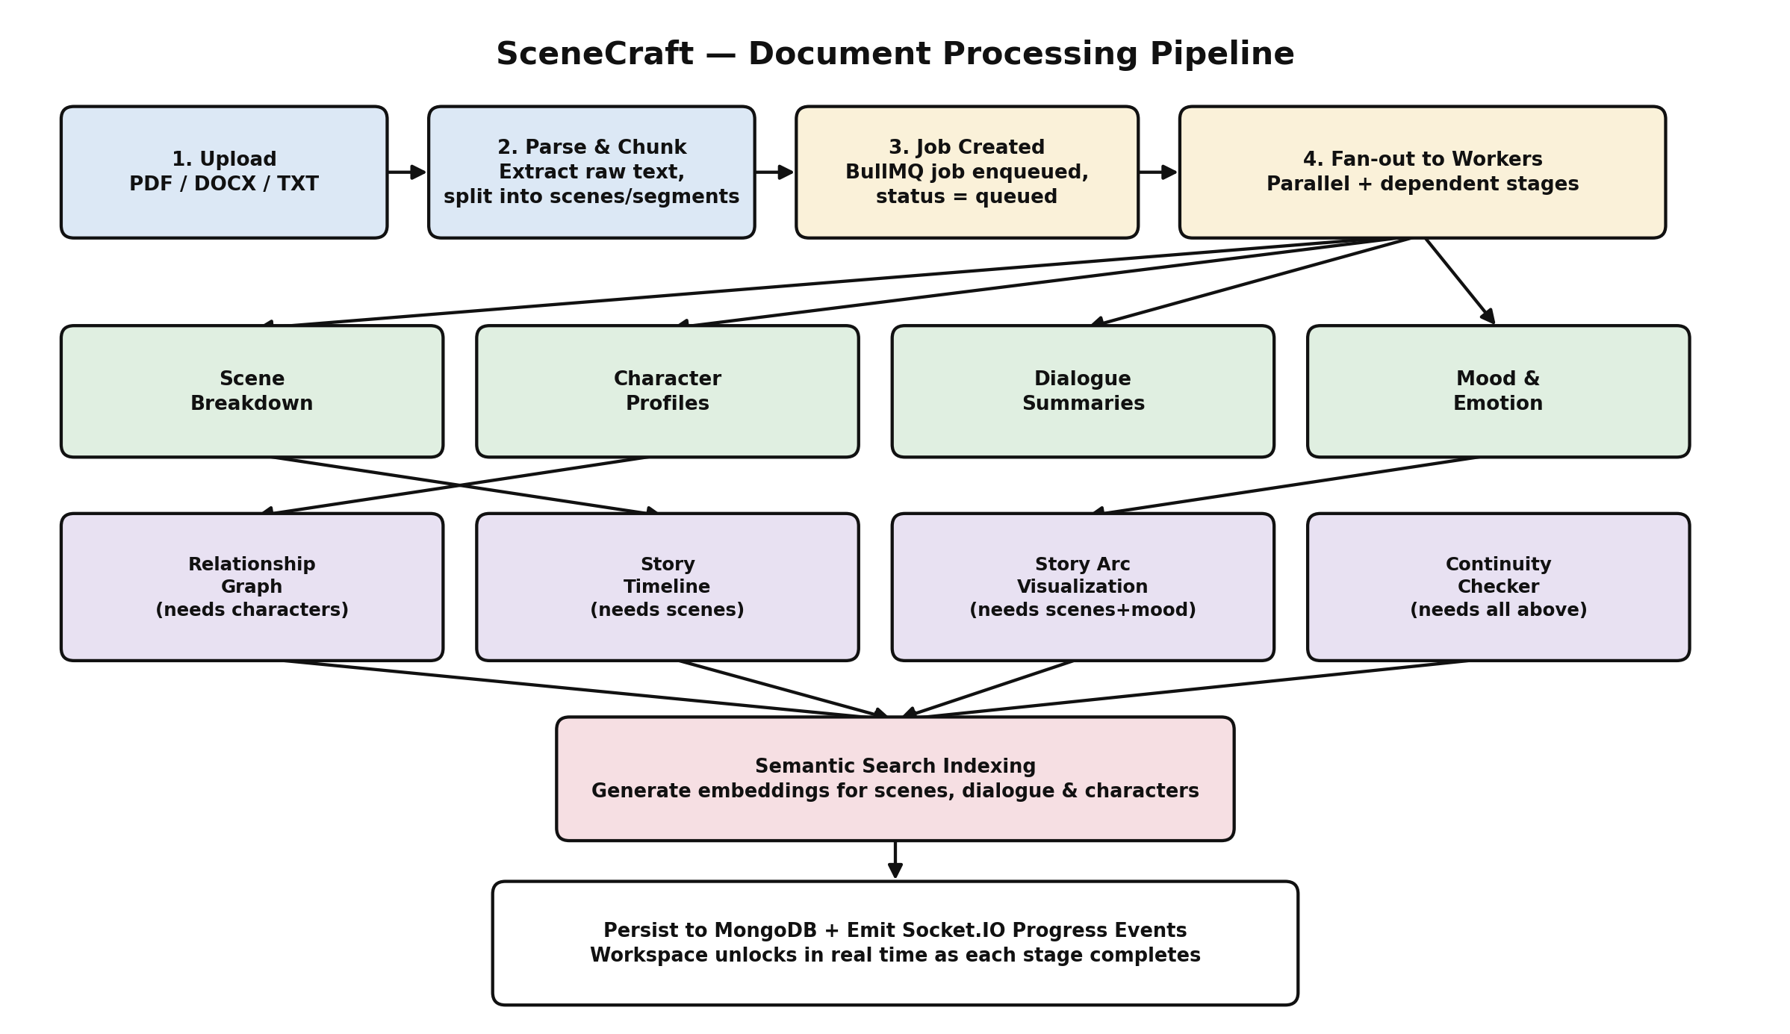
Figure 1 — Document processing pipeline, from upload to a fully explorable workspace.

4.1 Primary Users
User | What They Do in SceneCraft
Fiction Writers | Upload drafts to check continuity, visualize story arcs, and keep character sheets in sync as they revise.
Screenwriters | Break scripts into scenes, track dialogue tone per character, and validate pacing against the story arc.
Readers / Book Clubs | Explore character relationships and timelines without re-reading, and search for specific moments.
Students & Educators | Use structured breakdowns of assigned texts for study guides, essays, and classroom discussion.
Editors / Story Consultants | Spot continuity issues and pacing problems quickly across long manuscripts.

5. Module 1 — Scene Breakdown
The Scene Breakdown module segments the uploaded story into discrete scenes, giving every other module — timeline, relationships, mood — a consistent unit of analysis to build on.

5.1 How It Works
- The parsed document is chunked using structural cues (chapter breaks, scene breaks, dialogue shifts, location/time changes).
- An AI pass labels each chunk with a scene title, location, participating characters, and a concise summary.
- Scenes are ordered and numbered sequentially, and linked to their source text offsets for reference.
- Each scene record becomes the anchor that timeline, mood, dialogue, and continuity analysis attach to.

5.2 Key Capabilities
Capability | Details
Automatic Segmentation | Detects scene boundaries from structural and narrative cues, no manual tagging required.
Scene Summaries | Two to three sentence AI-generated summary per scene, written in plain language.
Location & Cast Tagging | Each scene lists its setting and the characters present.
Source Text Linking | Every scene stores the original text offsets so the reader can jump back to the source.
Word/Length Metrics | Scene length and pacing metrics available for arc and continuity analysis.

Why It Matters | Scene breakdown is the backbone of the whole platform — every visualization (timeline, arc, relationships) is built on top of consistent scene units rather than re-parsing the raw text each time.

6. Module 2 — Character Profiles
The Character Profiles module builds a living character sheet for every named character, tracking traits, roles, and how each character evolves across the story.

6.1 How It Works
- Named entities are extracted across all scenes and de-duplicated, merging aliases and nicknames into one character record.
- For each character, the AI pass generates a role classification (protagonist, antagonist, supporting), a trait list, and a short description.
- The character's scene-by-scene appearances are linked, forming the basis for an arc summary of how they change.
- Profiles update automatically as more of the document is processed, rather than requiring a second full pass.

6.2 Key Capabilities
Capability | Details
Automatic Entity Extraction | Detects and de-duplicates character names and aliases across the full document.
Role Classification | Flags protagonists, antagonists, and supporting characters based on narrative prominence.
Trait & Description Generation | Produces a concise personality/trait summary grounded in the source text.
Appearance Timeline | Lists every scene a character appears in, enabling quick cross-referencing.
Arc Summary | Short narrative of how the character changes from first to last appearance.

7. Module 3 — Relationship Graph
The Relationship Graph module maps how characters are connected — allies, rivals, family, romantic interests — and how the sentiment of those connections shifts across the story.

7.1 How It Works
- Once character profiles exist, scenes are scanned for co-occurrence and interaction patterns between characters.
- Each character pair is classified with a relationship type (ally, rival, family, romantic, mentor) and a sentiment score.
- The relationship graph is rendered as an interactive node-link diagram using React Flow, with edges weighted by interaction frequency.
- Relationship sentiment is tracked per scene, so users can see a connection strengthen or break down over the story.

7.2 Key Capabilities
Capability | Details
Interactive Node Graph | Characters as nodes, relationships as edges, rendered with React Flow for pan/zoom exploration.
Relationship Typing | Classifies each connection: ally, rival, family, romantic, mentor, and more.
Sentiment Over Time | Tracks how a relationship's tone shifts from scene to scene.
Interaction Weighting | Edge thickness reflects how frequently two characters interact.
Scene Drill-Down | Clicking an edge shows the exact scenes that shaped that relationship.

8. Module 4 — Story Timeline
The Story Timeline module reconstructs a chronological view of events — essential for non-linear narratives, flashbacks, and multi-POV stories that jump around in time.

8.1 How It Works
- Each scene is analyzed for explicit and implicit time markers (dates, "the next morning", flashback cues).
- Scenes are placed on a chronological axis that may differ from their order of appearance in the document.
- Both a narrative order (as written) and chronological order (as it happened) are stored and can be toggled in the UI.
- Key events are highlighted on the timeline with short labels pulled from the scene summaries.

8.2 Key Capabilities
Capability | Details
Dual Ordering | Toggle between "as written" and "chronological" views of the same events.
Time Marker Detection | Identifies explicit and implicit time references within scene text.
Flashback/Flash-forward Flags | Marks scenes that break linear chronology for easy identification.
Interactive Scrubbing | Horizontal timeline UI lets users scrub through events and jump to a scene.
Event Highlights | Major plot beats are surfaced automatically on the timeline.

9. Module 5 — Dialogue Summaries
The Dialogue Summaries module extracts and condenses spoken exchanges per character and per scene, so users can understand what was said without reading full transcripts.

9.1 How It Works
- Dialogue lines are extracted from each scene and attributed to the speaking character.
- An AI pass condenses each character's dialogue in a scene into a short summary, preserving tone and intent.
- A small set of the most narratively important lines are retained as key quotes for reference.
- Dialogue summaries are linked back to scenes and feed into the mood and character-arc analysis.

9.2 Key Capabilities
Capability | Details
Speaker Attribution | Associates each line of dialogue with the correct character.
Per-Scene Condensation | Summarizes what each character said in a scene in one or two sentences.
Key Quote Extraction | Surfaces a small number of the most significant lines per scene.
Tone Tagging | Labels dialogue tone (e.g., defensive, affectionate, sarcastic) to support mood analysis.

10. Module 6 — Mood & Emotion Analysis
The Mood & Emotion module scores the emotional tone of every scene, giving writers and readers a fast, visual read on the story's emotional rhythm.

10.1 How It Works
- Each scene's narration and dialogue are analyzed for dominant emotions (joy, tension, grief, fear, and others).
- A primary mood label and an intensity score are assigned to the scene.
- Mood scores are mapped to a soft colour scale so the whole story's emotional rhythm can be viewed at a glance.
- Mood data feeds directly into the Story Arc module to correlate tension with pacing.

10.2 Key Capabilities
Capability | Details
Emotion Scoring | Multi-label emotion scores per scene (joy, tension, grief, fear, and more).
Primary Mood Tag | One dominant mood label assigned per scene for quick scanning.
Color-Coded Visualization | Scenes are shaded on a soft pastel scale reflecting emotional intensity.
Dialogue-Aware Scoring | Incorporates dialogue tone alongside narration for a more accurate read.

11. Module 7 — Story Arc Visualization
The Story Arc module plots narrative tension across the story, helping writers evaluate pacing and identify the climax and resolution.

11.1 How It Works
- Tension scores are derived by combining scene mood intensity, conflict indicators, and pacing signals.
- Scenes are plotted on a tension curve across the length of the story.
- The system flags the likely climax (peak tension) and resolution (falling tension after climax).
- Writers can compare their arc shape against common narrative structures (three-act, hero's journey) as a reference overlay.

11.2 Key Capabilities
Capability | Details
Tension Curve | Interactive line chart of narrative tension scene by scene.
Climax Detection | Automatically flags the scene with peak tension as the likely climax.
Structure Overlay | Optional reference curves (three-act structure, hero's journey) for comparison.
Scene Drill-Down | Clicking any point on the curve opens the corresponding scene.

12. Module 8 — Continuity Checker
The Continuity Checker cross-references scenes, characters, and the timeline to flag contradictions the writer may have missed.

12.1 How It Works
- Character attributes (appearance, age, possessions) are tracked across every scene they appear in.
- The system compares mentions across scenes and flags contradictions (e.g., a changed eye colour, an object appearing after it was destroyed).
- Timeline data is cross-checked for impossible sequences, such as a character appearing in two places at once.
- Each flagged issue is logged with severity, the conflicting scenes, and a plain-language description for the writer to review.

12.2 Key Capabilities
Capability | Details
Attribute Tracking | Monitors character details across scenes to catch inconsistencies.
Timeline Cross-Checks | Flags impossible sequences or unexplained gaps in chronology.
Severity Ranking | Issues are ranked so writers can triage major plot holes first.
Reviewable Log | Every flagged issue can be marked reviewed, dismissed, or resolved.

Why It Matters | Continuity checking is the feature most requested by novelists revising long manuscripts — it turns something normally caught (or missed) by a human editor into an automated, always-on pass.

13. Module 9 — Semantic Search
The Semantic Search module lets users ask natural-language questions about the story and get precise, source-linked answers instead of re-reading the text.

13.1 How It Works
- Every scene, dialogue summary, and character profile is embedded into a vector representation during processing.
- User queries (e.g., "when does Maya find out the truth") are embedded and matched against stored vectors using similarity search.
- Results are ranked and returned with direct links to the originating scene, character, or dialogue record.
- Search combines semantic similarity with keyword filters (character, scene, mood) for precise results.

13.2 Key Capabilities
Capability | Details
Natural-Language Queries | Ask questions in plain English instead of using exact keyword matches.
Vector Similarity Search | Embeddings enable finding conceptually related moments, not just exact text matches.
Source-Linked Results | Every result links directly back to its scene, character, or dialogue record.
Combined Filtering | Semantic search can be narrowed by character, scene range, or mood tag.

14. System Architecture
SceneCraft is built as a job-oriented, multi-service system rather than a single request/response app. Uploads are parsed and handed to a background job queue, where independent and dependent AI analysis stages run in parallel where possible, streaming progress to the client via WebSockets as each stage completes.
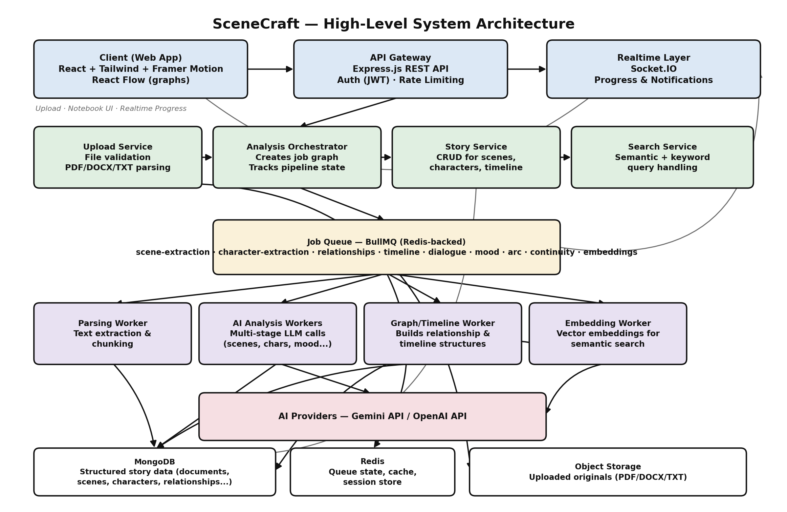
Figure 2 — High-level system architecture.

14.1 Architecture Layers
Layer | Technology | Responsibility
Client | React, Tailwind CSS, Framer Motion, React Flow | Notebook-style UI, upload flow, interactive pages, relationship graph rendering.
API Gateway | Node.js + Express.js | REST endpoints, authentication (JWT), request validation, rate limiting.
Realtime Layer | Socket.IO | Streams job progress, stage completion, and error events to the client.
Orchestration | Node.js service layer | Creates the job graph per document and tracks pipeline state.
Job Queue | BullMQ (Redis-backed) | Queues and schedules each analysis stage; retries failed jobs.
Workers | Node.js worker processes | Execute parsing, AI analysis calls, graph building, and embedding generation.
AI Providers | Gemini API / OpenAI API | Perform the underlying language understanding for each analysis stage.
Data Store | MongoDB | Persists structured story data — documents, scenes, characters, relationships, etc.
Cache / Queue State | Redis | Backs BullMQ, caches frequent reads, stores session/rate-limit data.
Object Storage | Cloud object storage (e.g., S3-compatible) | Stores original uploaded files (PDF/DOCX/TXT).

14.2 Why a Job Queue Instead of a Single Request
A full story analysis involves nine distinct AI passes, several of which depend on the output of earlier stages (for example, the relationship graph needs character profiles first). Running all of this inside a single HTTP request would time out and provide no visibility into progress. Instead:
- The orchestrator creates a job graph per document, with dependent stages queued after their prerequisites complete.
- BullMQ (backed by Redis) manages retries, concurrency limits, and per-stage status.
- Socket.IO pushes stage-level progress events to the client, so the workspace unlocks incrementally — scenes and characters appear before slower stages like continuity checking finish.
- Failed stages can be retried independently without re-running the entire pipeline.

15. Database Schema
SceneCraft uses MongoDB as its primary data store. Story data is naturally nested and variable in shape (a character may have zero or many aliases; a scene may reference any number of characters), which fits MongoDB's document model better than a rigid relational schema. Redis is used only for queue state and caching, not as a system of record.

15.1 users
Registered accounts for writers, editors, and readers using the platform.
Field | Type | Description
_id | ObjectId | Primary key.
name | String | Display name.
email | String | Unique login email.
passwordHash | String | Hashed credential (bcrypt).
plan | String | free | pro | team — feature/usage tier.
createdAt | Date | Account creation timestamp.

15.2 documents
One record per uploaded story, holding metadata and overall processing status.
Field | Type | Description
_id | ObjectId | Primary key.
userId | ObjectId (ref: users) | Owner of the uploaded document.
title | String | Story title, user-editable.
originalFilename | String | Name of the uploaded file.
fileType | String | pdf | docx | txt.
storageUrl | String | Object storage location of the original file.
status | String | uploaded | processing | ready | failed.
wordCount | Number | Total word count of the parsed story.
totalScenes | Number | Count of scenes detected once processing completes.
uploadedAt | Date | Upload timestamp.

15.3 processing_jobs
Tracks each pipeline stage's status for a document, powering the real-time progress UI.
Field | Type | Description
_id | ObjectId | Primary key.
documentId | ObjectId (ref: documents) | Document this job belongs to.
stage | String | parsing | scenes | characters | relationships | timeline | dialogue | mood | arc | continuity | embeddings.
status | String | queued | running | completed | failed.
progress | Number | 0–100 completion percentage for this stage.
dependsOn | String[] | Stage names that must complete before this stage can start.
error | String | Error message if the stage failed.
startedAt / completedAt | Date | Stage timing for diagnostics and analytics.

15.4 scenes
The core narrative unit that most other collections reference.
Field | Type | Description
_id | ObjectId | Primary key.
documentId | ObjectId (ref: documents) | Parent document.
sceneNumber | Number | Sequential order as written.
title | String | Short AI-generated scene title.
summary | String | Two to three sentence scene summary.
location | String | Setting of the scene, if identifiable.
characterIds | ObjectId[] (ref: characters) | Characters present in this scene.
textRange | { start: Number, end: Number } | Offsets into the parsed source text.
wordCount | Number | Length of the scene, used for pacing analysis.

15.5 characters
One record per de-duplicated character, aggregating traits and appearances.
Field | Type | Description
_id | ObjectId | Primary key.
documentId | ObjectId (ref: documents) | Parent document.
name | String | Primary display name.
aliases | String[] | Alternate names/nicknames merged into this record.
role | String | protagonist | antagonist | supporting.
traits | String[] | Short personality/trait tags.
description | String | AI-generated character description.
arcSummary | String | Summary of how the character changes across the story.
sceneIds | ObjectId[] (ref: scenes) | Every scene this character appears in.

15.6 relationships
Pairwise connections between characters, used to render the relationship graph.
Field | Type | Description
_id | ObjectId | Primary key.
documentId | ObjectId (ref: documents) | Parent document.
characterAId / characterBId | ObjectId (ref: characters) | The two characters in this relationship.
type | String | ally | rival | family | romantic | mentor | other.
sentimentScore | Number | -1 to 1, current overall tone of the relationship.
sentimentBySceneId | Map<ObjectId, Number> | Sentiment score tracked per scene, for over-time analysis.
sceneIds | ObjectId[] (ref: scenes) | Scenes where this relationship is evidenced.

15.7 timeline_events
Chronological placement of scenes, separate from their narrative (as-written) order.
Field | Type | Description
_id | ObjectId | Primary key.
documentId | ObjectId (ref: documents) | Parent document.
sceneId | ObjectId (ref: scenes) | Scene this event corresponds to.
chronologicalOrder | Number | Position in the reconstructed chronological sequence.
timeLabel | String | Human-readable time marker (e.g., "Three years earlier").
isFlashback | Boolean | Flags scenes that break linear narrative order.

15.8 dialogue_summaries
Condensed per-character dialogue for each scene.
Field | Type | Description
_id | ObjectId | Primary key.
documentId | ObjectId (ref: documents) | Parent document.
sceneId | ObjectId (ref: scenes) | Scene this summary belongs to.
characterId | ObjectId (ref: characters) | Speaking character.
summaryText | String | One to two sentence condensation of what was said.
keyQuotes | String[] | A small set of the most significant lines.
tone | String | Dominant tone tag for this character's dialogue in the scene.

15.9 mood_analysis
Emotion scoring for each scene.
Field | Type | Description
_id | ObjectId | Primary key.
documentId | ObjectId (ref: documents) | Parent document.
sceneId | ObjectId (ref: scenes) | Scene being scored.
primaryMood | String | Dominant emotion label for the scene.
emotionScores | Map<String, Number> | Scores per emotion category (joy, tension, grief, fear, etc.).
intensity | Number | 0–1 overall emotional intensity.

15.10 story_arcs
Tension scoring across the story, used for the arc visualization.
Field | Type | Description
_id | ObjectId | Primary key.
documentId | ObjectId (ref: documents) | Parent document.
arcPoints | Array<{ sceneId, tensionScore, label }> | Ordered tension values across the story.
climaxSceneId | ObjectId (ref: scenes) | Scene identified as the peak-tension climax.

15.11 continuity_issues
Flagged inconsistencies surfaced by the continuity checker.
Field | Type | Description
_id | ObjectId | Primary key.
documentId | ObjectId (ref: documents) | Parent document.
type | String | attribute-conflict | timeline-conflict | unexplained-gap.
description | String | Plain-language explanation of the flagged issue.
sceneIds | ObjectId[] (ref: scenes) | Scenes involved in the conflict.
severity | String | low | medium | high.
status | String | open | reviewed | dismissed | resolved.

15.12 embeddings
Vector representations powering semantic search, stored alongside a reference to their source record.
Field | Type | Description
_id | ObjectId | Primary key.
documentId | ObjectId (ref: documents) | Parent document.
sourceType | String | scene | character | dialogue_summary.
sourceId | ObjectId | Reference to the originating record.
vector | Number[] | Embedding vector generated by the AI provider.
model | String | Embedding model/version used, for future re-indexing.

15.13 Indexing Strategy
- Compound index on { documentId, sceneNumber } in scenes for fast ordered retrieval.
- Index on { documentId, status } in processing_jobs to power the live progress UI.
- Text index on characters.name and characters.aliases for quick lookup during entity resolution.
- Vector index (Atlas Vector Search or equivalent) on embeddings.vector for semantic search.
- Index on { userId } in documents to list a user's library efficiently.

16. Frontend Experience & UI Flow
The interface is designed to feel like opening a storybook rather than using a conventional AI dashboard: a clean white background, black typography, soft pastel accents, generous whitespace, and subtle paper-inspired visuals throughout.
Page | Experience
Notebook Cover (Upload) | The upload area is styled as a closed notebook cover; dropping a file feels like placing a manuscript on a desk.
Loading Sequence | An animated sequence of books stacking communicates progress while background jobs run.
Page-Flip Transition | A page-flipping animation (Framer Motion) carries the user from upload into the analysis workspace.
Overview Page | Story-level summary: total scenes, characters, mood snapshot, and pipeline completion status.
Characters Page | Card-based character profiles with traits, role, arc summary, and appearance timeline.
Relationship Graph Page | Interactive React Flow node-link diagram with filters by relationship type and sentiment.
Timeline Page | Horizontal scrubbable timeline with a toggle between narrative order and chronological order.
Scenes Explorer | Scene-by-scene browsing with summaries, mood colour tags, and dialogue highlights.
Story Arc Page | Tension curve chart with climax detection and optional structure overlays.
Search | A single search bar for natural-language, source-linked semantic search across the whole story.

17. Technology Stack
Layer | Technology | Why
Frontend | React | Component-driven UI well suited to many interactive, data-heavy pages.
Styling | Tailwind CSS | Rapid, consistent implementation of the minimal notebook-inspired design system.
Animation | Framer Motion | Smooth page-flip transitions and the book-stacking loading sequence.
Graph Visualization | React Flow | Purpose-built for interactive node-link diagrams like the relationship graph.
Backend Runtime | Node.js | Shared JavaScript across frontend/backend and a strong async ecosystem for I/O-heavy workloads.
API Framework | Express.js | Lightweight, well-understood REST framework for the API gateway.
Database | MongoDB | Flexible document model fits the nested, variable-shape structure of story data.
Cache / Queue Backing | Redis | In-memory store backing BullMQ and caching frequent reads.
Job Queue | BullMQ | Reliable background job processing with retries, concurrency control, and dependency handling.
Realtime Updates | Socket.IO | Bi-directional events to stream pipeline progress to the client.
AI Analysis | Gemini API / OpenAI API | Powers the nine analysis stages — scene, character, mood, and more.

18. Implementation Roadmap
A phased build lets each layer of the system be demoed independently — useful both for maintaining momentum and for showing incremental progress in a portfolio.
Phase | Focus | Key Deliverables
Phase 1 | Foundations | File upload, parsing (PDF/DOCX/TXT), MongoDB schema, basic auth.
Phase 2 | Core AI Pipeline | Scene breakdown, character profiles, BullMQ job orchestration, Socket.IO progress events.
Phase 3 | Deeper Analysis | Relationship graph, timeline, dialogue summaries, mood & emotion scoring.
Phase 4 | Visualization & UX | Notebook-inspired frontend, page-flip transitions, React Flow relationship graph, story arc chart.
Phase 5 | Advanced Features | Continuity checker, embeddings, and semantic search.
Phase 6 | Polish & Deploy | Performance tuning, error handling, responsive design, deployment, and portfolio write-up.

19. Why This Project Stands Out

19.1 Comparison
Comparison | Typical AI Portfolio Project | SceneCraft
AI Usage | One prompt, one response. | Nine coordinated analysis stages with dependencies.
Data Model | Often stateless or minimally stored. | Rich, cross-referenced schema across twelve collections.
Processing | Synchronous request/response. | Background job queue with real-time progress streaming.
UX | Generic chat or dashboard layout. | Custom notebook-inspired, animated interface.
Depth | Summarizes text. | Builds an explorable, searchable structured workspace.

19.2 Skills Demonstrated
- Multi-stage AI orchestration with dependency-aware background jobs (BullMQ).
- Real-time systems design using Socket.IO for live progress updates.
- Thoughtful NoSQL data modeling for nested, variable-shape narrative data.
- Interactive data visualization — node-link graphs, timelines, and tension curves.
- Semantic search using vector embeddings and similarity retrieval.
- Polished, distinctive frontend design and motion work, not a generic template.

Every Story Deserves More Than a Summary.

