- Here I adedd two links of portfolio and github but it showing portfolio links and https only it is not able to recognize which link it is so keep it proper first keep separate inputs to put separate links 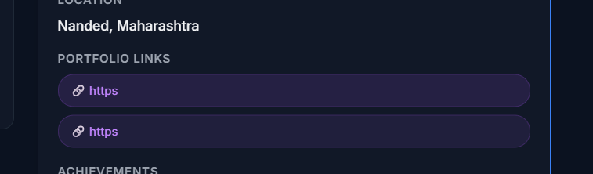
- Here not able to check whether msg is sent what’s going on exactly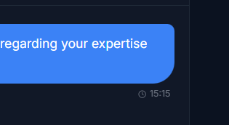
- Here first keep msg for request mentorship, then a template to ask as it is now and for nexr chat keep message option only for second time chat with same person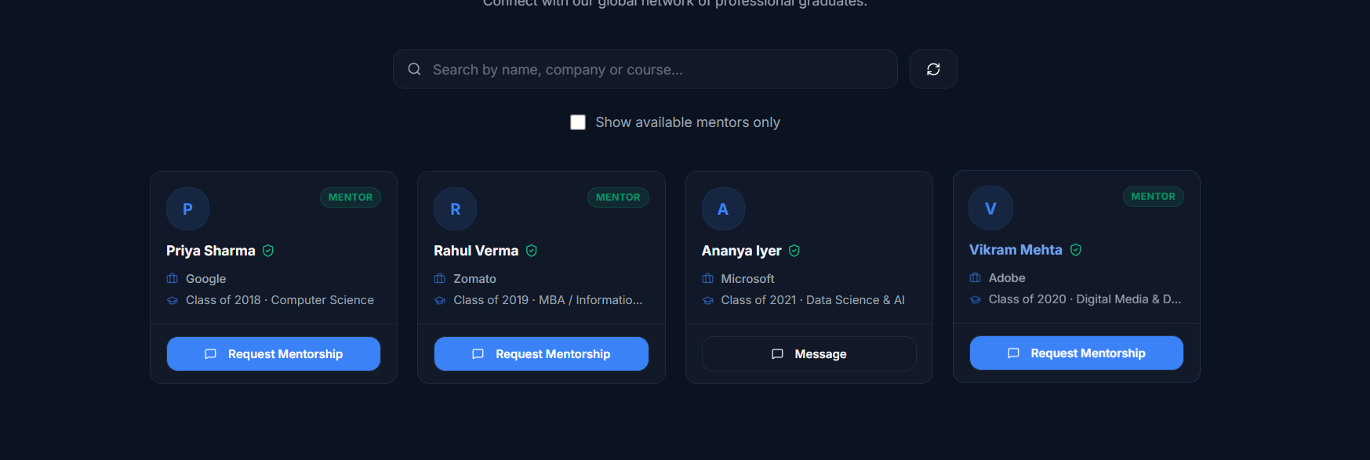
- Here just keep the option of events only not register, etc. because all events make offline and it should delete automatically after the events done on that particular day within 1, 2 days no need to keep everytime
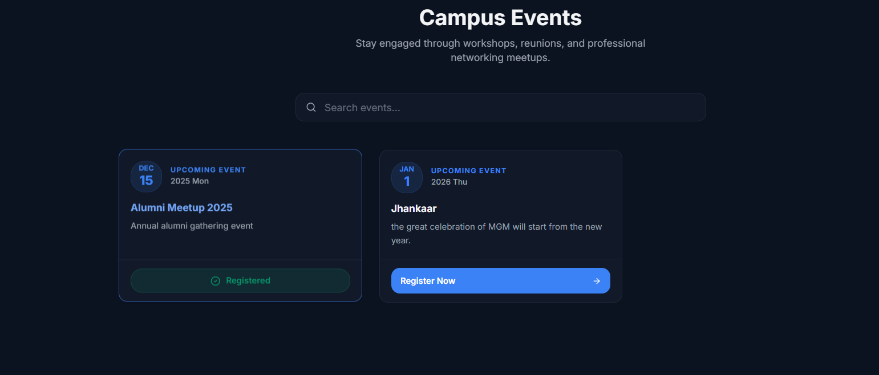
- It is requiring time to load images from database