**Data analysis on Social Media Addiction**

Social Media Addiction data includes Students data showing records of students and their social media usage habits, along with details like academic performance, sleep, mental health, and addiction score

* Column Descriptions

1. Student_ID:- Unique identifier assigned to each student.

2. Age:- Age of the student (in years).

3. Gender:- Gender identity of the student.

4. Academic_Level:- Current academic level of the student.

5. Country:- Country of residence or study.

6. Avg_Daily_Usage_Hours:- Average number of hours the student spends on social media daily.

7. Most_Used_Platform:- The social media platform the student uses most frequently.

8. Affects_Academic_Performance:- Whether the student believes social media affects their academic performance.

9. Sleep_Hours_Per_Night:- Average number of hours the student sleeps per night.

10. Mental_Health_Score:- Self-assessed mental health rating from 1- 10

11. Relationship_Status:- Current relationship status of the student.

12. Conflicts_Over_Social_Media:- Number of social media-related conflicts (e.g., with friends, family, or partners).

13. Addicted_Score:- A score indicating the student's level of social media addiction ranging from 0 to 10

Analysis on Given data using SQL

1. select * from social_media;

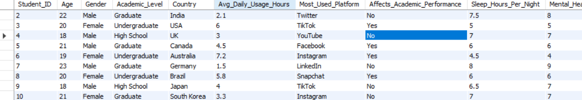

1. select student id which are females

select Student_ID as female_Id from social_media

where Gender = 'Female';

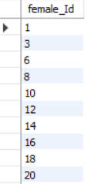

1. select student id which are males

select Student_ID as male_Id from social_media

where Gender = 'male';

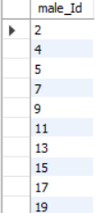

1. select count of undergraduate graduate and high school

SELECT Academic_Level, COUNT(*) AS Count

FROM social_media

GROUP BY Academic_Level;

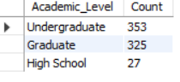

1. sum daily avg hours by gender

select Gender, sum(Avg_Daily_Usage_Hours) as Daily_Hours_use

FROM social_media

GROUP BY Gender;

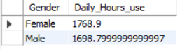

1. sum of avg hours by platform

select Most_Used_Platform, sum(Avg_Daily_Usage_Hours) as Daily_Hours_use

FROM social_media

GROUP BY Most_Used_Platform;

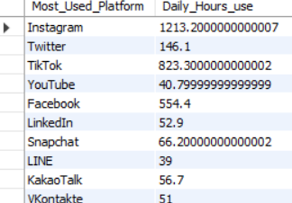

1. select platform with is maximum addicted score

select Most_Used_Platform, Max(Addicted_Score)

FROM social_media

GROUP BY Most_Used_Platform;

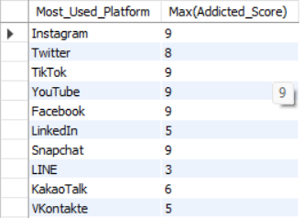

1. avg of mental health by gender

select Gender, avg(Mental_Health_Score)

from social_media

group by Gender;



1. sum addicted score by gender

select Gender, sum(Addicted_Score)

from social_media

group by Gender;



1. Select Student having addicted score is greater than equal to 5

select Student_ID, Addicted_Score

from social_media

where Addicted_Score >= 5;

