AMITY SCHOOL OF ENGINEERING AND TECHNOLOGY
(Amity University Punjab) MOHALI, PUNJAB


Computer Networks (CSE 310)
Department of Computer Science and Engineering

Submitted By: Submitted To:
Samiksha Walia Dr. Himanshu Verma Enrollment. No.: A25305222069
B.Tech CSE (6th Semester)

INDEX

S.No | Topic | Date of Experiment | Date of Submission | Page No. | Remarks
1. | Implementation of Stop and Wait Protocol and Sliding Window Protocol. | 23/01/2025 | 30/01/2025 | 4
2. | Study of Socket Programming and Client – Server model | 30/01/2025 | 06/02/2025 | 12
3. | Write a code simulating ARP  /RARP protocols. | 06/02/2025 | 13/02/2025 | 17
4. | Write a code simulating PING and TRACEROUTE commands | 13/02/2025 | 20/02/2025 | 21
5. | Create a socket for HTTP for web page upload and download. | 20/02/2025 | 06/03/2025 | 26
6. | Write a program to implement RPC (Remote Procedure Call) | 06/03/2025 | 13/03/2025 | 30
7. | Implementation of Subnetting . | 13/03/2025 | 27/03/2025 | 36
8. | Applications using TCP Sockets like  Echo client and echo server, Chat, File Transfer | 27/03/2025 | 03/04/2025 | 40
9. | Applications using TCP and UDP Sockets like DNS, SNMP, File Transfer | 03/04/2025 | 10/04/2025 | 41
10. | Study of Network simulator (NS).and Simulation of Congestion Control Algorithms using NS | 10/04/2025 | 17/04/2025 | 42
11. | Perform a case study about the different routing algorithms to select the network path with its optimum and economical during data transfer. i. Link State routing  ii. Flooding iii. Distance vector | 17/04/2025 | 24/04/2025 | 43
12. | To learn handling and configuration of networking hardware like RJ-45 connector, CAT-6 cable, crimping tool, etc. | 24/04/2025 | 31/04/2025 | 46

13. | Configuration of router, hub, switch etc. (using real devices or simulators) | 31/04/2025 | 08/05/2025 | 48
14. | Running and using services/commands like ping, traceroute, nslookup, arp, telnet, ftp, etc. | 08/05/2025 | 15/05/2025 | 50
15. | Network packet analysis using tools like Wireshark, tcpdump, etc. | 15/05/2025 | 22/05/2025 | 52

- Implementation of Stop and Wait Protocol and Sliding Window Protocol.

CODE:

# Stop and Wait Protocol Simulation import time
import random

def sender():
frames = ['A', 'B', 'C', 'D']
for frame in frames:
print(f"Sender: Sending frame '{frame}'") time.sleep(1)

ack = receiver(frame) if ack:
print(f"Sender: Acknowledgment for frame '{frame}' received\n") else:
print(f"Sender: No ACK received. Resending frame '{frame}'\n") time.sleep(1)
ack = receiver(frame)

def receiver(frame):
if random.choice([True, False]):
print(f"Receiver: Frame '{frame}' received successfully") return True
else:
print(f"Receiver: Frame '{frame}' lost or damaged") return False

sender()
# Sliding Window Protocol Simulation
def sliding_window(frames, window_size): i = 0
while i < len(frames):
print(f"Sender: Sending window frames {frames[i:i+window_size]}") for j in range(i, min(i + window_size, len(frames))):
print(f"Receiver: Frame '{frames[j]}' received") i += window_size
print("Acknowledgment sent for current window\n")

frames = ['F1', 'F2', 'F3', 'F4', 'F5', 'F6', 'F7']
window_size = 3 sliding_window(frames, window_size)

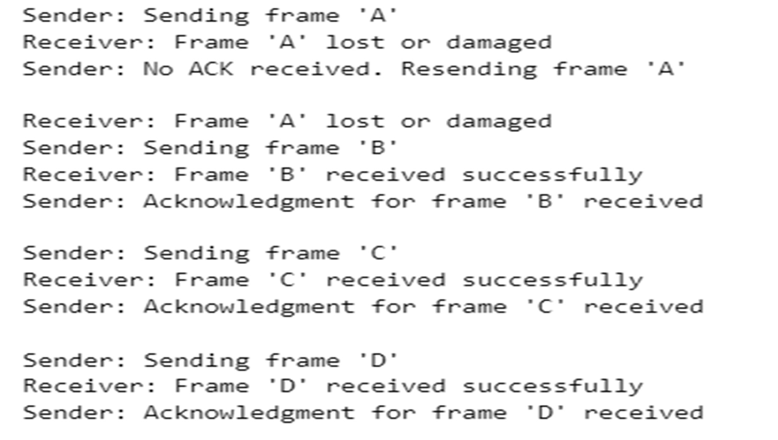
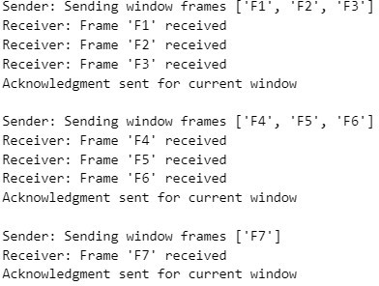
OUTPUT:

- Study of Socket Programming and Client – Server model.

CODE:
Server:

import socket
server_socket = socket.socket(socket.AF_INET, socket.SOCK_STREAM) server_socket.bind(('localhost', 12345))
server_socket.listen(1)
print("Server is listening on port 12345...")
conn, addr = server_socket.accept() print(f"Connected by {addr}")

data = conn.recv(1024).decode() print(f"Received from client: {data}") conn.send("Hello from server!".encode())

conn.close() server_socket.close()

Client:

import socket

client_socket = socket.socket(socket.AF_INET, socket.SOCK_STREAM) client_socket.connect(('localhost', 12345))

client_socket.send("Hello from client!".encode()) data = client_socket.recv(1024).decode() print(f"Received from server: {data}")

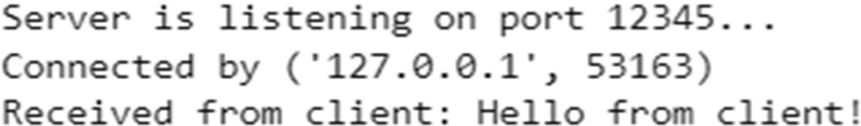
client_socket.close() OUTPUT:

- Write a code simulating ARP /RARP protocols.

CODE:
# ARP and RARP Simulation arp_table = {
"192.168.1.1": "00:0a:95:9d:68:16",
"192.168.1.2": "00:0a:95:9d:68:17",
"192.168.1.3": "00:0a:95:9d:68:18"
}

def arp(ip):
if ip in arp_table:
print(f"ARP Reply: MAC address of {ip} is {arp_table[ip]}") else:
print("ARP Reply: IP address not found.")

def rarp(mac): found = False
for ip, mac_addr in arp_table.items(): if mac_addr == mac:
print(f"RARP Reply: IP address of {mac} is {ip}") found = True
break if not found:
print("RARP Reply: MAC address not found.")
# Test the simulation print("Simulating ARP request...") arp("192.168.1.2")
print("\nSimulating RARP request...") rarp("00:0a:95:9d:68:18")

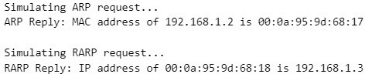
OUTPUT:

- Write a code simulating PING and TRACEROUTE commands.

CODE:

# PING Simulation using system command import os
hostname = "google.com" # Replace with any hostname or IP
response = os.system(f"ping -n 4 {hostname}" if os.name == 'nt' else f"ping -c 4
{hostname}")
if response == 0: print(f"{hostname} is reachable.")
else:
print(f"{hostname} is not reachable.")

# TRACEROUTE Simulation using system command import os

hostname = "google.com"
command = "tracert" if os.name == 'nt' else "traceroute" os.system(f"{command} {hostname}")

OUTPUT:

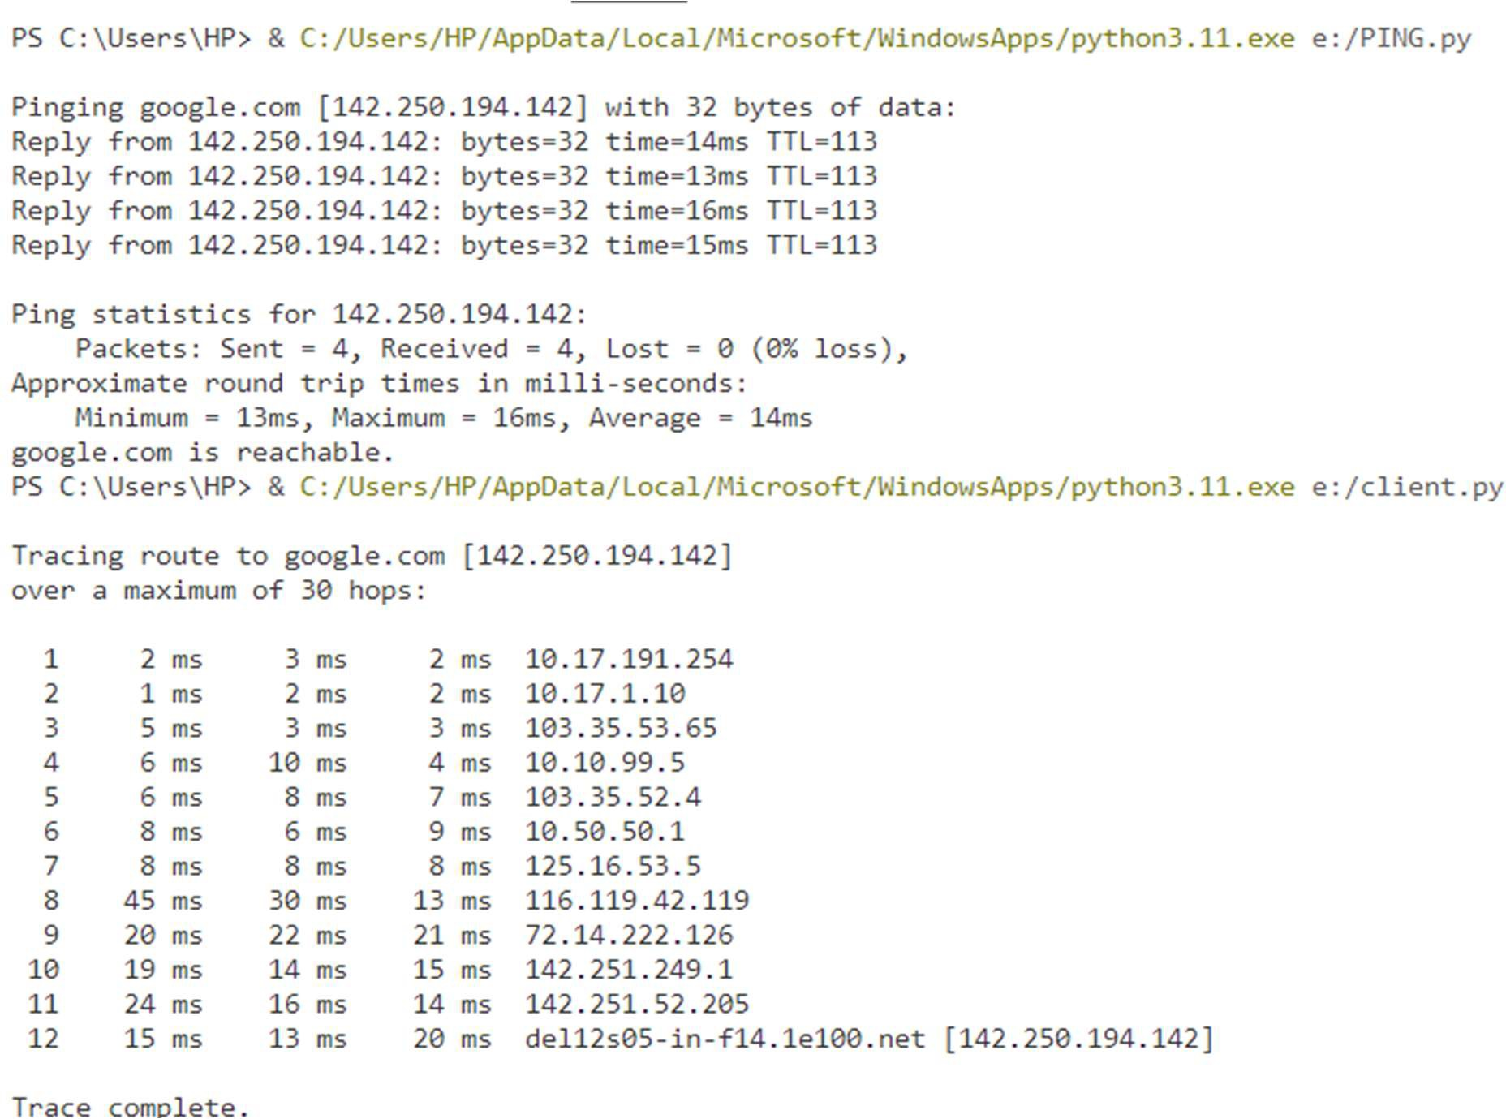

- Create a socket for HTTP for web page upload and download.

CODE:

HTTP GET Client:
import socket
host = "example.com" port = 80
request = f"GET / HTTP/1.1\r\nHost: {host}\r\nConnection: close\r\n\r\n"
client_socket = socket.socket(socket.AF_INET, socket.SOCK_STREAM) client_socket.connect((host, port))
client_socket.send(request.encode())

response = b"" while True:
part = client_socket.recv(1024) if not part:
break response += part

client_socket.close()
print(response.decode(errors='ignore')) # Prints HTML of example.com

HTTP POST Client:

import socket

host = "httpbin.org" port = 80
data = "name=student&project=networking" content_length = len(data)

request = f"""POST /post HTTP/1.1\r Host: {host}\r
Content-Type: application/x-www-form-urlencoded\r Content-Length: {content_length}\r
Connection: close\r\n\r
{data}"""

client_socket = socket.socket(socket.AF_INET, socket.SOCK_STREAM) client_socket.connect((host, port))
client_socket.send(request.encode()) response = b""

while True:
part = client_socket.recv(1024) if not part:
break response += part

client_socket.close() print(response.decode(errors='ignore'))

OUTPUT:
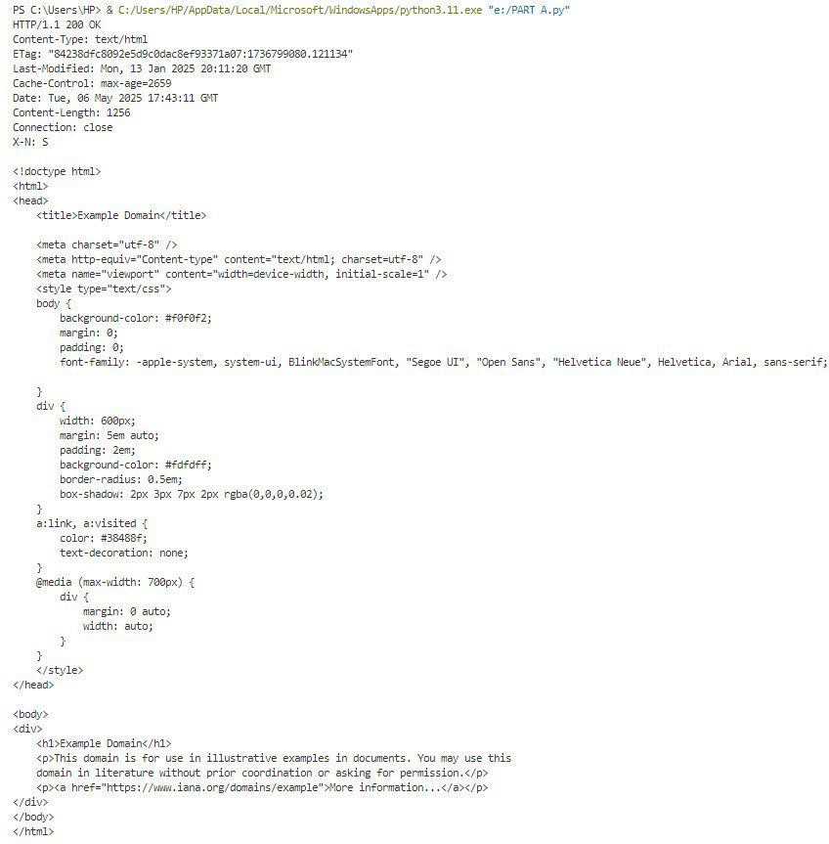


PS C: \Users\HP> .& C: /Users/HP/ AppData/local/Mic:rosoft/\.IindowsApps/p1'1:hon3.11. exe "e: /PART B.py" HTTP /L 1 200 OK
Date: Tue, 06 May 2025 17:44:00 a: T
Content-Type: application/json Content- ength: 403 Connection: close
Server: gunicorn/19.9.0 Access-Control-Allow-Origin:: *
Access-Control-Allow-Credentials: true

{
"args": {},

" iles":: {L
11·fonm 1: {
"name": "student"J
"project": "nebmrking"
L
"headers": {
"Content- ength": "31",
"Content- Type": "application/x- uiw-form- urlencoded" ,. "Host":: "httpbin.. org",
"X-Amzn- Trace-Id":: "Root=l-681a4a5f-44bd9121331cd5337cd59adl"
},
"json": nullJ.
"origin": "103.35.. 53. 67"J
"url" .: "http.: / /httpbin. org/pos.t"
}

- Write a program to implement RPC (Remote Procedure Call)

CODE;

RPC_SERVER:
from xmlrpc.server import SimpleXMLRPCServer def add(x, y):
return x + y
def subtract(x, y): return x - y
server = SimpleXMLRPCServer(("localhost", 8000)) print("RPC Server listening on port 8000...")
server.register_function(add, "add") server.register_function(subtract, "subtract")

server.serve_forever()

RPC_CLIENT:

import xmlrpc.client
proxy = xmlrpc.client.ServerProxy("http://localhost:8000/") print("Calling add(5, 3):", proxy.add(5, 3))
print("Calling subtract(10, 4):", proxy.subtract(10, 4))

OUTPUT:
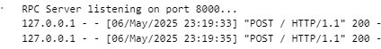
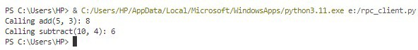

- Implementation of Subnetting .

CODE:

import ipaddress
def subnet_details(ip_with_subnet):
network = ipaddress.ip_network(ip_with_subnet, strict=False)
print(f"IP Network: {network}")
print(f"Network Address: {network.network_address}") print(f"Broadcast Address: {network.broadcast_address}") print(f"Total Hosts: {network.num_addresses}") print(f"Valid Hosts: {network.num_addresses - 2}") print(f"First Host: {list(network.hosts())[0]}")
print(f"Last Host: {list(network.hosts())[-1]}")

# Example: IP + Subnet subnet_details('192.168.1.10/27')

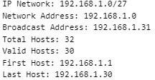
OUTPUT:

- Applications using TCP Sockets like
  - Echo client and echo server
  - Chat
  - File Transfer
CODE:

Echo Server and Client (Message sent by client is echoed back by server)

SERVER(ECHO_SERVER.PY):

import socket

server_socket = socket.socket(socket.AF_INET, socket.SOCK_STREAM) server_socket.bind(('localhost', 5000))
server_socket.listen(1) print("Echo Server is running...")
conn, addr = server_socket.accept() print(f"Connected by {addr}")
while True:
data = conn.recv(1024) if not data:
break
conn.sendall(data) # Echo back conn.close()
CLIENT (ECHO_CLIENT.PY)

import socket

client_socket = socket.socket(socket.AF_INET, socket.SOCK_STREAM) client_socket.connect(('localhost', 5000))

msg = input("Enter message: ") client_socket.sendall(msg.encode())

data = client_socket.recv(1024) print("Echoed from server:", data.decode())

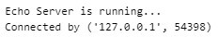
client_socket.close() OUTPUT:

Chat using TCP Sockets (basic 1-to-1 message exchange)

CHAT_SERVER

import socket

server = socket.socket() server.bind(('localhost', 6000)) server.listen(1)
print("Chat server started...")

conn, addr = server.accept() print(f"Connected to {addr}")

while True:
msg = conn.recv(1024).decode() if msg.lower() == 'bye':
break print("Client:", msg) reply = input("You: ")
conn.send(reply.encode()) conn.close()
CHAT_CLIENT
import socket
client = socket.socket() client.connect(('localhost', 6000))

while True:
msg = input("You: ") client.send(msg.encode()) if msg.lower() == 'bye':
break
reply = client.recv(1024).decode() print("Server:", reply)

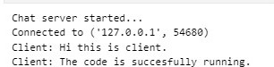
client.close() OUTPUT:

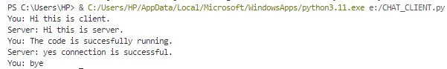

File Transfer (Send a text file from client to server)

SERVER (FILE_SERVER.PY)

import socket

server = socket.socket() server.bind(('localhost', 7000)) server.listen(1)
print("File server ready...")

conn, addr = server.accept() print("Connected by", addr)

with open("received.txt", "wb") as f: while True:
data = conn.recv(1024) if not data:
break f.write(data)

print("File received.") conn.close()
CLIENT (FILE_CLIENT.PY)
import socket
client = socket.socket() client.connect(('localhost', 7000))
with open("send.txt", "rb") as f: data = f.read(1024)
while data: client.send(data) data = f.read(1024)

print("File sent.") client.close()

OUTPUT:
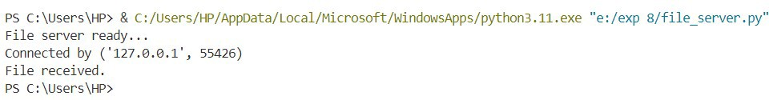

- Applications using TCP and UDP Sockets like:
  - DNS
  - SNMP
  - File Transfer
CODE:

DNS

SERVER:

import socket

server_socket = socket.socket(socket.AF_INET, socket.SOCK_DGRAM) server_socket.bind(('localhost', 8050))
print("DNS Server is ready...")

while True:
domain, addr = server_socket.recvfrom(1024) domain = domain.decode()
try:
ip = socket.gethostbyname(domain) server_socket.sendto(ip.encode(), addr)
except socket.gaierror:
server_socket.sendto("Invalid domain".encode(), addr)

CLIENT:

import socket

client_socket = socket.socket(socket.AF_INET, socket.SOCK_DGRAM)

domain = input("Enter domain to resolve: ") client_socket.sendto(domain.encode(), ('localhost', 8050)) ip, _ = client_socket.recvfrom(1024)
print("Resolved IP:", ip.decode()) client_socket.close()
OUTPUT:

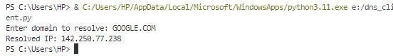

SNMP:

SERVER:

import socket import platform import os

data_store = {
"hostname": platform.node(),
"os": platform.system() + " " + platform.release(), "cwd": os.getcwd()
}

server_socket = socket.socket(socket.AF_INET, socket.SOCK_DGRAM) server_socket.bind(('localhost', 8060))
print("SNMP Server is running...")

while True:
request, addr = server_socket.recvfrom(1024) key = request.decode()
print(f"Received request for: {key}")
response = data_store.get(key, "Key not found") server_socket.sendto(response.encode(), addr)

CLIENT:
import socket

client_socket = socket.socket(socket.AF_INET, socket.SOCK_DGRAM)

key = input("Enter info key (hostname / os / cwd): ") client_socket.sendto(key.encode(), ('localhost', 8060)) response, _ = client_socket.recvfrom(1024) print("Response from server:", response.decode())

client_socket.close()

OUTPUT:
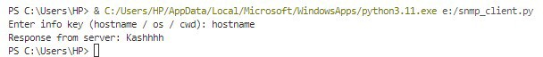

FILE TRANSFER:

SERVER:
import socket
server_socket = socket.socket(socket.AF_INET, socket.SOCK_DGRAM) server_socket.bind(('localhost', 8070))
print("UDP File Server is ready...")
with open("received_file.txt", "wb") as f: while True:
data, addr = server_socket.recvfrom(1024) if data == b'EOF':
print("File transfer complete.") break
f.write(data)

CLIENT:

import socket import os

print("Current Directory:", os.getcwd())
client_socket = socket.socket(socket.AF_INET, socket.SOCK_DGRAM) # Change this path if needed
filename = "E:/exp 8/text_sent.txt"

if not os.path.exists(filename): print("text_sent.txt not found!")
else:
with open(filename, "rb") as f: data = f.read(1024)
while data:
client_socket.sendto(data, ('localhost', 8070))

data = f.read(1024)

# Send EOF to indicate file is done client_socket.sendto(b'EOF', ('localhost', 8070)) print("File sent successfully.")

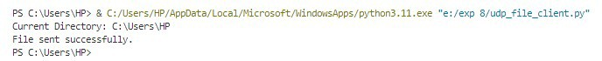
client_socket.close() OUTPUT:

- Study of Network simulator (NS).and Simulation of Congestion Control Algorithms using NS.

CODE:

import random
import matplotlib.pyplot as plt

# Initialize parameters time_limit = 50
cwnd = 1
ssthresh = 16 cwnd_log = []

for time in range(time_limit): cwnd_log.append((time, cwnd))

if cwnd < ssthresh:
cwnd *= 2 # Slow start else:
cwnd += 1 # Congestion avoidance

# Simulate random packet loss (10% chance) if random.random() < 0.1:
print(f"[Time {time}] Packet loss detected. Reducing cwnd.") ssthresh = cwnd // 2
cwnd = 1 # In Reno, we would go to ssthresh and enter fast recovery, but this is simplified

# Plotting the result
times, cwnds = zip(*cwnd_log)
plt.plot(times, cwnds, marker='o', linestyle='-', color='blue') plt.title('TCP Reno Congestion Control Simulation') plt.xlabel('Time')
plt.ylabel('Congestion Window (cwnd)') plt.grid(True)
plt.show()

OUPUT:
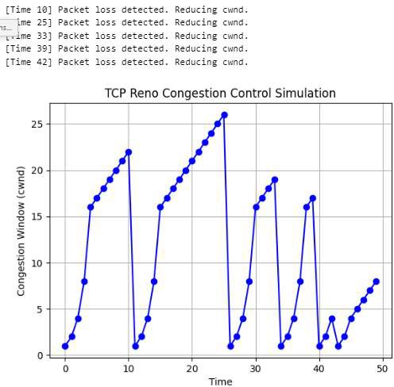

- Perform a case study about the different routing algorithms to select the network path with its optimum and economical during data transfer.
  - Link State routing
  - Flooding
  - Distance vector

CODE:

import heapq
from collections import defaultdict, deque

# Sample Graph graph = {
'A': {'B': 1, 'C': 4},
'B': {'A': 1, 'C': 2, 'D': 5},
'C': {'A': 4, 'B': 2, 'D': 1},
'D': {'B': 5, 'C': 1}
}
# ---------- 1. Link State Routing (Dijkstra) ---------- def dijkstra(graph, start):
queue = [(0, start)]
distances = {node: float('inf') for node in graph} distances[start] = 0

while queue:
current_dist, current_node = heapq.heappop(queue) for neighbor, weight in graph[current_node].items():
distance = current_dist + weight if distance < distances[neighbor]:
distances[neighbor] = distance heapq.heappush(queue, (distance, neighbor))
return distances

# ---------- 2. Flooding (Simplified Simulation) ---------- def flooding(graph, start):
visited = set() packets_sent = []

def flood(node, source): if node in visited:
return visited.add(node)
packets_sent.append((source, node)) for neighbor in graph[node]:
if neighbor != source: flood(neighbor, node)

flood(start, None) return packets_sent

# ---------- 3. Distance Vector (Bellman-Ford) ---------- def bellman_ford(graph, start):
distances = {node: float('inf') for node in graph} distances[start] = 0

for _ in range(len(graph) - 1): for u in graph:
for v, weight in graph[u].items():
if distances[u] + weight < distances[v]: distances[v] = distances[u] + weight
return distances

# RUN ALL
print("=== 1. Link State Routing (Dijkstra's) ===") dijkstra_result = dijkstra(graph, 'A')
for node in sorted(dijkstra_result):
print(f"Shortest distance from A to {node}: {dijkstra_result[node]}")

print("\n=== 2. Flooding Simulation ===") flooding_result = flooding(graph, 'A')
for src, dst in flooding_result: print(f"Packet sent from {src} to {dst}")

print("\n=== 3. Distance Vector (Bellman-Ford) ===") bellman_result = bellman_ford(graph, 'A')
for node in sorted(bellman_result):
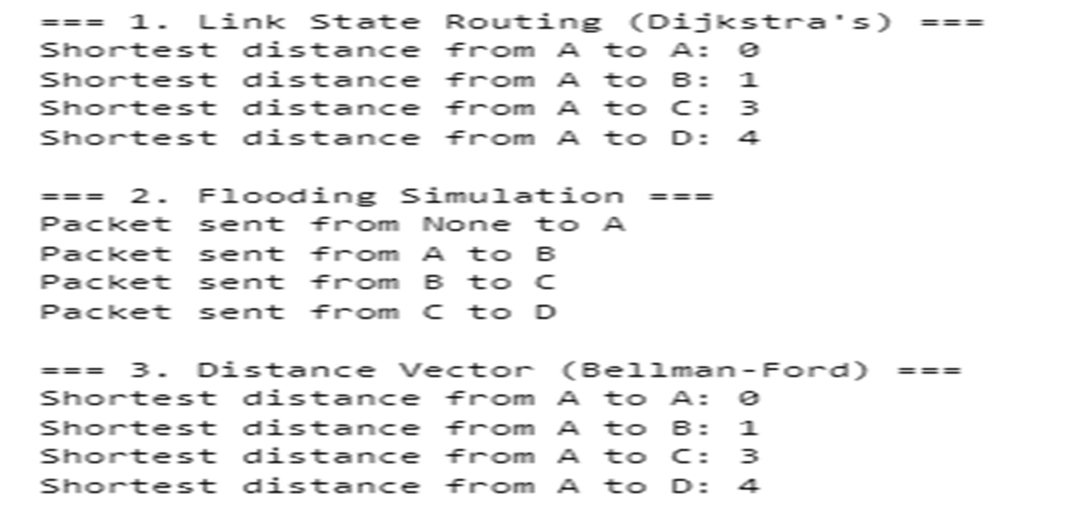
print(f"Shortest distance from A to {node}: {bellman_result[node]}") OUTPUT:

- To learn handling and configuration of networking hardware like RJ- 45 connector, CAT-6 cable, crimping tool, etc.

OBJECTIVE:
To understand and demonstrate the handling and configuration of essential networking components like RJ-45 connectors, CAT-6 cables, and the crimping tool used in creating physical network connections.

REQUIRED TOOLS:
- CAT-6 Ethernet cable
- RJ-45 connectors
- Crimping tool
- Wire stripper
- Cable tester

PROCEDURE:
  - Cut the CAT-6 cable to the desired length.
  - Strip approximately 1 inch of the cable jacket.
  - Untwist and straighten all 8 wires.
  - Arrange the wires according to the T568B standard:
White-Orange, Orange, White-Green, Blue, White-Blue, Green, White-Brown, Brown
  - Trim the wires evenly to about 0.5 inch.
  - Insert the wires into the RJ-45 connector.
  - Use the crimping tool to secure the connector.
  - Repeat for the second end of the cable.
  - Test the cable using a cable tester.

EXPECTED OUTPUT:
- A working Ethernet cable that passes signal continuity and pin integrity tests.
- Cable tester shows all 8 LEDs lighting up sequentially.

WHERE TO PERFORM:
- Networking lab with access to physical tools.
- Simulation using video tutorials or virtual labs.

- Configuration of router, hub, switch etc. (using real devices or simulators)

OBJECTIVE:
To configure routers, switches, and hubs to set up a basic network, assign IPs, and enable communication between devices.

TOOLS REQUIRED:
- Cisco Packet Tracer (for simulation) or physical Cisco routers and switches
- PCs/Laptops for testing
- Ethernet cables (real)
- Console cable (for CLI access to devices)

PROCEDURE:

ROUTER CONFIGURATION:
- Connect to the router using console access.
- Assign IP addresses to interfaces:
Router> enable
Router# configure terminal Router(config)# interface g0/0
Router(config-if)# ip address 192.168.1.1 255.255.255.0 Router(config-if)# no shutdown

SWITCH CONFIGURATION:
- Configure VLANs and access ports:
Switch> enable
Switch# configure terminal Switch(config)# vlan 10 Switch(config-vlan)# name STAFF Switch(config)# interface fa0/1
Switch(config-if)# switchport mode access Switch(config-if)# switchport access vlan 10

HUB CONFIGURATION:
  - Hubs are not configurable.
  - Just plug in cables to broadcast traffic to all ports.

EXPECTED OUTPUT:
  - PC connected to router via switch can successfully ping another PC.
  - Proper VLAN assignment and port settings on switch.
  - Devices are reachable across the network.

WHERE TO PERFORM:
  - Cisco Packet Tracer for simulation.
  - Networking lab for hands-on practice.

- Running and using services/commands like ping, traceroute, nslookup, arp, etc.

CODE:

- ping google.com

OUTPUT:
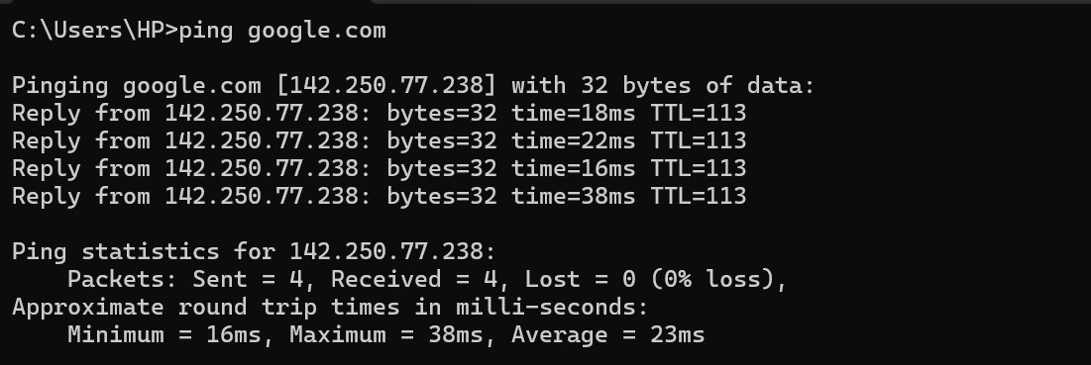
- tracert google.com # Windows traceroute google.com # Linux/macOS

OUTPUT:
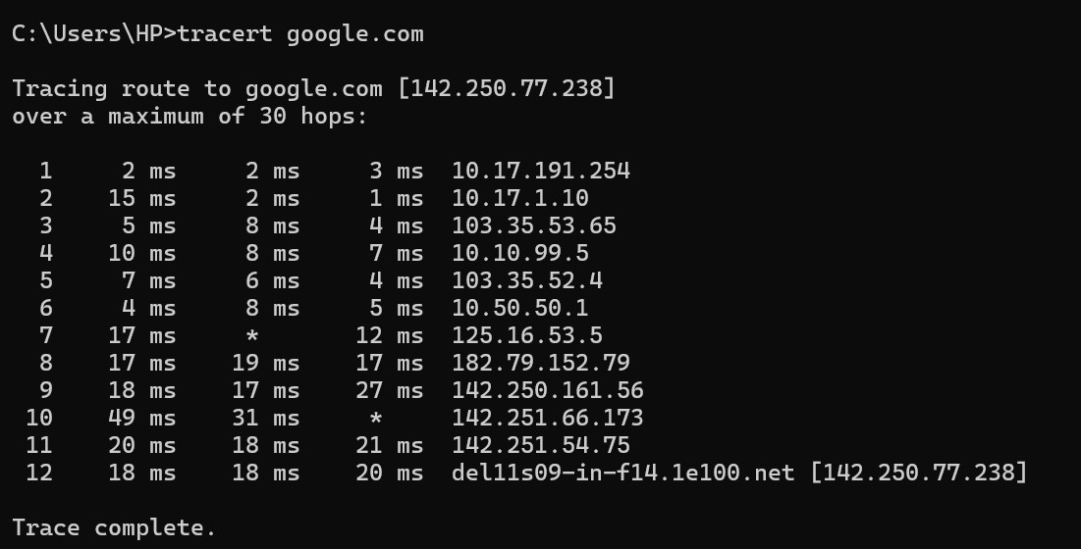

- nslookup google.com

OUTPUT:

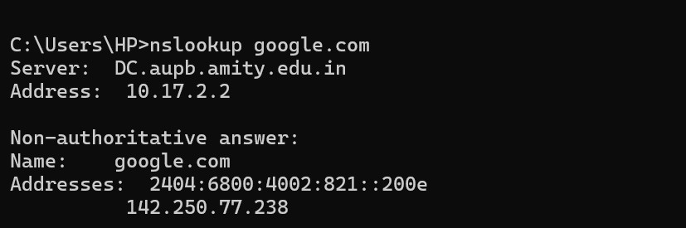

- arp -a

OUTPUT:
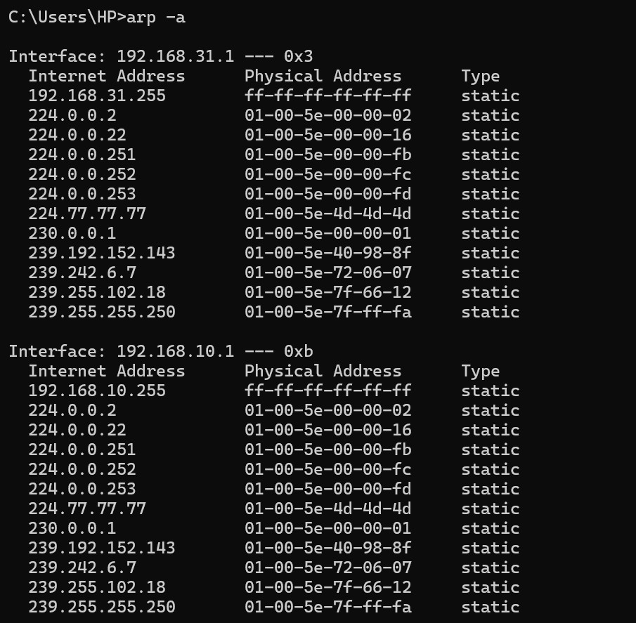
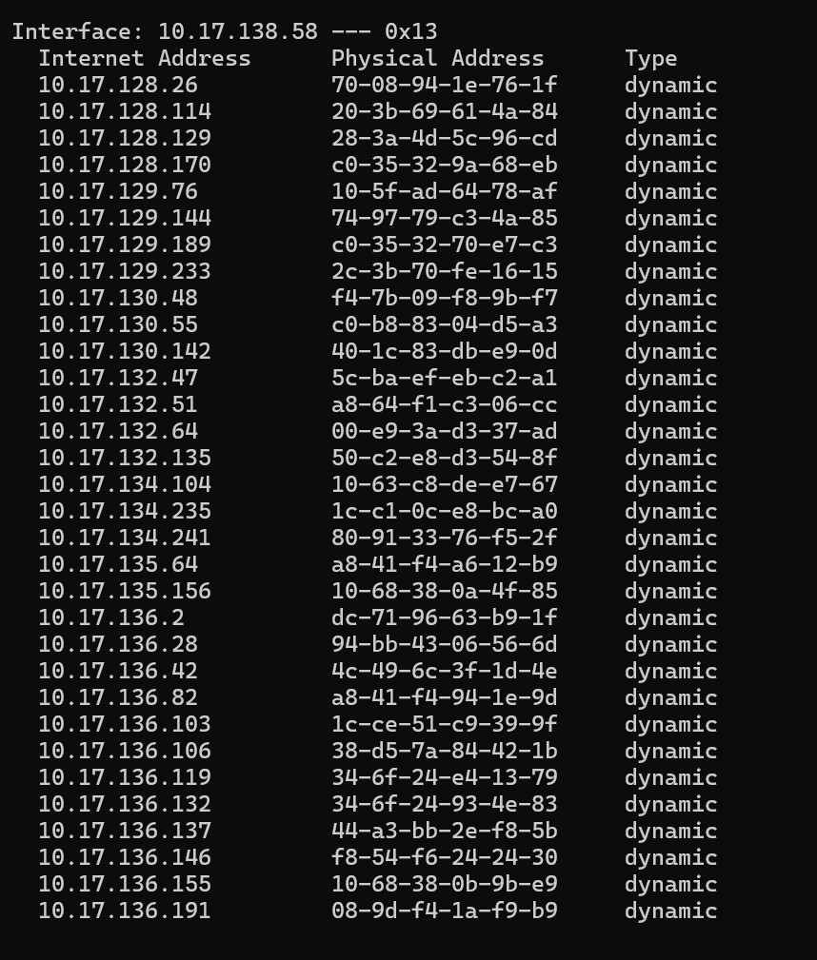

- Network packet analysis using tools like Wireshark, tcpdump, etc.

OBJECTIVE:
To analyze network packets using packet capturing tools like Wireshark or tcpdump and understand network protocols, headers, and communication patterns.

TOOLS REQUIRED:
- Wireshark (GUI-based) or tcpdump (CLI-based)
- Live internet or LAN connection
- Administrative privileges

PROCEDURE (WIRESHARK):
- Open Wireshark and select the active network interface (e.g., Ethernet, Wi-Fi).
- Click Start Capture.
- Perform network activity (e.g., open a webpage, ping a site).
- Stop the capture after a few seconds.
- Use filters like:
  - icmp to see ping traffic
  - http or tcp.port == 80 for web traffic
  - ip.addr == 192.168.1.1 to filter by IP
- Inspect the packet details including source, destination, protocol, headers, and payload.

PROCEDURE (TCPDUMP):
sudo tcpdump -i eth0

  - Captures packets in real-time on interface eth0.

EXPECTED OUTPUT:
  - List of packets with details like source/destination IP, ports, and protocol.
  - Deep packet inspection reveals protocol headers and flags.

WHERE TO PERFORM:
  - Wireshark: Windows/Linux/Mac with GUI
  - tcpdump: Linux/macOS terminal with root access
  - Ideal for systems with internet or local network access.

