SHOPNEST SALES ANALYTICS DASHBOARD
Power BI Capstone Project Report
Submitted By: Samiksha

Project Overview
The ShopNest Sales Analytics Dashboard was developed using Power BI to analyze and visualize key business metrics from the ShopNest e-commerce dataset. The dashboard covers sales performance, revenue trends, product ratings, payment methods, delivery performance and customer purchasing patterns.
Interactive visualizations and slicers allow the data to be explored by Customer State, Year and Product Category. Drillthrough is also used for detailed delivery analysis.

Tools Used
Power BI Desktop | Data Modeling
DAX Measures | Data Visualization

Dashboard Coverage
- Top categories & delayed orders by category
- Monthly delayed vs on-time orders with drillthrough
- Payment methods & product ratings
- State-wise sales, monthly/quarterly trends & yearly revenue
- Slicers: Customer State, Year & Product Category

Key Measurable Findings
- 99,000+ orders analyzed; ~7.9% delayed (7,827 of 99,441).
- Credit card was the most-used payment method at ~73.9%.
- Beauty & Health was the highest-sales category at ~1.25M.
- São Paulo (SP) recorded the highest state-level sales at ~5M.
- Revenue increased from ~6.2M in 2017 to ~7.4M in 2018.

QUESTION 1 — Top Categories by Total Sales
Task: Identify and visually represent the top 10 product categories by total sales.
Visualization: Bar chart showing the Top 10 Product Categories ranked by total sales.
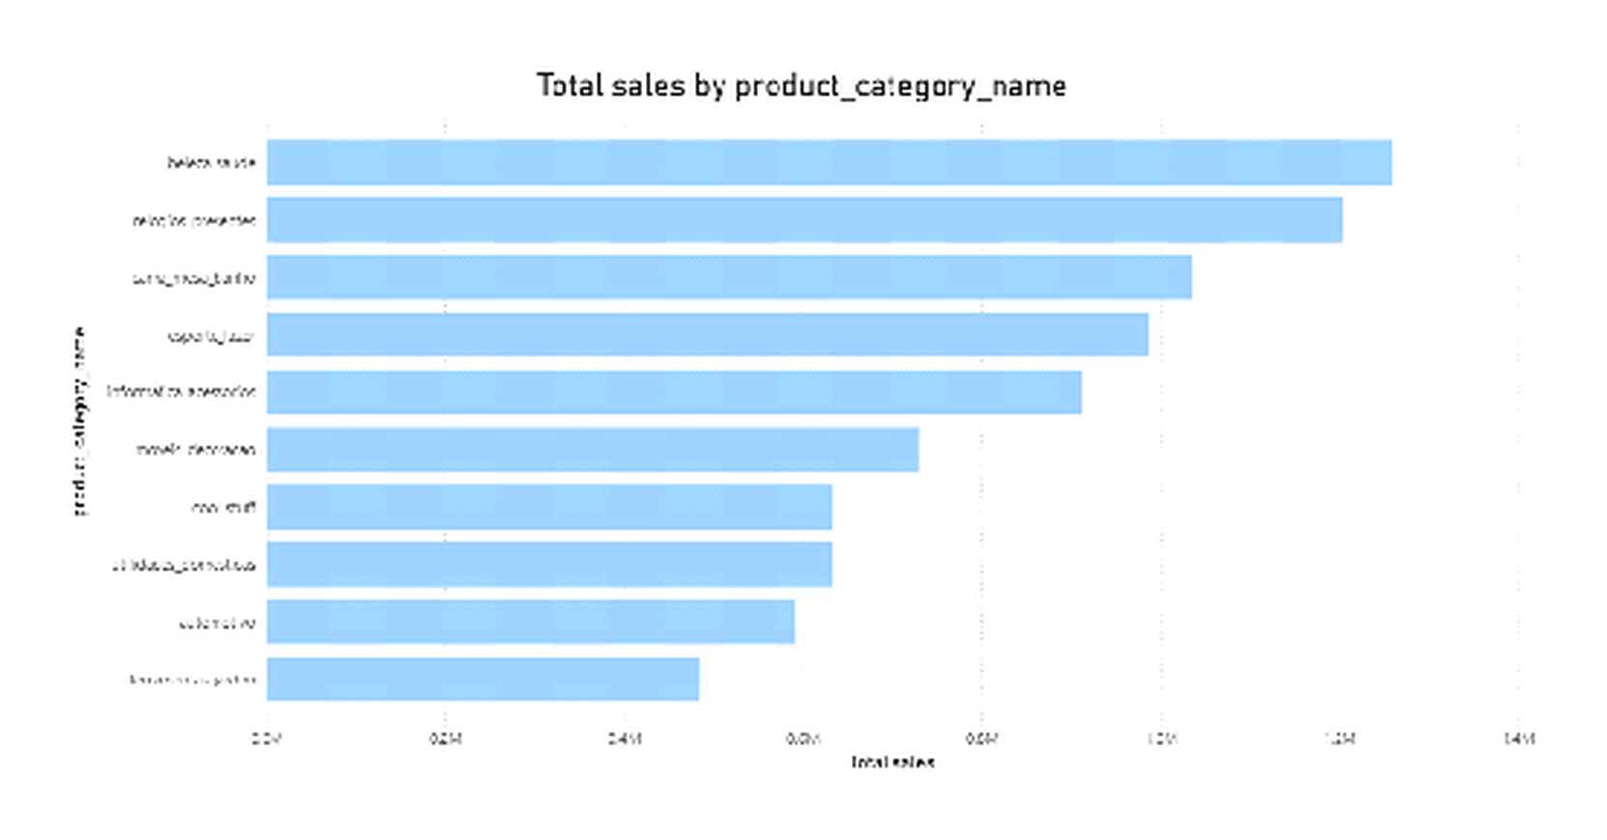
Explanation: The chart ranks the ten highest-performing categories by sales value. Beauty & Health appears as the highest-sales category at approximately 1.25M.

QUESTION 2 — Delayed Orders Analysis
Task: Determine delayed orders in each category where actual delivery date is later than the estimated delivery date.
Visualization: Bar chart displaying delayed-order count across product categories.
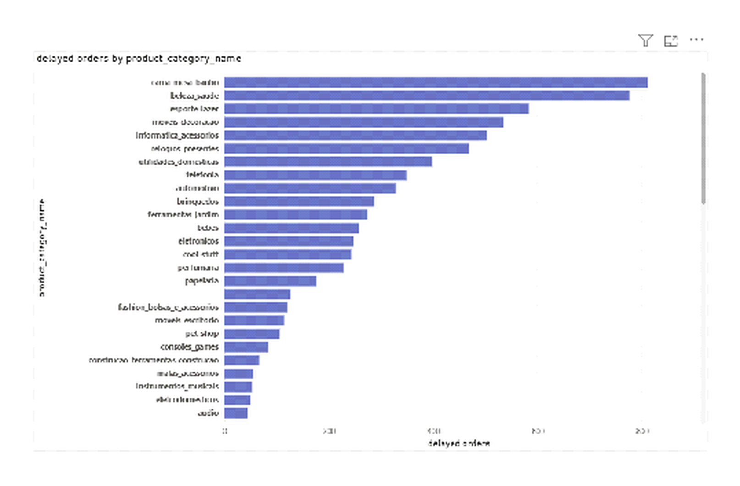
Explanation: The visual groups delayed deliveries by category to show where delays occurred more frequently. Approximately 7.9% of all orders were delayed. It shows the pattern of delays, not their root cause.

QUESTION 3 — Monthly Delayed vs On-Time Orders
Task: Compare delayed and on-time orders for each month and use drillthrough for detailed delivery analysis.
Visualization: Clustered column chart comparing Delayed Orders and On-Time Orders by month.
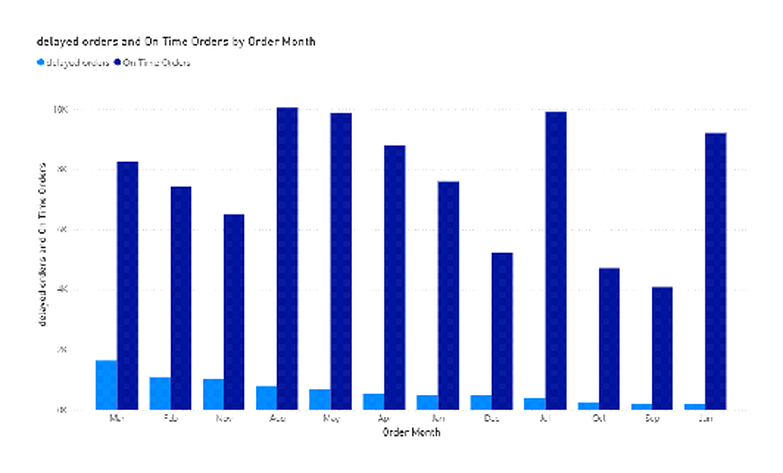
Explanation: The visual provides a month-by-month comparison of delivery performance. The PBIX also includes a Delivery Analysis drillthrough page for order-level investigation.

QUESTION 4 — Payment Method Analysis
Task: Analyze the payment methods most frequently used by customers.
Visualization: Donut chart showing transaction distribution across payment methods.
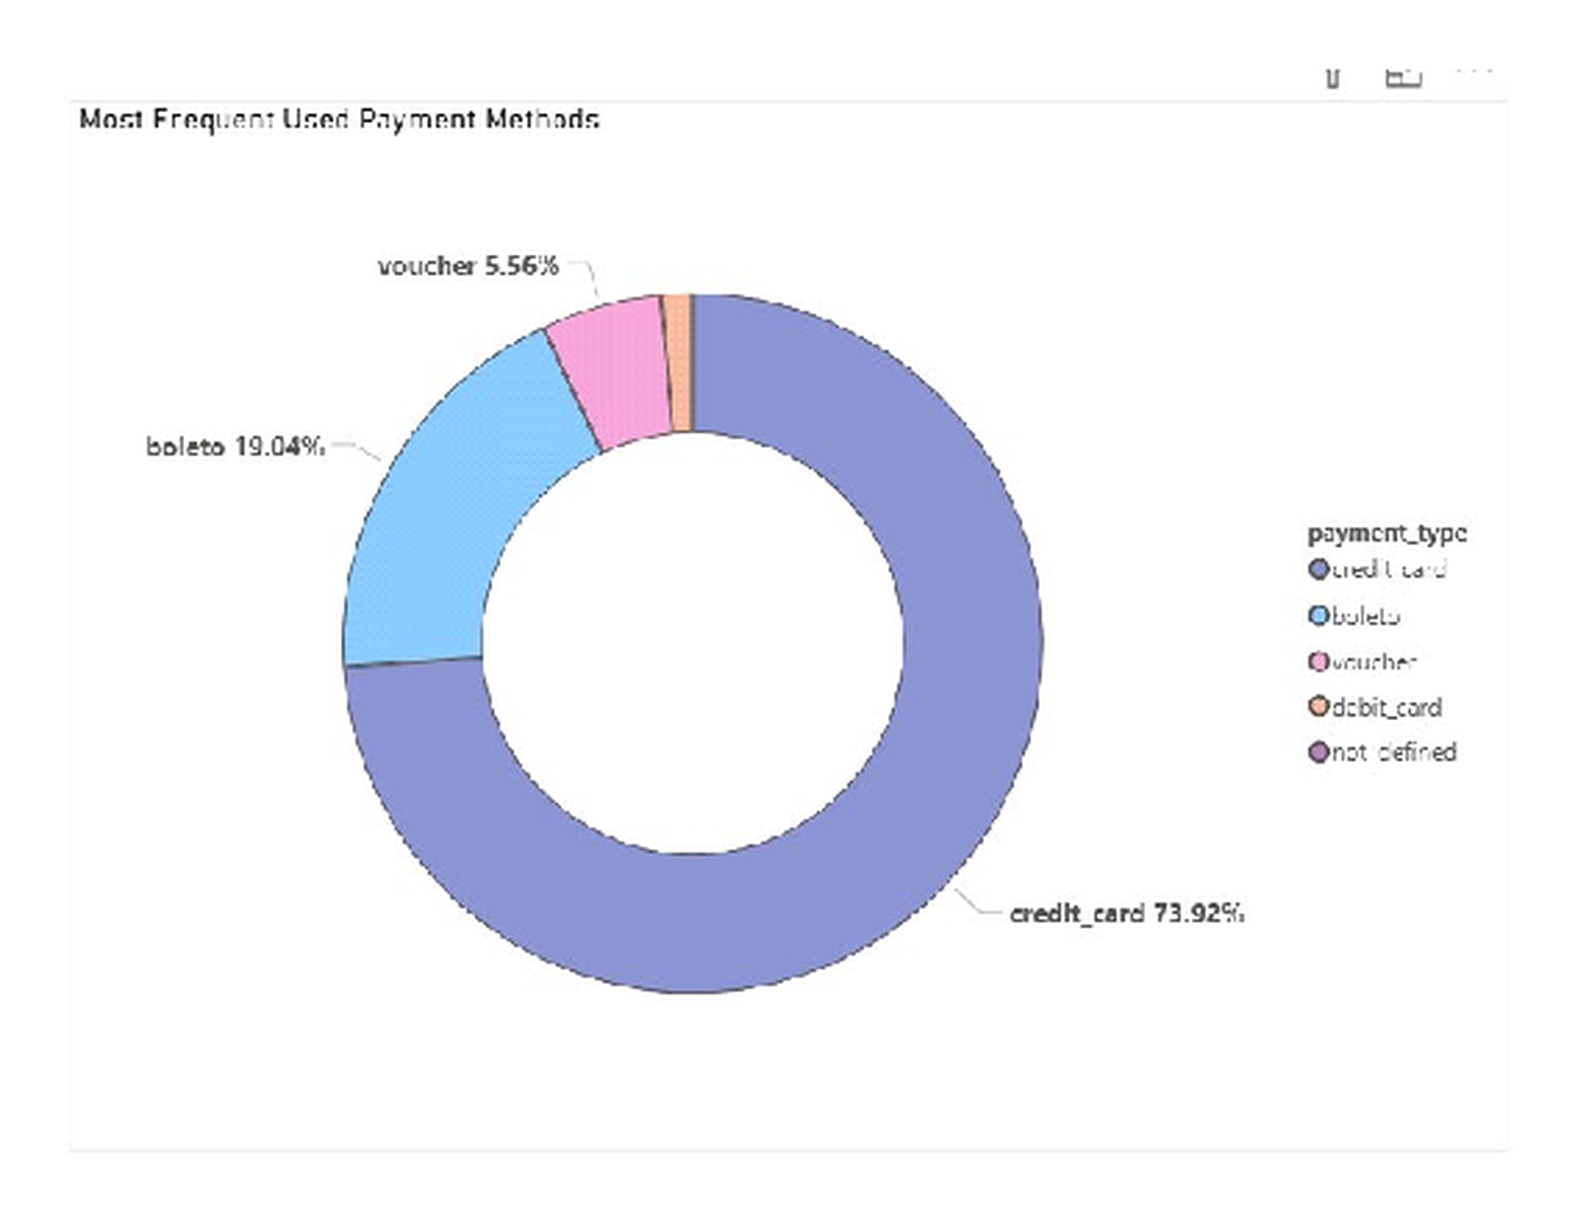
Explanation: Credit card is the dominant payment method at approximately 73.9%, followed by boleto at approximately 19.0% and voucher at approximately 5.6%.

QUESTION 5 — Product Rating Analysis
Task: Determine the top 10 highest-rated and bottom 10 lowest-rated products.
Visualization: Two bar charts comparing the Top 10 Highest-Rated and Bottom 10 Lowest-Rated Products.
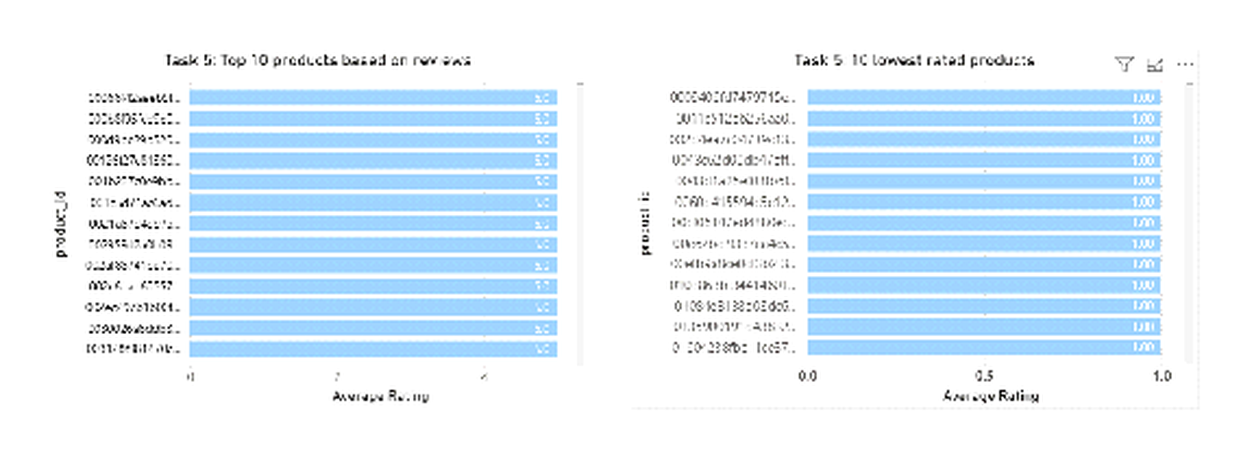
Explanation: The visual compares both ends of the rating distribution and identifies products with relatively high and low average ratings. The ratings do not explain the reason for the scores.

QUESTION 6 — State-wise Sales Performance
Task: Identify and visually represent states with high and low sales.
Visualization: Bar charts comparing total sales across states.
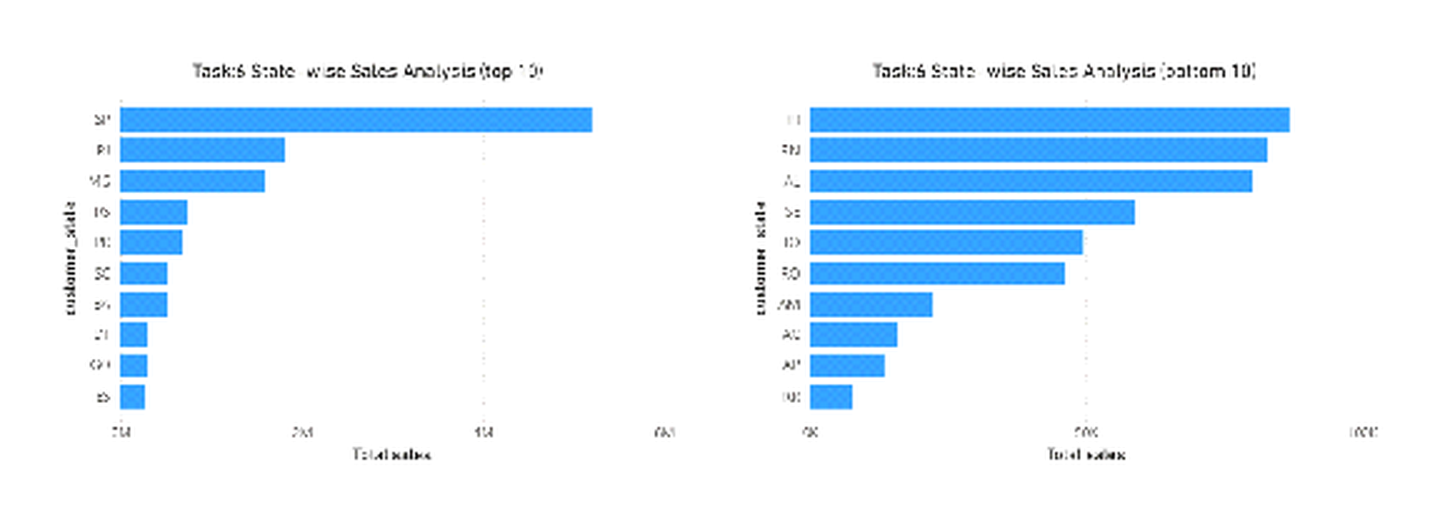
Explanation: The visual highlights geographic variation in sales. São Paulo (SP) records the highest state-level sales at approximately 5M.

QUESTION 7 — Monthly and Quarterly Sales Trends
Task: Investigate seasonal patterns and sales trends over the course of the year.
Visualization: Line chart for month-wise sales and clustered column chart for quarterly sales.
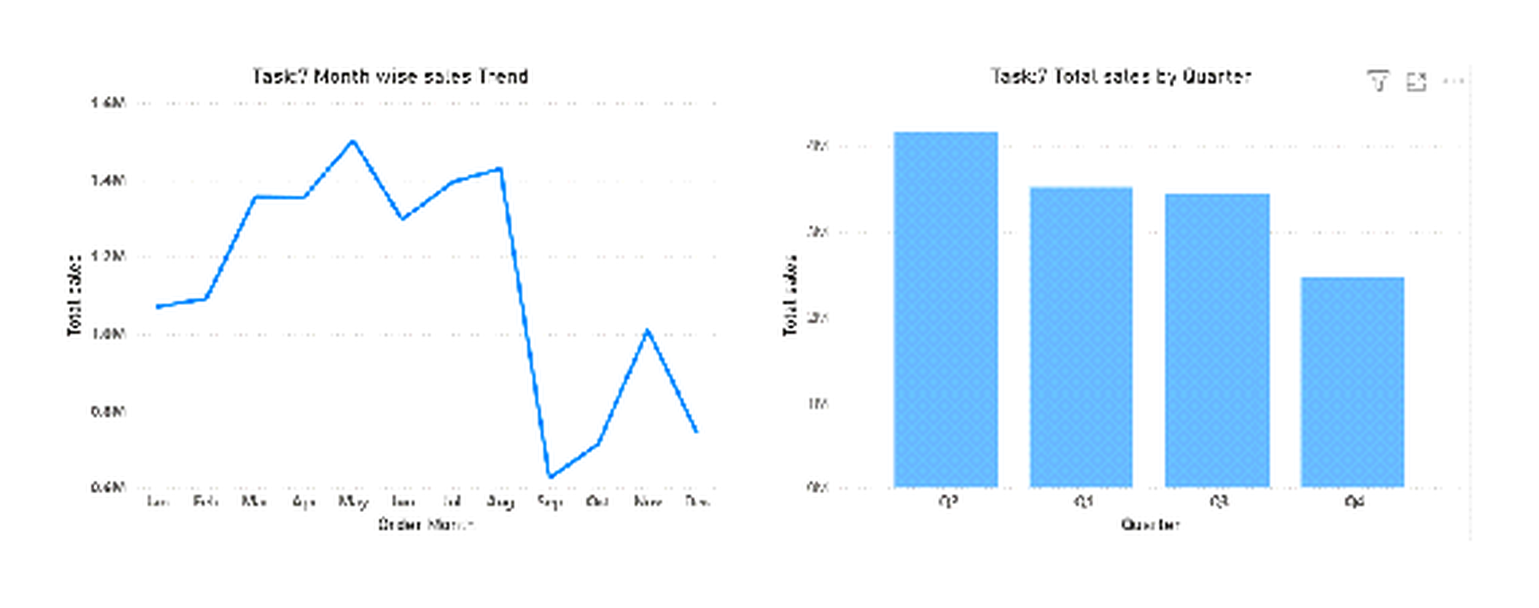
Explanation: The monthly view shows how sales change across months, while the quarterly view provides a broader comparison across the four quarters.

QUESTION 8 — Year-wise Revenue Trend
Task: Determine total revenue and analyze how it changes over time.
Visualization: Line chart showing the Year-wise Revenue Trend.
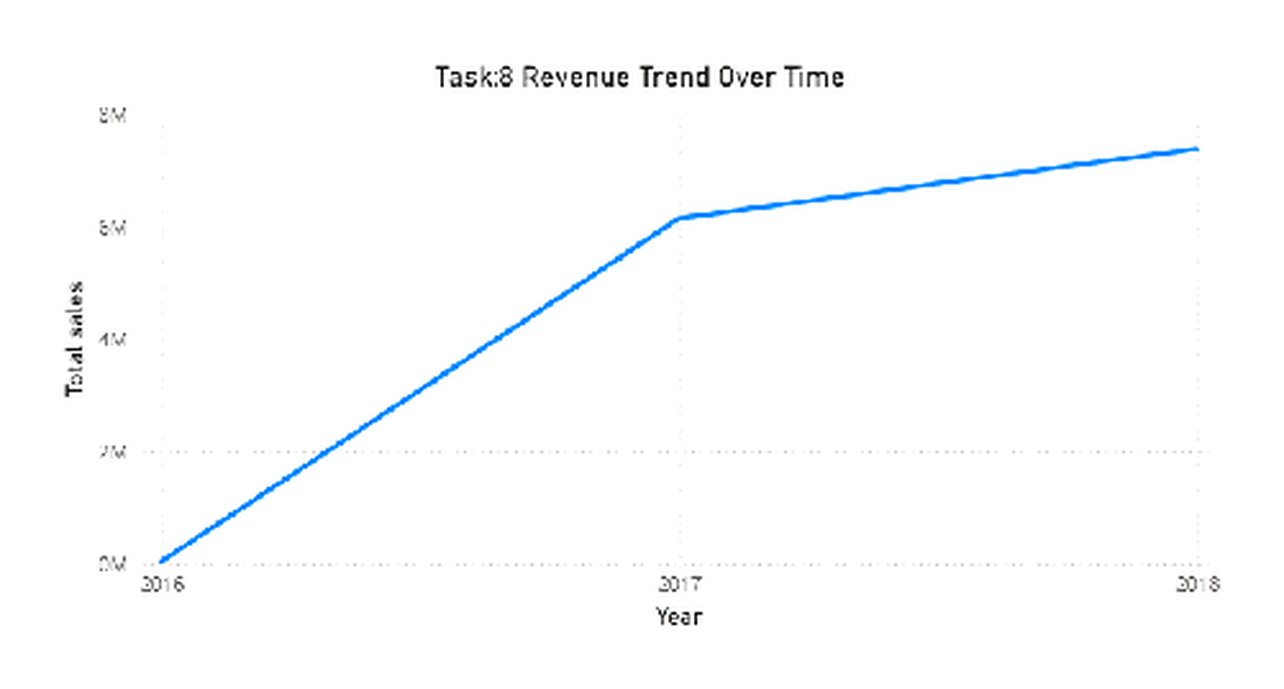
Explanation: The chart compares recorded revenue across the available years. Revenue increases from approximately 6.2M in 2017 to approximately 7.4M in 2018; the earliest year is only a partial starting period.

Dashboard Interactivity
The final ShopNest dashboard supports interactive exploration of the analysis rather than only static chart viewing. Connected visuals respond to selected filters, allowing the same dashboard to be viewed from different business perspectives.
- Customer State slicer — filters connected visuals for the selected state.
- Year slicer — updates the dashboard for the selected year.
- Product Category slicer — filters the analysis to the selected category.
- Drillthrough — opens the Delivery Analysis page for detailed delayed/on-time order records.
- Responsive visuals — connected charts update according to the selected slicer values.

Conclusion
The ShopNest project demonstrates practical use of Power BI, data modeling, DAX measures, chart selection, slicers and drillthrough. The analysis brings together sales, delivery performance, payment preferences, product ratings, geography, seasonal patterns and revenue in one reporting project.
The project also demonstrates how measurable findings can be communicated without going beyond what the available dataset supports. The dashboard can be used to compare business patterns and identify areas that may need further investigation.

Project Skills Demonstrated
- Data modeling and relationship-based reporting
- DAX-based measures and KPI calculations
- Business-focused visual selection and comparison
- Interactive filtering and drillthrough analysis
- Interpretation and communication of measurable findings

