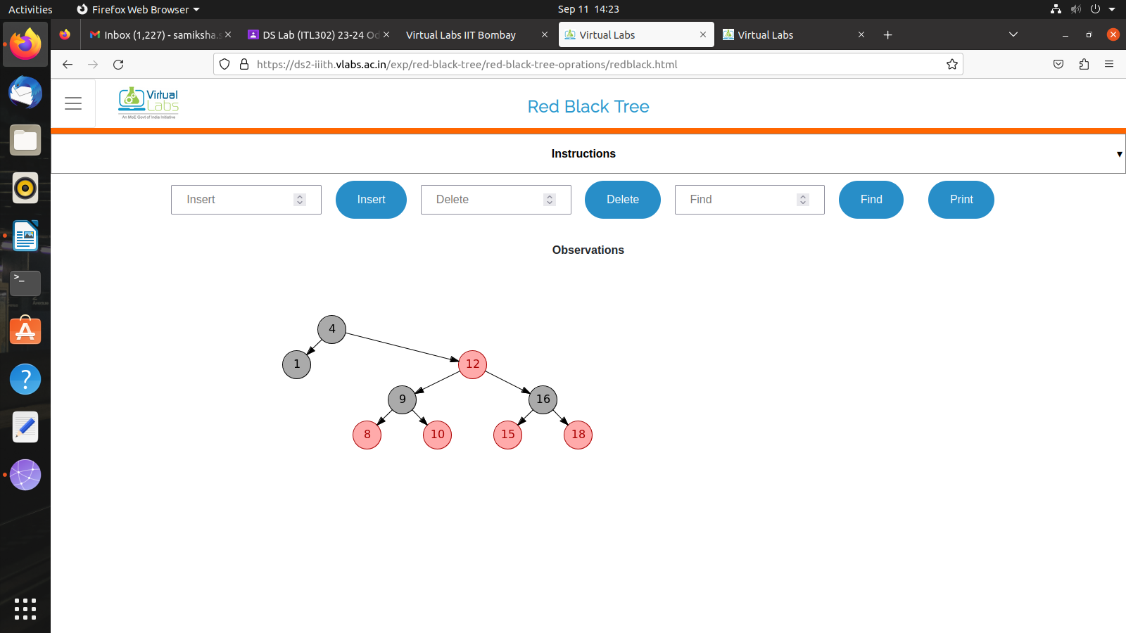
EXPERIMENT 11

Name-Samiksha Terwankar
Roll No.-59
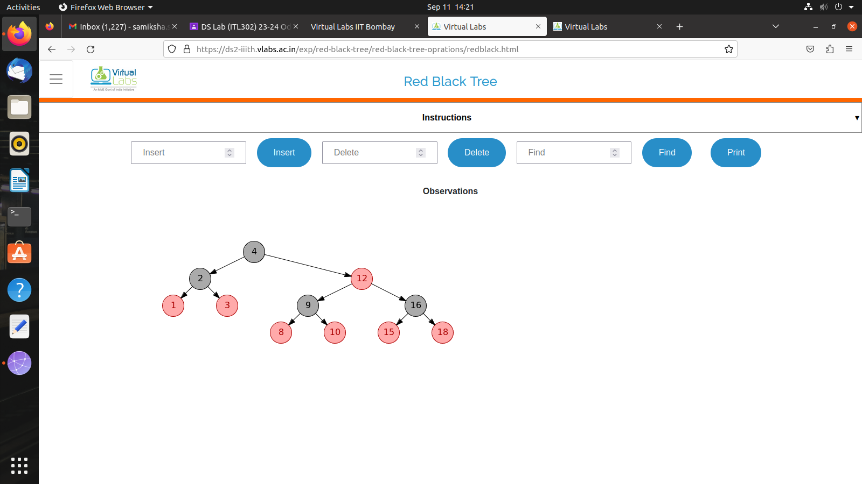
SYIT

