**EXPERIMENT 7**

**Name-Samiksha Terwankar**

**SYIT**

**S3-59**

**Code-**

#include <stdio.h>

#include <stdlib.h>

int source,V,E, time,visited [20], G[20][20];

void DFS(int i)

{

int j;

visited[i]=1;

printf("%d->",i+1);

for(j=0;j<V; j++)

{

if(G[i][j]==1&&visited[j]==0)

DFS(j);

}

}

int main()

{

int i,j,v1,v2;

printf("\t\t\tGraphs\n");

printf("Enter the no of edges: ");

scanf("%d", &E);

printf("Enter the no of vertices:");

scanf("%d", &V);

for(i=0;i<V;i++)

{

for(j=0;j<V; j++) G[i][j]=0;

}

for(i=0;i<E;i++)

{

printf("Enter the edges (format: V1 V2) : ");

scanf("%d %d",&v1,&v2);

G[v1-1][v2-1]=1;

}

for(i=0;i<V;i++)

{

for(j=0;j<V; j++)

printf("%d ",G[i][j]);

printf("\n");

}

printf("Enter the source: ");

scanf("%d", &source);

DFS (source-1);

return 0;

}

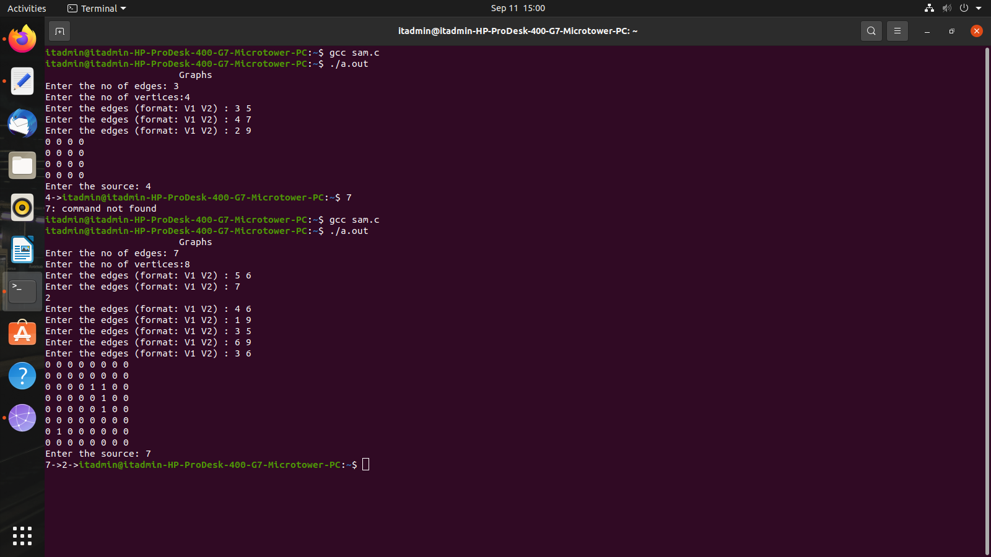

**Code-**

#include<stdio.h>

int a[20][20],q[20],visited[20],n,f = -1,r= -1;

void bfs(int v)

{

int i;

for(i=0;i<n;i++)

{

if(a[v][i] !=0 && visited[i]==0)

{ r=r+1;

q[r]=i;

visited[i]=1;

printf("%d",i);

}

}

f=f+1;

if(f<=r)

bfs(q[f]);

}

int main()

{

int v,i,j;

printf("\n Enter number of vertices");

scanf("%d",&n);

for(i=0;i<n;i++)

{

visited[i]=0;

}

printf("\nEnter graph data in matrix form\n");

for(i=0;i<n;i++)

for(j=0;j<n; j++)

scanf("%d",&a[i][j]);

printf("\n Enter the starting vertex");

scanf("%d",&v);

f=r=0;

q[r]=v;

visited[v]=1;

printf("%d ",v);

bfs(v);

if(r!=n-1)

printf("\nBFS not possible");

printf("\n");

return 0;

}

