

REPORT

NATIONAL SERVICE SCHEME (BNSK359)

# Student Name with USN: Samiksha - 4GW23CS094

# Semester: 3rd

**Branch & Section:CSE, B**

# Title of the activity: Organic farming & Waste Management Group members (student names with USN):

1. Shambhavi J M(4GW23CS097)

2.Vijetha K(4GW23CS125)

3.Samiksha (4GW23CS094)

4.Rachana A J(4GW23CS084)

Submitted to: Syeda Nausheen Fathima

Assistant Professor

GSSSITEW, Mysuru.

# Aim & objective:

To know about the usefulness of organic farming, wet waste management in neighbouring places & villages

To know about the activities through which we can eﬀectively manage wastPhotos (include one photo of student doing presentation):

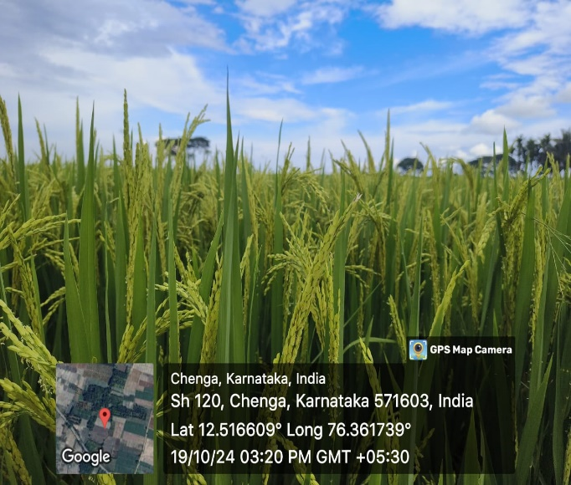 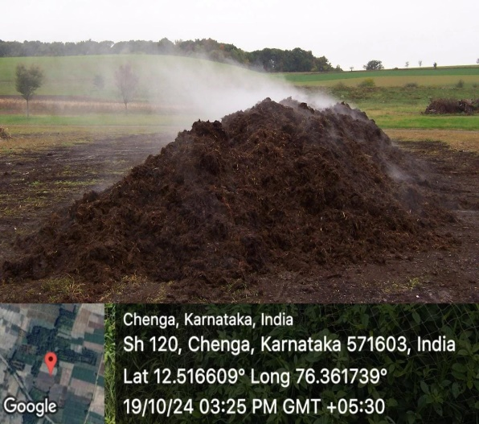

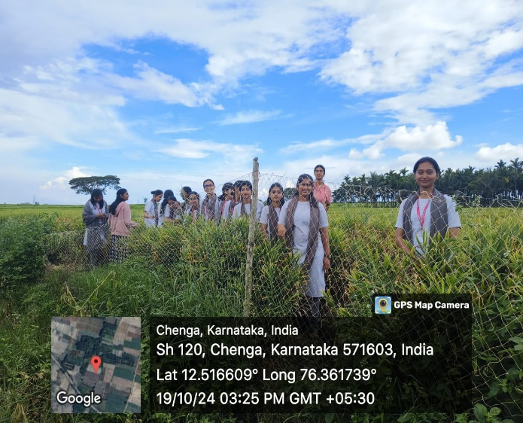 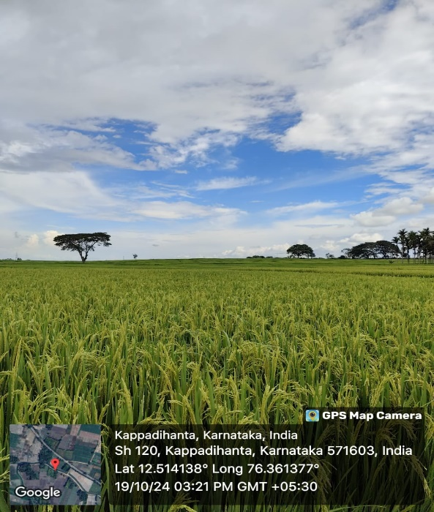

**Description:**

Participating in an organic farming activity in Chenga, a small village in the KR Nagar region of Karnataka, was a unique and enriching experience. As a student used to a classroom environment, spending time on a farm provided me with a fresh perspective on agriculture, sustainability, and rural life. The village’s serene landscape, with its fertile ﬁelds and the simplicity of rural living, set the perfect

backdrop for learning about organic farming practices that are both environmentally friendly and deeply connected to traditional agricultural knowledge.

1. Preparation of Organic Manure

One of the primary activities in organic farming is the preparation and use of organic manure. Organic farmers avoid synthetic fertilizers and instead rely on compost, green manure, and animal waste.

Composting is a common technique, where organic waste, such as crop residues, kitchen waste, and

livestock manure, is decomposed by microorganisms. This process enriches the soil with nutrients and beneﬁcial microorganisms. Organic manure improves the soil structure, increases water retention, and helps in the growth of healthy plants.

2.Crop Rotation and Companion Planting

Another essential aspect of organic farming is crop rotation and companion planting. Crop rotation involves growing diﬀerent crops in the same area across a sequence of seasons. This practice helps maintain soil fertility, reduces soil erosion, and prevents the build-up of pests and diseases that typically attack monocultures. For example, a farmer may plant legumes like peas or beans one season, followed by grains like wheat or barley the next season. Legumes have nitrogen-ﬁxing bacteria that enrich the soil, while grains absorb the nitrogen, maintaining a balanced nutrient cycle in the soil.

3.Pest and Weed Management

organic farming, pest and weed control methods are natural and ecological. Farmers avoid synthetic pesticides and herbicides, which are harmful to the environment and human health. Instead, they use biological pest control, which involves introducing natural predators like ladybugs to control aphids, or using natural plant-based insecticides like neem oil. Integrated Pest Management (IPM) is commonly used in organic farming, which combines biological, cultural, and mechanical practices to manage pests without harmful chemicals.the soil as the mulch decomposes. Manual weeding and using cover crops, such as clover or ryegrass, can also prevent weed establishment.

4.Animal Husbandry in Organic Farming

For those farmers who include livestock in their farming operations, organic farming involves rearing animals in an ethical and sustainable manner. Animals are given access to natural pastures, and their feed is organic, free from antibiotics, hormones, and genetically modiﬁed organisms (GMOs). Livestock are raised in conditions that promote their natural behavior, such as grazing outdoors and having space to roam freely.

6.Beneﬁts of Organic Farming

Organic farming oﬀers several environmental, health, and economic beneﬁts:

Environmental Beneﬁts: Organic farming minimizes the use of synthetic chemicals, reducing soil, water, and air pollution. The emphasis on biodiversity, such as crop rotation and polyculture, helps improve ecosystem health, including promoting beneﬁcial insects and wildlife. By avoiding synthetic fertilizers and pesticides, organic farming preserves soil health and promotes carbon sequestration, which can mitigate climate change.

Health Beneﬁts: Organic farming produces healthier crops and livestock, as they are free from harmful pesticides, antibiotics, and synthetic hormones. Organic food is often fresher, as it does not contain preservatives that prolong shelf life. Many consumers believe that organic food has a higher nutritional value than conventionally grown food.

Economic Beneﬁts: Organic products often fetch higher prices in the market due to growing consumer demand for clean, chemical-free produce. While the initial transition to organic farming can be costly and labor-intensive, the long-term beneﬁts of improved soil health, reduced input costs (since farmers avoid synthetic fertilizers and pesticides), and premium market prices make it a ﬁnancially sustainable option for many farmers.

1. Beneﬁts of Organic Farming

Organic farming oﬀers several environmental, health, and economic beneﬁts:

Environmental Beneﬁts: Organic farming minimizes the use of synthetic chemicals, reducing soil, water, and air pollution. The emphasis on biodiversity, such as crop rotation and polyculture, helps improve ecosystem health, including promoting beneﬁcial insects and wildlife

Health Beneﬁts: Organic farming produces healthier crops and livestock, as they are free from harmful pesticides, antibiotics, and synthetic hormones. Organic food is often fresher, as it does not contain preservatives that prolong shelf life. Many consumers believe that organic food has a higher nutritional value than conventionally grown food.

1. Challenges in Organic Farming

Despite the numerous beneﬁts, organic farming presents several challenges:

Lower Yields: Organic farms often have lower yields compared to conventional farms, especially in the early stages of transition. Without synthetic fertilizers and pesticides, managing soil fertility and controlling pests can be more labor-intensive and less predictable.

Labor-Intensive: Organic farming practices, such as manual weeding, composting, and crop rotation, require more labor and time compared to conventional farming methods. This can increase production costs.

As a student of computer science, this experience in organic farming at Chenga was a welcome break from my usual academic routine. This activity was more than just a lesson in farming—it was a lesson in patience, sustainability, and respect for the environment. It reminded me of the value of traditional

# Outcome/conclusion:

Sustainability: Organic farming promotes sustainable agricultural practices by reducing the use of synthetic fertilizers, pesticides, and chemicals that harm the environment. The soil's fertility is maintained through natural processes, leading to long-term ecological balance.

1. Healthier Soil: Organic farming practices, such as composting, crop rotation, and using natural fertilizers, improve soil structure and nutrient content. Healthier soil is more resilient to erosion and can better retain water.
2. Biodiversity: Organic farming encourages biodiversity by creating a balanced ecosystem. The absence of chemical pesticides allows beneﬁcial insects, birds, and other wildlife to thrive.
3. Improved Food Quality: Organic produce is generally considered to have higher nutritional value and fewer pesticide residues than conventionally grown food. Many consumers prefer organic food for health and safety reasons.

# Suggestions/ recommendations:

1.Soil Health Management:

Regular Soil Testing: Conduct soil tests periodically to monitor pH, nutrient levels, and organic matter content. This will help in understanding what nutrients the soil lacks and guide proper amendments.

Use of Organic Fertilizers: Incorporate compost, manure, green manure, and other organic fertilizers to improve soil fertility and provide necessary nutrients to crops.

3.Enhancing Biodiversity:

Diverse Crop Selection: Grow a variety of crops to maintain biodiversity, improve soil health, and reduce the risk of total crop failure due to pests or diseases.

Agroforestry and Polyculture: Combine trees, shrubs, and diﬀerent crops in the same farming system. This increases biodiversity, improves ecosystem services, and can enhance yield stability.

# References:

1. IFOAM – Organics International

The International Federation of Organic Agriculture Movements (IFOAM) is a leading organization that sets standards and promotes organic farming worldwide. Their website oﬀers resources on organic farming principles, certiﬁcation, and sustainability practices.

1. Rodale Institute

This research and education organization is a leader in regenerative organic farming. The Rodale Institute oﬀers reports, research papers, and practical guides on improving soil health, pest management, and organic certiﬁcation.

1. United States Department of Agriculture (USDA) – National Organic Program (NOP)

The USDA’s NOP provides guidelines for organic certiﬁcation and production in the U.S. It includes information on organic standards, accreditation, and certiﬁcation processes.

# Faculty signature: