Task 1: Screenshots
EKS Cluster created:
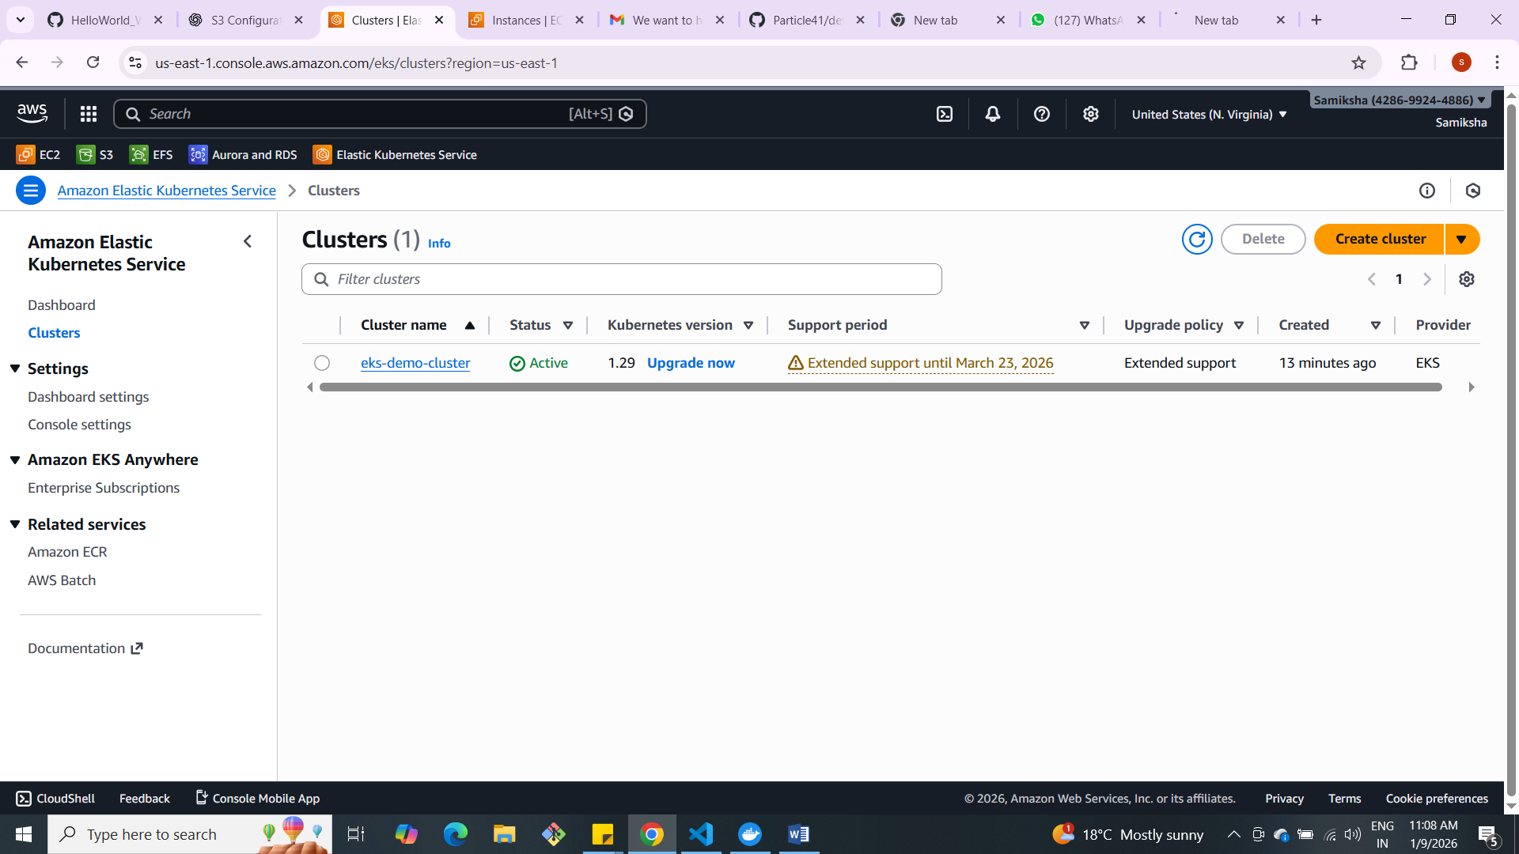

2) 2 Private Node created:
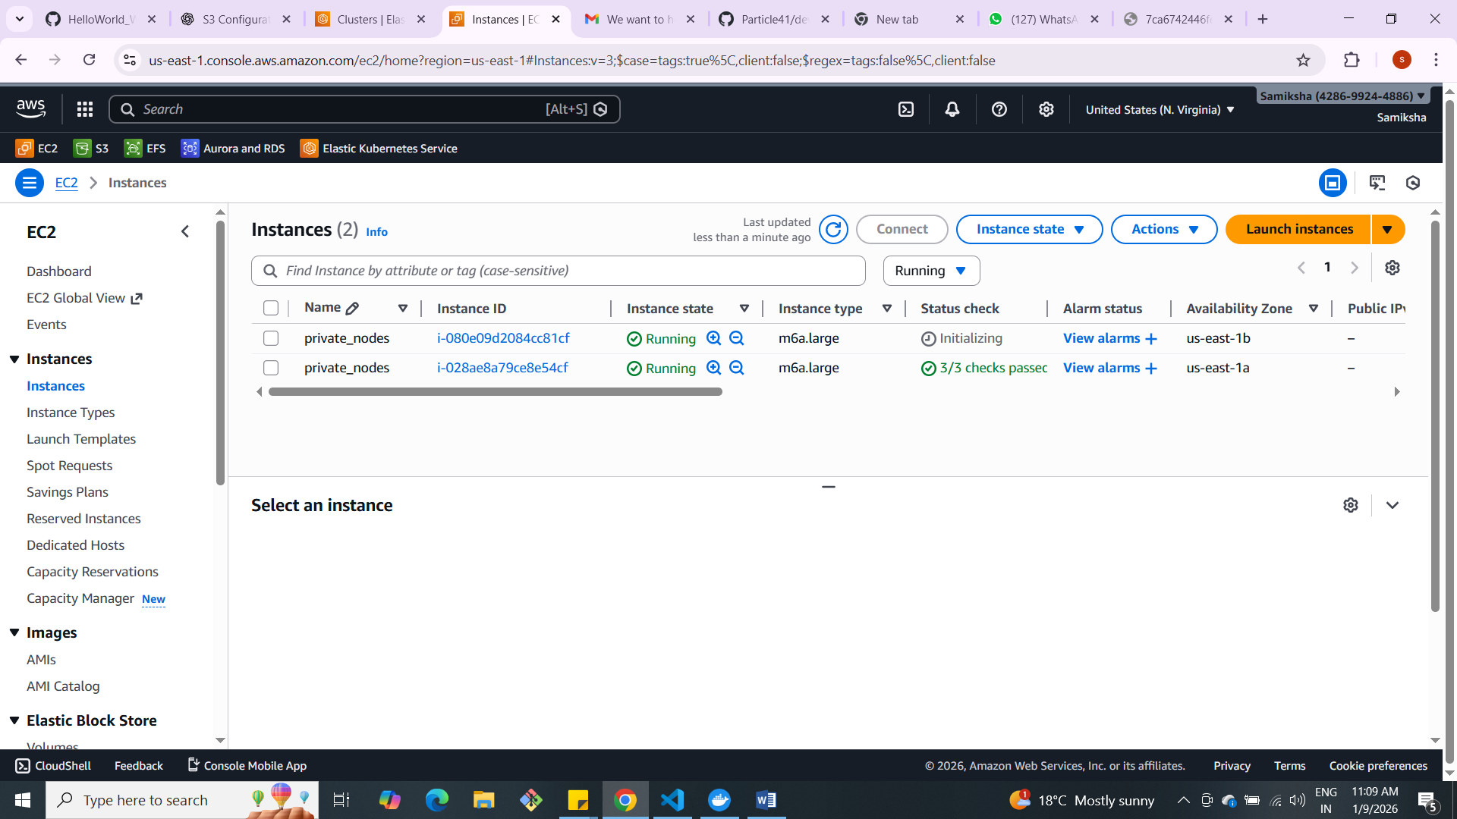

3) remote Terraform backend (S3 and DynamoDB) for state and locking

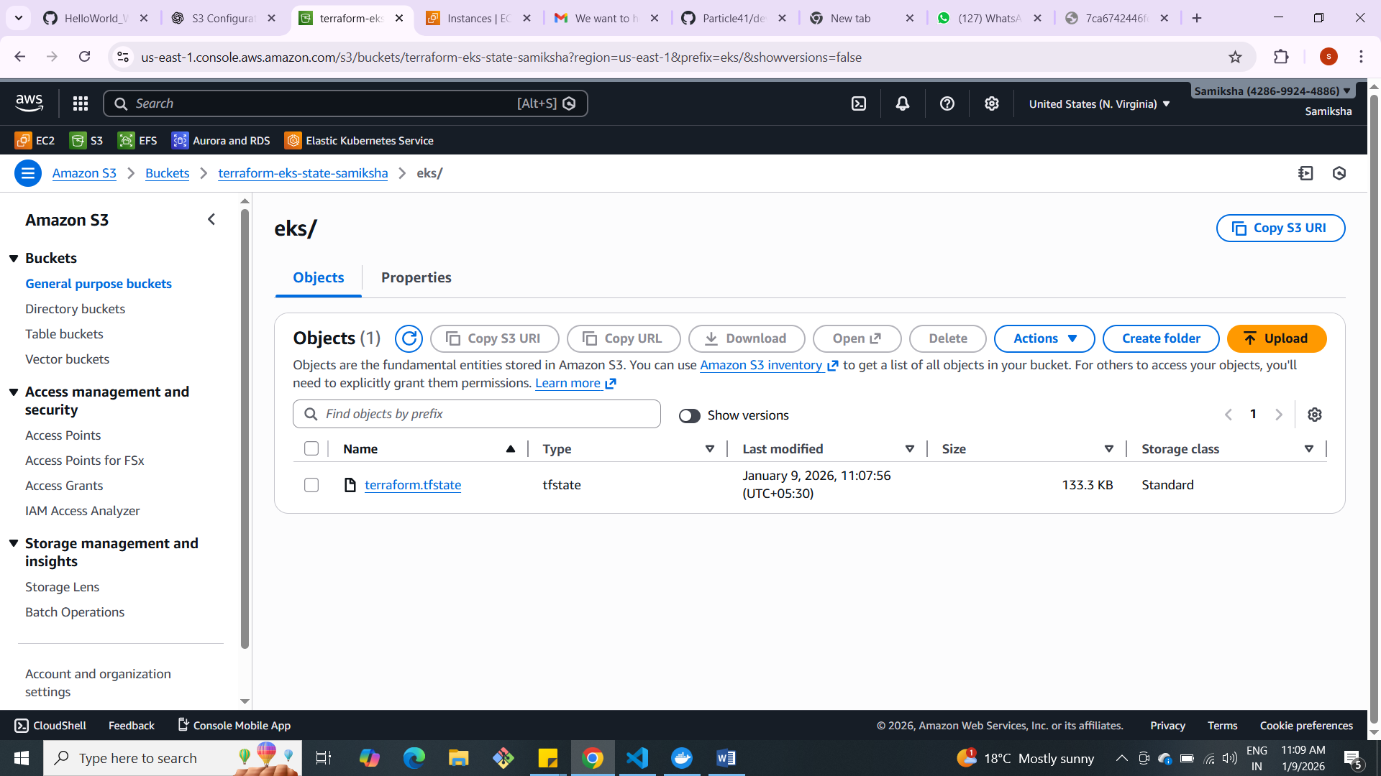

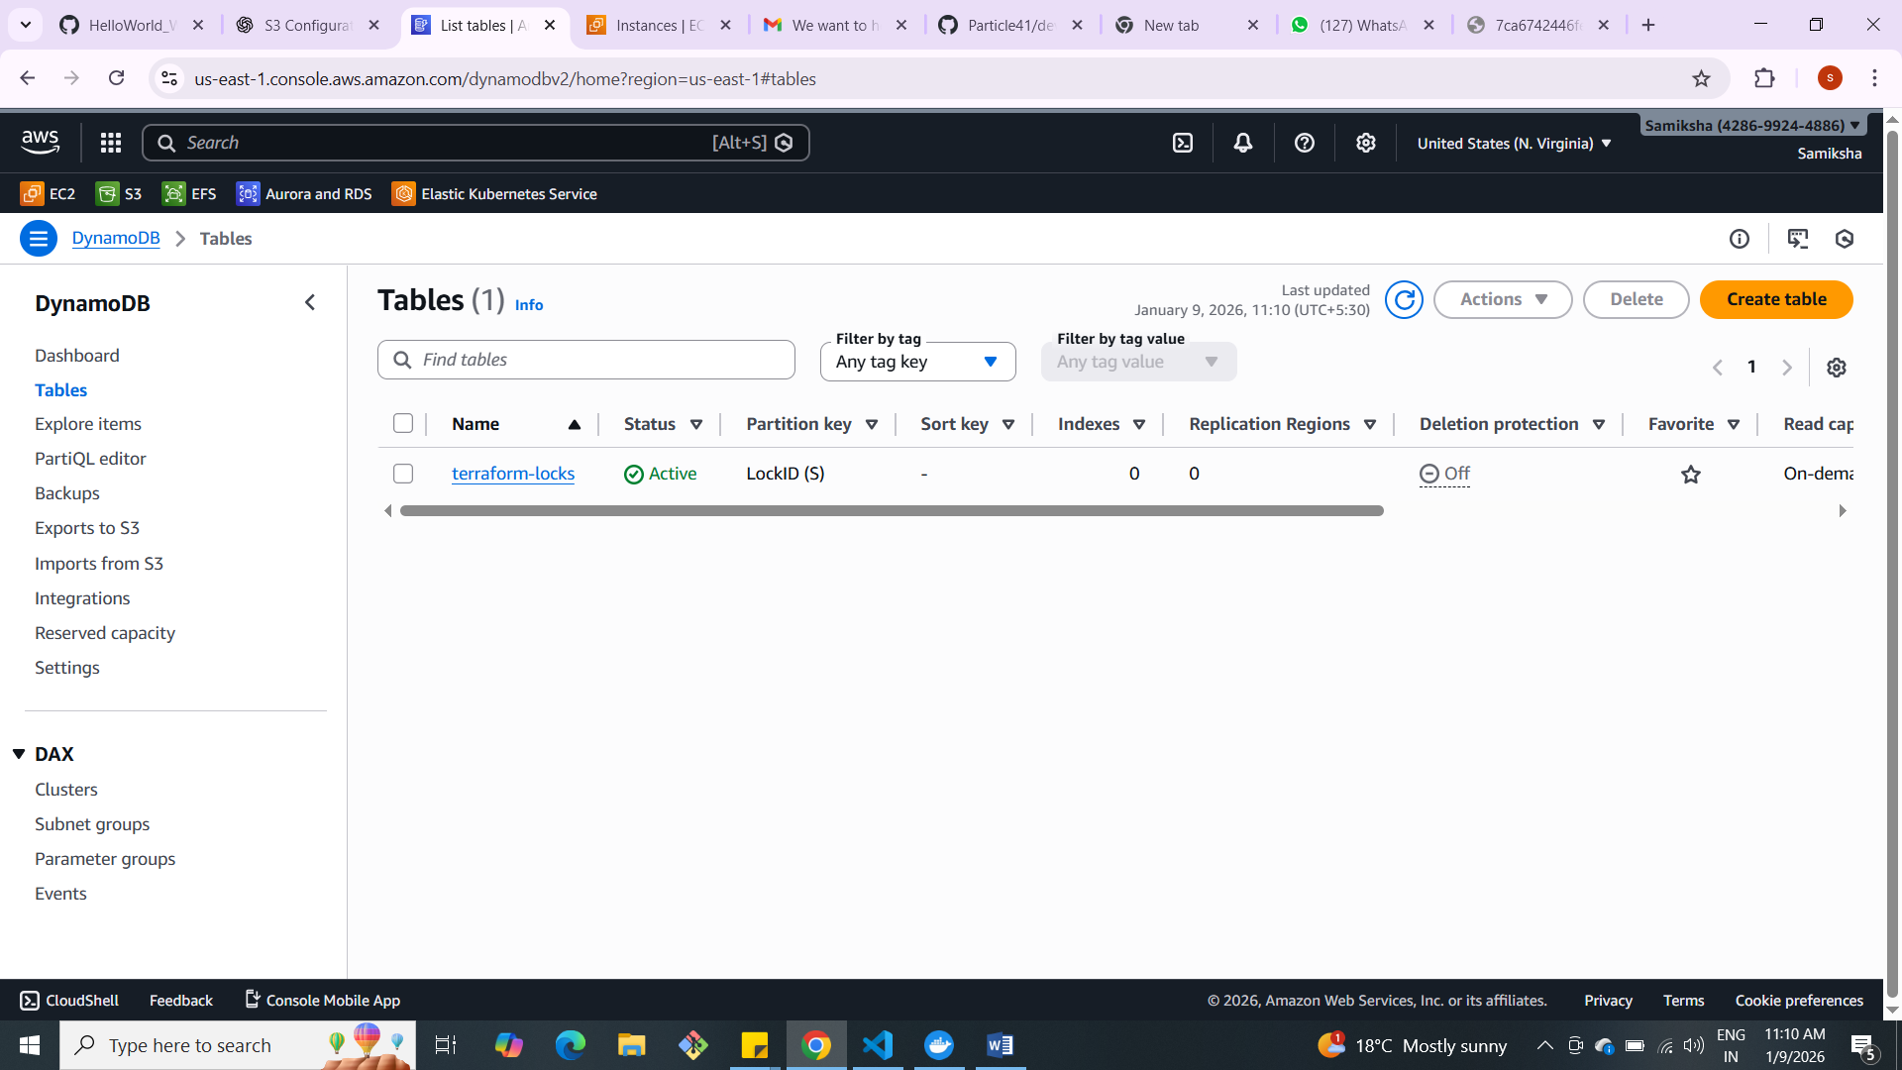

4) VPC created
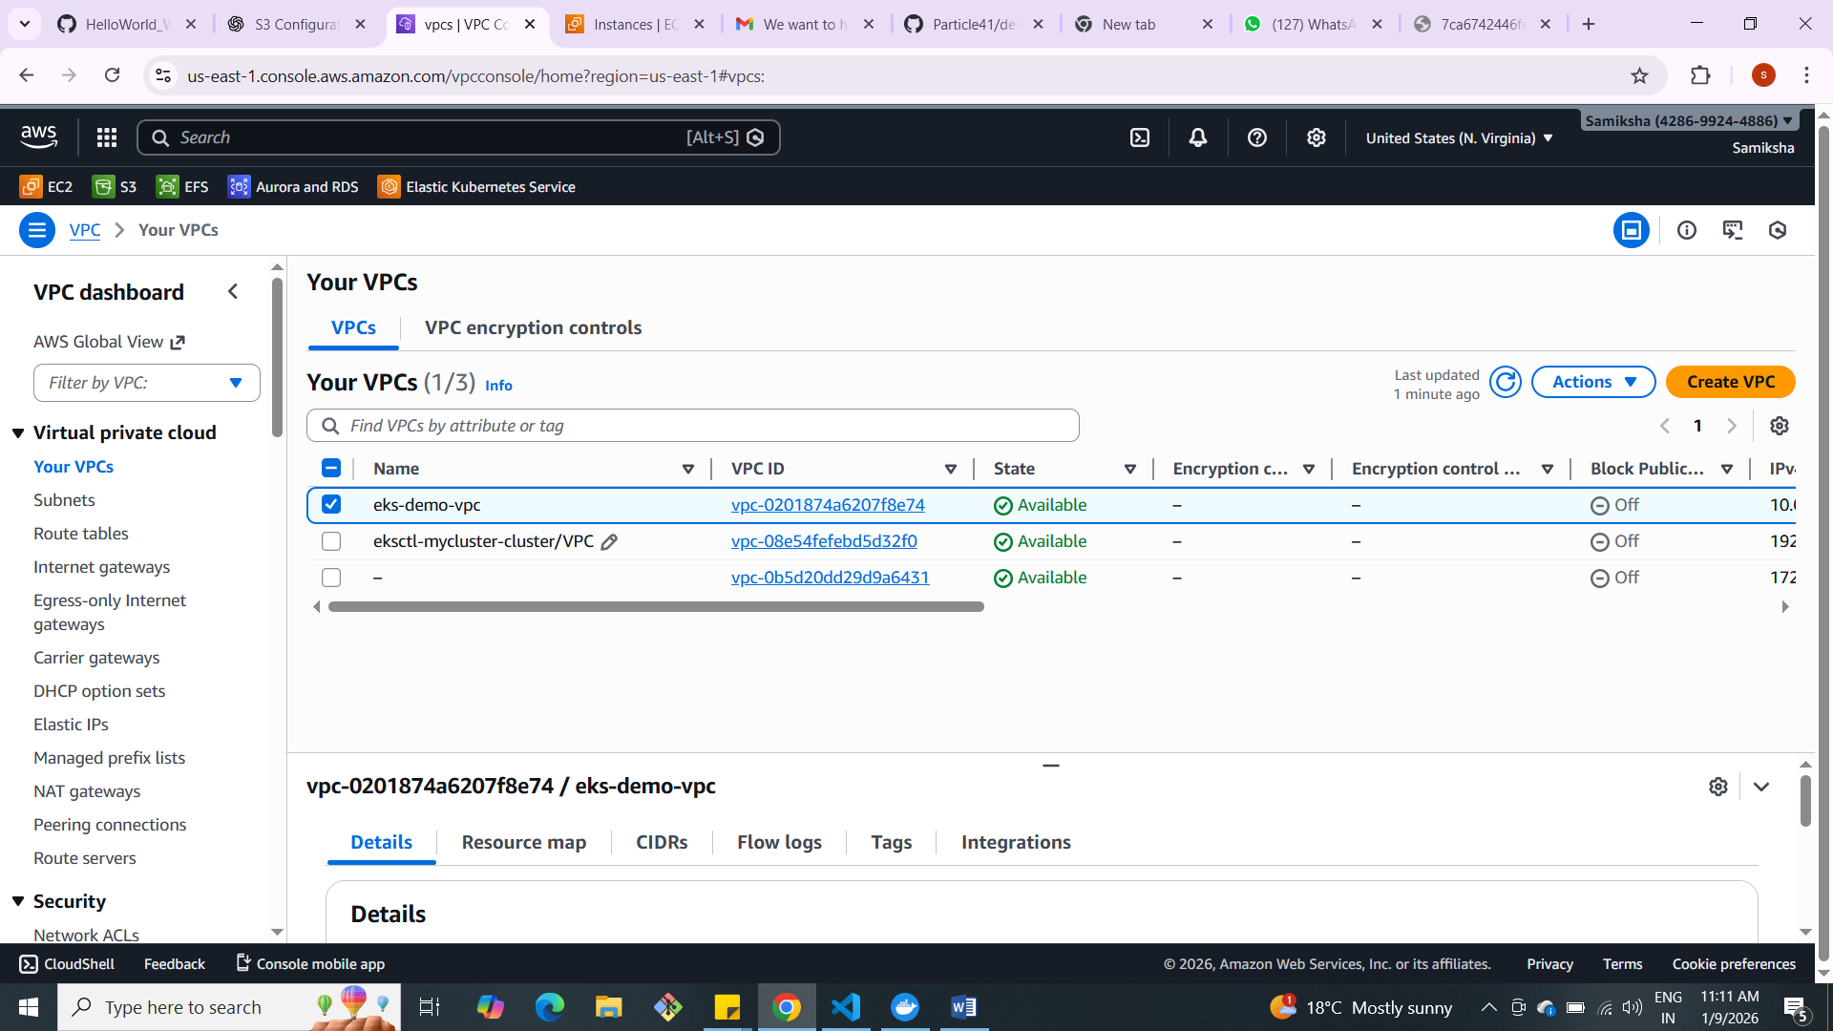
5) Total 4 subnet created- 2 Public and 2 Private
