**TO SUPPLY LEFTOVER FOOD TO POOR**

### 1. Introduction

**1.1 Project Overview** The Leftover Food Connect app, built on the Salesforce platform, is a mobile application designed to bridge the gap between businesses with excess food and individuals in need. The app facilitates efficient food donation and distribution, reducing food waste and addressing food insecurity.

**1.2 Project Goals**

* Connect businesses with excess food to individuals and organizations that can utilize it.
* Minimize food waste and promote sustainable food practices.
* Improve food security and address hunger in the community.
* Provide a user-friendly platform for both businesses and individuals.

### 2. System Requirements

**2.1 Hardware Requirements**

* Mobile device (iOS or Android) with a compatible operating system.
* Internet connection.

**2.2 Software Requirements**

* Salesforce mobile app.
* Leftover Food Connect app (Salesforce Lightning component).

### 3. System Architecture

**3.1 Salesforce Objects**

* **Business:** Stores information about businesses that donate excess food.
* **Food Item:** Tracks details of food items available for donation.
* **Donation Request:** Records requests for food from individuals or organizations.
* **Donation:** Manages the process of food donation, including pickup and delivery.

**3.2 Lightning Components**

* **Business Registration:** Allows businesses to register and create profiles.
* **Food Donation:** Enables businesses to post available food items.
* **Donation Request:** Facilitates individuals or organizations to submit food requests.
* **Donation Management:** Manages the process of food donation, including matching requests with donations.

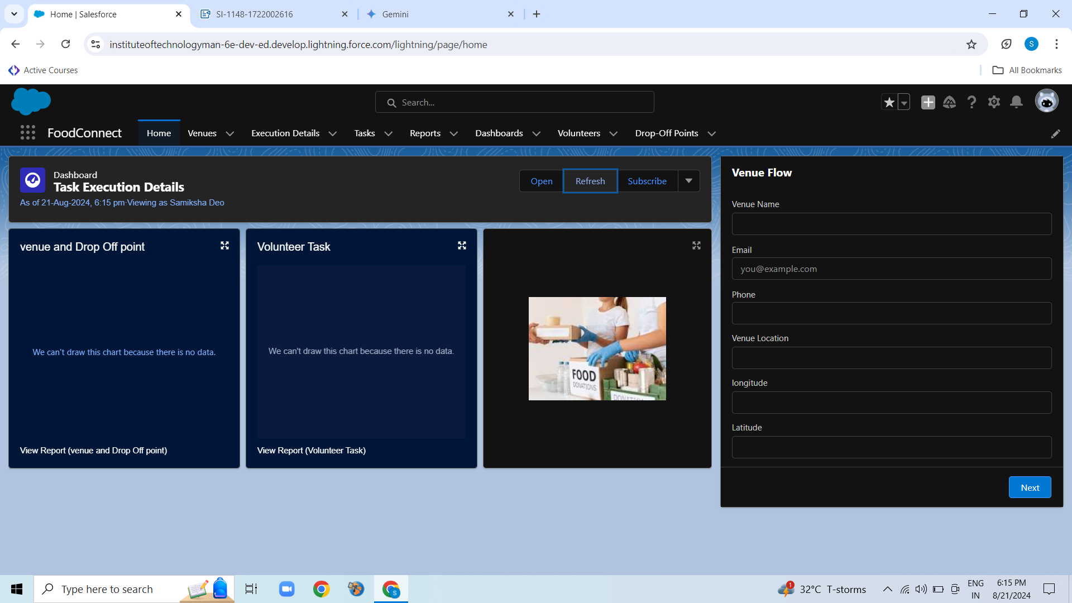

**3.3 Integration**

* **Location Services:** Uses GPS to determine the location of businesses and individuals for efficient matching.
* **Notifications:** Sends push notifications to businesses and individuals about new donations or requests.

### 4. User Interface (UI) Design

**4.1 Business User Interface**

* Dashboard to view available food items and donation requests.
* Option to post new food items.
* Ability to manage donation requests and track donations.

**4.2 Individual User Interface**

* Search functionality to find food donations near their location.
* Option to submit food requests.
* Ability to view donation history.

### 5. Functional Requirements

* **Business Registration:** Businesses can create profiles, provide contact information, and specify their location.
* **Food Donation:** Businesses can post food items, including quantity, type, and expiration date.
* **Donation Request:** Individuals or organizations can submit food requests, specifying their needs and location.
* **Matching and Notification:** The app matches requests with donations based on location and food type. Notifications are sent to both parties when a match is found.
* **Donation Management:** The app tracks the status of donations, from posting to pickup and delivery.

### 6. Non-Functional Requirements

* **Performance:** The app should load quickly and respond efficiently to user interactions.
* **Security:** User data and food information should be protected from unauthorized access.
* **Scalability:** The app should be able to handle a growing number of users and donations.
* **Usability:** The user interface should be intuitive and easy to navigate.

### 7. Testing and Quality Assurance

* **Unit Testing:** Testing individual components of the app to ensure they function correctly.
* **Integration Testing:** Testing the interaction between different components of the app.
* **System Testing:** Testing the entire app to verify that it meets the specified requirements.
* **User Acceptance Testing (UAT):** Testing the app with real users to gather feedback and ensure it meets their needs.

### 8. Deployment and Maintenance

* **Deployment:** Deploying the app to the Salesforce AppExchange or directly to businesses and individuals.
* **Maintenance:** Regularly updating and maintaining the app to address bugs, improve performance, and add new features.