DETECTION AND CLASSIFICATION OF FRUIT DISEASES USING IMAGE PROCESSING & CLOUD COMPUTING
In this paper author is using KMEANS segmentation and SVM algorithm to predict diseases from fruits. KMEANS segmentation helps in clustering similar colour and clustering features will be used to train SVM classifier and then whenever we give new image then SVM classifier classify that input image as normal or contains any disease.
To implement this project author has designed following modules
- Image Acquisition: In this module we will take dataset images as input for KMEANS segmentation and to train SVM classifier
- Preprocessing: In this module we will read all fruit images and assign label to each image as a healthy fruit or contain disease. In this dataset we have 4 different types of diseases such as 'Black spot', 'Canker', 'Greening', 'healthy', 'scab'. In this module noise will be removed from images
- Segmentation: In this module we will apply KMEANS segmentation to cluster similar colour pixels into same group or convert image into multiple segments with different colours and classifier can effectively match similar colour pixels for disease identification
- Features Extraction: In this module we will extract colour, spots and shape from fruit images and then build a training model. This training model will be divided into two parts called training and testing where application used 80% dataset size for training SVM classifier and remaining 20% dataset will be applied on trained model to calculate prediction accuracy and specificity.
- Classification: after feature extraction we will train SVM classifier and in this module we will upload new test image and then apply SVM classifier to predict whether image is normal or contains any disease.
Here author using cloud server to store training dataset but we don’t have any cloud servers so we are storing training dataset in local machine only and then implementing above modules as simulation.
All fruit images dataset saved inside ‘FruitDataset’ folder
SCREENSHOTS
To run project double click on ‘run.bat’ file to get below screen
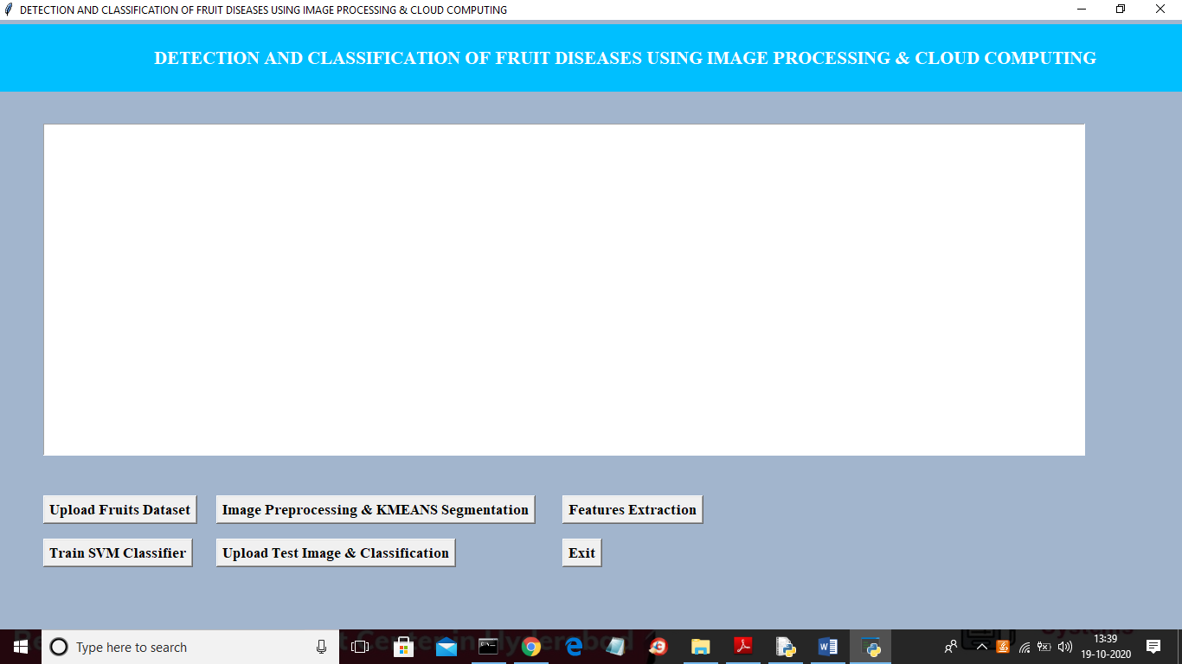
In above screen click on ‘Upload Fruits Dataset’ button and upload dataset
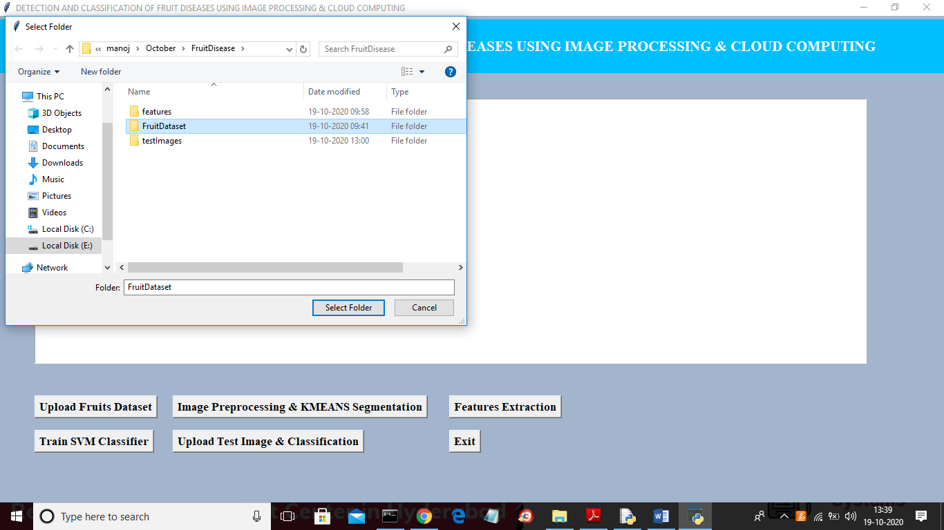
In above screen selecting and uploading ‘FruitDataset’ folder and then click on ‘Select Folder’ button to load dataset and to get below screen
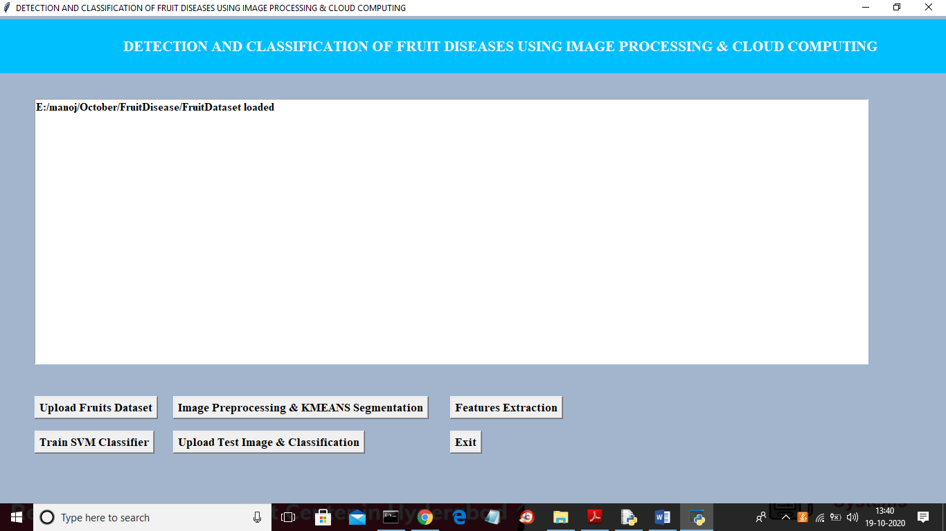
In above screen dataset is loaded and now click on ‘Image Preprocessing & KMEANS Segmentation’ button to read images and to perform segmentation
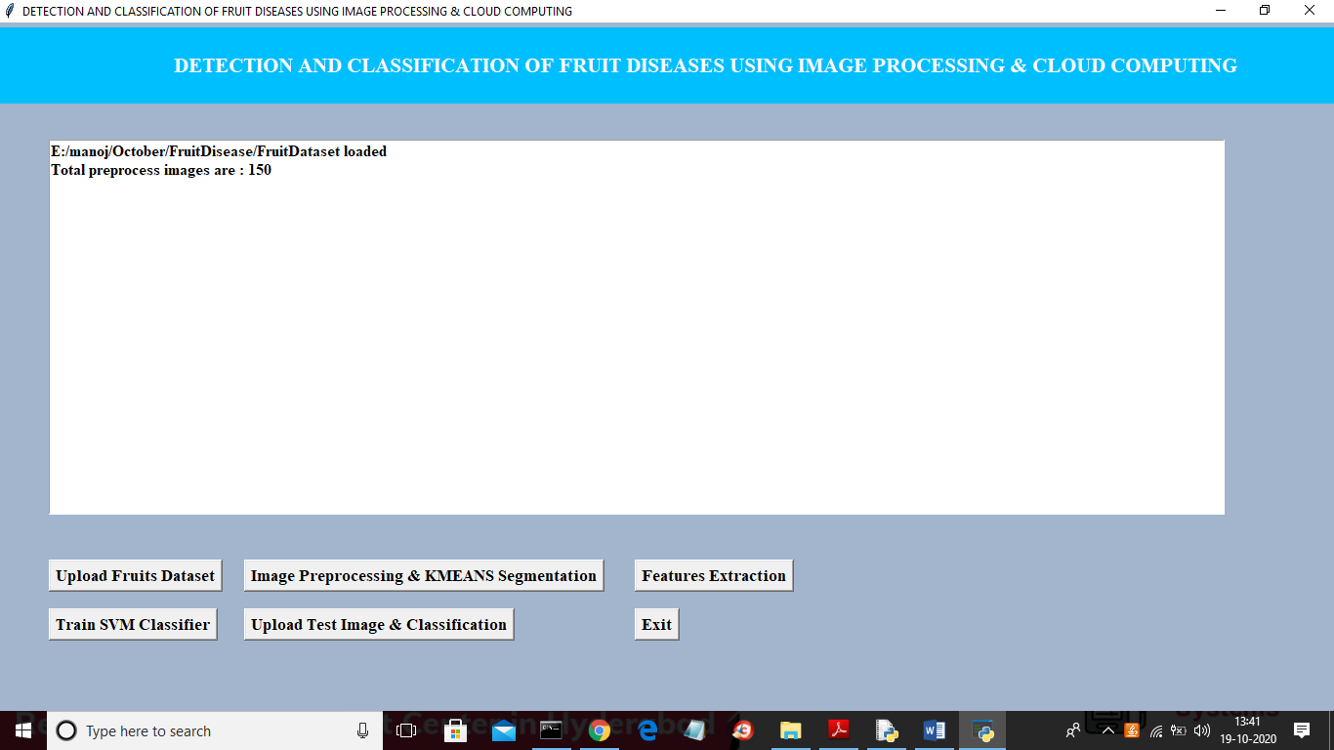
In above screen all 150 images read from dataset and then preprocess and segment it to build train model and now click on ‘Features Extraction’ button to convert image data into features
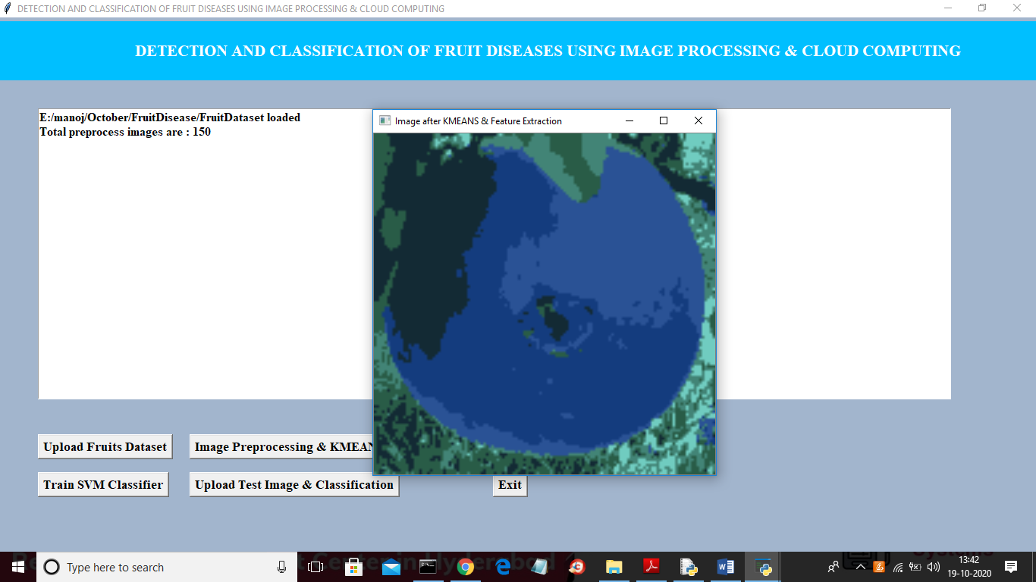
In above screen I am showing one image as segmented image where u can see all similar colours pixels are in one place and now close above image to get train data details
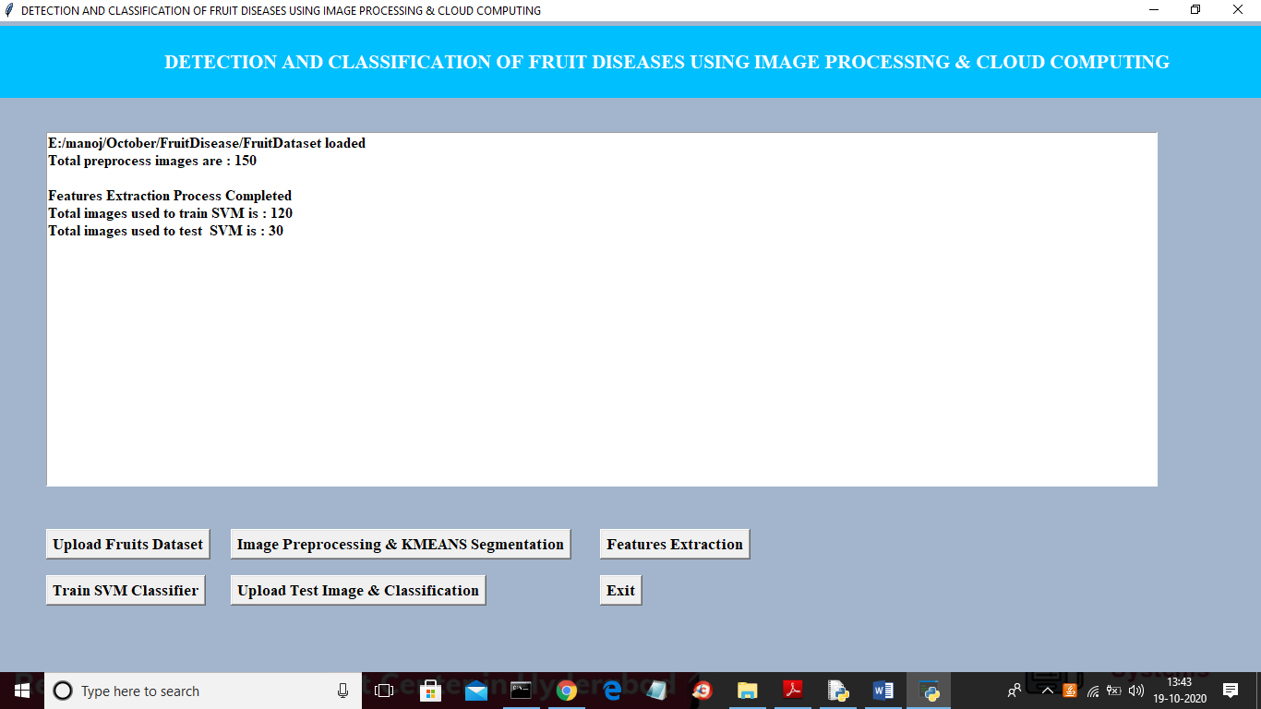
In above screen we can see out of total 150 images application using 120 (80%) images to train model and 30 (20%) images for testing. Now both train and test images data is ready and now click on ‘Train SVM Classifier’ button to train SVM with above train and test data and then calculate prediction accuracy
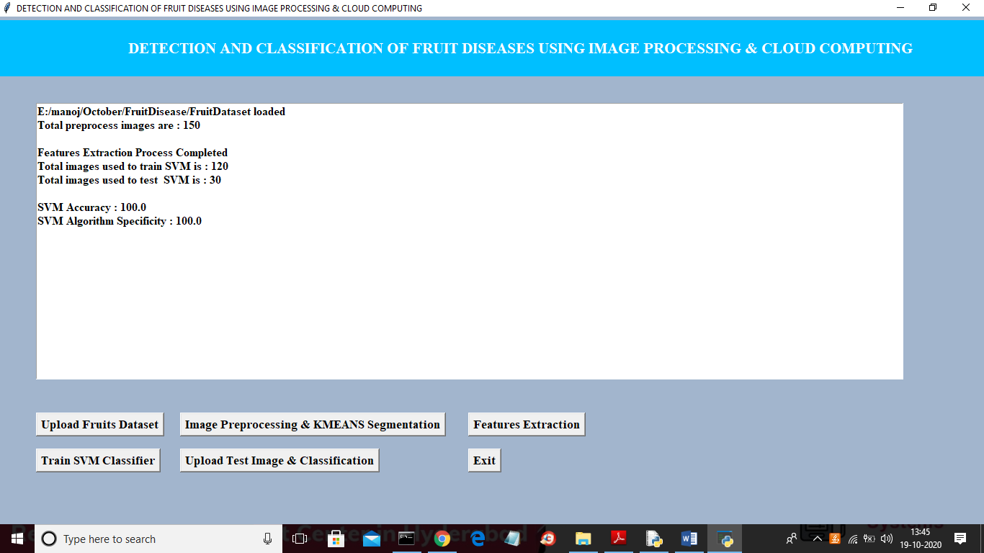
In above screen SVM classifier model is generated with prediction accuracy and specificity as 100% and now click on ‘Upload Test Image & Classification’ button to upload any test image and predict disease
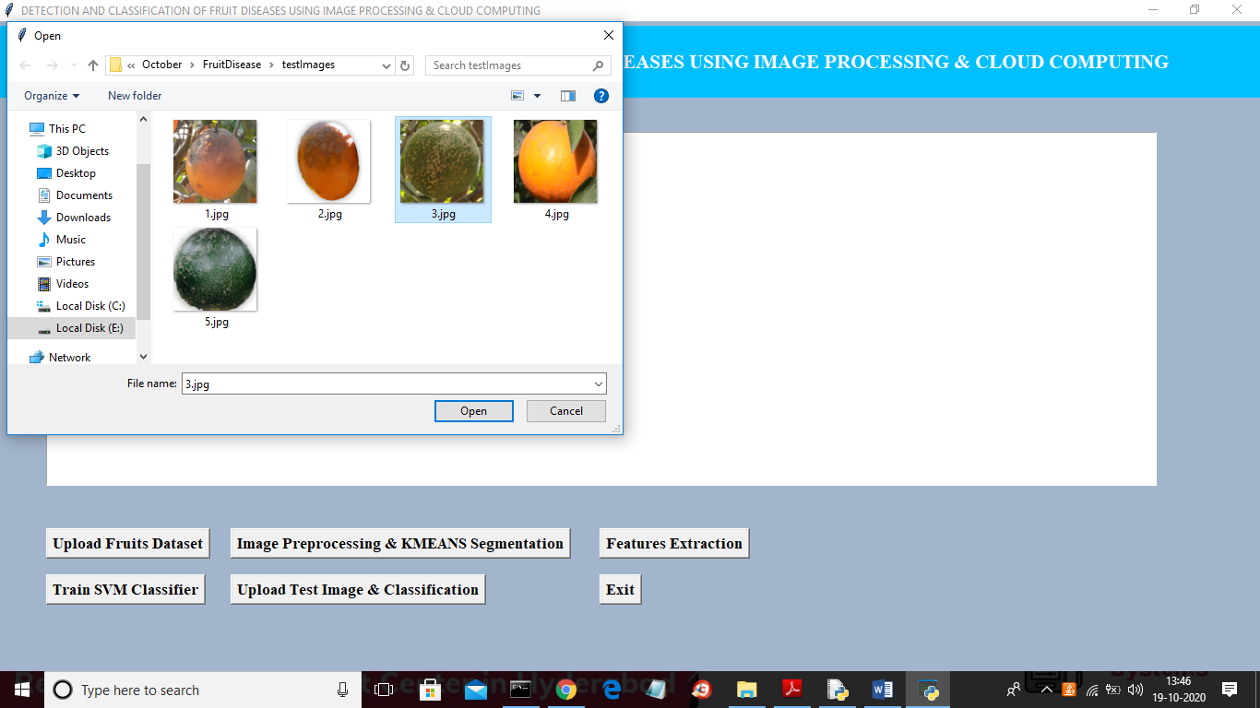
In above screen uploading test image as 3.jpg and then click on ‘Open’ button to classify image
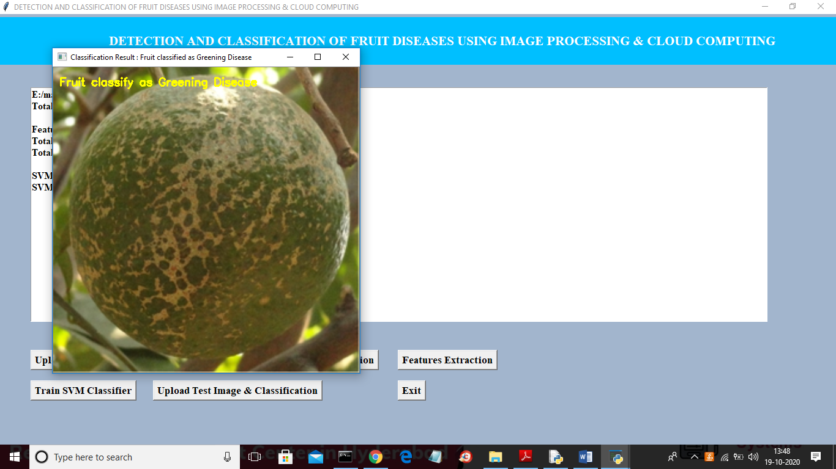
In above screen image is classified as ‘Greening Disease’ and now upload another image and test
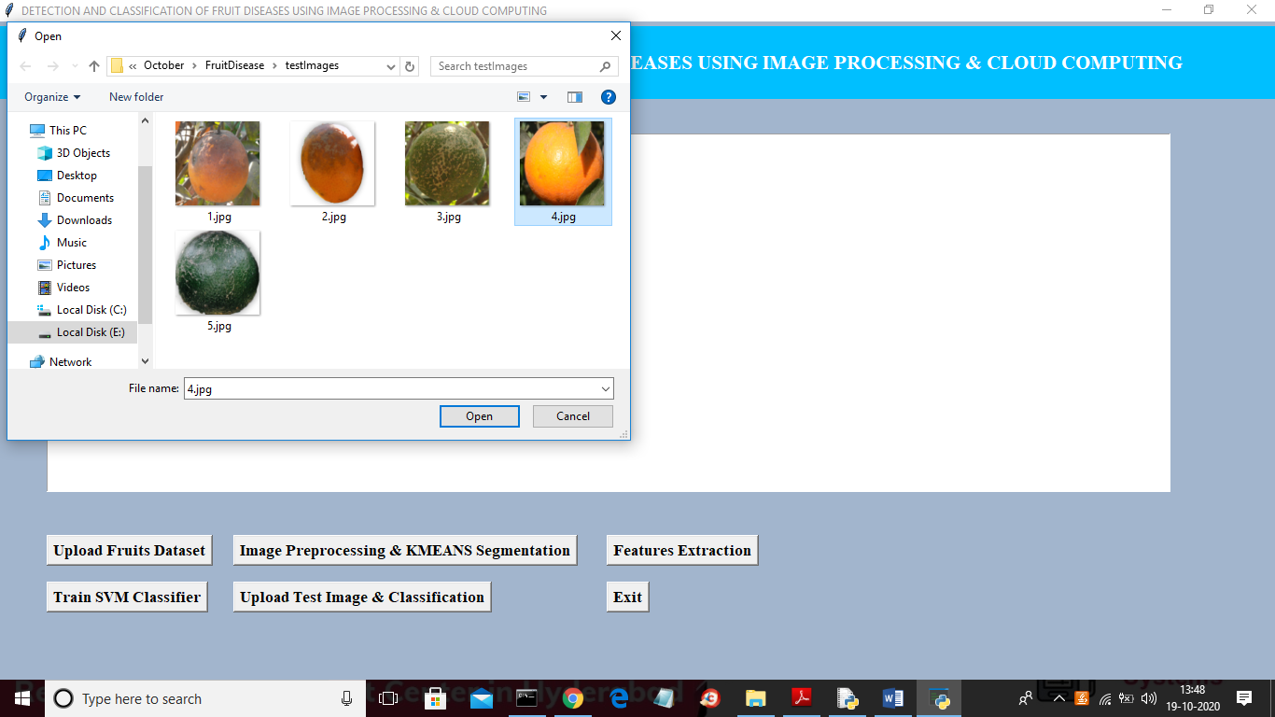
In above screen uploading ‘4.jpg’ and then click on ‘Open’ button to get below result
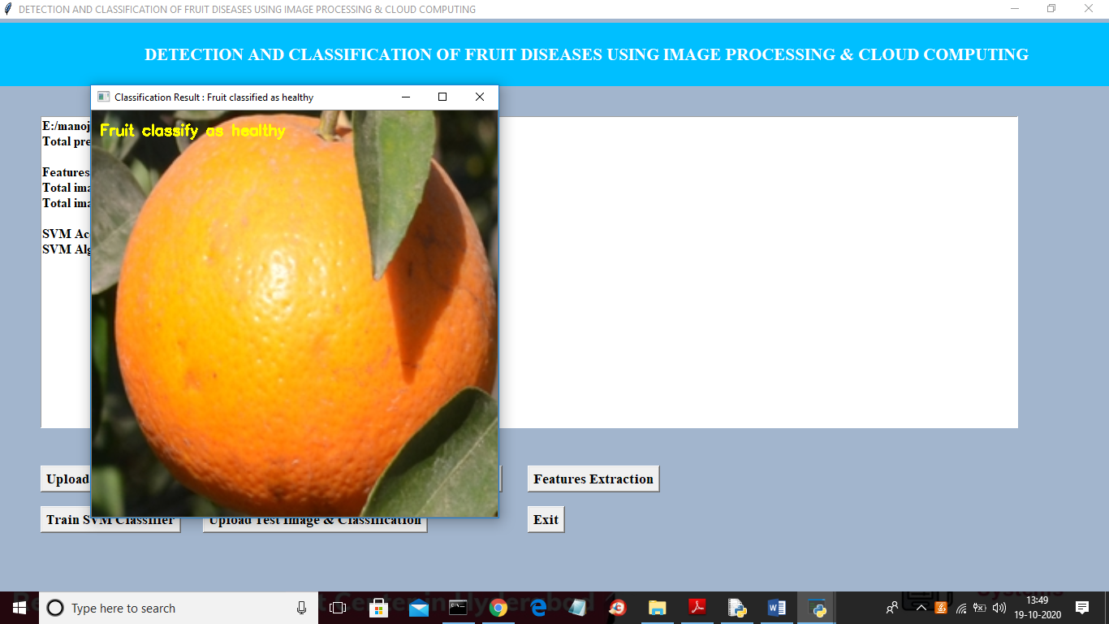
In above screen uploaded image is classified as Healthy. Similarly you can upload any image and classify it disease.

