
DEPARTMENT OF COMPUTER SCIENCE AND ENGINEERING
A
PROJECT REPORT
ON

"WINDMILLS- A RENEWABLE SOURSE OF ENERGY”

SUBMITTED BY. ROLL.NO.

HARDIK P. RUNWAL . 04
MRUNAL JAIN. 67
SAMIKSHA S. GAIKWAD. 02
RAJAL A. PATIL. 19
ADITI S. PUNEKAR. 20

Under the Guidance of
MS. RUKADE SUNEETA KALLAPPA


YEAR: 2016-2017
CERTIFICATE

This is to certify that the students,
Name of student. Roll. No.
HARDIK P. RUNWAL . 04
MRUNAL JAIN. 67
SAMIKSHA S. GAIKWAD. 02
RAJAL A. PATIL. 19
ADITI S. PUNEKAR. 20

S.E. computer science and engineering Students were satisfactorily completed Environmental Science Project work on “Windmills- a renewable source of energy” towards the partial fulfillment of the award of Bachelor of Engineering (Computer science and Engineering) Degree as laid by the Shivaji University, Kolhapur, during the academic year 2016-17.

Ms. Rukade Suneeta Kallappa Mrs. Kelkar
Project guide H. O. D.

ACKNOWLEDGEMENT

We express our sincere thanks to Director Dr. V. A. Raikar and our college for providing us with a platform to excel in life.
With a sense of regard and gratitude to our project, we would like to thank our guide Ms. Suneeta Rukade. for her guidance, interest and constructive suggestion during the study course.
This project would not have been possible without her support and help. We thank her for his valuable and immense knowledge and timely help, which made this, project a reality. We would also like to thank our H.O.D. Mrs Kelkar.
We are very Thankful to theses who help directly &indirectly to carry out this Project.

Date:
Place: Kolhapur

DECLARATION
We are hereby declaring that, the project entitled “Windmills- a renewable source of energy” is our original work carried out by us, under the subject of Environmental studies .The empirical findings in this report are based on the data collected by us. The matter assimilated in this report is not reproduction from any readymade report. This project or part of it has not been submitted previously for any other degree or any other purpose.
Place: - Atigre
Date:

Name Signature
HARDIK P. RUNWAL .
MRUNAL JAIN.
SAMIKSHA S. GAIKWAD.
RAJAL A. PATIL.
ADITI S. PUNEKAR.

INDEX
No. |  | CONTENTS | PAGE NO.
1 |  | Introduction | 6-7
 | 1.1 | Objective | 7
 | 1.2 | Hypothesis | 7
2 |  | Methodology | 8-23
 | 2.1 | Renewable Energy Resources | 8
 | 2.2 | Wind power In India | 8
 | 2.3 | Wind Turbines: The Electricity Generators | 13
 | 2.4 | How Electricity Is Generated In Windmills | 16
 | 2.5 | Environmental Impact Of Windmills | 19
 | 2.6 | Advantages And Disadvantages Of Windmills | 21
3 |  | Result | 23
4 |  | Conclusion | 24
5 |  | Summary | 25
6 |  | Reference | 26

1. INTRODUCTION:
A windmill is a machine which converts the energy of wind into rotational energy by means of vanes called sails or blades. Originally windmills were developed for milling grain for food production. In the course of history the windmill was adapted to many other industrial uses. An important application was to pump water. Windmills used for generating electricity are commonly known as wind turbines. Wind power is the conversion of wind energy into a useful form of energy, such as using wind turbines to make electricity, windmills for mechanical power, wind pumps for water pumping or drainage, or sails to propel ships.
The total amount of economically extractable power available from the wind is considerably more than present human power use from all sources. At the end of 2010, worldwide nameplate capacity of wind-powered generators was 197 giga watts (GW Wind power now has the capacity to generate 430 TWh annually, which is about 2.5% of worldwide electricity usage. Over the past five years the average annual growth in new installations has been 27.6 percent. Wind power market penetration is expected to reach 3.35 percent by 2013 and 8 percent by 2018. Several countries have already achieved relatively high levels of wind power penetration, such as 21% of stationary electricity production in Denmark, 18% in Portugal, 16% in Spain, 14% inIreland and 9% in Germany in 2010. As of 2011, 83 countries around the world are using wind power on a commercial basis. A large wind farm may consist of several hundred individual wind turbines which are connected to the electric power transmission network. Offshore wind power can harness the better wind speeds that are available offshore compared to on land, so offshore wind power’s contribution in terms of electricity supplied is higher. Small onshore wind facilities are used to provide electricity to isolated locations and utility companies increasingly buy back surplus electricity produced by small domestic wind turbines. Although a variable source of power, the intermittency of wind seldom creates problems when using wind power to supply up to 20% of total electricity demand, but as the proportion rises, increased costs, a need to use storage such as pumped-storage hydroelectricity, upgrade the grid, or a lowered ability to supplant conventional production may occur. Power management techniques such as excess capacity, storage, dispatchable backing supply (usually natural gas), exporting and importing power to neighboring areas or reducing demand when wind production is low, can mitigate these problems.
Wind power, as an alternative to fossil fuels, is plentiful, renewable, widely distributed, clean, produces no greenhouse gas emissions during operation, and uses little land. In operation, the overall cost per unit of energy produced is similar to the cost for new coal and natural gas installations. The construction of wind farms is not universally welcomed, but any effects on the environment from wind power are generally much less problematic than those of any other power source.

1. OBJECTIVE:
- To study the wind mills as renewable source of energy.
- To study the production of wind energy in windmills.
- To study the impact of wind mills on environment.

2. HYPOTHESIS:
- Wind turbine is suitable to install in remote rural area, water pumping and grinding mills.
- The total cost can be cheaper than solar system but more expensive than hydro.
- Reduces or even eliminates the cost of electricity.
- Allows you to tap into the abundance of free renewable wind energy that is literally in-your-face everyday.
2. Methodology

2.1. RENEWABLE ENERGY RESOURCES:-
Renewable resources can be generated continuously in nature and are inexhaustible. Renewable energy effectively uses natural resources such as sunlight, wind, rain, tides and geothermal heat, which are naturally replenished. The Renewable energy technology range from solar power, wind power, hydroelectricity/ micro hydro, biomass and biofuels for transporation.
In 2006, about 18 percent of global final energy consumption came from renewables, with 13% coming from traditional biomass, like wood-burning. Hydropower was the next largest renewable source providing 3%. Modern technologies, such as geothermal, wind, solar and ocean energy together provided some 0.8% of final energy consumption.

2.2WIND POWER IN INDIA:
The development of wind power in India began in the 1990s, and has significantly increased in the last few years. Although a relative newcomer to the wind industry compared with Denmark or the United States, India has the fifth largest installed wind power capacity in the world. In 2009-10 India's growth rate was highest among the other top four countries.
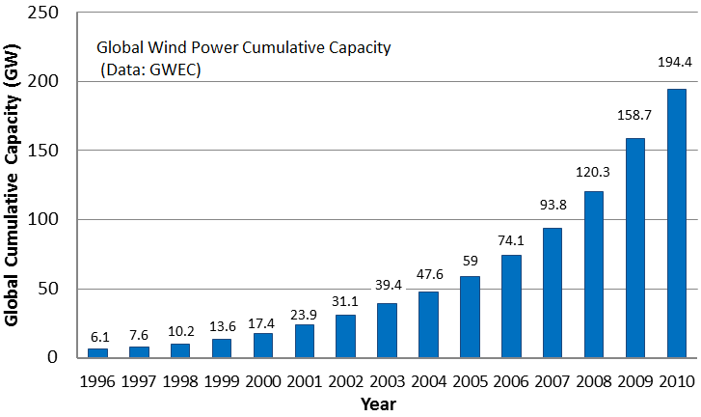

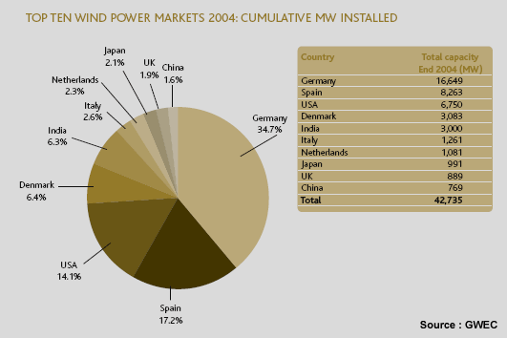

- World Market Share:
According to REN21- Global Status Report 2011 (GSR-2011), Indian company Suzlon was among top ten manufacturers of Wind Turbine manufacturer’s in the world with world market share of 6.7%. Also major world companies are pouring into the fast evolving Wind Energy market in India: Vestas, GE Wind, Enercon and Gamesa have already opened up their establishments across various cities in India.

- Government Support and Policies:
Several states have come up with renewable energy policies likeKarnataka, Tamil Nadu and Andhra Pradesh.

- Installed Capacity:
According to MNRE‘s achievent report, The cumulative installed capacity of Grid Interactive Wind Energy in India by the end of September 2011 was 14989MW (of which 833MW was installed during 2011-2012 against a target of 2400MW). Aerogenerators and hybrid systems contributed 1.20MW during 2011-12 to yield cumulative off-grid wind capacity of 15.55MW.
India in the windy world:
In 2008, India shared 6.58% of total wind energy installed capacity around the world, according to World Wind Energy Report-2008. According to GSR-2011, the world witnessed highest renewable energy installations through wind energy. Total installed capacity of wind energy reached 198GW by the end of 2010. India ranked third in the world in annual capacity additions and fifth in terms of total wind energy installed capacity. India has been able to fast pace its growth in wind energy installations and bring down costs of power production.
- Clean Wind to overcome power shortage:
Electricity losses in India during transmission and distribution have been extremely high over the years and this reached a worst proportion of about 24.7% during 2010-11. India is in a pressing need to tide over a peak power shortfall of 13% by reducing losses due to theft. Theft of electricity, common in most parts of urban India, amounts to 1.5% of India’s GDP. Due to shortage of electricity, power cuts are common throughout India and this has adversely affected the country’s economic growth. Hence a cheaper, non-polluting and environment friendly solution to power rural India is needed.
- Wind energy as job generator:
Wind energy utilization creates many more jobs than centralized, non-renewable energy sources. Wind Energy companies have opened up huge career options. Also the ease and accessibility of manufacturing technology has given entrepreneurs with new business options to venture in. The wind sector worldwide has become a major job generator: Within only three years, the wind sector worldwide almost doubled the number of jobs from 235,000 in 2005 to 440,000 in the year 2008. These highly skilled employees are contributing to the generation of 260 TWh of electricity.

WINDMILL PROJECTS IN INDIA
POWER PLANT | PRODUCER | LOCATION | STATE | TOTAL CAPACITY (MWE)
Vankusawade Wind Park | Suzlon Energy Ltd. | Satara Dist. | Maharashtra | 259
Cape Comorin | Aban Loyd Chiles Offshore Ltd. | Kanyakumari | Tamil Nadu | 33
Kayathar Subhash | Subhash Ltd. | Kayathar | Tamil Nadu | 30
Ramakkalmedu | Subhash Ltd. | Ramakkalmedu | Kerala | 25
Muppandal Wind | Muppandal Wind Farm | Muppandal | Tamil Nadu | 22
Gudimangalam | Gudimangalam Wind Farm | Gudimangalam | Tamil Nadu | 21
Puthlur RCI | Wescare (India) Ltd. | Puthlur | Andhra Pradesh | 20
Lamda Danida | Danida India Ltd. | Lamda | Gujarat | 15
Chennai Mohan | Mohan Breweries & Distilleries Ltd. | Chennai | Tamil Nadu | 15
Jamgudrani MP | MP Windfarms Ltd. | Dewas | Madhya Pradesh | 14
Jogmatti BSES | BSES Ltd. | Chitradurga Dist | Karnataka | 14
Perungudi Newam | Newam Power Company Ltd. | Perungudi | Tamil Nadu | 12
Kethanur Wind Farm | Kethanur Wind Farm | Kethanur | Tamil Nadu | 11
Hyderabad APSRTC | Andhra Pradesh State Road Transport Corp. | Hyderabad | Andhra Pradesh | 10
Muppandal Madras | Madras Cements Ltd. | Muppandal | Tamil Nadu | 10
Poolavadi Chettinad | Chettinad Cement Corp. Ltd. | Poolavadi | Tamil Nadu | 10
Shalivahana Wind | Shalivahana Green Energy. Ltd. | Tirupur | Tamil Nadu | 20.4

2.3.WIND TURBINES: THE ELECTRICITY GENERATORS:
Wind turbine is a device that converts kinetic energy from the wind into mechanical energy. If the mechanical energy is used to produce electricity, the device may be called a wind generator or wind charger. If the mechanical energy is used to drive machinery, such as for grinding grain or pumping water, the device is called a windmill or wind pump. Developed for over a millennium, today's wind turbines are manufactured in a range of vertical and horizontal axis types. The smallest turbines are used for applications such as battery charging or auxiliary power on sailing boats; while large grid-connected arrays of turbines are becoming an increasingly large source of commercial electric power.

TYPES
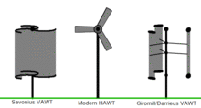

The three primary types:VAWT Savonius, HAWT towered; VAWT Darrieus as they appear in operation. Wind turbines can rotate about either a horizontal or a vertical axis, the former being both older and more common.
- Horizontal axis
Horizontal-axis wind turbines (HAWT) have the main rotor shaft and electrical generator at the top of a tower, and must be pointed into the wind. Small turbines are pointed by a simple wind vane, while large turbines generally use a wind sensor coupled with a servo motor. Most have a gearbox, which turns the slow rotation of the blades into a quicker rotation that is more suitable to drive an electrical generator. Since a tower produces turbulence behind it, the turbine is usually positioned upwind of its supporting tower. Turbine blades are made stiff to prevent the blades from being pushed into the tower by high winds. Additionally, the blades are placed a considerable distance in front of the tower and are sometimes tilted forward into the wind a small amount.
Downwind machines have been built, despite the problem of turbulence (mast wake), because they don't need an additional mechanism for keeping them in line with the wind, and because in high winds the blades can be allowed to bend which reduces their swept area and thus their wind resistance. Since cyclical (that is repetitive) turbulence may lead to fatigue failures, most HAWTs are of upwind design. Turbines used in wind farms for commercial production of electric power are usually three-bladed and pointed into the wind by computer-controlled motors. These have high tip speeds of over 320 km/h (200 mph), high efficiency, and low torque ripple, which contribute to good reliability. The blades are usually colored light gray to blend in with the clouds and range in length from 20 to 40 metres (66 to 130 ft) or more. The tubular steel towers range from 60 to 90 metres (200 to 300 ft) tall. The blades rotate at 10 to 22 revolutions per minute. At 22 rotations per minute the tip speed exceeds 90 metres per second (300 ft/s). A gear box is commonly used for stepping up the speed of the generator, although designs may also use direct drive of an annular generator. Some models operate at constant speed, but more energy can be collected by variable-speed turbines which use a solid-state power converter to interface to the transmission system. All turbines are equipped with protective features to avoid damage at high wind speeds, by feathering the blades into the wind which ceases their rotation, supplemented by brakes.
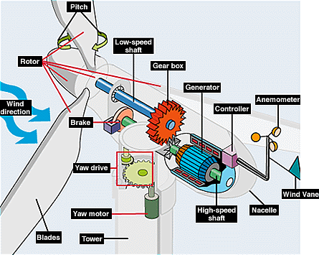
COMPONENTS OF HORIZONTAL AXIS WIND MILLS

Vertical axis design :
Vertical-axis wind turbines (or VAWTs) have the main rotor shaft arranged vertically. Key advantages of this arrangement are that the turbine does not need to be pointed into the wind to be effective. This is an advantage on sites where the wind direction is highly variable, for example when integrated into buildings. The key disadvantages include the low rotational speed with the consequential higher torque and hence higher cost of the drive train, the inherently lower power coefficient, the 360 degree rotation of the aerofoil within the wind flow during each cycle and hence the highly dynamic loading on the blade, the pulsating torque generated by some rotor designs on the drive train, and the difficulty of modelling the wind flow accurately and hence the challenges of analysing and designing the rotor prior to fabricating a prototype. With a vertical axis, the generator and gearbox can be placed near the ground, using a direct drive from the rotor assembly to the ground-based gearbox, hence improving accessibility for maintenance.
When a turbine is mounted on a rooftop, the building generally redirects wind over the roof and this cans double the wind speed at the turbine. If the height of the rooftop mounted turbine tower is approximately 50% of the building height, this is near the optimum for maximum wind energy and minimum wind turbulence. It should be borne in mind that wind speeds within the built environment are generally much lower than at exposed rural sites.
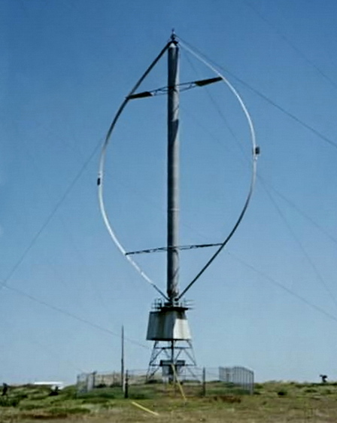
VERTICAL AXIS WIND MILLS

2.4. HOW ELECTRICITY IS GENERATED IN WINDMILLS

Windmills are not only beautiful structures, but also very practical structures. Windmills have been used throughout history for many purposes such as grinding wheat and grains. They are now used for generating electricity. Windmills harness the power of the wind. In order to understand how windmills work, let’s first explore how wind is formed and how it can be used for energy. Wind is air that is simply in motion; it is a renewable and a free type of energy. Wind is usually formed by the sun heating air on the surface of the earth unevenly. Since air over land heats faster than air over water, wind is usually found near the coasts and near lakes. As air over land heats up, it rises and leaves an empty space, which is filled by cooler air. The movement of this air results in wind.

Windmills are structures used to harness the energy of wind. As stated above, throughout history it was used for many different purposes, such as grinding wheat, but today, the vast majority of windmills are used to create electricity. Many people are familiar with the windmills located in Europe, specifically in Holland. Windmills use blades to gather wind that flows over it. Just like an airplane uses wings for lift, windmills use their blades for lift as well – in this case to turn the windmill. Windmills are pretty simple structures; their blades are connected to a drive shaft that is connected to an electric generator. As the blades turn, this turns the drive shaft and creates electricity. Electricity is sent through wires and collected.
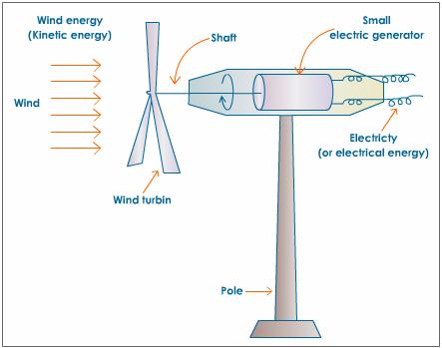

There are several different types of windmills, categorized by the direction in which their blades rotate. Two different types of windmills, most commonly called turbines when producing energy, are the horizontal axis turbines and the vertical axis turbines. Horizontal turbines are by far the most popular type of turbine and are the traditional type of windmill with blades that are similar to an airplane’s propeller.

Wind Turbines and Production of Electricity
Wind turbines come in many sizes; there are turbines with blades only a few feet in diameter and much larger wind turbines that span hundreds of feet across. Wind turbines can be used to create electricity for one home or for thousands of homes when working together collectively with hundreds of other wind turbines on a wind farm. Small wind turbines usually create about 100 kilowatts of energy or more, while large wind turbine farms can create several megawatts of electricity which can be consumed by an entire community.
Wind energy is a renewable form of energy. It is free to harness and doesn’t create pollution or contribute to global warming; however it does have a very big drawback. The drawback is that wind is never constant and another form of energy is needed to create electricity when there is no wind. Over the years, as research and technology have improved, windmills have dropped in price and have increased in effectiveness harnessing wind energy and changing it into electricity. In the years to come, expect to see more wind turbines being used around the world to create electricity for homes, businesses and industries.
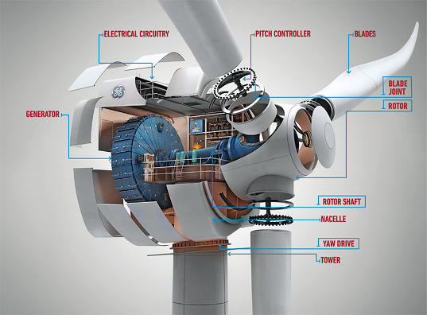
Wind power is converted into electricity by magnets moving past stationary coils of wire known as the stator. As the magnets pass the stator, AC electricity is produced. It is then converted into DC electricity which can be used to charge batteries which store the electrical energy or can also be fed into a grid interactive inverter for feeding power into the electricity grid.
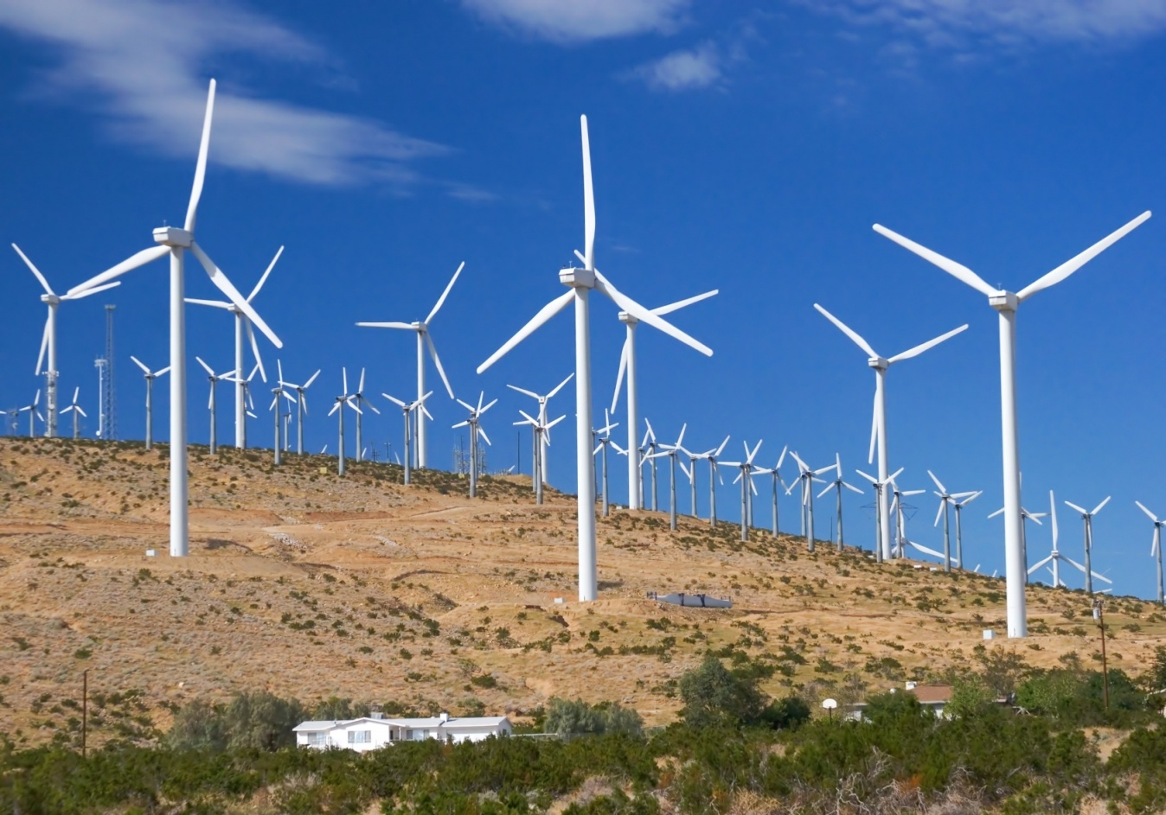

2.5. ENVIRONMENTAL IMPACT OF WINDMILLS:
Compared to the environmental impact of traditional energy sources, the environmental impact of wind power is relatively minor. Wind power consumes no fuel, and emits no air pollution, unlike fossil fuel power sources. The energy consumed to manufacture and transport the materials used to build a wind power plant is equal to the new energy produced by the plant within a few months. While a wind farm may cover a large area of land, many land uses such as agriculture are compatible, with only small areas of turbine foundations and infrastructure made unavailable for use. There are reports of bird and bat mortality at wind turbines as there are around other artificial structures. The scale of the ecological impact may or may not be significant, depending on specific circumstances. Prevention and mitigation of wildlife fatalities, and protection of peat bogs, affect the sitting and operation of wind turbines. There are anecdotal reports of negative effects from noise on people who live very close to wind turbines. Peer-reviewed research has generally not supported these statements.

CARBON DIOXIDE EMISSIONS AND POLLUTION
Wind power consumes no fuel and no water for continuing operation, and has no emissions directly related to electricity production. Wind turbines produce no carbon dioxide, carbon monoxide, sulfur dioxide, nitrogen dioxide, mercury, radioactive waste, particulates, or any other type of air pollution, unlike fossil fuel power sources. Wind power plants consume resources in manufacturing and construction. During manufacture of the wind turbine, steel, concrete, aluminium and other materials will have to be made and transported using energy-intensive processes, generally using fossil energy sources. A 2006 study found the CO₂ emissions of wind power to range from 14 to 33 tonnes (15 to 36 short tons) per GWh of energy produced. Most of the CO₂ emission comes from producing the concrete for wind-turbine foundations.

ECOLOGY :

Land Use:
Wind farms are often built on land that has already been impacted by land clearing. The vegetation clearing and ground disturbance required for wind farms is minimal compared with coal mines and coal-fired power stations. If wind farms are decommissioned, the landscape can be returned to its previous condition. Farmers and grazers often lease land to companies building wind farms. The land can still be used for farming and cattle grazing. Livestock are unaffected by the presence of wind farms. Wind-energy advocates contend that less than 1% of the land would be used for foundations and access roads, the other 99% could still be used for farming. Turbines are not generally installed in urban areas. Buildings interfere with wind, turbines must be sited a safe distance ("setback") from residences in case of failure, and the value of land is high.

Impact on wildlife :
Environmental assessments are routinely carried out for wind farm proposals, and potential impacts on the local environment (e.g. plants, animals, soils) are evaluated. Turbine locations and operations are often modified as part of the approval process to avoid or minimise impacts on threatened species and their habitats. Any unavoidable impacts can be offset with conservation improvements of similar ecosystems which are Noise.
Modern wind turbines produce significantly less noise than older designs. Turbine designers work to minimize noise, as noise reflects lost energy and output. Noise levels at nearby residences may be managed through the sitting of turbines, the approvals process for wind farms, and operational management of the wind farm.
Benefits of wind power:-
- Wind power is a clean energy source that can be relied on for the long-term future.
- A wind turbine creates reliable, cost-effective, pollution free energy. It is affordable, clean and sustainable.
- One wind turbine can be sufficient to generate energy for a household. Because wind is a source of energy which is non-polluting and renewable, wind turbines create power without using fossil fuels, without producing greenhouse gases or radioactive or toxic waste.
- Wind power reduces global warming.

2.6. ADVANTAGES AND DISADVANTAGES OF WINDMILLS
The advantages and disadvantages of wind power as a means to satisfy some or all of your own electricity needs are somewhat out of balance. Today the positives far out way the negatives thanks to current technology and quality homemade windmill plans.
No longer do you have to feel like a helpless victim of the escalating cost of energy because dramatically cutting your electricity bill is finally in your control. Consider the following if you are thinking about utilizing wind generated electricity.

THE ADVANTAGES OF WIND POWER:
- Reduces or even eliminates the cost of electricity
- Reduces dependence on power companies
- Excess electricity produced can be sold back to the power company at a profit
- Allows you to tap into the abundance of free renewable wind energy that is literally in-your-face everyday
- It is good for the environment because windmills produce no polluting exhaust
- It helps our country reduce its dependence on foreign oil
- Building a windmill can be a family bonding experience that can teach our next generation that everyone can have a significant impact on cutting energy costs while improving our environment
- The cost to operate a windmill is very low
- The simple design of a wind turbine means low maintenance costs - just install it and forget it.
- Wind energy is friendly to the surrounding environment, as no fossil fuels are burnt to generate electricity from wind energy.
- Wind turbines take up less space than the average power station. Windmills only have to occupy a few square meters for the base; this allows the land around the turbine to be used for many purposes, for example agriculture.
- Newer technologies are making the extraction of wind energy much more efficient. The wind is free, and we are able to cash in on this free source of energy.
- Wind turbines are a great resource to generate energy in remote locations, such as mountain communities and remote countryside. Wind turbines can be a range of different sizes in order to support varying population levels.
- Another advantage of wind energy is that when combined with solar electricity, this energy source is great for developed and developing countries to provide a steady, reliable supply of electricity.

THE DISADVANTAGES OF WIND POWER:
- It is weather dependent - no wind equals no electricity
- There is a dependence on the zoning rules of each community
- Purchasing commercial pre-build wind turbine systems can be costly and require 8 or more years to pay back the initial investment
- The solution for inconsistent wind is often solved by storing the windmill generated electricity in a battery bank. This combined with a hybrid system that also uses solar panels and has access to power off the grid will insure a continuous stream of power.
- The main disadvantage regarding wind power is down to the winds unreliability factor. In many areas, the winds strength is too low to support a wind turbine or wind farm, and this is where the use of solar power or geothermal power could be great alternatives.
- Winds turbines generally produce allot less electricity than the average fossil fuelled power station, requiring multiple wind turbines to be built in order to make an impact.
- Wind turbine construction can be very expensive and costly to surrounding wildlife during the build process.
- The noise pollution from commercial wind turbines is sometimes similar to a small jet engine. This is fine if you live miles away, where you will hardly notice the noise, but what if you live within a few hundred meters of a turbine? This is a major disadvantage.
- Protests and/or petitions usually confront any proposed wind farm development. People feel the countryside should be left in tact for everyone to enjoy its beauty.

Effects of Noise Pollution caused by Wind Mills:
- Contraction of blood vessels and muscles make the skin pain and also responsible for high blood pressure.
- It causes muscles to contract leading to nerve breakdown, tension and even insanity.
- I affect the health efficiency and person behavior, it may cause damage to heart, brain, kidney, liver, and may also produce emotional disturbance.
- Physiological disorders are also developed due to continuous exposure to noise. These are neurosis, hypertension, increase in sweating, and undesirable change in gastro-intenstinal activities, sleeplessness, hepatic diseases etc.It causes injuries to health to health of growing foetus also.

3: Results

- The wind energy is a renewable source of energy and it is generated in huge amount and utilized in India.
- It reduces the load of the energy generation of non-renewable sources. India is 5th largest country generating wind energy.
- This generation of wind energy is profitable and safe as it makes less pollution and had less adverse impact on environment.

4. Conclusion

Wind power can be an excellent complement to a solar power system. Here in India, when the sun isn't shining, the wind is usually blowing. Wind power is especially helpful here in the winter to capture both the ferocious and gentle mountain winds during the times of least sunlight and highest power use. In most locations wind is not suitable as the only source of power--it simply fills in the gaps left by solar power quite nicely.The power available in the wind goes up by a factor of 8 as the windspeed doubles.
Other critical factors are rotor size and tower height. The power a wind turbine can harvest goes up by at least a factor of 4 as you double the rotor size. And making a tower higher gets you above turbulence for better performance and greatly increased power output. Putting a wind turbine on a short tower is like mounting solar panels in the shade!

5. Summary

A windmill is a machine which converts the energy of wind into rotational energy by means of vanes called sails or blades. Wind power is the conversion of wind energy into a useful form of energy. Wind energy utilization creates many more jobs than centralized, non-renewable energy sources. Wind turbine is a device that converts kinetic energy from the wind into mechanical energy.
Windmills use blades to gather wind that flows over it. Just like an airplane uses wings for lift, windmills use their blades for lift as well – in this case to turn the windmill.Compared to the environmental impact of traditional energy sources, the environmental impact of wind power is relatively minor.Environmental assessments are routinely carried out for wind farm proposals, and potential impacts on the local environment (e.g. plants, animals, soils) are evaluated. Wind farms may affect weather in their immediate vicinity.

6. References

1] sciencing.com/build-kids-project-electricity-windmills-6635918.html
2] https://simple.wikipedia.org/wiki/Windmill
3] www.builditsolar.com/Projects/Wind/wind.html
4] www.conserve-energy-future.com/how-windmills-work.php

