FNP Sales Analysis Dashboard
A fully interactive Sales Analysis Dashboard built in Microsoft Excel using Pivot Tables, Pivot Charts, Slicers, and KPI Cards.

Project Overview
This project analyzes sales performance, customer spending behavior, delivery trends, product revenue, and city-wise order distribution. The dashboard transforms raw sales data into meaningful business insights.

Dashboard Preview
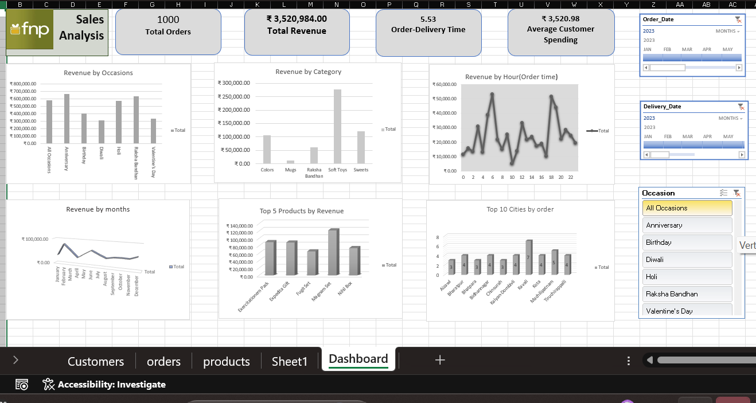

Features
- KPI Cards: Total Orders, Total Revenue, Average Delivery Time, Average Customer Spending
- Revenue by Occasion Analysis
- Revenue by Product Category
- Revenue by Hour (Order Time)
- Monthly Revenue Trends
- Top 5 Products by Revenue
- Top 10 Cities by Orders
- Interactive Slicers for dynamic filtering

Tools & Skills Used
- Microsoft Excel
- Pivot Tables
- Pivot Charts
- Slicers
- Data Cleaning
- Dashboard Design
- Business Analytics

Dataset Sheets
- Customers
- Orders
- Products
- Dashboard

Business Insights
- Identify high-revenue occasions
- Find top-selling products
- Analyze customer spending behavior
- Track monthly sales performance
- Identify peak order timings
- Compare city-wise order volume

Future Improvements
- Power BI version of dashboard
- SQL integration
- Automated refresh using Power Query
- Sales forecasting
- Customer segmentation analysis

Author
Samiksha Sakpal
Aspiring Data Analyst

