Samiksha Singh, Spring’2025
Decoding Liberal vs. Conservative Sentiment on Trump’s Trade Tariffs: A Reddit Discussion Analysis (1498 words)
Introduction
The Trump administration introduced a series of tariffs targeting Canada, Mexico, and China with the intent of restructuring trade agreements and addressing trade imbalances (Thorbecke, 2025). These tariffs altered economic dynamics, leading to price fluctuations, shifts in supply chains, and diplomatic responses from affected nations. The administration formally announced these measures to protect American industries and enforce fair trade practices (The White House, 2025). While certain sectors benefited from the protectionist stance, the broader economic implications—such as retaliatory tariffs and market instability—sparked debate among economists and policymakers (Bown & Kolb, 2020).
Social media platforms like Reddit serve as important arenas for public discourse, where individuals across the political spectrum discuss and debate economic policies. This study examines public engagement with Trump’s trade tariffs by analysing sentiment among two politically distinct groups—liberals and conservatives. By applying sentiment analysis to Reddit discussions, the research seeks to provide insight into how each group perceives and reacts to trade policies, offering a broader understanding of ideological divides between them.

Research Question
How do liberal and conservative Reddit communities express sentiment differently when discussing Trump’s trade tariffs?

Method
Data
The dataset consists of a total of 500 comments, with 250 comments each from r/politics and r/conservative, representing liberal and conservative perspectives, respectively. These subreddits were selected because they are known to lean ideologically and regularly host discussions on national policy issues, including trade.
To ensure relevance, data was gathered using Reddit’s “hot” algorithm, which surfaces posts with high engagement and current visibility. Since the topic was relatively new and attracted limited first-level comments, seven posts from r/conservative and two posts from r/politics were selected to meet the target of 250 comments per subreddit. Only first-level comments—those made directly on the post—were collected to maintain context and relevance to the main discussion. The keywords used for filtering content were “tariff” and “trade,” and they were not case-sensitive.
The data collection period spans from February 1st, 2025, to March 31st, 2025, beginning with the date the tariff policy was enacted. This timeframe was chosen to capture both immediate and sustained public reactions.
The PRAW (Python Reddit API Wrapper) library was used to extract comments from selected post IDs based on their URLs, and the raw data was stored in CSV files. The extracted information included author, text(comment), date, and score (upvotes or downvotes). Comments were then separated into two files—one for liberal subreddit comments and one for conservative. As a final step, manual cleaning was performed to remove any comments that were marked as removed or deleted or clearly added by bots.
Analysis
After the datasets were ready, preprocessing was implemented that included stripping extra white spaces, removing hyperlinks, and checking for missing values. The cleaned liberal and conservative comment datasets were stored in separate pre-processed CSV files.
For sentiment evaluation, the VADER (Valence Aware Dictionary and sEntiment Reasoner) tool was employed. Each comment was passed through VADER to compute sentiment polarity scores—positive, negative, neutral, and a compound score ranging from -1 (very negative) to 1 (very positive). Based on the compound score, sentiment categories were defined using a custom function that binned scores into five evenly spaced categories: Very Negative, Negative, Near Neutral, Positive, and Very Positive (Table 1).
These categories were then used to generate comparative visualizations.
Visualizations created using matplotlib and seaborn included:
- KDE Plots to depict compound sentiment distribution (Fig 1),
- Bar Charts for categorical sentiment comparisons (Fig 2),
- Grouped Bar Plots showing average polarity across groups (Fig 3),
- Line Charts tracking average sentiment over time (Fig 4).
Two new CSV files were then generated—one for liberal comments and one for conservative comments—each containing additional columns for the VADER-generated sentiment scores: negative, positive, neutral, and compound. To complement polarity analysis, the EMPATH lexicon-based tool was applied on the newly generated csv files. EMPATH extracted scores across predefined lexical categories (e.g., business, economics, fear, anger, suffering, swearing_terms) using a custom function. These category scores were aggregated and normalized separately for liberals and conservatives to understand topical focus and emotional tone. The results were visualized using stacked bar charts to highlight ideological variations (Fig 5).

Compound Score Range | Sentiment Category
score > 0.5 | Very Positive
0.1 < score ≤ 0.5 | Positive
-0.1 < score ≤ 0.1 | Near Neutral
-0.5 < score ≤ -0.1 | Negative
score ≤ -0.5 | Very Negative
Table 1: Compound Score Range and Corresponding Sentiment Categories
Results

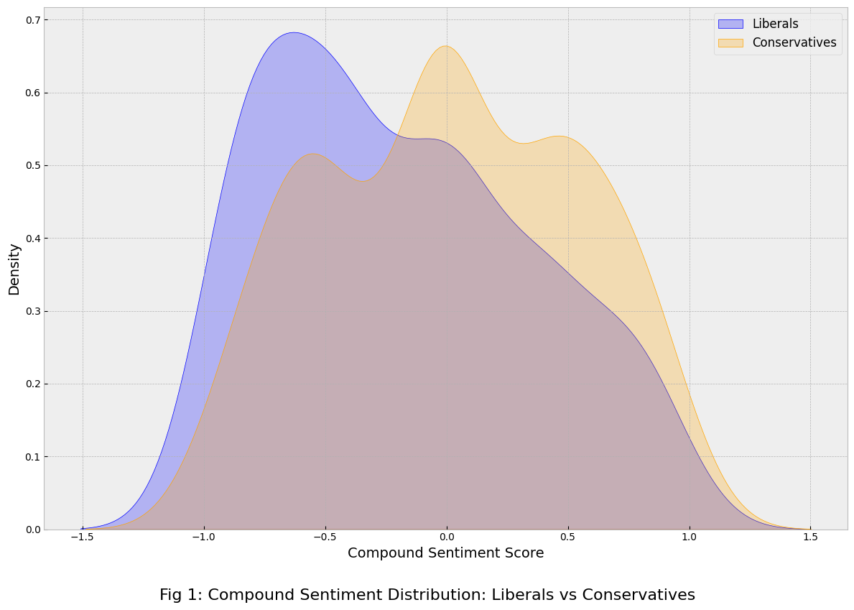
Fig 1 illustrates the distribution of compound sentiment scores across liberal and conservative Reddit comments. The liberal curve peaks sharply in the negative range, indicating that users in r/politics predominantly expressed negative sentiment toward Trump’s trade tariffs. In contrast, the conservative curve is more centred and slightly shifted toward the positive side, suggesting that r/conservative users responded with more neutral or positive sentiment. This divergence reflects: liberal users often criticized the tariffs for their potential economic fallout and international implications, while conservative users tend to support the policy as consistent with the “America First” agenda. For example, rising import prices might prompt liberals to complain about consumer costs, while conservatives might praise the policy for protecting domestic industries—highlighting how the same event is emotionally interpreted through different political lenses.

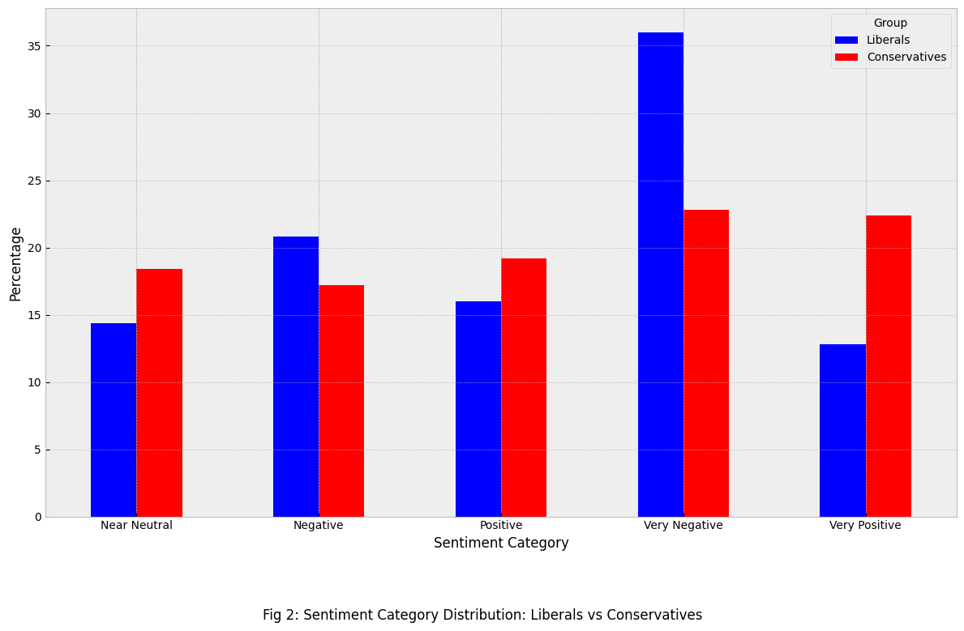
Fig 2 compares sentiment categories between liberal and conservative Reddit users discussing Trump’s trade tariffs. Liberals showed a stronger lean toward Very Negative and Negative sentiments, while conservatives exhibited more Positive and Very Positive responses. This variation reflects ideological framing—liberals often emphasize potential social or diplomatic fallout, whereas conservatives may interpret the same policy as a show of national strength. For example, while liberals might express concern over rising vehicle costs due to tariffs on automobile parts from China, conservatives may support such measures as necessary responses to geopolitical threats. This is particularly evident in the context of U.S.–China tensions, where Chinese cyber and intelligence operations have been portrayed as ongoing threats to U.S. national security (Borger, 2025).

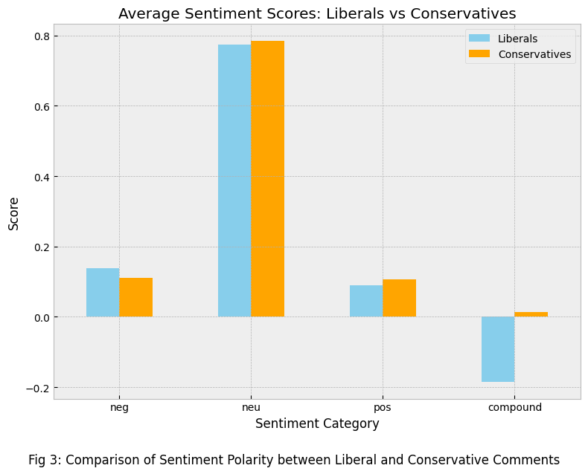
Fig 3 compares the average sentiment polarity scores—negative, neutral, positive, and compound—between liberal and conservative Reddit comments on Trump’s trade tariffs. While both groups exhibit high neutral scores, liberal users show a higher average negative score and a lower compound score, indicating a more critical tone overall. In contrast, conservatives display slightly higher positive sentiment and a marginally positive compound score, reflecting a more supportive stance. These differences suggest that political ideology significantly influences how economic policies are emotionally interpreted. For instance, in the recent Canada–U.S. tariff dispute, Trump’s retaliatory actions and mocking remarks about Canada becoming the 51st U.S. state sparked backlash from liberal voices concerned about national sovereignty and food insecurity, while conservatives largely framed it as a strong defence of American interests (Lobosco, 2025).
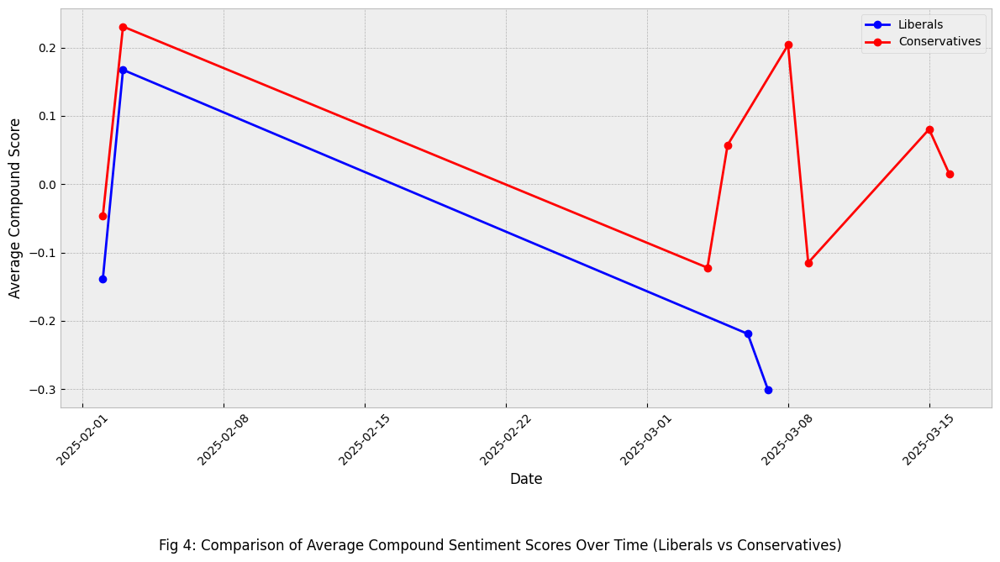
Fig 4 illustrates the trend of average compound sentiment scores over time between liberal and conservative Reddit users in response to Trump’s trade tariffs. Initially, both groups began with relatively positive sentiment in early February, but over time, a gradual decline is observed—especially among liberal users, whose sentiment steadily shifts toward the negative. Conservative sentiment remains more volatile but generally more positive, showing intermittent spikes. To interpret this shift, we can consider this that early in the policy cycle, U.S. tariffs and immigration restrictions may have seemed beneficial, potentially protecting domestic industries and signalling a tough stance on foreign competition. However, as other nations like Canada and China began asserting their own interests through counter-tariffs, the global economic balance shifted, introducing new costs and political tensions.
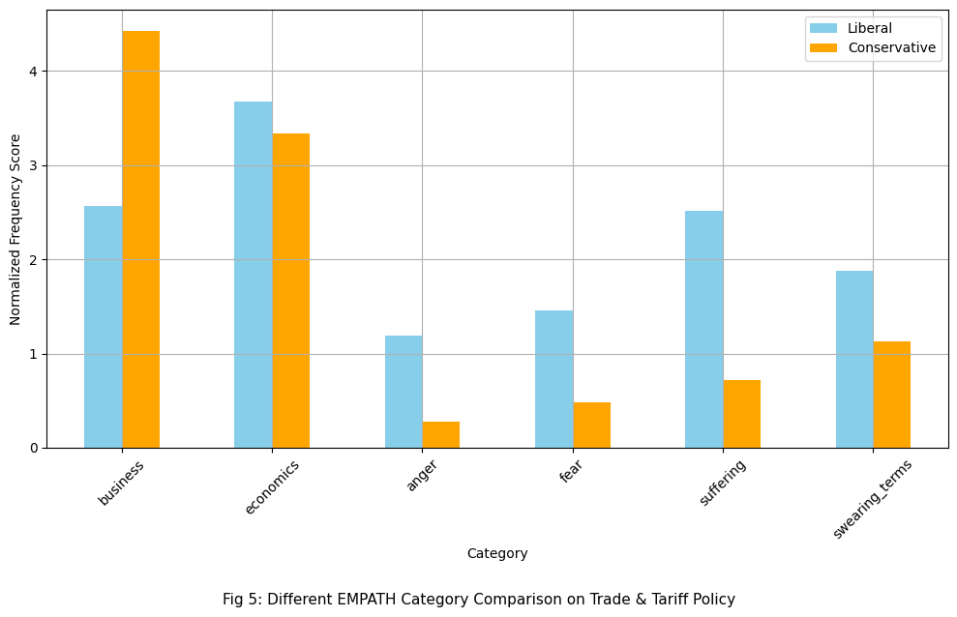
Fig 5 illustrates the differences between liberal and conservative Reddit users discussing trade and tariffs, as analysed through EMPATH category scores. Conservatives predominantly used terms related to business and economics, indicating a focus on market impacts and financial rationale, aligning with their support for protectionist policies. Liberals, conversely, exhibited higher frequencies in categories such as anger, fear, suffering, and swearing_terms, reflecting emotional responses and concerns over social consequences. For instance, while a conservative might comment on how tariffs "protect American manufacturing," a liberal might argue that such policies "hurt families with rising food costs," highlighting apprehensions about the human impact.
Conclusion
This study examined how liberal and conservative Reddit users responded to Trump’s trade tariffs. These findings, when viewed alongside real-world examples, indicate that liberals expressed predominantly negative sentiment, often focusing on issues like economic fallout and rising consumer costs. In contrast, conservatives tended to show more positive or neutral sentiment, emphasizing themes of national strength, economic protectionism, and policy justification. Over time, liberal sentiment declined steadily, while conservative sentiment remained relatively stable, with noticeable spikes. EMPATH analysis revealed distinct thematic focus—liberals used language reflecting emotional and social concerns, whereas conservatives concentrated on financial and nationalistic reasoning. These patterns collectively demonstrate how political ideology shapes sentiment in an online public discourse around revised trade policy.

Limitations
Firstly, the research focuses on an ongoing and evolving topic, with new developments occurring daily. As of April 2, 2025, President Trump plans to impose fresh tariffs, a day he has termed “liberation day,” adding further volatility to the policy landscape (CBS News, 2025). This dynamic nature means that significant and prolonged impacts are anticipated but have yet to fully materialize. Additionally, the study is based on a limited dataset of 500 comments, which may not capture the complete spectrum of public sentiment. Furthermore, continuous modifications and the introduction of new policies add complexity to the analysis, as the situation remains fluid and subject to change.

References
Bown, C. P., & Kolb, M. (2020). Trump’s trade war timeline: An up-to-date guide. Peterson Institute for International Economics. https://www.piie.com/blogs/trade-and-investment-policy-watch/2018/trumps-trade-war-timeline-date-guide
Thorbecke, C. (2025, March 6). Timeline of Trump tariffs on Canada, Mexico, and China. ABC News. https://abcnews.go.com/Business/timeline-trump-tariffs-canada-mexico-china/story?id=119506883
The White House. (2025, February). Fact sheet: President Donald J. Trump imposes tariffs on imports from Canada, Mexico, and China. https://www.whitehouse.gov/fact-sheets/2025/02/fact-sheet-president-donald-j-trump-imposes-tariffs-on-imports-from-canada-mexico-and-china/
u/Conservative. (2024, March 11). Trudeau tells Trump: “We will not back down” from tariffs [Online forum post]. Reddit. https://www.reddit.com/r/Conservative/comments/1j3gw1e/trudeau_tells_trump_we_will_not_back_down_from/
u/Conservative. (2024, February 24). Trump says Canada, Mexico, and China tariffs will stay [Online forum post]. Reddit. https://www.reddit.com/r/Conservative/comments/1ig07wo/trump_says_canada_mexico_and_china_tariffs_will/
u/Conservative. (2024, March 11). Trump says tariffs on Canada will increase if they retaliate [Online forum post]. Reddit. https://www.reddit.com/r/Conservative/comments/1j3iql5/trump_says_tariffs_on_canada_will_increase_if/
u/Conservative. (2024, February 24). Trump signs tariffs on imports from Canada, Mexico, and China [Online forum post]. Reddit. https://www.reddit.com/r/Conservative/comments/1ifkovu/trump_signs_tariffs_on_imports_from_canada_mexico/
u/Conservative. (2024, March 11). Ontario Premier threatens to cut power to 15 manufacturers over tariffs [Online forum post]. Reddit. https://www.reddit.com/r/Conservative/comments/1j39jgh/ontario_premier_threatens_to_cut_power_to_15/
u/Conservative. (2024, March 14). Canada has ‘nuclear weapon’ in trade war: Ban American ketchup [Online forum post]. Reddit. https://www.reddit.com/r/Conservative/comments/1jby1gw/canada_has_nuclear_weapon_in_trade_war_ban/
u/Conservative. (2024, March 12). What do you think about tariffs? [Online forum post]. Reddit. https://www.reddit.com/r/Conservative/comments/1j6g3sc/what_do_you_think_about_tariffs/
u/politics. (2024, March 12). Trump press sec accidentally blurts out real goal of tariffs [Online forum post]. Reddit. https://www.reddit.com/r/politics/comments/1j4xezx/trump_press_sec_accidentally_blurts_out_real_goal/
u/politics. (2024, February 24). Trump says potential pain caused by tariffs worth the trade-off [Online forum post]. Reddit. https://www.reddit.com/r/politics/comments/1ifyhy7/trump_says_potential_pain_caused_by_tariffs_worth/
Borger, J. (2025, March 25). China's military and intelligence pose growing cyber threat, US says. The Guardian. https://www.theguardian.com/us-news/2025/mar/25/china-military-cyber-threat-us-intelligence
Lobosco, K. (2025, March 28). Canada hits US with tariffs; Trump retaliates with harsh words. CNN. https://www.cnn.com/2025/03/28/business/canada-tariffs-carney-trump-retaliaton/index.html
CBS News. (2025, March 28). Trump says he's planning more tariffs on April 2, calling it "liberation day." Here's what it means. https://www.cbsnews.com/news/trump-tariffs-april-2-liberation-day/

