# Phase 3: Data Modeling & Relationships

Franchise Management CRM Project

Goal: Build the data structure for Franchise CRM.

## 1. Standard & Custom Objects

Standard Object:  
 - Contact → Customers of franchise outlets.  
 Custom Objects:  
 - Outlet • → Represents each franchise outlet.  
 - Order → Represents sales/bookings made at an outlet.  
  
Hands-on:  
1. Go to Setup → Object Manager → Create → Custom Object.  
 - Object Label: Outlet  
 - Object Name: Outlet__c  
 - Record Name: Auto Number or Text (Outlet ID).  
2. Create another custom object:  
 - Object Label: Order  
 - Object Name: Order__c  
 - Record Name: Auto Number (Order-0001, Order-0002…).

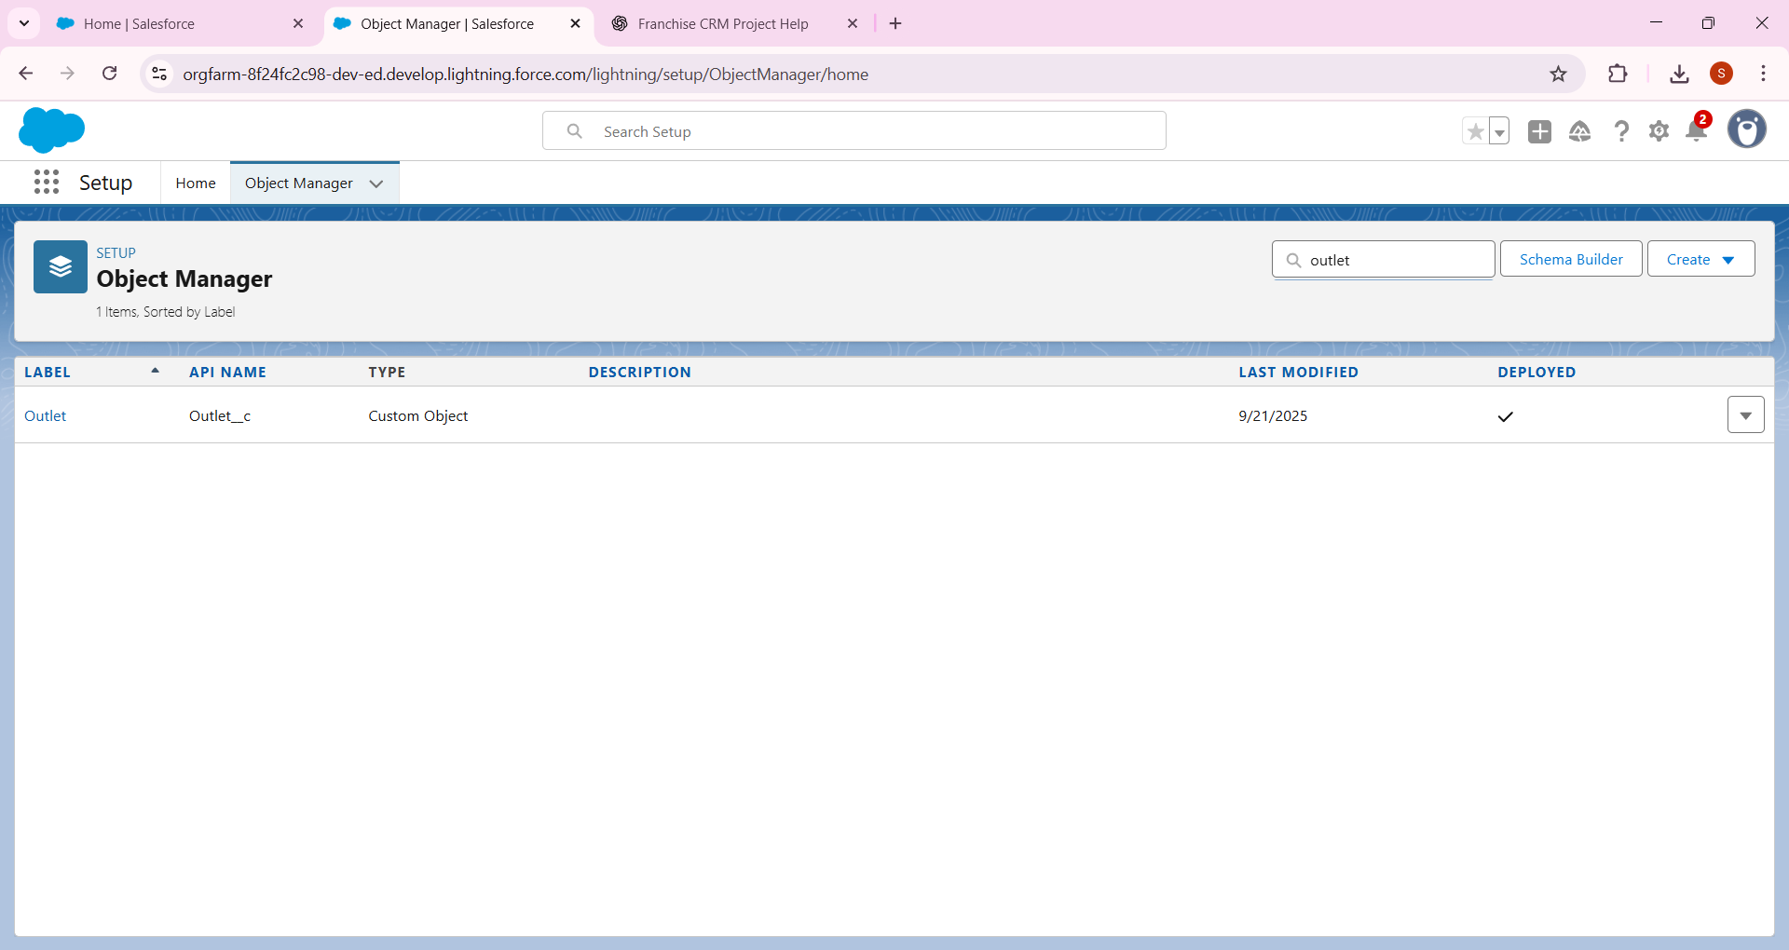

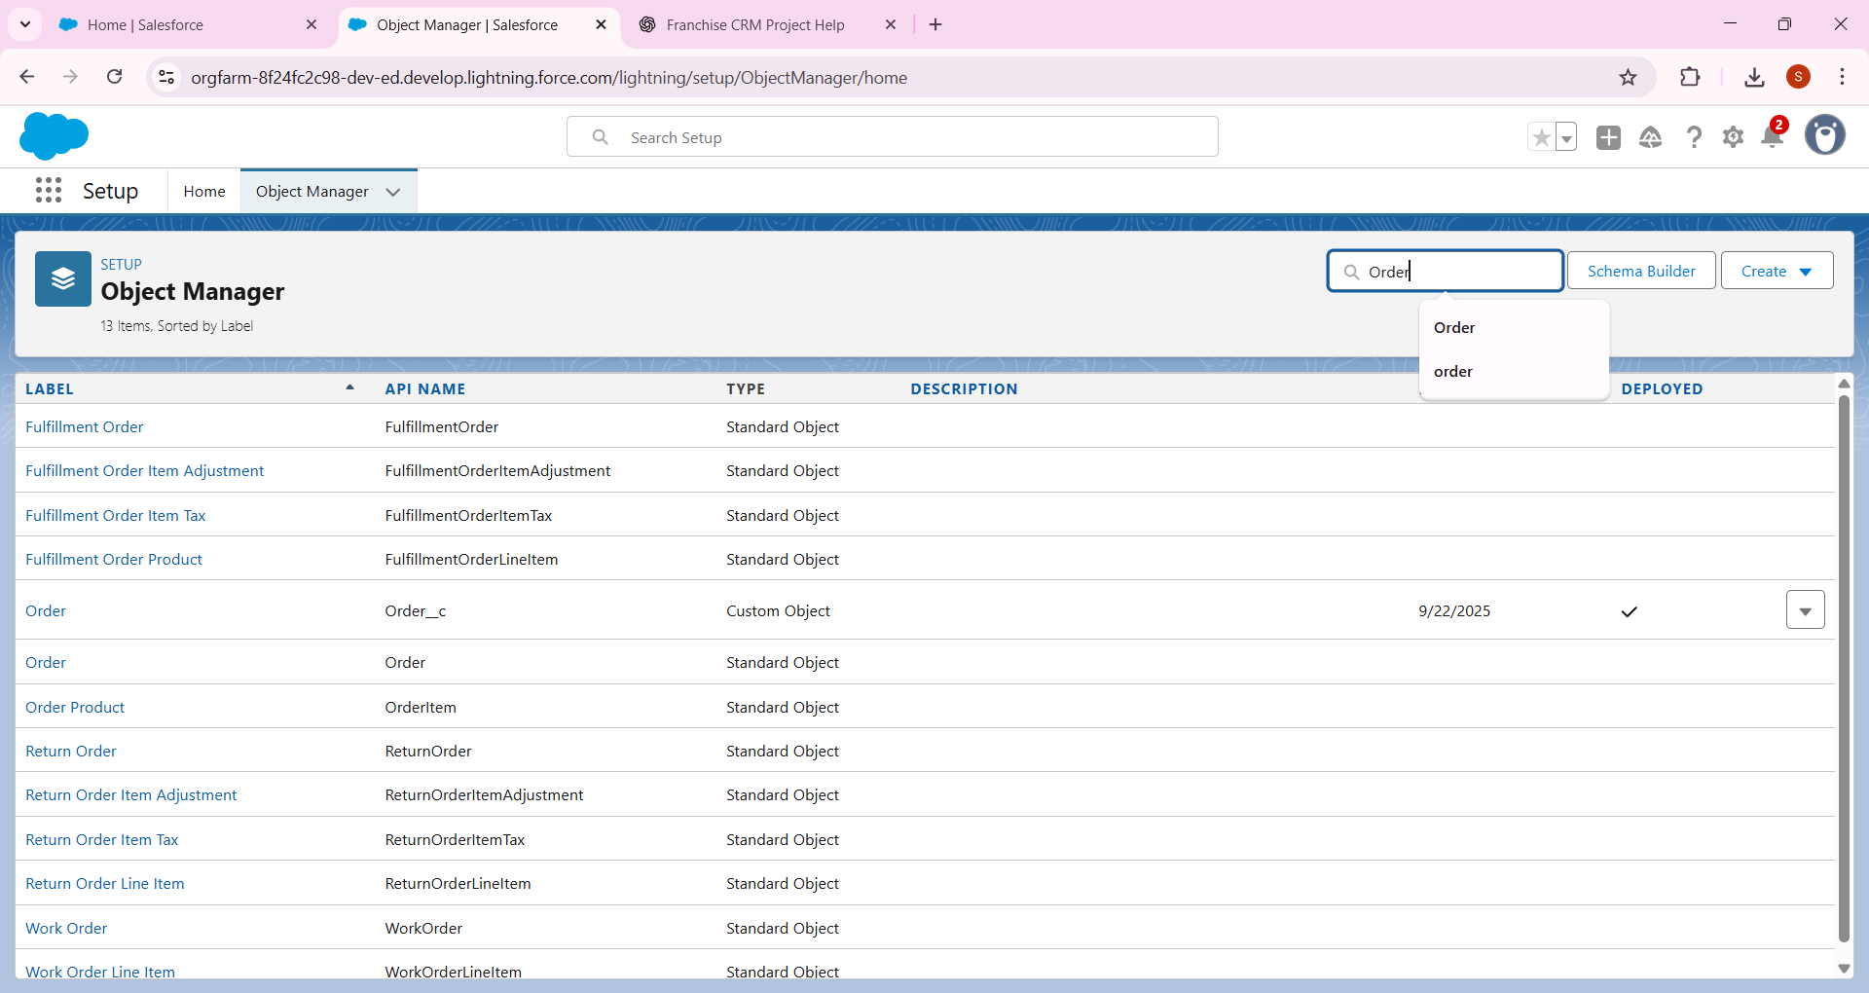

## 2. Fields

• Outlet fields:  
 - Location (Text)  
 - Opening Date (Date)  
 - Status (Picklist: Active, Inactive)  
  
• Order fields:  
 - Order Date (Date)  
 - Amount (Currency)  
 - Payment Status (Picklist: Paid, Pending, Cancelled)  
 - Lookup → Outlet (which outlet this order belongs to)  
 - Lookup → Contact (customer making the order)

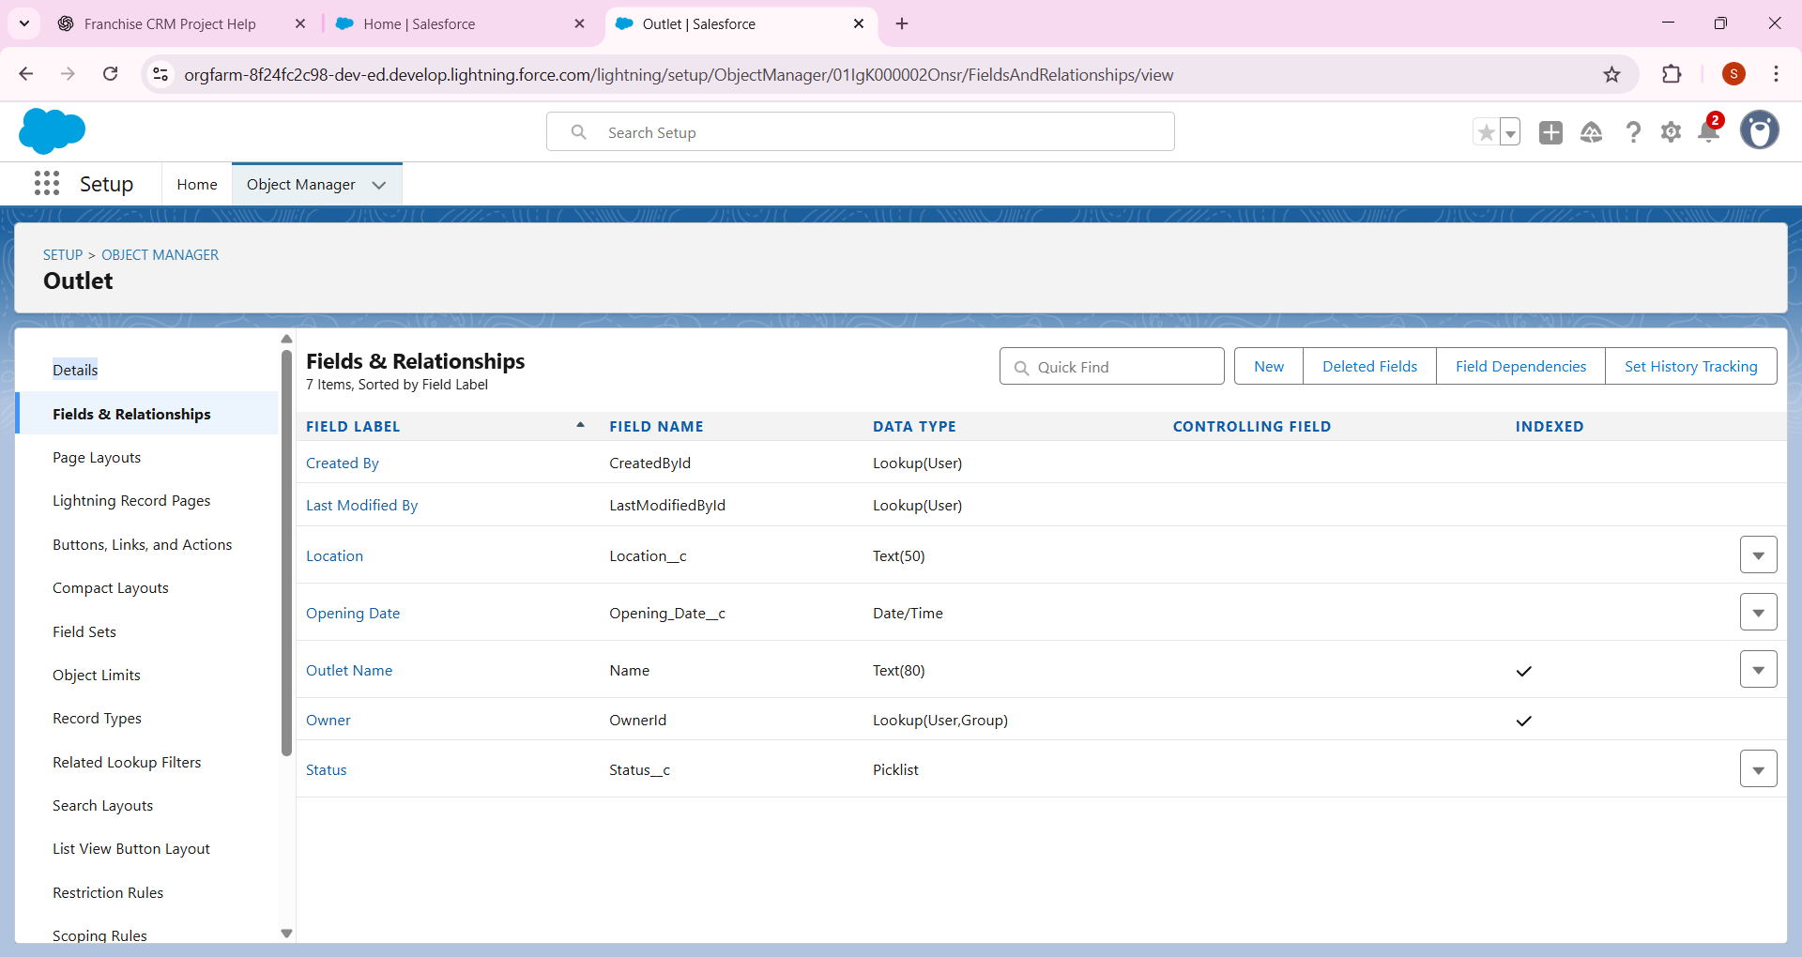

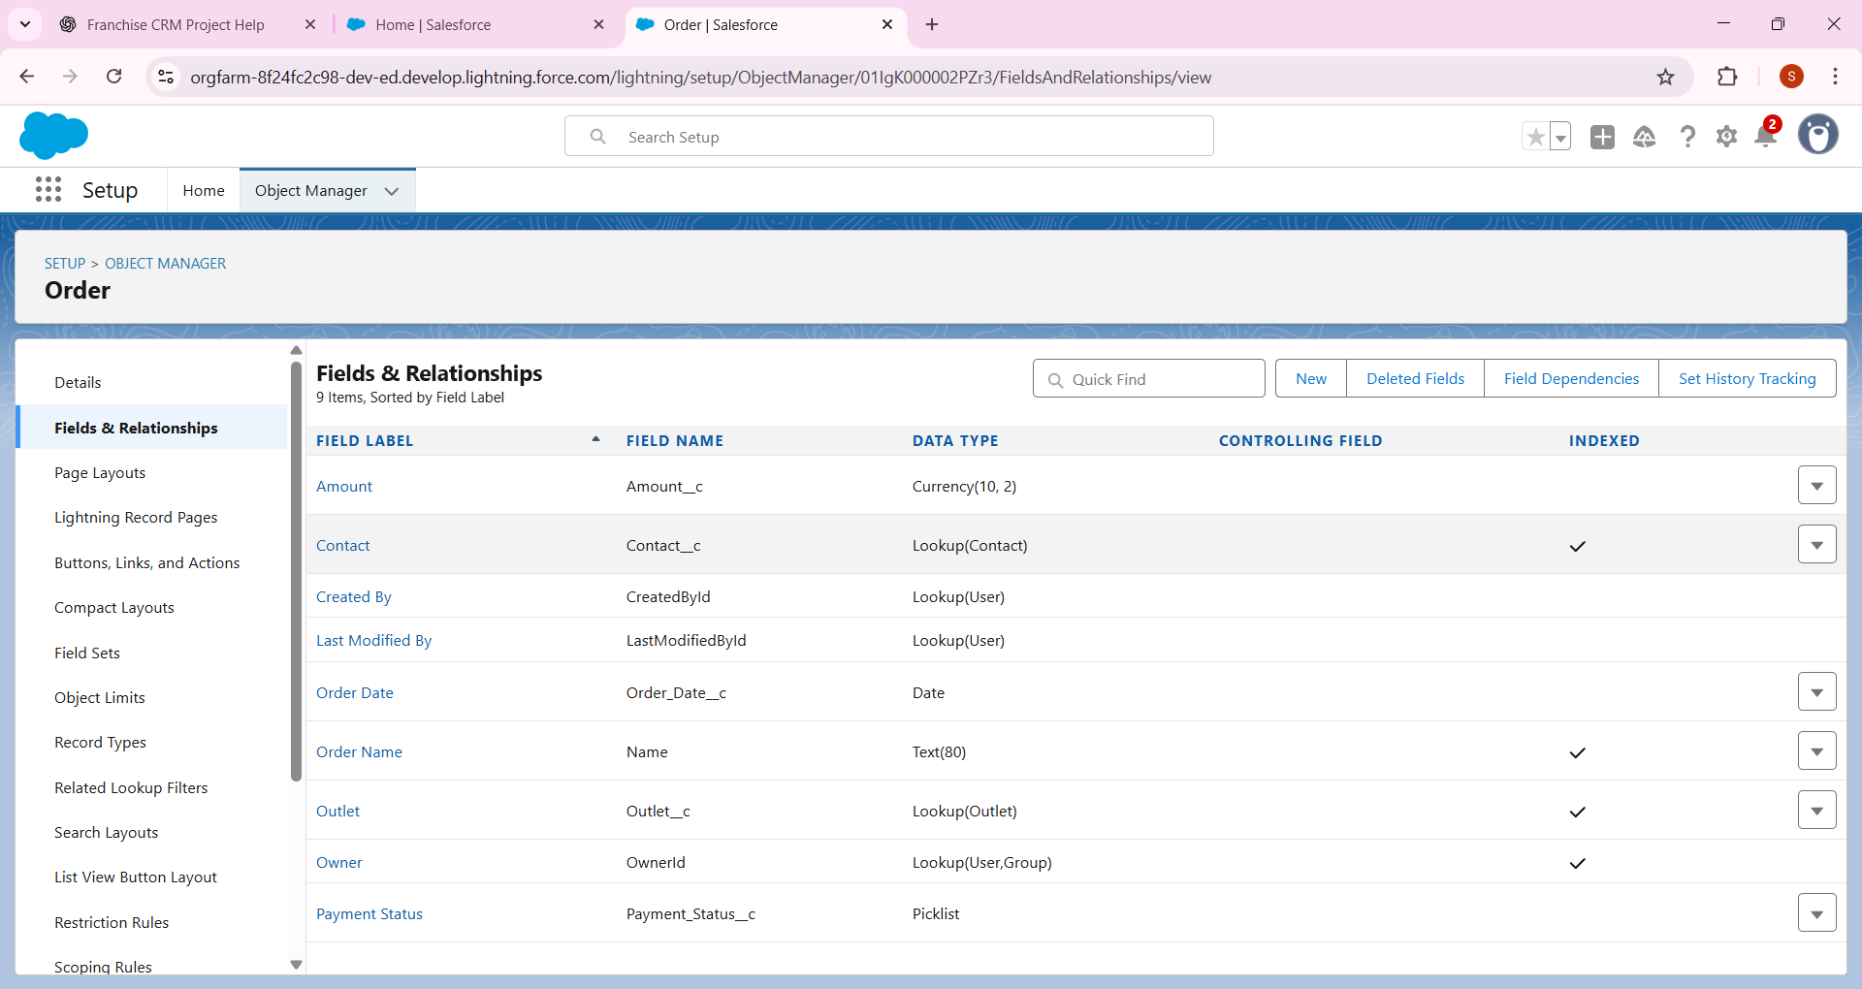

## 3. Record Types

• For Orders create two record types:  
 - Walk-in Order  
 - Online Order  
  
Hands-on:  
1. Go to Object Manager → Order → Record Types → New.  
2. Create two record types and assign to profiles (Outlet Manager).

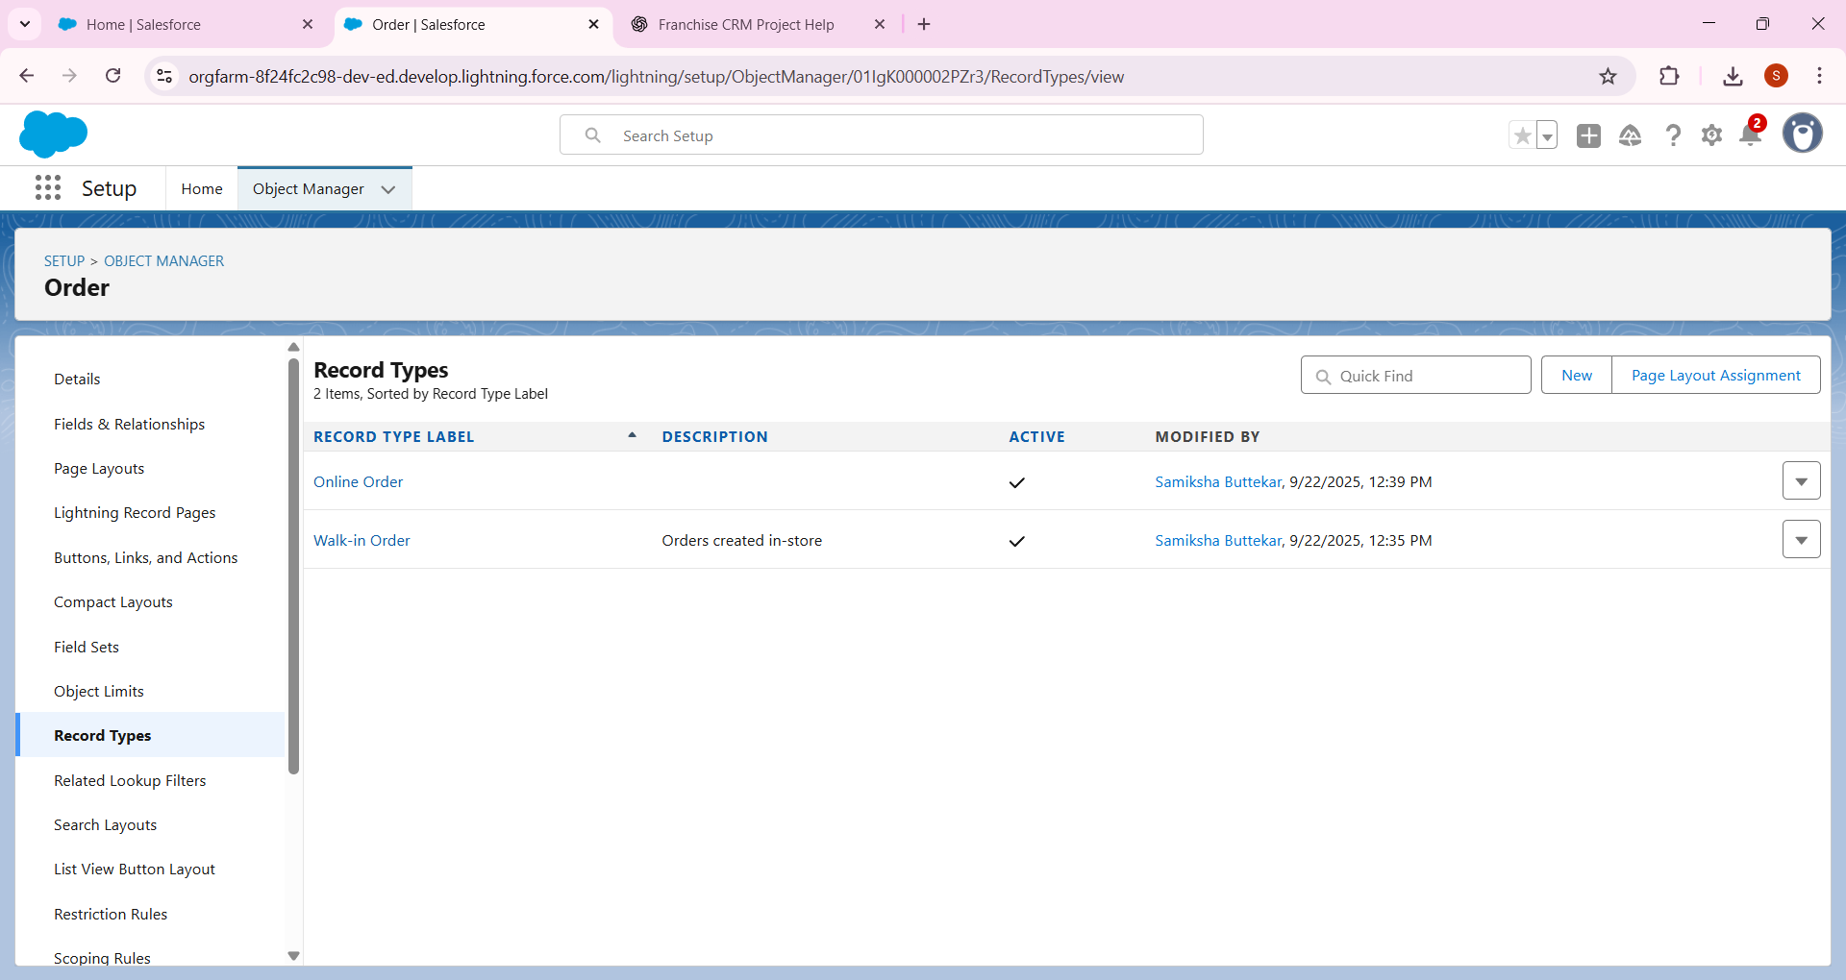

## 4. Page Layouts

• Outlet Page Layout: Show Outlet details + related list of Orders.  
• Order Page Layout: Show Order details + related Outlet & Customer.

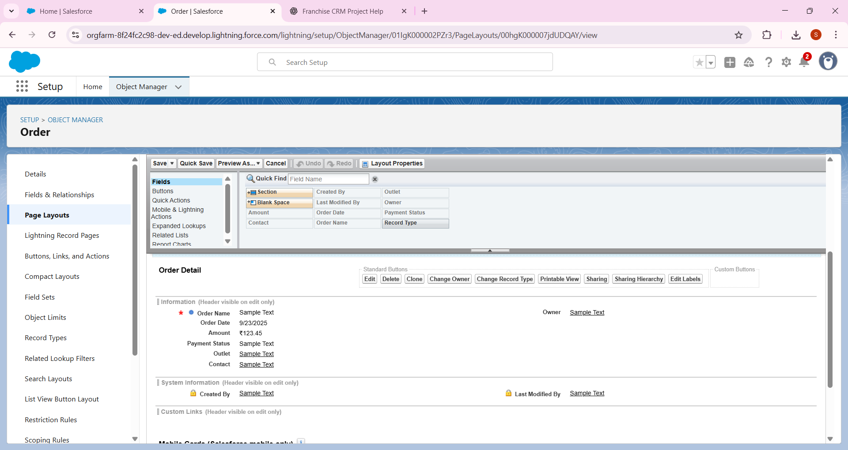

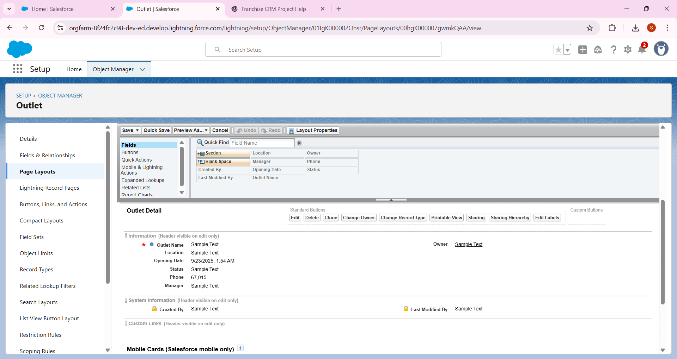

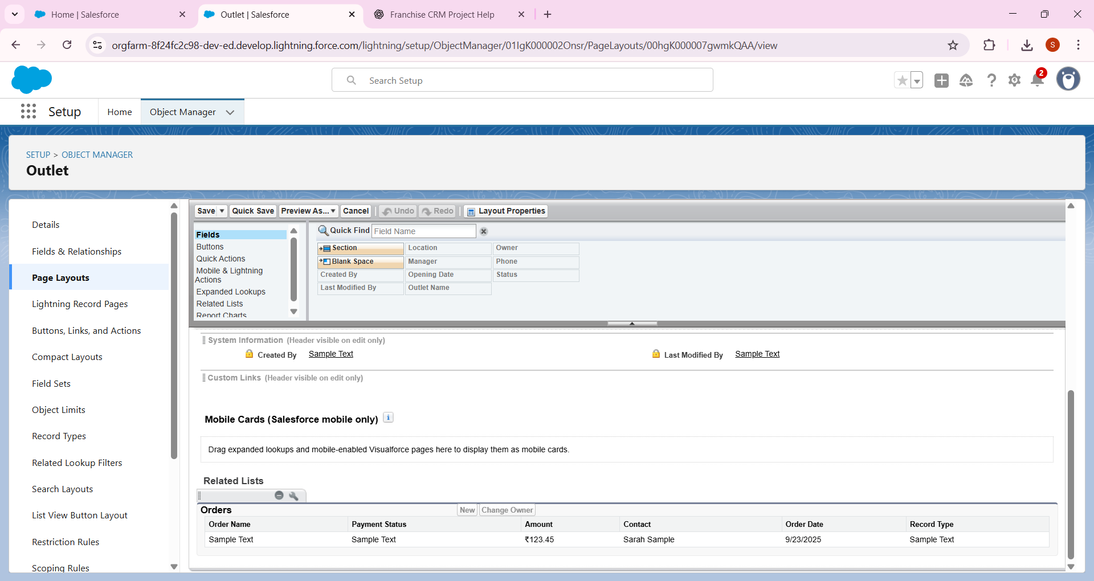

## 5. Compact Layouts

• Outlet Compact Layout (for Mobile): Show Name, Location, Status.  
• Order Compact Layout: Show Order Date, Amount, Payment Status.

- Orders → 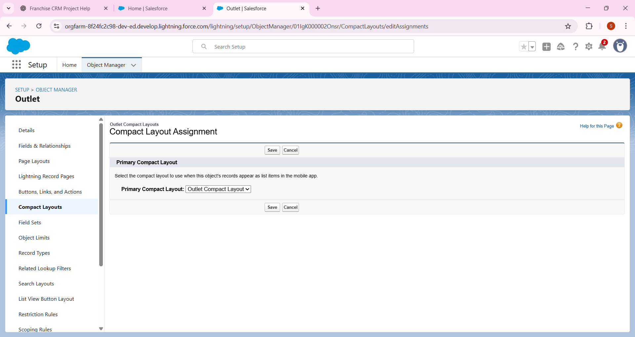

Contact (Lookup)

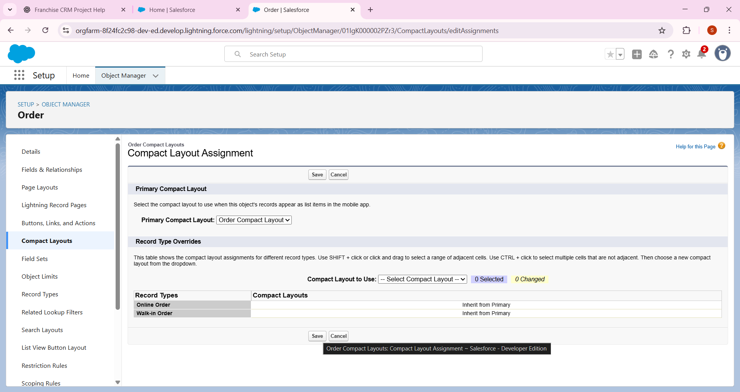

### ****.6 Schema Builder****

* Go to **Setup → Schema Builder**.
* Drag objects (Outlet, Order, Contact).
* Draw relationships:
  + **Outlet → Orders (Master-Detail)**
  + **Orders → Contact (Lookup)**
* 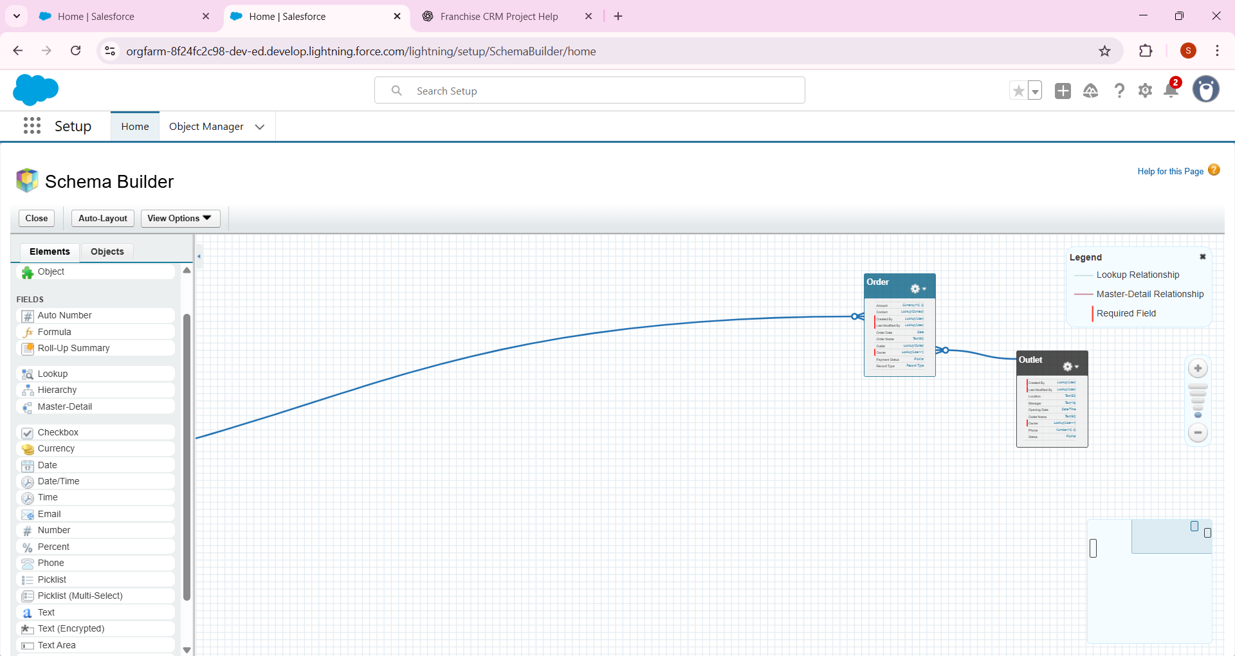

## 7. Lookup vs Master-Detail vs Hierarchical

* Outlet ↔ Orders: : Lookup Relationship
* Order ↔ Contact: Lookup (order may exist even if no contact linked).  
   Hierarchical: Only applies for Users (already covered in Phase 2 role hierarchy).

## 8. Junction Objects

• Not required here.  
• If one order could belong to multiple outlets, we’d create a junction object.

## 9. External Objects

• If franchise used external payment DB or inventory DB, we’d bring it as an External Object.  
• For now, not implemented.