# Phase 4: Process Automation (Admin) – Franchise Management CRM

🎯 Goal: Automate key franchise operations to reduce manual work.

## 1. Validation Rules

Example: Sales Record → End Date must be after Start Date  
- Setup → Object Manager → Sales Record → Validation Rules → New.  
- Rule Name: EndDate_After_StartDate  
- Formula: End_Date__c < Start_Date__c  
- Error Message: “End Date must be after Start Date.”  
- Error Location: End Date field.

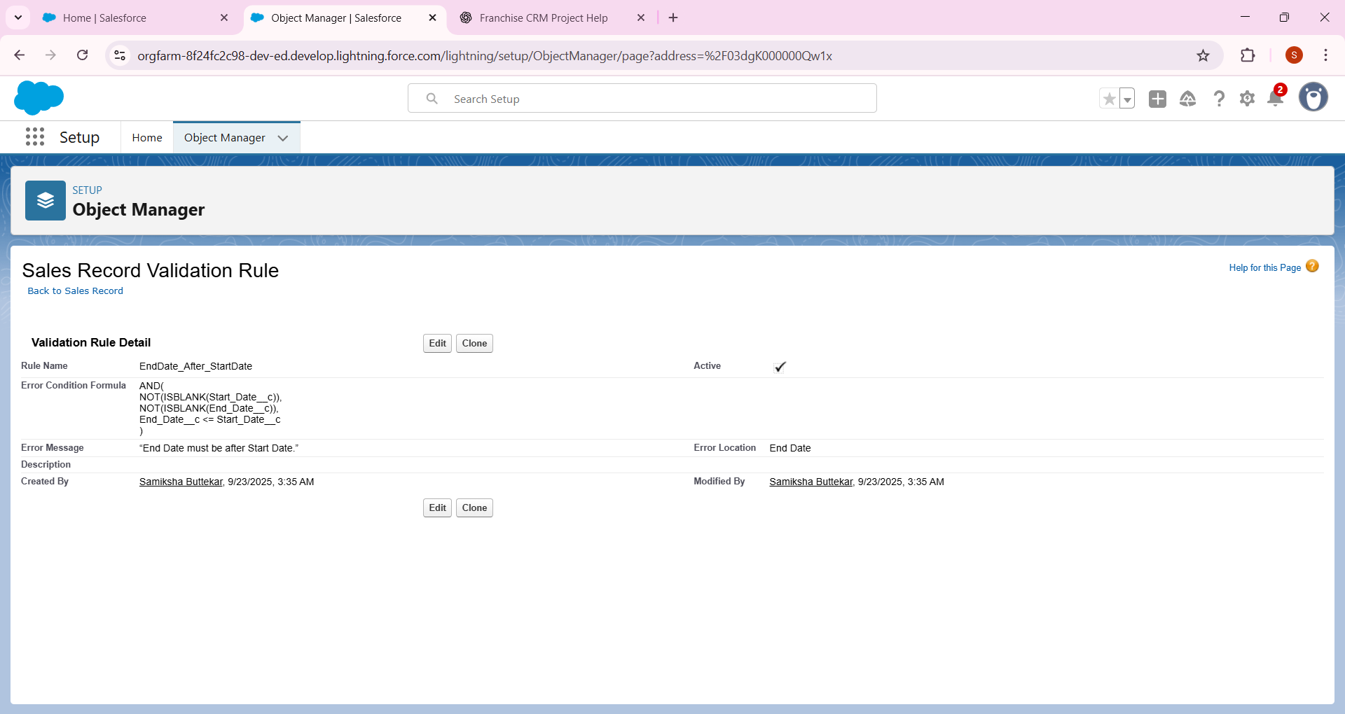

## 2. Workflow Rules (Legacy)

Salesforce recommends Flow now, but you can create one for awareness.  
Example: When Compliance Record = Non-Compliant, send an auto email.

1. Click New Email Alert (top of the page).
2. Fill the form:
   * **Description / Label** → Example: Booking Confirmation Alert.
   * **API Name** → Auto-fills (leave it).
   * **Object** → Select the object you want this email tied to (e.g., **Sales Record** or your custom **Booking__c**).
   * **Email Template** → Choose an existing email template (or you can create one in **Setup → Classic Email Templates** if none exist yet).
   * **Recipients**:
     + You can add **User**, **Role**, or **Related Contact**.
     + For your Franchise Management CRM project, pick something like **Outlet Manager Role** or **Franchise Owner**.
3. **Save**

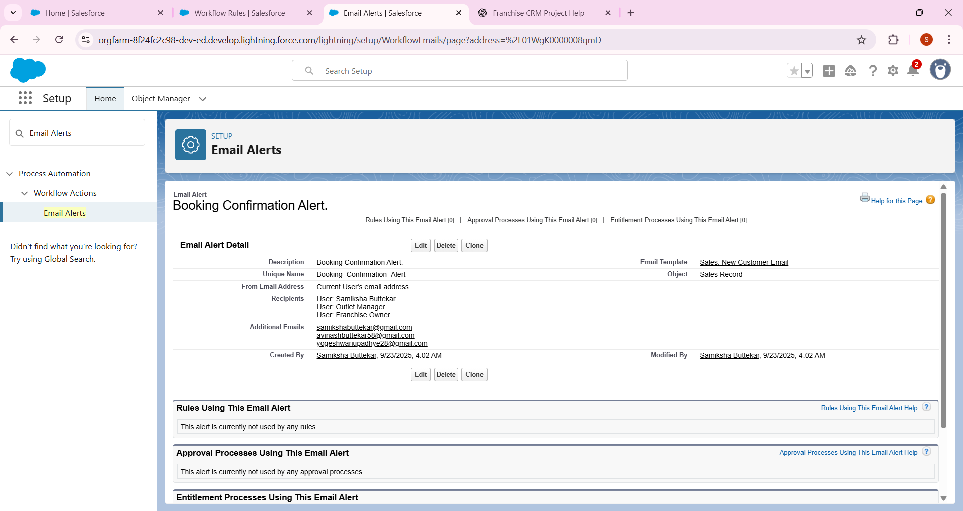

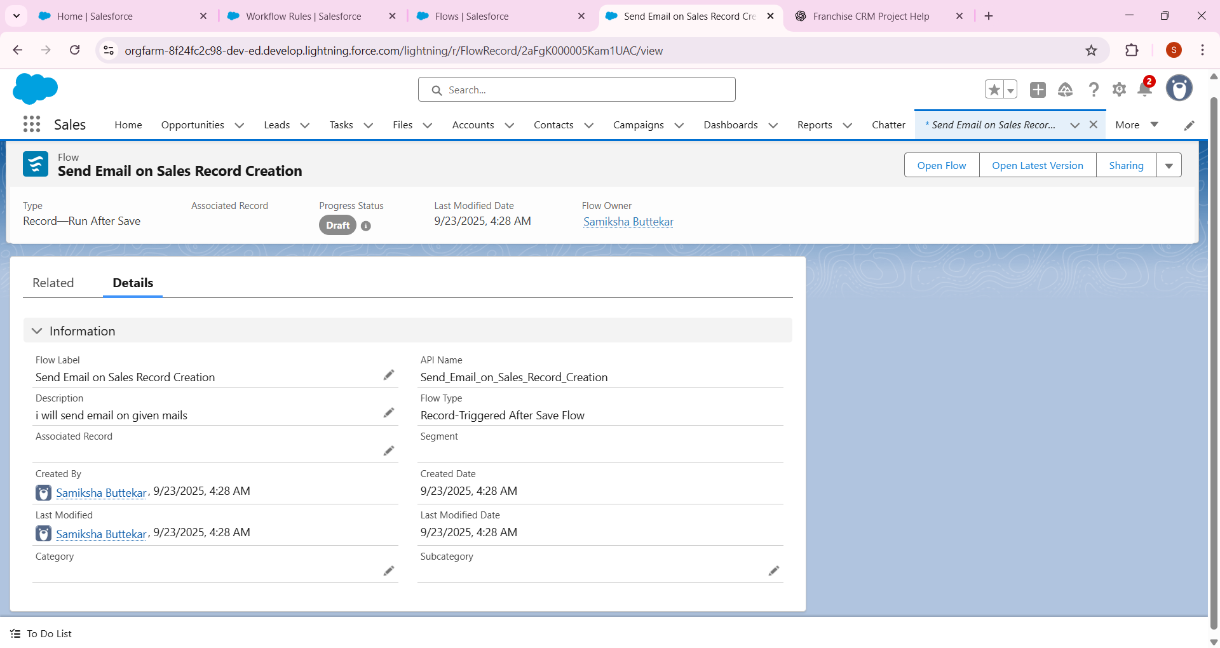

1. 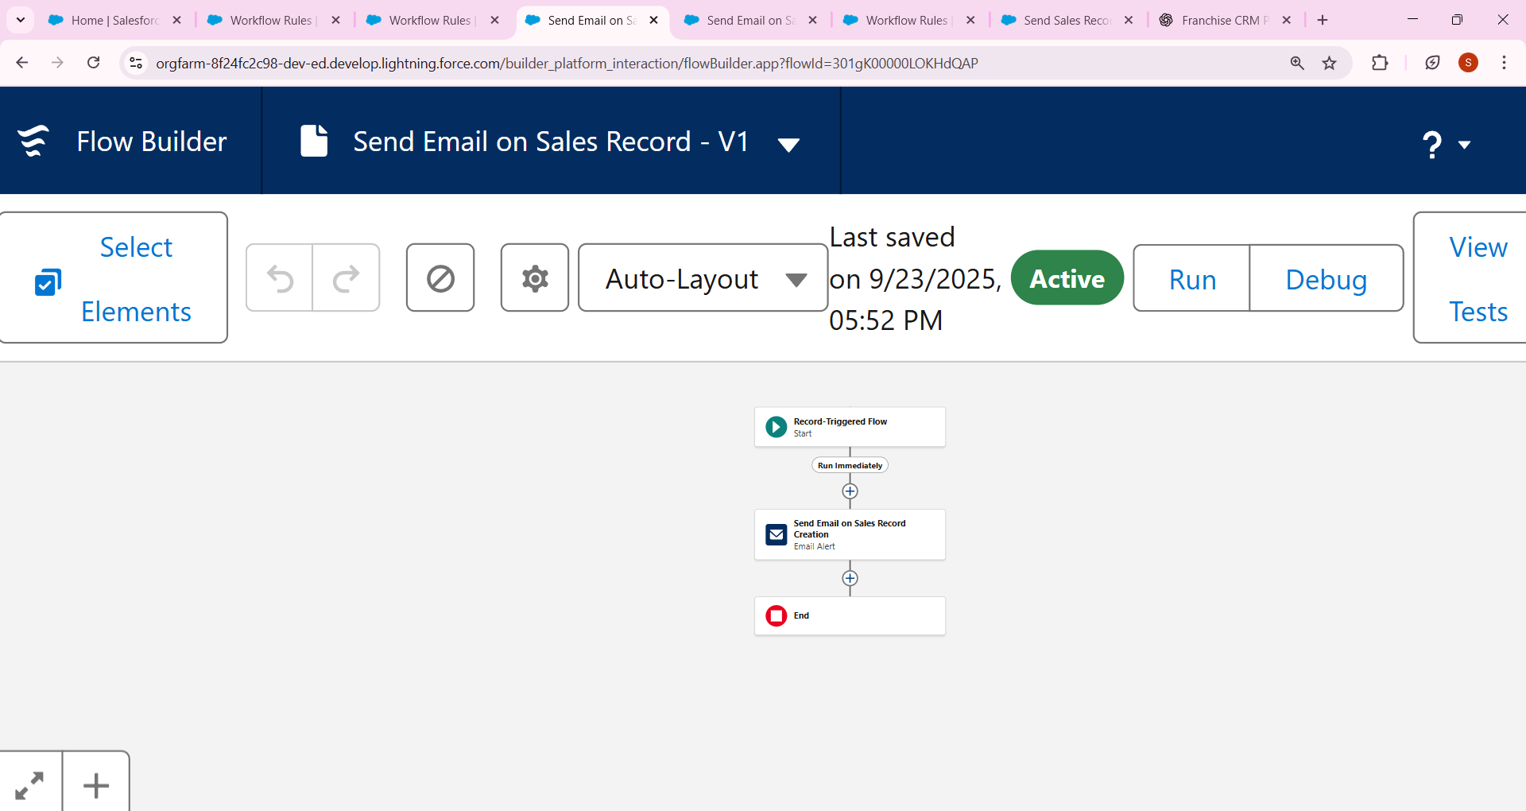

## ****3. Process Builder (Legacy – awareness only)****

* Example: Auto-update **Compliance Status → “Needs Review”** if flagged.
* But Salesforce is replacing this with Flow.
* Just note this step; no need to build if Flow is enough

## 4. Approval Process

Example: If Sales Record > ₹10,000 → send for Manager Approval.  
- Setup → Approval Processes → Object: Sales Record.  
- Name: High_Value_Sales_Approval  
- Criteria: Amount__c > 10000  
- Step 1 Approver: Franchise Owner  
- Final Action: Approve → Status = Approved, Reject → Status = Rejected.

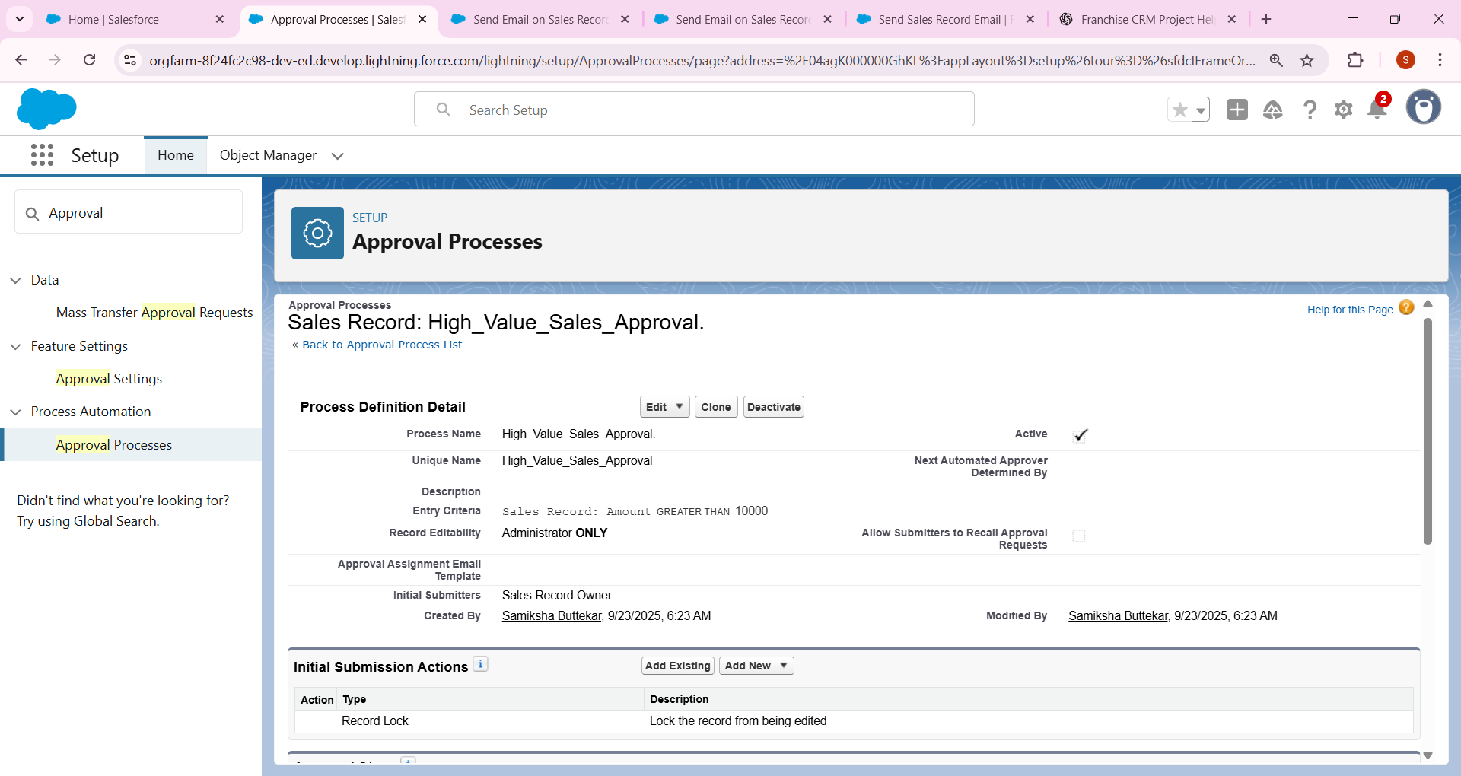

## 5. Flow Builder

a) Record-Triggered Flow → Auto-calculate Total Amoun

### Record-Triggered Flow

* Example: When Sales Record is created → **Auto calculate Total Amount**.
  + Setup → Flow → New Flow → Record-Triggered Flow.
  + Object: Sales Record.
  + Trigger: On Create.
  + Add Assignment Element:
  + Total_Amount__c = Quantity__c * Price__c
  + Save & Activate

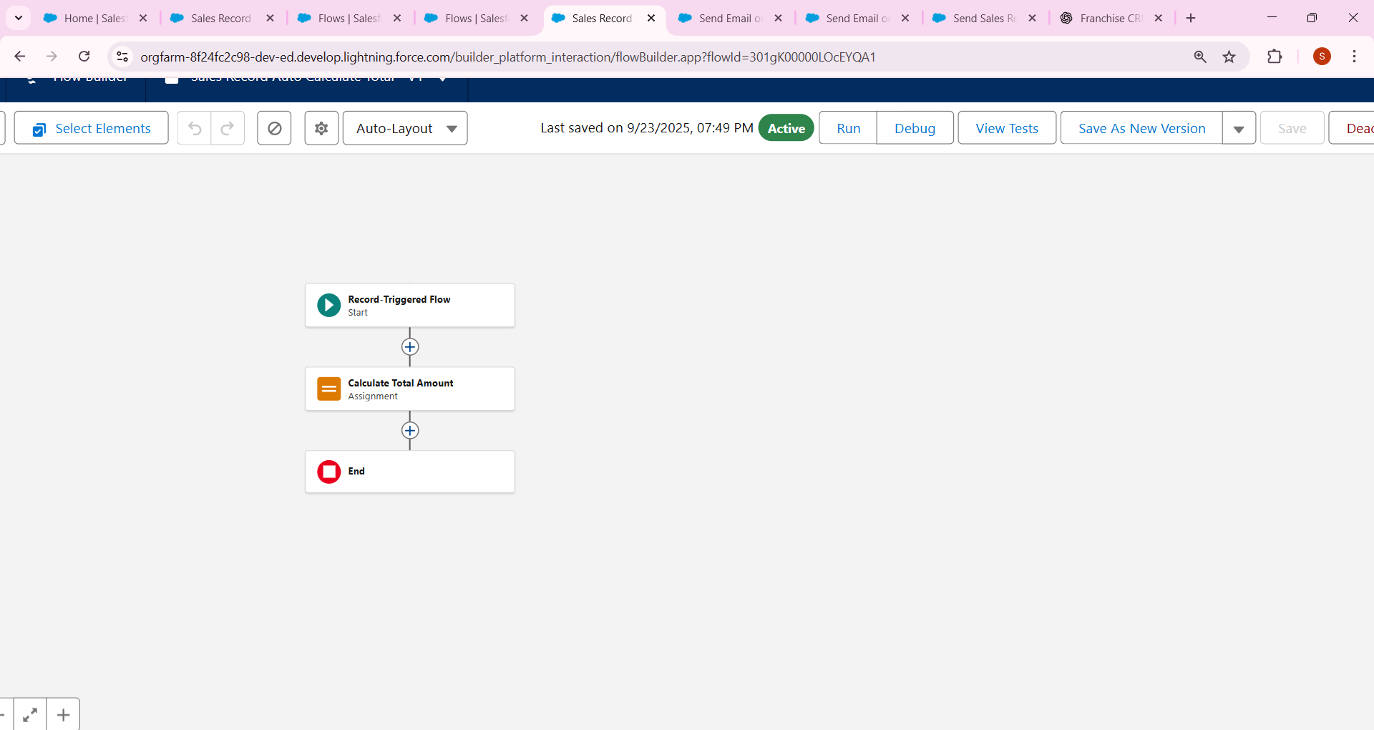

b) Screen Flow → Franchise Outlet Registration Form.

### (b) Screen Flow

* Example: **Franchise Outlet Registration Form.**
  + Setup → Flow → New Flow → Screen Flow.
  + Add fields: Outlet Name, Location, Manager.
  + On submit → Create Outlet record.
  + Save & Activate → Add to Lightning Page.

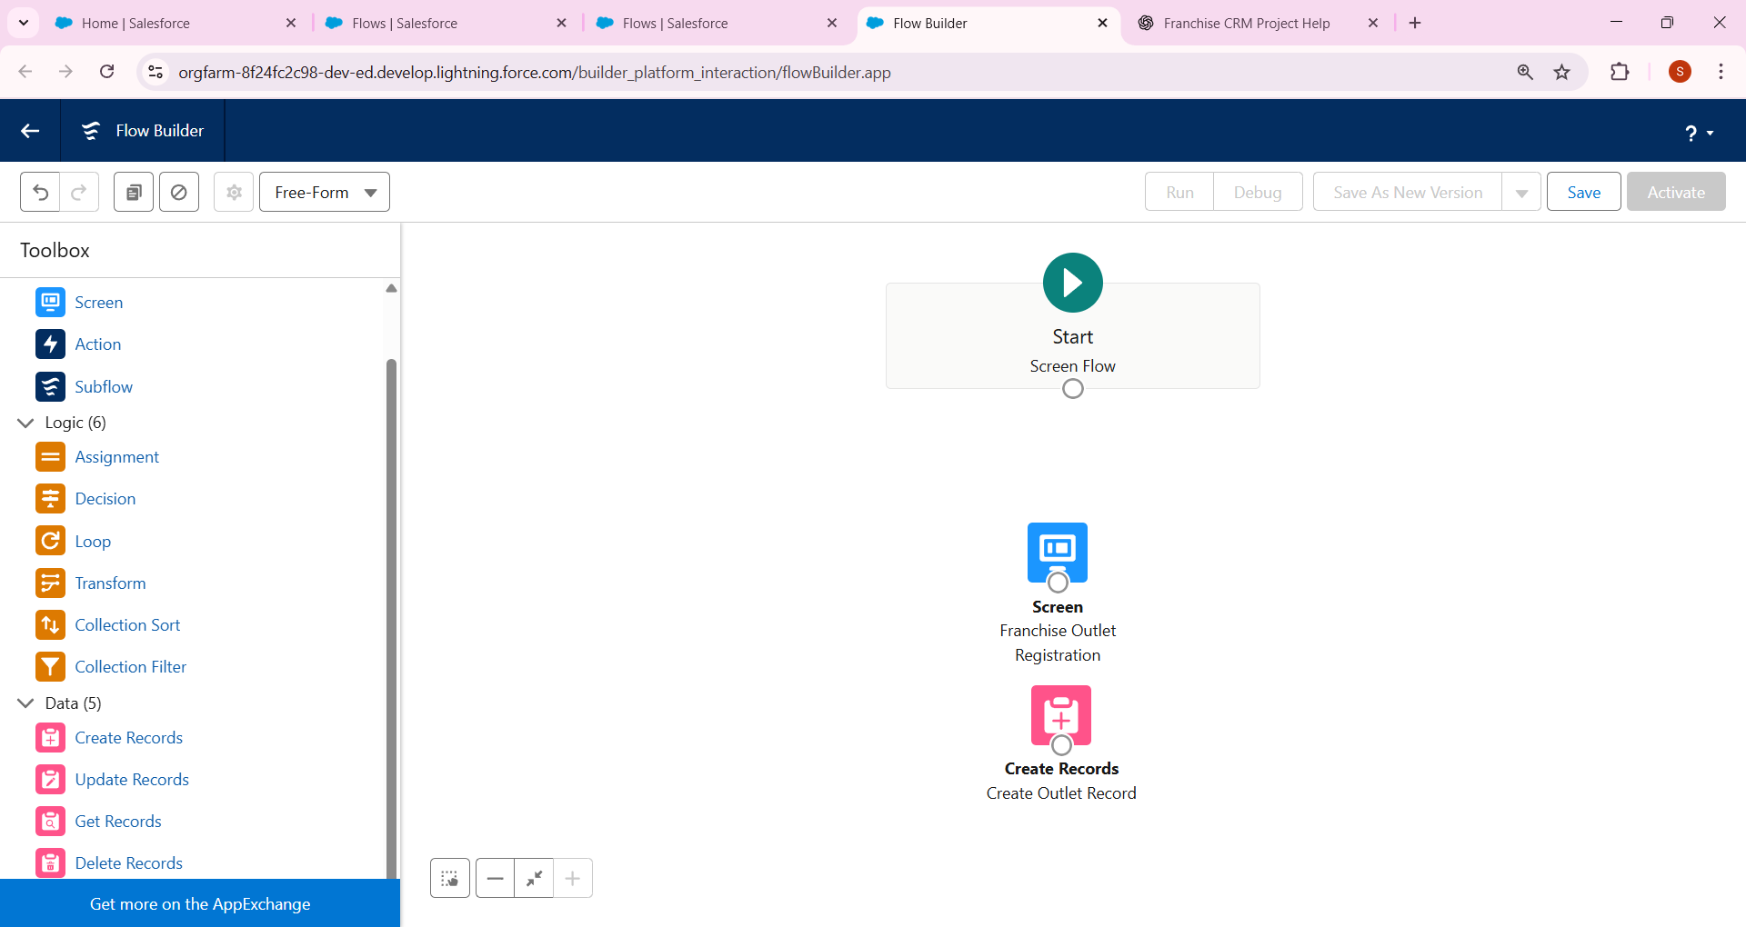

Example: After Approval of Sales Record → Email Customer.  
- Setup → Email Alerts → New → Template: 'Your Order has been Approved'.  
- Recipient: Contact related to Sales Record.

## ****6. Email Alerts****

* Example: **After Approval of Sales Record → Email Customer.**
  + Setup → Email Alerts → New.
  + Template: “Your Order has been Approved”.
  + Recipient: Contact related to Sales Record.
  + Trigger via Approval Process or Flow.

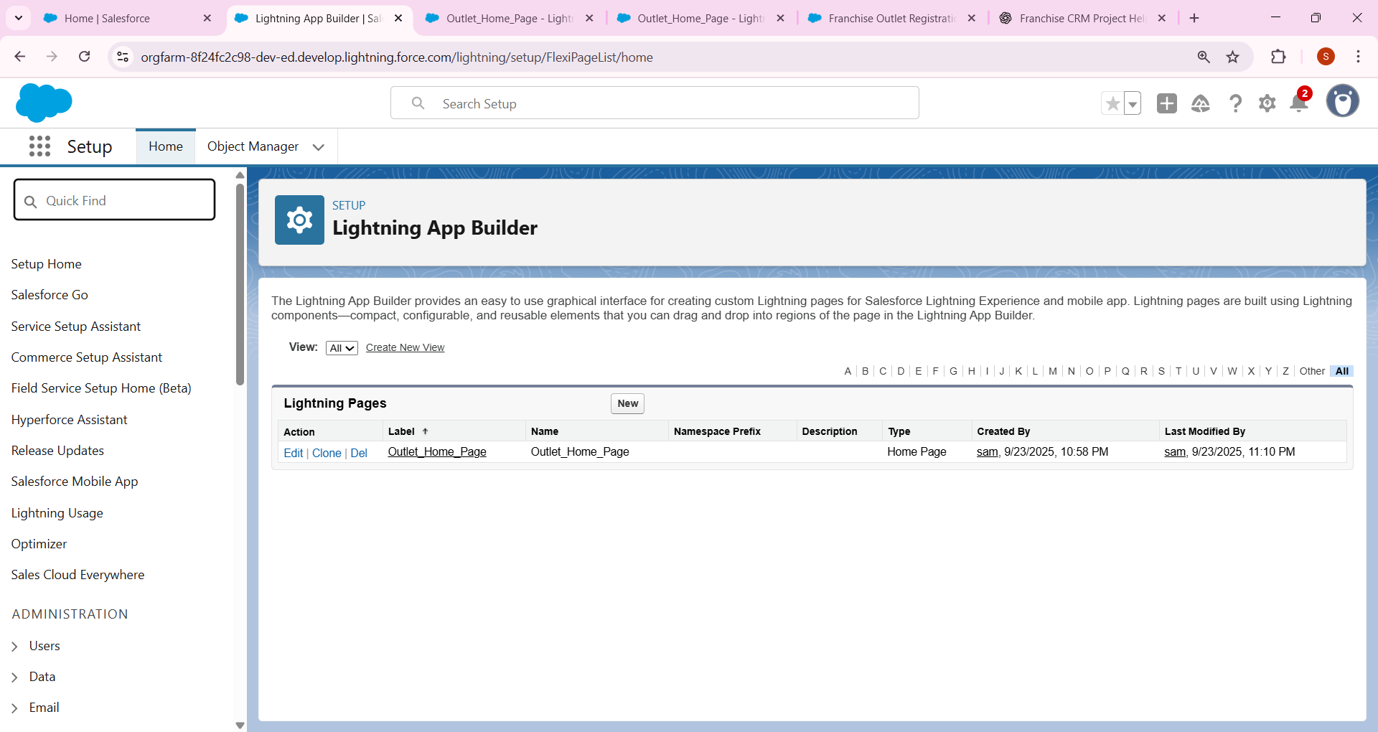

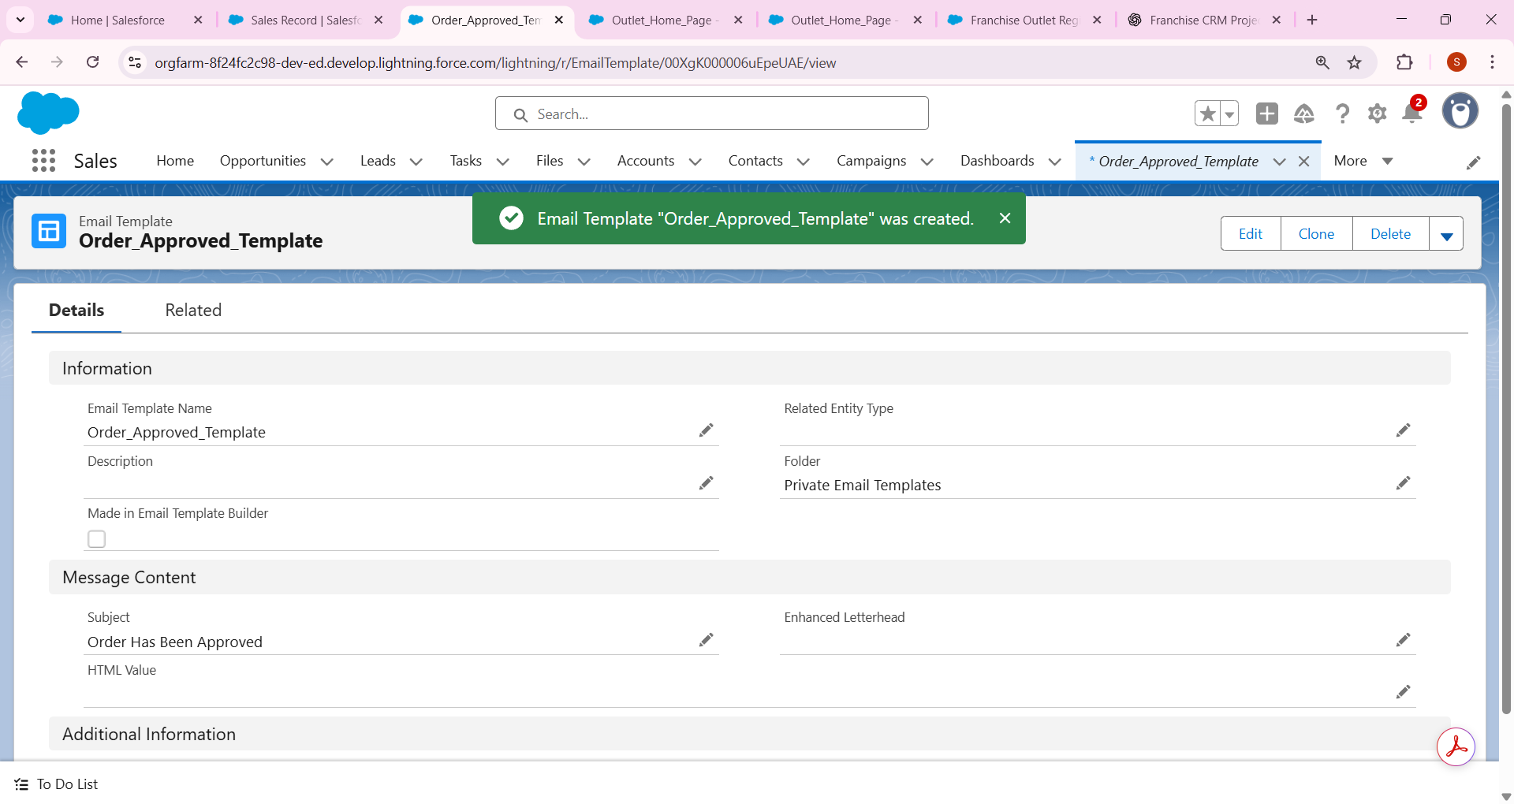

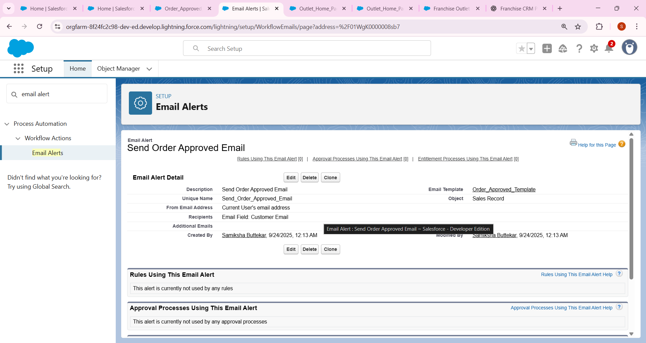

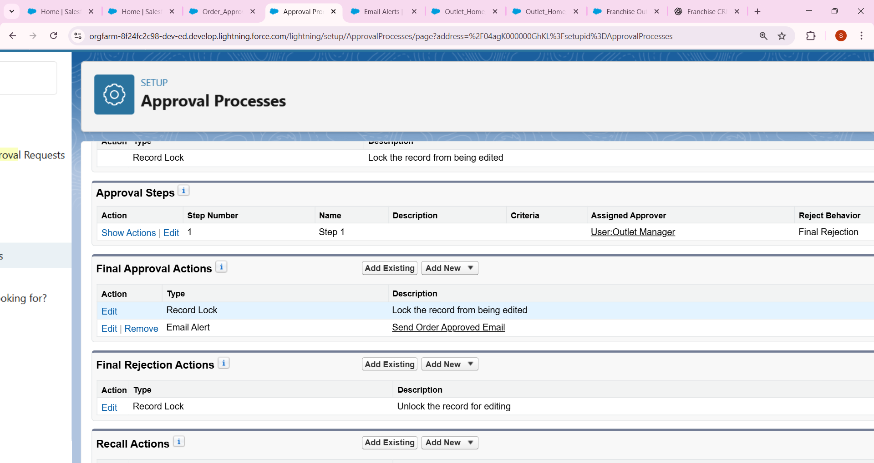

## 7. Field Updates

Example: After approval, update Sales Status = Confirmed.  
- In Approval Process → Final Approval Actions → Add Field Update.

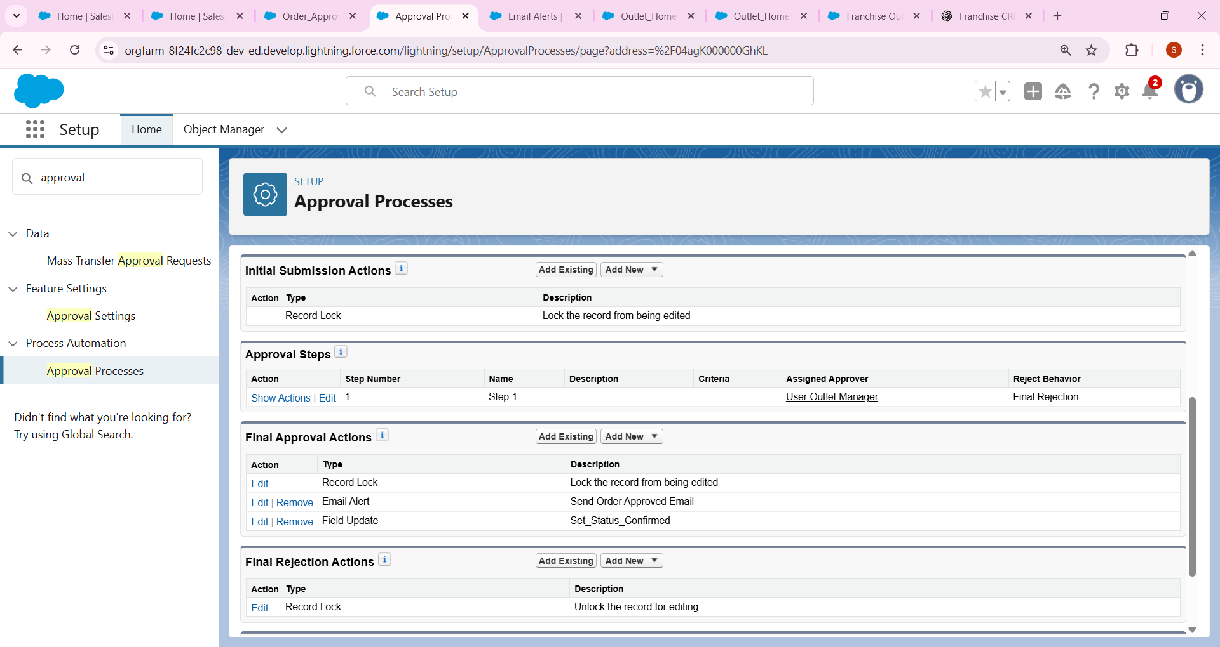

## 8. Tasks

Example: When Sales is Approved → Task for Outlet Manager.  
- Action → Create Task: 'Prepare Order for Customer.'

* Example: When Sales is Approved → Task for Outlet Manager.
  + Setup → Flow → After Approval.
  + Action → Create Task.
    - Subject: “Prepare Order for Customer.”
    - Assigned To: Outlet Manager.

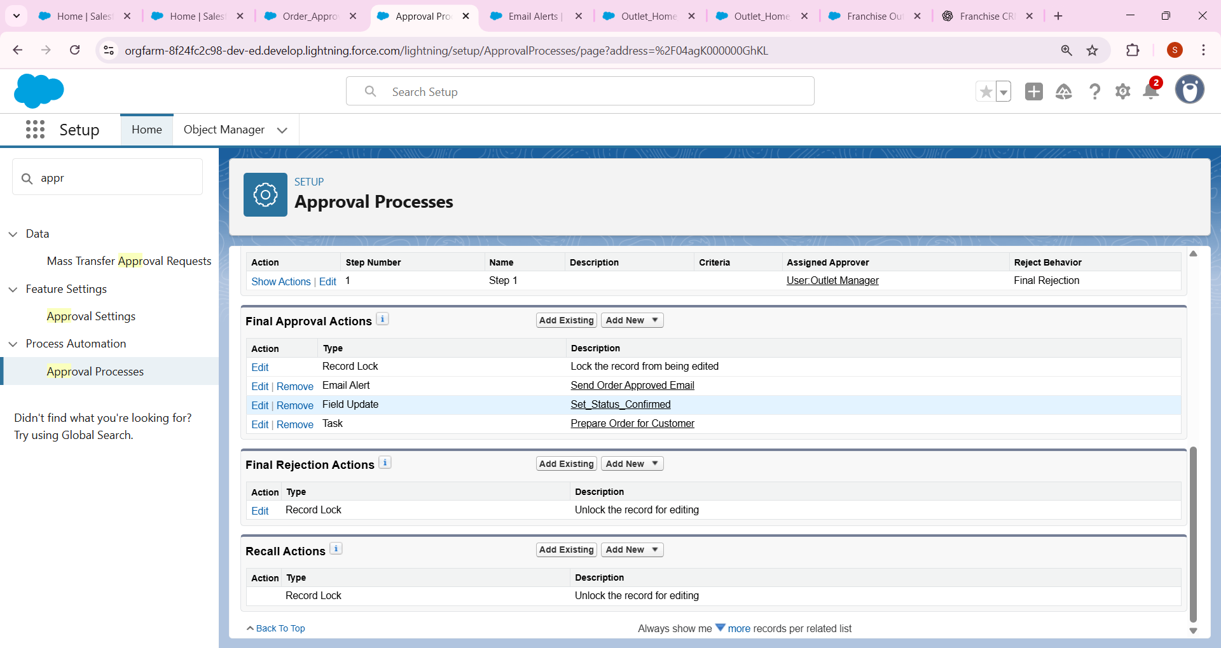

## 9. Custom Notifications

Example: Notify Franchise Owner when an Outlet is marked Non-Compliant.  
- Setup → Notification Builder → Custom Notification.  
- In Flow → Add Action → Send Custom Notification.

* Example: Notify **Franchise Owner** when an Outlet is marked “Non-Compliant.”
  + Setup → Notification Builder → Custom Notification → New.
    - Name: Compliance Alert.
  + In Flow → Add Action → Send Custom Notification.
    - Recipient: Franchise Owner.
    - Message: “Outlet XYZ marked Non-Compliant.”

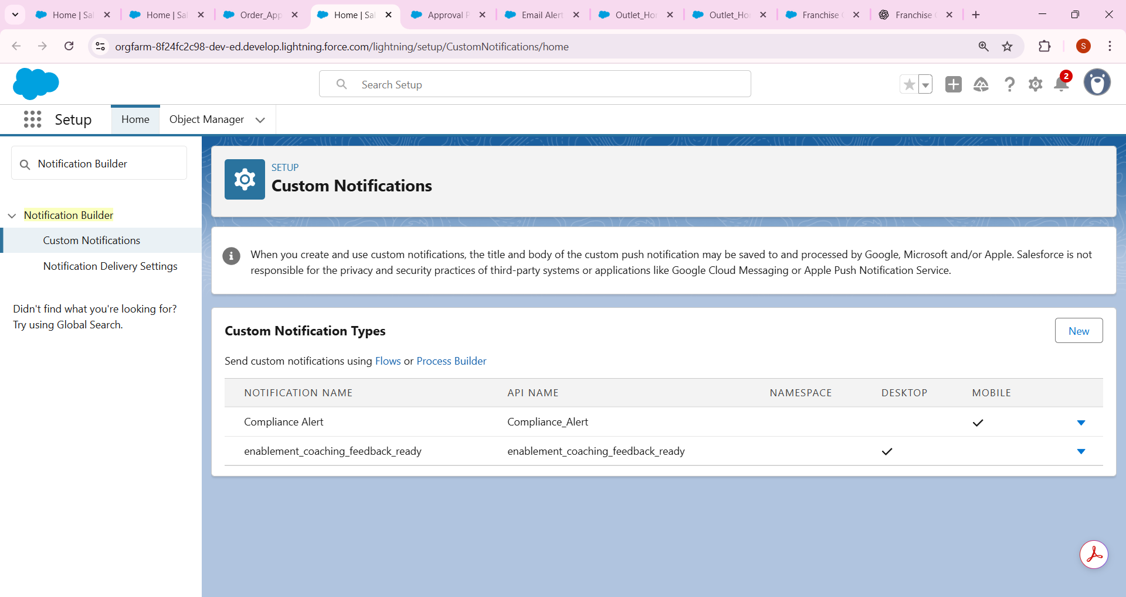

* Here we create outlet record name as pune outlet

