CSA5159 Cryptography and Network Security for Infrastructure Protection
Programs

1.Write a program for Caesar cipher involves replacing each letter of the alphabet with the letter standing k places further down the alphabet, for k in the range 1 through 25.
Program:
text = input("Enter plaintext: ").upper()
k = int(input("Enter key: "))
cipher = ""
for ch in text:
if ch.isalpha():
cipher += chr((ord(ch) - 65 + k) % 26 + 65)
else:
cipher += ch

print("Cipher Text:", cipher)

Output:
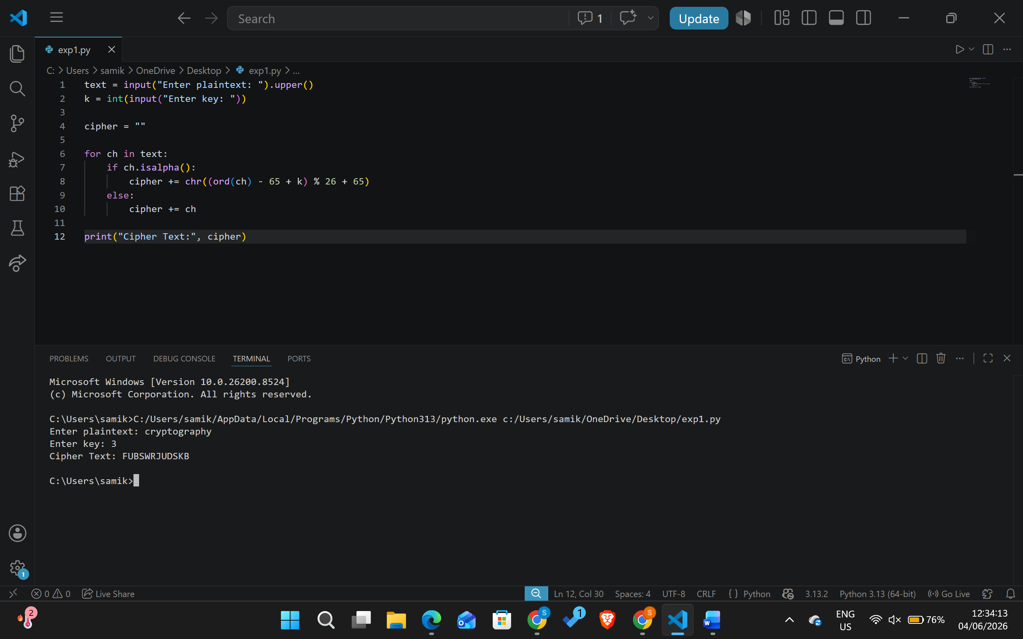
2. Write a program for monoalphabetic substitution cipher maps a plaintext alphabet to a ciphertext alphabet, so that each letter of the plaintext alphabet maps to a single unique letter of the ciphertext alphabet.

Program:
plain = "ABCDEFGHIJKLMNOPQRSTUVWXYZ"
cipher = "QWERTYUIOPASDFGHJKLZXCVBNM"
text = input("Enter plaintext: ").upper()
encrypted = ""
for ch in text:
if ch in plain:
index = plain.index(ch)
encrypted += cipher[index]
else:
encrypted += ch
print("Cipher Text:", encrypted)

Output:
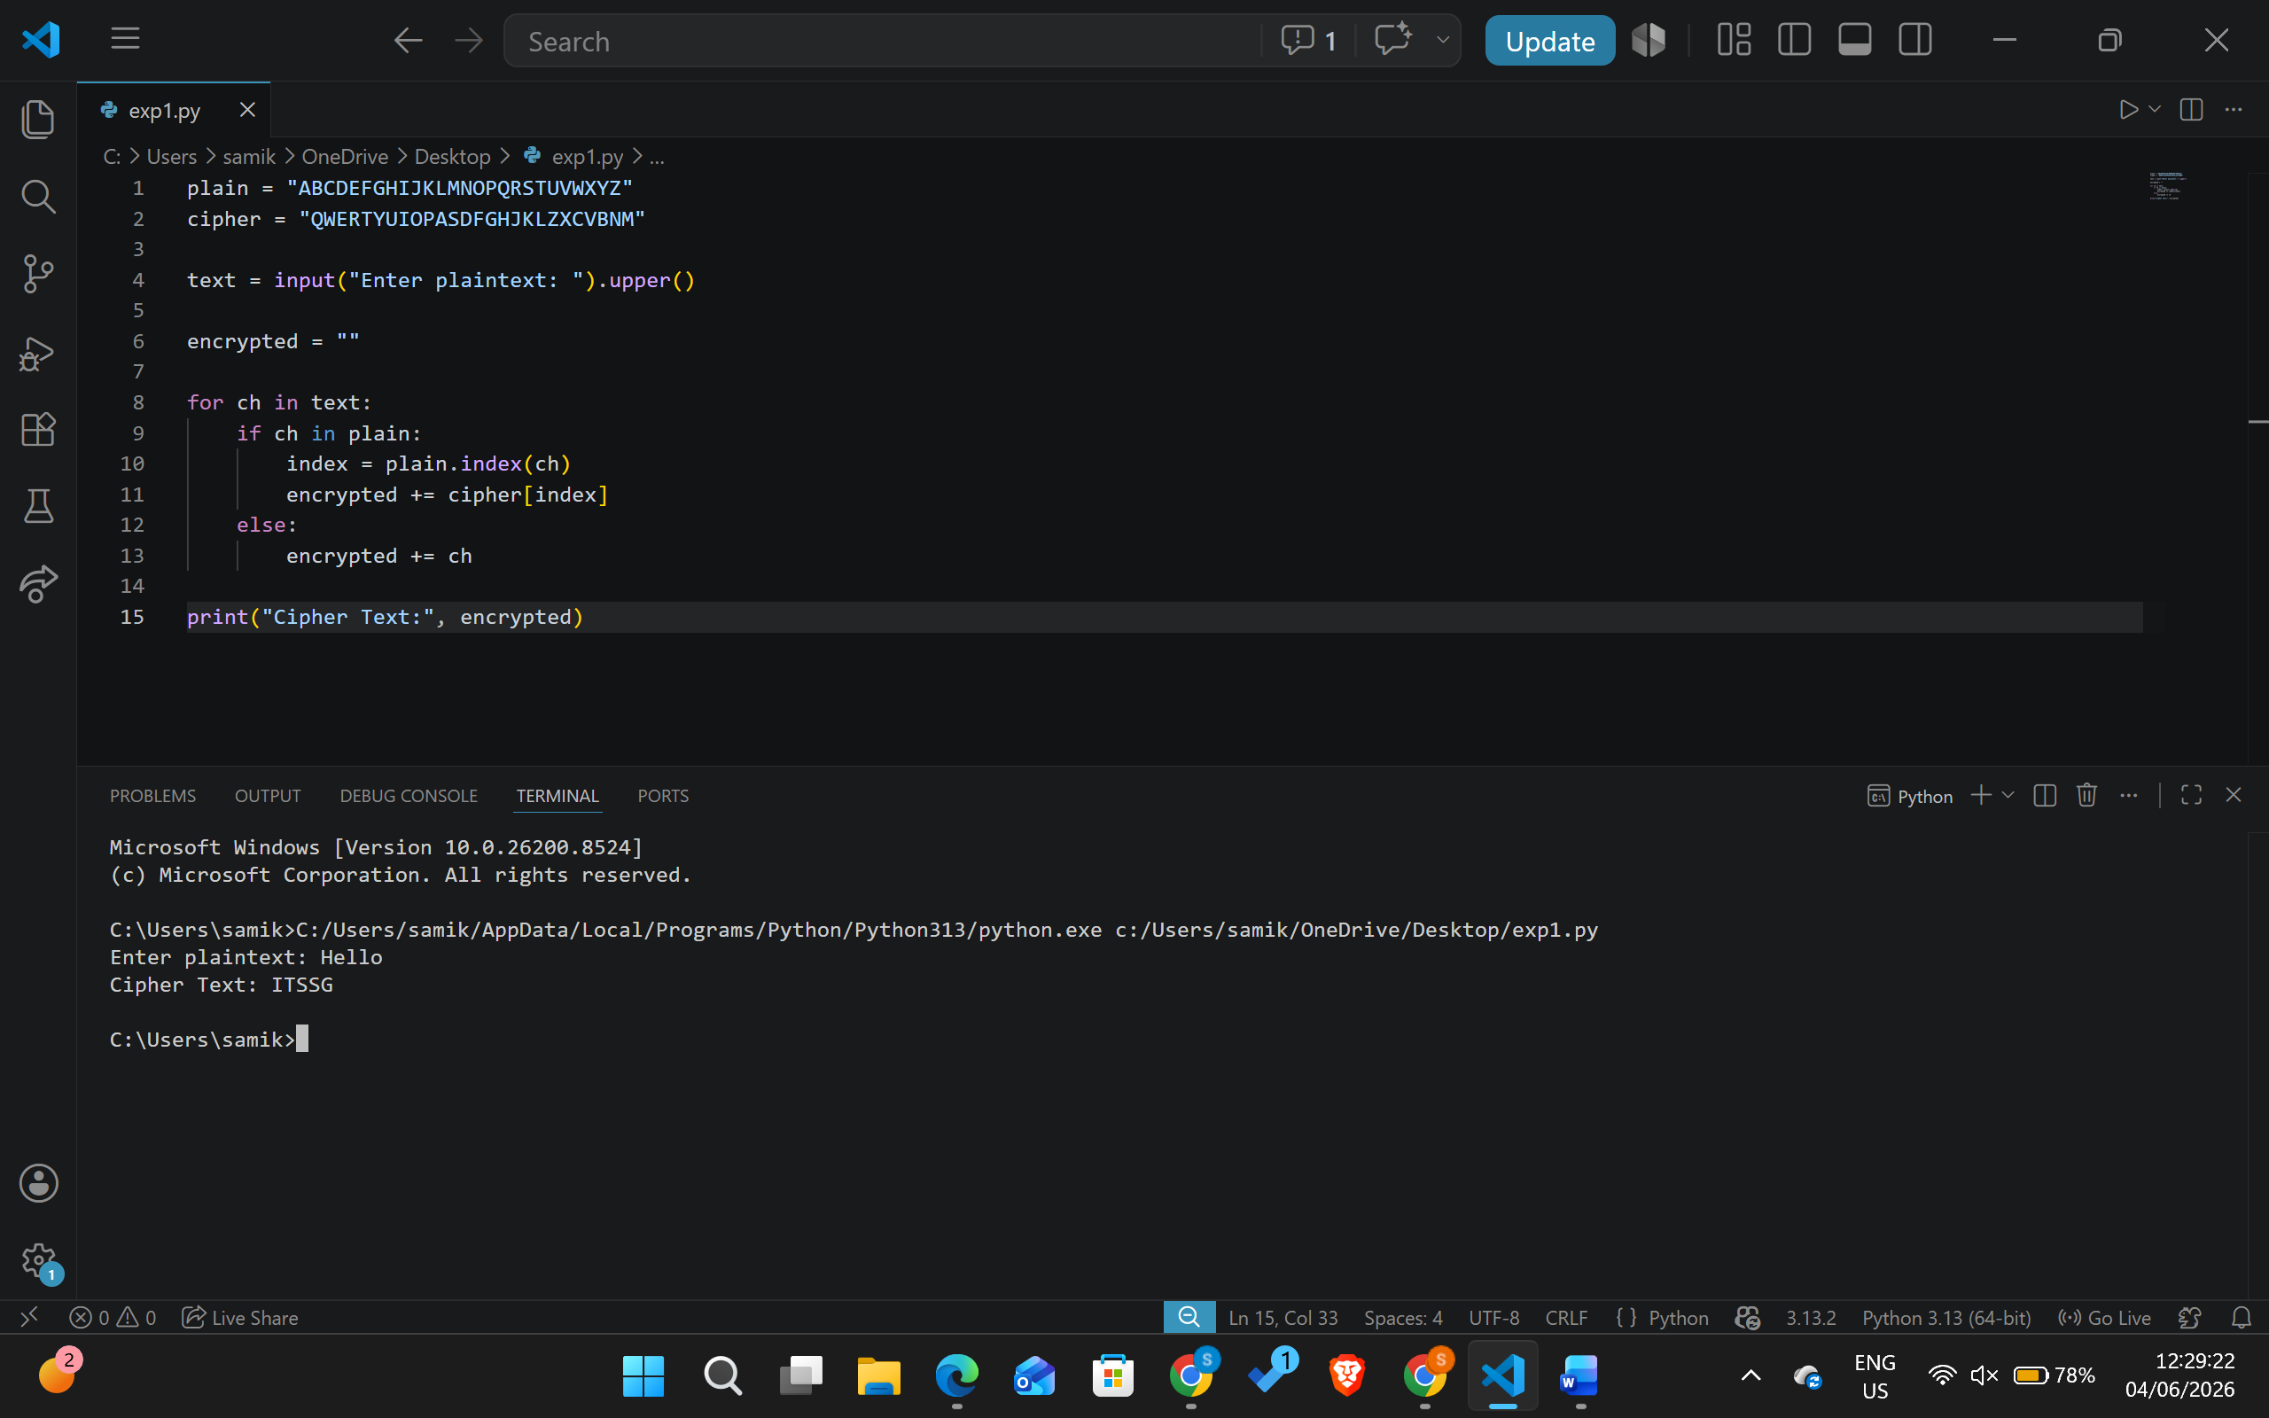

3. Write a program for Playfair algorithm is based on the use of a 5 X 5 matrix of letters constructed using a keyword. Plaintext is encrypted two letters at a time using this matrix.
Program:
def generate_matrix(key):
key = key.upper().replace("J", "I")
matrix = []

for ch in key:
if ch not in matrix and ch.isalpha():
matrix.append(ch)

for ch in "ABCDEFGHIKLMNOPQRSTUVWXYZ":
if ch not in matrix:
matrix.append(ch)

return [matrix[i:i+5] for i in range(0, 25, 5)]

def find_pos(matrix, ch):
if ch == 'J':
ch = 'I'
for i in range(5):
for j in range(5):
if matrix[i][j] == ch:
return i, j

def encrypt(text, matrix):
text = text.upper().replace("J", "I").replace(" ", "")

pairs = []
i = 0
while i < len(text):
a = text[i]
b = text[i+1] if i+1 < len(text) else 'X'

if a == b:
pairs.append(a + 'X')
i += 1
else:
pairs.append(a + b)
i += 2

cipher = ""

for pair in pairs:
r1, c1 = find_pos(matrix, pair[0])
r2, c2 = find_pos(matrix, pair[1])

if r1 == r2:
cipher += matrix[r1][(c1+1)%5]
cipher += matrix[r2][(c2+1)%5]
elif c1 == c2:
cipher += matrix[(r1+1)%5][c1]
cipher += matrix[(r2+1)%5][c2]
else:
cipher += matrix[r1][c2]
cipher += matrix[r2][c1]

return cipher

key = input("Enter key: ")
plaintext = input("Enter plaintext: ")

matrix = generate_matrix(key)

print("Matrix:")
for row in matrix:
print(row)

print("Cipher Text:", encrypt(plaintext, matrix))

Output:
