**Lab Report**

Title: Digital agriculture and irrigation management

Notice: Dr. Bryan Runck

Author: Samikshya Subedi

Date: 9/28/2022

**Project Repository:** *<if applicable weblink to public repository>*

**Time Spent:**Around 6 hours

**Abstract**

As deep percolation is seen right away following a rain or irrigation event, precipitation and irrigation have a significant impact on the quantity and timing of nitrate leaching.The current weather, the amount of water in the soil, the type of crop being grown, and its stage of development all have an impact on crop water use (Evapotranspiration ET). Sensitivity Analysis comparing different data input using same model (Cambell and GEMS).Evapotranspiration model evaluation and comparison will be done for the analysis.

**Problem Statement**

Sensitivity Analysis comparing different data input using same model Mohana code python and Hargreaves-Samani (HS) (GEMS and Campbell).Evapotranspiration model evaluation and comparison

Table 1:

|  |  |  |  |  |  |
| --- | --- | --- | --- | --- | --- |
| **#** | **Requirement** | **Defined As** | **Attribute Data** | **Dataset** | **Preparation** |
| 1 | Weather Data | Major inputs include precipitation (P) or rainfall and irrigation (Irr) | Amount of precipitation | Precipitation (P) or rainfall and irrigation (Irr) | Estimate ETc using two step approach. ETc = ETref x Kc and compare different ETref calculation methods. |

**Input Data**

|  |  |  |  |
| --- | --- | --- | --- |
| **#** | **Title** | **Purpose in Analysis** | **Link to Source** |
| 1 | GEMS gridded weather | Evapotranspiration ET model intercomparison | https://gems.umn.edu/gridding-global-agriculture |
| 2 | Campbell Station | ET model intercomparison | https://www.campbellsci.com/automated-weather-stations |

**Method**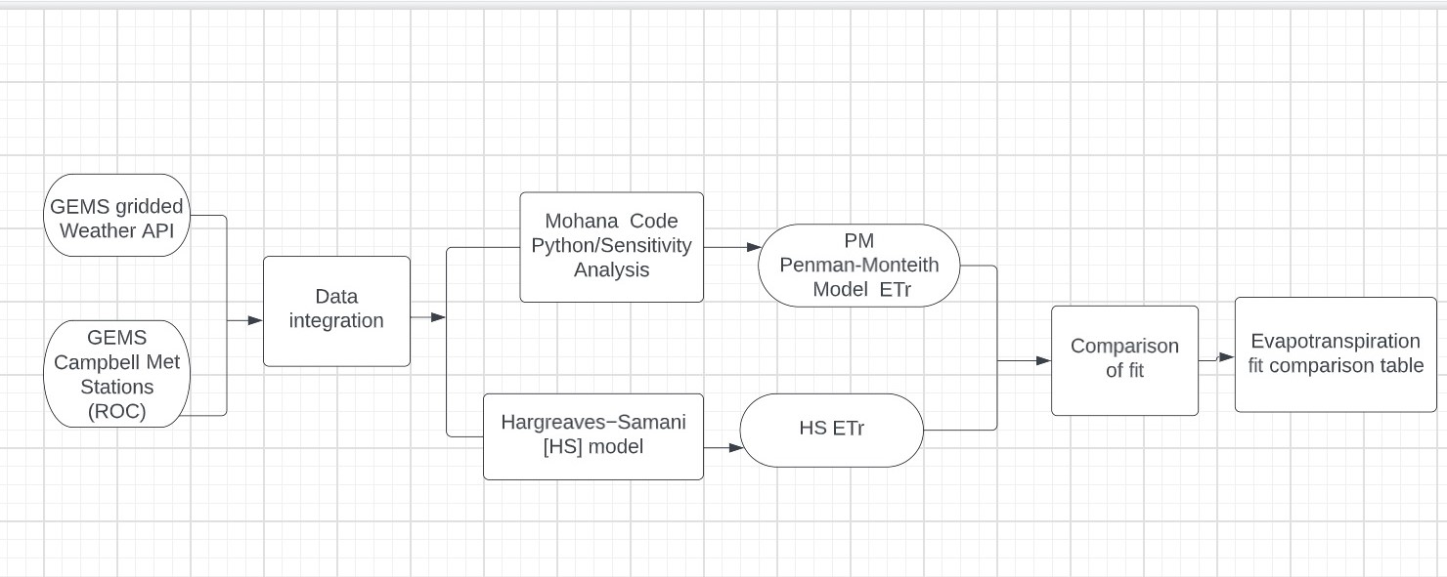

Figure 1: Figure showing data flow diagram

Estimate ETc using two step approach. ETc = ETref x Kc and compare different ETref calculation methods

Sensitivity analysis for ETref by using Mohana code Python and Hargreaves-Somani Model and Evapotranspiration fit comparison table.

**Anticipated Results**

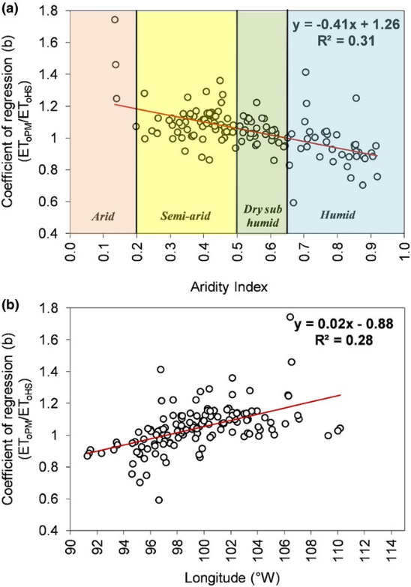

Fig1: My result will look somehow like this but will get the results after all the analysis (Kukul, 2020)

Table 3: My result table will look somehow like this on ET but will know after all the analysis (Kukul, 2020)

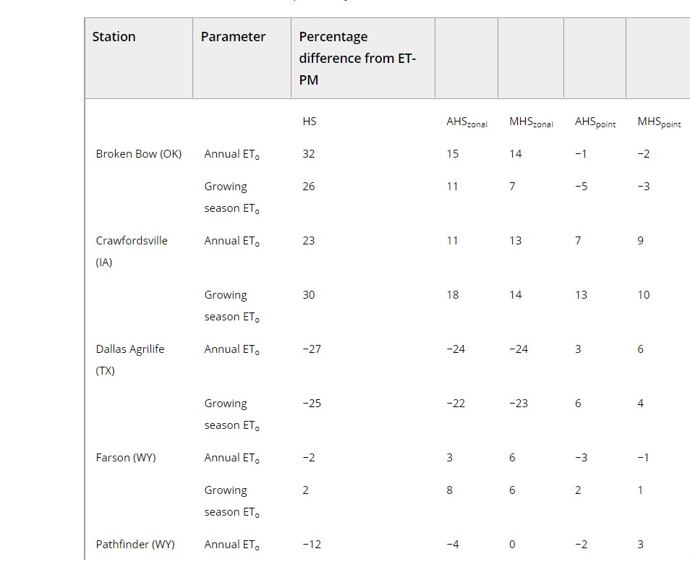

**Results Verification**

If results are accurate in evaluating crop evapotranspiration.

**Discussion and Conclusion**

*What did you learn? How does it relate to the main problem?*

**References**

Al-Kaisi, M. M., & Broner, I. (2009). Crop water use and growth stages. Colorado State University Extension Fort Collins, CO, USA.

Kukal, M. S., S. Irmak, H. Walia, and L. Odhiambo. "Spatio‐temporal calibration of Hargreaves‐Samani model to estimate reference evapotranspiration across US High Plains." *Agronomy Journal* 112, no. 5 (2020): 4232-4248.

Li, P., Wu, J., & Qian, H. (2012). Groundwater quality assessment based on rough sets attribute reduction and TOPSIS method in a semi-arid area, China. *Environmental Monitoring and Assessment*, *184*(8), 4841–4854.

Wang, Z., Li, J., & Li, Y. (2014). Simulation of nitrate leaching under varying drip system uniformities and precipitation patterns during the growing season of maize in the North China Plain. *Agricultural Water Management*, *142*, 19–28.

**Self-score**

*Fill out this rubric for yourself and include it in your lab report. The same rubric will be used to generate a grade in proportion to the points assigned in the syllabus to the assignment.*

|  |  |  |  |
| --- | --- | --- | --- |
| **Category** | **Description** | **Points Possible** | **Score** |
| **Structural Elements** | All elements of a lab report are included **(2 points each)**:  Title, Notice: Dr. Bryan Runck, Author, Project Repository, Date, Abstract, Problem Statement, Input Data w/ tables, Methods w/ Data, Flow Diagrams, Results, Results Verification, Discussion and Conclusion, References in common format, Self-score | 28 |  |
| **Clarity of Content** | Each element above is executed at a professional level so that someone can understand the goal, data, methods, results, and their validity and implications in a 5 minute reading at a cursory-level, and in a 30 minute meeting at a deep level **(12 points)**. There is a clear connection from data to results to discussion and conclusion **(12 points)**. | 24 |  |
| **Reproducibility** | Results are completely reproducible by someone with basic GIS training. There is no ambiguity in data flow or rationale for data operations. Every step is documented and justified. | 28 |  |
| **Verification** | Results are correct in that they have been verified in comparison to some standard. The standard is clearly stated **(10 points)**, the method of comparison is clearly stated **(5 points)**, and the result of verification is clearly stated **(5 points)**. | 20 |  |
|  |  | 100 |  |