**TITLE**:**TO DEMONSTRATE THE SIMPLE PROGRAM IN C++.**

**OBJECTIVE:**

**1.**To be familiar with object oriented programming.

2.To apply the concept of object oriented program.

**THEORY:**

C++ is a cross-platform language that can be used to create high-performance applications.it was developed by Bjarne Stroustrup as an extension to the C programming language.It gives programmers a high level of control over system resources and memory.

Object Oriented Programming (OOP) is a programming paradigm that uses the concept of objects to design and organize software.Objects are the instances of classes.It is associated with the concept of class and objects and various other concepts like inheritance,abstraction,encapsulation and many more.

**1:Write a program to print the message “HELLO WORLD”.**

//Source Code:

#include<iostream>

using namespace std;

int main(){

cout<<"HELLO WORLD"<<endl;

return 0;

}

**OUTPUT:**

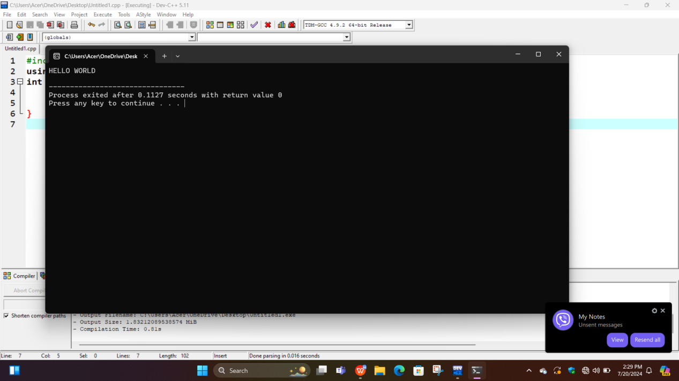

**2:Write a program to input a number and display whether it is even or odd.**

//Source Code:

#include<iostream>

using namespace std;

int main(){

int n;

cout<<"Enter the number"<<endl;

cin>>n;

if(n%2==0){

cout<<"The Number is Even";

}

else{

cout<<"The Number is Odd";

}

return 0;

}

**OUTPUT:**

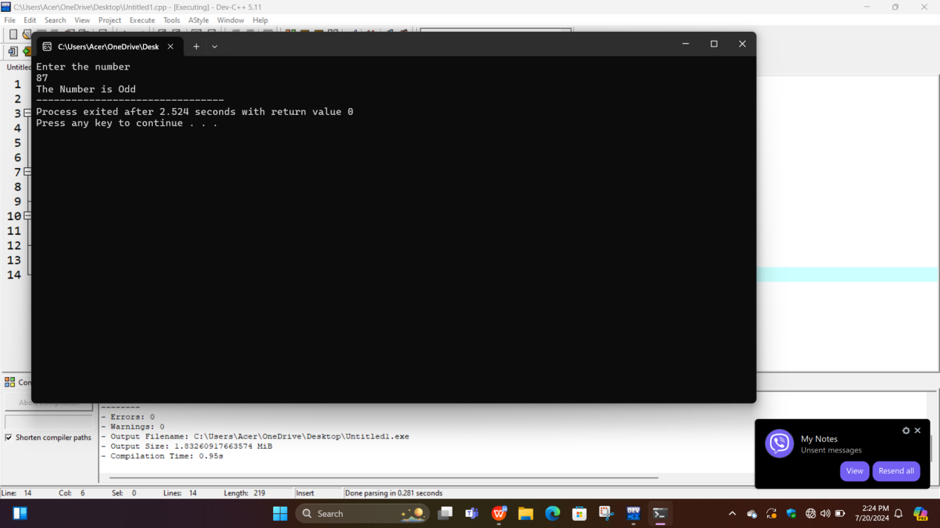

**3.Write a program to input a number and display its table upto 10 term.**

//Source Code:

#include<iostream>

using namespace std;

int main(){

int i , n;

cout<<"Enter the number"<<endl;

cin>>n;

for(i=1;i<=10;i++){

cout<<n;

cout<<"*";cout<<i;cout<<"=";cout<<n*i<<endl;

}

return 0;

}

**OUTPUT:**

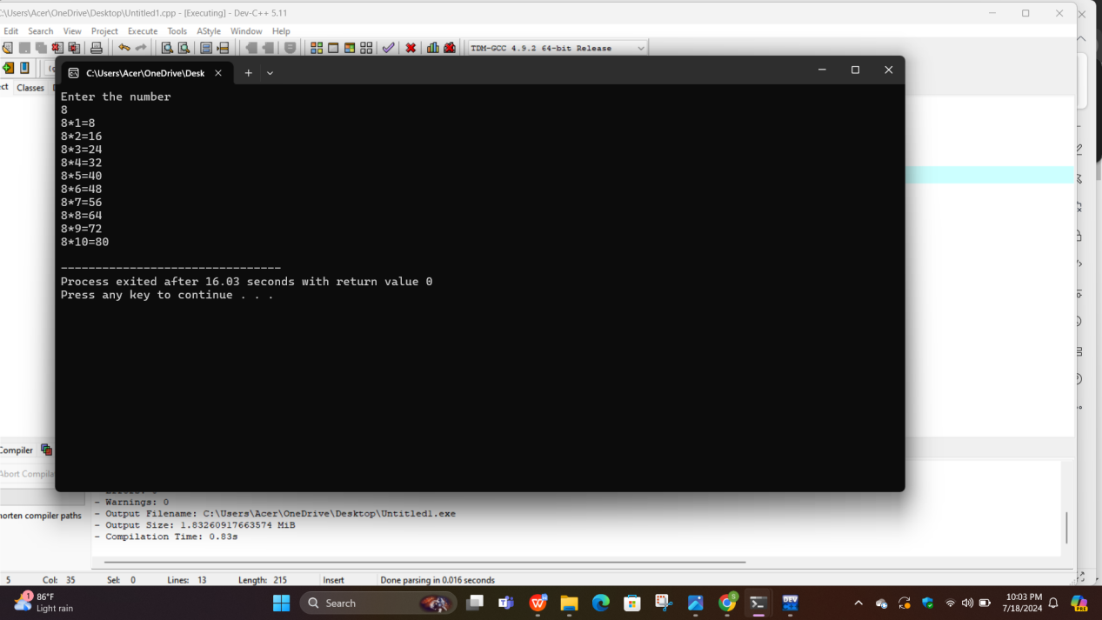

**4.Write a program to input two number and display their sum,difference product and division.**

//Source Code:

#include<iostream>

using namespace std;

int main(){

int num1, num2;

cout<<"Enter the first number"<<endl;

cin>>num1;

cout<<"Enter the second number"<<endl;

cin>>num2;

cout<<"The sum of these numnbers is:"<<num1+num2<<endl;

cout<<"The differnce of these numnbers is:"<<num1-num2<<endl;

cout<<"The product of these numnbers is:"<<num1*num2<<endl;

cout<<"The division of these numnbers is:"<<num1/num2<<endl;

return 0;

}

**OUTPUT:**

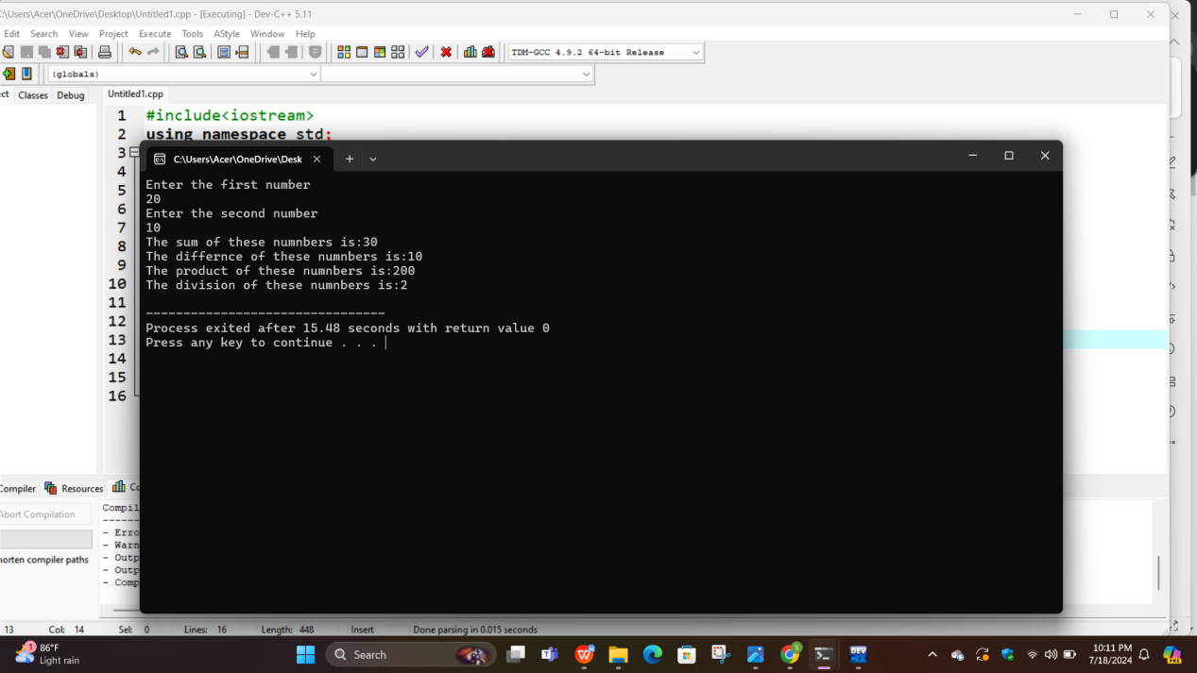

**5.Write a program to input three value and display the middle value.**

//Source Code:

#include <iostream>

using namespace std;

int main() {

int num1, num2, num3 , middle;

cout << "Enter three numbers: ";

cin >> num1 >> num2 >> num3;

if ((num1 >= num2 && num1 <= num3) || (num1 <= num2 && num1 >= num3))

middle = num1;

else if ((num2 >= num1 && num2 <= num3) || (num2 <= num1 && num2 >= num3))

middle = num2;

else

middle = num3; cout << "The middle value is: " << middle << endl;

return 0;

}

**OUTPUT:**

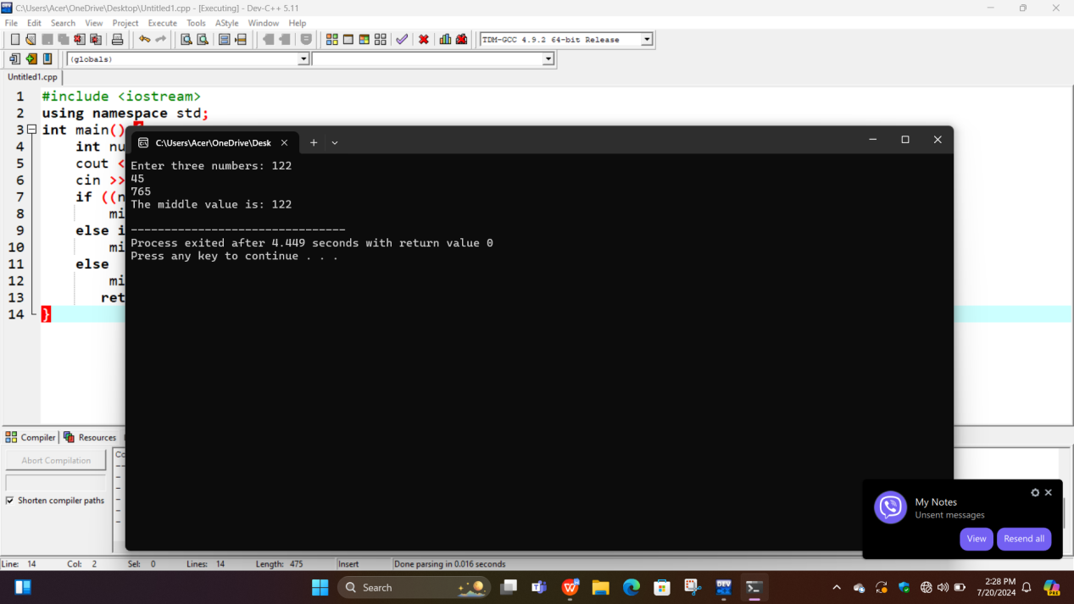

**6.Write a program to input a number and display prime or cmposite.**

//Source code

#include<iostream>

using namespace std;

int main()

{

int num, i, count=0;

cout<<"\n Enter Number : ";

cin>>num;

for(i=2;i<num;i++)

{

if(num%i==0)

{

count++;

break;

}

}

if(count==0)

{

cout<<"\n Prime Number";

}

else

{

cout<<" \n Not a Prime Number";

}

return 0;

}

**OUTPUT**

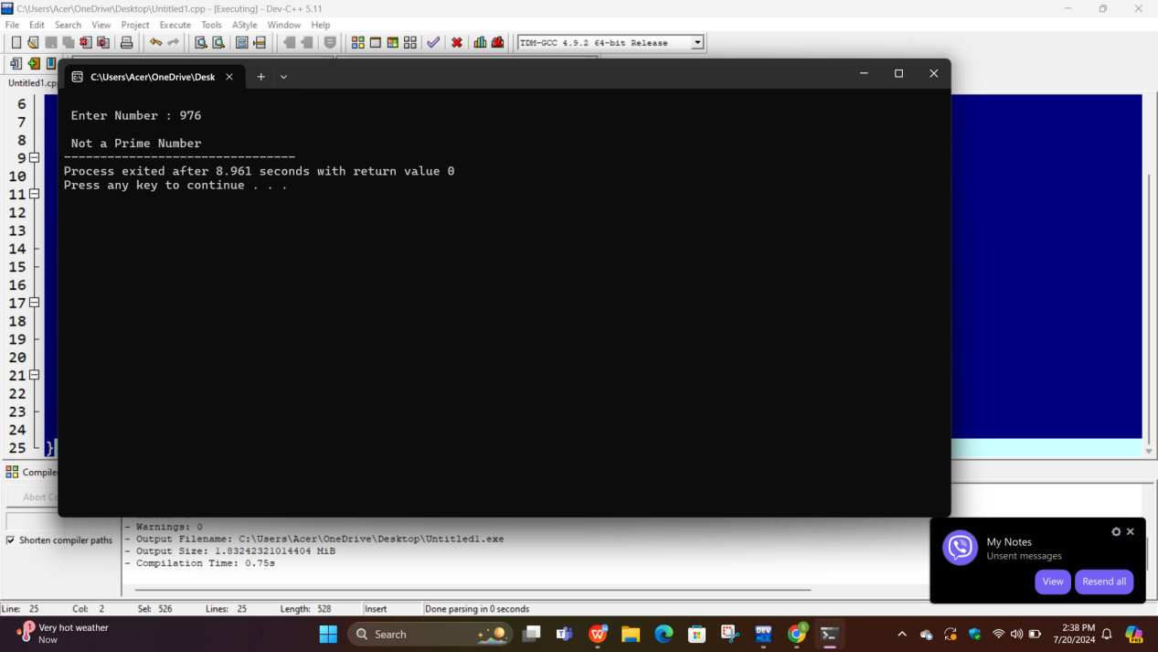

**CONCLUSION:**

In this lab we have become familiar with the basics of C++ programming language.we run different types of programs with the concept of c++ programming language.