

Where-to-go

A Point-Of-Interest Recommendation System

**Software Project Lab 3**

**Submitted by**

Samima Aktar

BSSE 0841

Institute of Information Technology

University of Dhaka

**Submitted to**

Software Project Lab 3 Committee

**Supervised By**

Md. Nurul Ahad Tawhid

Assistant Professor

Institute of Information Technology

University of Dhaka

**Submission Date**: 01 september, 2019

Letter of Transmittal

01 September, 2019

Coordinator,

Software Project Lab 3,

Institute of Information Technology,

University of Dhaka.

Subject: Submission of technical report on SPL-3 project.

Sir,

With due respect, I am pleased to submit the technical report on **Where-to-go**, A point-of-interest recommendation system. Although this report may have shortcomings, I have tried my level best to produce an acceptable technical report. I would be highly obliged if you overlooked the mistakes and accepted the effort that has been put in this report.

Sincerely yours, Approved by,

Samima Aktar (BSSE 0841) Md. Nurul Ahad Tawhid

Institute of Information Technology, Assistant Professor

University of Dhaka. InstituteofInformationTechnology,

University of Dhaka.

Acknowledgement

I am highly indebted for getting such a tremendous opportunity to prepare the technical report on **Where to go** A point-of-interest recommendation system. I would like to thank whole-heartedly my supervisor, Md. Nurul Ahad Tawhid, Assistant Professor, Institute of Information Technology, University of Dhaka, for giving me guidelines about how I can prepare this report.

Abstract

A point-of-interest is a specific point location that someone may find useful or interesting. POI recommendation system is advantageous as it helps user to quickly find useful place or location. We have intended to make a POI recommendation system using user-based collaborative filtering along with considering social influence and geographical influence. In this system, a user has been given POI recommendation according to his/her previous point-of-interests and friend-list.

Contents

**Chapter 1: Introduction** **7**

**Purpose** **8**

**Intended Audience** **8**

**1.3 Conclusion** **8**

**Chapter 2: Quality Function Deployment** **9**

**2.1 Introduction** **9**

**2.2 Quality Function Deployment** **9**

**2.2.1 Normal Requirements** **9**

**2.2.2 Usage Scenario** **10**

**Chapter 3: Scenario Based Modeling** **12**

**3.1 Introduction** **12**

**3.2 Definition of Use Case** **12**

**3.3 Use Case Diagram** **12**

**3.3.4 Level-1.2 Use Case Diagram-Authentication** **16**

**3.4 Activity Diagram** **18**

**Chapter 4: Data Modeling** **22**

**4.1 Data Modeling Concept** **22**

**4.2 Data Object Concept** **23**

**4.3 Noun Identification** **23**

**4.4 Potential Data Object** **24**

**4.5 Analysis for Finalizing Data Objects** **24**

**4.6 Final Data Objects** **24**

**4.7 Schema Table** **25**

**4.8 Relationship among Data Objects** **25**

**4.9 ER Diagram** **26**

***Table of Figures:***

Figure 1: Relationship among Data Objects 30

Figure 2: ER Diagram 31

Figure 3: CRC Diagram 40

Figure 4: Architectural Context Diagram 42

Figure 5: System Components 43

Figure 6: Component Elaboration 44

### **Chapter 1: Introduction**

### **Purpose**

This document briefly describes the overall system of proposed recommendation system **Where to go**. It contains functional, non-functional and supporting requirements and establishes a requirements baseline for the development of the system. The requirements contained in the technical report are independent, uniquely numbered and organized by topic. The technical report serves as an official means of communicating user requirements to the developer and provides a common reference point for both the developer team and the stakeholder community. The technical report will evolve over time as users and developers work together to validate, clarify and expand its contents.

### **Intended Audience**

This technical report is intended for several audiences including the customers as well as the project managers, designers, developers, and testers.

### **1.3 Conclusion**

This analysis of the audience helped me to focus on the users who will be using our analysis. This overall document will help each person related to this project to have a better idea about the project.

### **Chapter 2: Quality Function Deployment**

### 

### **2.1 Introduction**

Requirements Elicitation is a part of requirements engineering that is the practice of gathering requirements from the users, customers and other stakeholders. We have faced many difficulties, like understanding the problems, making questions for the stakeholders, limited communication with stakeholders due to a short amount of time and volatility. Though it is not easy to gather requirements within a very short time, we have surpassed these problems in an organized and systematic manner.

### **2.2 Quality Function Deployment**

Quality Function Deployment (QFD) is a technique that translates the needs of the customer into technical requirements for software. Ultimately the goal of QFD is to translate subjective quality criteria into objective ones that can be quantified and measured, and which can then be used to design and manufacture the product. It is a methodology that concentrates on maximizing customer satisfaction from the software engineering process. So, we have followed this methodology to identify the requirements for the project. The requirements, which are given below, are identified successfully by the QFD.

### **2.2.1 Normal Requirements**

Normal requirements consist of objectives and goals that are stated during the meeting with the customers. Normal requirements of our project are:

1. User-friendly design.
2. Signup and login system of users
3. Searching friends and adding friends
4. Getting nearest and accepted POI’s list and details

### **2.2.2 Usage Scenario**

A point-of-interest is a specific point location that someone may find useful or interesting. POI recommendation system is advantageous as it helps user to quickly find useful place or location. I have intended to make a POI recommendation system using user-based collaborative filtering along with considering social influence and geographical influence. In this system, a user has been given POI recommendation according to his/her previous point-of-interests and friend-list.

**POI Recommendation Model:**

At the very beginSystem ning, a POI recommendation model will be created according to a dataset - named Gowala. This model will be generated using user-based collaborative filtering along with considering social influence and geographical influence.

**Authentication:**

User has to register for his/her account. He/she will provide username, name and password to register. will check whether that username is unique or not. After registration process, user can login to his/her account by providing his/her username and password.

**User Profile:**

After first login, user has to create his/her user profile. User profile consists of two things: user’s previous point-of-interests and friend list. To define his/her previous point-of-interests, user can search places/POIs using a search box and select his/her previous POIs. User’s selected POIs will be saved in the database.

Then user has to create his/her friend list. User can search other users using a search box and make friends by selecting other user/s from the search result. User’s selected users will be saved in the database. Anytime user can update his/her user profile data: he/she can edit and delete POIs or friend list.

**POI Recommendation System:**

User can ask for POI recommendation from the system. According to the user’s selected POIs and friend list incorporated with pre-built POI recommendation model, a list of POIs will be generated. That list of POIs is the recommendation given by our POI recommendation system.

### **Chapter 3: Scenario Based Modeling**

This chapter describes the Scenario Based Model for “Where to go”.

### **3.1 Introduction**

Scenario based modelling is the first phase where the usage of product can be visualized. This model enables us to get a vivid idea how user will use the product. In the following, we describe how the user story and use case.

### **3.2 Definition of Use Case**

**A Use Case captures a contract that describes the system behavior under various conditions as the system responds to a request from one of its stakeholders. A Use Case tells a stylized story about how an end user interacts with the system under a specific set of circumstances. A Use Case diagram simply describes a story using corresponding actors who perform important roles in the story and makes the story understandable for the users.**

**The first step in writing a Use Case is to define that set of “users” that will be involved in the story.Users are the different people that use the system or product within the context of the function and behavior that is to be described. Users represent the roles that people play as the system operators. Every user has one or more goals when using system.**

### **3.3 Use Case Diagram**

Use Case diagrams give the non-technical view of overall system.

**3.3.1 Level-0 Use Case Diagram- Where to go**

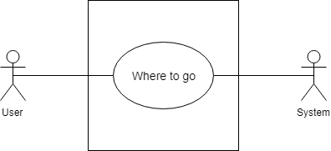

Level 0:Where to go

**Name:** where to go

**ID:** Level-0 Use Case

**Primary Actors:** User, System

**Secondary Actors:** None

**Description of Level 0 Use Case Diagram:**

After analyzing the user story we found that there are two actors who will use this system as a system operator.

Those actors are given below:

* User
* System

**3.3.2 Level-1 Use Case Diagram-Subsystems**

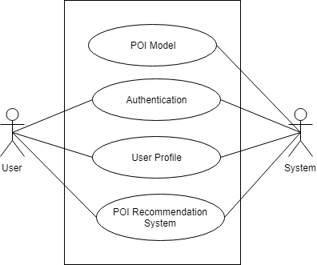  
Level 1:Subsystems

**Name:** Subsystems of where to go

**ID:** Level-1 Use Case

**Primary Actors:** User, System

**Secondary Actors:** None

**Action-Replay:**

Action 1: Provided registration Information

Reply 1: Registration successful

Action 2: Enter login credentials

Reply 2: Login successful

Action 3: Activate User

Reply 3: user Activated

**Description of Level 1 Use Case Diagram:**

There are four subsystems:

* POI model
* Authentication
* User Profile
* POI recommendation system

**3.3.3 Level-1.1 Use Case Diagram-POI model**

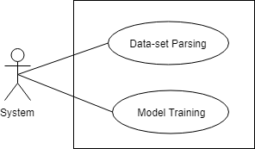

Level 1.1: POI model

**Name:** POI model

**ID:** Level-1.1 Use Case

**Primary Actors:** System

### **3.3.4 Level-1.2 Use Case Diagram-Authentication**

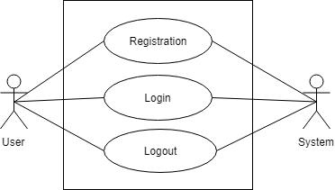  
Level 1.2: Authentication

**Name:** Authentication

**ID:** Level-1.2 Use Case

**Primary Actors:** User, System

**3.3.5 Level-1.3 Use Case Diagram-User Profile**

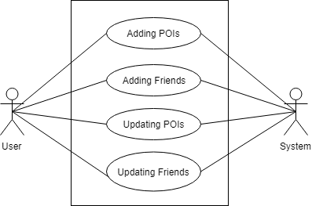

Level 1.3: User profile

**Name:** User Profile

**ID:** Level-1.3 Use Case

**Primary Actors:** user, System

**3.3.6 Level-1.4 Use Case Diagram-POI recommendation system**

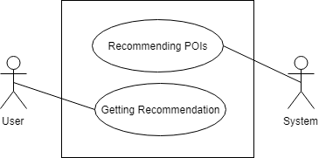

Level 1.4: POI recommendation system

**Name:** POI recommendation system

**ID:** Level-1.4 Use Case

**Primary Actors:** User, System

### **3.4 Activity Diagram**

**3.4.1 Level-1.1 Activity Diagram- POI model**

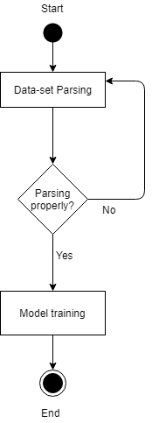

Level 1.1: POI model

**3.4.2 Level-1.2.1 Activity Diagram- Registration**

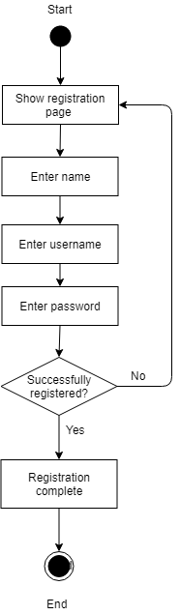

Level 1.2.1: Registration

**3.4.3 Level-1.2.2 Activity Diagram- Login**

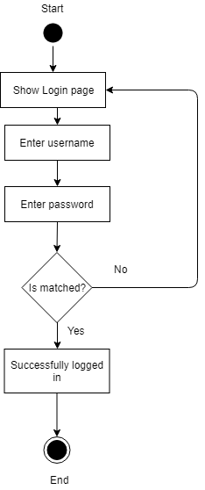

Level 1.2.2: Login

**3.4.4 Level-1.3 Activity Diagram- UserProfile**

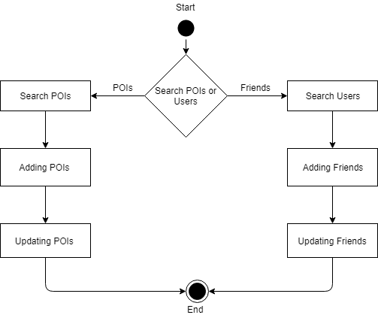

Level 1.3: UserProfile

**3.4.5 Level-1.4 Activity Diagram- POIs Recommendation Model**

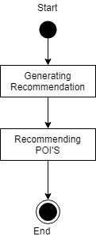

Level 1.4:POIs Recommendation Model

### 

### **Chapter 4: Data Modeling**

This Chapter is intended to describe data modeling of Where to go.

### **4.1 Data Modeling Concept**

If software requirements include the necessity to create, extend or interact with a database or complex data structures need to be constructed and manipulated, then the software team chooses to create data models as part of overall requirements modeling. The entity-relationship diagram (ERD) defines all data objects that are processed within the system, the relationships between the data objects and the information about how the data objects are entered, stored, transformed and produced within the system.

### **4.2 Data Object Concept**

A data object is a representation of composite information that must be understood by the software. Here, composite information means information that has a number of different properties or attributes. A data object can be an external entity, a thing, an occurrence, a role, an organizational unit, a place or a structure.

### **4.3 Noun Identification**

|  |  |  |  |
| --- | --- | --- | --- |
| **SL**  **No.** | **Nouns** | **P/S** | **Attributes** |
| 1 | Point | P |  |
| 2 | Location | P |  |
| 3 | POI recommendation system | P |  |
| 4 | User | S | 6, 9-11,14 |
| 5 | Place | P |  |
| 6 | Friend-list | S |  |
| 7 | POI recommendation model | S | 8 |
| 8 | Model | S |  |
| 9 | Name | S |  |
| 10 | Username | S |  |
| 11 | Password | S |  |
| 12 | System | P |  |
| 13 | User profile | P |  |
| 14 | Point-of-interests | S |  |
| 15 | Search | P |  |
| 16 | Friends | P |  |
| 17 | Registration | S | 9-11 |
| 18 | Authentication | S | 9-11 |

### **4.4 Potential Data Object**

**User:** user_id, username, password, name, friendlist, pois.

**Registration:** user_id, name, username, password.

**Authentication:** user_id, name, username, password.

### **4.5 Analysis for Finalizing Data Objects**

1. Authentication and Registration have the same attributes, so they are merged together into a single data object - Authentication

### **4.6 Final Data Objects**

|  |  |  |
| --- | --- | --- |
| **No.** | **Entity** | **Attributes** |
| 1 | User | user_id**,** username, password, name, friendlist, pois |
| 2 | Authentication | user_id, name, username, password. |

### **4.7 Schema Table**

|  |  |  |
| --- | --- | --- |
| 1. **User** | | |
| **Attributes** | **Types** | **Size** |
| User ID  Username  Password  name  Friendlist  POIs | NUMBER  VARCHAR2  VARCHAR2  VARCHAR2  VARCHAR2  VARCHAR2 | 5  25  20  20  15  40 |

|  |  |  |
| --- | --- | --- |
| **2.**  **Authentication** | | |
| **Attributes** | **Types** | **Size** |
| User ID  Name  Username  Password | NUMBER  VARCHAR2  VARCHAR2  VARCHAR2 | 5  20  25  20 |

### 

### **4.8 Relationship among Data Objects**



*Figure 1: Relationship among Data Objects*

### **4.9 ER Diagram**

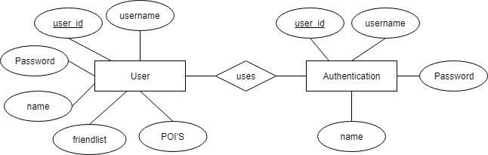

*Figure 2: ER Diagram*

**Chapter 5: Methodology**

### **5.1 Point-of-Interests**

### Point-of-interests (POI) recommendation system is a system that recommends point-of-interest (possible location of interest or favor) of individual based on training data. POI recommendation system mainly works using user-based collaborative filtering approach. For example, user 1 and user 2 have similar taste regarding point of interest :

User1 check-ins at places: A, B, C, D & E

User2 check-ins at places: A, B, C, E & F.

So according to user-based collaborative filtering, it is more likely that, user1 may prefer/like place F and user2 may prefer/like place D.

Most of the POI recommendation system mainly works using user-based collaborative filtering approach. However, according to a state-of-the-art research [1], incorporating social influence (friend-based collaborative filtering) and geographical influence with the typical user-based collaborative filtering approach can improve the performance of POI recommendation system.

How do social influence and geographical influence work? To understand those influences, Figure 1 might be helpful.

According to Figure 1, users u1 and u2 have common POI - l2 and l3. They may be considered as similar users who are assumed to share similar check-in behaviors, i.e., preference of POIs. As a result, l1 is a good candidate for recommendation to user u2 since u1 has visited this POI before. On the other hand, social influence of friends can be incorporated in the recommendation process. For example, when considering l4 as a recommendations candidate for u1, the social influence of u4 on u1 may contribute to the decision making. Finally, the geographical influence of POIs on nearby POIs can be considered. As shown in the example, since u2 has visited l2 and l3 before, their nearby POIs l1 and l5 may be considered positively due to the geographical influence.

**Chapter 6: Conclusion**

This technical report draws a path for implementing the application. With the help of this technical report, any developer can understand the whole system requirement and design. So, it acts as a guideline for the developers who will build the real application. Besides, this technical report also helps the quality assurance team to check whether the built system is valid or not.

**Chapter 7: Reference**

1. Ye, M., Yin, P., Lee, W. C., & Lee, D. L. (2011, July). Exploiting geographical influence for collaborative point-of-interest recommendation. In Proceedings of the 34th international ACM SIGIR conference on Research and development in Information Retrieval (pp. 325-334). ACM.

2. Yuan, Q., Cong, G., Ma, Z., Sun, A., & Thalmann, N. M. (2013, July). Time-aware point-of-interest recommendation. In Proceedings of the 36th international ACM SIGIR conference on Research and development in information retrieval (pp. 363-372). ACM.

3. Cheng, C., Yang, H., Lyu, M. R., & King, I. (2013, June). Where you like to go next: Successive point-of-interest recommendation. In Twenty-Third international joint conference on Artificial Intelligence.

4. Gao, H., Tang, J., Hu, X., & Liu, H. (2015, February). Content-aware point of interest recommendation on location-based social networks. In Twenty-Ninth AAAI Conference on Artificial Intelligence.