Atlas-Resolution-Aware Source-Space EEG Graph Learning for Alzheimer’s Disease: A Controlled Participant-Level Study
[Author names, affiliations and corresponding author — to be completed by the authors]
DRAFT v1 for author review. Formatted to the section order of the OJEMB Science Manuscript format (as described on the journal’s Instructions for Authors page); the official Word/LaTeX template could not be downloaded in this environment and must be applied before submission.
Abstract— Objective: Low-density EEG limits how finely source-space graph models of Alzheimer's disease (AD) can resolve cortical regions, yet atlas resolution is rarely examined. We asked how atlas resolution, inverse solution, connectivity, and network design affect participant-level AD-versus-control discrimination. Results: On OpenNeuro ds004504 (36 AD, 29 controls; 52 development participants, five-fold participant-grouped cross-validation), leadfield rank (18) and cross-talk analysis selected a 12-region atlas. An anatomically informed dual-layer graph convolutional network (LCMV sources, phase-locking value, spectral power) reached AUC 0.858 (95% CI 0.749–0.966) and accuracy 84.6%; an 18-region multiband network reached AUC 0.859. No difference among architectures, connectivity measures, inverses, atlases, or ablations survived multiplicity correction; selection optimism was +0.03 to +0.08 AUC. Conclusions: Resolution-aware design yields compact source-space graphs, but complexity bought no supported gain. Estimates are development cross-validation on 52 participants, not external validation.
Index Terms— Alzheimer's disease, electroencephalography, graph neural networks, source imaging, functional connectivity, atlas resolution
Visual Summary: to be prepared from Fig. 1 (pipeline) and Fig. 3g (AUC by atlas) in the journal’s one-page visual-summary format; not yet produced.

I. INTRODUCTION
Alzheimer's disease (AD) alters resting-state EEG: power shifts toward slower rhythms and coherence in faster rhythms declines, which has been attributed to functional disconnection between cortical areas [1]. Consensus work argues that EEG markers merit evaluation in clinical trials but are not yet endorsed by guidelines [2]. Routine clinical recordings, however, use few electrodes, typically the 19 sites of the 10–20 system.
Scalp connectivity is confounded by volume conduction [3], which motivates estimating connectivity between reconstructed cortical sources [4]. Source accuracy, in turn, depends on sensor density and coverage [5]. With 19 average-referenced channels the leadfield spans at most 18 spatial dimensions, so a 68-region parcellation necessarily contains regions whose signals are linear combinations of others. Whether a given atlas is observable from such a montage is a property of the measurement, but it is seldom made explicit when graph models are built on source regions.
Graph convolutional networks (GCNs) [6] are a natural way to combine regional spectral features with interregional connectivity. EEG-based GNNs for AD have used phase-lag graphs on electrodes [7], effective-connectivity graphs on ds004504 under leave-one-subject-out validation [8], per-band mixtures of graph experts [9], and a multi-graph network combining functional and structural connectivity with differential-entropy features [10]. Most operate on electrodes, evaluation protocols differ (subject-level or epoch-level), and the resolution of the node set is rarely tested.
We study source-space graph learning on the public ds004504 dataset [11] with the explicit aim of testing which design choices matter at participant level. The contributions are:
1) A resolution-aware source-space framework: a pre-specified, label-blind rule based on leadfield rank, cross-talk and own-region dominance selects the cortical atlas for a 19-electrode montage (12 lobar regions), with the finer 68- and 18-region atlases compared in development cross-validation.
2) A controlled participant-level evaluation under a frozen split and a fixed 60-epoch protocol of LCMV versus wMNE sources, PLV versus |ciPLV|, single-band, band-averaged and multiband networks, graph sparsification and window count, with selection-bias accounting across 280 configurations.
3) A source-space adaptation of an anatomically informed dual-layer GCN (functional layer followed by a fixed cortical-surface-contiguity layer), with ablations showing that neither this prior nor added architectural complexity yields a statistically supported improvement.
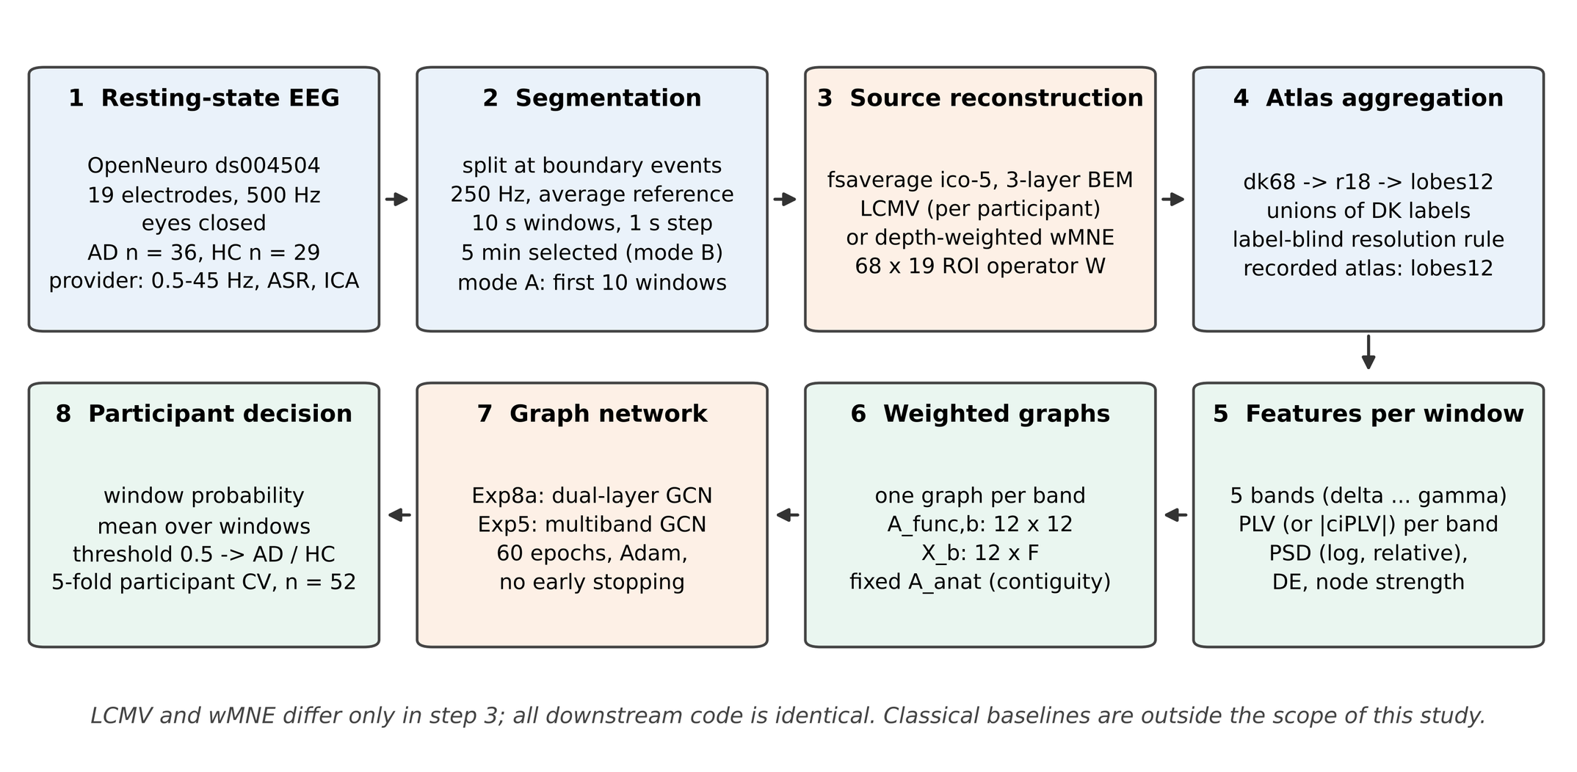
Fig. 1. End-to-end source-space EEG graph-learning pipeline. Resting-state eyes-closed EEG (OpenNeuro ds004504; 19 electrodes; 36 AD, 29 HC) is segmented at provider boundary events, resampled to 250 Hz and average-referenced; five minutes per participant are cut into 10 s windows with a 1 s step (mode B; mode A uses the first 10 accepted windows). Sources are reconstructed with LCMV or depth-weighted wMNE into 68 Desikan-Killiany ROI signals and aggregated to coarser atlases (r18, lobes12). Per window and band, PLV (or |ciPLV|), PSD and differential entropy define weighted band graphs on which a graph network is trained for 60 epochs; window probabilities are averaged per participant and evaluated by five-fold participant-grouped cross-validation on the 52 development participants.

II. RESULTS
A. Spatial resolution supported by 19 electrodes
The average-referenced leadfield (fsaverage ico-5, three-layer BEM, 20,484 sources) has numerical rank 18 and entropy-effective rank 12.8; nine singular values hold 95% of its energy, 14 hold 99%, and only five exceed the wMNE regularisation level. Consequently 50 of the 68 Desikan–Killiany ROI signals are exact linear combinations of the others, and the median ROI draws 0.86–0.87 of its variance from other regions (Fig. 3). The pre-specified rule (median cross-talk ≤ 0.60, own-region dominance ≥ 0.80, no forced redundancy, both inverses) rejected dk68, a 34-region gyral atlas (analysed only) and the 18-region atlas r18 (own-region dominance 0.778 for LCMV), and accepted only the 12-region lobar atlas lobes12 (worst-case cross-talk 0.415, dominance 0.833). The r18 atlas was nevertheless evaluated in development cross-validation as an exploratory, post-hoc comparison.
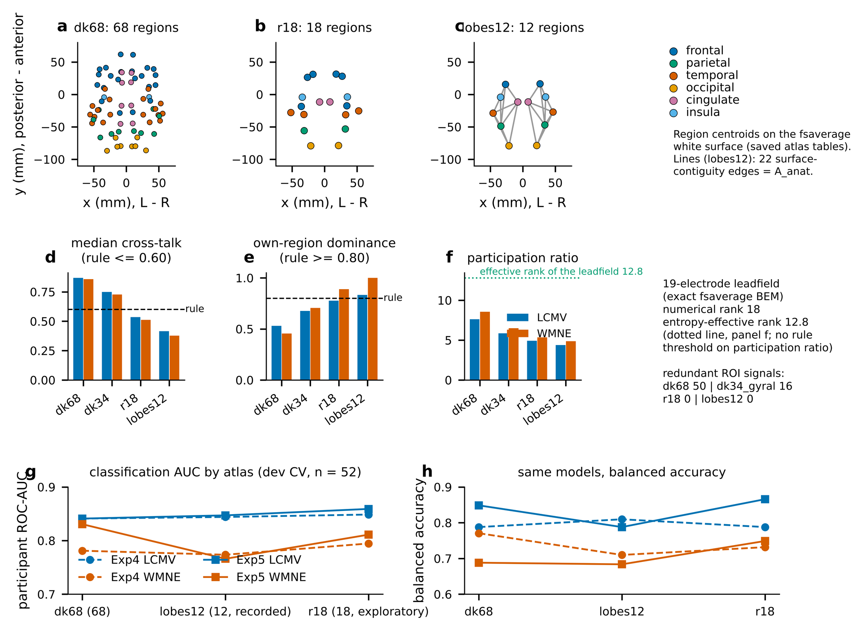
Fig. 3. Atlas resolution under a 19-electrode montage. (a-c) Region centroids (fsaverage white surface, axial projection) of dk68, r18 and lobes12, coloured by lobe; lines in (c) are the 22 surface-contiguity edges of the anatomical layer. (d-f) Exact-BEM resolution analysis for LCMV and wMNE: median cross-talk (rule <= 0.60), own-region dominance (rule >= 0.80) and participation ratio; the leadfield has numerical rank 18 and entropy-effective rank 12.8. Only lobes12 meets both criteria for both inverses (r18 misses dominance for LCMV, 0.778). dk34_gyral is analysed only (not classified). (g, h) Participant-level development-CV AUC and balanced accuracy of the same matched models (Exp4 band-mean GCN, Exp5 separate-encoder multiband GCN; LCMV and wMNE; PLV; mode B; dense graph; n = 52) on dk68, lobes12 and r18; no difference is statistically supported, and lobes12 was recorded as the analysis atlas.
B. Primary model
The primary model (Exp8a: LCMV sources, PLV graphs, PSD node features, lobes12, dense graph, all windows) reached participant-level AUC 0.858 (DeLong 95% CI 0.749–0.966), accuracy 84.6% (44/52), balanced accuracy 85.8%, sensitivity 75.9% (22/29) and specificity 95.7% (22/23); one control and seven AD participants were misclassified (Table I, Fig. 5). Using only the first ten windows lowered the AUC to 0.804. These are development cross-validation estimates; the model was emphasised after results were visible, and it was neither the highest-AUC configuration nor tested on independent data.
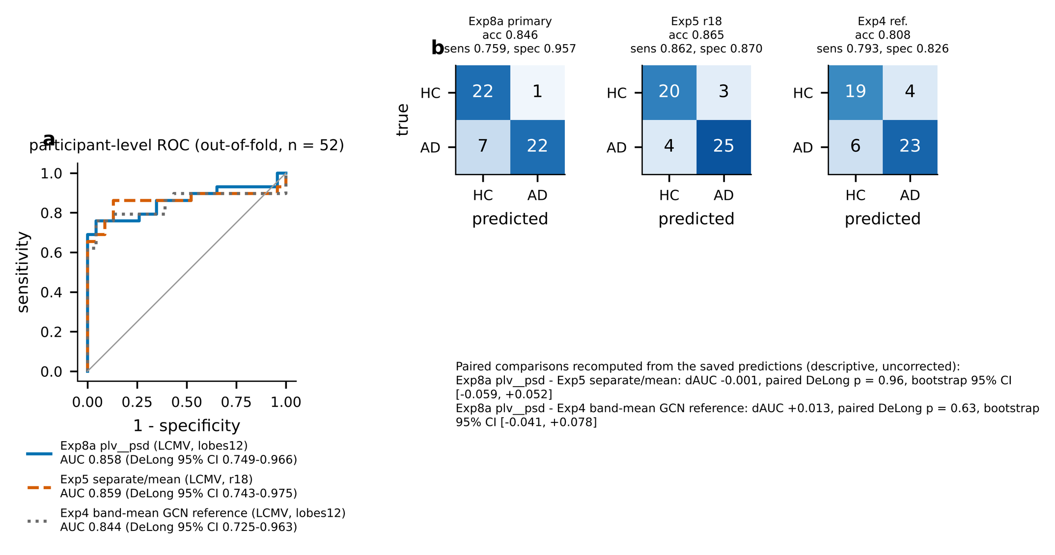
Fig. 5. Participant-level out-of-fold ROC curves and confusion matrices (threshold 0.5) for the primary model (Exp8a, LCMV, PLV + PSD, lobes12), the Exp5 separate-encoder multiband GCN on r18 and the Exp4 band-mean GCN reference on lobes12 (all LCMV, mode B, dense; one score per participant, n = 52: 29 AD, 23 HC). AUC 0.858 (DeLong 95% CI 0.749-0.966), 0.859 (0.743-0.975) and 0.844 (0.725-0.963). Paired DeLong tests recomputed from the saved predictions (uncorrected, descriptive) show no difference (primary vs Exp5 r18: dAUC -0.001, p = 0.96; primary vs Exp4: +0.013, p = 0.63). Development cross-validation, not independent test performance; the model was emphasised retrospectively.
TABLE I PARTICIPANT-LEVEL DEVELOPMENT RESULTS (WINDOW MODE B, DENSE GRAPH; 5-FOLD PARTICIPANT-GROUPED CV, N = 52 UNLESS STATED)
Model | Inv. | Atlas | n | AUC (DeLong 95% CI) | Acc. | Bal. acc. | Sens. | Spec. | TN/FP/FN/TP
Exp8a dual-layer GCN, plv__psd (primary; retrospective emphasis) | LCMV | lobes12 | 52 | 0.858 (0.749–0.966) | 0.846 | 0.858 | 0.759 | 0.957 | 22/1/7/22
Exp8a, ciplv__psd (highest LCMV AUC) | LCMV | lobes12 | 52 | 0.865 (0.757–0.973) | 0.808 | 0.810 | 0.793 | 0.826 | 19/4/6/23
Exp8a, plv__psd_de_strength__abl_anatomical_both (highest AUC of all GNNs) | wMNE | lobes12 | 52 | 0.873 (0.767–0.978) | 0.769 | 0.766 | 0.793 | 0.739 | 17/6/6/23
Exp5 multiband GCN, separate encoders, mean fusion (PLV) | LCMV | lobes12 | 52 | 0.847 (0.729–0.965) | 0.788 | 0.788 | 0.793 | 0.783 | 18/5/6/23
Exp5, same configuration (post-hoc atlas) | LCMV | r18 | 52 | 0.859 (0.743–0.975) | 0.865 | 0.866 | 0.862 | 0.870 | 20/3/4/25
Exp5, same configuration (post-hoc atlas) | LCMV | dk68 | 52 | 0.841 (0.723–0.959) | 0.846 | 0.849 | 0.828 | 0.870 | 20/3/5/24
Exp5, shared encoder + band identity, mean fusion (best Exp5 on lobes12) | LCMV | lobes12 | 52 | 0.849 (0.733–0.964) | 0.846 | 0.853 | 0.793 | 0.913 | 21/2/6/23
Exp4 band-averaged GCN, plv__psd (minimal reference) | LCMV | lobes12 | 52 | 0.844 (0.725–0.963) | 0.808 | 0.810 | 0.793 | 0.826 | 19/4/6/23
Holdout (descriptive; previously inspected): Exp8a abl_anatomical_both | wMNE | lobes12 | 13 | 0.786 (0.522–1.000) | 0.615 | 0.631 | 0.429 | 0.833 | 5/1/4/3
Accuracy is derived from the confusion matrices; threshold 0.5; AD positive. Rows 5–6 are the exploratory atlas comparison (r18 approved after the exact-BEM analysis; dk68 failed the resolution rule). The holdout row is a single model, descriptive, and not the primary model.
C. Multiband designs and atlas resolution (Exp5)
The multiband GCN with separate band encoders and mean fusion reached AUC 0.847 on lobes12, 0.841 on dk68 and 0.859 on r18 (accuracy 78.8%, 84.6% and 86.5%) for LCMV, and 0.766, 0.831 and 0.811 for wMNE (Fig. 3g,h; Table I). The r18 result is the highest Exp5 value, but r18 failed the pre-specified rule, was added after the exact-BEM analysis, and the ordering is not reproduced by wMNE. Mean fusion matched or exceeded attention fusion in the LCMV comparisons, and shared encoders with band identity performed like separate encoders. Compared with the band-averaged GCN (Exp4), multiband variants differed by a median of +0.004 AUC (16 pairs; none supported after Holm correction). Paired DeLong tests on the saved participant scores show the primary model and the r18 network to be indistinguishable (ΔAUC −0.001, p = 0.96; uncorrected, descriptive), and likewise the primary model and the Exp4 reference (ΔAUC +0.013, p = 0.63).
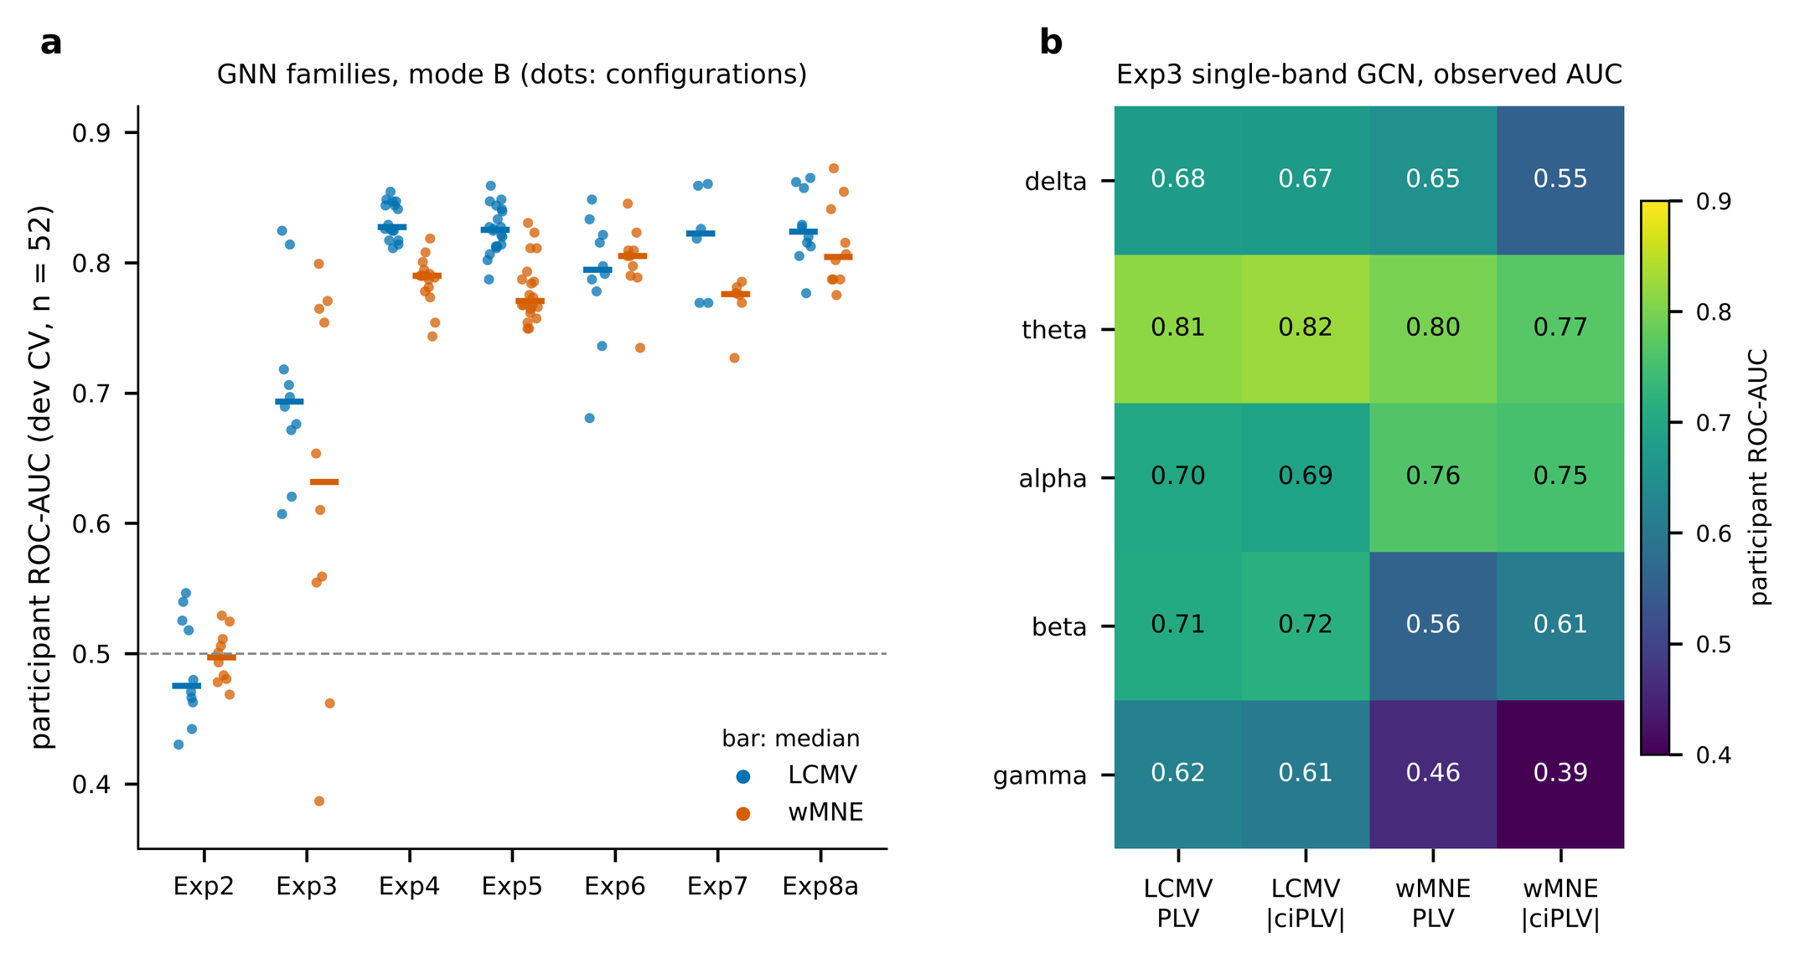
Fig. 4. Performance of the GNN families and of single frequency bands. (a) Participant-level development-CV ROC-AUC (n = 52) of every configuration in Exp2-Exp8a, window mode B; dots are configurations, bars are medians. The spread reflects differences between configurations and is not a confidence interval. (b) Exp3 single-band GCN (lobes12, dense): observed AUC for each band, inverse solution and connectivity measure. No band difference was tested with correction.
D. Ablations
Spectral features carried most of the signal: removing PSD gave the lowest Exp6 AUCs (LCMV 0.681, wMNE 0.735), whereas removing strength or learned fusion changed AUC by less than 0.04. In Exp8a, the 12 comparisons of the full model with its ablations and alternative anatomical prior had a median AUC difference of +0.002 (range −0.045 to +0.066), the full model being higher in six and lower in six, and none was supported after Holm correction (Fig. 6a). The highest development AUC of all GNNs (0.873, wMNE) belongs to the variant in which the functional adjacency is replaced by the anatomical one; its node-strength features still summarise connectivity. Among single bands, theta was strongest for LCMV (AUC 0.81–0.83) and gamma weakest (Fig. 4b).
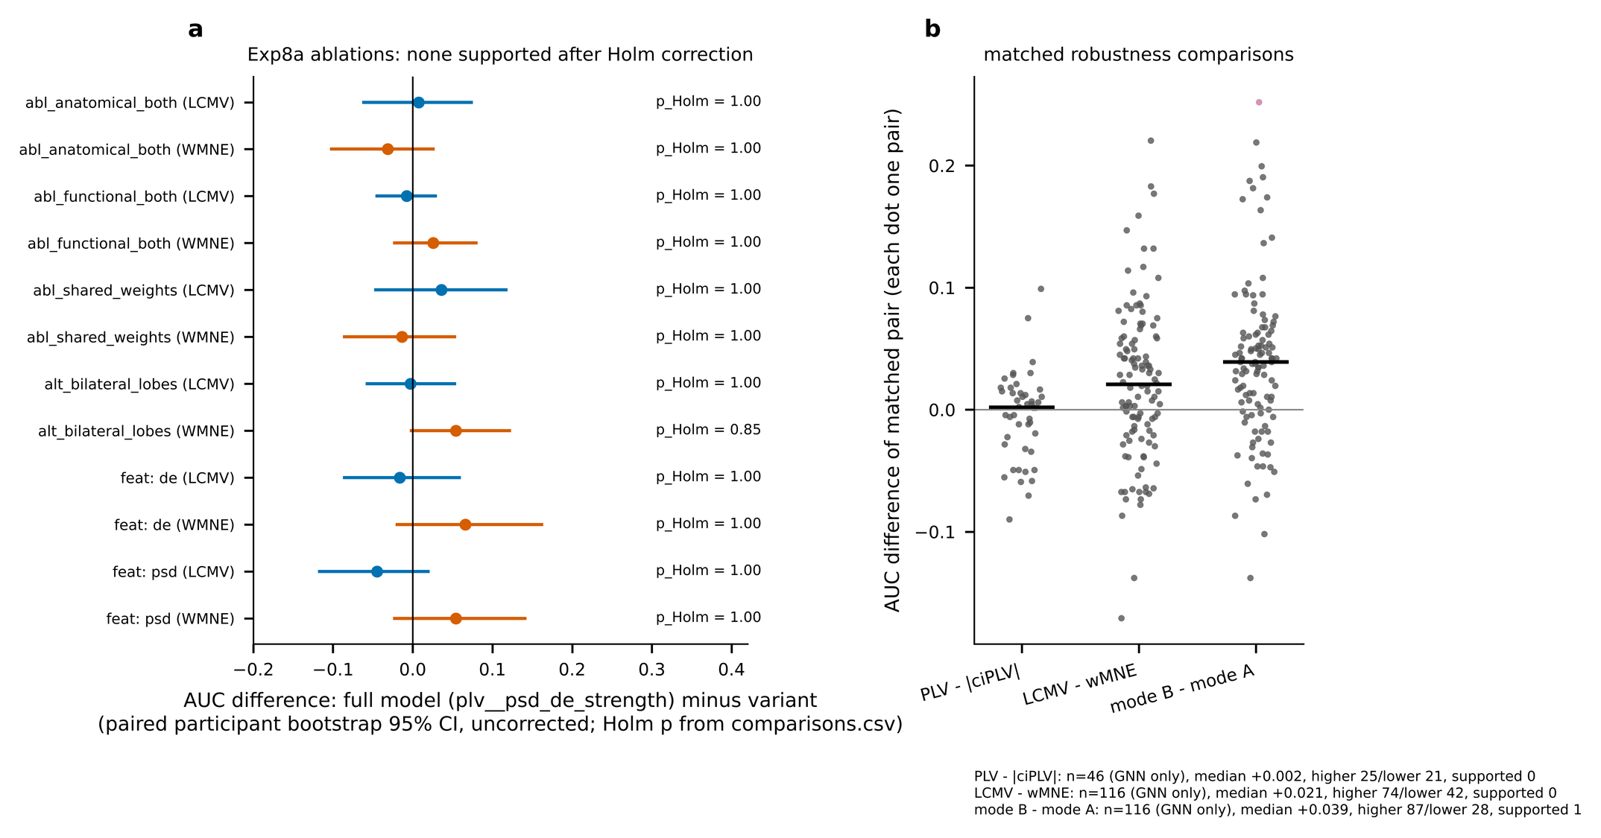
Fig. 6. Ablations and robustness. (a) Exp8a: AUC of the full model (PLV, PSD + DE + strength) minus each ablation or alternative, per inverse; bars are paired participant-bootstrap 95% intervals (uncorrected); Holm-adjusted p-values are those saved for the comparison family. No ablation is supported. (b) Matched pairs differing in one factor (GNN configurations only): PLV vs |ciPLV| (n = 46), LCMV vs wMNE (n = 116), window mode B vs A (n = 116); each dot is one pair, bars are medians, the pink dot is the single pair supported after Holm correction (Exp7, LCMV, |ciPLV| mean fusion; mode B > A).
E. Robustness
Across 46 matched pairs, PLV and |ciPLV| differed by a median of +0.002 AUC (25 higher, 21 lower; none supported). Across 116 matched GNN pairs LCMV exceeded wMNE by a median of +0.021 (74 higher, 42 lower; none supported). Using all windows rather than ten raised AUC in 87 of 116 pairs (median +0.039); one pair remained supported after correction (Fig. 6b). Graph sparsification did not improve on the dense graph by the pre-specified margin (≥ 0.02 in at least three of four reference cells; dense mean AUC 0.808), so the dense graph was kept.
F. Model selection and descriptive holdout
Because the reported maxima are best-of-many, we estimated optimism by participant bootstrap: for the 52 candidates of Exp2–6 and Exp8a the optimism of the best model was +0.075 (LCMV) and +0.058 (wMNE), with out-of-bag winner AUC 0.808 and 0.822; under permuted labels the best of 52 reached 0.726 and 0.721 at the 95th percentile (Fig. S1). The unit with the highest development AUC (wMNE, anatomical layers only; 0.873) was evaluated once on the 13-participant holdout, which had been inspected in earlier work: AUC 0.786 (DeLong 0.522–1.000), accuracy 61.5%, sensitivity 42.9% and specificity 83.3% (Fig. S2). This result concerns that model only and is descriptive.

III. DISCUSSION
Physical observability and atlas choice. With 19 electrodes the number of independent source signals cannot exceed 18, and cross-talk, not anatomy, limits the node set: 68 regions are mostly linear mixtures, whereas 12 lobar regions are individually dominated by their own sources. Choosing the atlas from this physical analysis, rather than from classification, makes the node set defensible before any model is trained. Two caveats apply. The rule's thresholds are author-set, and the resolution analysis assumes independent equal-variance regional activity and a template head with template electrode positions. In addition, the recorded atlas decision followed the development-only comparison of atlases and cites it; the rule and its recommendation are label-blind, the final decision was not made blind to the comparison.
Why spectral features dominate, and why complexity did not help. Removing PSD cost the most AUC, constant-feature networks were at chance, and the band-averaged GCN was matched by every later design. This is consistent with AD-related spectral slowing [1] and with a regime in which 12 coarse regions and 52 participants leave little room for learned edge structure. Because leakage-robust |ciPLV| performed like PLV, either connectivity adds little beyond spectra here or leakage-sensitive coupling carries no extra diagnostic information; these explanations cannot be separated. With wide intervals (typically ±0.1 AUC) and low power, absent differences are not evidence of equivalence [19].
The anatomical prior. The second layer propagates features over 22 within-hemisphere contiguity edges of 12 large regions. It is an atlas-derived neighbourhood prior, not structural connectivity, and with so few edges it mainly smooths lobar features. Replacing it, doubling the functional layer, or sharing band weights changed AUC within noise, so the data do not show that the anatomical layer improves classification. We therefore present the architecture as a source-space adaptation of a dual-layer design [10] whose prior is accommodated but not shown to help.
Inverse solutions. LCMV tended to exceed wMNE in mode B, but not supportedly, and the highest AUC belongs to a wMNE model. LCMV adapts its filter to each participant's covariance, whereas the wMNE operator is identical for all participants; whether this explains the tendency was not tested.
Exp5 versus Exp8a. The r18 multiband network and the lobes12 dual-layer network have indistinguishable AUC (0.859 vs 0.858) and differ by one participant in accuracy (45 vs 44 of 52), with different error profiles (balanced versus specificity-heavy). The paper centres on Exp8a with lobes12 because that atlas satisfies the resolution rule for both inverses and the model embeds an explicit anatomical prior, not because it scored highest; the choice was made after results were visible and is disclosed as such.
Relation to the literature. Published EEG-GNN results on ds004504 are not directly comparable. Burger et al. report 83.08% subject-level accuracy and AUC 0.866 under leave-one-subject-out validation with electrode nodes [8]; Ding et al. report accuracy 0.83 ± 0.09 and AUC 0.89 ± 0.07 under five-fold subject-independent validation [9]; Cao et al. report 77.8% in a three-class task on a private cohort [7]. Xu et al. report higher figures with a multi-graph network [10], but we did not verify their dataset or protocol and draw no comparison. Our estimates sit in the same range as the subject-level studies but come from a smaller development split and are optimism-prone; we claim no superiority (Table II).
TABLE II COMPARISON WITH RELATED EEG-GNN STUDIES (NOT DIRECTLY COMPARABLE)
Study | Data / participants | Nodes and graph | Validation | Reported performance | Comparability
Cao et al. [7] | Private cohort; 16 AD, 20 MCI, 21 HC (3-class) | Electrodes; PLI edges; GCN | Fixed 7:3:1 split by subject (12 test subjects) | 77.8% (3-class, PLV node features) | Different cohort and task; sensor space
Burger et al. [8] | ds004504 (36 AD, 23 FTD, 29 CN); AD vs CN task | 19 electrodes; PCMCI effective-connectivity edges; edge-feature GCN | Leave-one-subject-out; majority vote over epochs | Accuracy 83.08%, AUC 0.866 (subject level); 70.16% / 0.776 at epoch level | Same dataset, subject-level protocol; electrode nodes; no CIs
Ding et al. [9] | ds004504 (+ private cohort); 36 AD, 29 HC | 19 electrodes; per-band adjacency (construction not specified); mixture of graph experts | Subject-independent five-fold CV | Accuracy 0.83 ± 0.09, AUC 0.89 ± 0.07 (main table; ablation table reports AUC 0.92 ± 0.10) | Same dataset; different CV; adjacency undefined; internally inconsistent tables
Xu et al. [10] | Dataset and protocol not verified by us | Multi-graph GCN, functional + structural connectivity, DE of five bands | Not verified | Accuracy 96.15%, AUC 98.74% (abstract) | Not comparable until dataset and split are verified
This work | ds004504; 36 AD, 29 HC; 52 development | Source ROIs (12 or 18 or 68); PLV or |ciPLV|; dual-layer or multiband GCN | Frozen participant split; five-fold participant-grouped CV | AUC 0.858 (0.749–0.966), accuracy 84.6% (primary, LCMV); AUC 0.859, accuracy 86.5% (Exp5 r18) | Development CV, optimism-prone; no external validation
Values transcribed from the authors’ literature workbook and verified only as to existence of the articles; Xu et al. figures are from the abstract only.
Confounds and meaning. AD and control groups differ in sex ratio (24/36 vs 11/29 women) and, by construction, in MMSE; recordings come from one site and device, and the provider's ICA and artifact subspace reconstruction may shape spectra. Discrimination in a development split is not a validated biomarker, and no external cohort was available.
Limitations. (i) Small single-site cohort: 52 development participants, wide intervals and low power. (ii) No external validation; the 13-participant holdout was inspected earlier and was run for one model only. (iii) A template head model and template electrode positions with 19 channels leave substantial cross-talk even for 12 regions (median 0.38–0.54). (iv) The primary model and the r18 and anatomical-layer analyses were emphasised or added after results were visible, and 280 configurations were examined on the same participants, so maxima are optimistic. (v) The recorded atlas decision followed the development-only atlas comparison. (vi) Classical spectral baselines were run in the same framework but are outside the scope of this paper; the present results therefore do not show that graph networks outperform them, and any comparative claim requires reporting them. (vii) Training loss approached zero at the fixed 60 epochs; no validation-based stopping was used.

IV. CONCLUSIONS
Under a conservative participant-level protocol, source-space graph networks on 19-electrode EEG discriminated AD from controls with development AUC of roughly 0.77–0.87. A label-blind resolution analysis showed why only a coarse, 12-region atlas is physically well resolved by the montage, yet classification was statistically indistinguishable across atlases. Architectural complexity, an anatomical prior, connectivity measure and inverse solution produced no statistically supported gains, whereas spectral node features and window count mattered. The primary model's AUC of 0.858 (95% CI 0.749–0.966) is an optimism-prone development estimate on 52 participants; external validation and a comparison with non-graph baselines are required before any claim of clinical utility.

V. MATERIALS AND METHODS
A. Dataset and evaluation protocol
We used the resting-state eyes-closed recordings of OpenNeuro ds004504 [11]: 36 AD and 29 healthy control (HC) participants, 19 scalp electrodes, 500 Hz, provider-preprocessed (0.5–45 Hz band-pass, re-referencing, artifact subspace reconstruction, ICA). Frontotemporal dementia participants were excluded by design. A single participant-level split was frozen before the experiments (seed 20250702): 52 development participants (29 AD, 23 HC) and 13 holdout participants (7 AD, 6 HC). Development performance is the pooled out-of-fold result of five-fold participant-grouped cross-validation; all windows of a participant are in one fold, and every fitted transform sees training participants only. A model's participant score is the mean probability of its windows, the threshold is 0.5, and the primary metric is the participant-level ROC-AUC, reported with DeLong intervals; sensitivity and specificity use the 0.5 threshold. Accuracy is derived from the saved confusion matrices.
B. Preprocessing and windowing
Recordings were split at provider boundary events and each continuous segment was resampled to 250 Hz on its own, then average-referenced. Five minutes of usable EEG per participant were selected (the first segment interior holding 300 s, otherwise interiors in time order), and cut into 10 s windows with a 1 s step; each window lies at least 3.3 s (the largest analytic-filter half-length) from its segment ends, so no filtered sample crosses a discontinuity. Windows with artifacts were rejected by an adaptive median-absolute-deviation peak-to-peak rule (k = 5, at most 15% bad channels); participants with fewer than five clean windows would be excluded (none were). Mode B uses all accepted windows (up to 291 per participant); mode A uses the first ten.
C. Source reconstruction
The forward model used fsaverage (ico-5, 20,484 sources), the three-layer BEM and the 19 stored electrode coordinates. For an LCMV beamformer, the filter of source s with leadfield l_s and regularised data covariance C_λ is w_s = C_λ⁻¹ l_s / (l_sᵀ C_λ⁻¹ l_s), implemented with MNE's make_lcmv (regularisation 0.05 of the mean eigenvalue, unit-noise-gain-invariant normalisation, rank estimated from each participant's own accepted broadband data, fixed cortical-normal orientation). The wMNE estimate is x̂ = R Lᵀ (L R Lᵀ + λ² C_n)⁻¹ y with depth weighting 0.8, loose orientation 0.2, λ² = 1/9, ad-hoc noise covariance and signed normal component. Both are linear in the data; the ROI signals are x_roi = W x (1), with W (R × 19) obtained by passing an identity probe through the inverse and the label extraction, and checked against MNE's own application on real data. Region signals use mean-flip extraction over the Desikan–Killiany labels [14]; coarser regions are unions of whole labels of one hemisphere, extracted with the same pipeline (never averaged from 68-ROI signals).
D. Atlas resolution analysis
For each atlas and inverse, the region resolution matrix is Γ = W G_reg (2), where column j of G_reg is the leadfield of unit activity of region j. The cross-talk of region i is c_i = 1 − Γ_ii² / Σ_j Γ_ij² (3), under independent equal-variance region activity; own-region dominance is the fraction of regions with argmax_j |Γ_ij| = i; the participation ratio of the leakage correlation matrix gives the effective number of independent ROI signals; the numerical rank of W counts forced redundancy. The rule required median c ≤ 0.60, dominance ≥ 0.80 and no redundancy for both inverses, and chose the finest atlas satisfying it, without EEG data or labels. LCMV resolution used a model covariance rather than participant covariances.
E. Connectivity and node features
For each window and band (delta 0.5–4, theta 4–8, alpha 8–13, beta 13–25, gamma 25–45 Hz) the ROI signals were band-passed with a finite zero-phase analytic FIR kernel (1 Hz transitions) and the unit-modulus analytic signals z_i = a_i/|a_i| formed. With C = Z Zᴴ/T (4), PLV_ij = |C_ij| (5) [15] and the corrected imaginary PLV is ciPLV_ij = Im C_ij / √(1 − (Re C_ij)²) (6) [16]; adjacencies use the magnitude |ciPLV|, never the signed value (which is not directed connectivity). Node features were the Welch PSD (2 s Hann, 50% overlap) log10 and relative band power, the differential entropy DE = ½ ln(2πe σ²) (7) of the band signal, and node strength s_i = (R − 1)⁻¹ Σ_{j≠i} A_ij (8). Features were standardised per (band, ROI, feature) on training windows only. The primary model uses PLV graphs with [log PSD, relative PSD] (F = 2).
F. Graph networks
Every network uses the weighted-adjacency GCN layer H′ = ReLU(Ñ(A) H W + b) with Ñ(A) = D^(−1/2)(A + I)D^(−1/2) (9) [6]. Exp2–Exp4 use one graph (a single band or the band mean); Exp5 uses five band graphs with either one shared encoder carrying a one-hot band identity or separate encoders, mean or attention fusion, and mean-max readout (hidden 32, two layers, dropout 0.3). The primary Exp8a network applies, per band b, H1_b = ReLU(Ñ(A_func,b) X_b W1_b + c1_b) (10) with W1_b: 2 → 32, then H2_b = ReLU(Ñ(A_anat) H1_b W2_b + c2_b) (11) with W2_b: 32 → 2 and a fixed 12 × 12 matrix A_anat linking regions that share an edge of the fsaverage cortical mesh within a hemisphere (22 edges); band outputs are flattened (5 × 12 × 2 = 120), passed through dropout 0.3 and fully connected layers 120 → 32 → 32 → 1 (5,771 parameters; Fig. 2). The anatomical matrix depends on region names only and is not structural connectivity.
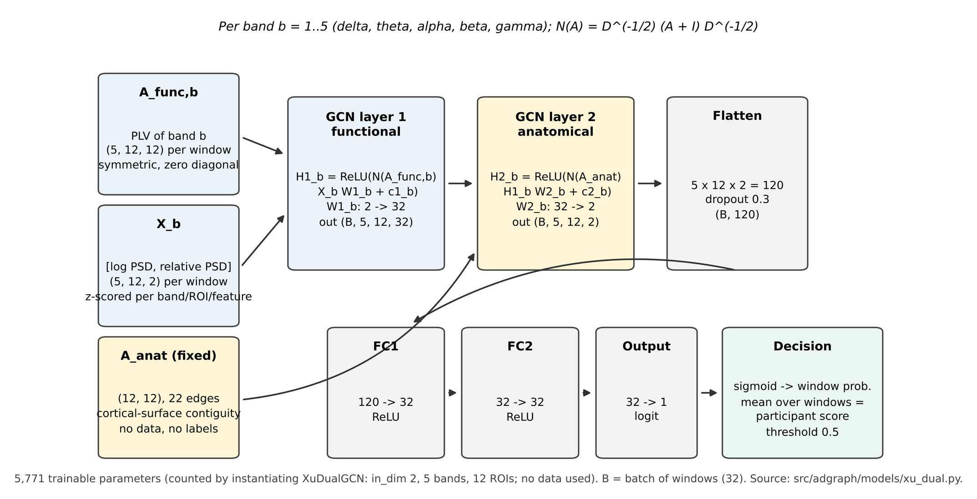
Fig. 2. Architecture of the primary model (exp8a_xu_dual_gcn_surface, variant plv__psd). For each of five bands, a band-specific graph convolution propagates [log PSD, relative PSD] node features over the window's own PLV graph (layer 1, 2 -> 32), then over a fixed 12 x 12 cortical-surface-contiguity matrix (layer 2, 32 -> 2). Band outputs (5 x 12 x 2 = 120) are flattened, passed through dropout (0.3) and two fully connected layers (32, 32) to one logit. N(A) = D^(-1/2)(A + I)D^(-1/2). The anatomical matrix is an atlas-derived neighbourhood prior, not structural (white-matter) connectivity. 5,771 trainable parameters.
G. Training and statistics
All GNNs use the same fixed protocol: Adam (learning rate 10⁻³, weight decay 10⁻⁴), batch 32, exactly 60 epochs, no early stopping and no hyperparameter search. The loss is the weighted binary cross-entropy L = Σ_n w_n ℓ_n / N (12), with window weights such that each participant sums to its class weight and classes are balanced by participant count. Paired AUC differences were tested with DeLong's test [17] with bootstrap intervals (2,000 participant resamples) and Holm correction [18] within each comparison family. Selection optimism was estimated by resampling participants, choosing the best candidate in-bag and scoring it on out-of-bag participants, and compared with the best-of-m AUC under permuted labels. Descriptive statistics recomputed from saved participant predictions (Fig. 5) were checked against the saved results. The study ran Exp2–Exp8a for both inverses and both window modes (280 saved configurations; 104 in the frozen holdout plan); the amended Exp8a was run in its own code namespace after the original anatomical rule produced an empty matrix on lobes12. Classical baselines (Exp0, Exp1) were run but are not analysed here.

SUPPLEMENTARY MATERIALS
Supplementary material (separate file) contains the dataset and preprocessing parameters, the full results of all 280 completed GNN configurations with confusion matrices, the graph-construction, Exp6 and Exp3-balanced-accuracy figures, the selection-optimism figure (Fig. S1), the descriptive single-model holdout (Fig. S2), the amendment and provenance record, and the code and commit identifiers needed to regenerate every figure from saved outputs.

ACKNOWLEDGMENT
[To be completed by the authors.]

REFERENCES
[1] J. Jeong, "EEG dynamics in patients with Alzheimer's disease," Clin. Neurophysiol., vol. 115, no. 7, pp. 1490–1505, 2004, doi: 10.1016/j.clinph.2004.01.001.
[2] C. Babiloni et al., "What electrophysiology tells us about Alzheimer's disease: A window into the synchronization and connectivity of brain neurons," Neurobiol. Aging, vol. 85, pp. 58–73, 2020, doi: 10.1016/j.neurobiolaging.2019.09.008.
[3] G. Nolte et al., "Identifying true brain interaction from EEG data using the imaginary part of coherency," Clin. Neurophysiol., vol. 115, no. 10, pp. 2292–2307, 2004, doi: 10.1016/j.clinph.2004.04.029.
[4] M. Hassan and F. Wendling, "Electroencephalography source connectivity: Aiming for high resolution of brain networks in time and space," IEEE Signal Process. Mag., vol. 35, no. 3, pp. 81–96, May 2018, doi: 10.1109/MSP.2017.2777518.
[5] J. Song et al., "EEG source localization: Sensor density and head surface coverage," J. Neurosci. Methods, 2015 [volume and pages to be confirmed].
[6] T. N. Kipf and M. Welling, "Semi-supervised classification with graph convolutional networks," in Proc. Int. Conf. Learn. Represent. (ICLR), 2017, arXiv:1609.02907.
[7] J. Cao et al., "Identification of Alzheimer's disease brain networks based on EEG phase synchronization," 2025, doi: 10.1186/s12938-025-01361-0 [journal name inferred from DOI prefix; to be confirmed].
[8] J. Burger et al., "ECoGNet: An EEG-based effective connectivity graph neural network for brain disorder detection," in Proc. Int. Joint Conf. Neural Netw. (IJCNN), 2025, doi: 10.1109/IJCNN64981.2025.11228047.
[9] J.-E. Ding et al., "Variational mixture of graph neural experts for Alzheimer's disease recognition across frequency bands in EEG brain networks," 2026, arXiv:2510.11917; doi: 10.1109/TASE.2026.3724335 [publication venue to be confirmed].
[10] Xu et al., "A multi-graph convolutional network method for Alzheimer's disease diagnosis based on multi-frequency EEG data with dual-mode connectivity," Front. Neurosci., vol. 19, Art. 1555657, 2025, doi: 10.3389/fnins.2025.1555657.
[11] A. Miltiadous et al., "A dataset of scalp EEG recordings of Alzheimer's disease, frontotemporal dementia and healthy subjects from routine EEG," Data, vol. 8, no. 6, p. 95, 2023, doi: 10.3390/data8060095; OpenNeuro ds004504, doi: 10.18112/openneuro.ds004504.v1.0.9.
[12] B. D. Van Veen, W. van Drongelen, M. Yuchtman, and A. Suzuki, "Localization of brain electrical activity via linearly constrained minimum variance spatial filtering," IEEE Trans. Biomed. Eng., vol. 44, no. 9, pp. 867–880, Sep. 1997 [author list to be confirmed].
[13] M. S. Hämäläinen and R. J. Ilmoniemi, "Interpreting magnetic fields of the brain: Minimum norm estimates," Med. Biol. Eng. Comput., vol. 32, no. 1, pp. 35–42, 1994, doi: 10.1007/BF02512476.
[14] R. S. Desikan et al., "An automated labeling system for subdividing the human cerebral cortex on MRI scans into gyral based regions of interest," NeuroImage, vol. 31, no. 3, pp. 968–980, 2006, doi: 10.1016/j.neuroimage.2006.01.021.
[15] J.-P. Lachaux, E. Rodriguez, J. Martinerie, and F. J. Varela, "Measuring phase synchrony in brain signals," Hum. Brain Mapp., vol. 8, no. 4, pp. 194–208, 1999.
[16] R. Bruña, F. Maestú, and E. Pereda, "Phase locking value revisited: Teaching new tricks to an old dog," J. Neural Eng., vol. 15, no. 5, Art. 056011, 2018, doi: 10.1088/1741-2552/aacfe4.
[17] E. R. DeLong, D. M. DeLong, and D. L. Clarke-Pearson, "Comparing the areas under two or more correlated receiver operating characteristic curves: A nonparametric approach," Biometrics, vol. 44, no. 3, pp. 837–845, 1988.
[18] S. Holm, "A simple sequentially rejective multiple test procedure," Scand. J. Stat., vol. 6, no. 2, pp. 65–70, 1979.
[19] G. Varoquaux, "Cross-validation failure: Small sample sizes lead to large error bars," NeuroImage, vol. 180, pp. 68–77, 2018, doi: 10.1016/j.neuroimage.2017.06.061.

