D3 Manuscript Figure Plan and Reproducibility Guide
Companion to the manuscript draft v1. All figures are produced by manuscript_figures/build_all_figures.py (also run by D3_Manuscript_Figure_Generation.ipynb) from saved outputs only; Exp0/Exp1 never appear. Numbering is identical in the manuscript, the captions (manuscript_figures/captions.json) and the generated files. OJEMB limit as read from the journal page snippets (to be re-checked): at most 8 display items in the main text; the manuscript uses 6 figures and 2 tables.

Final summary table
Figure | Main / supplement | Existing or new | Source data | Code | Status
Fig. 1 | Main | New (generated) | none (drawn from the configuration: configs/source_graphs.yaml, gnn.ya | build_all_figures.py::fig_pipeline | Draft - visual QA by authors
Fig. 2 | Main | New (generated) | src/adgraph/models/xu_dual.py, configs/final/amendments/exp8a_xu_dual_ | build_all_figures.py::fig_architecture | Draft - visual QA by authors
Fig. 3 | Main | New (generated) | src/adgraph/source/atlas_tables.json | build_all_figures.py::fig_atlas | Draft - surface rendering optional
Fig. 4 | Main | New (generated) | development_results_all.csv | build_all_figures.py::fig_landscape | Draft
Fig. 5 | Main | New (generated) | <processed>/FINAL_v1/<rel_dir>/predictions_participants.csv (rel_dir i | build_all_figures.py::fig_roc | Draft - layout polish possible
Fig. 6 | Main | New (generated) | comparisons.csv (GNN-only subsets) | build_all_figures.py::fig_ablation | Draft - author to decide whether to re-correct GNN-only
Fig. S1 | Supplement | New (generated) | selection_check.json | build_all_figures.py::fig_selection | Draft
Fig. S2 | Supplement | New (generated) | single_model_holdout predictions_participants.csv (13 participants) | build_all_figures.py::fig_holdout | Draft
Fig. S3 | Supplement | New (generated) | development_results_all.csv | build_all_figures.py::fig_graph_sparsity | Draft
Fig. S4 | Supplement | New (generated) | development_results_all.csv | build_all_figures.py::fig_exp6 | Draft
Fig. S5 | Supplement | New (generated) | development_results_all.csv | build_all_figures.py::fig_landscape | Draft
Existing figures that are not reused unchanged: fig1_primary_forest, fig2_family_summary, fig3_lcmv_vs_wmne, fig4_modeB_vs_modeA, fig6_selection_bias (all contain Exp0/Exp1 data or a mismatched estimator; see D3_Existing_Figures_Audit.md). fig5_ablations and fig7_plv_vs_ciplv remain acceptable supplementary figures.

Fig. 1. End-to-end source-space graph-learning pipeline
Item | Content
Scientific question | What processing chain turns recordings into participant-level predictions?
Manuscript section | II / Intro (also Visual Summary basis)
Source | Generated (drawn)
Input files | none (drawn from the configuration: configs/source_graphs.yaml, gnn.yaml)
Plotting code | manuscript_figures/build_all_figures.py, figure id fig01 (notebook cell 5 calls the same function)
Output files | manuscript_figures/generated/fig01_pipeline.pdf / .svg / .png (600 dpi)
Caption | Fig. 1. End-to-end source-space EEG graph-learning pipeline. Resting-state eyes-closed EEG (OpenNeuro ds004504; 19 electrodes; 36 AD, 29 HC) is segmented at provider boundary events, resampled to 250 Hz and average-referenced; five minutes per participant are cut into 10 s windows with a 1 s step (mode B; mode A uses the first 10 accepted windows). Sources are reconstructed with LCMV or depth-weighted wMNE into 68 Desikan-Killiany ROI signals and aggregated to coarser atlases (r18, lobes12). Per window and band, PLV (or |ciPLV|), PSD and differential entropy define weighted band graphs on which a graph network is trained for 60 epochs; window probabilities are averaged per participant and evaluated by five-fold participant-grouped cross-validation on the 52 development participants.
Interpretation for Results | Shows the sequence and that LCMV/wMNE differ only in step 3.
Limitations / caveats | Schematic; does not depict results.
Publication-readiness | Draft - visual QA by authors
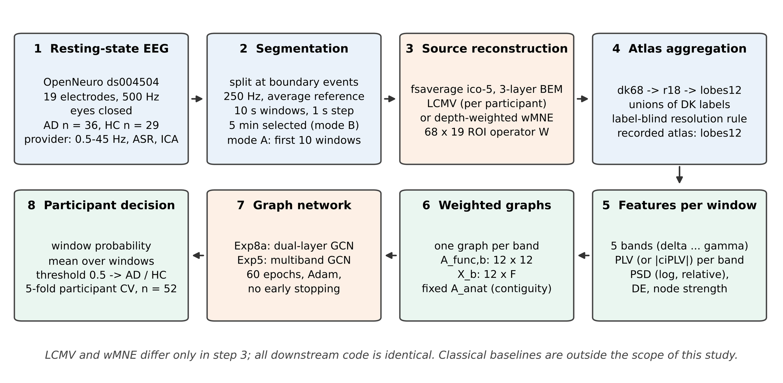

Fig. 2. Exp8a dual-layer GCN architecture
Item | Content
Scientific question | What exactly is the primary network?
Manuscript section | V.F Methods
Source | Generated (drawn; shapes verified against src/adgraph/models/xu_dual.py; 5,771 parameters counted by instantiation)
Input files | src/adgraph/models/xu_dual.py, configs/final/amendments/exp8a_xu_dual_gcn_surface.yaml
Plotting code | manuscript_figures/build_all_figures.py, figure id fig02 (notebook cell 5 calls the same function)
Output files | manuscript_figures/generated/fig02_exp8a_architecture.pdf / .svg / .png (600 dpi)
Caption | Fig. 2. Architecture of the primary model (exp8a_xu_dual_gcn_surface, variant plv__psd). For each of five bands, a band-specific graph convolution propagates [log PSD, relative PSD] node features over the window's own PLV graph (layer 1, 2 -> 32), then over a fixed 12 x 12 cortical-surface-contiguity matrix (layer 2, 32 -> 2). Band outputs (5 x 12 x 2 = 120) are flattened, passed through dropout (0.3) and two fully connected layers (32, 32) to one logit. N(A) = D^(-1/2)(A + I)D^(-1/2). The anatomical matrix is an atlas-derived neighbourhood prior, not structural (white-matter) connectivity. 5,771 trainable parameters.
Interpretation for Results | Makes the anatomical layer explicit: fixed 12 x 12 matrix, 22 edges.
Limitations / caveats | Anatomical matrix is not structural connectivity.
Publication-readiness | Draft - visual QA by authors
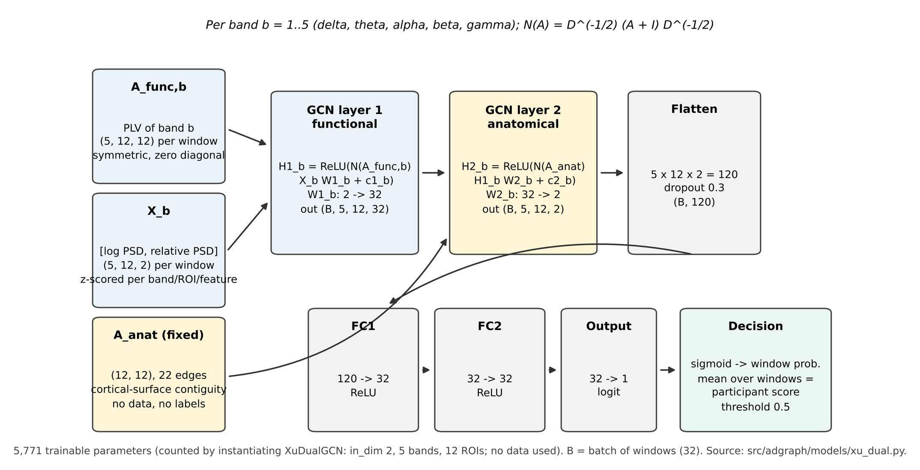

Fig. 3. Atlas resolution and classification by atlas
Item | Content
Scientific question | What spatial resolution does a 19-electrode montage support, and does classification depend on it?
Manuscript section | II.A, II.C
Source | Generated (atlas tables + saved resolution table + results CSV)
Input files | src/adgraph/source/atlas_tables.json; resolution_by_atlas.csv; development_results_all.csv
Plotting code | manuscript_figures/build_all_figures.py, figure id fig03 (notebook cell 5 calls the same function)
Output files | manuscript_figures/generated/fig03_atlas_resolution.pdf / .svg / .png (600 dpi)
Caption | Fig. 3. Atlas resolution under a 19-electrode montage. (a-c) Region centroids (fsaverage white surface, axial projection) of dk68, r18 and lobes12, coloured by lobe; lines in (c) are the 22 surface-contiguity edges of the anatomical layer. (d-f) Exact-BEM resolution analysis for LCMV and wMNE: median cross-talk (rule <= 0.60), own-region dominance (rule >= 0.80) and participation ratio; the leadfield has numerical rank 18 and entropy-effective rank 12.8. Only lobes12 meets both criteria for both inverses (r18 misses dominance for LCMV, 0.778). dk34_gyral is analysed only (not classified). (g, h) Participant-level development-CV AUC and balanced accuracy of the same matched models (Exp4 band-mean GCN, Exp5 separate-encoder multiband GCN; LCMV and wMNE; PLV; mode B; dense graph; n = 52) on dk68, lobes12 and r18; no difference is statistically supported, and lobes12 was recorded as the analysis atlas.
Interpretation for Results | Only lobes12 meets the rule; AUC/BA by atlas show no consistent ordering across inverses.
Limitations / caveats | Centroid map, not a cortical-surface rendering (surface rendering code provided but not executed); dk34 analytic only; r18 and dk68 classifier rows are exploratory.
Publication-readiness | Draft - surface rendering optional
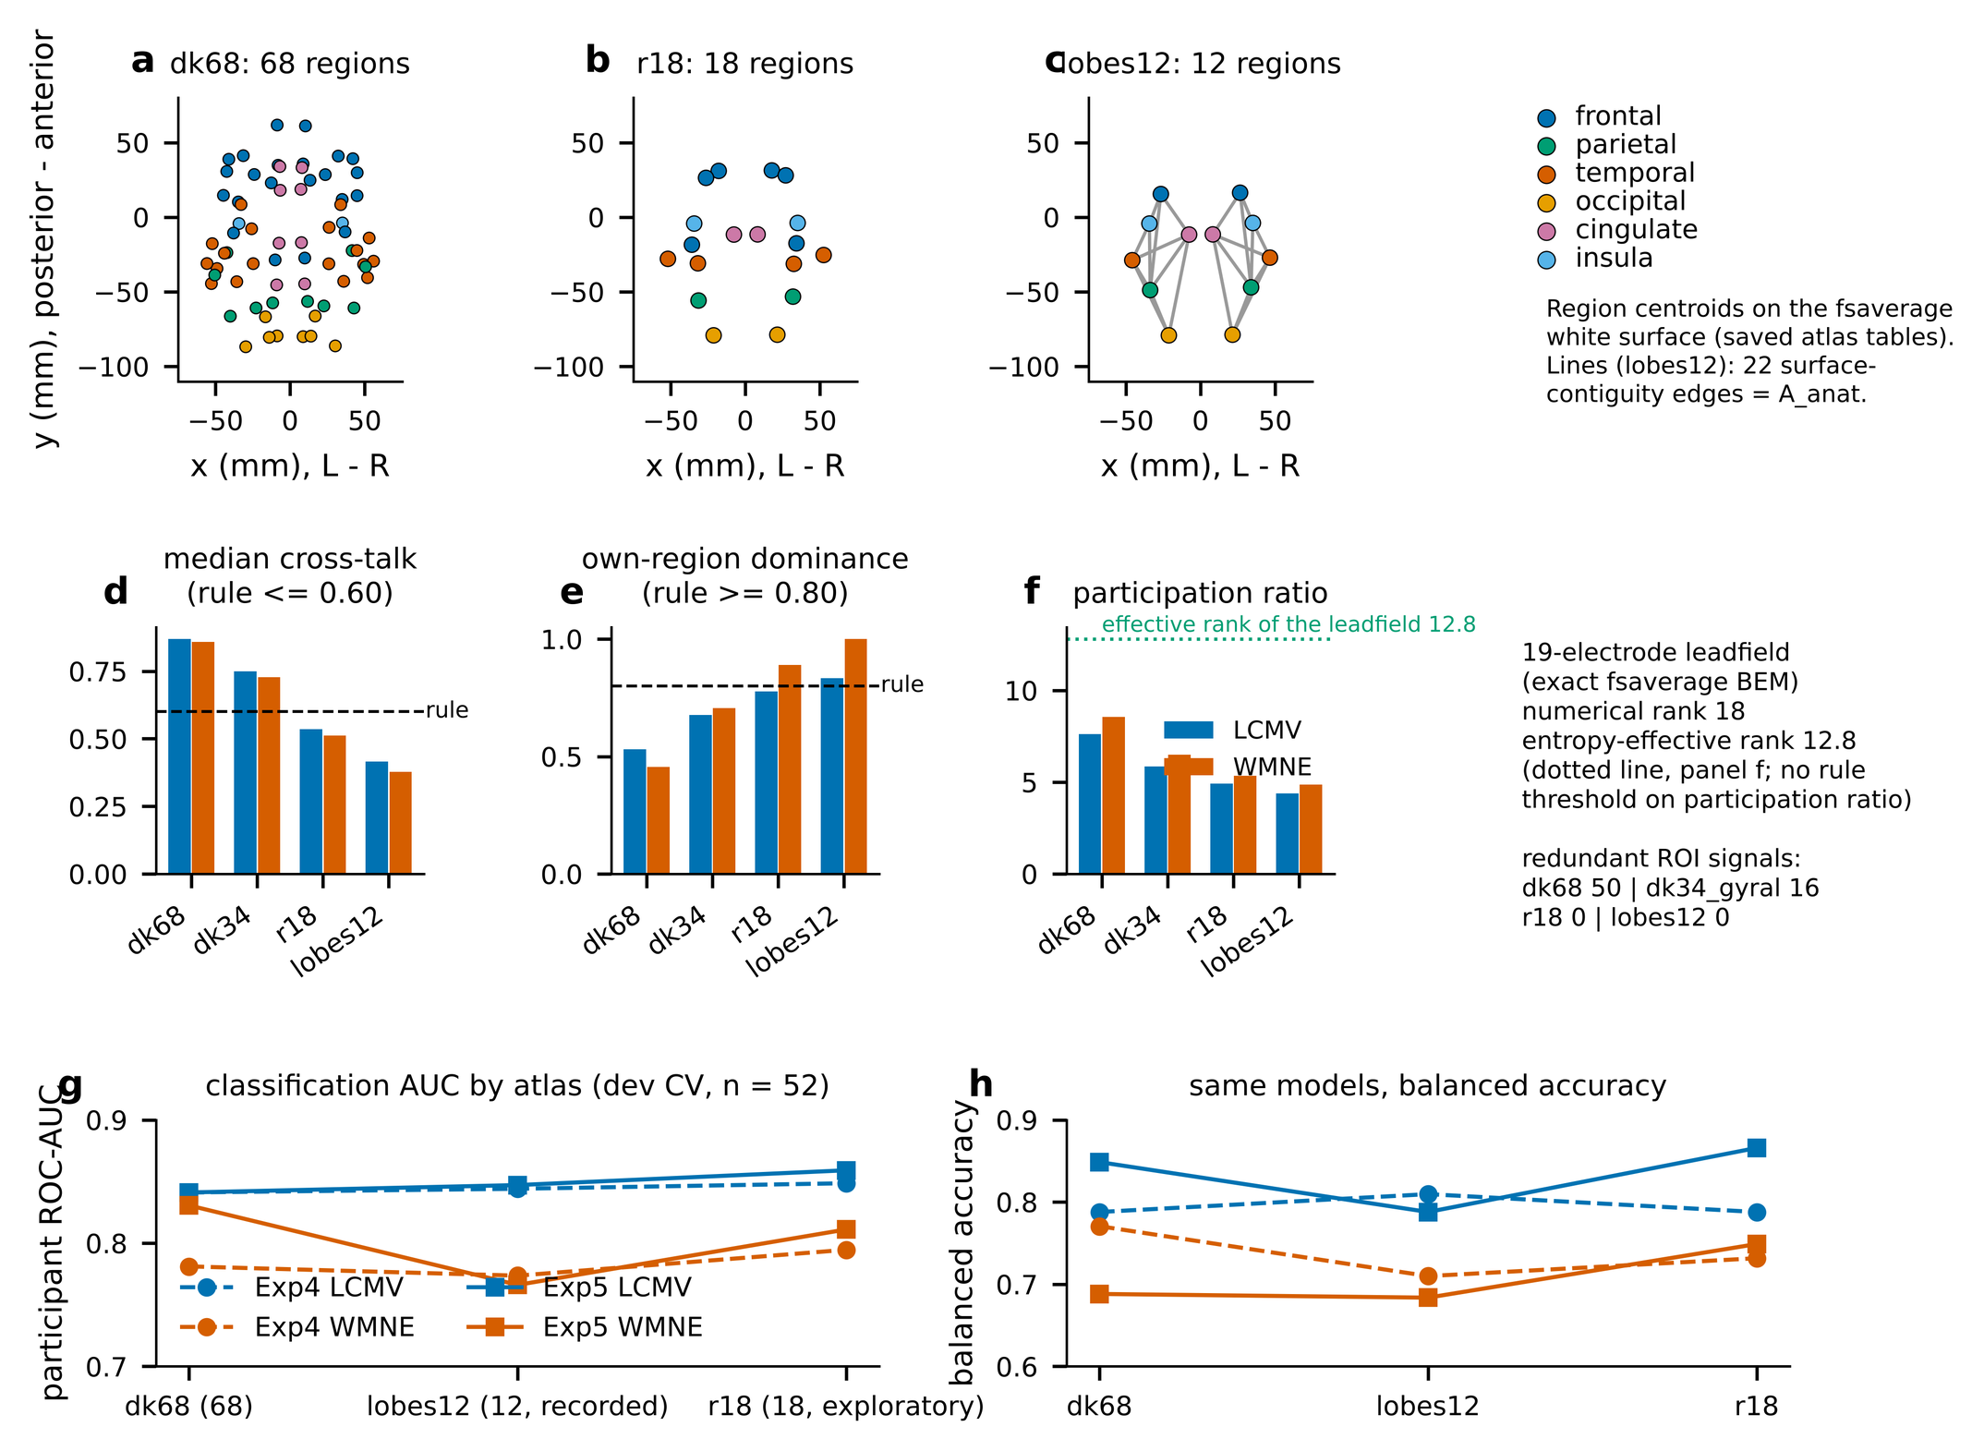

Fig. 4. GNN family performance and single-band heatmap
Item | Content
Scientific question | How much do families and frequency bands differ?
Manuscript section | II.D, II.E
Source | Generated (replaces existing fig2_family_summary, which contained Exp0/Exp1)
Input files | development_results_all.csv
Plotting code | manuscript_figures/build_all_figures.py, figure id fig04 (notebook cell 5 calls the same function)
Output files | manuscript_figures/generated/fig04_family_and_band_performance.pdf / .svg / .png (600 dpi)
Caption | Fig. 4. Performance of the GNN families and of single frequency bands. (a) Participant-level development-CV ROC-AUC (n = 52) of every configuration in Exp2-Exp8a, window mode B; dots are configurations, bars are medians. The spread reflects differences between configurations and is not a confidence interval. (b) Exp3 single-band GCN (lobes12, dense): observed AUC for each band, inverse solution and connectivity measure. No band difference was tested with correction.
Interpretation for Results | Exp2 at chance; Exp4-Exp8a overlap; theta strongest single band.
Limitations / caveats | Spread across configurations is not a CI; no corrected band test.
Publication-readiness | Draft
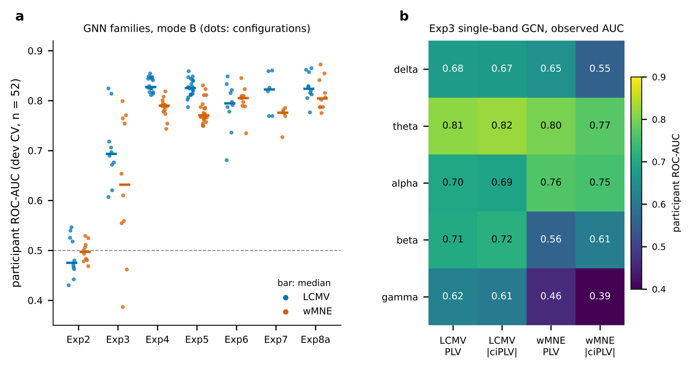

Fig. 5. Participant-level ROC and confusion matrices
Item | Content
Scientific question | How do the primary model, Exp5 r18 and the Exp4 reference behave at participant level?
Manuscript section | II.B, II.C
Source | Generated from saved participant-level out-of-fold predictions (three units)
Input files | <processed>/FINAL_v1/<rel_dir>/predictions_participants.csv (rel_dir in development_results_all.csv): A2/.../exp8a.../plv__psd/xu_dev_cv; release/.../r18/dense/exp5_multibranch/plv__separate__mean/xu_dev_cv; release/.../lobes12/dense/exp4_band_mean/plv__psd/xu_dev_cv
Plotting code | manuscript_figures/build_all_figures.py, figure id fig05 (notebook cell 5 calls the same function)
Output files | manuscript_figures/generated/fig05_roc_confusion.pdf / .svg / .png (600 dpi)
Caption | Fig. 5. Participant-level out-of-fold ROC curves and confusion matrices (threshold 0.5) for the primary model (Exp8a, LCMV, PLV + PSD, lobes12), the Exp5 separate-encoder multiband GCN on r18 and the Exp4 band-mean GCN reference on lobes12 (all LCMV, mode B, dense; one score per participant, n = 52: 29 AD, 23 HC). AUC 0.858 (DeLong 95% CI 0.749-0.966), 0.859 (0.743-0.975) and 0.844 (0.725-0.963). Paired DeLong tests recomputed from the saved predictions (uncorrected, descriptive) show no difference (primary vs Exp5 r18: dAUC -0.001, p = 0.96; primary vs Exp4: +0.013, p = 0.63). Development cross-validation, not independent test performance; the model was emphasised retrospectively.
Interpretation for Results | Primary vs Exp5 r18: dAUC -0.001, p 0.96; vs Exp4: +0.013, p 0.63 (recomputed, uncorrected).
Limitations / caveats | Development CV; model emphasised retrospectively; ROC panel is small because of equal aspect.
Publication-readiness | Draft - layout polish possible
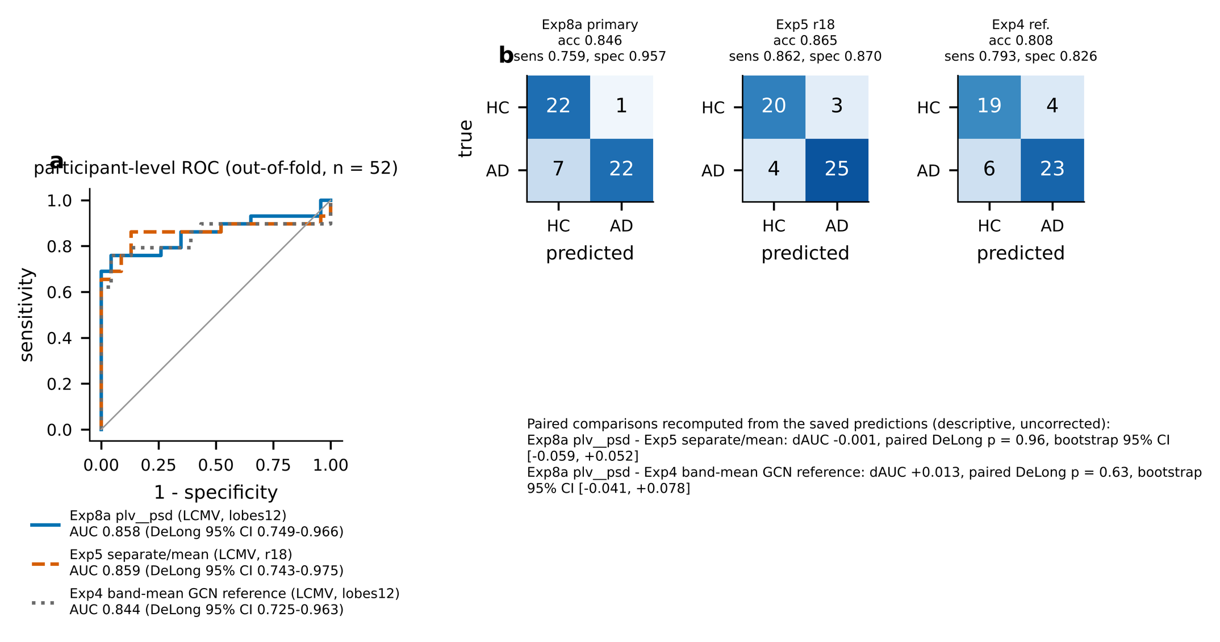

Fig. 6. Ablations and matched robustness comparisons
Item | Content
Scientific question | Do ablations or robustness factors produce supported differences?
Manuscript section | II.D, II.E
Source | Generated (replaces fig3/fig4/fig5/fig7 for the main text)
Input files | comparisons.csv (GNN-only subsets)
Plotting code | manuscript_figures/build_all_figures.py, figure id fig06 (notebook cell 5 calls the same function)
Output files | manuscript_figures/generated/fig06_ablation_and_robustness.pdf / .svg / .png (600 dpi)
Caption | Fig. 6. Ablations and robustness. (a) Exp8a: AUC of the full model (PLV, PSD + DE + strength) minus each ablation or alternative, per inverse; bars are paired participant-bootstrap 95% intervals (uncorrected); Holm-adjusted p-values are those saved for the comparison family. No ablation is supported. (b) Matched pairs differing in one factor (GNN configurations only): PLV vs |ciPLV| (n = 46), LCMV vs wMNE (n = 116), window mode B vs A (n = 116); each dot is one pair, bars are medians, the pink dot is the single pair supported after Holm correction (Exp7, LCMV, |ciPLV| mean fusion; mode B > A).
Interpretation for Results | No ablation supported; one mode pair supported.
Limitations / caveats | Holm p-values are those saved for the full families, which included classical pairs for LCMV-vs-wMNE and mode comparisons.
Publication-readiness | Draft - author to decide whether to re-correct GNN-only
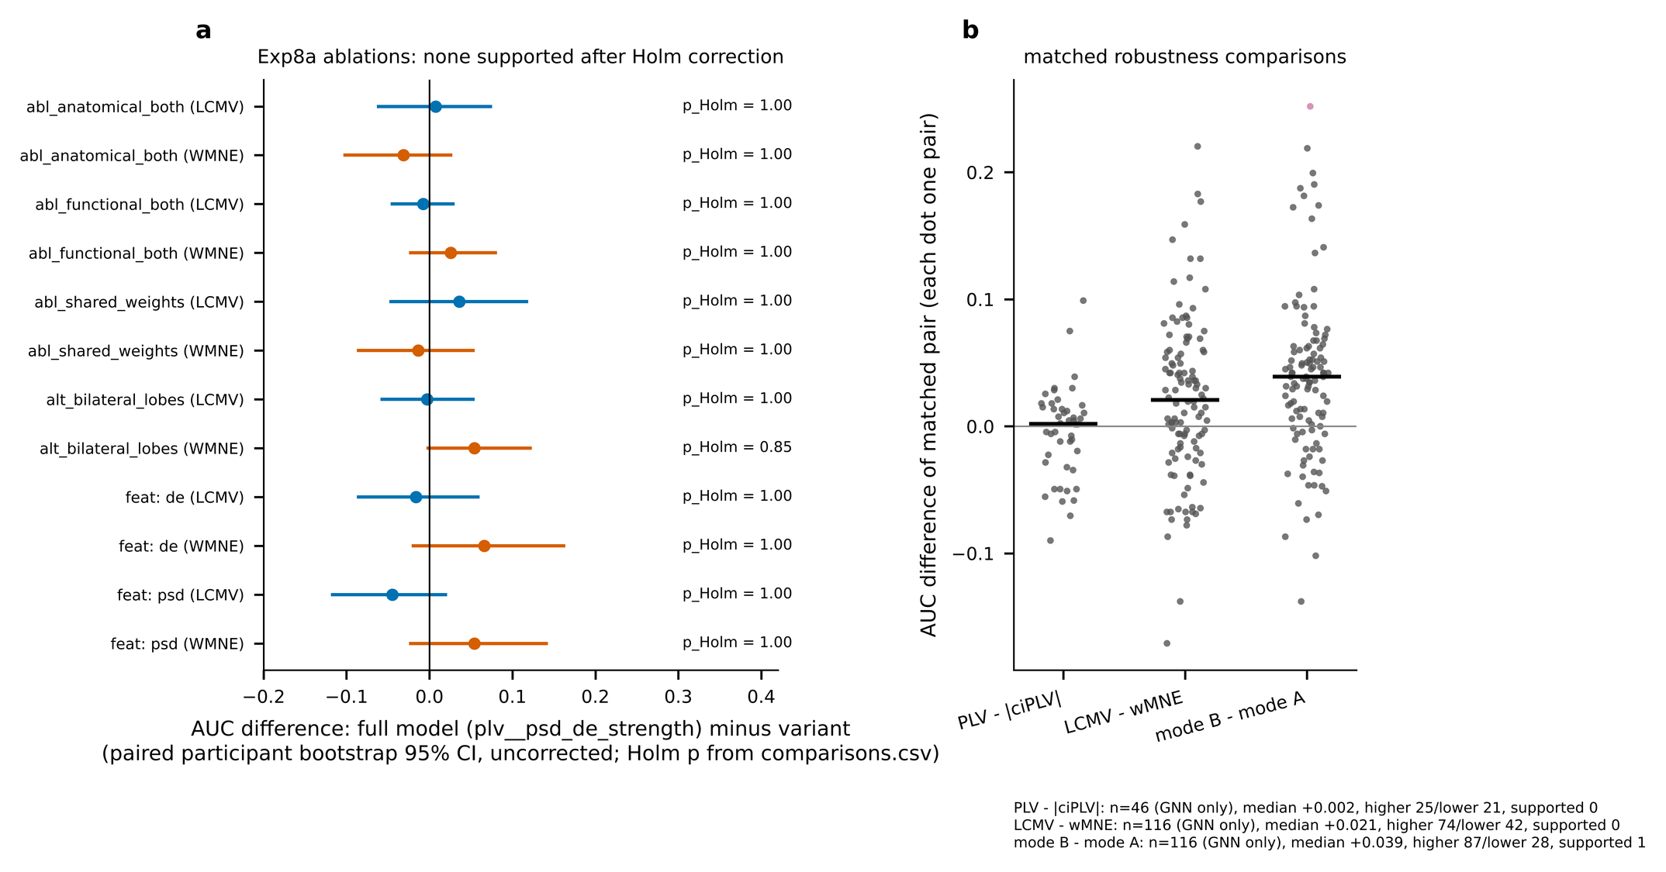

Fig. S1. Selection optimism
Item | Content
Scientific question | How optimistic are best-of-many AUCs?
Manuscript section | II.F (supplement)
Source | Generated
Input files | selection_check.json
Plotting code | manuscript_figures/build_all_figures.py, figure id figS_selection (notebook cell 5 calls the same function)
Output files | manuscript_figures/generated/figS_selection_optimism.pdf / .svg / .png (600 dpi)
Caption | Fig. S1. Selection optimism. For each candidate set, the observed best AUC (n = 52), the mean bootstrap out-of-bag winner AUC, observed minus the bootstrap optimism, and the 95th percentile of the best-of-m AUC under permuted labels. Participants were resampled with replacement; the winner was chosen in-bag and scored on out-of-bag participants. This is a within-development estimate, not an independent test.
Interpretation for Results | Optimism +0.03 to +0.08; null 95th percentile about 0.67-0.73.
Limitations / caveats | OOB estimate is a within-development resampling, not an independent test.
Publication-readiness | Draft
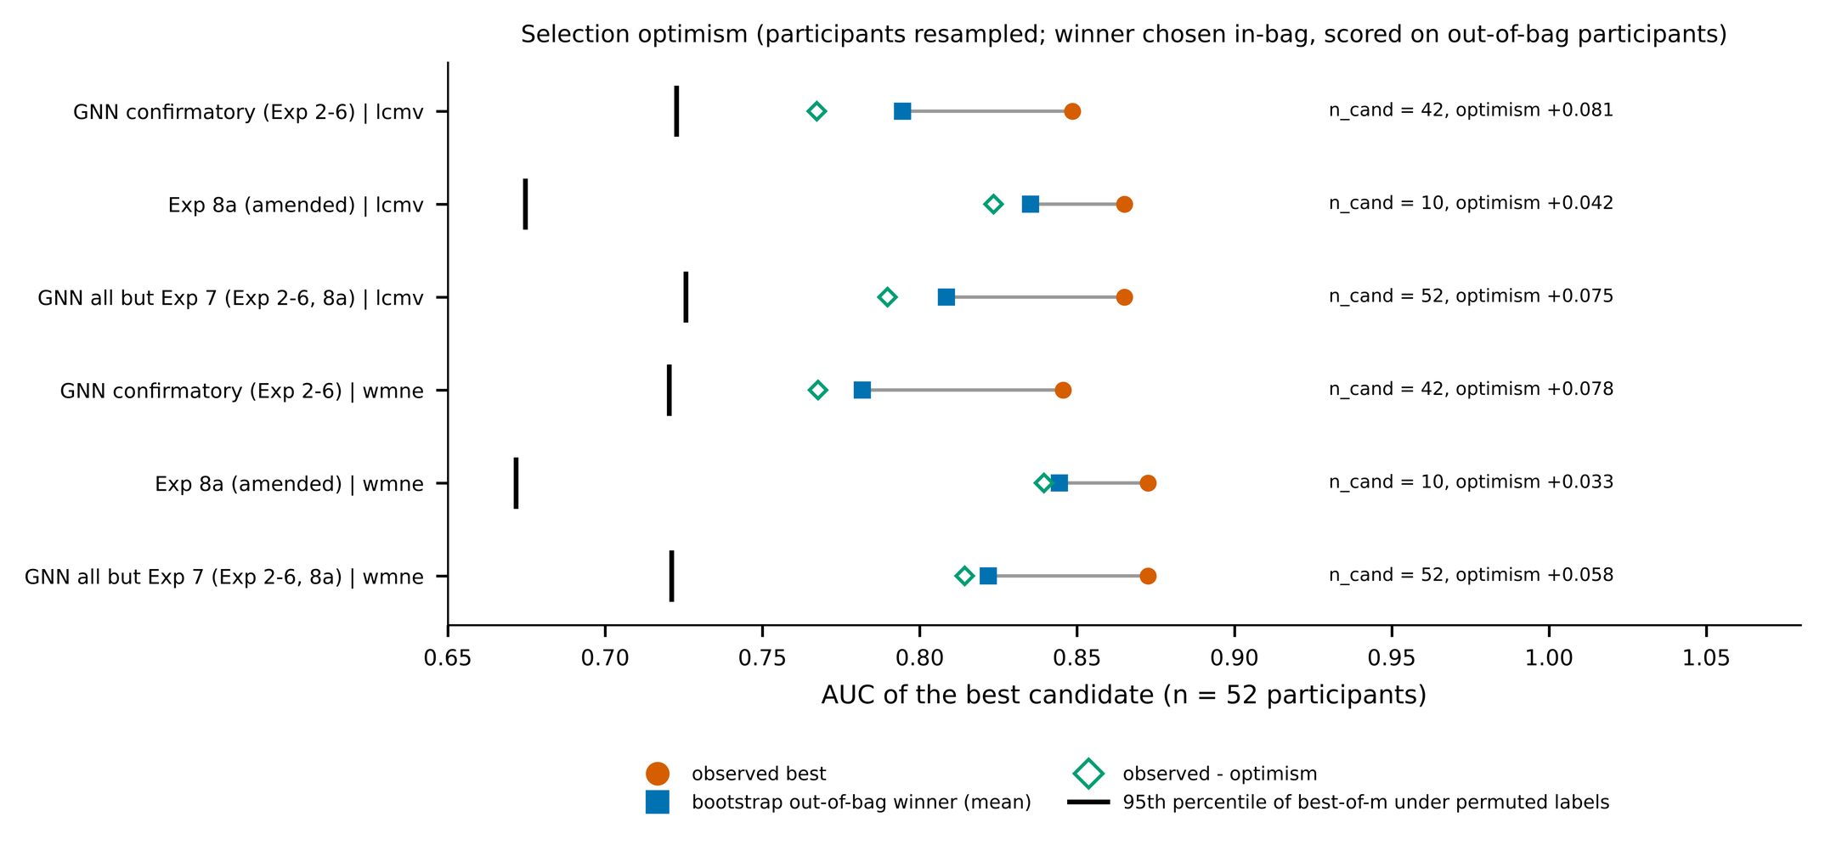

Fig. S2. Descriptive single-model holdout
Item | Content
Scientific question | What happened for the one holdout-evaluated model?
Manuscript section | II.F (supplement)
Source | Generated from saved holdout predictions
Input files | single_model_holdout predictions_participants.csv (13 participants)
Plotting code | manuscript_figures/build_all_figures.py, figure id figS_holdout (notebook cell 5 calls the same function)
Output files | manuscript_figures/generated/figS_holdout_descriptive.pdf / .svg / .png (600 dpi)
Caption | Fig. S2. Descriptive holdout of the single selected model (wMNE, Exp8a plv__psd_de_strength__abl_anatomical_both, lobes12, dense): 13 participants (7 AD, 6 HC), fitted once on the 52 development participants. The holdout had been inspected in earlier work and is not an untouched test; it is not the LCMV plv__psd primary model.
Interpretation for Results | AUC 0.786 (DeLong 0.522-1.000), sensitivity 0.429.
Limitations / caveats | Previously inspected holdout; wMNE model, not the primary model.
Publication-readiness | Draft
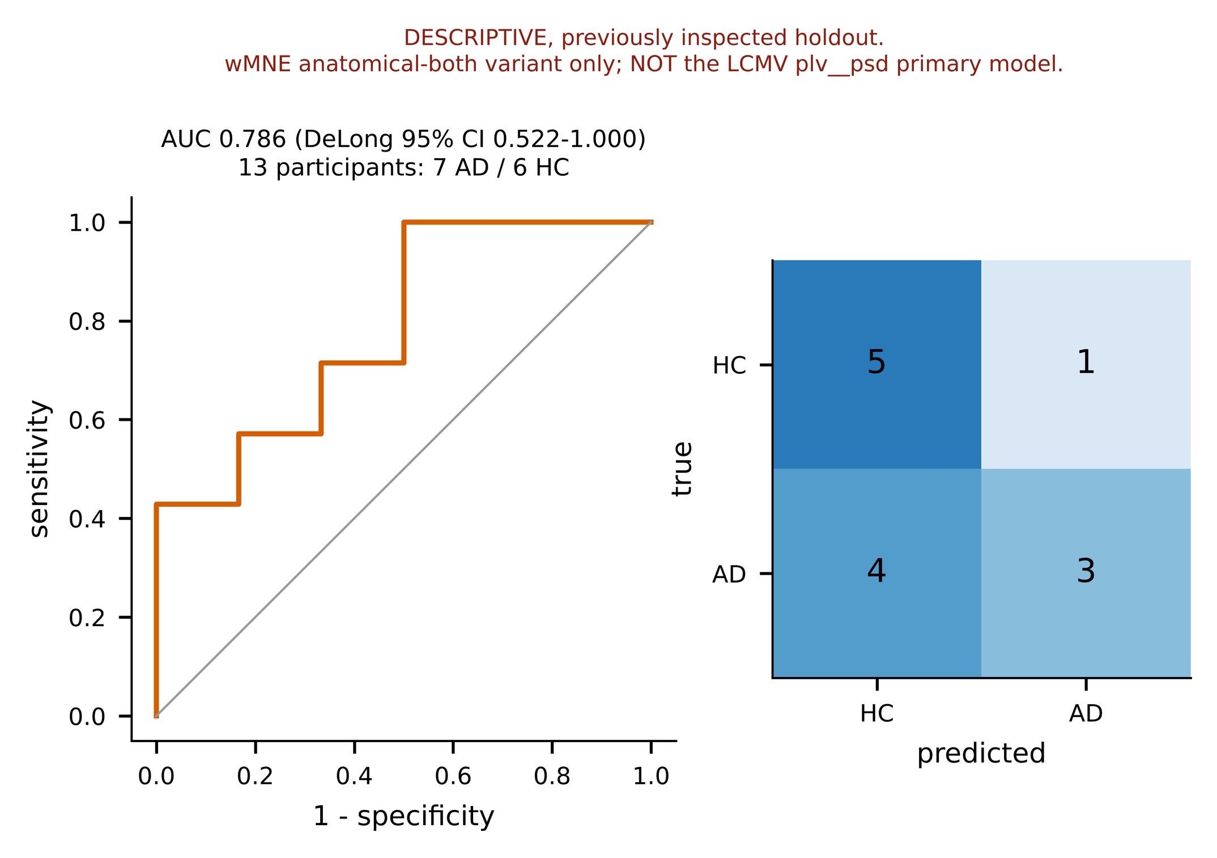

Fig. S3. Graph construction
Item | Content
Scientific question | Does sparsification help?
Manuscript section | II.E (supplement)
Source | Generated
Input files | development_results_all.csv
Plotting code | manuscript_figures/build_all_figures.py, figure id figS_graph (notebook cell 5 calls the same function)
Output files | manuscript_figures/generated/figS_graph_construction.pdf / .svg / .png (600 dpi)
Caption | Fig. S3. Graph construction on lobes12 (mode B, n = 52): participant-level AUC of eleven constructions for the Exp4 band-mean GCN and the Exp5 separate-encoder GCN. The pre-specified rule kept the dense graph; the feature-similarity graph is reported only.
Interpretation for Results | Dense kept by rule.
Limitations / caveats | Two reference models only.
Publication-readiness | Draft
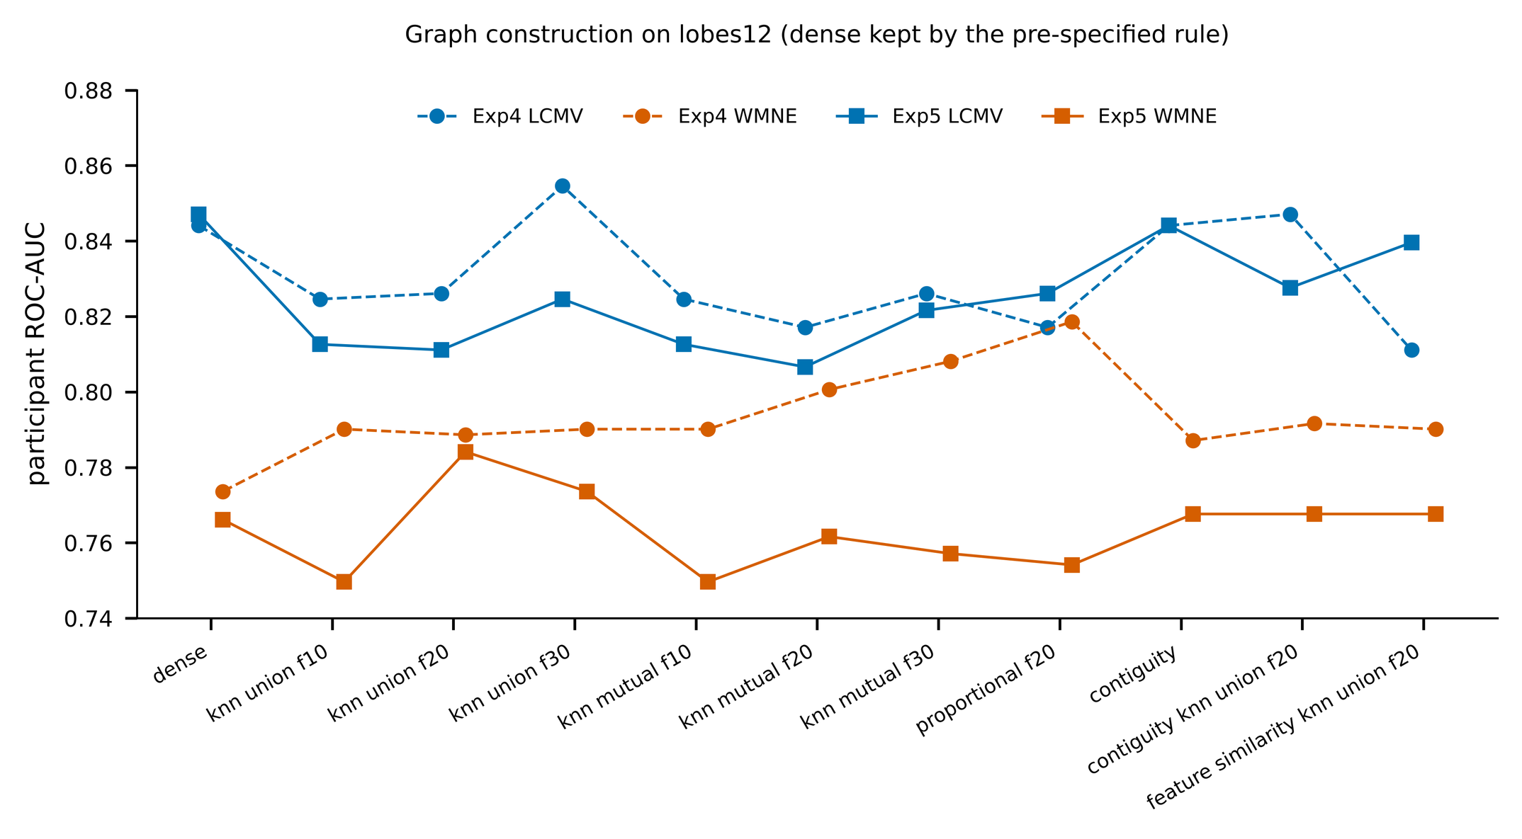

Fig. S4. Exp6 ablations
Item | Content
Scientific question | Which inputs matter?
Manuscript section | II.D (supplement)
Source | Generated
Input files | development_results_all.csv
Plotting code | manuscript_figures/build_all_figures.py, figure id figS_exp6 (notebook cell 5 calls the same function)
Output files | manuscript_figures/generated/figS_exp6_ablations.pdf / .svg / .png (600 dpi)
Caption | Fig. S4. Exp6 feature, fusion and band ablations (mode B): participant-level AUC with DeLong 95% intervals (n = 52).
Interpretation for Results | no_psd lowest.
Limitations / caveats | Single run per variant.
Publication-readiness | Draft
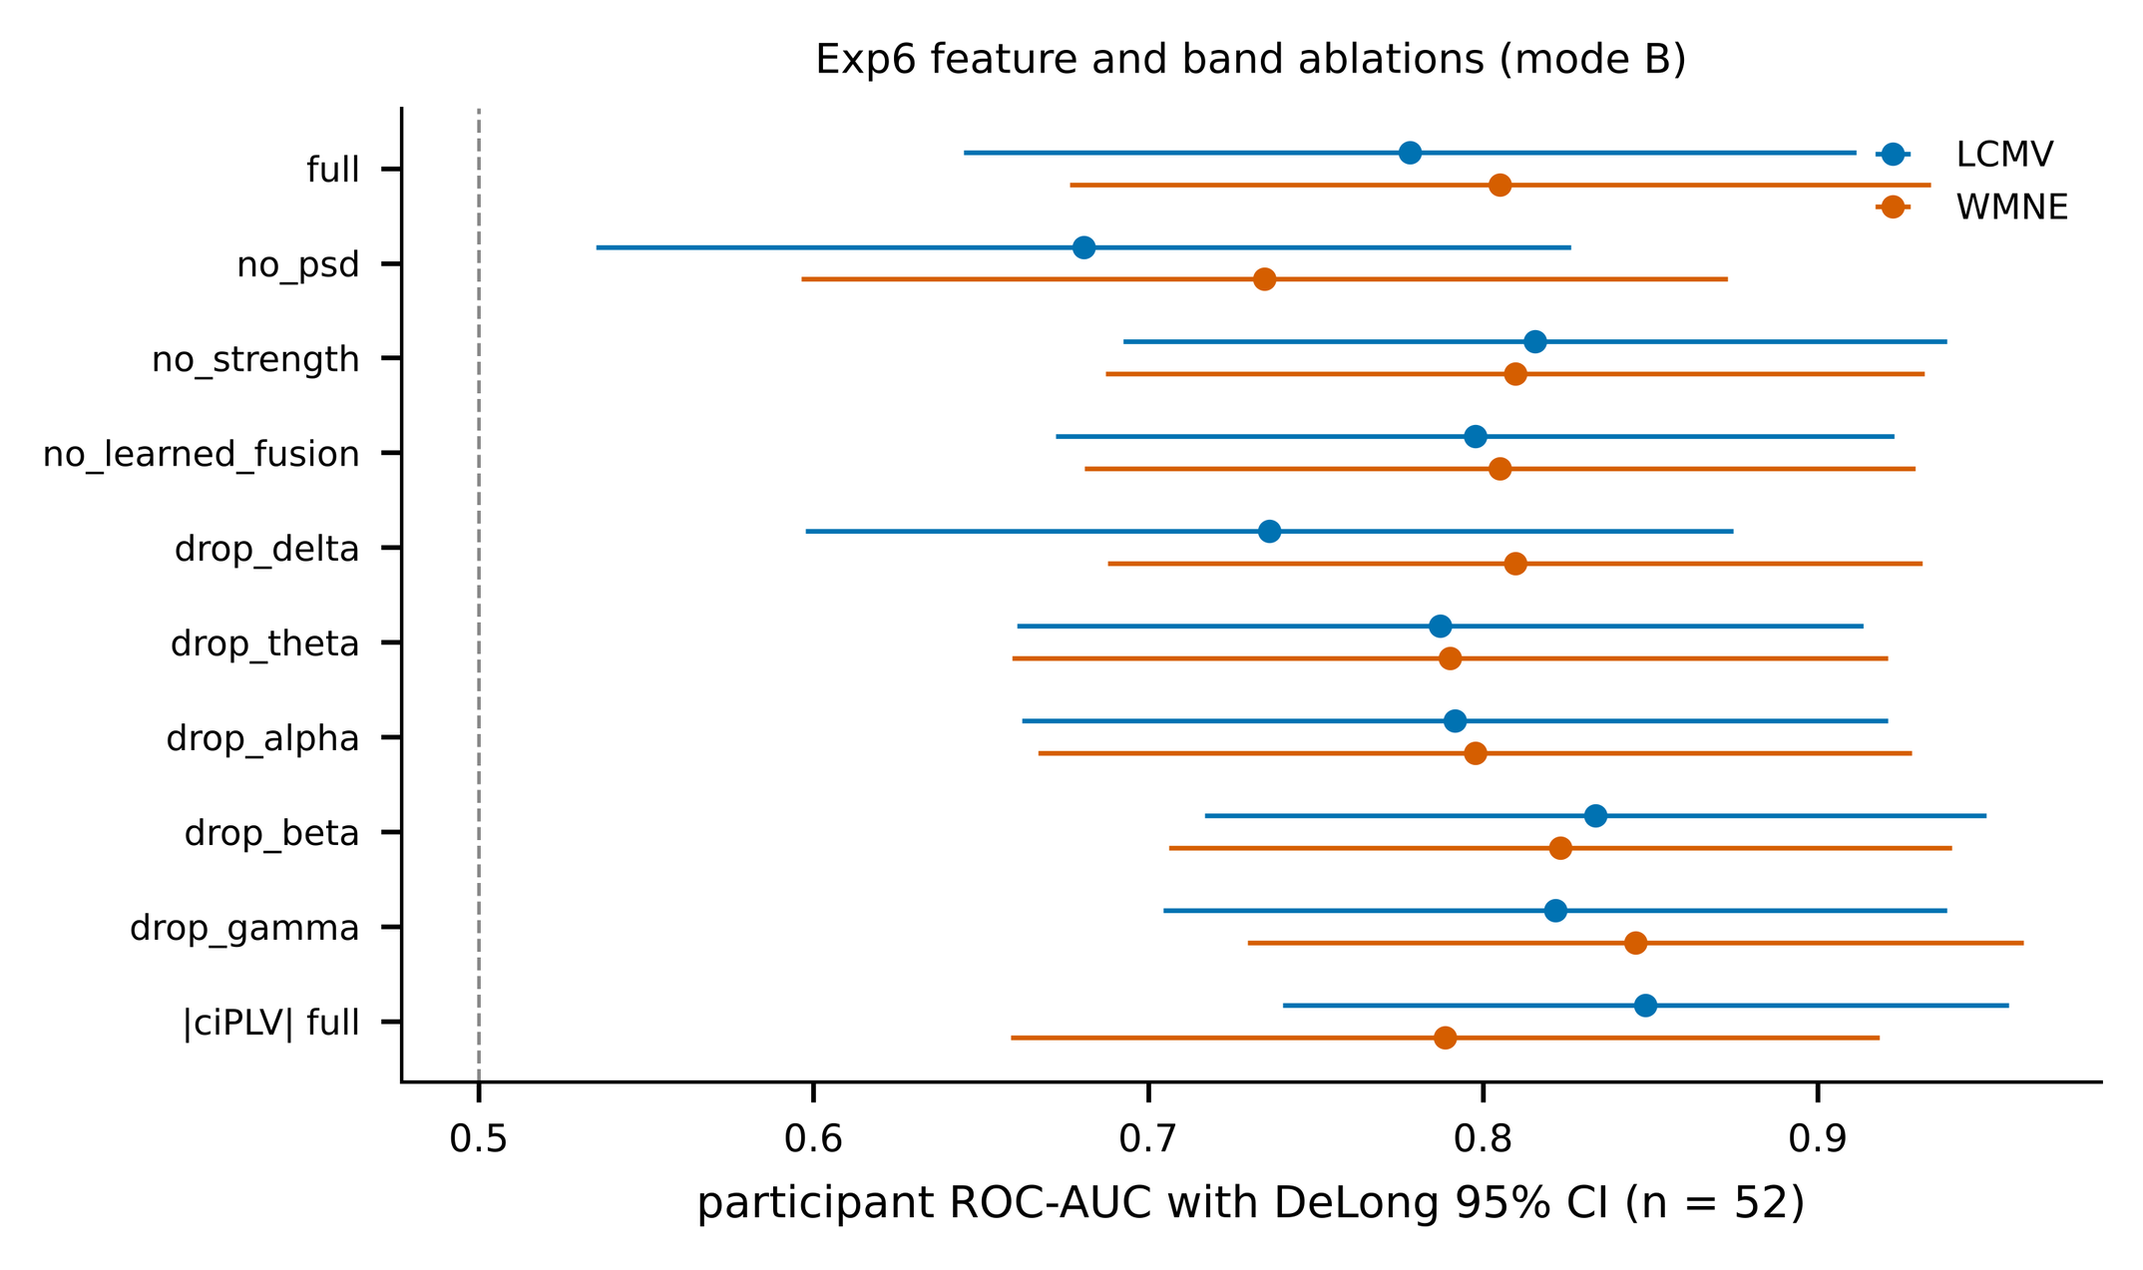

Fig. S5. Exp3 balanced-accuracy heatmap
Item | Content
Scientific question | Same as Fig. 4b in balanced accuracy
Manuscript section | II.D (supplement)
Source | Generated
Input files | development_results_all.csv
Plotting code | manuscript_figures/build_all_figures.py, figure id figS_bands (notebook cell 5 calls the same function)
Output files | manuscript_figures/generated/figS_exp3_band_heatmap_balanced_accuracy.pdf / .svg / .png (600 dpi)
Caption | Fig. S5. Exp3 single-band GCN, balanced accuracy at threshold 0.5 (lobes12, dense, mode B).
Interpretation for Results | Consistent with AUC heatmap.
Limitations / caveats | Threshold 0.5.
Publication-readiness | Draft
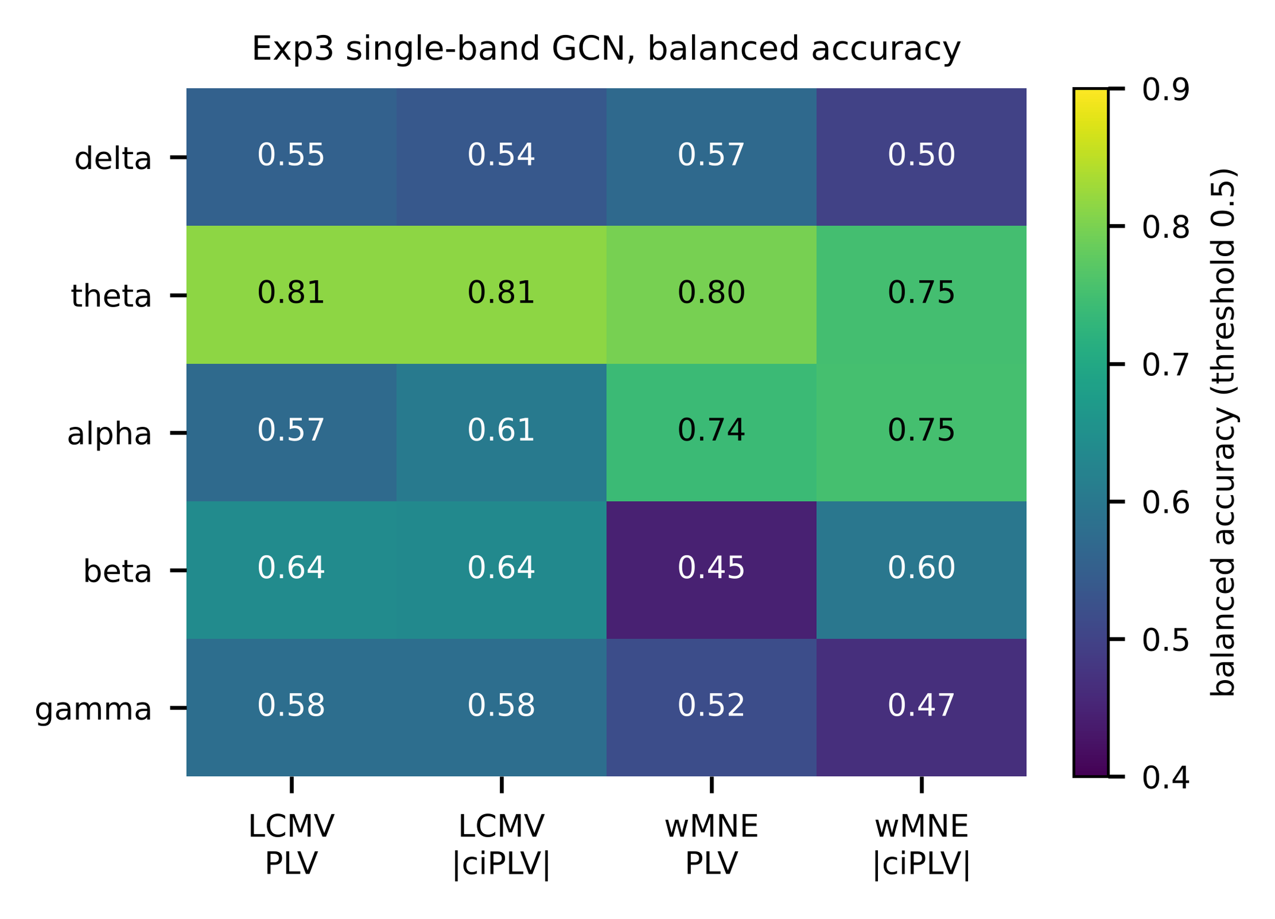

Reproducing the figures
- Open D3_Manuscript_Figure_Generation.ipynb in Colab and run all cells (mounts Drive, validates inputs, builds all figures, writes figure_manifest.csv and source_inventory.csv with SHA-256 of every input).
- Or: python manuscript_figures/build_all_figures.py --processed /content/drive/MyDrive/AD-LEB/processed
- Missing inputs raise MissingInput and that figure is skipped; nothing is simulated. A prediction file whose recomputed AUC or confusion matrix differs from the saved table aborts the run.
- Outputs go to a separate folder; paths inside FINAL_v1 or amendment namespaces are refused.
Build status: the offline test build used local copies of the Drive files for the three unit predictions, the holdout predictions, the results and comparison tables, selection_check.json (partial copy) and resolution_by_atlas.csv; the live Drive discovery path has not been executed.

