Supplementary Material
Atlas-Resolution-Aware Source-Space EEG Graph Learning for Alzheimer's Disease: A Controlled Participant-Level Study. All results are development cross-validation (52 participants) unless marked as the single-model holdout.

S1. Dataset and preprocessing parameters
Item | Value
Participants | 65 (36 AD, 29 HC); FTD excluded by design. Age AD 66.4 ± 7.9, HC 67.9 ± 5.4 years; MMSE AD 17.8 ± 4.5, HC 30.0 ± 0.0; women AD 24/36, HC 11/29 (public participants.tsv aggregates, docs/dataset_d3.md)
Split | Frozen: 52 development (29 AD / 23 HC), 13 holdout (7 / 6); seed 20250702; five-fold participant-grouped CV (seed 0)
Recording | 19 electrodes (Fp1, Fp2, F3, F4, C3, C4, P3, P4, O1, O2, F7, F8, T3, T4, T5, T6, Fz, Cz, Pz), 500 Hz, eyes closed; provider: 0.5–45 Hz Butterworth, A1–A2 re-reference, ASR, ICA (ICLabel)
This pipeline | No second band-pass; split at boundary events (56 of 65 recordings); per-segment resampling to 250 Hz; average reference; 10 s windows, 1 s step; five-minute selection; margin 825 samples (3.3 s); MAD rejection k = 5, max 15% bad channels; minimum 5 windows
Bands (Hz) | delta 0.5–4, theta 4–8, alpha 8–13, beta 13–25, gamma 25–45; finite zero-phase analytic FIR, 1 Hz transitions
Source space | fsaverage ico-5 (20,484 sources), three-layer BEM fsaverage-5120-5120-5120, mindist 5 mm; Colin27 electrode lookup; LCMV (reg 0.05, unit-noise-gain-invariant, per-participant data covariance, data rank) and wMNE (depth 0.8, loose 0.2, lambda² 1/9, normal component)
Windows | Mode B: all accepted windows (171–291 per participant observed in the saved predictions); mode A: first 10
Training | Adam 1e-3, weight decay 1e-4, batch 32, 60 epochs, no early stopping; seed 1000 x repeat + fold; torch 2.11.0 (CUDA build for Exp0–5, 7, 8a; CPU build for Exp6)
Code pins | Release 59a9ab70a55d107c5ad72acff1fb48f3ef42dff0 (Exp2–7); amendment A2 7fa470c668b8cce64ca152372422638be3ee8203 (Exp8a); A3 branch claude/a3-final-analysis

S2. Provenance and amendments
- Exp8 (original anatomical layer lobe_hemisphere) produced no result on lobes12 because the layer is the zero matrix; the units failed before training (not_completed_provenance.csv, graph run 58078565e7119b35). Exp8a (amendment A2, 2026-10-23, post-design, pre-result) replaces the layer by cortical-surface contiguity (22 edges for lobes12).
- Amendment A1 (2026-10-19) approved r18 stores as an exploratory, post-result comparison; it did not change the atlas rule.
- Atlas decision lobes12 recorded by the author on 2026-10-19T15:32:56Z after the development-only comparison (notebook 04); the record cites the resolution rule and development-CV classification.
- Dense graph recorded on 2026-10-20 by the pre-specified rule (no candidate improved mean AUC by 0.02 in 3 of 4 cells).
- Amendment A3 froze 116 units (104 GNN) for a descriptive holdout; only one single-model holdout (wMNE Exp8a abl_anatomical_both) was run.

S3. Supplementary figures
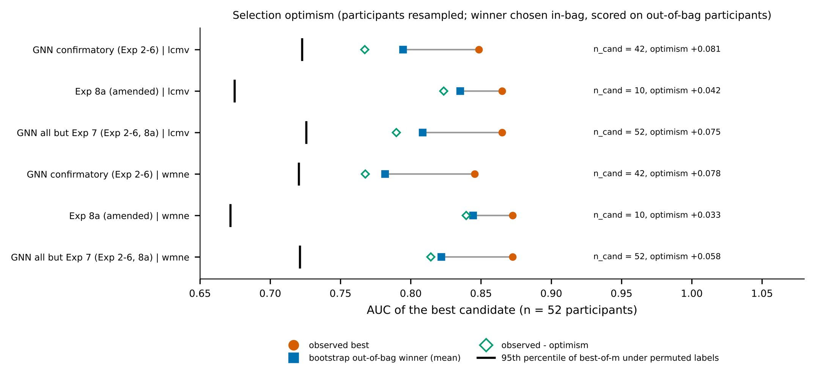
Fig. S1. Selection optimism. For each candidate set, the observed best AUC (n = 52), the mean bootstrap out-of-bag winner AUC, observed minus the bootstrap optimism, and the 95th percentile of the best-of-m AUC under permuted labels. Participants were resampled with replacement; the winner was chosen in-bag and scored on out-of-bag participants. This is a within-development estimate, not an independent test.
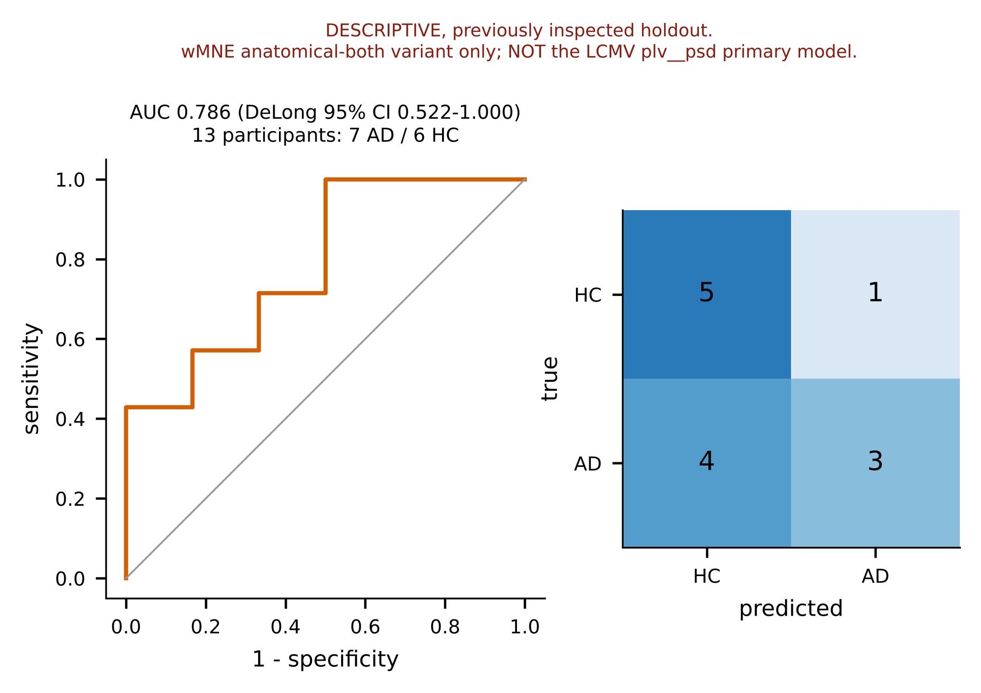
Fig. S2. Descriptive holdout of the single selected model (wMNE, Exp8a plv__psd_de_strength__abl_anatomical_both, lobes12, dense): 13 participants (7 AD, 6 HC), fitted once on the 52 development participants. The holdout had been inspected in earlier work and is not an untouched test; it is not the LCMV plv__psd primary model.
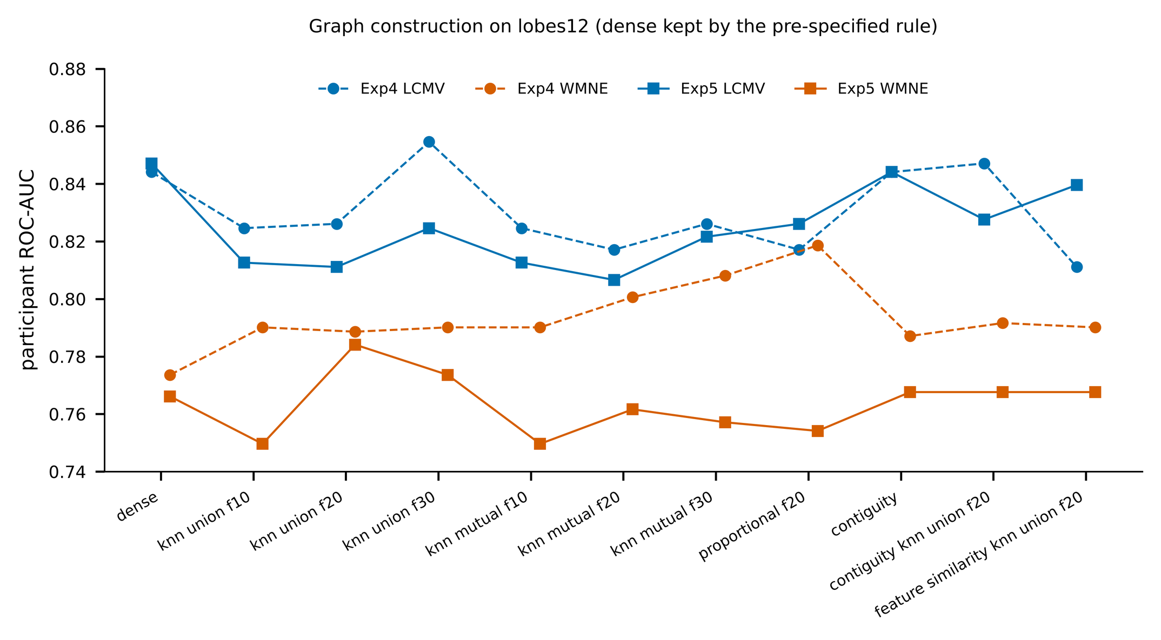
Fig. S3. Graph construction on lobes12 (mode B, n = 52): participant-level AUC of eleven constructions for the Exp4 band-mean GCN and the Exp5 separate-encoder GCN. The pre-specified rule kept the dense graph; the feature-similarity graph is reported only.
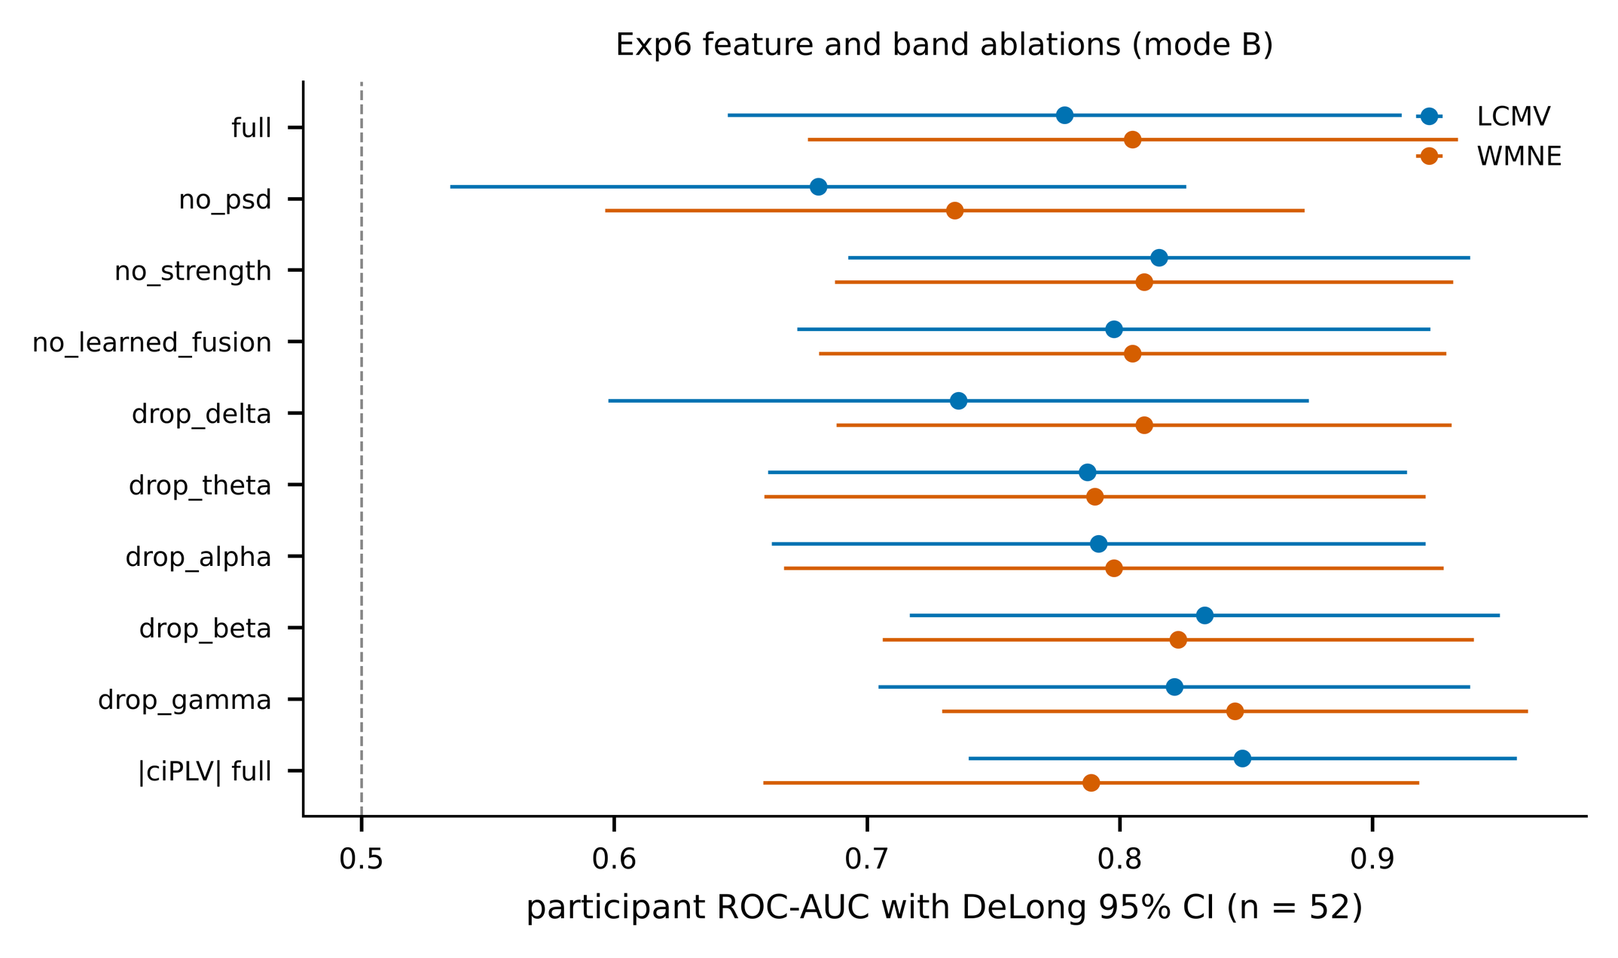
Fig. S4. Exp6 feature, fusion and band ablations (mode B): participant-level AUC with DeLong 95% intervals (n = 52).
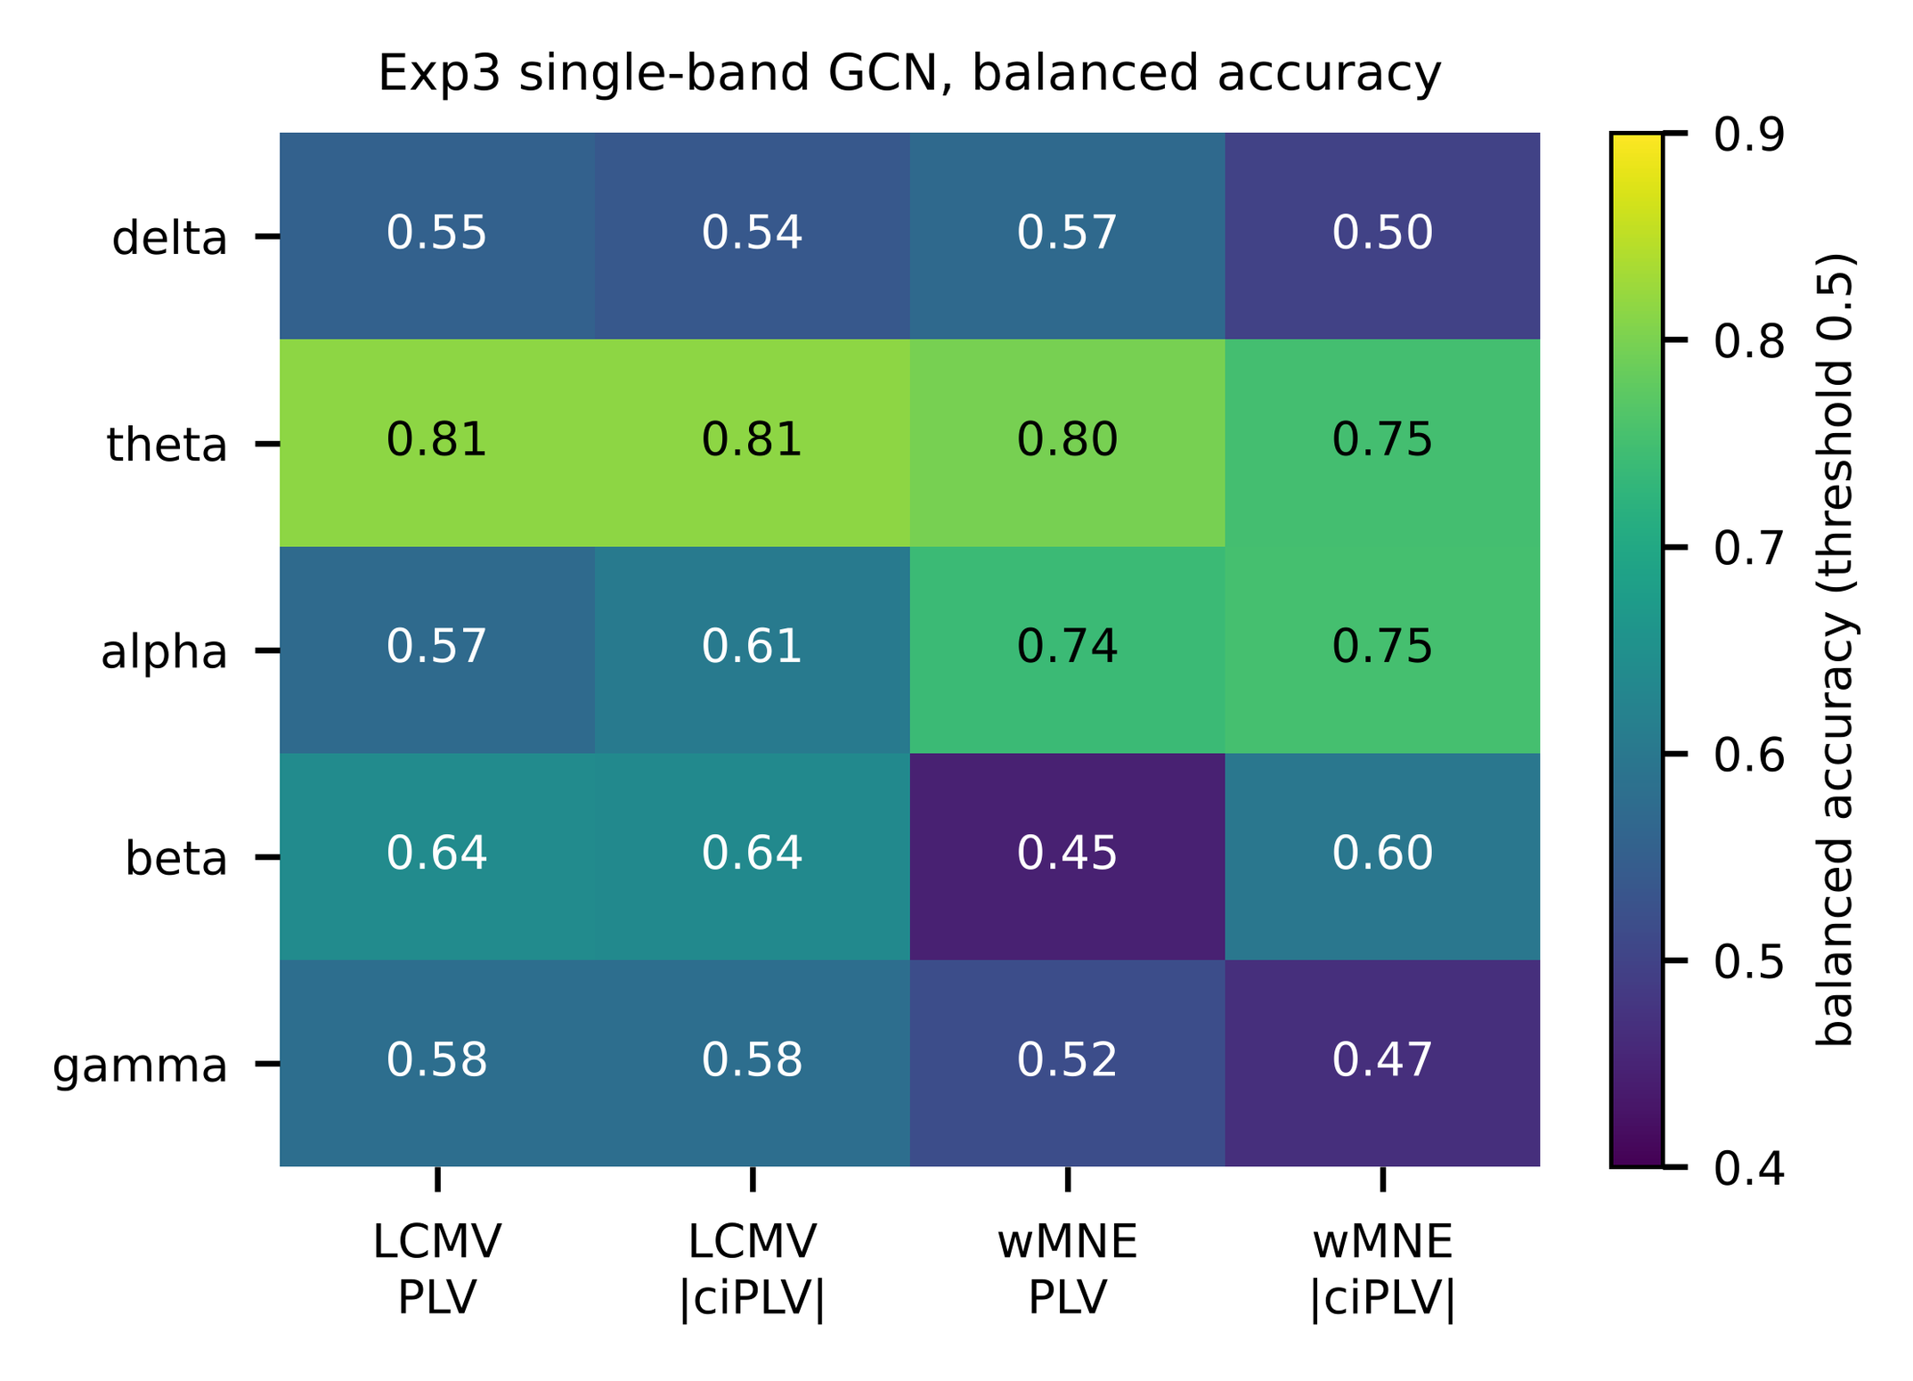
Fig. S5. Exp3 single-band GCN, balanced accuracy at threshold 0.5 (lobes12, dense, mode B).

S4. Complete results of all 280 completed GNN configurations
One row per saved configuration (participant level, n = 52). The CSV supplementary_all_280_gnn_configurations.csv holds the same rows with commit, namespace, role, F1, MCC, window-level AUC, threshold and the relative result directory (rel_dir) for traceability. Counts verified: 320 saved results = 280 GNN + 40 classical (excluded here); 104 GNN configurations in the frozen plan (Exp2 20, Exp3 20, Exp4 8, Exp5 16, Exp6 20, Exp8a 20; Exp7 0).

Exp | Variant | Inv. | Mode | Atlas | Graph | AUC (DeLong CI) | Acc. | BA | Sens. | Spec. | TN/FP/FN/TP | Fold AUC
Exp2 | ciplv__alpha | LCMV | A | lobes12 | dense | 0.489 (0.326–0.652) | 0.442 | 0.500 | 0.000 | 1.000 | 23/0/29/0 | 0.367±0.146
Exp2 | ciplv__beta | LCMV | A | lobes12 | dense | 0.531 (0.370–0.692) | 0.558 | 0.522 | 0.828 | 0.217 | 5/18/5/24 | 0.546±0.150
Exp2 | ciplv__delta | LCMV | A | lobes12 | dense | 0.558 (0.397–0.718) | 0.519 | 0.533 | 0.414 | 0.652 | 15/8/17/12 | 0.588±0.063
Exp2 | ciplv__gamma | LCMV | A | lobes12 | dense | 0.556 (0.395–0.718) | 0.558 | 0.522 | 0.828 | 0.217 | 5/18/5/24 | 0.575±0.138
Exp2 | ciplv__theta | LCMV | A | lobes12 | dense | 0.550 (0.389–0.711) | 0.558 | 0.500 | 1.000 | 0.000 | 0/23/0/29 | 0.638±0.146
Exp2 | plv__alpha | LCMV | A | lobes12 | dense | 0.502 (0.338–0.666) | 0.500 | 0.511 | 0.414 | 0.609 | 14/9/17/12 | 0.395±0.228
Exp2 | plv__beta | LCMV | A | lobes12 | dense | 0.532 (0.369–0.695) | 0.500 | 0.516 | 0.379 | 0.652 | 15/8/18/11 | 0.463±0.225
Exp2 | plv__delta | LCMV | A | lobes12 | dense | 0.580 (0.421–0.740) | 0.519 | 0.533 | 0.414 | 0.652 | 15/8/17/12 | 0.700±0.082
Exp2 | plv__gamma | LCMV | A | lobes12 | dense | 0.540 (0.379–0.701) | 0.538 | 0.505 | 0.793 | 0.217 | 5/18/6/23 | 0.500±0.168
Exp2 | plv__theta | LCMV | A | lobes12 | dense | 0.517 (0.356–0.679) | 0.519 | 0.510 | 0.586 | 0.435 | 10/13/12/17 | 0.423±0.115
Exp2 | ciplv__alpha | LCMV | B | lobes12 | dense | 0.518 (0.359–0.677) | 0.442 | 0.500 | 0.000 | 1.000 | 23/0/29/0 | 0.517±0.037
Exp2 | ciplv__beta | LCMV | B | lobes12 | dense | 0.480 (0.320–0.639) | 0.538 | 0.505 | 0.793 | 0.217 | 5/18/6/23 | 0.514±0.097
Exp2 | ciplv__delta | LCMV | B | lobes12 | dense | 0.471 (0.312–0.629) | 0.442 | 0.500 | 0.000 | 1.000 | 23/0/29/0 | 0.553±0.077
Exp2 | ciplv__gamma | LCMV | B | lobes12 | dense | 0.525 (0.368–0.683) | 0.538 | 0.505 | 0.793 | 0.217 | 5/18/6/23 | 0.500±0.000
Exp2 | ciplv__theta | LCMV | B | lobes12 | dense | 0.540 (0.381–0.698) | 0.558 | 0.500 | 1.000 | 0.000 | 0/23/0/29 | 0.492±0.075
Exp2 | plv__alpha | LCMV | B | lobes12 | dense | 0.463 (0.304–0.621) | 0.462 | 0.472 | 0.379 | 0.565 | 13/10/18/11 | 0.427±0.144
Exp2 | plv__beta | LCMV | B | lobes12 | dense | 0.430 (0.273–0.588) | 0.442 | 0.437 | 0.483 | 0.391 | 9/14/15/14 | 0.450±0.190
Exp2 | plv__delta | LCMV | B | lobes12 | dense | 0.442 (0.286–0.599) | 0.442 | 0.478 | 0.172 | 0.783 | 18/5/24/5 | 0.403±0.154
Exp2 | plv__gamma | LCMV | B | lobes12 | dense | 0.466 (0.304–0.628) | 0.519 | 0.484 | 0.793 | 0.174 | 4/19/6/23 | 0.486±0.195
Exp2 | plv__theta | LCMV | B | lobes12 | dense | 0.546 (0.387–0.706) | 0.558 | 0.500 | 1.000 | 0.000 | 0/23/0/29 | 0.537±0.051
Exp2 | ciplv__alpha | WMNE | A | lobes12 | dense | 0.483 (0.319–0.646) | 0.442 | 0.500 | 0.000 | 1.000 | 23/0/29/0 | 0.437±0.251
Exp2 | ciplv__beta | WMNE | A | lobes12 | dense | 0.547 (0.385–0.709) | 0.519 | 0.533 | 0.414 | 0.652 | 15/8/17/12 | 0.527±0.126
Exp2 | ciplv__delta | WMNE | A | lobes12 | dense | 0.516 (0.353–0.678) | 0.442 | 0.500 | 0.000 | 1.000 | 23/0/29/0 | 0.525±0.169
Exp2 | ciplv__gamma | WMNE | A | lobes12 | dense | 0.553 (0.392–0.714) | 0.538 | 0.528 | 0.621 | 0.435 | 10/13/11/18 | 0.545±0.206
Exp2 | ciplv__theta | WMNE | A | lobes12 | dense | 0.576 (0.415–0.736) | 0.538 | 0.528 | 0.621 | 0.435 | 10/13/11/18 | 0.675±0.134
Exp2 | plv__alpha | WMNE | A | lobes12 | dense | 0.499 (0.337–0.662) | 0.442 | 0.500 | 0.000 | 1.000 | 23/0/29/0 | 0.404±0.189
Exp2 | plv__beta | WMNE | A | lobes12 | dense | 0.529 (0.363–0.695) | 0.538 | 0.528 | 0.621 | 0.435 | 10/13/11/18 | 0.547±0.232
Exp2 | plv__delta | WMNE | A | lobes12 | dense | 0.550 (0.389–0.711) | 0.481 | 0.481 | 0.483 | 0.478 | 11/12/15/14 | 0.595±0.197
Exp2 | plv__gamma | WMNE | A | lobes12 | dense | 0.520 (0.357–0.683) | 0.558 | 0.522 | 0.828 | 0.217 | 5/18/5/24 | 0.481±0.174
Exp2 | plv__theta | WMNE | A | lobes12 | dense | 0.519 (0.355–0.683) | 0.538 | 0.528 | 0.621 | 0.435 | 10/13/11/18 | 0.465±0.122
Exp2 | ciplv__alpha | WMNE | B | lobes12 | dense | 0.493 (0.334–0.653) | 0.442 | 0.500 | 0.000 | 1.000 | 23/0/29/0 | 0.540±0.048
Exp2 | ciplv__beta | WMNE | B | lobes12 | dense | 0.501 (0.340–0.662) | 0.442 | 0.478 | 0.172 | 0.783 | 18/5/24/5 | 0.663±0.145
Exp2 | ciplv__delta | WMNE | B | lobes12 | dense | 0.478 (0.319–0.637) | 0.442 | 0.500 | 0.000 | 1.000 | 23/0/29/0 | 0.496±0.125
Exp2 | ciplv__gamma | WMNE | B | lobes12 | dense | 0.506 (0.348–0.664) | 0.442 | 0.500 | 0.000 | 1.000 | 23/0/29/0 | 0.524±0.054
Exp2 | ciplv__theta | WMNE | B | lobes12 | dense | 0.529 (0.371–0.687) | 0.481 | 0.516 | 0.207 | 0.826 | 19/4/23/6 | 0.530±0.067
Exp2 | plv__alpha | WMNE | B | lobes12 | dense | 0.511 (0.350–0.673) | 0.442 | 0.500 | 0.000 | 1.000 | 23/0/29/0 | 0.541±0.301
Exp2 | plv__beta | WMNE | B | lobes12 | dense | 0.469 (0.309–0.628) | 0.462 | 0.472 | 0.379 | 0.565 | 13/10/18/11 | 0.504±0.111
Exp2 | plv__delta | WMNE | B | lobes12 | dense | 0.481 (0.320–0.641) | 0.462 | 0.472 | 0.379 | 0.565 | 13/10/18/11 | 0.562±0.093
Exp2 | plv__gamma | WMNE | B | lobes12 | dense | 0.484 (0.323–0.644) | 0.500 | 0.489 | 0.586 | 0.391 | 9/14/12/17 | 0.404±0.160
Exp2 | plv__theta | WMNE | B | lobes12 | dense | 0.525 (0.364–0.685) | 0.538 | 0.505 | 0.793 | 0.217 | 5/18/6/23 | 0.491±0.119
Exp3 | ciplv__alpha | LCMV | A | lobes12 | dense | 0.676 (0.523–0.829) | 0.596 | 0.588 | 0.655 | 0.522 | 12/11/10/19 | 0.731±0.209
Exp3 | ciplv__beta | LCMV | A | lobes12 | dense | 0.666 (0.516–0.816) | 0.635 | 0.641 | 0.586 | 0.696 | 16/7/12/17 | 0.642±0.167
Exp3 | ciplv__delta | LCMV | A | lobes12 | dense | 0.577 (0.420–0.734) | 0.538 | 0.546 | 0.483 | 0.609 | 14/9/15/14 | 0.623±0.222
Exp3 | ciplv__gamma | LCMV | A | lobes12 | dense | 0.433 (0.274–0.592) | 0.481 | 0.490 | 0.414 | 0.565 | 13/10/17/12 | 0.416±0.084
Exp3 | ciplv__theta | LCMV | A | lobes12 | dense | 0.849 (0.743–0.954) | 0.750 | 0.762 | 0.655 | 0.870 | 20/3/10/19 | 0.924±0.091
Exp3 | plv__alpha | LCMV | A | lobes12 | dense | 0.655 (0.499–0.812) | 0.500 | 0.502 | 0.483 | 0.522 | 12/11/15/14 | 0.675±0.288
Exp3 | plv__beta | LCMV | A | lobes12 | dense | 0.702 (0.558–0.845) | 0.673 | 0.675 | 0.655 | 0.696 | 16/7/10/19 | 0.696±0.153
Exp3 | plv__delta | LCMV | A | lobes12 | dense | 0.568 (0.410–0.727) | 0.481 | 0.481 | 0.483 | 0.478 | 11/12/15/14 | 0.593±0.209
Exp3 | plv__gamma | LCMV | A | lobes12 | dense | 0.430 (0.272–0.589) | 0.481 | 0.485 | 0.448 | 0.522 | 12/11/16/13 | 0.393±0.091
Exp3 | plv__theta | LCMV | A | lobes12 | dense | 0.832 (0.719–0.945) | 0.769 | 0.780 | 0.690 | 0.870 | 20/3/9/20 | 0.884±0.072
Exp3 | ciplv__alpha | LCMV | B | lobes12 | dense | 0.690 (0.545–0.835) | 0.596 | 0.606 | 0.517 | 0.696 | 16/7/14/15 | 0.701±0.247
Exp3 | ciplv__beta | LCMV | B | lobes12 | dense | 0.718 (0.576–0.861) | 0.635 | 0.636 | 0.621 | 0.652 | 15/8/11/18 | 0.728±0.080
Exp3 | ciplv__delta | LCMV | B | lobes12 | dense | 0.672 (0.521–0.822) | 0.519 | 0.537 | 0.379 | 0.696 | 16/7/18/11 | 0.691±0.184
Exp3 | ciplv__gamma | LCMV | B | lobes12 | dense | 0.607 (0.452–0.763) | 0.577 | 0.580 | 0.552 | 0.609 | 14/9/13/16 | 0.632±0.120
Exp3 | ciplv__theta | LCMV | B | lobes12 | dense | 0.825 (0.707–0.942) | 0.808 | 0.814 | 0.759 | 0.870 | 20/3/7/22 | 0.877±0.081
Exp3 | plv__alpha | LCMV | B | lobes12 | dense | 0.697 (0.553–0.841) | 0.558 | 0.572 | 0.448 | 0.696 | 16/7/16/13 | 0.710±0.255
Exp3 | plv__beta | LCMV | B | lobes12 | dense | 0.706 (0.562–0.851) | 0.635 | 0.641 | 0.586 | 0.696 | 16/7/12/17 | 0.683±0.085
Exp3 | plv__delta | LCMV | B | lobes12 | dense | 0.676 (0.524–0.828) | 0.538 | 0.555 | 0.414 | 0.696 | 16/7/17/12 | 0.709±0.247
Exp3 | plv__gamma | LCMV | B | lobes12 | dense | 0.621 (0.466–0.776) | 0.577 | 0.580 | 0.552 | 0.609 | 14/9/13/16 | 0.649±0.137
Exp3 | plv__theta | LCMV | B | lobes12 | dense | 0.814 (0.692–0.936) | 0.808 | 0.814 | 0.759 | 0.870 | 20/3/7/22 | 0.870±0.090
Exp3 | ciplv__alpha | WMNE | A | lobes12 | dense | 0.744 (0.606–0.881) | 0.731 | 0.736 | 0.690 | 0.783 | 18/5/9/20 | 0.786±0.106
Exp3 | ciplv__beta | WMNE | A | lobes12 | dense | 0.534 (0.372–0.696) | 0.500 | 0.493 | 0.552 | 0.435 | 10/13/13/16 | 0.541±0.082
Exp3 | ciplv__delta | WMNE | A | lobes12 | dense | 0.547 (0.387–0.707) | 0.558 | 0.558 | 0.552 | 0.565 | 13/10/13/16 | 0.604±0.216
Exp3 | ciplv__gamma | WMNE | A | lobes12 | dense | 0.250 (0.115–0.385) | 0.385 | 0.399 | 0.276 | 0.522 | 12/11/21/8 | 0.270±0.196
Exp3 | ciplv__theta | WMNE | A | lobes12 | dense | 0.807 (0.688–0.925) | 0.750 | 0.762 | 0.655 | 0.870 | 20/3/10/19 | 0.809±0.059
Exp3 | plv__alpha | WMNE | A | lobes12 | dense | 0.729 (0.588–0.869) | 0.712 | 0.714 | 0.690 | 0.739 | 17/6/9/20 | 0.779±0.118
Exp3 | plv__beta | WMNE | A | lobes12 | dense | 0.525 (0.362–0.687) | 0.481 | 0.481 | 0.483 | 0.478 | 11/12/15/14 | 0.533±0.092
Exp3 | plv__delta | WMNE | A | lobes12 | dense | 0.550 (0.390–0.710) | 0.538 | 0.537 | 0.552 | 0.522 | 12/11/13/16 | 0.609±0.239
Exp3 | plv__gamma | WMNE | A | lobes12 | dense | 0.298 (0.155–0.441) | 0.365 | 0.373 | 0.310 | 0.435 | 10/13/20/9 | 0.330±0.169
Exp3 | plv__theta | WMNE | A | lobes12 | dense | 0.817 (0.702–0.932) | 0.769 | 0.780 | 0.690 | 0.870 | 20/3/9/20 | 0.824±0.063
Exp3 | ciplv__alpha | WMNE | B | lobes12 | dense | 0.754 (0.619–0.889) | 0.750 | 0.753 | 0.724 | 0.783 | 18/5/8/21 | 0.758±0.122
Exp3 | ciplv__beta | WMNE | B | lobes12 | dense | 0.610 (0.450–0.770) | 0.596 | 0.597 | 0.586 | 0.609 | 14/9/12/17 | 0.632±0.063
Exp3 | ciplv__delta | WMNE | B | lobes12 | dense | 0.555 (0.392–0.717) | 0.462 | 0.499 | 0.172 | 0.826 | 19/4/24/5 | 0.621±0.135
Exp3 | ciplv__gamma | WMNE | B | lobes12 | dense | 0.387 (0.219–0.554) | 0.481 | 0.467 | 0.586 | 0.348 | 8/15/12/17 | 0.398±0.200
Exp3 | ciplv__theta | WMNE | B | lobes12 | dense | 0.771 (0.635–0.906) | 0.731 | 0.750 | 0.586 | 0.913 | 21/2/12/17 | 0.815±0.041
Exp3 | plv__alpha | WMNE | B | lobes12 | dense | 0.765 (0.632–0.898) | 0.731 | 0.741 | 0.655 | 0.826 | 19/4/10/19 | 0.806±0.138
Exp3 | plv__beta | WMNE | B | lobes12 | dense | 0.559 (0.398–0.720) | 0.462 | 0.445 | 0.586 | 0.304 | 7/16/12/17 | 0.587±0.033
Exp3 | plv__delta | WMNE | B | lobes12 | dense | 0.654 (0.502–0.805) | 0.577 | 0.571 | 0.621 | 0.522 | 12/11/11/18 | 0.691±0.161
Exp3 | plv__gamma | WMNE | B | lobes12 | dense | 0.462 (0.292–0.631) | 0.538 | 0.519 | 0.690 | 0.348 | 8/15/9/20 | 0.472±0.155
Exp3 | plv__theta | WMNE | B | lobes12 | dense | 0.799 (0.670–0.928) | 0.788 | 0.797 | 0.724 | 0.870 | 20/3/8/21 | 0.812±0.020
Exp4 | ciplv__de | LCMV | A | lobes12 | dense | 0.798 (0.671–0.925) | 0.769 | 0.775 | 0.724 | 0.826 | 19/4/8/21 | 0.798±0.138
Exp4 | ciplv__psd | LCMV | A | lobes12 | dense | 0.841 (0.726–0.956) | 0.769 | 0.771 | 0.759 | 0.783 | 18/5/7/22 | 0.857±0.112
Exp4 | plv__de | LCMV | A | lobes12 | dense | 0.801 (0.672–0.929) | 0.750 | 0.753 | 0.724 | 0.783 | 18/5/8/21 | 0.798±0.150
Exp4 | plv__psd | LCMV | A | lobes12 | dense | 0.831 (0.712–0.950) | 0.750 | 0.749 | 0.759 | 0.739 | 17/6/7/22 | 0.850±0.120
Exp4 | plv__psd | LCMV | B | dk68 | dense | 0.841 (0.728–0.954) | 0.788 | 0.788 | 0.793 | 0.783 | 18/5/6/23 | 0.844±0.104
Exp4 | plv__psd | LCMV | B | lobes12 | contiguity | 0.844 (0.723–0.965) | 0.827 | 0.836 | 0.759 | 0.913 | 21/2/7/22 | 0.859±0.124
Exp4 | plv__psd | LCMV | B | lobes12 | contiguity_knn_union_f20 | 0.847 (0.727–0.967) | 0.808 | 0.814 | 0.759 | 0.870 | 20/3/7/22 | 0.866±0.111
Exp4 | ciplv__de | LCMV | B | lobes12 | dense | 0.829 (0.705–0.953) | 0.788 | 0.792 | 0.759 | 0.826 | 19/4/7/22 | 0.855±0.087
Exp4 | ciplv__psd | LCMV | B | lobes12 | dense | 0.814 (0.692–0.936) | 0.750 | 0.753 | 0.724 | 0.783 | 18/5/8/21 | 0.819±0.084
Exp4 | plv__de | LCMV | B | lobes12 | dense | 0.847 (0.736–0.958) | 0.788 | 0.792 | 0.759 | 0.826 | 19/4/7/22 | 0.854±0.067
Exp4 | plv__psd | LCMV | B | lobes12 | dense | 0.844 (0.725–0.963) | 0.808 | 0.810 | 0.793 | 0.826 | 19/4/6/23 | 0.862±0.137
Exp4 | plv__psd | LCMV | B | lobes12 | feature_similarity_knn_union_f20 | 0.811 (0.685–0.937) | 0.788 | 0.797 | 0.724 | 0.870 | 20/3/8/21 | 0.809±0.144
Exp4 | plv__psd | LCMV | B | lobes12 | knn_mutual_f10 | 0.825 (0.702–0.947) | 0.808 | 0.814 | 0.759 | 0.870 | 20/3/7/22 | 0.804±0.094
Exp4 | plv__psd | LCMV | B | lobes12 | knn_mutual_f20 | 0.817 (0.691–0.943) | 0.788 | 0.792 | 0.759 | 0.826 | 19/4/7/22 | 0.803±0.081
Exp4 | plv__psd | LCMV | B | lobes12 | knn_mutual_f30 | 0.826 (0.704–0.948) | 0.788 | 0.792 | 0.759 | 0.826 | 19/4/7/22 | 0.819±0.092
Exp4 | plv__psd | LCMV | B | lobes12 | knn_union_f10 | 0.825 (0.702–0.947) | 0.808 | 0.814 | 0.759 | 0.870 | 20/3/7/22 | 0.804±0.094
Exp4 | plv__psd | LCMV | B | lobes12 | knn_union_f20 | 0.826 (0.703–0.949) | 0.827 | 0.836 | 0.759 | 0.913 | 21/2/7/22 | 0.811±0.092
Exp4 | plv__psd | LCMV | B | lobes12 | knn_union_f30 | 0.855 (0.743–0.966) | 0.846 | 0.853 | 0.793 | 0.913 | 21/2/6/23 | 0.871±0.069
Exp4 | plv__psd | LCMV | B | lobes12 | proportional_f20 | 0.817 (0.692–0.943) | 0.769 | 0.775 | 0.724 | 0.826 | 19/4/8/21 | 0.829±0.110
Exp4 | plv__psd | LCMV | B | r18 | dense | 0.849 (0.730–0.967) | 0.788 | 0.788 | 0.793 | 0.783 | 18/5/6/23 | 0.852±0.119
Exp4 | ciplv__de | WMNE | A | lobes12 | dense | 0.712 (0.568–0.856) | 0.692 | 0.702 | 0.621 | 0.783 | 18/5/11/18 | 0.713±0.152
Exp4 | ciplv__psd | WMNE | A | lobes12 | dense | 0.796 (0.671–0.921) | 0.692 | 0.702 | 0.621 | 0.783 | 18/5/11/18 | 0.846±0.151
Exp4 | plv__de | WMNE | A | lobes12 | dense | 0.705 (0.558–0.851) | 0.654 | 0.658 | 0.621 | 0.696 | 16/7/11/18 | 0.721±0.150
Exp4 | plv__psd | WMNE | A | lobes12 | dense | 0.787 (0.660–0.914) | 0.731 | 0.736 | 0.690 | 0.783 | 18/5/9/20 | 0.821±0.130
Exp4 | plv__psd | WMNE | B | dk68 | dense | 0.781 (0.640–0.922) | 0.769 | 0.771 | 0.759 | 0.783 | 18/5/7/22 | 0.788±0.072
Exp4 | plv__psd | WMNE | B | lobes12 | contiguity | 0.787 (0.658–0.916) | 0.731 | 0.727 | 0.759 | 0.696 | 16/7/7/22 | 0.782±0.207
Exp4 | plv__psd | WMNE | B | lobes12 | contiguity_knn_union_f20 | 0.792 (0.665–0.918) | 0.731 | 0.727 | 0.759 | 0.696 | 16/7/7/22 | 0.802±0.191
Exp4 | ciplv__de | WMNE | B | lobes12 | dense | 0.744 (0.602–0.885) | 0.692 | 0.688 | 0.724 | 0.652 | 15/8/8/21 | 0.743±0.140
Exp4 | ciplv__psd | WMNE | B | lobes12 | dense | 0.778 (0.645–0.911) | 0.731 | 0.723 | 0.793 | 0.652 | 15/8/6/23 | 0.785±0.147
Exp4 | plv__de | WMNE | B | lobes12 | dense | 0.754 (0.615–0.893) | 0.673 | 0.662 | 0.759 | 0.565 | 13/10/7/22 | 0.745±0.138
Exp4 | plv__psd | WMNE | B | lobes12 | dense | 0.774 (0.636–0.911) | 0.712 | 0.710 | 0.724 | 0.696 | 16/7/8/21 | 0.790±0.109
Exp4 | plv__psd | WMNE | B | lobes12 | feature_similarity_knn_union_f20 | 0.790 (0.661–0.919) | 0.769 | 0.766 | 0.793 | 0.739 | 17/6/6/23 | 0.820±0.126
Exp4 | plv__psd | WMNE | B | lobes12 | knn_mutual_f10 | 0.790 (0.659–0.921) | 0.750 | 0.744 | 0.793 | 0.696 | 16/7/6/23 | 0.798±0.152
Exp4 | plv__psd | WMNE | B | lobes12 | knn_mutual_f20 | 0.801 (0.674–0.927) | 0.731 | 0.723 | 0.793 | 0.652 | 15/8/6/23 | 0.800±0.158
Exp4 | plv__psd | WMNE | B | lobes12 | knn_mutual_f30 | 0.808 (0.680–0.937) | 0.712 | 0.701 | 0.793 | 0.609 | 14/9/6/23 | 0.798±0.149
Exp4 | plv__psd | WMNE | B | lobes12 | knn_union_f10 | 0.790 (0.659–0.921) | 0.750 | 0.744 | 0.793 | 0.696 | 16/7/6/23 | 0.798±0.152
Exp4 | plv__psd | WMNE | B | lobes12 | knn_union_f20 | 0.789 (0.660–0.917) | 0.692 | 0.679 | 0.793 | 0.565 | 13/10/6/23 | 0.786±0.199
Exp4 | plv__psd | WMNE | B | lobes12 | knn_union_f30 | 0.790 (0.656–0.924) | 0.750 | 0.744 | 0.793 | 0.696 | 16/7/6/23 | 0.791±0.146
Exp4 | plv__psd | WMNE | B | lobes12 | proportional_f20 | 0.819 (0.695–0.942) | 0.750 | 0.744 | 0.793 | 0.696 | 16/7/6/23 | 0.806±0.155
Exp4 | plv__psd | WMNE | B | r18 | dense | 0.795 (0.667–0.922) | 0.731 | 0.732 | 0.724 | 0.739 | 17/6/8/21 | 0.791±0.116
Exp5 | ciplv__separate__attention | LCMV | A | lobes12 | dense | 0.798 (0.666–0.929) | 0.769 | 0.771 | 0.759 | 0.783 | 18/5/7/22 | 0.790±0.157
Exp5 | ciplv__separate__mean | LCMV | A | lobes12 | dense | 0.795 (0.662–0.927) | 0.750 | 0.753 | 0.724 | 0.783 | 18/5/8/21 | 0.830±0.135
Exp5 | ciplv__shared_bandid__attention | LCMV | A | lobes12 | dense | 0.748 (0.607–0.889) | 0.692 | 0.693 | 0.690 | 0.696 | 16/7/9/20 | 0.751±0.164
Exp5 | ciplv__shared_bandid__mean | LCMV | A | lobes12 | dense | 0.787 (0.655–0.920) | 0.731 | 0.732 | 0.724 | 0.739 | 17/6/8/21 | 0.805±0.116
Exp5 | plv__separate__attention | LCMV | A | lobes12 | dense | 0.789 (0.653–0.924) | 0.750 | 0.749 | 0.759 | 0.739 | 17/6/7/22 | 0.823±0.150
Exp5 | plv__separate__mean | LCMV | A | lobes12 | dense | 0.790 (0.657–0.923) | 0.712 | 0.710 | 0.724 | 0.696 | 16/7/8/21 | 0.815±0.135
Exp5 | plv__shared_bandid__attention | LCMV | A | lobes12 | dense | 0.765 (0.627–0.902) | 0.673 | 0.671 | 0.690 | 0.652 | 15/8/9/20 | 0.798±0.153
Exp5 | plv__shared_bandid__mean | LCMV | A | lobes12 | dense | 0.781 (0.645–0.917) | 0.731 | 0.732 | 0.724 | 0.739 | 17/6/8/21 | 0.789±0.124
Exp5 | plv__separate__mean | LCMV | B | dk68 | dense | 0.841 (0.723–0.959) | 0.846 | 0.849 | 0.828 | 0.870 | 20/3/5/24 | 0.867±0.114
Exp5 | plv__separate__mean | LCMV | B | lobes12 | contiguity | 0.844 (0.726–0.962) | 0.827 | 0.831 | 0.793 | 0.870 | 20/3/6/23 | 0.875±0.119
Exp5 | plv__separate__mean | LCMV | B | lobes12 | contiguity_knn_union_f20 | 0.828 (0.703–0.952) | 0.808 | 0.814 | 0.759 | 0.870 | 20/3/7/22 | 0.845±0.127
Exp5 | ciplv__separate__attention | LCMV | B | lobes12 | dense | 0.814 (0.690–0.938) | 0.731 | 0.732 | 0.724 | 0.739 | 17/6/8/21 | 0.841±0.089
Exp5 | ciplv__separate__mean | LCMV | B | lobes12 | dense | 0.834 (0.714–0.953) | 0.827 | 0.831 | 0.793 | 0.870 | 20/3/6/23 | 0.852±0.116
Exp5 | ciplv__shared_bandid__attention | LCMV | B | lobes12 | dense | 0.787 (0.655–0.919) | 0.769 | 0.766 | 0.793 | 0.739 | 17/6/6/23 | 0.796±0.082
Exp5 | ciplv__shared_bandid__mean | LCMV | B | lobes12 | dense | 0.828 (0.704–0.951) | 0.769 | 0.766 | 0.793 | 0.739 | 17/6/6/23 | 0.834±0.091
Exp5 | plv__separate__attention | LCMV | B | lobes12 | dense | 0.820 (0.697–0.944) | 0.750 | 0.753 | 0.724 | 0.783 | 18/5/8/21 | 0.843±0.110
Exp5 | plv__separate__mean | LCMV | B | lobes12 | dense | 0.847 (0.729–0.965) | 0.788 | 0.788 | 0.793 | 0.783 | 18/5/6/23 | 0.869±0.136
Exp5 | plv__shared_bandid__attention | LCMV | B | lobes12 | dense | 0.802 (0.676–0.928) | 0.750 | 0.749 | 0.759 | 0.739 | 17/6/7/22 | 0.813±0.099
Exp5 | plv__shared_bandid__mean | LCMV | B | lobes12 | dense | 0.849 (0.733–0.964) | 0.846 | 0.853 | 0.793 | 0.913 | 21/2/6/23 | 0.874±0.110
Exp5 | plv__separate__mean | LCMV | B | lobes12 | feature_similarity_knn_union_f20 | 0.840 (0.721–0.958) | 0.808 | 0.814 | 0.759 | 0.870 | 20/3/7/22 | 0.849±0.091
Exp5 | plv__separate__mean | LCMV | B | lobes12 | knn_mutual_f10 | 0.813 (0.685–0.940) | 0.808 | 0.814 | 0.759 | 0.870 | 20/3/7/22 | 0.820±0.111
Exp5 | plv__separate__mean | LCMV | B | lobes12 | knn_mutual_f20 | 0.807 (0.679–0.934) | 0.788 | 0.792 | 0.759 | 0.826 | 19/4/7/22 | 0.812±0.099
Exp5 | plv__separate__mean | LCMV | B | lobes12 | knn_mutual_f30 | 0.822 (0.696–0.947) | 0.788 | 0.792 | 0.759 | 0.826 | 19/4/7/22 | 0.829±0.118
Exp5 | plv__separate__mean | LCMV | B | lobes12 | knn_union_f10 | 0.813 (0.685–0.940) | 0.808 | 0.814 | 0.759 | 0.870 | 20/3/7/22 | 0.820±0.111
Exp5 | plv__separate__mean | LCMV | B | lobes12 | knn_union_f20 | 0.811 (0.685–0.937) | 0.769 | 0.771 | 0.759 | 0.783 | 18/5/7/22 | 0.829±0.118
Exp5 | plv__separate__mean | LCMV | B | lobes12 | knn_union_f30 | 0.825 (0.699–0.950) | 0.808 | 0.814 | 0.759 | 0.870 | 20/3/7/22 | 0.836±0.114
Exp5 | plv__separate__mean | LCMV | B | lobes12 | proportional_f20 | 0.826 (0.702–0.950) | 0.808 | 0.814 | 0.759 | 0.870 | 20/3/7/22 | 0.821±0.107
Exp5 | plv__separate__mean | LCMV | B | r18 | dense | 0.859 (0.743–0.975) | 0.865 | 0.866 | 0.862 | 0.870 | 20/3/4/25 | 0.869±0.136
Exp5 | ciplv__separate__attention | WMNE | A | lobes12 | dense | 0.711 (0.567–0.854) | 0.635 | 0.636 | 0.621 | 0.652 | 15/8/11/18 | 0.723±0.104
Exp5 | ciplv__separate__mean | WMNE | A | lobes12 | dense | 0.745 (0.610–0.880) | 0.692 | 0.702 | 0.621 | 0.783 | 18/5/11/18 | 0.831±0.151
Exp5 | ciplv__shared_bandid__attention | WMNE | A | lobes12 | dense | 0.747 (0.610–0.883) | 0.673 | 0.684 | 0.586 | 0.783 | 18/5/12/17 | 0.776±0.145
Exp5 | ciplv__shared_bandid__mean | WMNE | A | lobes12 | dense | 0.790 (0.663–0.917) | 0.712 | 0.719 | 0.655 | 0.783 | 18/5/10/19 | 0.832±0.116
Exp5 | plv__separate__attention | WMNE | A | lobes12 | dense | 0.739 (0.602–0.876) | 0.654 | 0.654 | 0.655 | 0.652 | 15/8/10/19 | 0.776±0.112
Exp5 | plv__separate__mean | WMNE | A | lobes12 | dense | 0.724 (0.583–0.865) | 0.673 | 0.684 | 0.586 | 0.783 | 18/5/12/17 | 0.812±0.158
Exp5 | plv__shared_bandid__attention | WMNE | A | lobes12 | dense | 0.729 (0.588–0.870) | 0.692 | 0.706 | 0.586 | 0.826 | 19/4/12/17 | 0.775±0.131
Exp5 | plv__shared_bandid__mean | WMNE | A | lobes12 | dense | 0.787 (0.658–0.916) | 0.712 | 0.719 | 0.655 | 0.783 | 18/5/10/19 | 0.827±0.153
Exp5 | plv__separate__mean | WMNE | B | dk68 | dense | 0.831 (0.718–0.943) | 0.692 | 0.688 | 0.724 | 0.652 | 15/8/8/21 | 0.831±0.072
Exp5 | plv__separate__mean | WMNE | B | lobes12 | contiguity | 0.768 (0.637–0.899) | 0.654 | 0.645 | 0.724 | 0.565 | 13/10/8/21 | 0.741±0.152
Exp5 | plv__separate__mean | WMNE | B | lobes12 | contiguity_knn_union_f20 | 0.768 (0.638–0.898) | 0.692 | 0.684 | 0.759 | 0.609 | 14/9/7/22 | 0.735±0.164
Exp5 | ciplv__separate__attention | WMNE | B | lobes12 | dense | 0.775 (0.645–0.906) | 0.712 | 0.710 | 0.724 | 0.696 | 16/7/8/21 | 0.773±0.124
Exp5 | ciplv__separate__mean | WMNE | B | lobes12 | dense | 0.765 (0.632–0.897) | 0.712 | 0.705 | 0.759 | 0.652 | 15/8/7/22 | 0.751±0.154
Exp5 | ciplv__shared_bandid__attention | WMNE | B | lobes12 | dense | 0.793 (0.665–0.921) | 0.712 | 0.714 | 0.690 | 0.739 | 17/6/9/20 | 0.830±0.056
Exp5 | ciplv__shared_bandid__mean | WMNE | B | lobes12 | dense | 0.786 (0.658–0.913) | 0.692 | 0.684 | 0.759 | 0.609 | 14/9/7/22 | 0.777±0.087
Exp5 | plv__separate__attention | WMNE | B | lobes12 | dense | 0.787 (0.660–0.914) | 0.692 | 0.693 | 0.690 | 0.696 | 16/7/9/20 | 0.805±0.108
Exp5 | plv__separate__mean | WMNE | B | lobes12 | dense | 0.766 (0.634–0.898) | 0.692 | 0.684 | 0.759 | 0.609 | 14/9/7/22 | 0.751±0.137
Exp5 | plv__shared_bandid__attention | WMNE | B | lobes12 | dense | 0.823 (0.706–0.940) | 0.750 | 0.753 | 0.724 | 0.783 | 18/5/8/21 | 0.848±0.099
Exp5 | plv__shared_bandid__mean | WMNE | B | lobes12 | dense | 0.811 (0.690–0.932) | 0.769 | 0.766 | 0.793 | 0.739 | 17/6/6/23 | 0.822±0.041
Exp5 | plv__separate__mean | WMNE | B | lobes12 | feature_similarity_knn_union_f20 | 0.768 (0.636–0.899) | 0.712 | 0.710 | 0.724 | 0.696 | 16/7/8/21 | 0.773±0.134
Exp5 | plv__separate__mean | WMNE | B | lobes12 | knn_mutual_f10 | 0.750 (0.614–0.885) | 0.654 | 0.645 | 0.724 | 0.565 | 13/10/8/21 | 0.725±0.196
Exp5 | plv__separate__mean | WMNE | B | lobes12 | knn_mutual_f20 | 0.762 (0.630–0.893) | 0.673 | 0.671 | 0.690 | 0.652 | 15/8/9/20 | 0.731±0.174
Exp5 | plv__separate__mean | WMNE | B | lobes12 | knn_mutual_f30 | 0.757 (0.624–0.890) | 0.615 | 0.610 | 0.655 | 0.565 | 13/10/10/19 | 0.738±0.153
Exp5 | plv__separate__mean | WMNE | B | lobes12 | knn_union_f10 | 0.750 (0.614–0.885) | 0.654 | 0.645 | 0.724 | 0.565 | 13/10/8/21 | 0.725±0.196
Exp5 | plv__separate__mean | WMNE | B | lobes12 | knn_union_f20 | 0.784 (0.657–0.911) | 0.712 | 0.705 | 0.759 | 0.652 | 15/8/7/22 | 0.763±0.110
Exp5 | plv__separate__mean | WMNE | B | lobes12 | knn_union_f30 | 0.774 (0.644–0.903) | 0.692 | 0.684 | 0.759 | 0.609 | 14/9/7/22 | 0.751±0.154
Exp5 | plv__separate__mean | WMNE | B | lobes12 | proportional_f20 | 0.754 (0.620–0.888) | 0.654 | 0.654 | 0.655 | 0.652 | 15/8/10/19 | 0.751±0.122
Exp5 | plv__separate__mean | WMNE | B | r18 | dense | 0.811 (0.689–0.933) | 0.750 | 0.749 | 0.759 | 0.739 | 17/6/7/22 | 0.803±0.122
Exp6 | ciplv__full | LCMV | A | lobes12 | dense | 0.802 (0.678–0.926) | 0.731 | 0.736 | 0.690 | 0.783 | 18/5/9/20 | 0.832±0.116
Exp6 | plv__drop_alpha | LCMV | A | lobes12 | dense | 0.698 (0.547–0.848) | 0.692 | 0.684 | 0.759 | 0.609 | 14/9/7/22 | 0.756±0.175
Exp6 | plv__drop_beta | LCMV | A | lobes12 | dense | 0.840 (0.726–0.953) | 0.788 | 0.788 | 0.793 | 0.783 | 18/5/6/23 | 0.875±0.138
Exp6 | plv__drop_delta | LCMV | A | lobes12 | dense | 0.702 (0.556–0.849) | 0.673 | 0.671 | 0.690 | 0.652 | 15/8/9/20 | 0.751±0.159
Exp6 | plv__drop_gamma | LCMV | A | lobes12 | dense | 0.780 (0.652–0.907) | 0.712 | 0.719 | 0.655 | 0.783 | 18/5/10/19 | 0.806±0.120
Exp6 | plv__drop_theta | LCMV | A | lobes12 | dense | 0.718 (0.573–0.863) | 0.712 | 0.710 | 0.724 | 0.696 | 16/7/8/21 | 0.738±0.100
Exp6 | plv__full | LCMV | A | lobes12 | dense | 0.760 (0.619–0.901) | 0.750 | 0.753 | 0.724 | 0.783 | 18/5/8/21 | 0.802±0.168
Exp6 | plv__no_learned_fusion | LCMV | A | lobes12 | dense | 0.747 (0.603–0.890) | 0.692 | 0.688 | 0.724 | 0.652 | 15/8/8/21 | 0.773±0.158
Exp6 | plv__no_psd | LCMV | A | lobes12 | dense | 0.643 (0.492–0.795) | 0.577 | 0.580 | 0.552 | 0.609 | 14/9/13/16 | 0.660±0.188
Exp6 | plv__no_strength | LCMV | A | lobes12 | dense | 0.765 (0.627–0.902) | 0.673 | 0.671 | 0.690 | 0.652 | 15/8/9/20 | 0.798±0.153
Exp6 | ciplv__full | LCMV | B | lobes12 | dense | 0.849 (0.740–0.957) | 0.788 | 0.788 | 0.793 | 0.783 | 18/5/6/23 | 0.872±0.099
Exp6 | plv__drop_alpha | LCMV | B | lobes12 | dense | 0.792 (0.662–0.921) | 0.769 | 0.771 | 0.759 | 0.783 | 18/5/7/22 | 0.789±0.099
Exp6 | plv__drop_beta | LCMV | B | lobes12 | dense | 0.834 (0.717–0.950) | 0.827 | 0.831 | 0.793 | 0.870 | 20/3/6/23 | 0.834±0.085
Exp6 | plv__drop_delta | LCMV | B | lobes12 | dense | 0.736 (0.598–0.875) | 0.712 | 0.714 | 0.690 | 0.739 | 17/6/9/20 | 0.775±0.101
Exp6 | plv__drop_gamma | LCMV | B | lobes12 | dense | 0.822 (0.705–0.939) | 0.731 | 0.723 | 0.793 | 0.652 | 15/8/6/23 | 0.876±0.119
Exp6 | plv__drop_theta | LCMV | B | lobes12 | dense | 0.787 (0.661–0.913) | 0.731 | 0.732 | 0.724 | 0.739 | 17/6/8/21 | 0.819±0.084
Exp6 | plv__full | LCMV | B | lobes12 | dense | 0.778 (0.645–0.911) | 0.750 | 0.753 | 0.724 | 0.783 | 18/5/8/21 | 0.818±0.087
Exp6 | plv__no_learned_fusion | LCMV | B | lobes12 | dense | 0.798 (0.672–0.923) | 0.769 | 0.771 | 0.759 | 0.783 | 18/5/7/22 | 0.827±0.096
Exp6 | plv__no_psd | LCMV | B | lobes12 | dense | 0.681 (0.535–0.826) | 0.596 | 0.588 | 0.655 | 0.522 | 12/11/10/19 | 0.675±0.238
Exp6 | plv__no_strength | LCMV | B | lobes12 | dense | 0.816 (0.693–0.939) | 0.731 | 0.727 | 0.759 | 0.696 | 16/7/7/22 | 0.829±0.114
Exp6 | ciplv__full | WMNE | A | lobes12 | dense | 0.816 (0.694–0.937) | 0.788 | 0.797 | 0.724 | 0.870 | 20/3/8/21 | 0.829±0.103
Exp6 | plv__drop_alpha | WMNE | A | lobes12 | dense | 0.763 (0.630–0.896) | 0.692 | 0.688 | 0.724 | 0.652 | 15/8/8/21 | 0.776±0.167
Exp6 | plv__drop_beta | WMNE | A | lobes12 | dense | 0.781 (0.652–0.910) | 0.731 | 0.732 | 0.724 | 0.739 | 17/6/8/21 | 0.789±0.202
Exp6 | plv__drop_delta | WMNE | A | lobes12 | dense | 0.747 (0.609–0.885) | 0.654 | 0.649 | 0.690 | 0.609 | 14/9/9/20 | 0.749±0.055
Exp6 | plv__drop_gamma | WMNE | A | lobes12 | dense | 0.849 (0.741–0.956) | 0.788 | 0.797 | 0.724 | 0.870 | 20/3/8/21 | 0.849±0.099
Exp6 | plv__drop_theta | WMNE | A | lobes12 | dense | 0.649 (0.494–0.804) | 0.635 | 0.636 | 0.621 | 0.652 | 15/8/11/18 | 0.670±0.085
Exp6 | plv__full | WMNE | A | lobes12 | dense | 0.753 (0.620–0.885) | 0.712 | 0.714 | 0.690 | 0.739 | 17/6/9/20 | 0.787±0.187
Exp6 | plv__no_learned_fusion | WMNE | A | lobes12 | dense | 0.786 (0.657–0.914) | 0.731 | 0.732 | 0.724 | 0.739 | 17/6/8/21 | 0.853±0.170
Exp6 | plv__no_psd | WMNE | A | lobes12 | dense | 0.661 (0.509–0.814) | 0.596 | 0.593 | 0.621 | 0.565 | 13/10/11/18 | 0.678±0.202
Exp6 | plv__no_strength | WMNE | A | lobes12 | dense | 0.729 (0.588–0.870) | 0.692 | 0.706 | 0.586 | 0.826 | 19/4/12/17 | 0.775±0.131
Exp6 | ciplv__full | WMNE | B | lobes12 | dense | 0.789 (0.659–0.918) | 0.750 | 0.749 | 0.759 | 0.739 | 17/6/7/22 | 0.807±0.028
Exp6 | plv__drop_alpha | WMNE | B | lobes12 | dense | 0.798 (0.667–0.928) | 0.769 | 0.771 | 0.759 | 0.783 | 18/5/7/22 | 0.776±0.155
Exp6 | plv__drop_beta | WMNE | B | lobes12 | dense | 0.823 (0.706–0.940) | 0.788 | 0.792 | 0.759 | 0.826 | 19/4/7/22 | 0.838±0.156
Exp6 | plv__drop_delta | WMNE | B | lobes12 | dense | 0.810 (0.688–0.931) | 0.788 | 0.779 | 0.862 | 0.696 | 16/7/4/25 | 0.854±0.092
Exp6 | plv__drop_gamma | WMNE | B | lobes12 | dense | 0.846 (0.730–0.962) | 0.788 | 0.797 | 0.724 | 0.870 | 20/3/8/21 | 0.866±0.035
Exp6 | plv__drop_theta | WMNE | B | lobes12 | dense | 0.790 (0.659–0.921) | 0.712 | 0.714 | 0.690 | 0.739 | 17/6/9/20 | 0.806±0.138
Exp6 | plv__full | WMNE | B | lobes12 | dense | 0.805 (0.676–0.934) | 0.769 | 0.771 | 0.759 | 0.783 | 18/5/7/22 | 0.832±0.062
Exp6 | plv__no_learned_fusion | WMNE | B | lobes12 | dense | 0.805 (0.681–0.929) | 0.731 | 0.732 | 0.724 | 0.739 | 17/6/8/21 | 0.844±0.133
Exp6 | plv__no_psd | WMNE | B | lobes12 | dense | 0.735 (0.596–0.873) | 0.673 | 0.675 | 0.655 | 0.696 | 16/7/10/19 | 0.766±0.181
Exp6 | plv__no_strength | WMNE | B | lobes12 | dense | 0.810 (0.687–0.932) | 0.769 | 0.766 | 0.793 | 0.739 | 17/6/6/23 | 0.845±0.088
Exp7 | ciplv__fixed_adjacency | LCMV | A | lobes12 | dense | 0.660 (0.506–0.813) | 0.615 | 0.606 | 0.690 | 0.522 | 12/11/9/20 | 0.662±0.189
Exp7 | ciplv__full | LCMV | A | lobes12 | dense | 0.631 (0.474–0.788) | 0.596 | 0.593 | 0.621 | 0.565 | 13/10/11/18 | 0.640±0.100
Exp7 | ciplv__mean_fusion | LCMV | A | lobes12 | dense | 0.609 (0.451–0.767) | 0.577 | 0.576 | 0.586 | 0.565 | 13/10/12/17 | 0.598±0.145
Exp7 | plv__fixed_adjacency | LCMV | A | lobes12 | dense | 0.550 (0.390–0.710) | 0.538 | 0.537 | 0.552 | 0.522 | 12/11/13/16 | 0.627±0.225
Exp7 | plv__full | LCMV | A | lobes12 | dense | 0.588 (0.429–0.746) | 0.538 | 0.541 | 0.517 | 0.565 | 13/10/14/15 | 0.656±0.126
Exp7 | plv__mean_fusion | LCMV | A | lobes12 | dense | 0.654 (0.504–0.804) | 0.615 | 0.619 | 0.586 | 0.652 | 15/8/12/17 | 0.678±0.091
Exp7 | ciplv__fixed_adjacency | LCMV | B | lobes12 | dense | 0.859 (0.748–0.971) | 0.808 | 0.805 | 0.828 | 0.783 | 18/5/5/24 | 0.857±0.162
Exp7 | ciplv__full | LCMV | B | lobes12 | dense | 0.819 (0.695–0.943) | 0.769 | 0.771 | 0.759 | 0.783 | 18/5/7/22 | 0.827±0.108
Exp7 | ciplv__mean_fusion | LCMV | B | lobes12 | dense | 0.861 (0.750–0.972) | 0.808 | 0.801 | 0.862 | 0.739 | 17/6/4/25 | 0.870±0.075
Exp7 | plv__fixed_adjacency | LCMV | B | lobes12 | dense | 0.769 (0.640–0.898) | 0.692 | 0.693 | 0.690 | 0.696 | 16/7/9/20 | 0.809±0.154
Exp7 | plv__full | LCMV | B | lobes12 | dense | 0.769 (0.637–0.901) | 0.769 | 0.780 | 0.690 | 0.870 | 20/3/9/20 | 0.815±0.122
Exp7 | plv__mean_fusion | LCMV | B | lobes12 | dense | 0.826 (0.714–0.938) | 0.712 | 0.710 | 0.724 | 0.696 | 16/7/8/21 | 0.842±0.087
Exp7 | ciplv__fixed_adjacency | WMNE | A | lobes12 | dense | 0.699 (0.551–0.847) | 0.692 | 0.697 | 0.655 | 0.739 | 17/6/10/19 | 0.705±0.139
Exp7 | ciplv__full | WMNE | A | lobes12 | dense | 0.718 (0.570–0.866) | 0.692 | 0.697 | 0.655 | 0.739 | 17/6/10/19 | 0.730±0.174
Exp7 | ciplv__mean_fusion | WMNE | A | lobes12 | dense | 0.747 (0.605–0.889) | 0.731 | 0.736 | 0.690 | 0.783 | 18/5/9/20 | 0.738±0.164
Exp7 | plv__fixed_adjacency | WMNE | A | lobes12 | dense | 0.721 (0.579–0.864) | 0.673 | 0.671 | 0.690 | 0.652 | 15/8/9/20 | 0.714±0.170
Exp7 | plv__full | WMNE | A | lobes12 | dense | 0.655 (0.503–0.808) | 0.615 | 0.615 | 0.621 | 0.609 | 14/9/11/18 | 0.629±0.250
Exp7 | plv__mean_fusion | WMNE | A | lobes12 | dense | 0.717 (0.573–0.862) | 0.692 | 0.688 | 0.724 | 0.652 | 15/8/8/21 | 0.765±0.127
Exp7 | ciplv__fixed_adjacency | WMNE | B | lobes12 | dense | 0.777 (0.647–0.906) | 0.673 | 0.666 | 0.724 | 0.609 | 14/9/8/21 | 0.798±0.119
Exp7 | ciplv__full | WMNE | B | lobes12 | dense | 0.786 (0.660–0.911) | 0.692 | 0.693 | 0.690 | 0.696 | 16/7/9/20 | 0.796±0.095
Exp7 | ciplv__mean_fusion | WMNE | B | lobes12 | dense | 0.775 (0.647–0.904) | 0.692 | 0.693 | 0.690 | 0.696 | 16/7/9/20 | 0.781±0.124
Exp7 | plv__fixed_adjacency | WMNE | B | lobes12 | dense | 0.781 (0.652–0.910) | 0.731 | 0.732 | 0.724 | 0.739 | 17/6/8/21 | 0.783±0.159
Exp7 | plv__full | WMNE | B | lobes12 | dense | 0.727 (0.584–0.870) | 0.692 | 0.697 | 0.655 | 0.739 | 17/6/10/19 | 0.725±0.196
Exp7 | plv__mean_fusion | WMNE | B | lobes12 | dense | 0.769 (0.635–0.903) | 0.673 | 0.675 | 0.655 | 0.696 | 16/7/10/19 | 0.779±0.082
Exp8a | ciplv__de | LCMV | A | lobes12 | dense | 0.783 (0.653–0.912) | 0.731 | 0.736 | 0.690 | 0.783 | 18/5/9/20 | 0.827±0.130
Exp8a | ciplv__psd | LCMV | A | lobes12 | dense | 0.823 (0.700–0.947) | 0.788 | 0.792 | 0.759 | 0.826 | 19/4/7/22 | 0.855±0.152
Exp8a | ciplv__psd_de_strength | LCMV | A | lobes12 | dense | 0.768 (0.632–0.903) | 0.750 | 0.749 | 0.759 | 0.739 | 17/6/7/22 | 0.799±0.118
Exp8a | plv__de | LCMV | A | lobes12 | dense | 0.784 (0.659–0.909) | 0.712 | 0.719 | 0.655 | 0.783 | 18/5/10/19 | 0.800±0.131
Exp8a | plv__psd | LCMV | A | lobes12 | dense | 0.804 (0.677–0.931) | 0.731 | 0.732 | 0.724 | 0.739 | 17/6/8/21 | 0.828±0.124
Exp8a | plv__psd_de_strength | LCMV | A | lobes12 | dense | 0.789 (0.664–0.913) | 0.673 | 0.671 | 0.690 | 0.652 | 15/8/9/20 | 0.835±0.095
Exp8a | plv__psd_de_strength__abl_anatomical_both | LCMV | A | lobes12 | dense | 0.805 (0.687–0.924) | 0.692 | 0.688 | 0.724 | 0.652 | 15/8/8/21 | 0.832±0.062
Exp8a | plv__psd_de_strength__abl_functional_both | LCMV | A | lobes12 | dense | 0.826 (0.708–0.944) | 0.712 | 0.710 | 0.724 | 0.696 | 16/7/8/21 | 0.841±0.074
Exp8a | plv__psd_de_strength__abl_shared_weights | LCMV | A | lobes12 | dense | 0.775 (0.642–0.909) | 0.712 | 0.705 | 0.759 | 0.652 | 15/8/7/22 | 0.831±0.119
Exp8a | plv__psd_de_strength__alt_bilateral_lobes | LCMV | A | lobes12 | dense | 0.817 (0.701–0.934) | 0.673 | 0.666 | 0.724 | 0.609 | 14/9/8/21 | 0.865±0.099
Exp8a | ciplv__de | LCMV | B | lobes12 | dense | 0.828 (0.711–0.944) | 0.769 | 0.775 | 0.724 | 0.826 | 19/4/8/21 | 0.835±0.104
Exp8a | ciplv__psd | LCMV | B | lobes12 | dense | 0.865 (0.757–0.973) | 0.808 | 0.810 | 0.793 | 0.826 | 19/4/6/23 | 0.873±0.119
Exp8a | ciplv__psd_de_strength | LCMV | B | lobes12 | dense | 0.862 (0.752–0.972) | 0.788 | 0.792 | 0.759 | 0.826 | 19/4/7/22 | 0.862±0.140
Exp8a | plv__de | LCMV | B | lobes12 | dense | 0.829 (0.714–0.944) | 0.731 | 0.732 | 0.724 | 0.739 | 17/6/8/21 | 0.840±0.059
Exp8a | plv__psd | LCMV | B | lobes12 | dense | 0.858 (0.749–0.966) | 0.846 | 0.858 | 0.759 | 0.957 | 22/1/7/22 | 0.887±0.094
Exp8a | plv__psd_de_strength | LCMV | B | lobes12 | dense | 0.813 (0.695–0.930) | 0.731 | 0.732 | 0.724 | 0.739 | 17/6/8/21 | 0.831±0.130
Exp8a | plv__psd_de_strength__abl_anatomical_both | LCMV | B | lobes12 | dense | 0.805 (0.686–0.924) | 0.712 | 0.710 | 0.724 | 0.696 | 16/7/8/21 | 0.833±0.144
Exp8a | plv__psd_de_strength__abl_functional_both | LCMV | B | lobes12 | dense | 0.820 (0.703–0.937) | 0.712 | 0.710 | 0.724 | 0.696 | 16/7/8/21 | 0.824±0.129
Exp8a | plv__psd_de_strength__abl_shared_weights | LCMV | B | lobes12 | dense | 0.777 (0.650–0.903) | 0.692 | 0.693 | 0.690 | 0.696 | 16/7/9/20 | 0.795±0.145
Exp8a | plv__psd_de_strength__alt_bilateral_lobes | LCMV | B | lobes12 | dense | 0.816 (0.696–0.935) | 0.692 | 0.688 | 0.724 | 0.652 | 15/8/8/21 | 0.838±0.114
Exp8a | ciplv__de | WMNE | A | lobes12 | dense | 0.780 (0.648–0.912) | 0.769 | 0.775 | 0.724 | 0.826 | 19/4/8/21 | 0.775±0.179
Exp8a | ciplv__psd | WMNE | A | lobes12 | dense | 0.709 (0.568–0.851) | 0.635 | 0.632 | 0.655 | 0.609 | 14/9/10/19 | 0.790±0.121
Exp8a | ciplv__psd_de_strength | WMNE | A | lobes12 | dense | 0.739 (0.602–0.876) | 0.692 | 0.693 | 0.690 | 0.696 | 16/7/9/20 | 0.795±0.181
Exp8a | plv__de | WMNE | A | lobes12 | dense | 0.736 (0.593–0.879) | 0.788 | 0.801 | 0.690 | 0.913 | 21/2/9/20 | 0.721±0.161
Exp8a | plv__psd | WMNE | A | lobes12 | dense | 0.729 (0.591–0.866) | 0.635 | 0.632 | 0.655 | 0.609 | 14/9/10/19 | 0.816±0.147
Exp8a | plv__psd_de_strength | WMNE | A | lobes12 | dense | 0.754 (0.616–0.892) | 0.692 | 0.688 | 0.724 | 0.652 | 15/8/8/21 | 0.757±0.204
Exp8a | plv__psd_de_strength__abl_anatomical_both | WMNE | A | lobes12 | dense | 0.811 (0.690–0.932) | 0.769 | 0.766 | 0.793 | 0.739 | 17/6/6/23 | 0.839±0.213
Exp8a | plv__psd_de_strength__abl_functional_both | WMNE | A | lobes12 | dense | 0.754 (0.616–0.892) | 0.712 | 0.701 | 0.793 | 0.609 | 14/9/6/23 | 0.780±0.209
Exp8a | plv__psd_de_strength__abl_shared_weights | WMNE | A | lobes12 | dense | 0.805 (0.683–0.927) | 0.731 | 0.741 | 0.655 | 0.826 | 19/4/10/19 | 0.835±0.113
Exp8a | plv__psd_de_strength__alt_bilateral_lobes | WMNE | A | lobes12 | dense | 0.737 (0.596–0.877) | 0.692 | 0.688 | 0.724 | 0.652 | 15/8/8/21 | 0.766±0.209
Exp8a | ciplv__de | WMNE | B | lobes12 | dense | 0.787 (0.663–0.912) | 0.731 | 0.727 | 0.759 | 0.696 | 16/7/7/22 | 0.763±0.129
Exp8a | ciplv__psd | WMNE | B | lobes12 | dense | 0.807 (0.685–0.928) | 0.769 | 0.775 | 0.724 | 0.826 | 19/4/8/21 | 0.807±0.132
Exp8a | ciplv__psd_de_strength | WMNE | B | lobes12 | dense | 0.802 (0.675–0.929) | 0.750 | 0.749 | 0.759 | 0.739 | 17/6/7/22 | 0.822±0.153
Exp8a | plv__de | WMNE | B | lobes12 | dense | 0.775 (0.639–0.912) | 0.692 | 0.688 | 0.724 | 0.652 | 15/8/8/21 | 0.748±0.091
Exp8a | plv__psd | WMNE | B | lobes12 | dense | 0.787 (0.652–0.922) | 0.750 | 0.749 | 0.759 | 0.739 | 17/6/7/22 | 0.768±0.097
Exp8a | plv__psd_de_strength | WMNE | B | lobes12 | dense | 0.841 (0.729–0.953) | 0.769 | 0.775 | 0.724 | 0.826 | 19/4/8/21 | 0.878±0.063
Exp8a | plv__psd_de_strength__abl_anatomical_both | WMNE | B | lobes12 | dense | 0.873 (0.767–0.978) | 0.769 | 0.766 | 0.793 | 0.739 | 17/6/6/23 | 0.864±0.087
Exp8a | plv__psd_de_strength__abl_functional_both | WMNE | B | lobes12 | dense | 0.816 (0.697–0.934) | 0.750 | 0.744 | 0.793 | 0.696 | 16/7/6/23 | 0.836±0.125
Exp8a | plv__psd_de_strength__abl_shared_weights | WMNE | B | lobes12 | dense | 0.855 (0.741–0.968) | 0.846 | 0.849 | 0.828 | 0.870 | 20/3/5/24 | 0.870±0.075
Exp8a | plv__psd_de_strength__alt_bilateral_lobes | WMNE | B | lobes12 | dense | 0.787 (0.658–0.916) | 0.712 | 0.710 | 0.724 | 0.696 | 16/7/8/21 | 0.791±0.146

