**Introduction:**

We are doing this project for a easier communication between admin, doctor ,receptionist & patient & accessing info.

**User Category:**

There are five types of Users here. They are:

* Doctor
* Patient
* Admin
* Receptionist
* User

**Feature List:**

In this project the “Doctor” has the following features:

* Insert
* Update
* Delete
* Login
* Logout
* Load
* ID
* Name
* Designation
* Fee

In this project the “Patient” has the following features:

* ID
* Name
* Appointment
* Load
* Back
* Insert
* Update
* Delete

In this project the “Admin” has the following features:

* Add Doctor
* Add Receptionist
* Admin Profile
* Login
* Logout
* Insert
* Update
* Delete

In this project the “Receptionist” has the following features:

* Add Patient
* View Receptionist
* Login
* Logout
* Insert
* Update
* Delete

**GUI Description:**

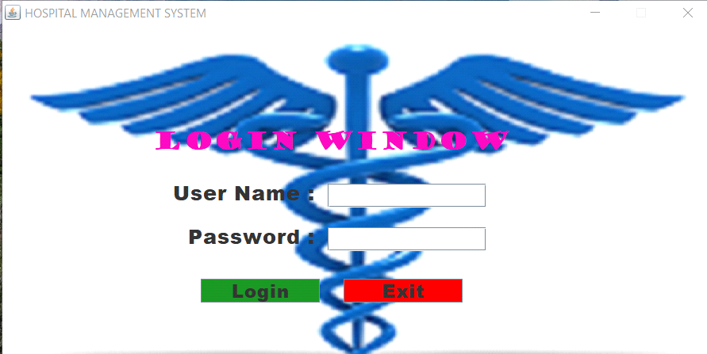 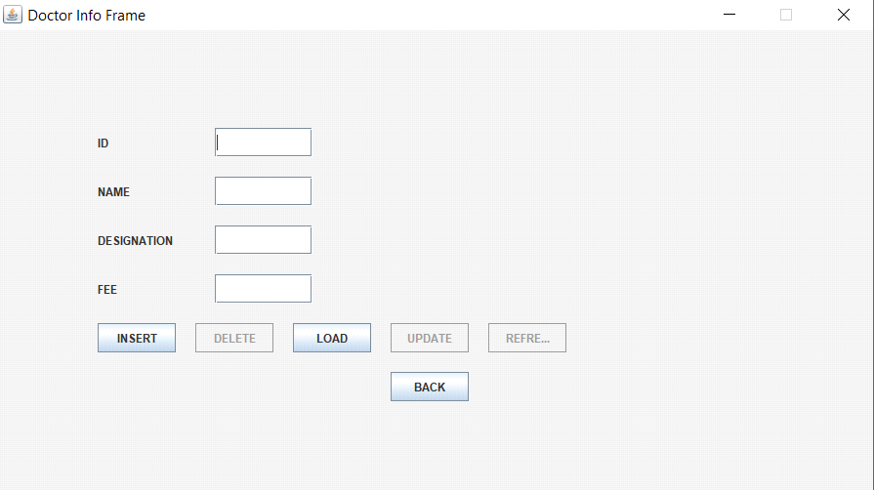

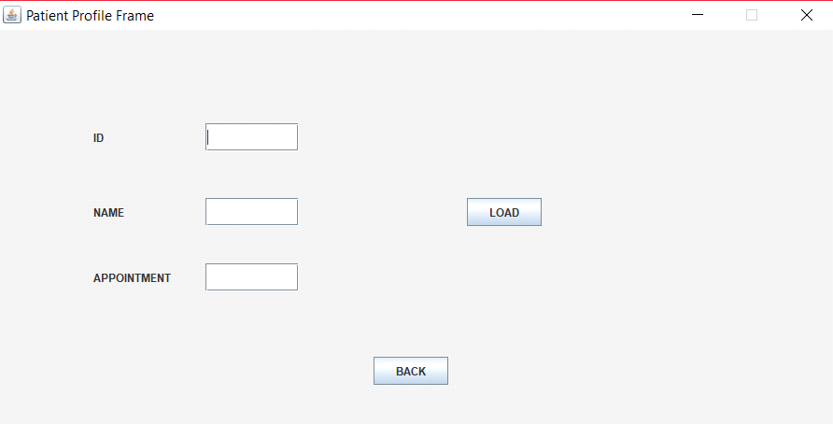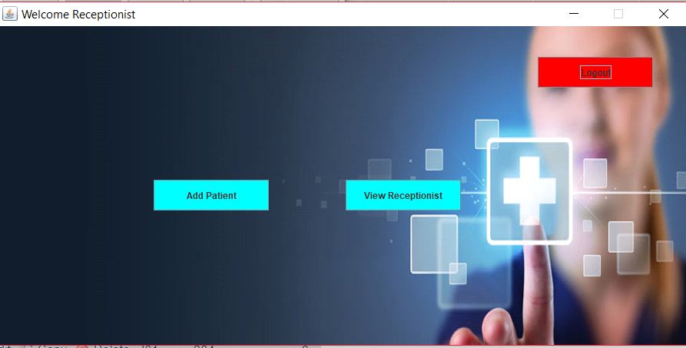￼￼

1.In login gui there is username,password label and login ,exit,show button.

2.In admin gui admin can see admin profile,add doctor,add receptionst.

3.In doctor gui doctor can see doctor profile,view patient.

4.In receptionist gui receptionist can add patient,view receptionist profile.

**Database Table Description:**

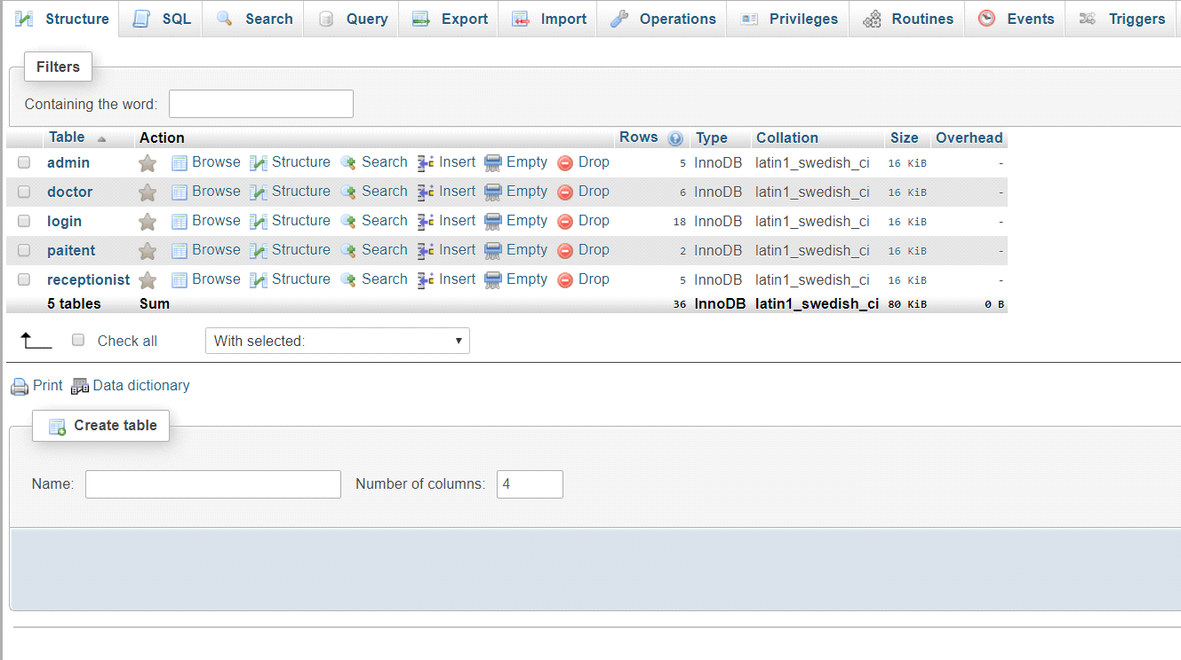

**Class Diagram:**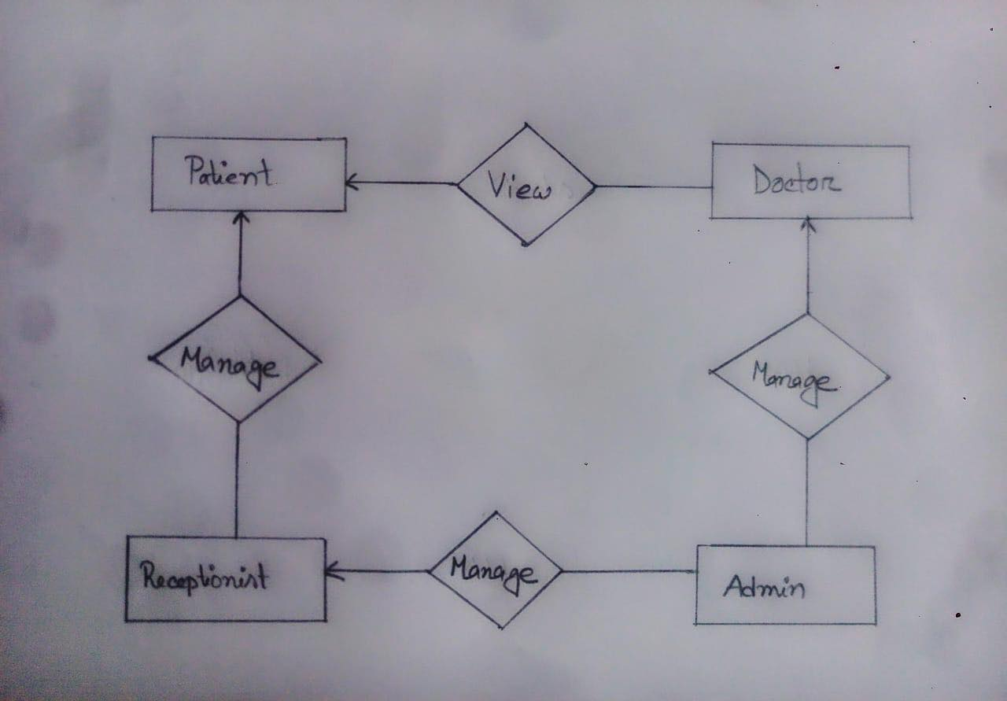

**Tools Used:**

To develop this project we have used the following:

* JDK
* JRE
* JVM
* JIT
* Notepad++
* Xampp

**OOP and Java Concepts Used:**

* Inheritance: We used the concept of a mechanism in which one class acquires the property of another class.
* Abstraction: We used the abstraction concept in our interface concept to inherit the function and write their body on repository package.
* Polymorphism:We used the polymorphism concept as we had functions with same name but with different purposes.
* Packages: We created entity,frame,interface,repository packages for different purposes.
* GUI: We created in total 11 guis as name as login,admininfo,adminprofile,doctorinfo,doctorprofile,receptionistifo,receptionistprofile,adminhome,doctorhome,receptionisthome,patientinfo.

**Impact of this Project:**

What impact this project will have on the society and economy?

How will people be benefitted from your project?

(Maximum 80 words)

**Limitations and Possible Future Improvements:**

(Maximum 80 words)