

American International University- Bangladesh

Web Technologies

Project Report

Spring 2021-22

Project Title: Online Kids Education System

Section: F

Online Kids Education System

**Introduction:**

Our Project name is Online Kids Education System. It is online educational platform. This platform covers kids Education Levels academic courses of most of the Primary School in Bangladesh. It also covers different branches of study. We are doing this project so that from our platform student not only learn new things but also they can develop their skills in their preferred sector.

**Background Study**

The project we made is an educational online platform inspired from “Ten Minutes School” and “Khan Academy”.

Ten minutes School is an online educational platform which is founded by Ayman Sadiq. He created 10 Minute School in mid-2014 as a YouTube channel. Then Largely self-sponsored in the beginning, 10 Minute School did not initially have a website and solely reached students through educational infographics. 10 Minute School went on to cover the entire academic syllabus from Class 1 to Class 12, university admission subjects covering topics from public and private university examinations and extensive software and skills training.

Khan Academy is an American non-profit educational organization created in 2008 by Salman Amin Khan. Its goal is creating a set of online tools that help educate students. The organization produces short lessons in the form of videos. Its website also includes supplementary practice exercises and materials for educators.

We studied a lot on these two platforms and tried to give some similar service with some distinct service for all of the users. In our proposed project we tried present the best qualities services for users. Here, we have 4 types of users.

1. Admin
2. Manger
3. Student
4. Teacher.

Online Kids Education System

Requirement Analysis:

In this website there will be 4 type users: 1. Admin 2. Manager 3. Student 4. Teacher.   
 

Common features:

* User can login and logout.
* User can resister to entry the system
* User can change password with two factor authentication

Admin

1. User can add manager
2. User can delete manager
3. User can view user list
4. User can update add user in user list
5. User can update delete user in user list
6. User can approve courses in the system
7. User remove courses from the system
8. User can view users’ personal info
9. User can set amount for particular course.
10. User can set amount for teachers
11. User can get CV for any recommended post

Manager

1. User can approve teacher’s profile
2. User can view students and teacher’s profile
3. User can delete student and teacher’s profile
4. User can approve courses
5. User can update the booklist
6. Manager can check payment history of other two users
7. User can see all feedbacks from the user
8. User can update list of users of the system
9. User set amount for particular course
10. User set amount for uploading courses
11. User can update his own profile

Online Kids Education System

Student

1. User can search the courses
2. User can enroll courses
3. User can update profile info
4. User can change password with two factor authentication
5. User can give feedback to every enroll course
6. User check all his enrolled course list
7. User can check his past payment history
8. User can buy books from booklist (search book from booklist)
9. User can communicate with teachers
10. Students will get notified if any new courses added to the system

Teacher

1. User can upload new course
2. User can add new elements to the course
3. User can check payment
4. User can update profile info
5. User can change password with two factor authentication
6. Teacher can view enrolled student list according to uploaded courses
7. User can give feedback (about any particulate students)
8. Teacher can delete his own course
9. User view the feedbacks.
10. Users can view each other’s contact list.

Online Kids Education System

Design:

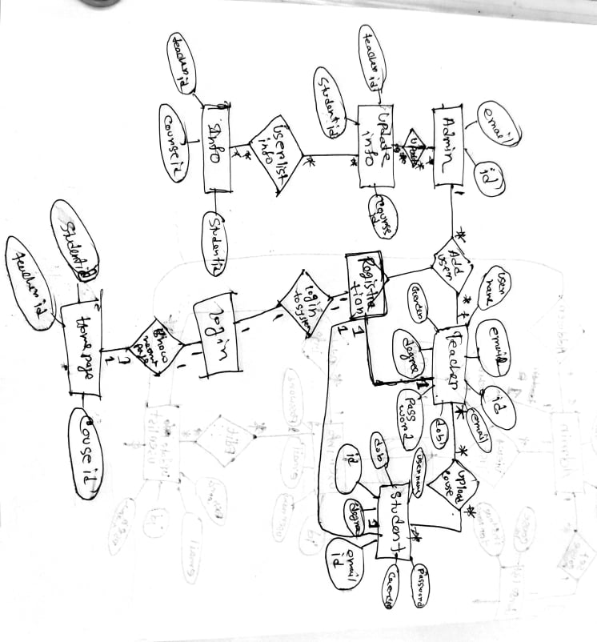

Online Kids Education System

Tools Used:

To develop this project, we have used the following:

* Html
* php

**Impact of this Project:**

In today’s modern society virtual platform is a very common image for everyone. Our project is made for educational purpose. In this situation of pandemic, we recovered as much we can but still now we need to be careful for our health. Here, our project can help both students and teacher in this state. They can easily learn their courses and develop their skill from home which is safe and also time saving. Also, in our online education platform any student can enroll as much course as he wants and can enrich their proficiency.

**Limitations and Possible Future Improvements:**

Like other project our proposed project has some limitations. We have set function for contact with teachers if students face any problem. But teacher or student can not communicate through live chat or call or content sharing. But it is possible to implement this function in our Study Verse project in future. We will try to improve our project in future with so on better service for the students and teachers so that they communicate in live.

Online Kids Education System

|  |  |  |  |  |  |
| --- | --- | --- | --- | --- | --- |
| Project Report Evaluation | | | | | |
| Project Proposal  (5) | Background  Study  (5) | Requirement Analysis  (5) | Entity  Diagram  (5) | System Images  against the  Specification (5) | Total (25) |
|  |  |  |  |  |  |
|  | | | | | |