Abstract
Good maths-solving AI are enormous. They run in a data centre, cost money every time we use it, and every question we ask it leaves a device. We wanted to know if a small AI could do the work on the device itself, and call for outside help only rarely.
We took google/gemma-4-E2B-it, a small model, squeezed it down to 4 bits so it fits in an ordinary graphics card, and trained it on 7,473 school maths problems. That took it from 36.32% to 55.88% correct on the 1,319 test problems, while reading about 8 times fewer words per question.
Then we built a cascade (a system where an easy step handles most of the work and a harder step is used only for the leftovers). The small AI answers every question. A gate (a piece of code that decides which questions look risky) picks out about 3 questions in 10. Only those go to a bigger AI, which marks the answer without ever being shown the correct one, and sends back a short hint. The small AI then tries again.
The best version reaches 68.46% — 903 of 1,319 problems. That is 93.9% of everything this small model could possibly have got right, and 7 out of 10 questions never leave the device.
Two results surprised us, and both are in this report:
- The obvious version of our idea did not work. Used on its own, the cascade scored 59.44% against 59.06% for simply asking the model three times and taking the most common answer — which is free. The difference was not statistically meaningful. The fix was to do both, in order: vote first, then send only the split votes to the checker. That added 42 correct answers at exactly the same cost.
- The bigger checker was the worse checker. A 9-billion-parameter model beat a 30-billion one on every measure and ran about twice as fast.
We do not claim a record. Other published systems score higher on this dataset. What we report is a trade-off curve: how much accuracy we get as a function of how rarely the device asks for help.

Contents
Chapter
1 | Introduction
2 | Background
3 | Related works
4 | Dataset
5 | Finetuning & QLoRA
6 | Checkpoint system
7 | Final System
8 | Every system we tried, one by one
9 | Results
10 | What did not work
11 | Limitations
12 | Conclusion and future work
A–D | Appendices

Chapter 1 — Introduction

1.1 The problem
The AI models that are good at maths are very large. They have hundreds of billions of internal numbers, they need racks of specialised hardware, and they live in data centres owned by a handful of companies. If we want to use one, we send a question over the internet and pay for the reply.
That is fine for some things. It is a bad fit for others:
- It costs money every single time. Not once — every question, forever.
- The question leaves the device. For a student's homework that may not matter. For a
medical form, a legal document, or a company's internal numbers, it matters a lot.
- It needs a working internet connection. Not everywhere has one that is reliable.
The obvious alternative is to run a small model on the device instead. The problem is that small models are much worse at maths. That is the gap this project tries to close.

1.2 The question we asked
Can a small model running on our own device do most of the work, and ask a bigger model for help only rarely — rarely enough that the cost and the privacy problem mostly go away?
The word "rarely" is doing the real work in that sentence. If the small model asks for help on every question, we have not built anything: we have just added a slow step in front of the big model. The whole design only means something if help is the exception.

1.3 What we built
Four pieces, all running on one ordinary desktop computer:
- A small AI that answers. google/gemma-4-E2B-it, squeezed to 4 bits and trained by us on school maths problems.
- A way of guessing when it is wrong. We ask it the same question three times. If it gives three different answers, it is unsure, and that question is probably wrong.
- A bigger AI that marks the answer. It shows the question and the small AI's working. It is never shown the correct answer. It replies with "right" or "wrong", plus a short hint.
- A retry. The small AI sees the hint and tries again.
Importantly, every model in this project — including the bigger checker — ran on our own machine. No cloud service was used for any reported number.

1.4 The headline result
Stage | Correct out of 1,319 | Score
The model before we trained it | 479 | 36.32%
The same model after we trained it | 737 | 55.88%
The full system | 903 | 68.46%

Before anyone reads 68.46% as "nearly there", here is the number that puts it in proportion:
72.93% is the ceiling. That is the score we would get if, out of the three answers the small model gives, a magic oracle always picked the right one. The model simply does not know the answer to the remaining 27% of questions, in any of its attempts. So the real space available to us was 55.88% → 72.93%. Our best score, 68.46%, is 93.9% of that ceiling, and it closes 73.8% of the gap between the trained model and the ceiling.
We think stating the ceiling next to the result is the honest way to report this, and we do it throughout.

1.5 What we are claiming
Three things, no more:
Claim 1 — the cascade has to be stacked, not substituted. Used instead of free majority voting, our supervised cascade could not be shown to beat it. Used on top of voting — vote first, escalate only the split votes — every version beat it, at exactly the same cost. We believe this is the most useful thing in the report, because it is the mistake a reader would otherwise repeat.
Claim 2 — checker strength is not the same as checker size. We tested four checkers of increasing size. The results do not go up in a straight line. The 9-billion model beat the 30-billion one on every measure we took.
Claim 3 — the gate can be free. The signal that best predicts a wrong answer is not the model's own confidence. It is whether the model contradicts itself across repeated attempts — and if we are already voting, we have paid for that signal anyway.

1.6 What we are not claiming
We are not claiming a record score on this dataset. We are not.
Published work reports higher numbers on the same problems: one system reports 81.5% using two models with fewer parameters than ours, and an off-the-shelf model is reported at 73.2% with no training and no cascade at all. Chapter 3 explains both in detail, including why the comparison is less direct than it first looks — in particular, "fewer parameters" does not mean "smaller to run". Ours is squeezed to 4 bits; theirs are not. Measured in memory, the model we deploy is the smallest of the three.
We are also not claiming the small AI reasons correctly. We only ever checked its final number. A right answer reached by muddled working still counts as right in our score. Chapter 11 says more.

Chapter 2 — Background
This chapter explains every technical word used later. If we already know them, skip to Chapter 3.

2.1 What a language model is
A language model is a program that predicts the next word. we give it some text, it guesses what comes next, then it adds that guess to the text and guesses again. Do that a few hundred times and we get a paragraph.
Everything a model "knows" sits in a huge list of numbers called parameters (the internal settings a model learns during training). A small model has a few billion. The big ones have hundreds of billions. More parameters usually means better answers and a bigger, slower, more expensive model.

2.2 Tokens
Models do not read words. They read tokens (pieces of text, usually about three quarters of a word). "Unhappiness" might be three tokens: un, happi, ness.
Tokens matter to us because tokens are the bill. Cloud AI services charge by the token, both for what we send and for what comes back. When we say a question costs 346 tokens, we mean that is what we would pay for.

2.3 GSM8K — our test
GSM8K is a public set of 8,792 school-level maths word problems, written by people. Each one takes two to eight steps of simple arithmetic. It is split into 7,473 for training and 1,319 for testing. We used the official split exactly as published, and every single number in this report is measured on all 1,319 test problems — never a sample.
Here is a real one:
Natalia sold clips to 48 of her friends in April, and then she sold half as many clips in May. How many clips did Natalia sell altogether in April and May?
And the answer that ships with it:
Natalia sold 48/2 = <<48/2=24>>24 clips in May.
Natalia sold 48+24 = <<48+24=72>>72 clips altogether in April and May.
#### 72
Two things to notice. The <<48/2=24>> bits are calculator notes built into the dataset. And the last line starts with ####. That marker is how GSM8K states the final answer, and it is what makes automatic grading possible — we look for #### and compare the number after it.
We chose GSM8K because it can be graded automatically with no human judgement and no room for argument. An answer is right or it is not.

2.4 Fine-tuning
A model that has been trained on the general internet can write English but is not especially good at any one job. Fine-tuning means taking that model and training it further on examples of the specific job we want. We fine-tuned on 7,473 maths problems so the model would learn the habit of working step by step and finishing with #### <number>.

2.5 Quantization — making the model smaller
Each parameter is normally stored as a 16-bit number. Quantization (storing each number with fewer bits so the model takes less memory) cuts that down. We used 4-bit, which is roughly a quarter of the size.
The trade is accuracy: rounding every number to 4 bits loses some detail, and the model gets slightly worse. We accepted that, because the entire premise of the project is a model that fits on modest hardware. A model that needs a data centre is not solving our problem.
The exact flavour we used is called NF4, which spaces the 4-bit values unevenly to match how these numbers are actually distributed, and loses less than plain rounding would.

2.6 LoRA and QLoRA — training without a supercomputer
Normally, fine-tuning means updating all of the model's parameters. For a model this size, that needs far more memory than a desktop graphics card has.
LoRA (Low-Rank Adaptation) avoids it. Instead of changing the original parameters, we freeze them and add a small set of new ones beside them. Only the new ones are trained. At the end we have a small adapter file that sits on top of the original model and changes its behaviour.
QLoRA is LoRA done on a model that has already been squeezed to 4 bits. It is what made this project possible on one desktop computer. In our case, the adapter holds 24,158,208 trainable parameters — about 0.5% of the model — and the file is 97 MB.

2.7 Greedy and temperature — how the model picks words
At each step the model has a ranked list of possible next tokens.
- Greedy means always take the top one. Same question in, same answer out, every time.
- Temperature means roll a weighted dice instead. Temperature 0 is greedy. Higher numbers make it more adventurous. We used 0.7 whenever we wanted variety.
This matters because our gate works by asking the same question three times at temperature 0.7 and seeing whether the answers agree. At temperature 0 we would get the same answer three times and learn nothing.

2.8 The cascade and the gate
A cascade is a system where a cheap step does most of the work and an expensive step handles only what the cheap step cannot.
The gate is the part that decides which questions get passed up. Escalating a question means sending it to the bigger checker. Escalation rate is what share of questions get sent — for us, usually 30%.

2.9 The checker
Throughout this report we use one word for the bigger model that marks answers: the checker. Other papers call it a verifier, a judge, or a supervisor. They all mean the same thing and we picked one word to avoid confusion.
The checker is shown the question and the small AI's working. It is never shown the correct answer. This is enforced in the code and there is an automatic test that fails if anyone ever changes it.

2.10 Terms used in the results
Term | What it means
Self-consistency | Ask the same question 3 times, keep the most common answer
pass@3 | Would any of the 3 attempts have been right? The ceiling
Recall | Of the wrong answers, what share did the checker catch?
False-reject rate | Of the right answers, what share did the checker wrongly fail?
Precision | When the checker said "wrong", how often was it correct?
AUC | How reliably a warning sign ranks wrong answers above right ones. 0.5 is a coin flip, 1.0 is perfect
p-value | The chance of seeing a result this lopsided if the two systems were really equal. Small means the difference is real
Flip matrix | How many answers a change turned from wrong to right, and how many it broke the other way
Stacking | Doing two things in order — here, voting first and escalating only the split votes

Chapter 3 — Related Works
We grouped the 25 papers we read by what they were trying to do. The last group is the uncomfortable one, and we put it in deliberately.

3.1 Making a small model good at maths
Cobbe and colleagues (2021) created GSM8K itself. They also had the original version of our idea: train a separate model to check answers, generate many candidates, and keep the one the checker likes best. With it, a 6-billion model beat a 175-billion model. That is the ancestor of everything in this report. The difference is that their checker picks between answers; ours sends feedback so the model can try again.
Wei and colleagues (2022) showed that asking a model to write out its steps before the answer — chain-of-thought — improves maths accuracy sharply. Our whole training set is in that format.
Hu and colleagues (2022) invented LoRA. Dettmers and colleagues (2023) combined it with 4-bit quantization to make QLoRA. Between them, they are the reason this project fits on one desktop.
Li and colleagues (2025) found something we should have taken more seriously earlier: small models learn badly from the very long reasoning that large models produce. Short, simple worked examples teach them better. Our training data is short and simple, which is probably lucky rather than clever.

3.2 Getting more out of one model at answer time
Wang and colleagues (2023) introduced self-consistency: sample several answers, take the majority. This is the most important paper for us, and not in a comfortable way — it is free, it needs no second model, and it is the baseline that nearly killed our result. On a 540-billion model it added 17.9 points. On ours it added 3.2. Any paper proposing a more complicated method must beat this one first, and Chapter 10 describes what happened when we tried.
Aggarwal and colleagues (2023) made voting adaptive — stop sampling once the answers agree. Same instinct as our gate: spend effort only where there is doubt.
Snell and colleagues (2024) showed that spending compute at answer time can beat a model 14 times larger. That is the strongest general argument for what we built.
"Self-Consistency Is Losing Its Edge" (2025) reports that on newer, stronger models the benefit of voting is shrinking. Worth knowing, but not true of ours: voting gave us a real, statistically solid gain.

3.3 Cascades and routing
Chen, Zaharia and Zou (2023) — FrugalGPT is the best-known cost-saving cascade: try a cheap model, and escalate to an expensive one when a scorer says the answer is weak. They report up to 98% cost reduction. There is one structural difference from us, and it matters: in FrugalGPT the expensive model answers the question. In ours it only marks the answer. The expensive model never writes a solution, so the cost is a short verdict rather than a full reply.
Gupta and colleagues (2024) is the closest published work to our gate. They use token-level uncertainty to decide when to defer, and they report that answer length is a biased signal. We measured the same thing: length was our weakest gate (AUC 0.676).
Zellinger and colleagues (2025) add the option of giving up early. Ong and colleagues (2024) — RouteLLM learn to route between models. Kim and colleagues (2023) — Big Little Decoder switch models mid-sentence. All share our premise; none of them feed a hint back for a retry.

3.4 Using one model to check another
Zheng and colleagues (2023) established that a strong model can judge answers and agree with human judges more than 80% of the time. They also documented self-enhancement bias — models prefer their own output. That predicts exactly the failure we measured when we asked our small model to check its own work (Chapter 10).
Lightman and colleagues (2023) showed that checking each step beats checking only the final answer. We check the whole solution at once, which is cheaper and weaker. Their result is a good description of what we left on the table.
"Not All Votes Count!" (2024) is the closest thing to our stacking result: use a checker to weight votes rather than replace them, reporting up to +18% on GSM8K. We found the same direction independently. Theirs weights the votes; ours escalates only where the vote is split.

3.5 The negative results that justify our design
Huang and colleagues (2024) — "LLMs Cannot Self-Correct Reasoning Yet" found that asking a model to revise its own answer without outside information makes things worse. We ran the same experiment on a model about 100 times smaller and got the same result: our blind-retry control dropped from 55.88% to 49.89%. That control is the reason we can say the checker is doing the work and not the retry.
Zhang and colleagues (2024) — "Small LMs Need Strong Verifiers" is the closest work to our checker-strength question. They compare two checker sizes. We extended it to four rungs and found the relationship is not monotonic — bigger stops helping and starts hurting.
Madaan and colleagues (2023) — Self-Refine and Shinn and colleagues (2023) — Reflexion both get improvements from iterative self-criticism, but on much larger models. The tension with Huang is real and unresolved in the literature; our own result sits on Huang's side.

3.6 Running models on ordinary hardware
Lu and colleagues (2024) survey small language models. "Demystifying SLMs for Edge Deployment" (2025) benchmarks over 60 of them and finds that compressed models under 7 billion parameters keep roughly 90–95% of their quality. That is the empirical basis for believing a 4-bit 2-billion model is worth building on at all.
Bondarenko and colleagues (2026), from Qualcomm, is the closest concurrent work: efficient reasoning on edge hardware. They optimise the model. We keep the model and add a checker. The approaches are complementary.

3.7 Has anyone beaten our 68.5%? Yes.
This section exists because a reader will ask, and it is better that we answer first.

First: "smaller model" needs defining
Both systems below are described as using smaller models than ours, and by parameter count that is true. But parameter count is not what decides whether something runs on a device. Memory is. And our model is stored at 4 bits, while the numbers reported for those systems are at the usual 16 bits.
Measured properly, at the precision each was actually reported at:
System | Parameters | Bits | Memory to run it
TinyGSM — needs both models loaded | 1.3B + 1.3B | 16 | 4.84 GB
Qwen2.5-1.5B-Instruct | 1.54B | 16 | 2.88 GB
Ours, as we actually deploy it | 5.12B stored | 4 | 2.39 GB

So on the axis this project is about — what fits on a modest device — our solver is the smallest of the three, despite having the largest parameter count on paper. TinyGSM needs twice our memory, because it has to hold two models at once.
Two honest qualifications:
- Those systems could be quantized too. A 4-bit Qwen2.5-1.5B would be about 0.72 GB, far smaller than ours. But no published score exists for it in that form, and quantizing costs accuracy — so we cannot assume the 73.2% survives the squeeze.
- We have assumed 16-bit for their figures, because that is the standard and neither paper reports quantized results.
The fair summary is therefore: they score higher, with fewer parameters, but not with a smaller memory footprint than the system we built. We should say all three parts of that.

TinyGSM — 81.5%
Liu and colleagues (2023) report 81.5% on GSM8K using a 1.3-billion generator and a 1.3-billion checker. Each model has fewer parameters than ours, though the pair together needs about twice our memory. That is 13 points above our best result, and we should say plainly that it is a better score.
The differences, so a reader can judge for themselves:
 | TinyGSM | Ours
Training data | 12.3M synthetic problems generated by GPT-3.5 | 7,473 real problems
Answer format | Python code, actually executed | Natural language
Checker | Trained for the job | Prompted, not trained
Generations per question | 48, all scored by the checker | 3
Metric | verify48@1 | greedy exact match

The 48 is the number to remember. Their headline is "generate 48 answers, let a trained checker rank them, take the top one". That is 16 times more work on the device — the exact axis this project is about. 81.5% versus 68.5% is not one system beating another at equal cost.
And the honest concession that goes with it: their fine-tuning-only model scored 68.2%, above our 55.88%. The reason is the 12.3 million synthetic training problems — about 1,600 times our data — not the architecture. We should say that rather than let someone find it.

Qwen2.5-1.5B-Instruct — 73.2%
The official Qwen2.5 technical report gives 73.2% on GSM8K for a 1.5-billion instruction model with no fine-tuning, no voting and no checker. That is a model with fewer parameters, straight out of the box, scoring above our entire system. As set out above, it is not smaller to run: at 16 bits it needs 2.88 GB against our 2.39 GB.
Our answer, in order of how much it is worth:
- Every claim we make is a paired comparison on one base model. We never claim our numbers are the best available. We claim that adding a gate and a checker to a given model improves it by a measured amount. That comparison is unaffected.
- The mechanism is the contribution, not the score. Claims 1–3 in Chapter 1 are about how the pieces behave, and they would still be worth knowing on a stronger base model.
- The measurements are not comparable. Their figure is 4-shot at full precision with lenient answer extraction. Ours is zero-shot at 4-bit requiring an exact #### N marker. Three differences, all favouring them. Neither number is wrong; they are different rulers.
- Benchmark contamination is a known issue with GSM8K. We mention this last and lightly, because leading with it reads as an excuse.

3.8 Where we sit
Honestly rated, piece by piece:
Piece | New?
Fine-tuning a small model on GSM8K | No — standard
A cascade that escalates hard questions | No — FrugalGPT and others
Using disagreement as the gate signal | Partly — closest to Gupta 2024
Breaking ties with confidence | Likely new in this form
Showing the cascade must be stacked on voting | Our main claim
Finding that checker quality is not monotonic in size | Likely new as a measured ladder
Blind retry hurting small models | Replication of Huang 2024

What we must never claim: that 68.5% is a record. Our contribution is the trade-off curve — accuracy as a function of how rarely the device asks for help — and the stacking result. Framed that way, both comparisons above become context rather than refutation.

Chapter 4 — Dataset

4.1 What we downloaded
We used the official GSM8K release, openai/gsm8k, configuration main, downloaded from the Hugging Face Hub by prepare_data.py.
Training problems | 7,473
Test problems | 1,319
Total | 8,792

We used the official split as published. We did not make our own split, and we never touched the test problems for anything except final measurement. When we needed to tune something — the checker's instructions, for example — we did it on training problems, which Chapter 10 describes.

4.2 What we did not do
This is worth stating plainly, because a reader will assume otherwise:
- No filtering. All 7,473 training problems were used. We did not drop hard ones, long
ones, or ones the model failed on.
- No deduplication. We did not check for near-duplicate problems.
- No cleaning. The calculator notes built into the data, like <<48/2=24>>, were left in
exactly as they came. The model learns to write them too.
- No manual shuffling. Whatever ordering the training library applies by default is what
happened.
The only transformation was reformatting each problem into the chat lawet the model expects.

4.3 The format we trained on
The model expects conversations marked with special tags. Every training example became one string in exactly this shape:
<start_of_turn>user
{the question}
<end_of_turn>
<start_of_turn>model
{the full worked solution, ending with #### N}
<end_of_turn>
<start_of_turn> and <end_of_turn> are markers the model was originally built to understand. They tell it where one speaker stops and the other starts.
The real first row of our training set, exactly as it sits on disk:
<start_of_turn>user
Natalia sold clips to 48 of her friends in April, and then she sold half as
many clips in May. How many clips did Natalia sell altogether in April and May?
<end_of_turn>
<start_of_turn>model
Natalia sold 48/2 = <<48/2=24>>24 clips in May.
Natalia sold 48+24 = <<48+24=72>>72 clips altogether in April and May.
#### 72
<end_of_turn>
The prepared data is saved to a folder called gsm8k_formatted/. One detail for anyone reproducing this: the saved files hold three columns — the question, the answer, and the combined text above. The prompt and the correct final number are not stored; they are worked out again at the moment they are needed. It makes no difference to any result, but "the dataset contains prompt and answer pairs" would be inaccurate.

4.4 Length
Every example is cut off at 1,024 tokens. Longer examples are truncated, not dropped — so in the rare case of a very long problem, the tail (including its #### N line) can be lost. We checked how often this matters and it is negligible at this length, but it is an honest description of what the code does.

4.5 How we grade an answer
This is the most important piece of code in the project, because every number in this report depends on it being right.
Step one: find the answer in the text. We look for #### and take the text after the last one. If there is no #### anywhere, we fall back to the last number in the reply. That fallback matters: in our full test run, only 1 out of 1,319 fine-tuned answers lacked the marker, but the baseline model failed to produce a usable answer on 16 examples.
Step two: compare it with the correct one. Before comparing, both are cleaned in this exact order:
- Trim spaces
- Remove every $
- Remove every %
- Remove trailing full stops
- Remove commas
- Take the first number-like piece of text
- If it contains /, treat it as a fraction and work it out
- Convert to an exact number and compare
So all of these count as matching:
Model said | Correct answer | Match?
72.0 | 72 | Yes
$1,200 | 1200 | Yes
1/2 | 0.5 | Yes
73 | 72 | No

There is no partial credit and no human judgement anywhere. An answer is right or it is not. The whole grading path is covered by automatic tests.

4.6 A side experiment we did not finish
prepare_data.py can also build a small sample of TruthfulQA, a dataset about whether a model repeats common false beliefs. We built it and wrote a rough scorer that checks whether the right words appear in the reply.
We never ran it to completion, and there is no results file. It is mentioned here only so that anyone reading the code knows what that option is. Treat GSM8K exact-answer accuracy as the only quantitative claim in this report.

Chapter 5 — Fine-tuning & QLoRA

5.1 The model we started with
google/gemma-4-E2B-it from Google. A few facts that matter later:
- It is multimodal — it can take images and audio as well as text. We only ever gave it
text, but the image and audio parts are still inside the file.
- The file holds 5.12 billion parameters in total, of which 4.65 billion belong to the
text part. The "E2B" in the name means effective 2 billion: the design only uses a fraction of those parameters for any one token, so it behaves like a 2-billion model while storing more.
- It has 35 layers, and an unusual feature: **20 of those 35 layers share their key and
value projections with earlier layers** instead of having their own. This becomes visible in our training setup, and it surprised us.

5.2 Why we shrank it
At the normal 16 bits per parameter, this model plus the extra memory that training needs does not fit on a 16 GB graphics card. There are three ways out: buy bigger hardware, use a smaller model, or shrink this one. Only the third is consistent with the point of the project.
So we loaded it in 4 bits, using these settings:
Setting | Value | In plain words
Bits | 4 | A quarter of the normal size
Type | NF4 | Spaces the 4-bit values to match how the numbers are really distributed
Double quantization | On | Compresses the compression data too — saves a little more
Compute type | bfloat16 | The actual sums are still done at 16 bits for accuracy

That last row is the one people miss. The model is stored in 4 bits; the arithmetic is still done at 16 bits. The saving is in memory, not in precision of the maths.
We accept that 4-bit costs accuracy. We did not measure how much, because a 16-bit version would not run on our hardware — which is the constraint the whole project is about.

5.3 Training only 0.5% of the model
We used QLoRA: freeze the whole 4-bit model, add a small trainable adapter beside it, and train only the adapter.
Setting | Value
Rank | 16
Alpha | 32
Dropout | 0.05
Bias | none

Rank 16 means each added piece is a pair of small matrices with an inner size of 16 — that is where the space saving comes from. Alpha 32 scales how strongly the adapter influences the frozen model.
We attached the adapter to all seven projection points in each layer: the four in the attention part (q, k, v, o) and the three in the feed-forward part (gate, up, down). We deliberately excluded the image and audio parts of the model, since we only train on text.
The thing that surprised us. We expected 35 layers × 7 places = 245 attached pieces. We got 205. The reason is the KV sharing mentioned above: the last 20 layers have no key or value projection of their own to attach to, so they get 5 attachments instead of 7. That is 15 × 7 + 20 × 5 = 205, which matches exactly.
This also explains a trap worth recording. The list of places to attach is written as a pattern matching model.language_model.layers.N..... The equivalent path in earlier Gemma versions is different. If we copy a standard Gemma 2 recipe, the pattern matches nothing, no adapter is attached, training appears to run fine, and we get a model that learned nothing. We hit this and it cost us time.
The final size:
Trainable parameters | 24,158,208
As a share of the whole model | 0.47%
Adapter file | 97 MB

So the thing we actually trained is about one two-hundredth of the model, and small enough to email.

5.4 Training only on the answer
The training text contains both the question and the answer. We did not want the model to get better at writing questions, so we masked the question out: the loss is computed only on the answer part, the #### N line, and the closing tag. Padding is masked too.
Technically this is done by setting the ignored positions to -100, which is the value the training library treats as "skip this". The practical effect is that all the learning goes into how to solve and present a problem, and none of it into how to pose one.

5.5 The settings we trained with
Setting | Value | Note
Learning rate | 2e-4
Schedule | cosine | Starts high, eases down to nearly zero
Warm-up | 50 steps | Starts gently to avoid an early wobble
Batch size | 1 | All that fits
Gradient accumulation | 16 | So the effective batch is 16
Epochs | 3 | Three full passes over the 7,473 problems
Max length | 1,024 tokens
Precision | bfloat16
Gradient checkpointing | On | Trades speed for memory
Optimizer | AdamW | Inherited default, not a choice we made
Seed | 42 | Also an inherited default

The last two rows are marked honestly. We did not set them; they are what the training library uses when we say nothing. Anyone reproducing this should know the difference between a decision and a default.

5.6 What training actually did
1,404 steps. That is exactly right: 7,473 problems ÷ 16 per batch = 468 steps per pass, × 3 passes = 1,404.
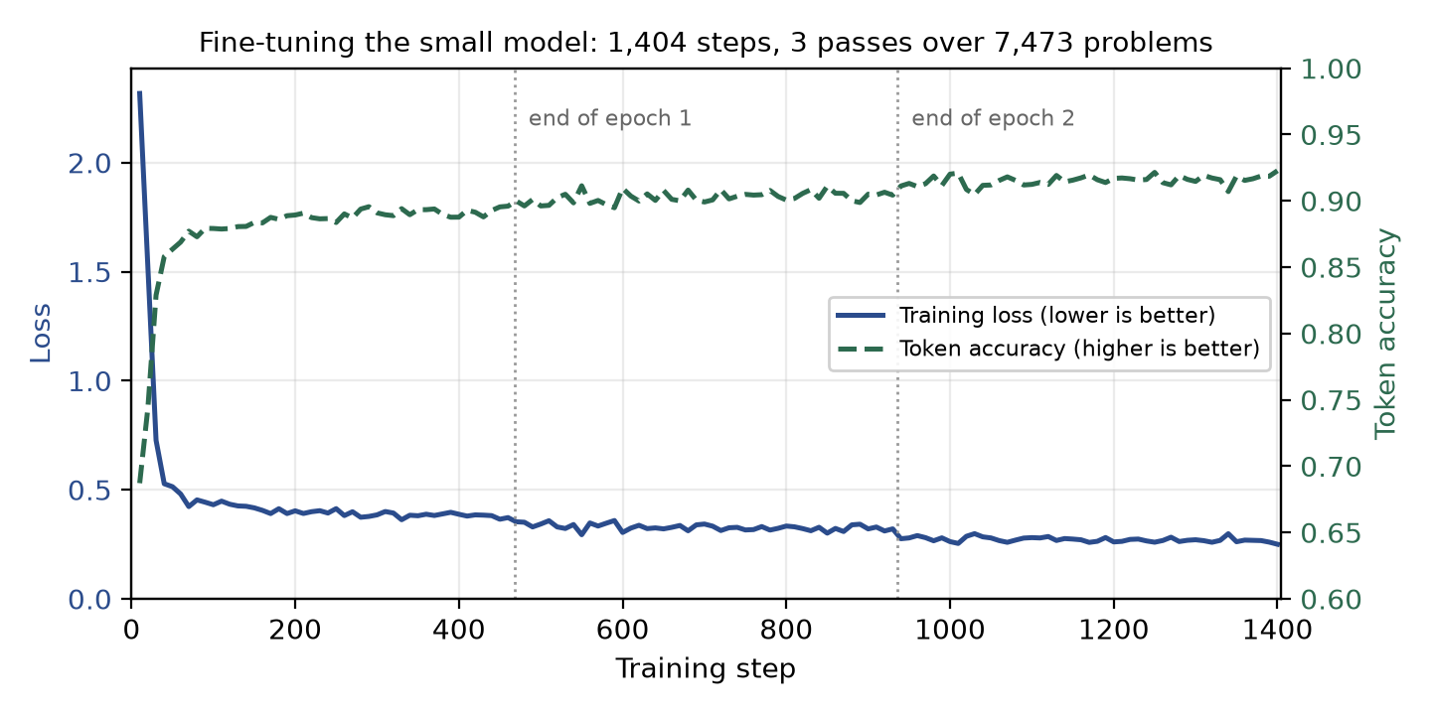
Figure 5.1: The model learning. Loss (lower is better) falls from 2.317 to 0.250. Token accuracy (higher is better) rises from 0.687 to 0.923. Measured from the training record at `checkpoints/checkpoint-1404/trainer_state.json`.
 | Start | End
Loss | 2.317 | 0.250
Token accuracy | 0.687 | 0.923

The curve does what a healthy training run should: a steep drop in the first pass, then slow steady improvement, with no spikes and no flattening that would suggest it had stopped learning.
One number people quote wrongly, so we will be precise. The run log records 4,080 seconds (68 minutes). That is the time for the final stretch after a restart, not the total. The run was interrupted partway and resumed, and the timer resets on resume. We do not have a reliable total wall-clock figure for training, and we do not quote one.

5.7 Evaluation during training had to be switched off
The training library can score the model at the end of each pass. We turned that off. It is not laziness — it crashed the machine.
From our own incident log, written at the time:
Trainer epoch-end evaluation caused CUDA OOM. Step 936. Epoch-end token-loss eval attempted extra 4.38 GiB allocation on 16 GB GPU. Resolution: resumed from checkpoint-900 with evaluation disabled; external generate/evaluate pipeline used instead.
So: the crash happened at step 936, which is the end of the second pass. We restarted from the checkpoint saved at step 900 and lost 36 steps of work. From there the run finished normally.
Instead of scoring during training, we score afterwards by actually generating answers to all 1,319 test problems and grading them. That is slower, but it measures the thing we care about — how many problems the model gets right — rather than a proxy.

Chapter 6 — Checkpoint system

6.1 The constraint
This project was built on one desktop computer in a place where the electricity is not guaranteed. Load shedding is a normal part of the day.
That is a problem, because of how long the jobs are:
Job | How long
Training the small model | about 6 hours
Generating answers to all 1,319 problems | about 5 hours
Building the three-sample bank | about 10 hours
One full cascade run | about 3.5 hours
The three cascade runs in one sitting | about 10.5 hours

A 10-hour job on a machine that might lose power is not a job we can simply run. Either we build it so an interruption costs almost nothing, or we never finish.
So we did. And the design that came out of it turned out to matter for a second reason we did not expect, which is the point of this chapter.

6.2 Three layers, three different things to lose
We protected three different units of work, in three different ways:
Layer | What it protects | Lost in a cut | How
Training | ~6 hours | at most 50 steps | checkpoints on disk
Answering | 10+ hours | one question | one line written per question
Checker verdicts | hundreds of calls | nothing at all | a cache of past verdicts

Layer 1 — training checkpoints
The trainer saves a full snapshot every 50 steps. When the machine comes back, we run exactly the same command and it picks up automatically.
Two design choices are worth explaining.
It picks the checkpoint by the number in the folder name, not by the file date. Folders are called checkpoint-1350, checkpoint-1400 and so on, and the code reads the number out of the name and takes the highest. This sounds fussy until we think about a power cut: a partial write can leave a folder with a newer date than a complete one. It cannot change the number in the name. A folder whose name does not match the pattern exactly — a half-created one, say — is scored below everything and can never win.
We save far more often than the defaults suggest. Out of the box the trainer saves every 200 steps and keeps 2 snapshots. We run it at every 50 steps, keeping 4. The checkpoints are numbered 1300, 1350, 1400, 1404 fifty apart. Saving four times as often costs a little disk space and a little time, and it cuts the worst case from 200 steps of lost work down to 50.
There are two ways to resume:
- Full resume brings back everything: the adapter, the optimizer's internal state, the
position in the learning-rate schedule, and the random number state. Training continues as if nothing happened.
- Adapter-only resume rescues just the trained weights and starts a fresh optimizer. we
need this if something in the software changed between the crash and the restart, so the saved optimizer state can no longer be read.
The second one loses the smooth learning-rate curve — it restarts the warm-up. So a power cut on its own is fully recoverable. A power cut plus a software update is only partly recoverable. Worth knowing before we update anything mid-project.
Finally, there is a check we can run before restarting. It opens the four risky files in the newest checkpoint and actually tries to read them. It does this cheapest file first, with the biggest and most fragile one last, and prints which file it is on as it goes — so if the machine dies during the check, we can see how far it got.
A file that exists is not necessarily a file that is complete. After a power cut, that distinction is the whole point.

Layer 2 — one line per question
Every long job writes its output one line at a time: one question answered, one line appended to the file, file closed. Not one big write at the end.
So an interruption costs us the single question that was in flight. Everything already answered is on disk.
When we restart with --resume, the program reads its own output file, sees which question numbers are already there, and skips them. There is no separate progress file anywhere. That is deliberate — a progress file is one more thing that can be lost in the same power cut as the work it is tracking. The output is the record of progress.
The failure that nearly broke this. A power cut during a write does not always leave a clean half-line. Windows can extend a file's length before the data has actually reached the disk, so we get the right file size filled with zero bytes. Both forms — the half-written line and the block of zeros — make the file unreadable, which meant the resume crashed on exactly the failure it existed to recover from.
The fix reads the file, drops any damaged rows, and writes it back. Three details in it are deliberate:
- The repair writes a new file beside the old one and then swaps them, so losing power during the repair cannot leave us worse off than before.
- A healthy file is never touched at all. Rewriting a file is itself a window in which power can be lost, so we do not open that window unless there is damage to fix.
- The damaged question is thrown away, not reconstructed. That question was never finished. The next run simply answers it again.
There are three different levels of tolerance in the codebase, and the difference between them is deliberate:
Situation | What happens to a broken line | Why
A file being resumed | Repaired — drop the bad row | A power cut is expected here
A file feeding the final analysis | Crash loudly | A corrupt file reaching the results must never pass silently
The verdict cache | Skipped quietly | Its last line is expected to be torn; losing one cached verdict costs one extra call

One honest engineering note. We do not force each line to the physical disk before continuing. Doing so for 1,319 rows across many runs would be slow. We accept that the operating system may not have finished writing when power is lost, and we repair the damage afterwards instead. That is a real trade-off in durability by repairing rather than durability by waiting and it is why the zero-byte case above is a real thing we had to handle rather than a theoretical one. The repair code has eight automatic tests covering it, including damage in the middle of a file rather than only at the end.

Layer 3 — the verdict cache
The checker is the expensive part. Asking about 1,319 answers takes about 45 minutes; a full cascade run makes several hundred calls. Losing those to a power cut would be the most painful loss of the three.
So every verdict is written to a cache. The cache key is built from five things: which provider was used, which model, the exact instructions given to the checker, the question, and the exact answer being judged.

6.3 Bringing everything back up
There is a single script to run when the machine comes back. It:
- Starts the checker server if it is not already running
- Waits for it to load its 17.5 GB model, with a 10-minute deadline
- Reports how many questions each job has finished
- Restarts the jobs with --resume
It is safe to run when we do not know what survived. Restarting a job that is already finished costs a few seconds — it reads the output file, finds everything present, and writes nothing.
That property matters more than it sounds. After a power cut we do not know what state things are in, and the last thing we want is a recovery procedure that requires we to work it out correctly first.

6.4 The part we did not expect
Here is the thing that makes this chapter worth more than a paragraph in an appendix.
The verdict cache was built for power cuts. But it turned out to be what makes one of our main experiments valid.
We ran three versions of the system that differ only in how much of a hint the checker sends back. Nothing, a pointer, or a full correction. For that comparison to mean anything, all three have to reject the same set of questions. Otherwise, any difference between them could be explained by which questions happened to get retried, not by the hint.
The trouble is that the checker is not perfectly repeatable. Run it twice on the same input and we can get different answers — we measured this directly: the same instructions and model gave a false-reject rate of 0.500 in one run and 0.417 in another. So judging each version independently would have produced three different rejection sets and a confounded experiment.
The cache removes the problem by construction. Judge once, replay for the other two. All three versions reject an identical set of questions, and hint content is the only thing that varies.
Measured: 396 of 396 first-attempt verdicts replayed identically across runs made a day apart.
So the constraint we were working around produced the control that makes the experiment sound. We did not plan that, and we think it is the most interesting thing in this chapter.

6.5 What we will not claim
To be precise about evidence: our logs do not record a specific power cut. The machinery above is real, and it is tested and in daily use. The recovery procedure was written because of the electricity situation. But the one interruption written down in the experiment log is the out-of-memory crash at step 936 described in Chapter 5, not an outage.

Chapter 7 — Final System

7.1 Architecture
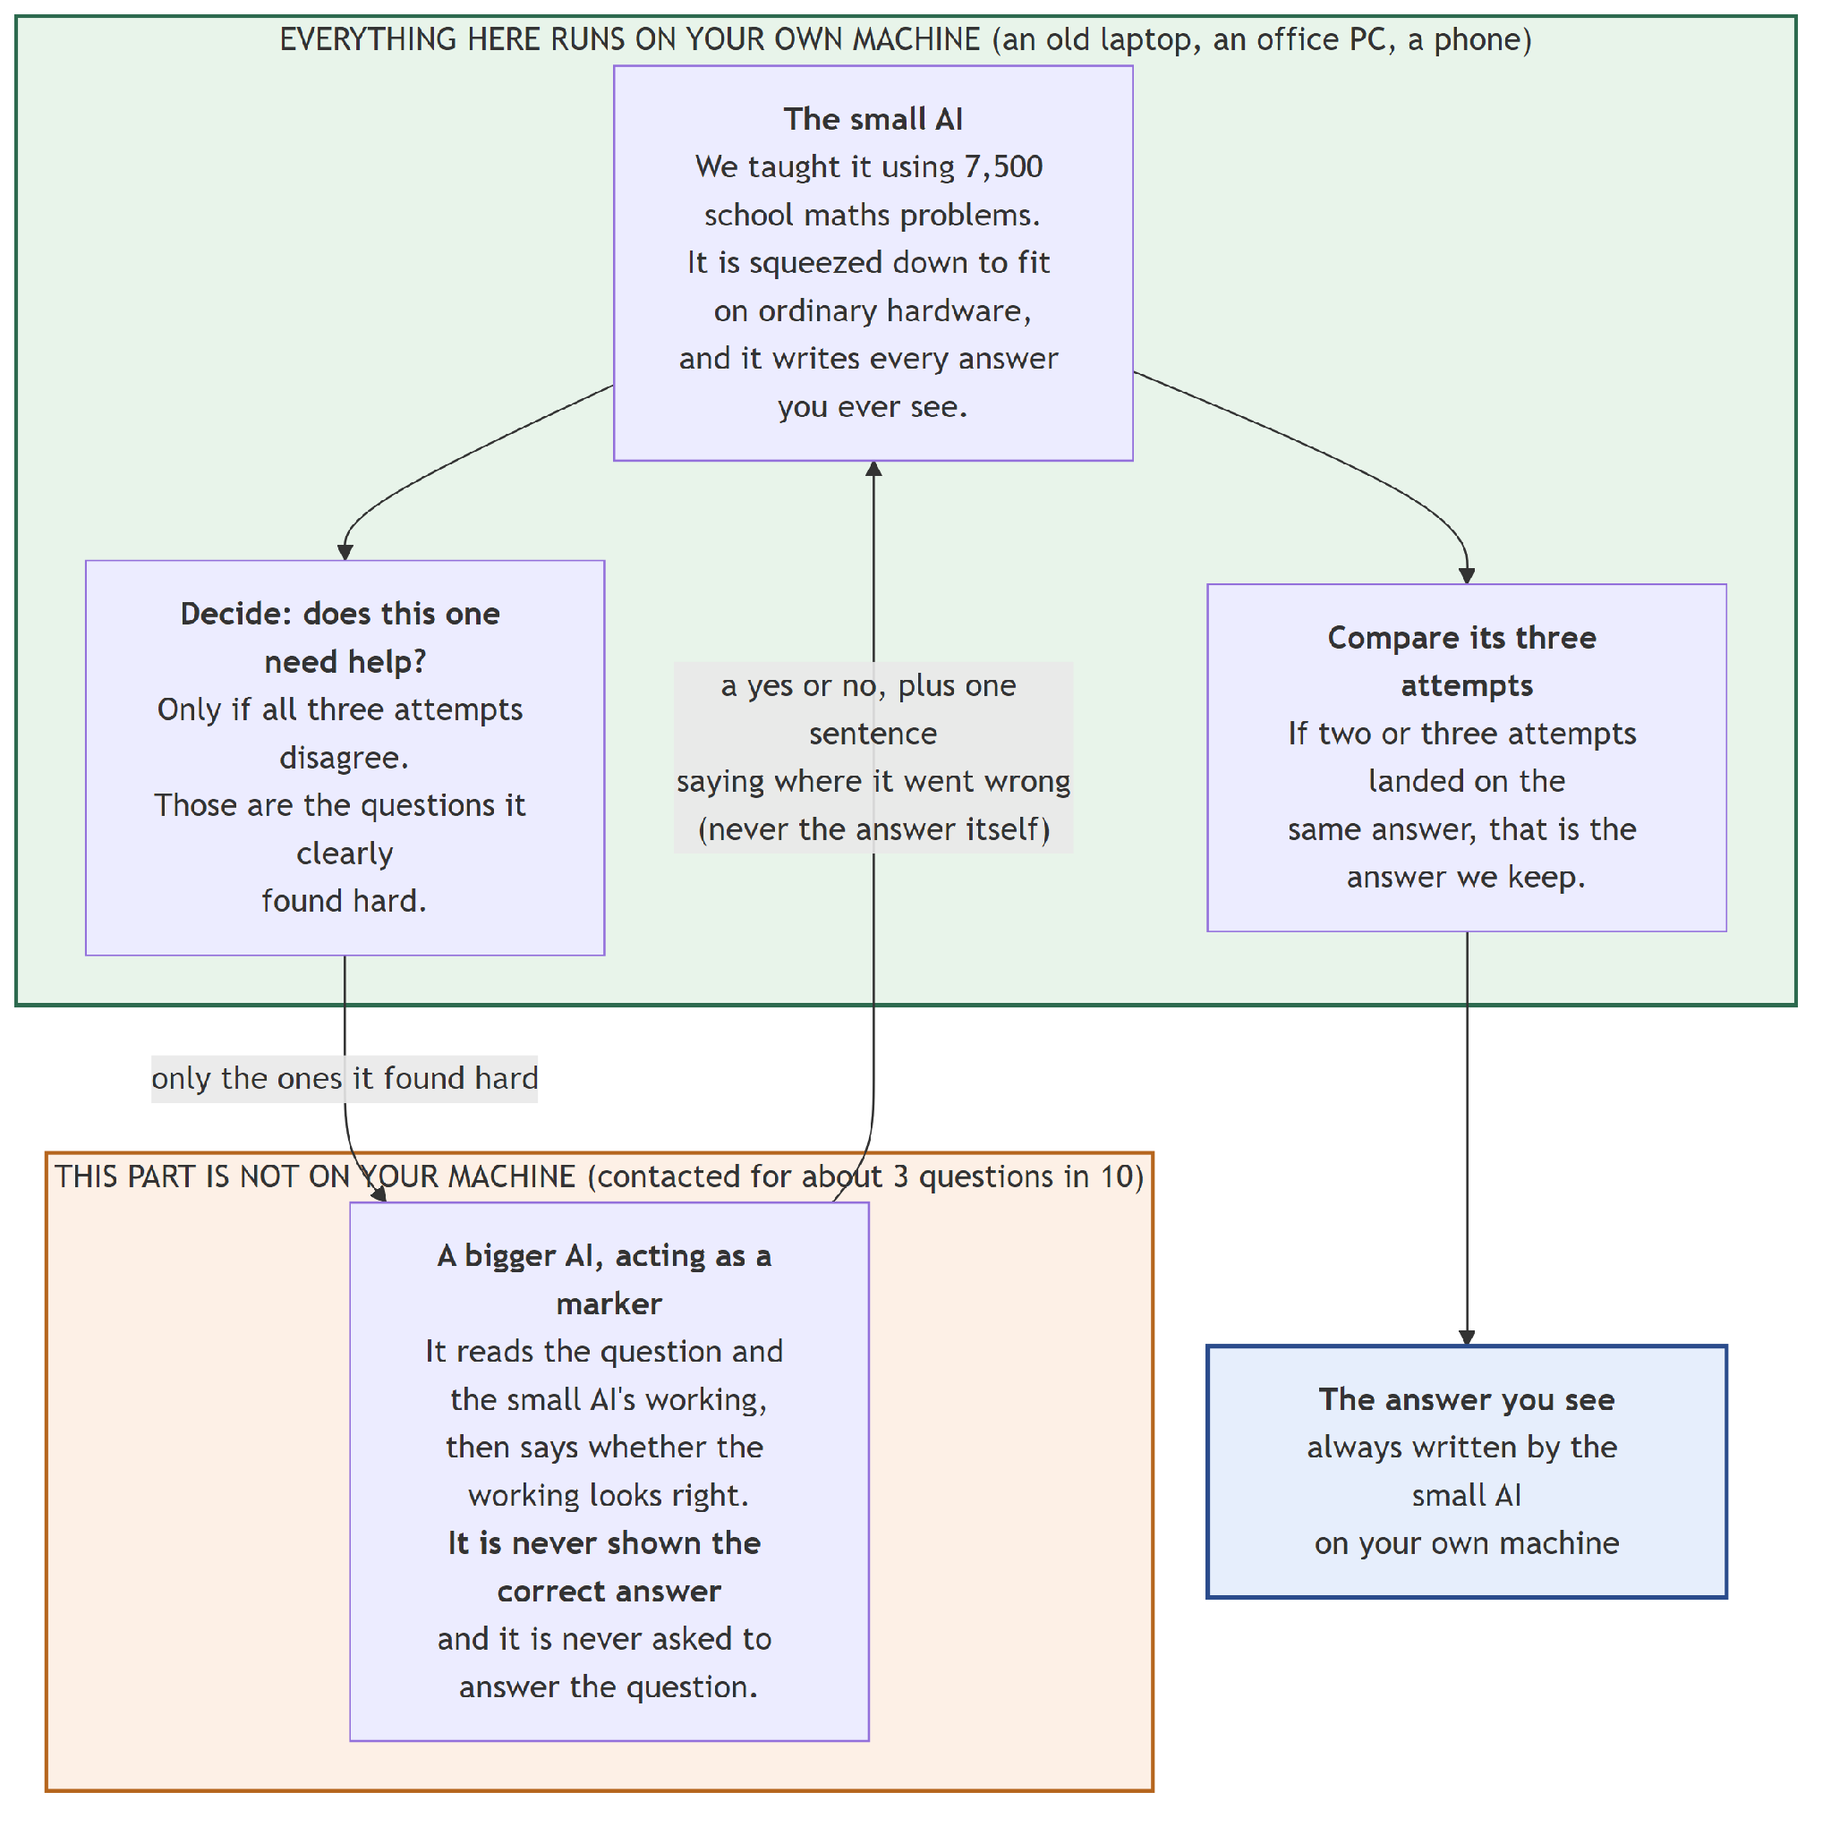
Figure 7.1: What the system is made of. Everything in the green box runs on the device. The checker is drawn outside it because in a real deployment it would be elsewhere — in our experiments it ran on the same machine. The checker is never shown the correct answer.

7.2 Step by step, system flow
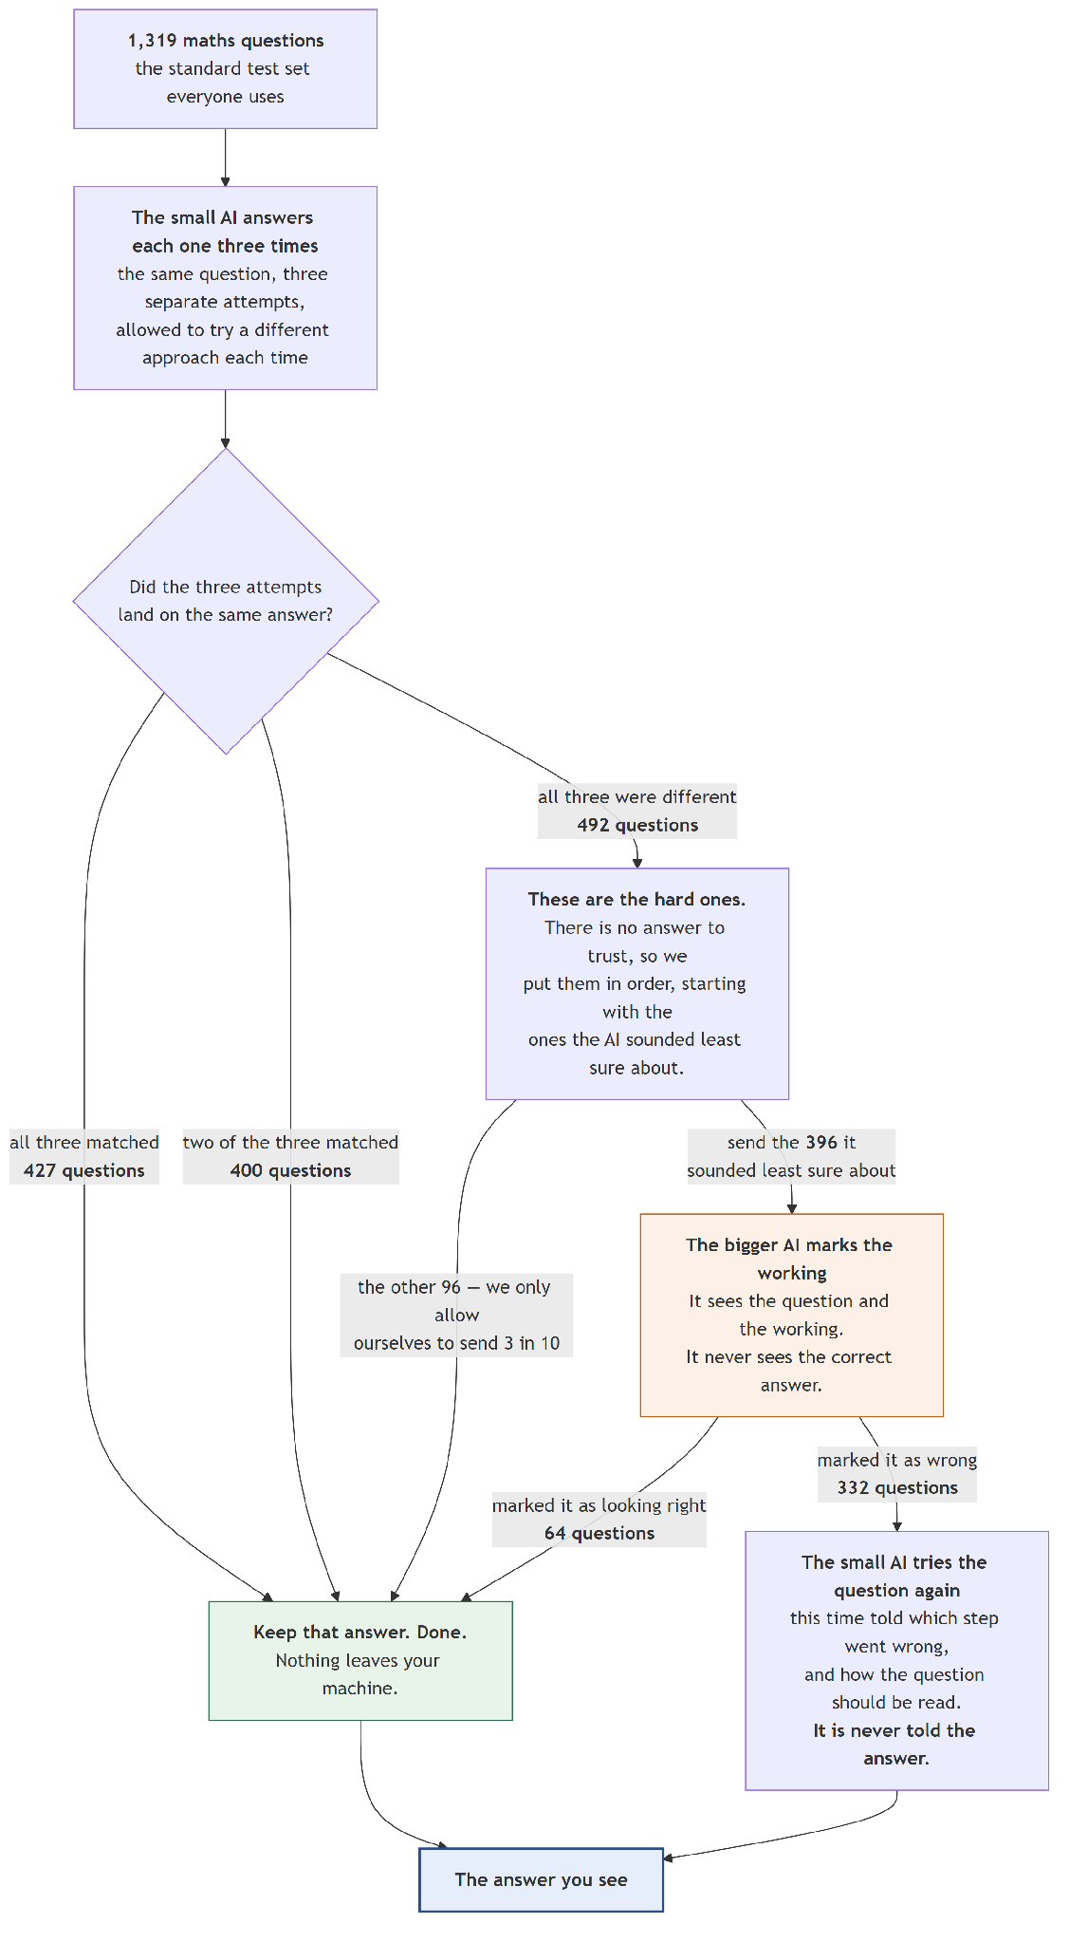
Figure 7.2: All 1,319 test questions flowing through the system. Every count is measured.
Step 1 — answer it three times. The small AI answers the question three times, with the randomness turned up (temperature 0.7) so the attempts are not identical.
Step 2 — sort the questions by how much the three attempts disagree. With three samples there are only three possible outcomes, so every question lands in one of three groups:
Group | Questions | What it means
All three agree | 427 | The model is confident
Two agree, one differs | 400 | Mild disagreement
All three differ | 492 | The model has no idea

Step 3 — take the majority vote where there is one. In the first two groups a majority exists, so we take it. That settles 827 of 1,319 questions, at no cost beyond the generating we already did.
Step 4 — escalate the split votes, up to the budget. The 492 questions where all three answers differ are the ones worth asking about. Our budget allows 30%, which is 396 questions. So 396 go to the checker and 96 do not — those 96 keep the first answer.
The result of steps 3 and 4 together: 923 questions — 70% — are settled entirely on the device and never leave it.
Step 5 — the checker marks the 396. It sees the question and the working, never the correct answer. It replies with a verdict and a short hint. It rejected 332 of the 396.
Step 6 — the small AI tries again with the hint. The checker then looks at the new answer. It accepts 85 of them. The remaining 247 get one last attempt, unchecked, and whatever comes out is the final answer.
Final: 903 right, 416 wrong. 68.46%.

7.3 Why steps 3 and 5 are both needed
This is the heart of the report, so it gets its own short section.
Voting and checking fix different questions, and they barely overlap.
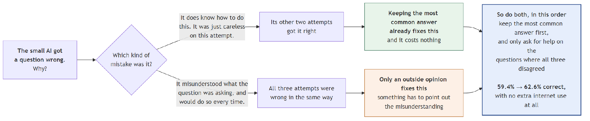
Figure 7.3: The two repair mechanisms work on different questions.
Voting only ever changes an answer in the middle group — where two attempts agree and one does not. It changed 81 answers there. In the "all three agree" group there is nothing to change, and in the "all three differ" group there is no majority to find.
The checker works precisely where voting cannot: the group where all three differ.
So they are not two ways of doing the same thing. They are two tools for two different problems, and using one instead of the other throws away free accuracy. Chapter 10 describes what happened when we learned this the hard way.

7.4 The gate: what escalation actually means
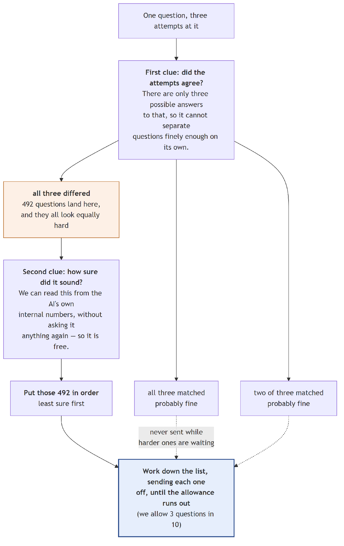
Figure 7.4: How the gate picks which questions to send.
Two separate things are going on, and they are easy to confuse:
The budget is how many questions we allow ourselves to send. We set it at 30% — 396 of 1,319. This is a limit we chose and enforced in the code. Sending everything would defeat the purpose of the project.
The gate is how we choose which 396. It ranks every question from "most unsure" to "most confident" using the disagreement signal above, and the budget draws a line.

Why 37.3% keeps appearing
With three samples, disagreement can only take three values. So the gate can only draw three honest lines: after 427 questions, after 827, or after all 1,319. The one that corresponds to "send all the questions where the model contradicts itself completely" is 492 questions, which is 37.3% of the test set.
That is the gate's natural threshold — the only escalation rate it truly expresses. Asking for 30% means cutting inside the 492, where the questions are tied and the code has to break the tie arbitrarily.
We report both. 30% is the budget we chose; 37.3% is what the gate would do if left alone.

Breaking ties with confidence
Inside the 492 tied questions, we can do better than picking arbitrarily. We also recorded how confident the model was in each answer, and we use that to order the tied group.
The important detail is that confidence is used only to break ties. It can never outrank disagreement. We tried letting confidence carry real weight and it scored worse than disagreement alone. Keeping it strictly subordinate means there is no weighting number to choose — and therefore no number we could have quietly tuned to flatter our own results on the test set.
Both signals were already being computed, so this costs nothing.

7.5 How much the checker is allowed to say
The hint the checker sends back is measured in tokens, and tokens are the cost we are trying to minimise. So we treated the amount of feedback as something to measure rather than choose:
Level | What comes back | Typical size
L0 | Just "wrong, try again" | about 12 tokens
L1 | Plus a pointer at the step that went wrong | about 30 tokens
L2 | Plus an explanation of the correct reading | about 57 tokens

A hint never contains the final answer. If the checker's reply happens to contain a #### line, it is stripped out before the small model sees it. There is an automatic test that fails if this protection is ever removed, and another that fails if the correct answer ever reaches the checker's prompt.
We expect to be asked about this at the defence, so we built it to be demonstrable rather than merely asserted.
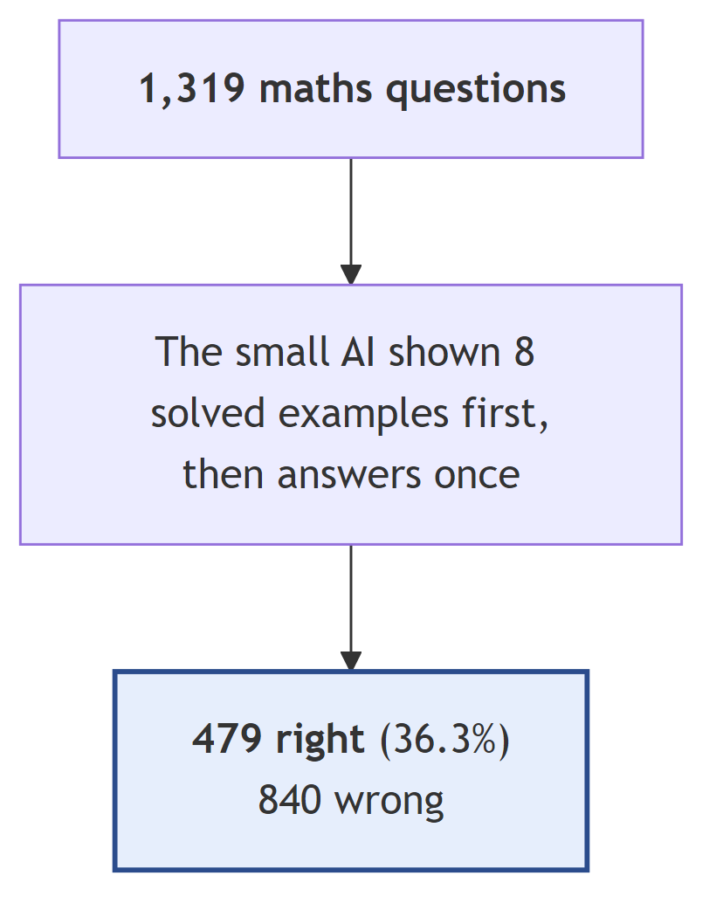

Chapter 8 — Every system we tried, one by one
We tested 19 complete systems on all 1,319 test problems. This chapter takes each one in turn: what it is, why we built it, what it scored, what it cost, and what we learned from it. Each comes with two diagrams — what the system is made of, and what happens to the questions as they pass through it.
The systems fall into five groups, and we explain each group before working through its members.
A note on the numbers in every results block below. "Turned right" and "turned wrong" are counted against System 02, the trained model answering once. They matter because a system can gain answers and break others at the same time, and the score on its own hides that. Times are estimated, not measured — Section 8.6 explains how, and how accurate the estimates are.

Group A — Systems 01 to 04: what we get for free
These four use nothing but the small model. No checker, no second machine, no cloud. They establish what the problem looks like before we add anything, and they set the bar that everything later has to clear.

System 01 — The model before we trained it
What it is. The stock google/gemma-4-E2B-it, squeezed to 4 bits, with no training from us at all. Before each test question it is shown 8 worked examples taken from the training split — the same 8 every time, in the same order.
Why we built it. This is the "before" picture, and getting it right matters more than it sounds. Our first instinct was to just ask the untrained model the question directly. That scored 1.5% — 20 problems out of 1,319 — and on 566 of them it produced nothing we could even extract an answer from. It mostly collapsed into repeating itself.
Comparing our trained model against that would have made our fine-tuning look far better than it really is. Showing the base model eight worked examples first is the standard way to make a model of this size attempt the task at all, and it is the honest comparison. So that is the baseline we report everywhere in this document.
What happened. 479 correct. It also failed to produce an extractable answer on 16 problems — far better than 566, but still a sign of a model working at the edge of its ability.
The cost line is the interesting one. It reads 1,617.7 tokens per question, and almost all of that is the eight worked examples being re-sent with every single question. The model's own answer is only 120.6 tokens. That 1,617.7 is what fine-tuning later deletes.
Correct | 479 of 1,319 — 36.32%
Attempts per question | 1.00
Tokens the model writes | 120.6
Tokens the model reads | 1,617.7
Sent to the checker | 0
Time for all 1,319 | 3 h 19 min (measured)

The time here is the one figure in this chapter that we measured rather than estimated. Our estimate said 5 h 00 min, which was 51% too high — the writing speed we based it on was measured with the training adapter loaded, and this system runs without it. We report the real number.
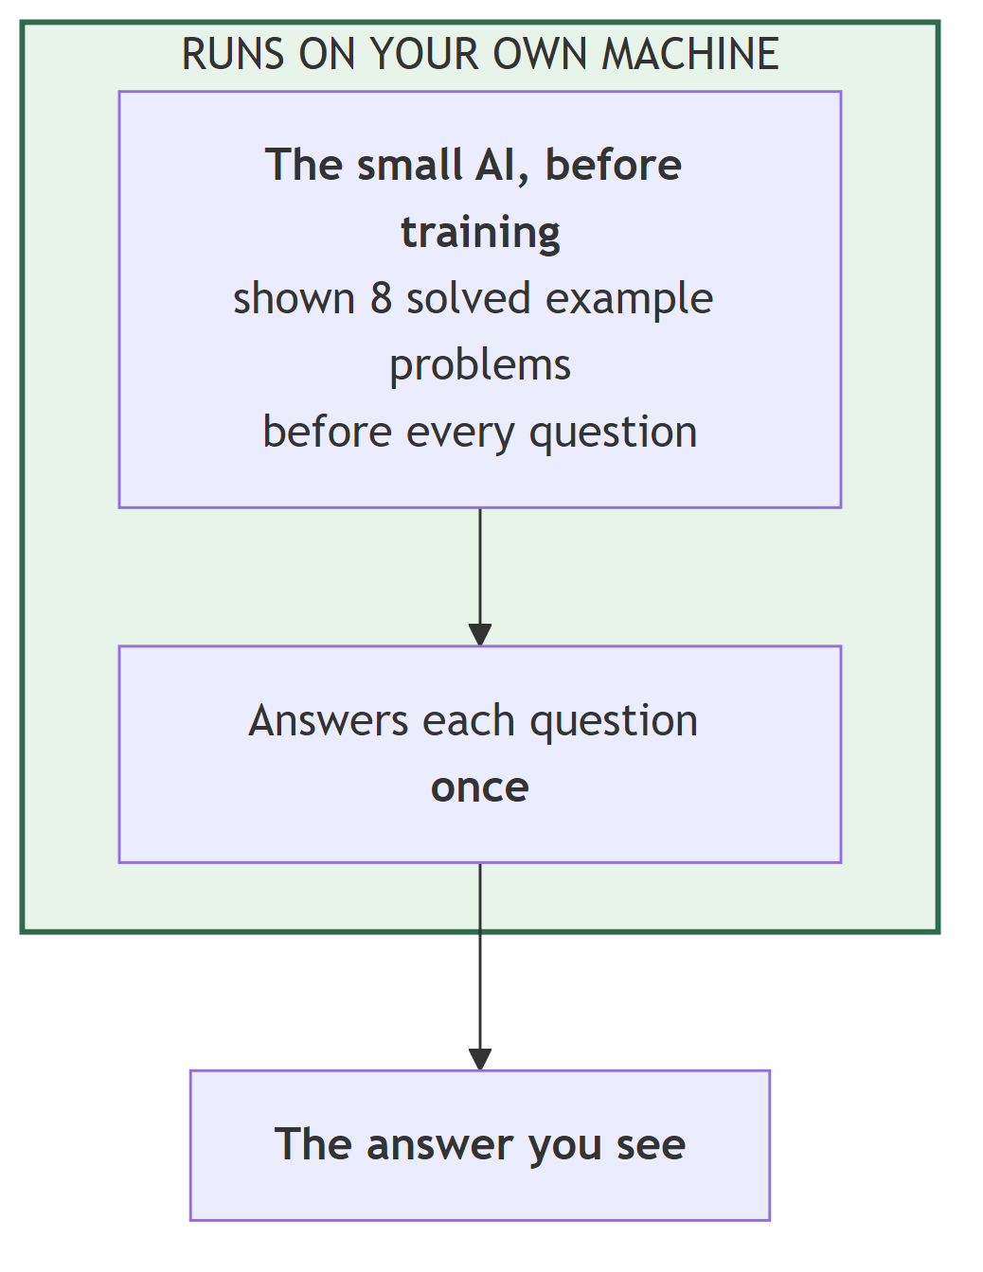

System 02 — The model after we trained it
What it is. The same model with our QLoRA adapter attached, answering each question once, greedily, with no worked examples in the prompt at all.
Why we built it. This is the reference point for the entire report. Every later system is measured against it, and the "turned right / turned wrong" columns everywhere are counted against this one.
What happened. 737 correct — +19.56 points over System 01.
And look at what happened to the prompt: 1,617.7 tokens down to 87.7. The model no longer needs to be shown how the task works, because that is now in the adapter. The saving is not that the model writes less — it writes slightly more, 125.9 tokens against 120.6. The saving is that we stopped having to explain the job every time.
Total tokens per question fall from 1,738.3 to 213.5: 12.3% of the original cost.
Correct | 737 of 1,319 — 55.88%
vs. System 01 | +19.56 points
Attempts per question | 1.00
Tokens the model writes | 125.9
Tokens the model reads | 87.7
Sent to the checker | 0
Time for all 1,319 | 5 h 13 min

One more thing worth recording: the trained model produced a usable #### N answer on 1,318 of 1,319 problems. Only one output was missing the marker. Whatever else fine-tuning did, it taught the output format completely.
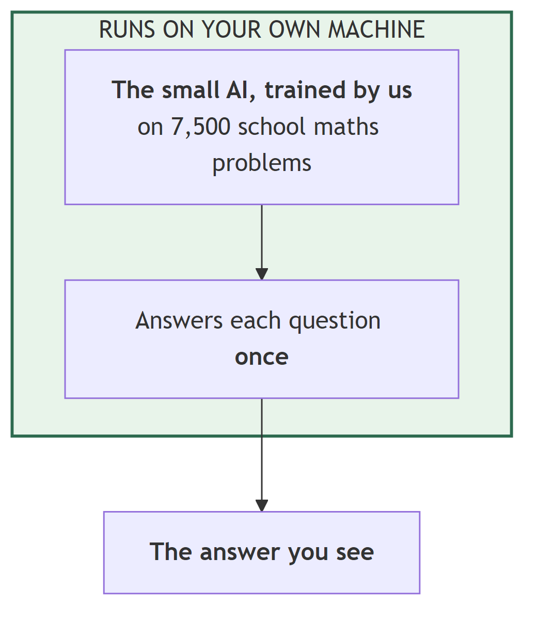
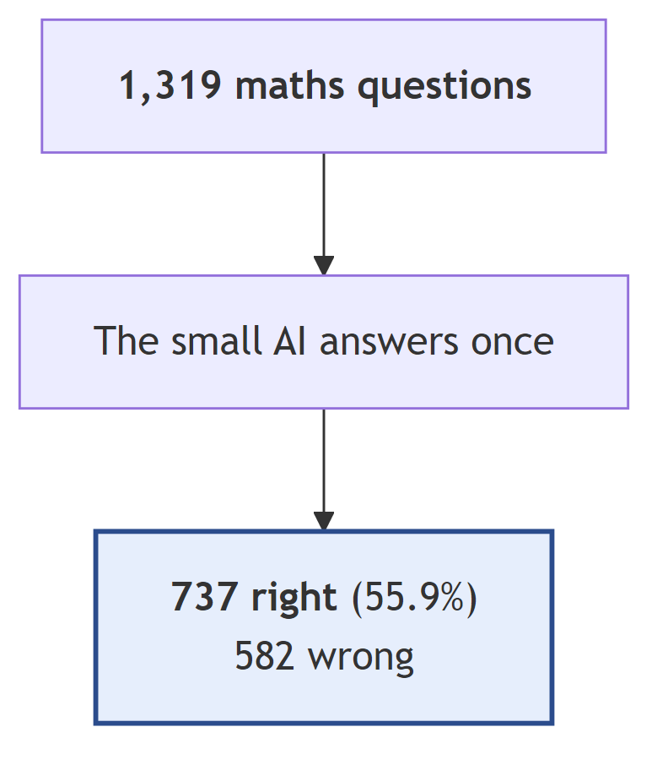

System 03 — Ask again, keep the second answer
What it is. The trained model answers, then answers again with randomness turned on (temperature 0.7), and we keep the second answer. No checker, no feedback, no reason given — just another go.
Why we built it. This is the control that makes the whole project meaningful. Our system does two things at once: it tells the model it was wrong, and it lets the model try again. If simply trying again were enough, the checker would be pointless and we would have built an expensive way to do nothing.
What happened. It got worse. 737 down to 658 — a loss of 6 points.
Looking at the individual questions explains why. The retry fixed 138 wrong answers, and broke 217 right ones. Resampling is not an even bet: it is easier to ruin a correct answer than to repair a wrong one.
That asymmetry is the single most important fact behind how we later judge checkers. It is why a checker that wrongly rejects correct answers is so expensive — every wrong rejection is a coin flip that is likely to land badly. It is why we care more about a checker's precision than its recall.
Correct | 658 of 1,319 — 49.89%
vs. System 02 | −5.99 points
Turned right | 138
Turned wrong | 217
Attempts per question | 2.00
Sent to the checker | 0
Time for all 1,319 | 10 h 43 min

This also matches the published literature: a well-known 2024 paper found that language models cannot reliably correct their own reasoning without outside information. Our result is the same finding on a model about a hundred times smaller.
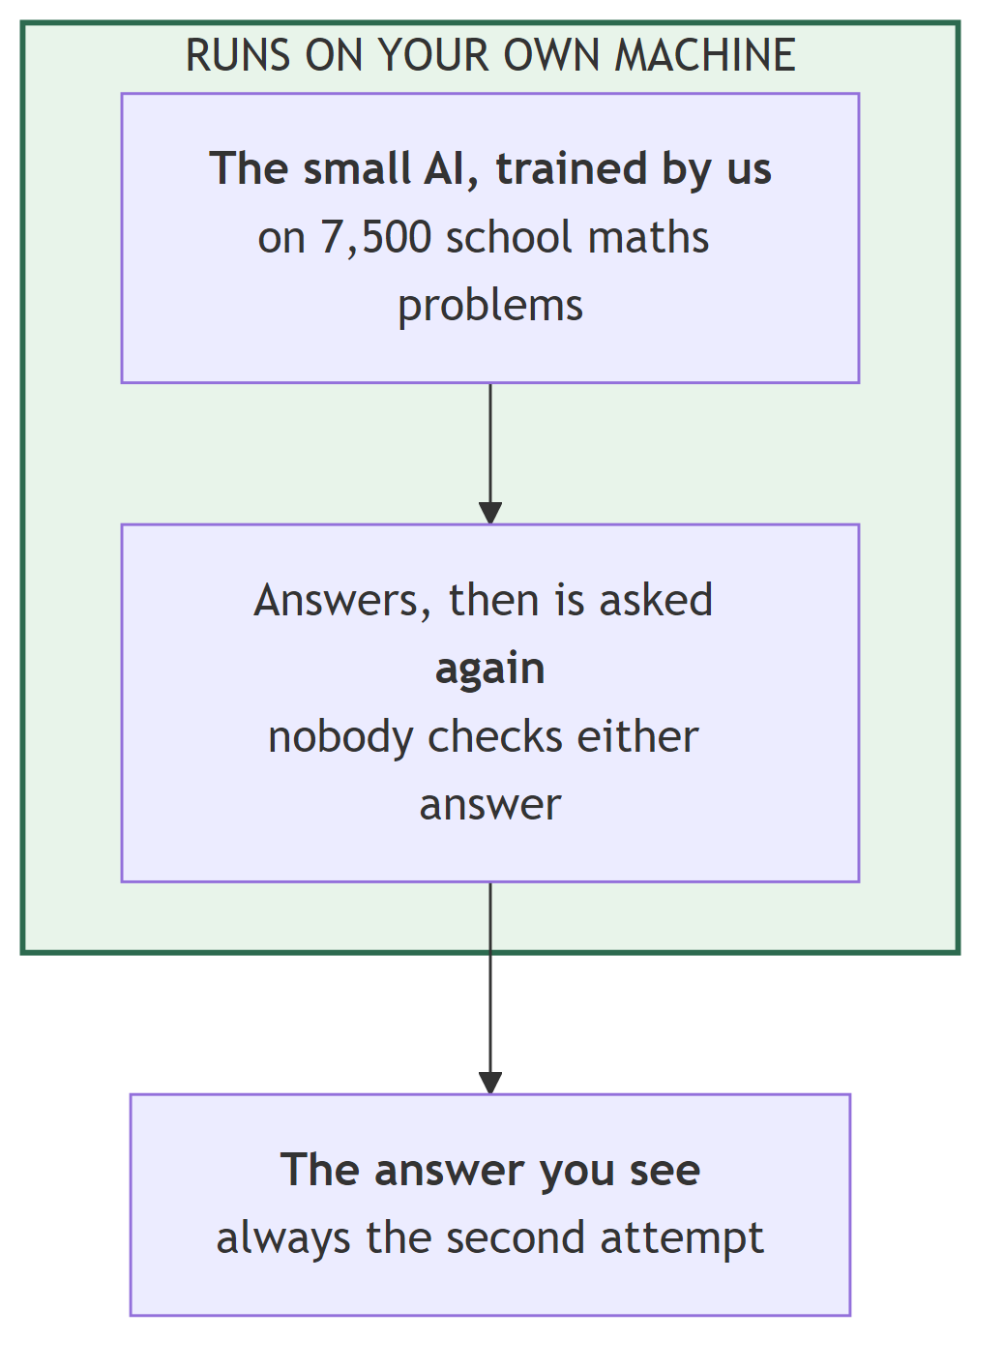
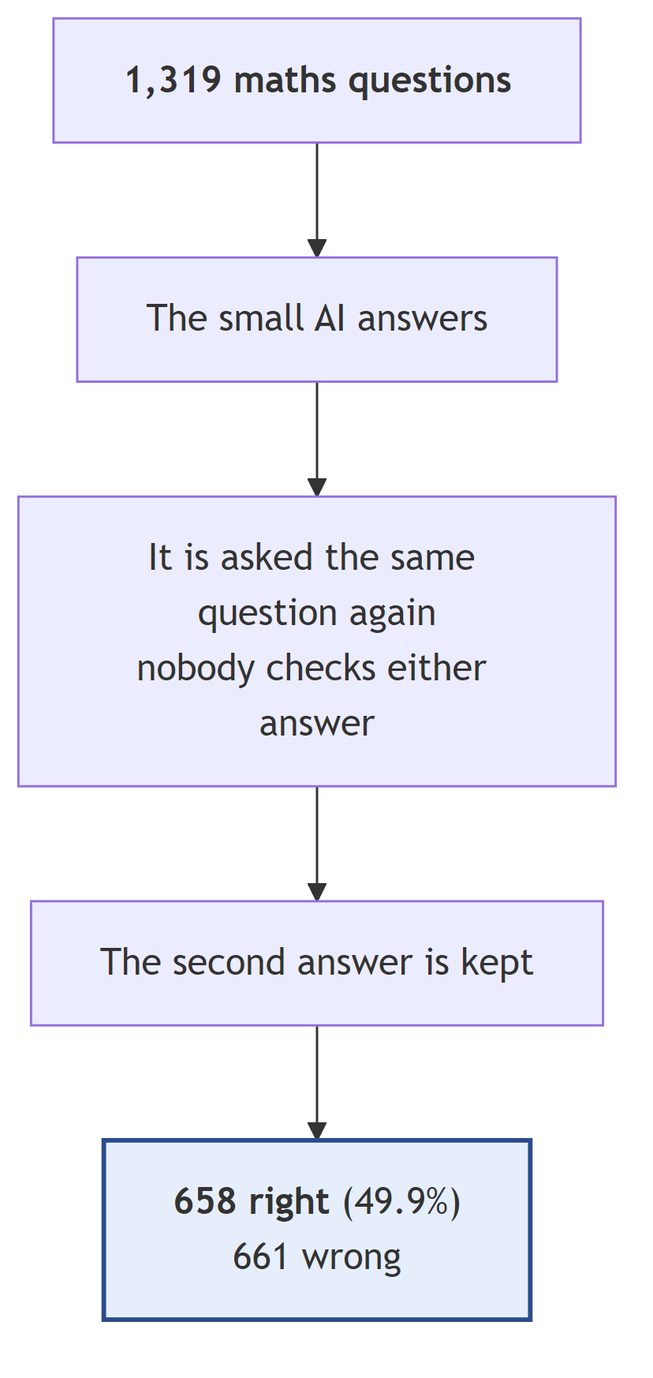

System 04 — Answer three times, keep the most common
What it is. The trained model answers the same question three times with randomness on, and we keep whichever answer appeared most often. This is called self-consistency. It needs no second model, no network, and no cleverness.
Why we built it. Because it is the rival. Any complicated design has to beat this one before it is worth anything, and this is the comparison our own first attempt failed (Section 10.1).
What happened. 779 correct — +3.18 points over System 02, at zero cost outside the device.
Notice how differently this behaves from System 03. Both ask the model more than once. But voting fixed 54 and broke only 12, while blind retry fixed 138 and broke 217. Asking three times and taking the majority is careful; asking once more and believing the new answer is reckless.
The three attempts also fall into three groups, and these three numbers turn up repeatedly through the rest of this report:
Group | Questions | What it means
All three answers agree | 427 | The model is confident
Two agree, one differs | 400 | Mild disagreement
All three differ | 492 | The model has no idea

Voting can only change anything in the middle group — the other two have either nothing to change or no majority to find. It changed 81 answers there. Remember that number; it is why voting and checking turn out to be complementary rather than competing (Section 7.3).
Correct | 779 of 1,319 — 59.06%
vs. System 02 | +3.18 points
Turned right | 54
Turned wrong | 12
Attempts per question | 3.00
Sent to the checker | 0
Time for all 1,319 | 16 h 11 min

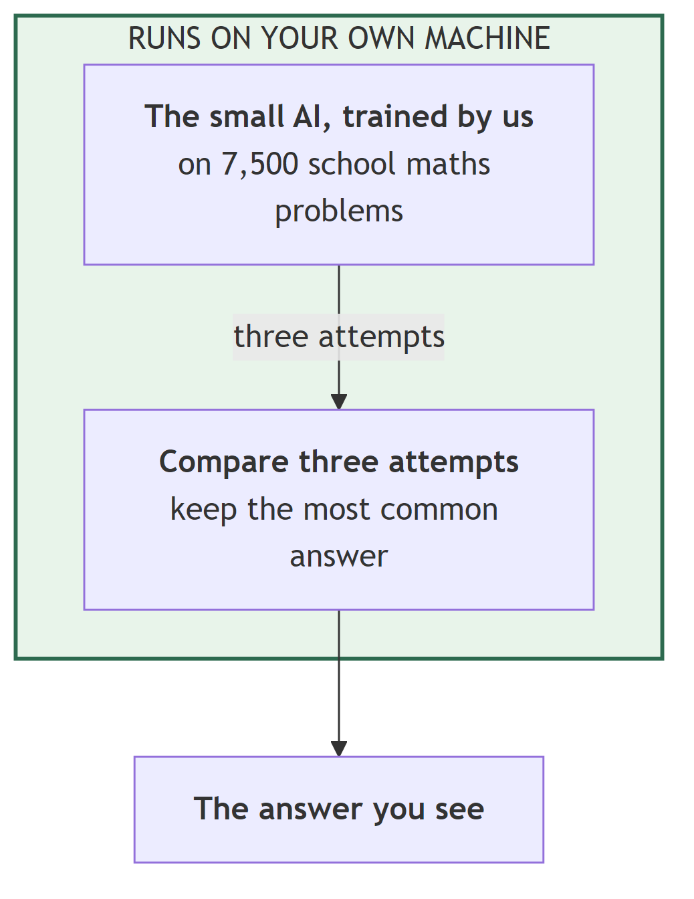
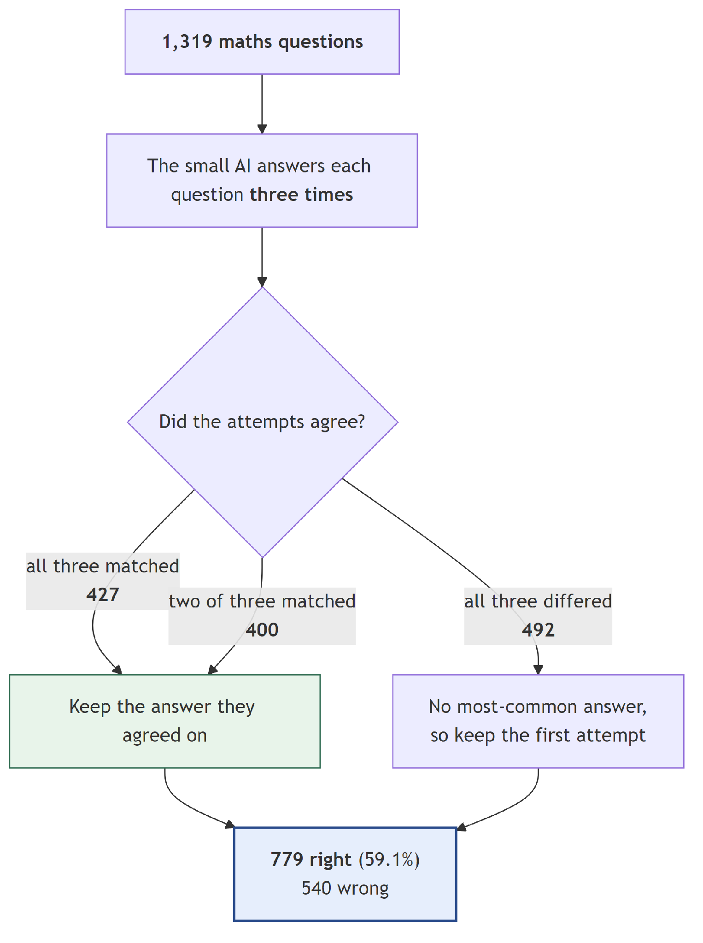

Group B — Systems 05 to 07: measuring the checker, not the system
These three do not try to improve anything. The checker marks all 1,319 answers, and not one answer is ever changed. There is no retry.
Because nothing changes, all three score exactly 737 of 1,319 — 55.88%, identical to System 02. That is correct and expected. If any of them scored differently, something would be broken.
So what are they for? They measure the marker. Before spending twenty hours running a checker inside a full system, we wanted to know how good each checker actually is at spotting a wrong answer. These three runs answer that, and their numbers feed the choice of checker in Group E.
How to read their results. The number that matters is not the score. It is how many of the 582 wrong answers the checker noticed, and how many of the 737 right answers it wrongly failed. Those two numbers pull against each other, and Group B is where we measure the trade.

System 05 — The 30-billion checker marks everything
What it is. GLM-4.7-Flash, a 30-billion-parameter model of which about 3 billion are active for any one token, served on our own machine. It sees every one of the 1,319 answers, along with the question and the working. It never sees the correct answer.
What happened. It said "wrong" about 674 answers. Of those, 486 really were wrong and 188 were actually right.
Score | 737 of 1,319 — 55.88% (unchanged, by design)
Wrong answers it caught | 486 of 582 — 83.5%
Right answers it wrongly failed | 188 of 737 — 25.5%
When it said "wrong", it was correct | 72.1%
Checker calls | 1,319
Checker tokens per question | 499.1
Seconds per check | 2.07
Time for all 1,319 | 5 h 59 min

What we learned. It is a decent spotter — it catches five wrong answers in six. But it fails one right answer in four, and from System 03 we know each of those is likely to be damaged by the retry that follows. A quarter is a lot.
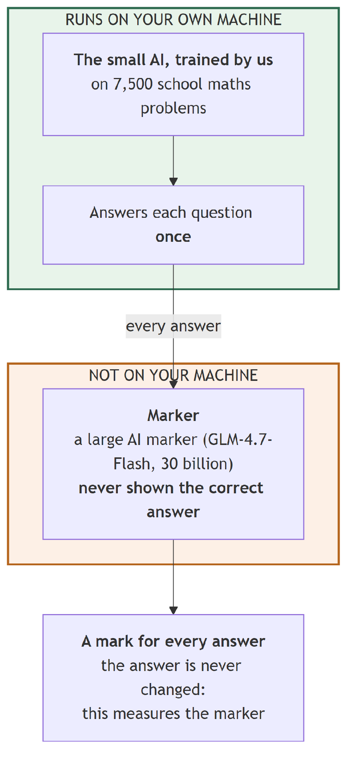
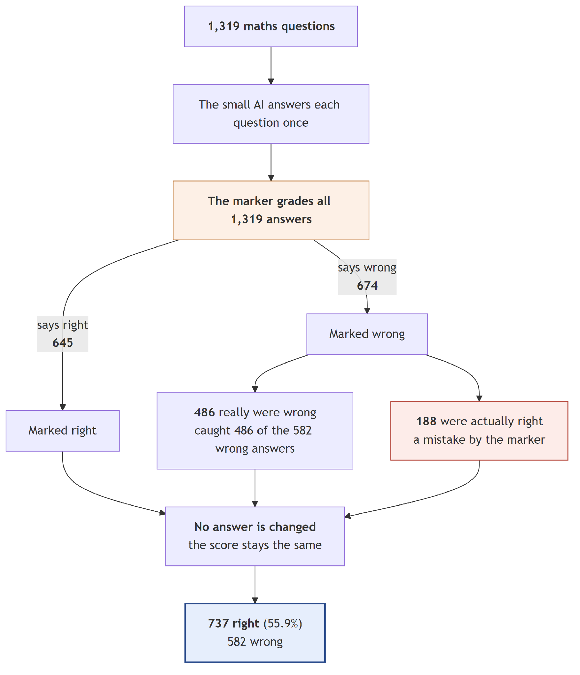

System 06 — The 9-billion checker marks everything
What it is. Identical to System 05 in every way except the checker: Qwen3.5-9B, about a third the size and a third the file.
What happened. This is the result that changed our final design. It is better than the bigger model at both jobs at once:
 | System 06 (9B) | System 05 (30B)
Wrong answers caught | 517 — 88.8% | 486 — 83.5%
Right answers wrongly failed | 137 — 18.6% | 188 — 25.5%
When it said "wrong", correct | 79.1% | 72.1%
Seconds per check | 1.00 | 2.07
File size | 5.6 GB | 16.3 GB

31 more mistakes caught, and 51 fewer correct answers wrongly failed. Twice as fast. A third of the size. We did not expect this, and Section 10.3 discusses what we think is going on.
One flaw worth reporting. 50 of its 1,319 replies were cut off before it finished writing, because the 9B model writes longer replies than the 30B one and our reply limit was too low. By our design rule, an unreadable reply counts as "looks fine" — so those 50 were treated as acceptances. Only 9 of them were on genuinely wrong answers, so the effect is small, but it means the caught-mistakes figure above is a slight under-statement of what this checker can do. We raised the limit for the runs in Group E.
Score | 737 of 1,319 — 55.88% (unchanged, by design)
Checker calls | 1,319
Checker tokens per question | 565.1
Replies cut off | 50
Time for all 1,319 | 5 h 35 min

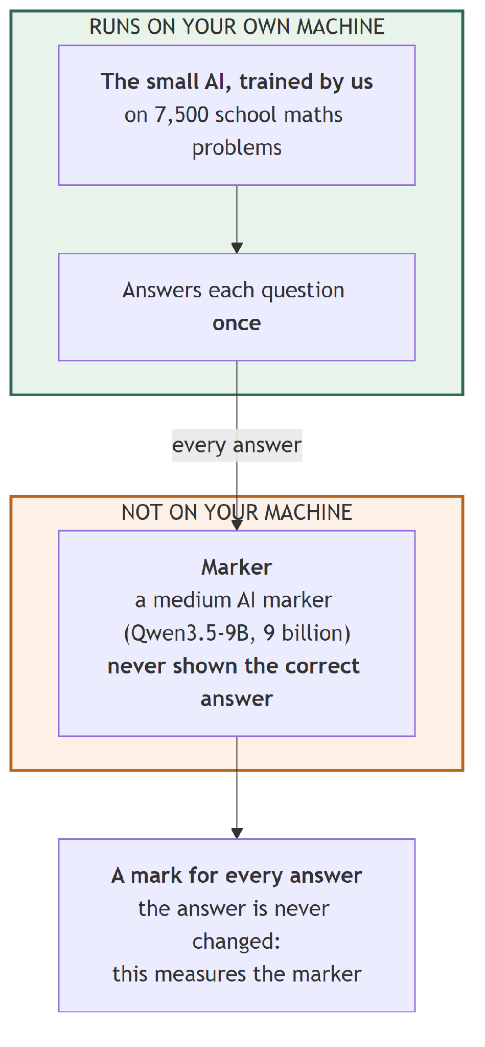
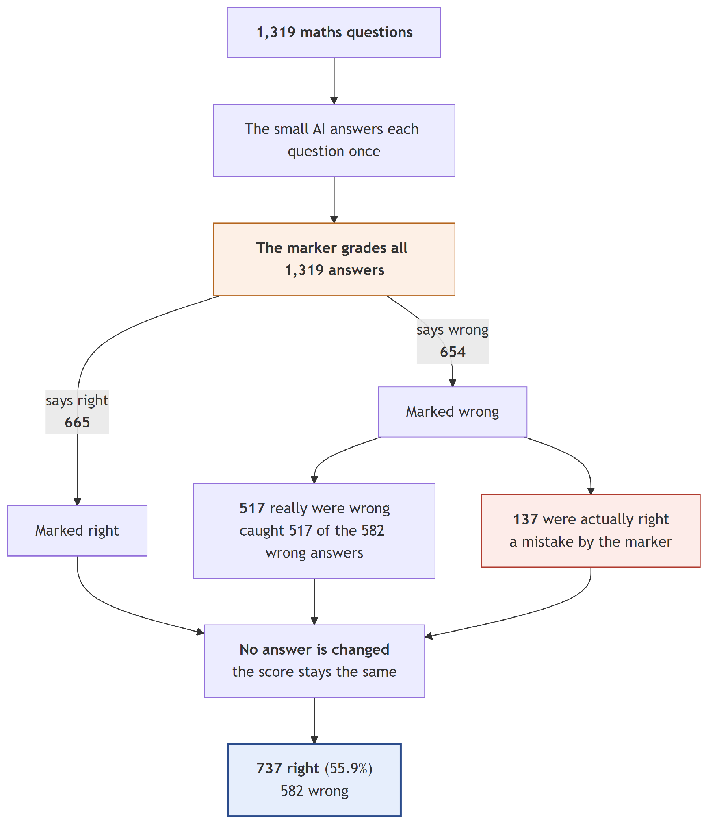

System 07 — The answer key used as the marker
What it is. Exactly what the name says. There is no second model in this experiment at all. Only the small AI runs. The "checker" is a few lines of code that compare each answer with the correct one.
We want to be blunt about this because it is easy to misread: System 07 involves no AI checker, exchanges zero tokens, and nothing leaves the machine.
Why we built it. Two reasons, and both are about trusting the rest of the numbers.
- It is the yardstick. It shows the best any checker could possibly do — catch every mistake, wrongly fail nothing. Systems 05 and 06 are measured against this.
- It proves our grading code works. If the answer key, compared against itself, scored anything other than 100%, we would have a bug in the most important piece of code in the project. It scores 100%, on all 1,319.
Score | 737 of 1,319 — 55.88% (unchanged, by design)
Wrong answers caught | 582 of 582 — 100%
Right answers wrongly failed | 0 — 0%
Checker tokens per question | 0.0
Time for all 1,319 | 5 h 13 min

It is not a system we could deploy. It scores perfectly only because it is allowed to see the answer, which is exactly what a real checker never gets.
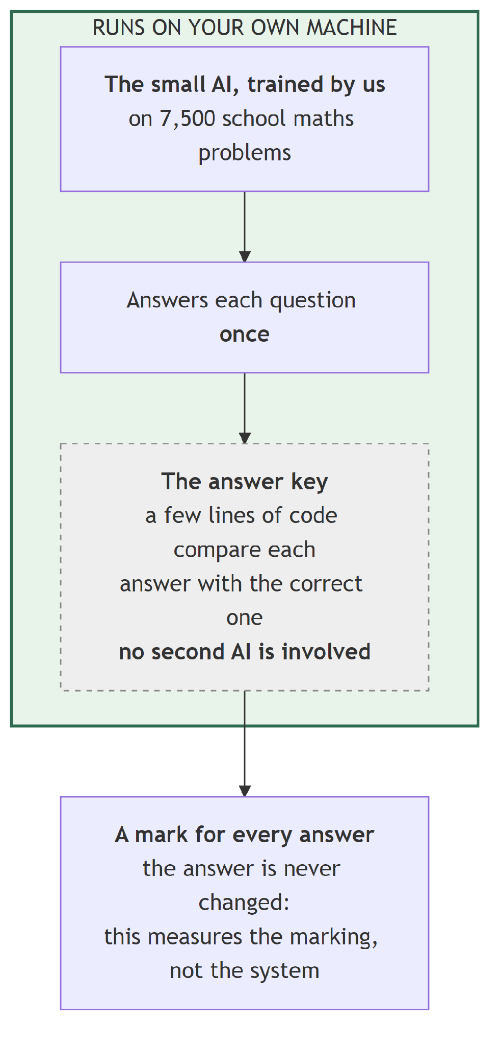
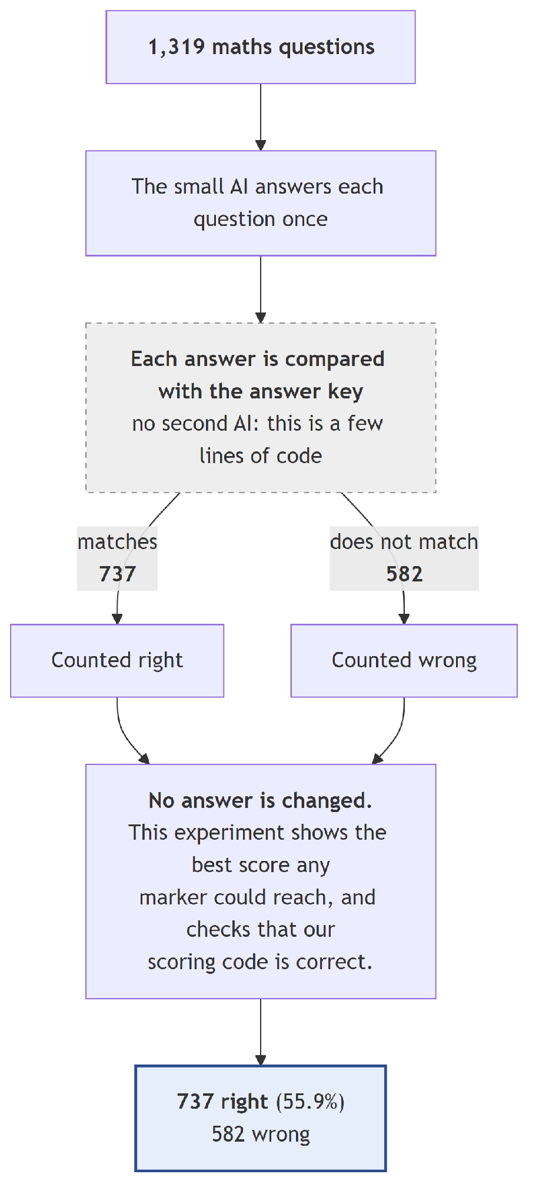

Group C — Systems 08 to 12: the cascade on its own
Now the full idea. The trained model answers, the gate picks the questions that look risky, the checker marks those, and the model retries with a hint. No voting anywhere.
Systems 08, 09 and 10 are a controlled experiment with one variable: how much the checker is allowed to say. Everything else is held fixed, and because of the verdict cache described in Chapter 6, all three reject an identical set of questions. Any difference between them is the hint content and nothing else.
Systems 11 and 12 then change one other thing each — how many questions are sent, and how they are chosen.

System 08 — Gate + 30B checker, no hint (L0)
What it is. The gate escalates 396 questions. The checker marks them and replies with a bare verdict — effectively "wrong, try again", about 12 tokens. No explanation.
Why we built it. It is the floor for feedback. If a bare rejection helps as much as a full explanation, the whole question of how much to say answers itself and the cheapest option wins.
What happened. 756 correct, +1.44 points over System 02. Turned 46 right and broke 27.
So a bare "no" does help a little. Told only that it was wrong, the model sometimes finds a better route on its own.
Correct | 756 of 1,319 — 57.32%
vs. System 02 | +1.44 points
Turned right / wrong | 46 / 27
Sent to the checker | 396 (30%)
Checker calls | 712
Checker tokens per question | 300.9
Attempts per question | 3.46
Time for all 1,319 | 20 h 12 min

Note on the call count: 396 questions but 712 calls, because most escalated questions are judged twice — once on the first answer and once on the retry.
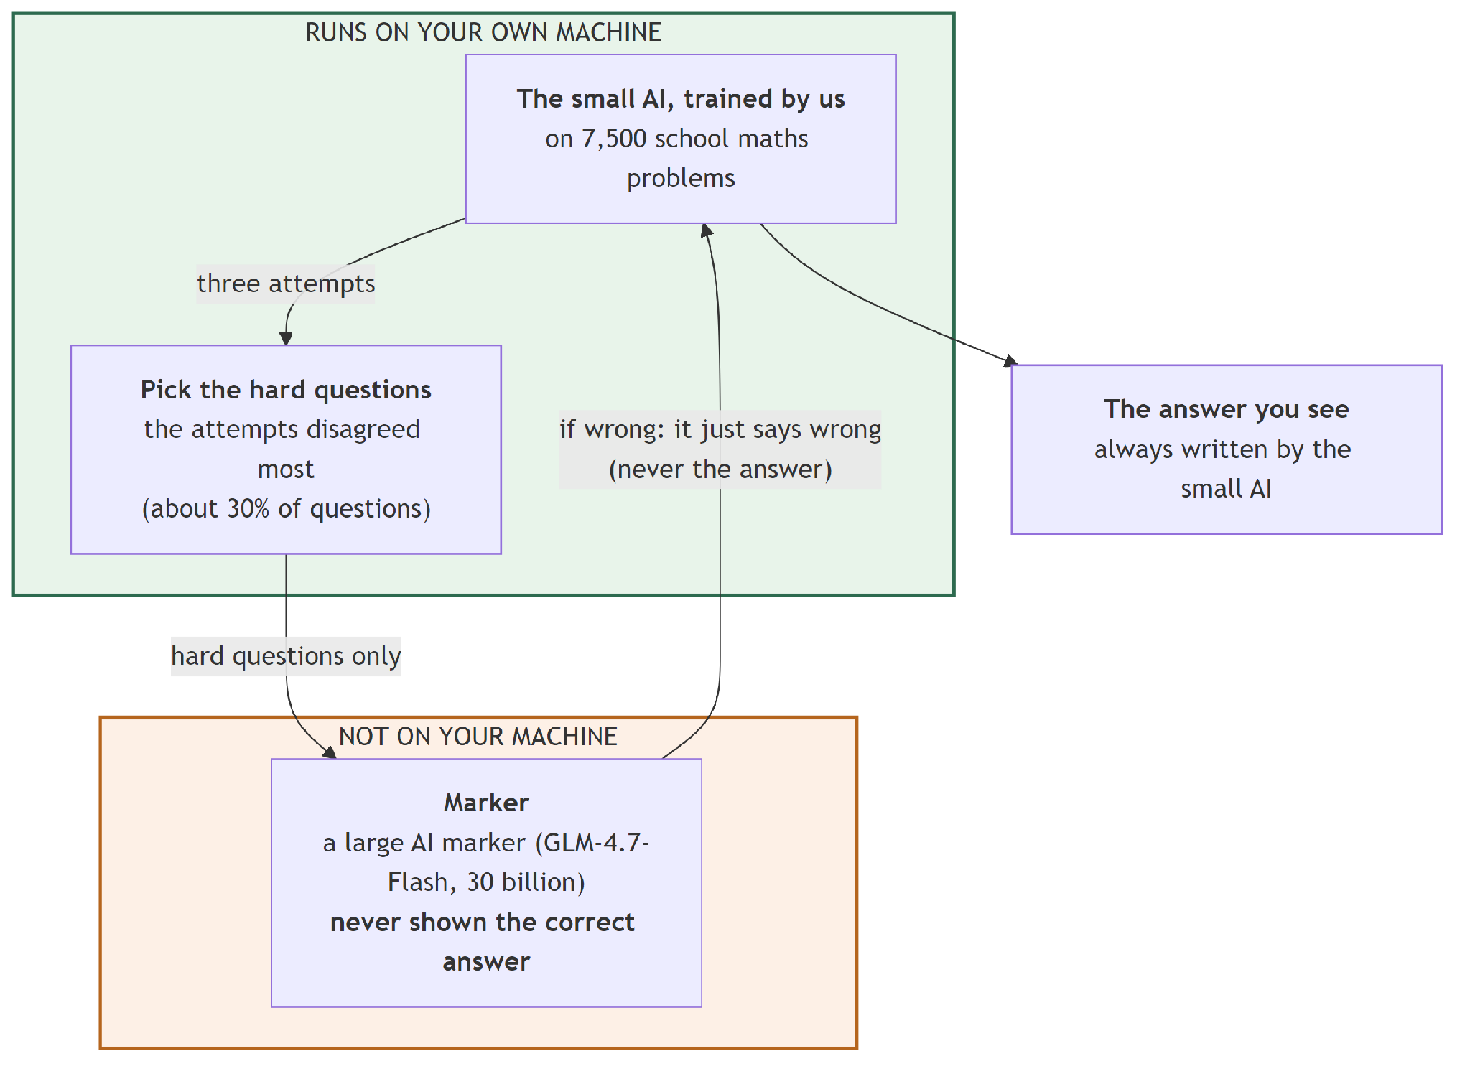
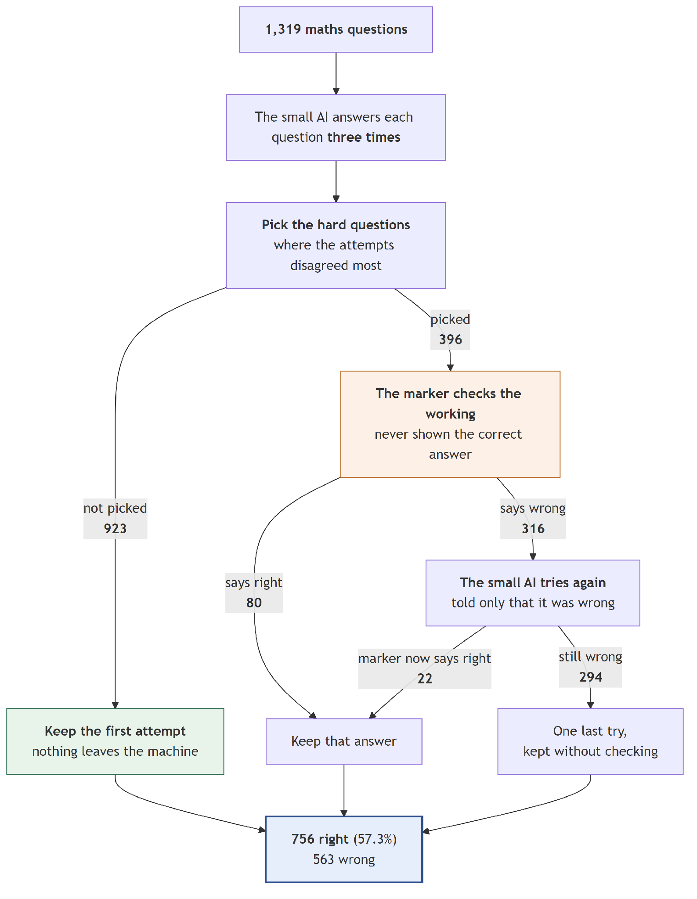

System 09 — Gate + 30B checker, short hint (L1)
What it is. Identical to System 08, except the checker also names the step that went wrong — a pointer, about 30 tokens.
What happened. 765 correct, +2.12 points. Turned 52 right, broke 24.
Compared with System 08: 9 more answers, for about 18 extra tokens coming back per escalated question. Pointing at the mistake helps more than just announcing there is one.
Correct | 765 of 1,319 — 58.00%
vs. System 02 | +2.12 points
Turned right / wrong | 52 / 24
Sent to the checker | 396 (30%)
Checker calls | 712
Checker tokens per question | 297.9
Time for all 1,319 | 19 h 57 min

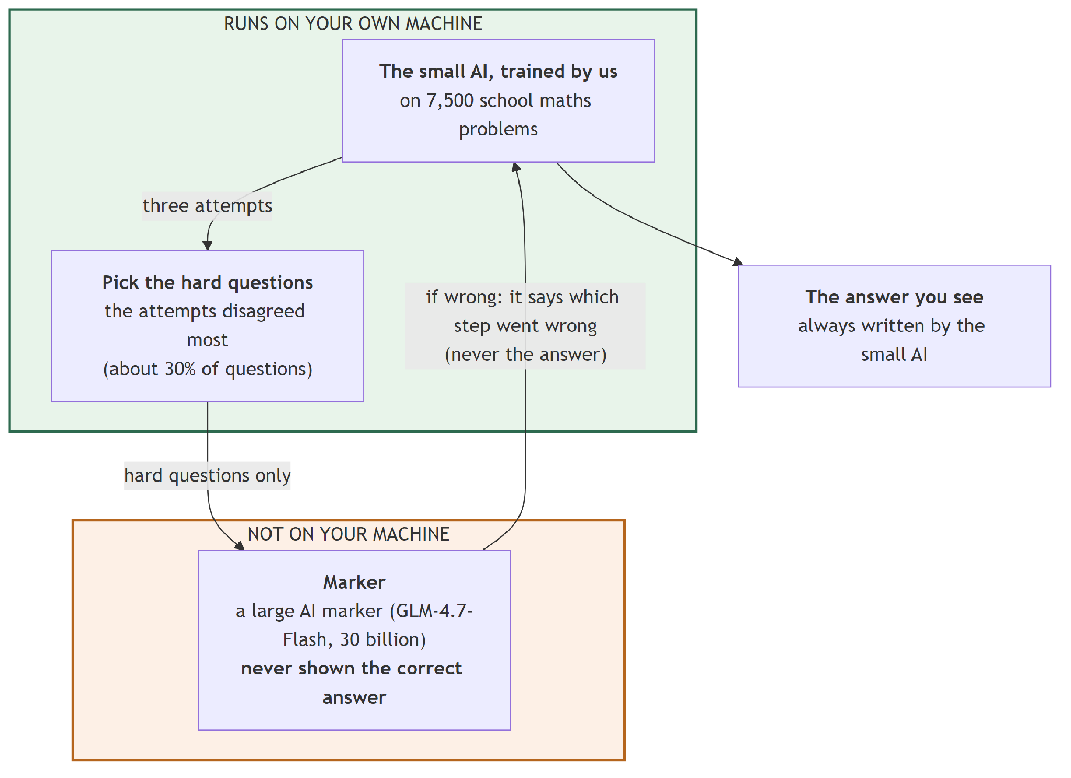
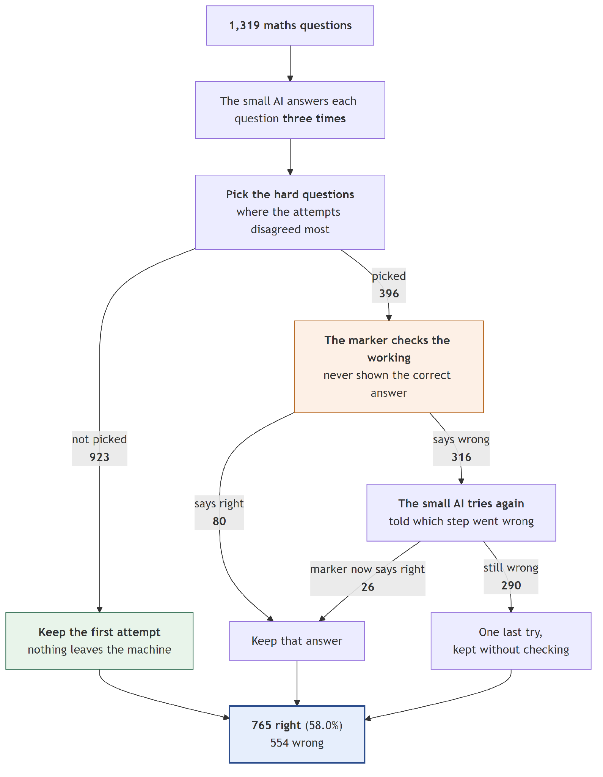

System 10 — Gate + 30B checker, full hint (L2)
What it is. Identical again, except the checker now also explains the correct reading of the problem — about 57 tokens. It is still forbidden from stating the final answer, and any #### line in its reply is stripped out before the model sees it.
What happened. 784 correct, +3.56 points. Turned 70 right, broke 23.
The pattern across the three is clean and it answers the question we set:
 | Hint size | Correct | Score
System 08 | ~12 tokens | 756 | 57.32%
System 09 | ~30 tokens | 765 | 58.00%
System 10 | ~57 tokens | 784 | 59.44%

More feedback is better, and the gain is worth having: the full hint costs about 5.5 times as many tokens coming back as the bare rejection, and buys 2.1 extra points.
But now compare System 10 with System 04. 59.44% against 59.06% — and System 04 is free. Five answers better, for 712 calls to a second model. That is the failure Section 10.1 is about, and it is the reason Groups D and E exist.
Correct | 784 of 1,319 — 59.44%
vs. System 02 | +3.56 points
vs. System 04 (free voting) | +0.38 points, not statistically meaningful
Turned right / wrong | 70 / 23
Sent to the checker | 396 (30%)
Checker calls | 712
Checker tokens per question | 296.0
Time for all 1,319 | 19 h 45 min

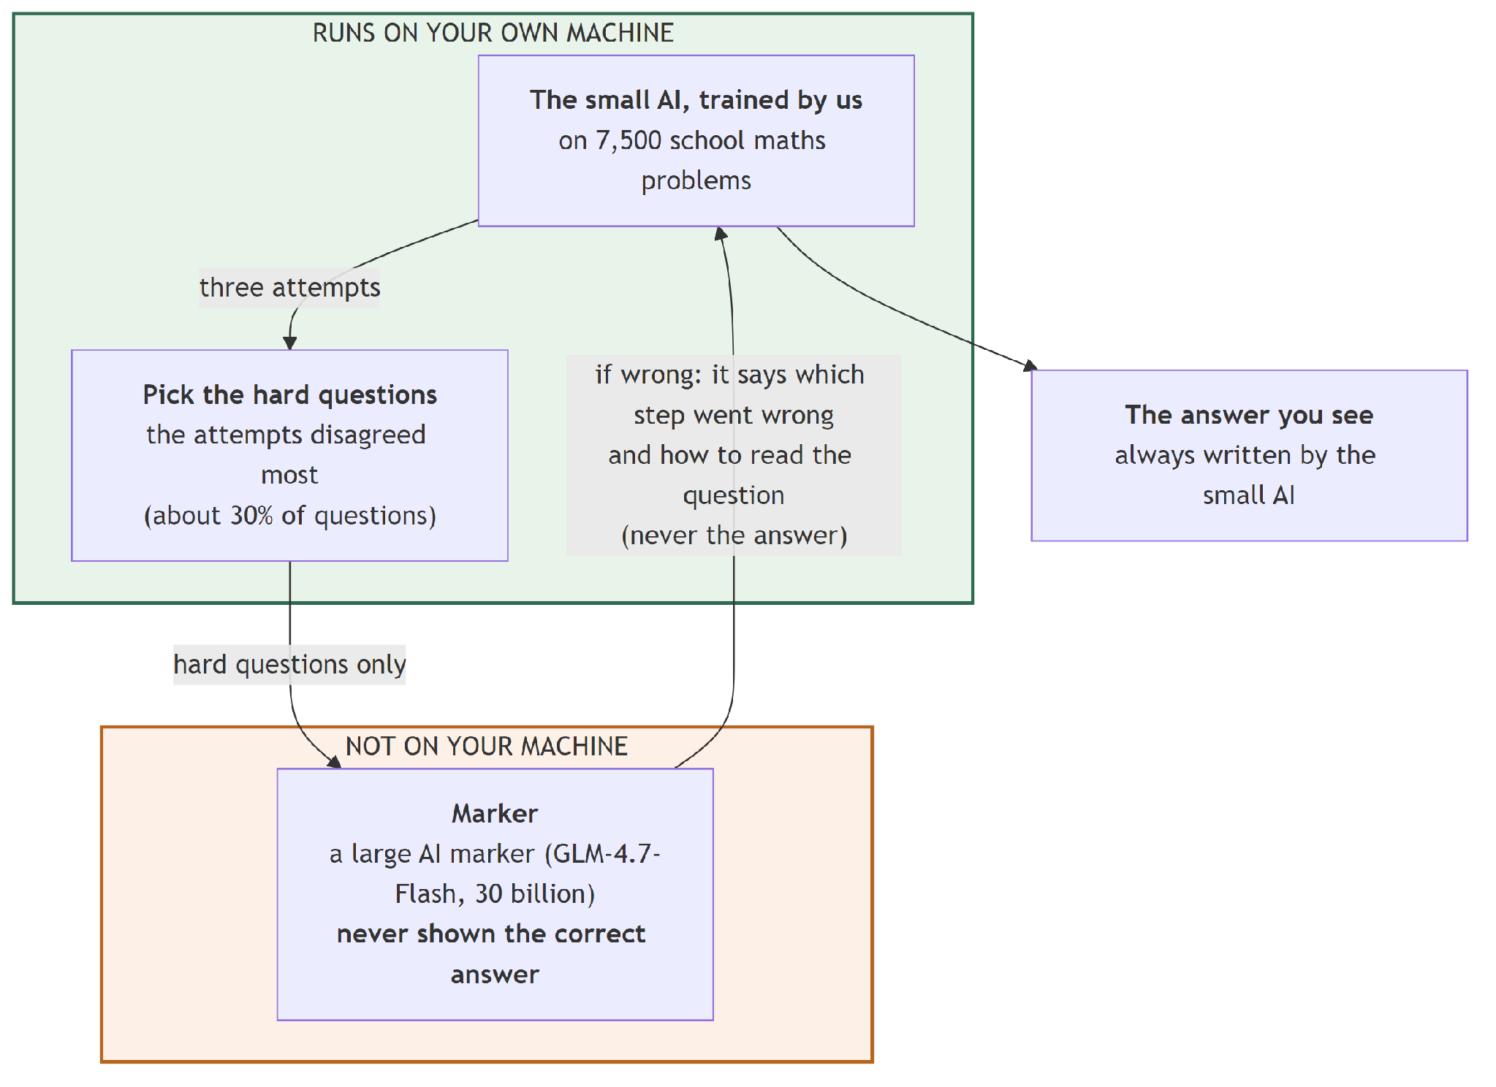
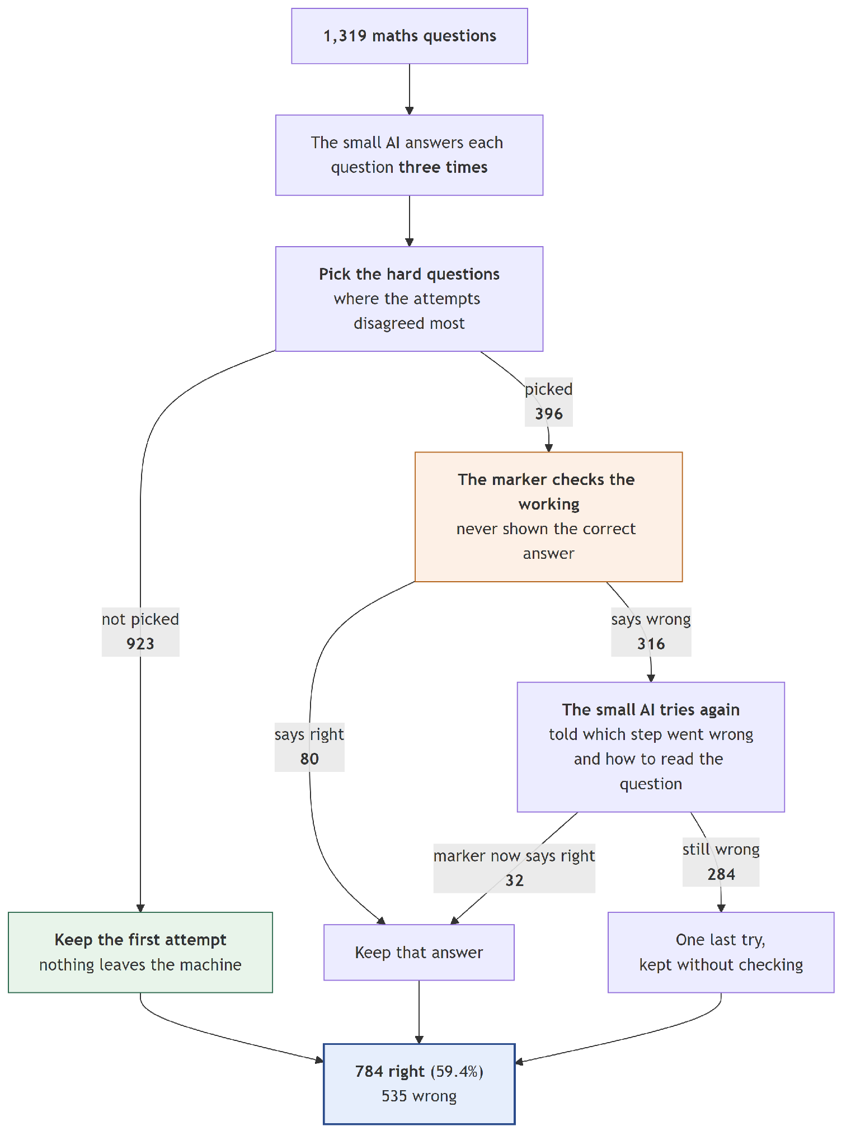

System 11 — The same, but sending 37.3% instead of 30%
What it is. System 10 with the budget raised from 396 questions to 492.
Why that number. 492 is not arbitrary — it is the gate's natural threshold. With three samples, disagreement can only take three values, so the gate can only draw three honest lines. The line that means "send every question where the model contradicts itself completely" falls at 492 questions, which is 37.3% of the test set. Asking for 30% cuts inside that group, where questions are tied and the code has to break the tie arbitrarily.
What happened. 801 correct, +4.85 points — the best of Group C.
The extra 96 questions were worth having, but they were not cheap: checker calls went from 712 to 889, and tokens per question from 296.0 to 369.0. That is 25% more cost for 17 more correct answers.
Correct | 801 of 1,319 — 60.73%
vs. System 02 | +4.85 points
vs. System 10 | +17 answers, at 25% more checker cost
Turned right / wrong | 94 / 30
Sent to the checker | 492 (37.3%)
Checker calls | 889
Checker tokens per question | 369.0
Time for all 1,319 | 20 h 37 min

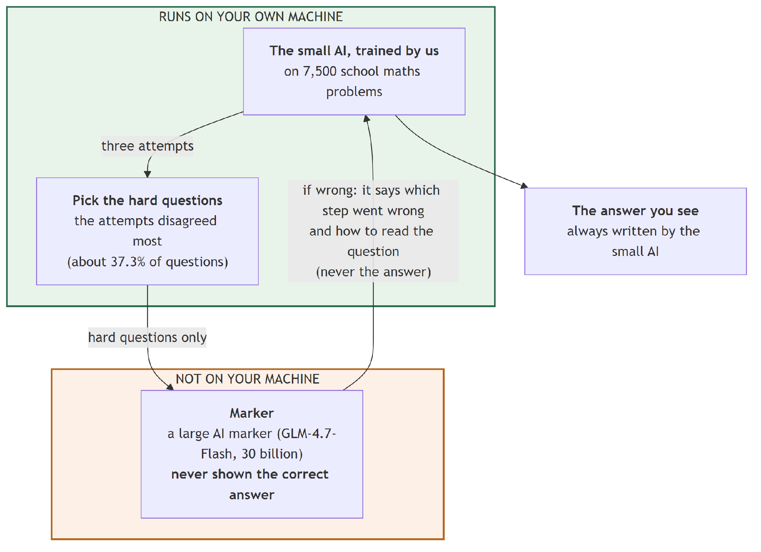
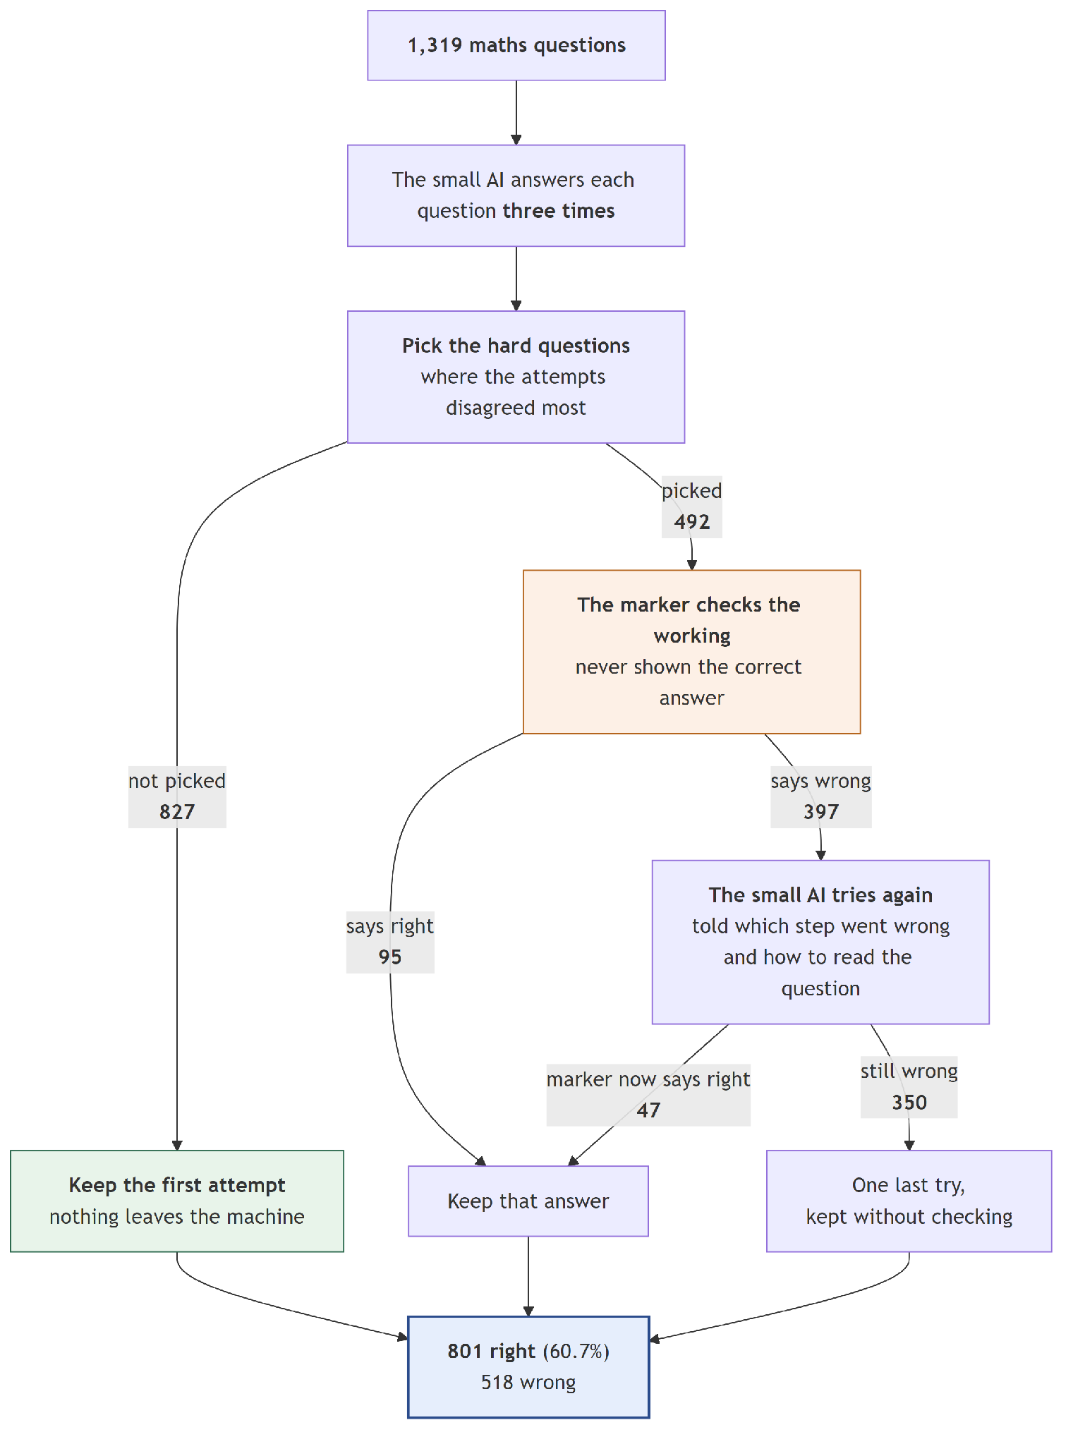

System 12 — The same, but with a smarter gate
What it is. System 10 with a better way of choosing which 396 questions to send. As well as counting how much the three attempts disagree, we use how confident the model was, to order the questions that are tied on disagreement.
Confidence is used only to break ties. It can never outrank disagreement. That matters for an honest reason as well as a technical one: because there is no weighting number to choose, there is no number we could have quietly tuned to flatter our own results on the test set.
What happened. 795 correct, +4.40 points. It swapped 76 of the 396 escalated questions for better ones, and its precision rose from 79.5% to 82.1%.
So the gate really is better at picking. But notice it lands below System 11, which simply sent more questions — and Section 10.4 shows that its advantage over System 10 is not statistically solid. The gate's improvement gets absorbed downstream before it reaches the score.
Where it clearly does win is cost: it reaches 60.27% for 307.5 tokens per question, where System 11 reaches 60.73% for 369.0 — 17% cheaper.
Correct | 795 of 1,319 — 60.27%
vs. System 02 | +4.40 points
vs. System 10 | +11 answers, p = 0.343 — not distinguishable from chance
Turned right / wrong | 80 / 22
Sent to the checker | 396 (30%)
Checker calls | 728
Checker tokens per question | 307.5
Time for all 1,319 | 20 h 02 min

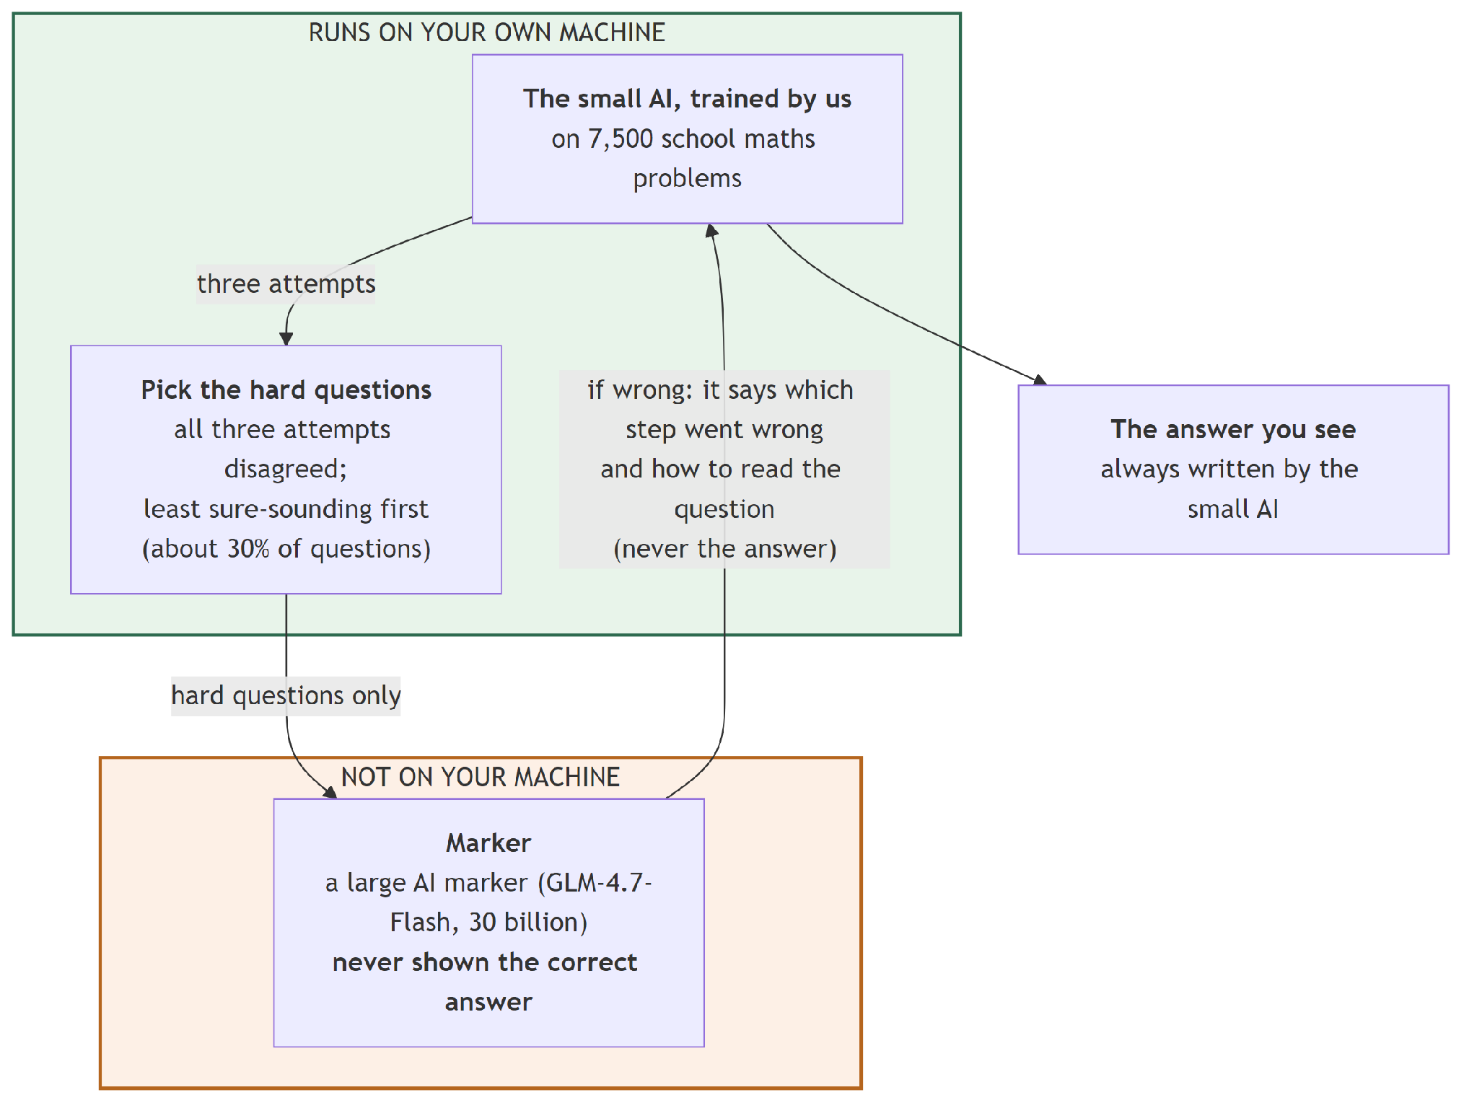
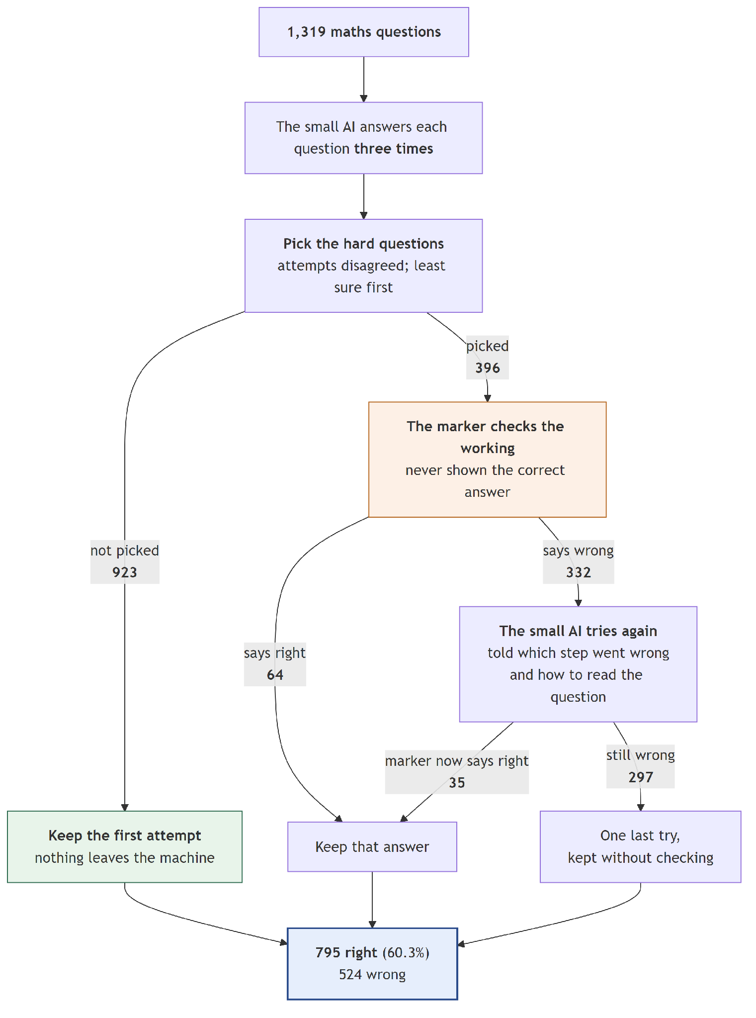

Group D — Systems 13 to 17: the same runs, stacked on voting
Here is the most important idea in the report, and it costs nothing.
Systems 13 to 17 are not new runs. They are Systems 08 to 12 read a second way. The gate already had to generate three samples per question in order to measure disagreement. Group C threw those samples away after using them to choose. Group D uses them.
The rule is: take the majority vote first. Use the cascade's answer only where the vote was split.
Every system in this group scores exactly 42 answers higher than its Group C twin, at exactly the same cost — the same checker calls, the same tokens, the same hours.
Why exactly 42, every time? Because voting and checking never touch the same question. Voting only changes answers in the middle group, where two of three attempts agree — it changed 81 there. The cascade only operates on the group where all three attempts differ. The two sets do not overlap, so the gains add cleanly and identically.
This is not a tuning trick. It is a structural property of how the two mechanisms divide the work.

System 13 — Vote + gate + 30B checker, no hint
What it is. System 08, stacked on the vote.
What happened. 756 → 798. +42.
Correct | 798 of 1,319 — 60.50%
Gain from stacking | +42, at zero extra cost
vs. System 04 (free voting) | +1.44 points, p = 0.034 — real
Turned right / wrong | 100 / 39
Checker tokens per question | 300.9

Worth pausing on that middle row. System 08 alone could not be shown to beat free voting. The identical run, read this way, beats it with a solid p-value.
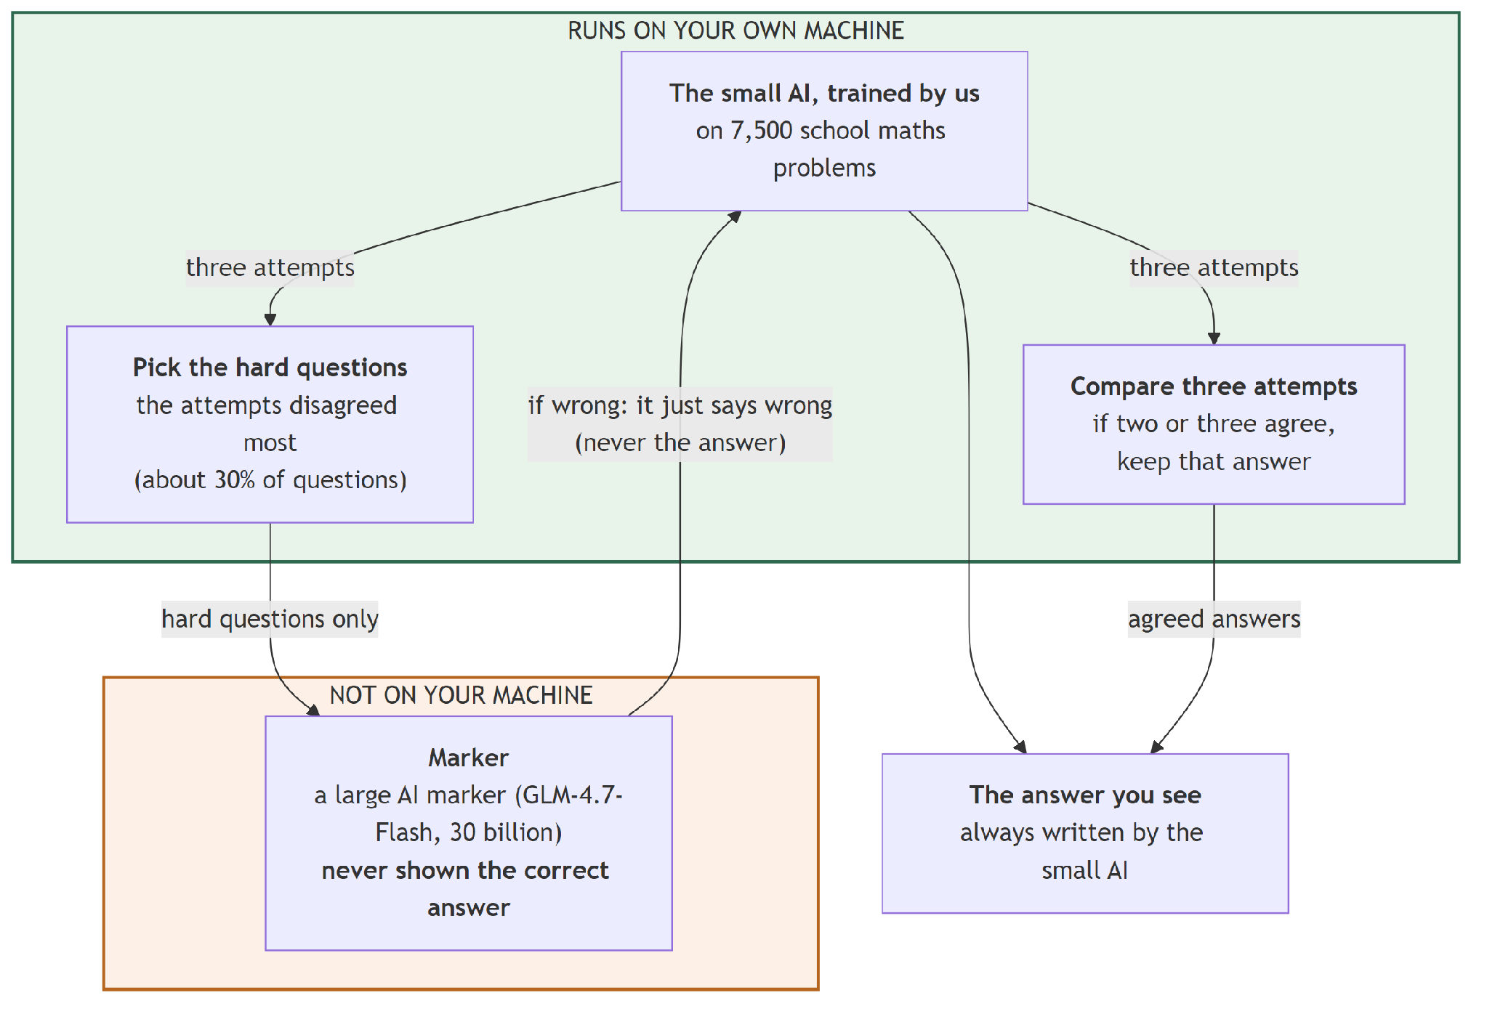
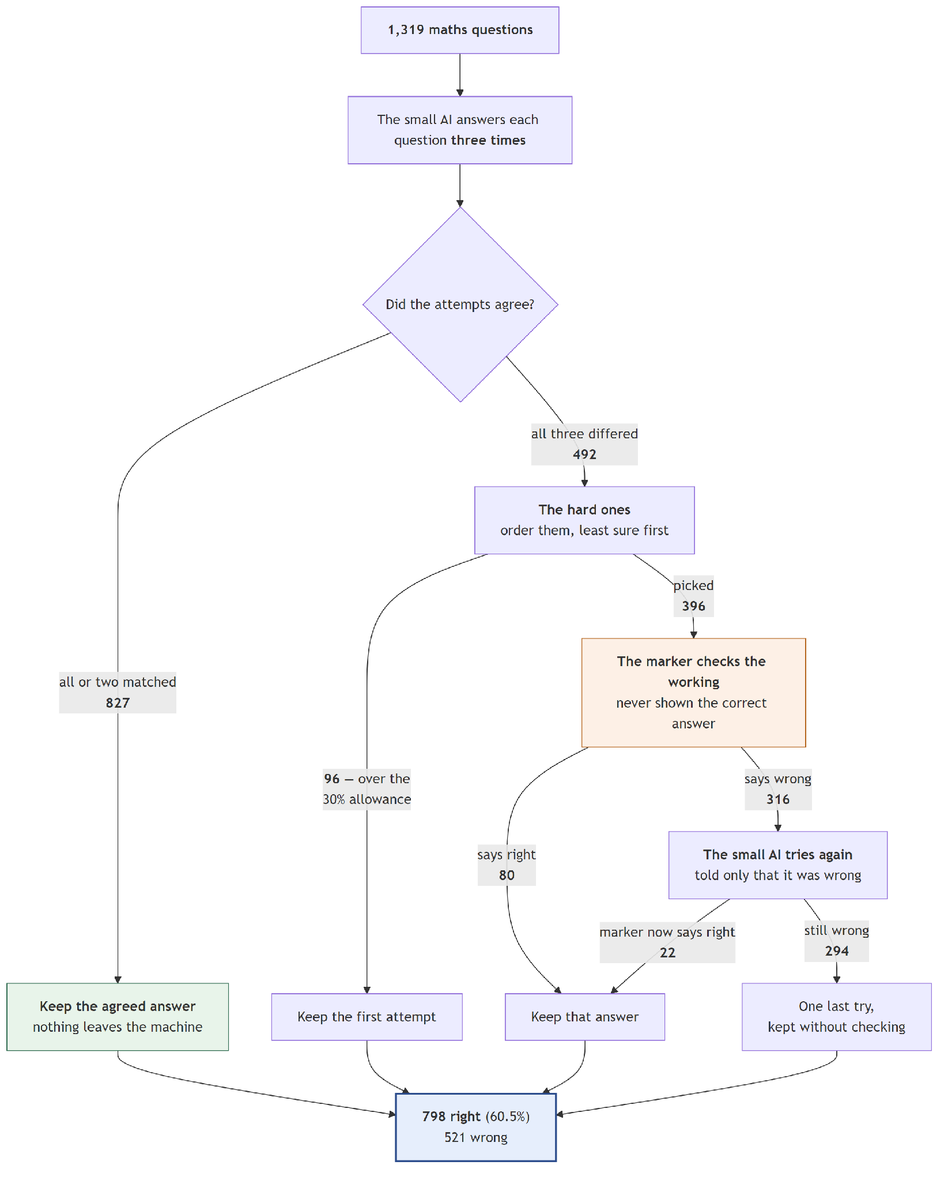

System 14 — Vote + gate + 30B checker, short hint
What it is. System 09, stacked.
What happened. 765 → 807. +42 again.
Correct | 807 of 1,319 — 61.18%
Gain from stacking | +42, at zero extra cost
vs. System 04 | +2.12 points, p = 0.0018 — real
Turned right / wrong | 106 / 36
Checker tokens per question | 297.9

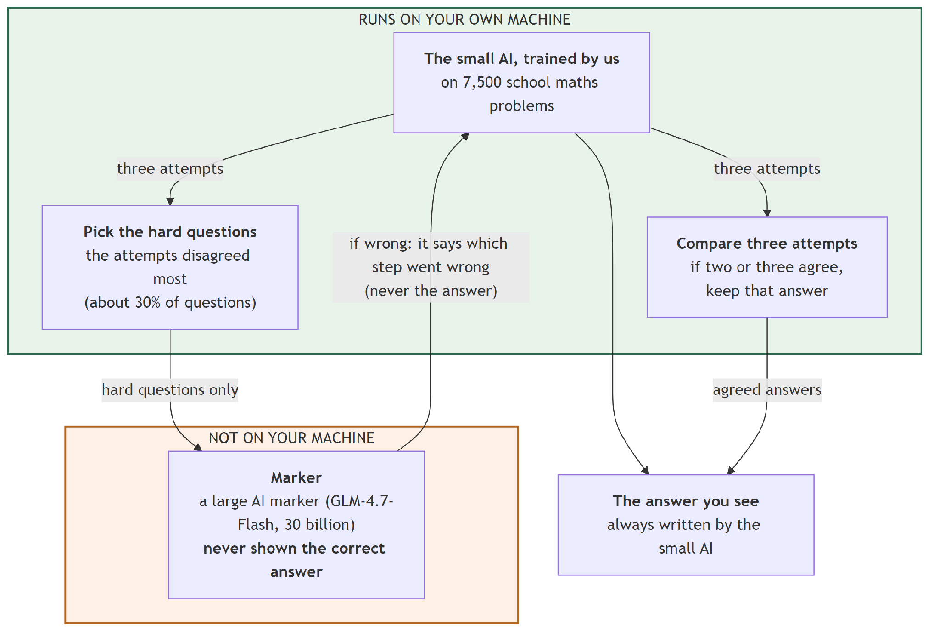
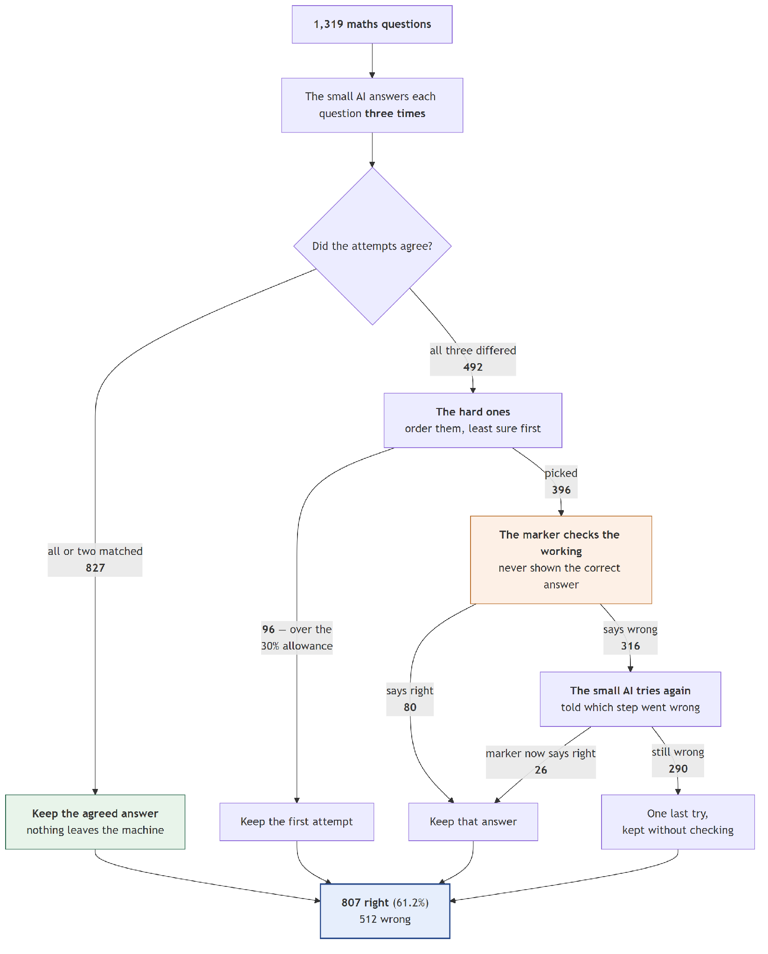

System 15 — Vote + gate + 30B checker, full hint
What it is. System 10, stacked. This is the direct answer to the failure in Section 10.1.
What happened. 784 → 826. +42.
 | System 10 | System 15
Correct | 784 | 826
Score | 59.44% | 62.62%
Checker calls | 712 | 712 — identical
Tokens per question | 296.0 | 296.0 — identical
vs. free voting | p = 0.751, not real | p < 0.001, real

Same run. Same cost. The difference between a result we could not defend and one we can is entirely in whether we throw the samples away.
Correct | 826 of 1,319 — 62.62%
Turned right / wrong | 124 / 35
Time for all 1,319 | 19 h 45 min

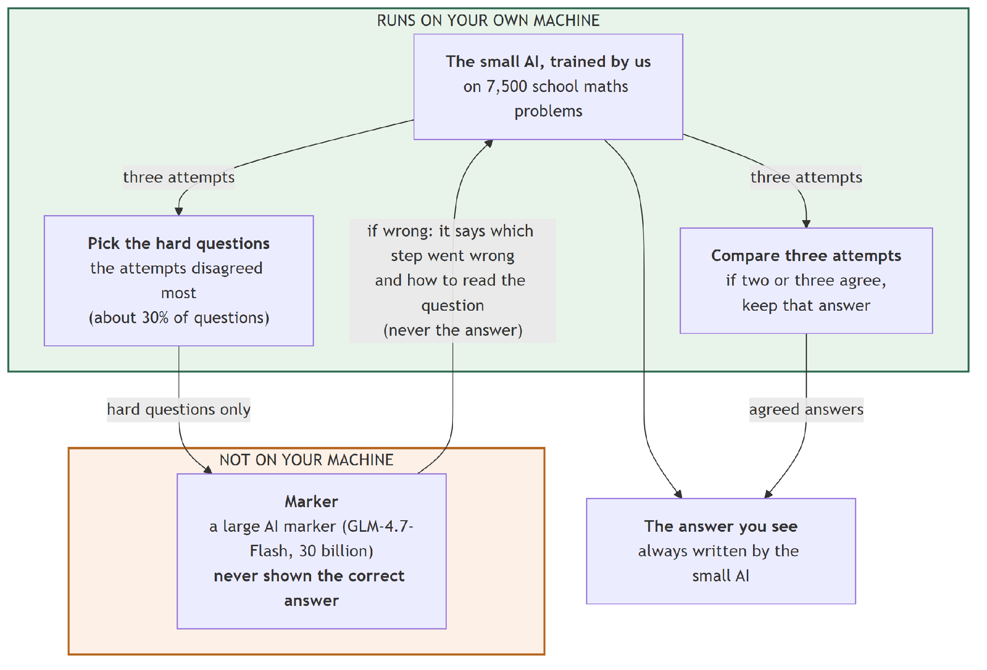
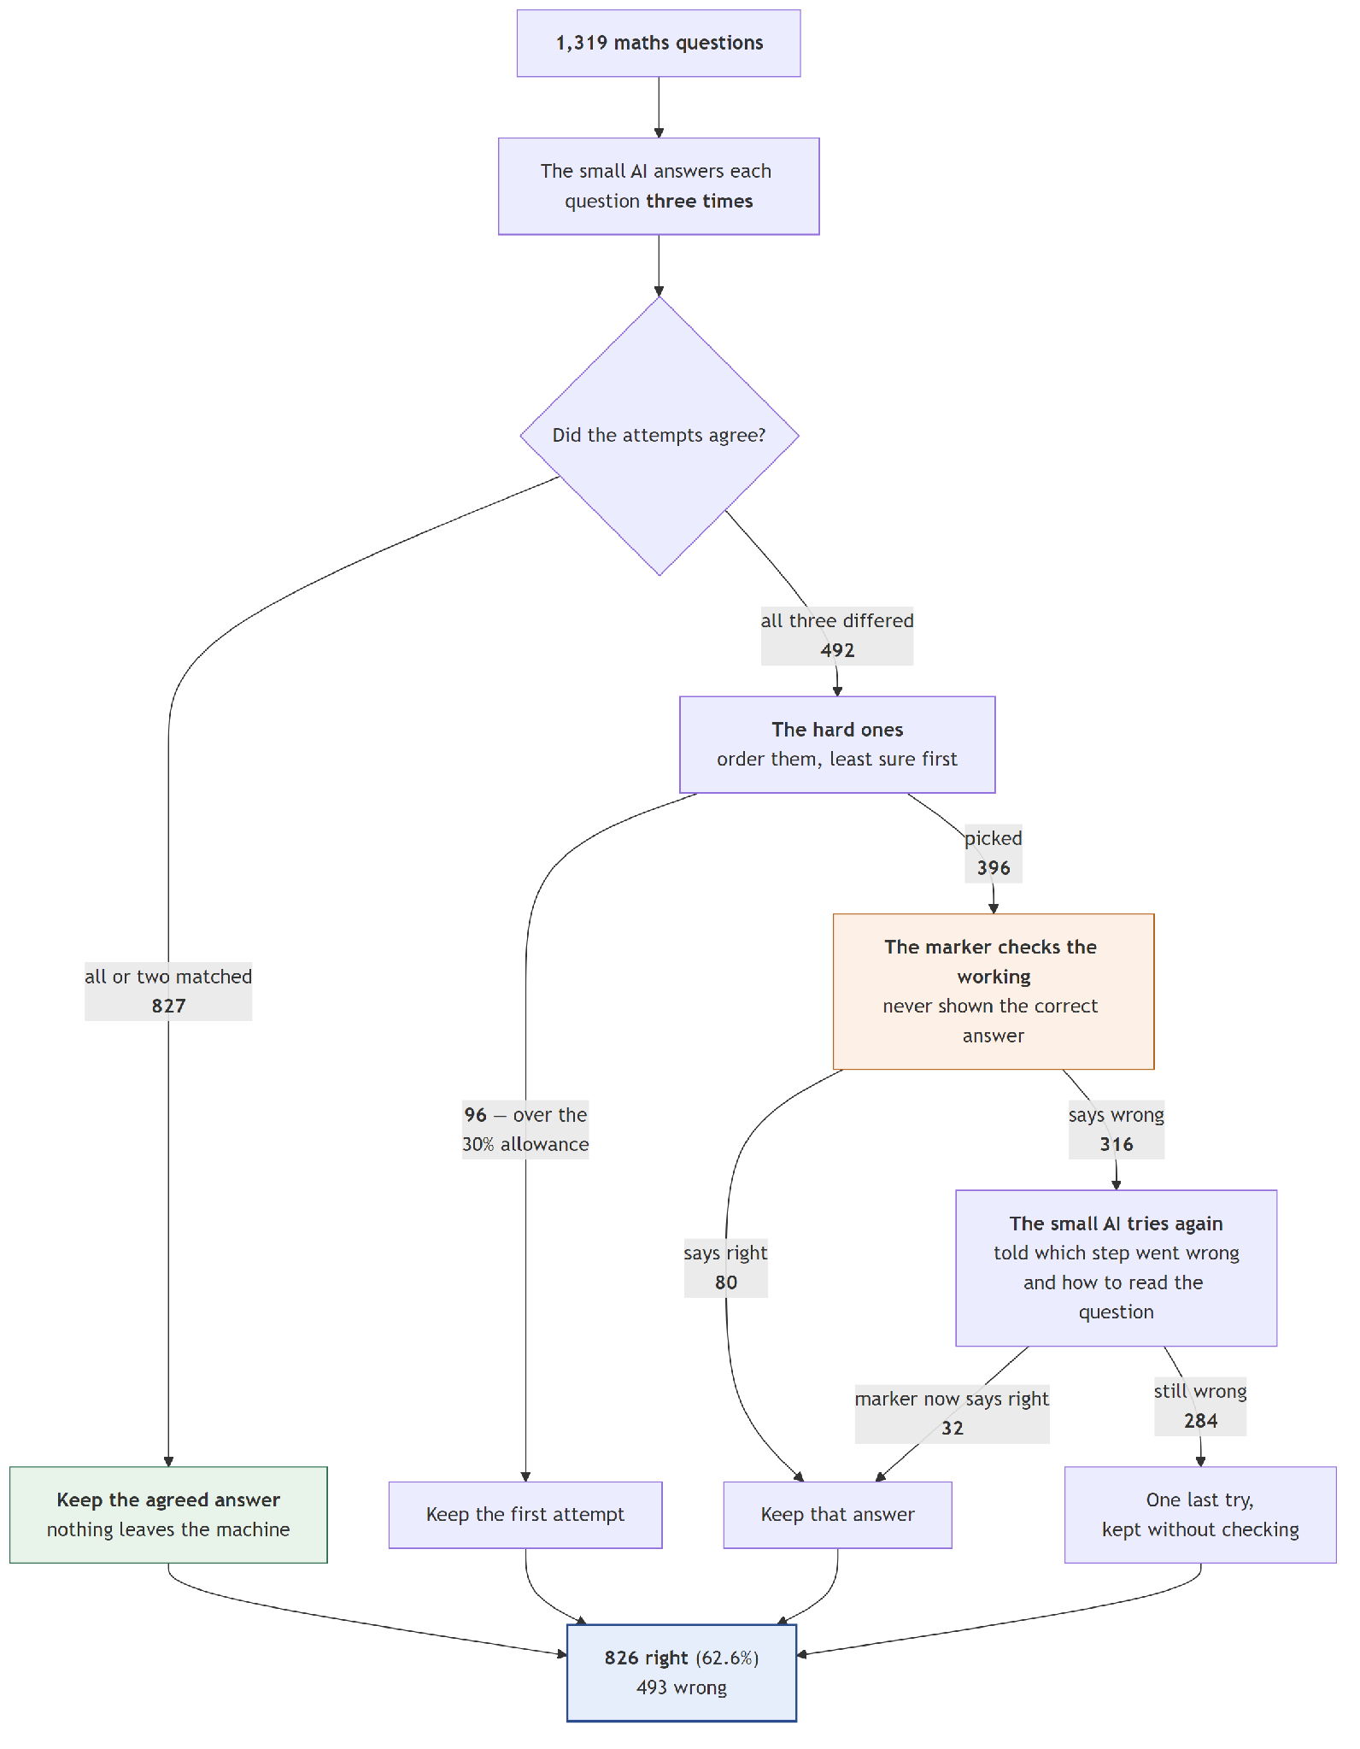

System 16 — Vote + gate at 37.3% + 30B checker, full hint
What it is. System 11, stacked. The best of the 30-billion-checker systems.
What happened. 801 → 843. +42.
Correct | 843 of 1,319 — 63.91%
vs. System 02 | +8.04 points
Gain from stacking | +42, at zero extra cost
Turned right / wrong | 148 / 42
Sent to the checker | 492 (37.3%)
Checker calls | 889
Checker tokens per question | 369.0
Time for all 1,319 | 20 h 37 min

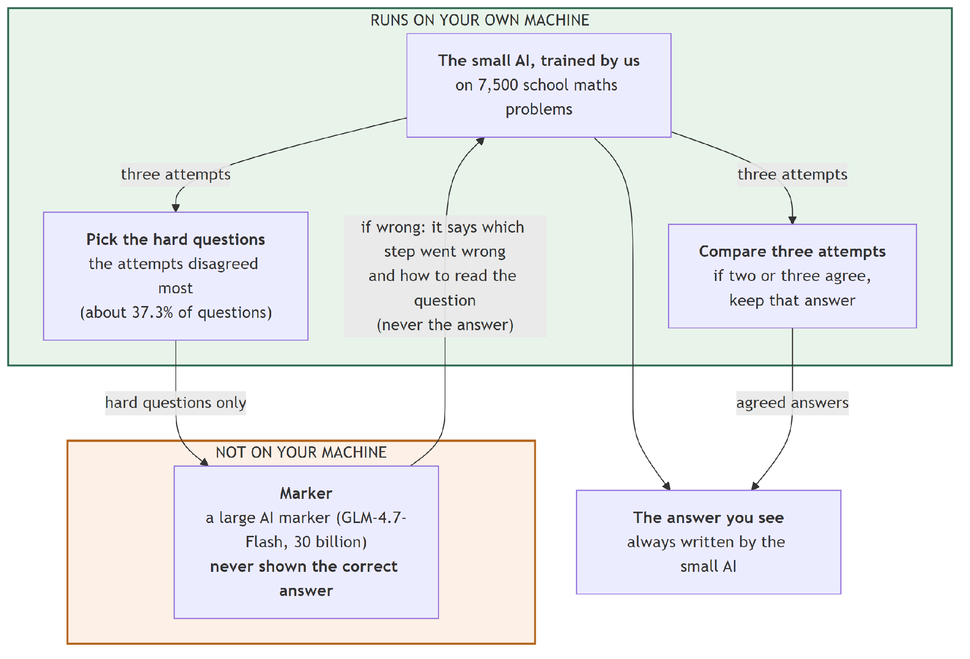
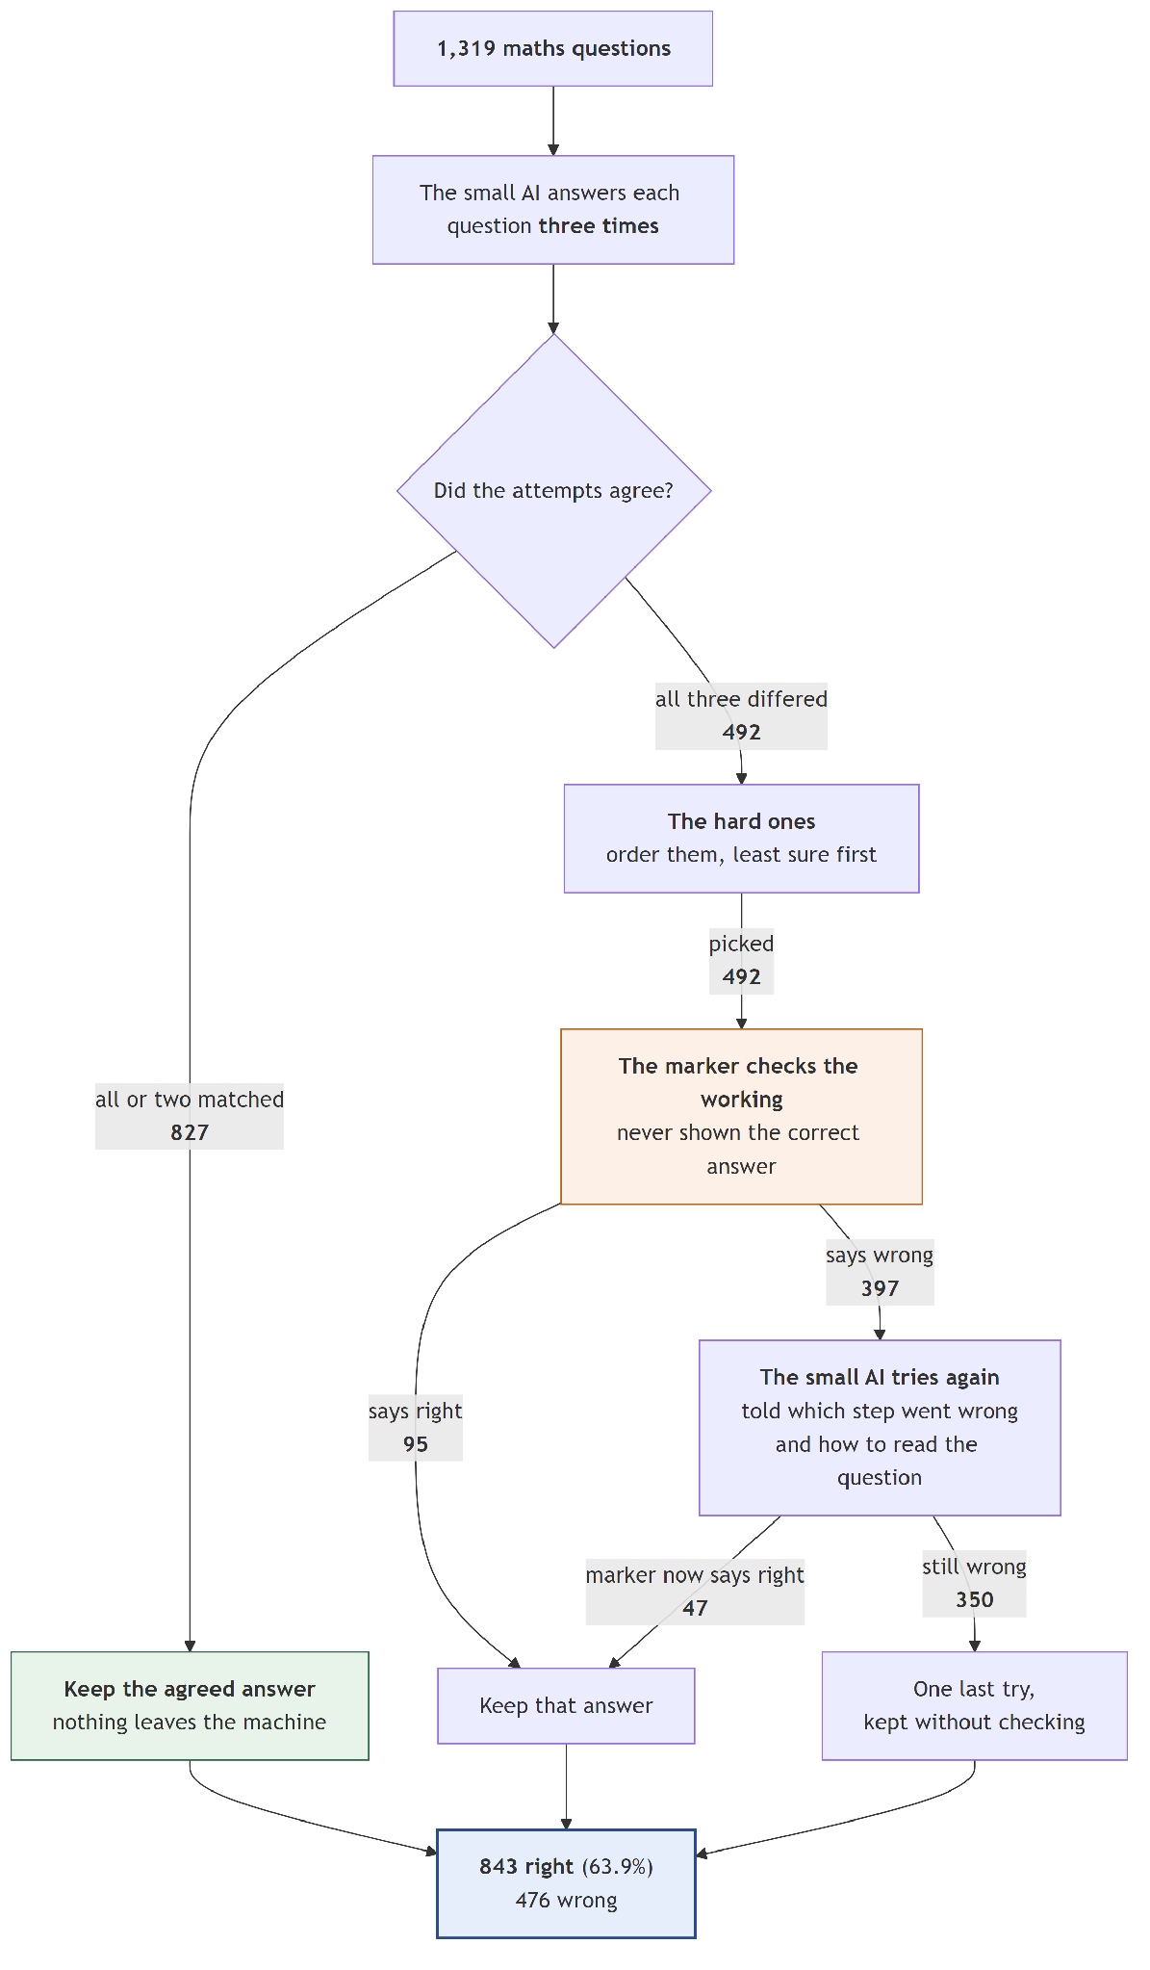

System 17 — Vote + smart gate + 30B checker, full hint
What it is. System 12, stacked.
What happened. 795 → 837. +42.
It scores slightly below System 16 but costs 17% fewer checker tokens (307.5 against 369.0). So within the 30-billion group the choice between them is a genuine trade: System 16 for the best score, System 17 for the better value.
Correct | 837 of 1,319 — 63.46%
vs. System 02 | +7.58 points
vs. System 16 | −6 answers, at 17% less cost, p = 0.640
Turned right / wrong | 134 / 34
Checker tokens per question | 307.5
Time for all 1,319 | 20 h 02 min

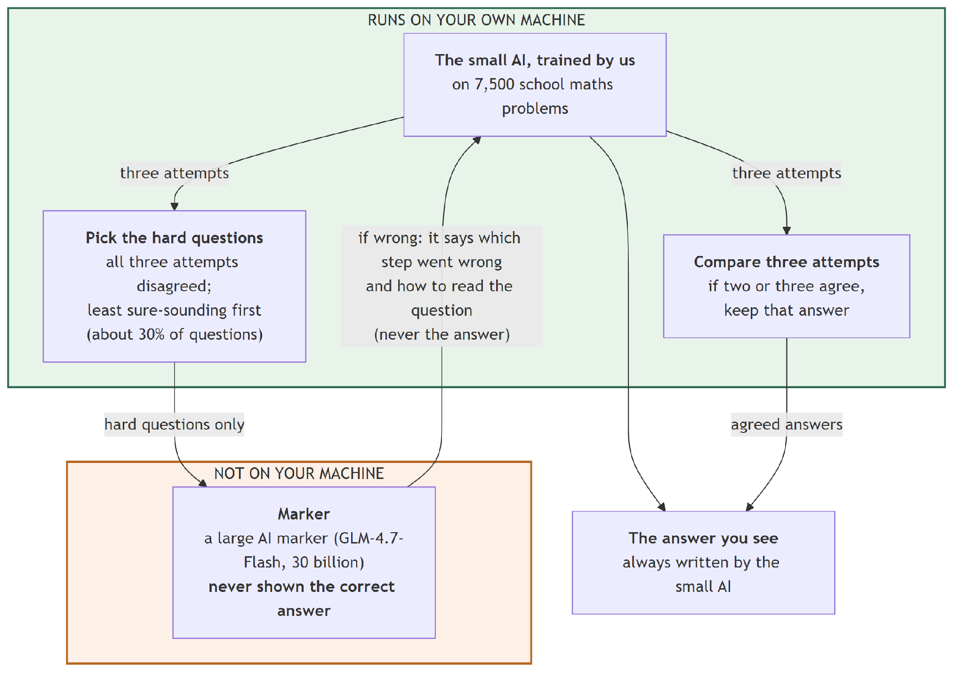
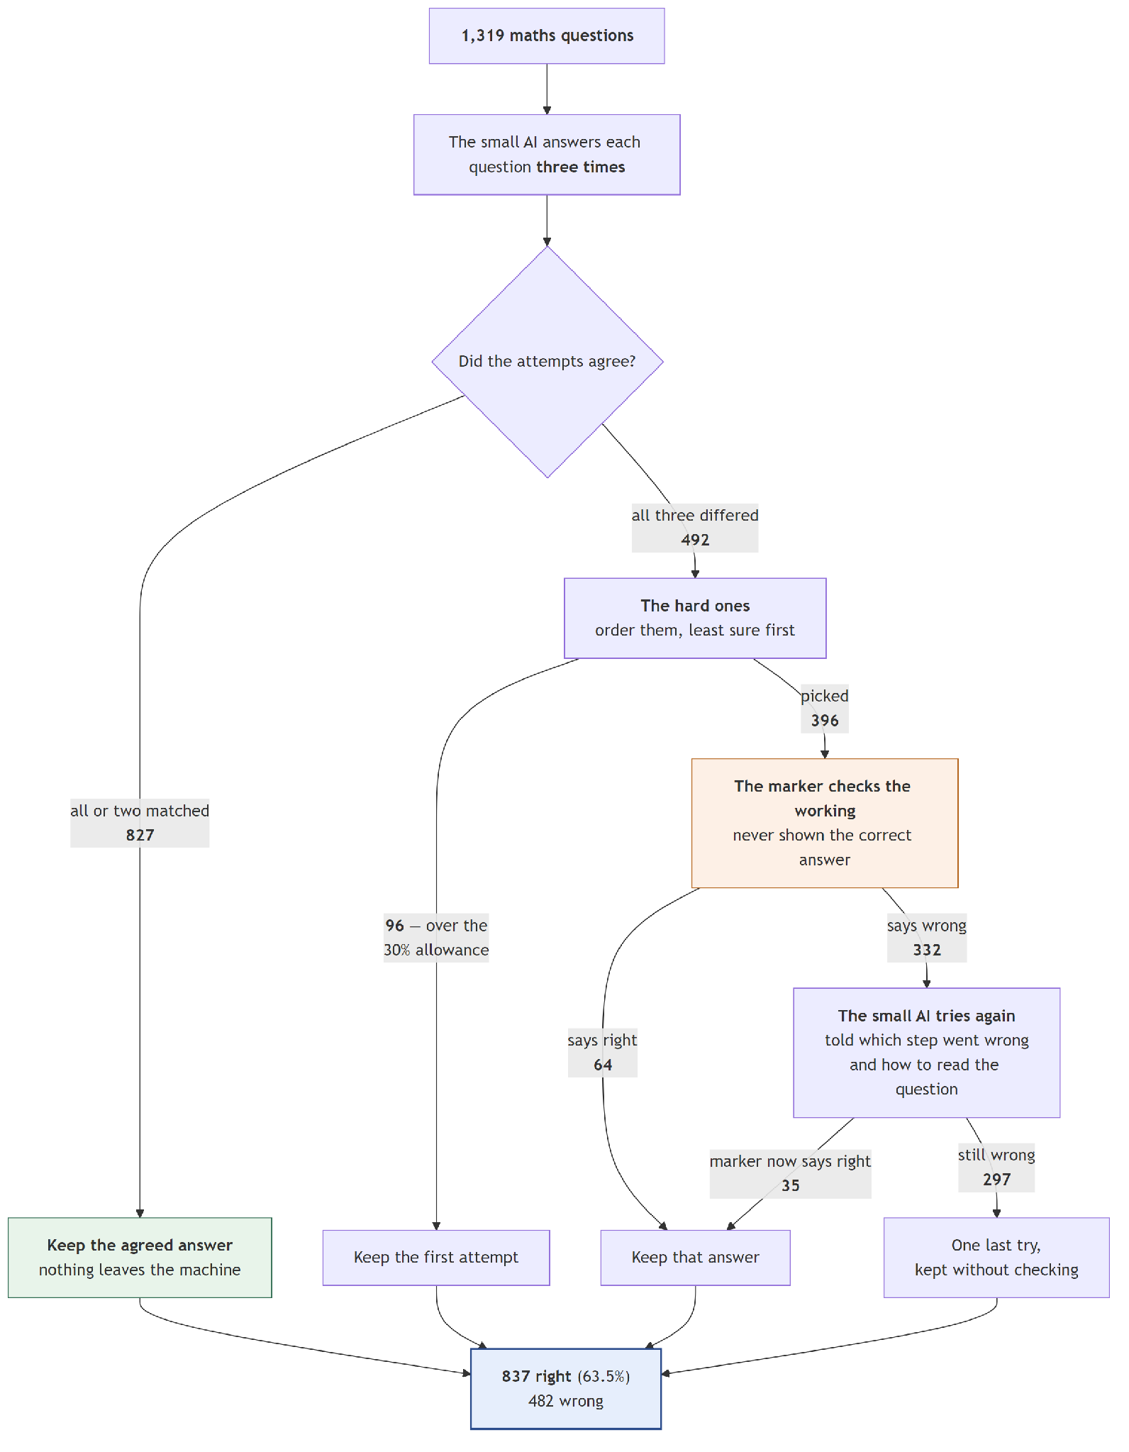

Group E — Systems 18 and 19: swapping in the better checker
Group B told us the 9-billion checker was better than the 30-billion one. These two systems test whether that holds up inside a complete system. They are Systems 12 and 17 with the checker swapped and nothing else changed.
The answer is that it holds up, and by more than we expected: changing the checker alone is worth more than every other improvement in this report put together.

System 18 — Smart gate + 9B checker, no voting
What it is. System 12 with the 9-billion checker in place of the 30-billion one.
What happened. 795 → 861. That is +66 answers from changing the checker alone, and it settles an argument.
Remember that every un-stacked system in Group C failed to beat free voting. System 18 does not:
 | Score | vs. free voting (59.06%)
System 12 (30B checker) | 60.27% | p = 0.247 — not real
System 18 (9B checker) | 65.28% | p < 0.001 — real

This tells us the failure in Section 10.1 was the checker's fault, not the design's. The cascade idea was sound all along; it was being run with a checker that rejected too many correct answers to pay for itself.
Look at the flip counts too. System 18 turned 136 right and broke only 12 — the lowest breakage of any system that changes answers, and a direct consequence of the 9B model's lower false-rejection rate.
Correct | 861 of 1,319 — 65.28%
vs. System 02 | +9.40 points
vs. System 12 | +66 answers, from the checker alone
Turned right / wrong | 136 / 12
Sent to the checker | 396 (30%)
Checker calls | 728
Checker tokens per question | 345.8
Replies cut off | 18
Time for all 1,319 | 19 h 27 min

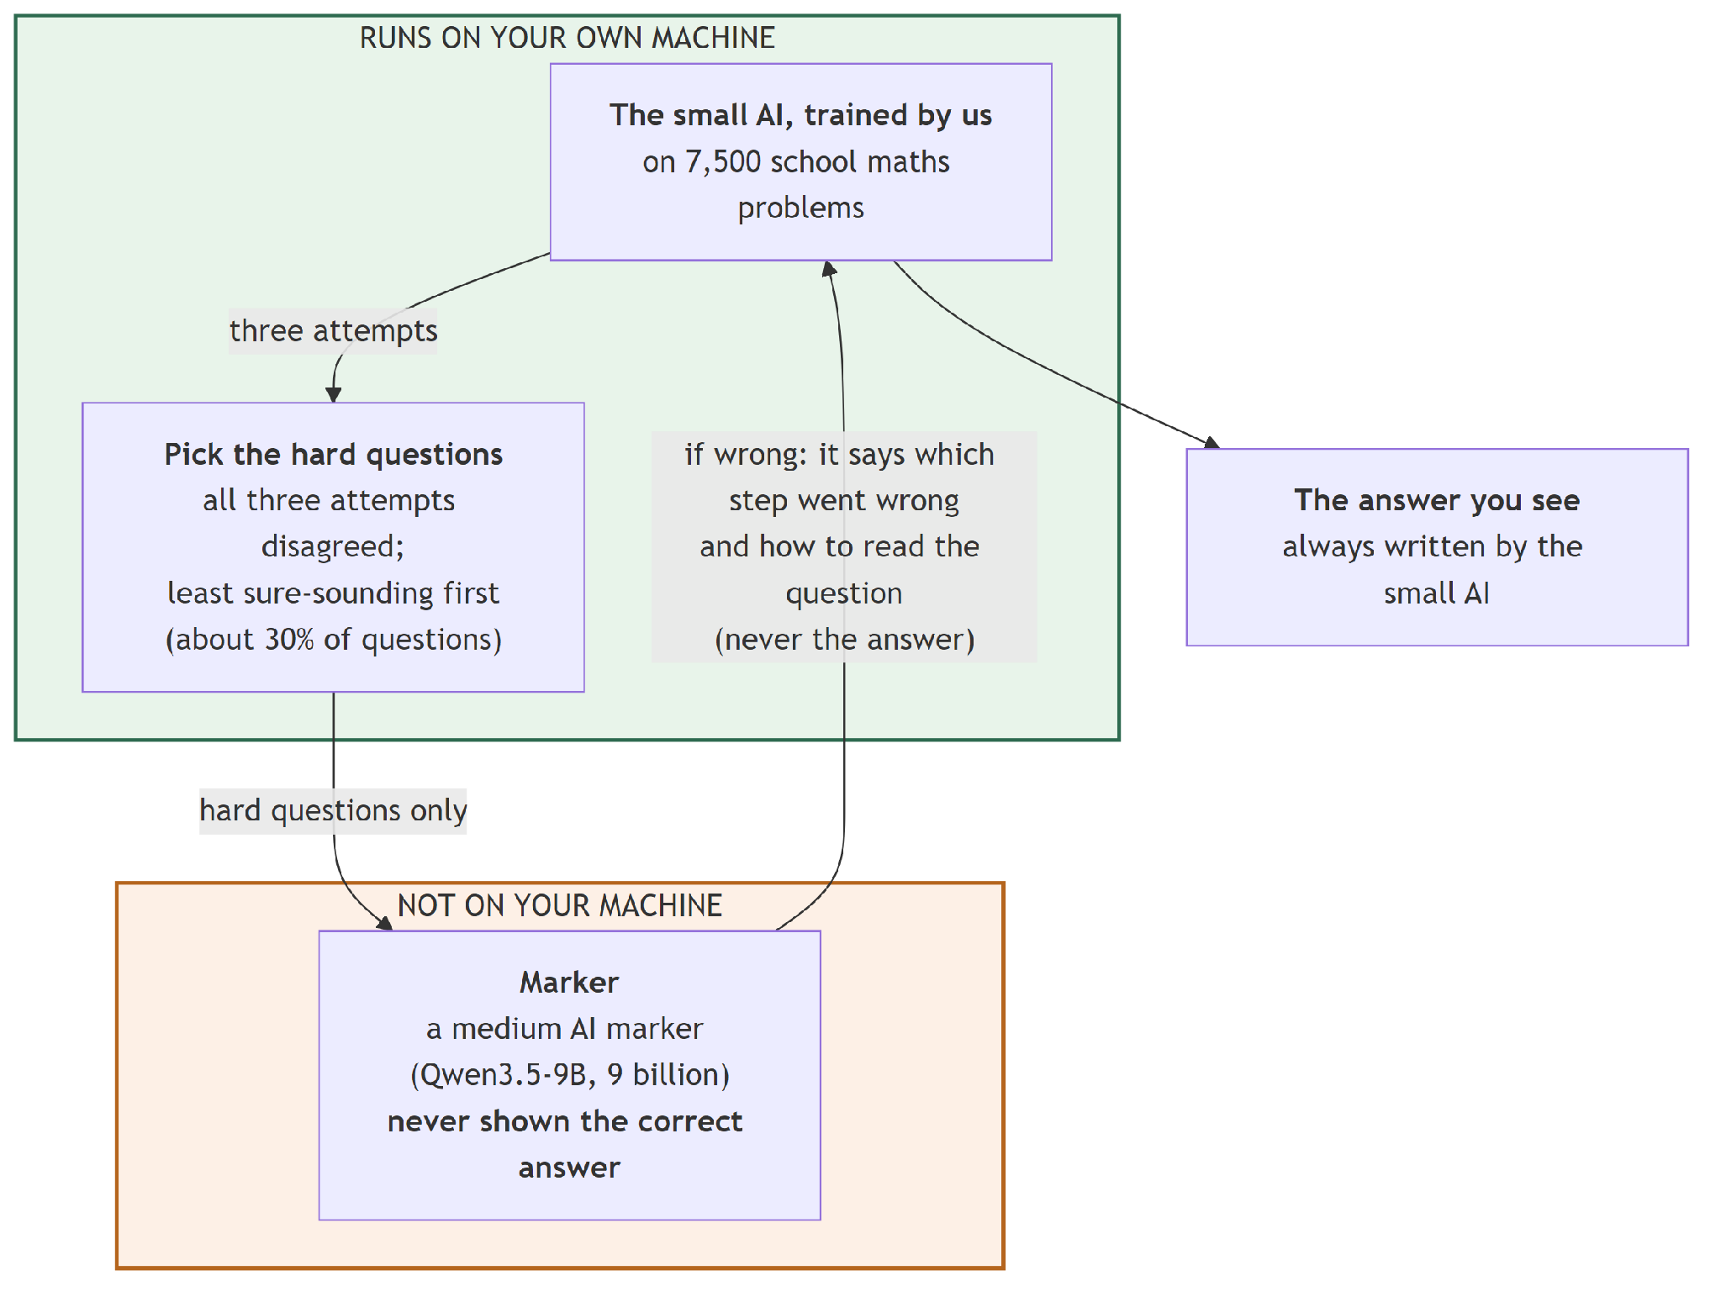
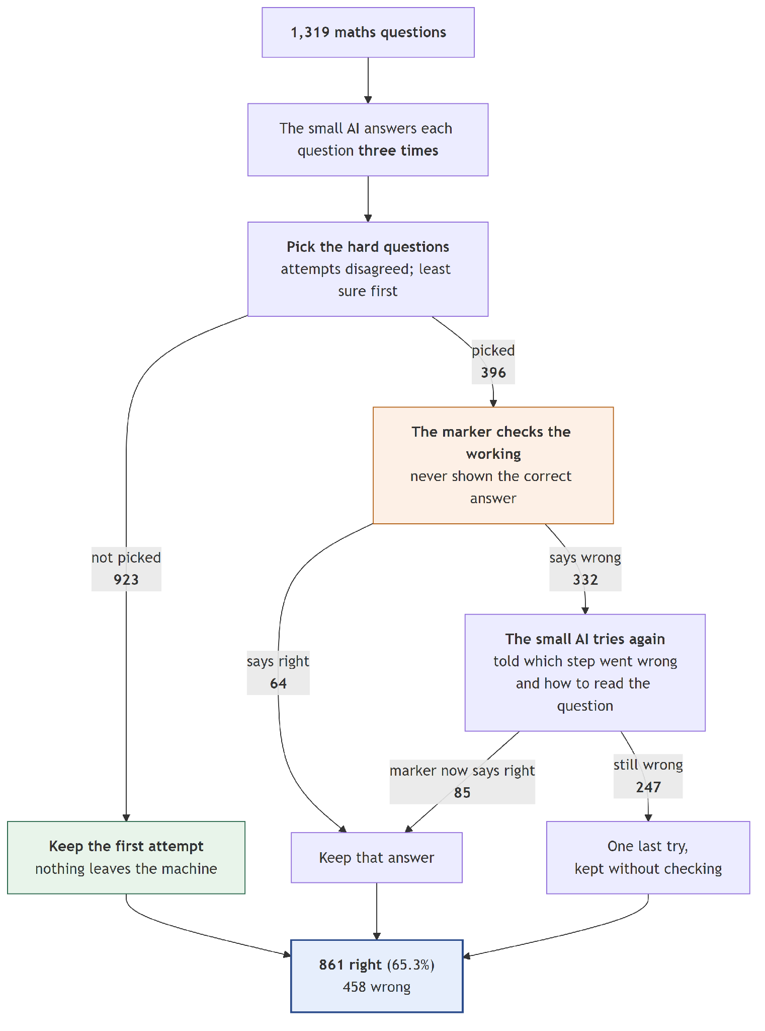

System 19 — Vote + smart gate + 9B checker, full hint — our best result
What it is. Everything we learned, in one system: fine-tune the model, answer three times, vote, escalate only the split votes using disagreement with confidence as a tie-break, have the 9-billion checker mark those, and retry with a full hint.
What happened. 903 of 1,319 — 68.46%.
Correct | 903 of 1,319 — 68.46%
vs. System 02 | +12.59 points
vs. System 04 (free voting) | +9.40 points, p < 0.001
vs. System 17 (same, 30B checker) | +66 answers, p < 0.001
Turned right / wrong | 190 / 24
Share of the 72.93% ceiling | 93.9%
Sent to the checker | 396 (30%)
Questions never leaving the device | 923 — 70%
Checker calls | 728
Checker tokens per question | 345.8
Attempts per question | 3.44
Time for all 1,319 | 19 h 27 min

Three things worth saying about this row.
190 fixed against 24 broken. No other system comes close to that ratio. It is what a good checker buys we: it finds mistakes without manufacturing them.
70% of questions never leave the device. That is the number the whole project is about. Of the 1,319 questions, 827 are settled by the vote and another 96 are left alone by the budget — 923 in total answered entirely locally.
93.9% of the ceiling. The remaining gap to 72.93% is made of questions the small model never answered correctly in any of its three attempts. No checker can find an answer the model never produced.
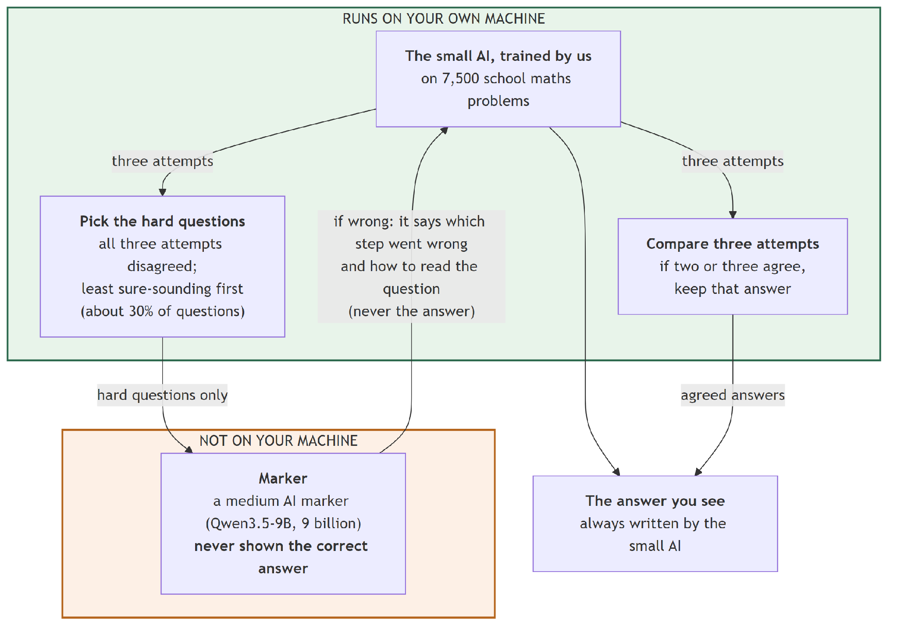
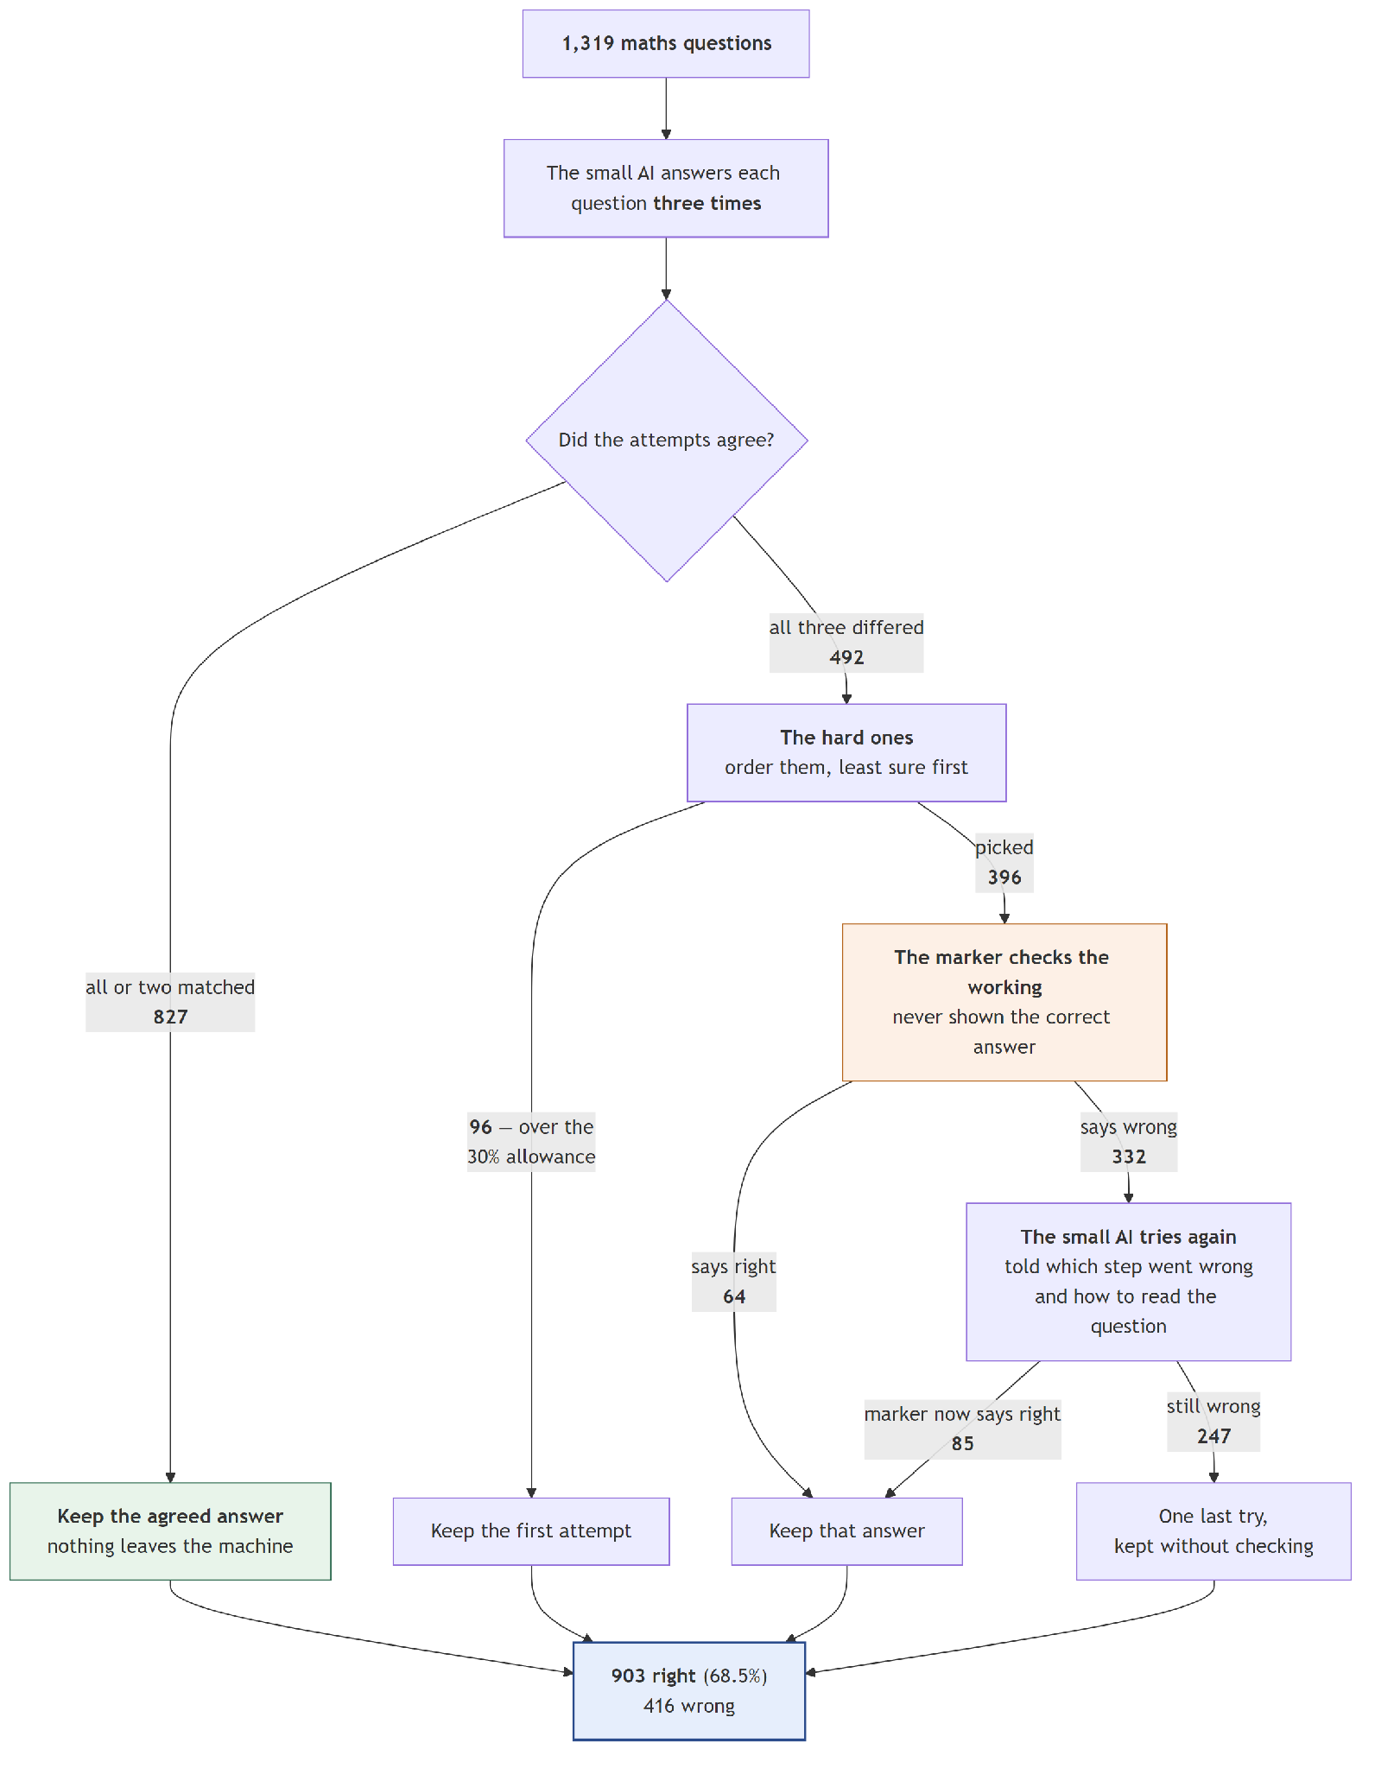

8.6 All 19 together
# | System | Correct | Score | vs. System 02 | Turned right | Turned wrong
01 | Before training (8 examples) | 479 | 36.32% | −19.56 | 138 | 396
02 | After training | 737 | 55.88% | — | — | —
03 | Blind retry | 658 | 49.89% | −5.99 | 138 | 217
04 | Majority vote | 779 | 59.06% | +3.18 | 54 | 12
05 | 30B marks all | 737 | 55.88% | +0.00 | 0 | 0
06 | 9B marks all | 737 | 55.88% | +0.00 | 0 | 0
07 | Answer key marks all | 737 | 55.88% | +0.00 | 0 | 0
08 | Gate + 30B, no hint | 756 | 57.32% | +1.44 | 46 | 27
09 | Gate + 30B, short hint | 765 | 58.00% | +2.12 | 52 | 24
10 | Gate + 30B, full hint | 784 | 59.44% | +3.56 | 70 | 23
11 | Gate at 37.3% + 30B | 801 | 60.73% | +4.85 | 94 | 30
12 | Smart gate + 30B | 795 | 60.27% | +4.40 | 80 | 22
13 | Vote + gate + 30B, no hint | 798 | 60.50% | +4.62 | 100 | 39
14 | Vote + gate + 30B, short hint | 807 | 61.18% | +5.31 | 106 | 36
15 | Vote + gate + 30B, full hint | 826 | 62.62% | +6.75 | 124 | 35
16 | Vote + gate at 37.3% + 30B | 843 | 63.91% | +8.04 | 148 | 42
17 | Vote + smart gate + 30B | 837 | 63.46% | +7.58 | 134 | 34
18 | Smart gate + 9B | 861 | 65.28% | +9.40 | 136 | 12
19 | Vote + smart gate + 9B | 903 | 68.46% | +12.59 | 190 | 24
— | Ceiling: right if any of 3 attempts was right | 962 | 72.93% | +17.06 | — | —

8.7 What each one costs
# | Attempts per question | Tokens written | Tokens read | Sent to checker | Checker calls | Checker tokens per question | Estimated time for all 1,319
01 | 1.00 | 120.6 | 1617.7 | 0 | 0 | 0.0 | 3 h 19 min (measured)
02 | 1.00 | 125.9 | 87.7 | 0 | 0 | 0.0 | 5 h 13 min
03 | 2.00 | 258.4 | 175.3 | 0 | 0 | 0.0 | 10 h 43 min
04 | 3.00 | 389.8 | 263.0 | 0 | 0 | 0.0 | 16 h 11 min
05 | 1.00 | 125.9 | 87.7 | 1,319 | 1,319 | 499.1 | 5 h 59 min
06 | 1.00 | 125.9 | 87.7 | 1,319 | 1,319 | 565.1 | 5 h 35 min
07 | 1.00 | 125.9 | 87.7 | 1,319 | — | 0.0 | 5 h 13 min
08 | 3.46 | 476.8 | 399.1 | 396 (30%) | 712 | 300.9 | 20 h 12 min
09 | 3.46 | 470.8 | 405.4 | 396 (30%) | 712 | 297.9 | 19 h 57 min
10 | 3.45 | 466.2 | 415.1 | 396 (30%) | 712 | 296.0 | 19 h 45 min
11 | 3.57 | 484.5 | 451.9 | 492 (37%) | 889 | 369.0 | 20 h 37 min
12 | 3.48 | 472.7 | 426.2 | 396 (30%) | 728 | 307.5 | 20 h 02 min
13 | 3.46 | 476.8 | 399.1 | 396 (30%) | 712 | 300.9 | 20 h 12 min
14 | 3.46 | 470.8 | 405.4 | 396 (30%) | 712 | 297.9 | 19 h 57 min
15 | 3.45 | 466.2 | 415.1 | 396 (30%) | 712 | 296.0 | 19 h 45 min
16 | 3.57 | 484.5 | 451.9 | 492 (37%) | 889 | 369.0 | 20 h 37 min
17 | 3.48 | 472.7 | 426.2 | 396 (30%) | 728 | 307.5 | 20 h 02 min
18 | 3.44 | 464.1 | 442.8 | 396 (30%) | 728 | 345.8 | 19 h 27 min
19 | 3.44 | 464.1 | 442.8 | 396 (30%) | 728 | 345.8 | 19 h 27 min

Two notes on this table.
The times are estimates, not measurements. None of the runs recorded how long they took. We built the estimate from speeds we did measure — the small model writes 8.8 tokens per second, the 9B checker takes 1.00 s per check, the 30B takes 2.07 s — and then checked the method against three jobs whose real durations we can recover from timestamps. It was accurate to within 2–3.5% on all three. System 01 is the exception, and we report its measured time instead.
"Checker tokens" did not actually leave the machine. Our checker ran locally. The column counts what would travel to an outside service if the checker were one, because that is the cost this project argues about.

8.8 What the 19 systems add up to
Read in order, the chapter tells a fairly simple story:
Step | Systems | What it bought
Training the model | 01 → 02 | +19.56 points
Voting instead of retrying | 03 → 04 | +9.17 points over blind retry
Adding a checker | 04 → 10 | +0.38 points — not worth it
Stacking instead of substituting | 10 → 15 | +3.18 points, free
Changing the checker | 17 → 19 | +5.00 points

The two biggest wins after fine-tuning cost nothing extra: stacking was free, and swapping the checker made the system cheaper as well as better. The expensive step — adding a checker in the first place — is the one that did the least, until the other two fixed it.

Chapter 9 — Results

9.1 What fine-tuning bought
 | Correct | Score | Tokens read per question | Tokens written | Total
Before training, 8 examples | 479 | 36.32% | 1,617.7 | 120.6 | 1,738.3
After training, no examples | 737 | 55.88% | 87.7 | 125.9 | 213.5

+19.56 points, at 12.3% of the token cost.
The right way to say the second half of that: the trained model needs about 8 times fewer tokens per question. The wrong way — and it is an easy mistake — is "the trained model is 8 times more concise". It is not. Both models write about the same amount: 120.6 tokens versus 125.9. The entire saving is on the reading side, because the trained model does not need eight worked examples in front of every question.
So fine-tuning bought two separate things: it made the model better, and it made the prompt almost disappear.

9.2 What we get without any checker at all
System | Correct | Score | Cost outside the device
Trained model, once | 737 | 55.88% | none
Blind retry | 658 | 49.89% | none
Majority vote of 3 | 779 | 59.06% | none
Ceiling (any of the 3 right) | 962 | 72.93% | none

Three things to take from this table.
Blind retry is harmful. Asking again and keeping the new answer loses 6 points. Looking at individual questions explains why: on one of the samples, retrying fixed 141 wrong answers but broke 229 right ones. Resampling is not symmetric — it is easier to break a correct answer than to repair a wrong one. This is the single most important reason a checker's precision matters more than its recall in this design.
Voting is a strong free baseline. 59.06% for nothing but time.
72.93% is a hard ceiling. If the model does not produce the right answer in any of its three tries, no amount of checking can find it. Everything we do lives in the band between 55.88% and 72.93%.

9.3 Can the device tell when it is wrong?
This is what decides which questions get escalated. We measured four candidate signals with AUC — how reliably the signal ranks a wrong answer above a right one. 0.5 is a coin flip, 1.0 is perfect.
Signal | AUC | What it costs
How long the answer is | 0.676 | nothing
How confident the model was in the final number | 0.715 | one extra pass
Whether 3 attempts disagree | 0.840 | 2 extra generations
Disagreement, ties broken by confidence | 0.869 | nothing extra

The model's own confidence is a fairly poor judge of itself. Whether it contradicts itself across attempts is far stronger. That is the main finding here, and it has a practical consequence: if we are already voting, the best gate signal is already paid for.
What that means at our actual 30% budget, out of 582 wrong answers:
Signal | Mistakes caught | When it said "risky", how often it was right
Length | 249 | 62.9%
Confidence | 267 | 67.4%
Disagreement | 315 | 79.5%
Both | 325 | 82.1%

Same cost, 76 more mistakes found by choosing the right signal.

9.4 How good does the checker have to be?
We tested four checkers of increasing size. The results are not a straight line.
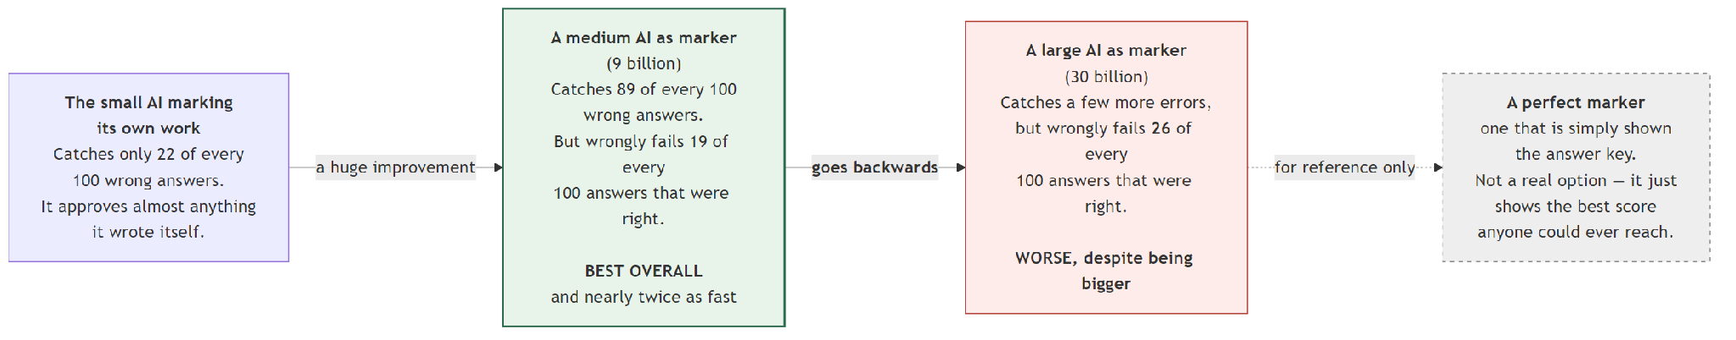
Figure 9.1: Checker strength as a measured variable. Bigger is not reliably better.
Checker | Size | Caught the wrong answers | Wrongly failed right answers | Time per check
The 2B checking its own work | 2B | 22% | 42% | 13.0 s
Qwen3.5-9B | 9B | 89% | 19% | 1.0 s
GLM-4.7-Flash | 30B | 84% | 26% | 2.1 s
The answer key | — | 100% | 0% | instant

The small model cannot check itself. It caught about one wrong answer in five, and wrongly failed more than two right answers in five. It was also unusable in practice: 19 of its 30 replies could not even be parsed. And it was 6 times slower per judgment than the 30-billion model, because the serving software and how many parameters are active per token matter far more than the total size.
The 9-billion model beat the 30-billion model on every measure, and ran about twice as fast (1.0 s per check against 2.1 s). It caught 31 more mistakes and wrongly failed 51 fewer correct answers. Its file is 5.6 GB against 16.3 GB.
We think the fair reading is that there is a size that fits this task, and 30 billion overshoots it — a larger model is more willing to find fault with correct working, and in this design that is expensive.
A caution on the 2B row: it is a 30-question trial, not a full run, so its error bars are wide. Chapter 10 explains why we do not take small trials very seriously any more.

9.5 The full system
System | Correct | Score | Checker tokens per question | Checker calls
Trained model alone | 737 | 55.88% | 0.0 | 0
Majority vote (free) | 779 | 59.06% | 0.0 | 0
GLM cascade, no voting | 784 | 59.44% | 296.0 | 712
GLM cascade, stacked | 826 | 62.62% | 296.0 | 712
GLM at 37.3%, stacked | 843 | 63.91% | 369.0 | 889
GLM smart gate, stacked | 837 | 63.46% | 307.5 | 728
Qwen cascade, no voting | 861 | 65.28% | 345.8 | 728
Qwen smart gate, stacked | 903 | 68.46% | 345.8 | 728
Ceiling | 962 | 72.93% | — | —

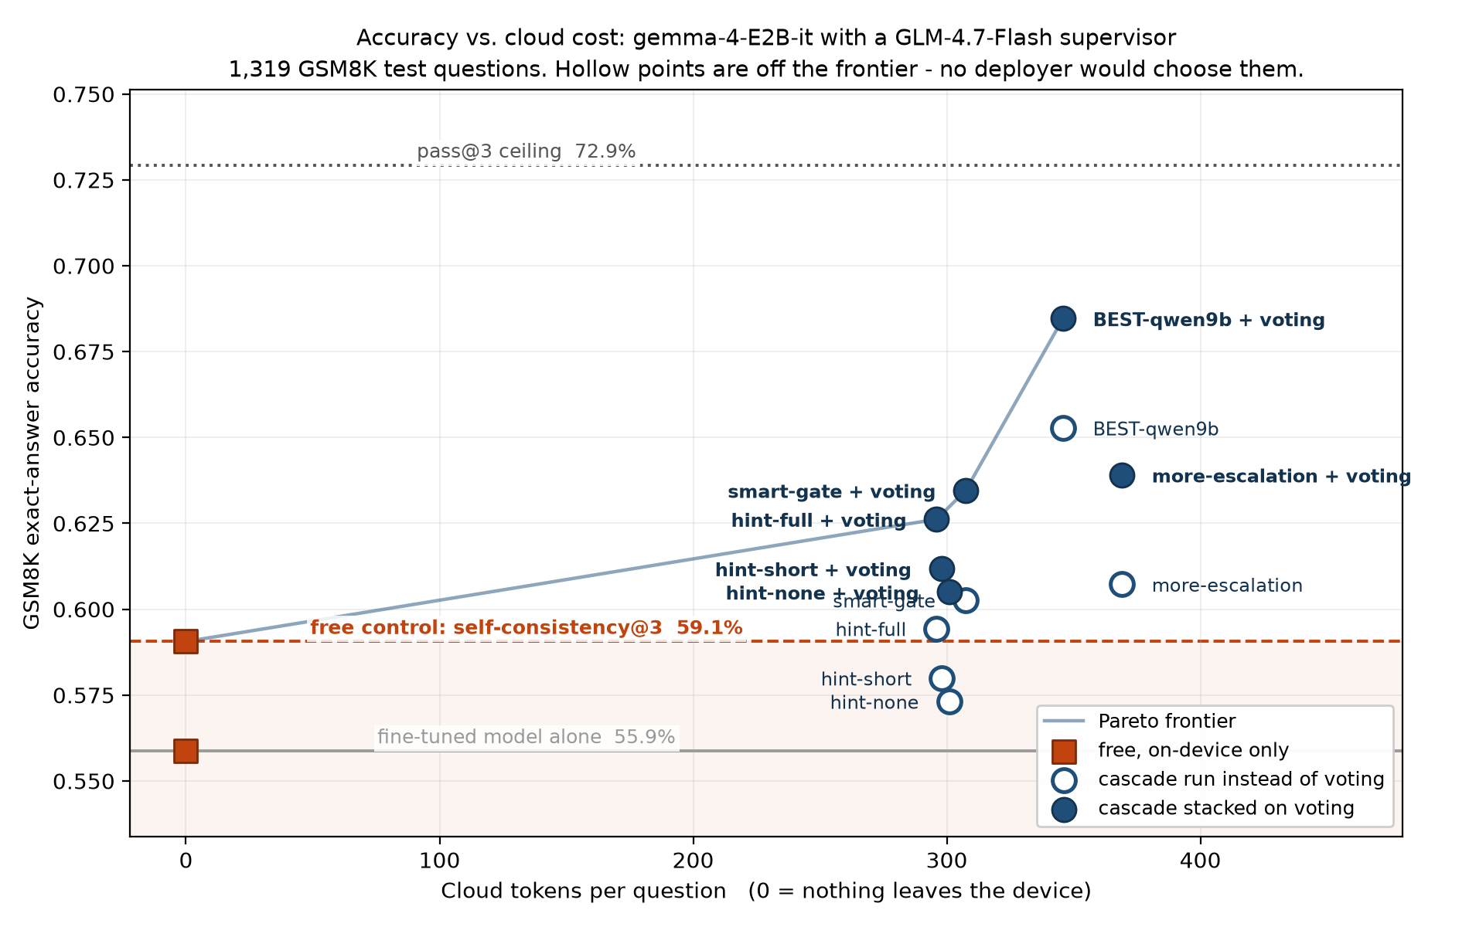
Figure 9.2: Accuracy against how many checker tokens each question costs. Hollow markers are configurations that another configuration beats on both measures at once.
68.46%, which is 93.9% of everything that was achievable.
And the cost side, which is the point of the project: 70% of questions are answered entirely on the device. Of the 30% that are escalated, the checker sees only the question and the working, and writes back an average of about 57 tokens.

9.6 Is the improvement real, or luck?
Both systems answered the identical 1,319 questions, so we can compare them question by question with McNemar's test. It throws away every question the two systems agreed on and looks only at the disagreements. If the two systems were really equally good, those disagreements should split roughly evenly. A small p-value means the split is too lopsided for that explanation.
We used the exact version of the test — counting the true probability rather than using the usual quick approximation — because some of our disagreement counts are small enough that the approximation is not guaranteed reliable.
Against the trained model on its own, every system wins clearly:
System | It won | Trained model won | p
GLM, no hint | 46 | 27 | 0.034
GLM, short hint | 52 | 24 | 0.0018
GLM, full hint | 70 | 23 | <0.001
Qwen, stacked | 190 | 24 | <0.001

Against free majority voting, which is the comparison that actually matters:
System | It won | Voting won | p | Real?
GLM, no hint, alone | 58 | 81 | 0.062 | No
GLM, short hint, alone | 64 | 78 | 0.275 | No
GLM, full hint, alone | 82 | 77 | 0.751 | No
GLM at 37.3%, alone | 106 | 84 | 0.127 | No
GLM smart gate, alone | 92 | 76 | 0.247 | No
GLM, no hint, stacked | 46 | 27 | 0.034 | Yes
GLM, full hint, stacked | 70 | 23 | <0.001 | Yes
Qwen, alone | 148 | 66 | <0.001 | Yes
Qwen, stacked | 136 | 12 | <0.001 | Yes

Five "No" rows. Every one of them is a GLM cascade used instead of voting. Chapter 10 is about what that means.

9.7 How slow is it?
We timed 40 questions end to end.
 | Time
The small model writing one answer | 15.1 s
The 9B checker judging one answer | 1.0 s
The 30B checker judging one answer | 2.1 s

Put together into the full system:
Path | Time
Question settled on the device | 45.4 s
Question escalated to the checker | 59.0 s
Average across all questions | 49.5 s

Against 15.1 s for a single plain answer, that is 3.3 times slower. Where does the time go?
 | Share
Generating the three samples | 91.7%
The retry | 7.7%
Waiting for the checker | 0.6%

This reframes the whole cost argument, and we want to be straight about it. We built this system to escalate rarely. The time cost of escalating is almost nothing — six tenths of one percent. The expense is generating three samples locally, which is the price of the gate, not of the checker.
So rare escalation must be justified by data staying on the device and by money, not by speed. Anyone reading this report should not take away "the cascade is fast".
One caveat: these numbers come from an RTX 4080 SUPER desktop graphics card, not from a phone or an old laptop. Treat them as a floor. We have not measured on the hardware this design is aimed at, and Chapter 11 lists that as a limitation.

Chapter 10 — What did not work
This is a real chapter, not a footnote. Several of these failures taught us more than the successes did, and one of them changed the design of the whole system.

10.1 The obvious version of our idea did not work
This is the most important thing in this report, and it must be read before any comparison against the untrained model.
We built the cascade first without voting: the model answers, the gate picks the hard questions, the checker marks them, the model retries with a hint. It scored 59.44%.
Free majority voting scores 59.06%.
 | Score | Checker calls | Tokens sent out per question
Majority vote of 3 | 59.06% | 0 | 0.0
Our cascade | 59.44% | 712 | 296.0

Five answers better, for 712 calls to a second model. And when we tested it properly, the difference was not statistically meaningful: p = 0.751. We could not show our system beat the free option at all.
We recorded it at the time as: as configured, the supervisor cascade is not justified over majority voting.
The fix was to stop treating them as alternatives. Voting and checking repair different questions (Section 7.3). The gate had already generated the three samples that voting needs — it needed them to measure disagreement. The un-stacked version simply threw them away.
So: take the vote first, and send only the split votes to the checker.
 | Score | Cost
Cascade instead of voting | 59.44% | 712 calls
Cascade stacked on voting | 62.62% | 712 calls — identical

+42 answers for nothing. And the same +42 on every version we tried, because the two mechanisms operate on groups of questions that never overlap.
We think this is the most useful thing in the report, precisely because it is the mistake a reader would otherwise make.

10.2 The small model cannot check its own work
The cheapest possible checker is the model we already have. We tried it.
 | The 2B checking itself | The 30B checker
Wrong answers caught | 22% | 84%
Right answers wrongly failed | 42% | 26%
Replies we could not read | 19 of 30 | 0 of 30
Time per judgment | 13.0 s | 2.2 s

It fails in every direction at once. It misses most mistakes, it rejects nearly half of the correct answers, and most of the time it does not produce a usable reply at all.
And it is 6 times slower than the model 15 times its size. That one genuinely surprised us. The explanation is that our small model runs through a general-purpose Python library while the checker runs through a specialised, heavily optimised server — and the big checker only activates about 3 billion of its 30 billion parameters for any one token. Parameter count is a poor predictor of speed.
This matches what the literature predicted: models are known to prefer their own output, so a model judging itself is the weakest possible arrangement.

10.3 The bigger checker was the worse checker
We expected the 30-billion checker to beat the 9-billion one. It did not.
 | Qwen 9B | GLM 30B
Wrong answers caught | 89% | 84%
Right answers wrongly failed | 19% | 26%
Seconds per check | 1.0 | 2.1
File size | 5.6 GB | 16.3 GB

Worse on both measures, twice as slow, three times the size.
The false-reject rate is the one that hurts. Remember from Section 9.2 that resampling breaks correct answers more often than it repairs wrong ones. So every correct answer the checker wrongly rejects is a coin flip that is likely to come up badly. A checker that is more willing to find fault is not more careful — it is more expensive.

10.4 The smarter gate did not survive to the end
The combined gate — disagreement with confidence breaking ties — is genuinely better at picking questions. At a 10% budget it caught 125 mistakes instead of 105, a 19% improvement, with 94.7% precision.
Then we ran it through the whole system, and the advantage mostly disappeared:
 | Score
Plain disagreement gate, stacked | 62.62%
Combined gate, stacked | 63.46%

+11 answers, and p = 0.343. Not distinguishable from chance.
Against the higher-budget version it was even less impressive: 6 answers better, p = 0.640 — but at 17% fewer checker tokens.
So the honest way to report this is as a gate finding and a cost saving, not an accuracy claim. The gate really is better at ranking questions. That improvement just gets absorbed by everything downstream — the checker's mistakes, the retry's unpredictability — before it reaches the final score.

10.5 A null result: picking answers by confidence
We had confidence numbers for every answer. It seemed obvious to use them for choosing between the three attempts, not just for the gate. We tried every version we could think of:
Method | Correct | Score
Always take the first answer | 737 | 55.88%
Majority vote | 779 | 59.06%
Take the most confident answer | 761 | 57.70%
Weight the votes by confidence | 679 | 51.48%
Vote, break ties by confidence | 789 | 59.82%
If an oracle always picked the right one | 962 | 72.93%

The best version gained 10 answers over plain voting, with p = 0.348 — not meaningful. And when we put it through the complete system, the final score was identical: 843 either way.
Weighting the votes by confidence was actively harmful, losing 100 answers.
We report this because it is a clean null result on a natural idea, and because someone else will otherwise spend a week on it.

10.6 We tuned the checker's instructions on the test set, and had to redo it
Our first checker instructions were too harsh. On 150 questions they rejected 111, with a false-reject rate of 54.9% — more than half of all correct answers thrown out.
We rewrote them and things improved a lot: 82 rejections, false-reject rate 28.0%.
Then we noticed the problem. We had done that tuning on test questions. Choosing anything by looking at the test set is exactly the mistake that makes a result untrustworthy.
So we redid the whole comparison on 150 training questions the checker had never seen. The result held, and it was worse for the original prompt than we had realised:
Prompt | False-reject rate | Expected net effect per 150 questions
Original | 53.1% | −3.2 (actively harmful)
Tightened | 27.1% | +2.6

We are reporting the mistake and the correction rather than quietly presenting only the clean version. The tightened prompt is the one used everywhere in this report, and it was validated on data that had nothing to do with our test set.

10.7 A small trial gave us the opposite recommendation
Before committing hours of computer time to a checker, we run a 30-question trial to see if it is worth it. For the 9-billion checker, that trial reported a false-reject rate of 0.417 — bad enough that we nearly did not run it at all.
The full 1,319-question run reported 0.186. The trial was wrong by a factor of more than two, and in the direction that would have made us discard our best checker.
Part of the cause was mechanical: the trial capped replies at 200 tokens and the 9B model writes longer replies than the 30B one, so 5 of its 30 answers were cut off mid-sentence. We raised the cap to 512 for the real run.
The rule we adopted afterwards, and we recommend it:
A small trial decides whether to spend the computer time. It never decides what to conclude.

10.8 The training crash
Covered earlier, listed here so the failures are in one place: the training crashed at step 936 when the library tried to score the model at the end of a pass and asked for 4.38 GB the graphics card did not have. We resumed from step 900, losing 36 steps, and turned that scoring off for good (Section 5.7).

Chapter 11 — Limitations
We would rather state these ourselves than have them found.
11.1 Everything is capped at 72.93%. If the model gets a question wrong in all three attempts, nothing downstream can save it. Every result should be read against the band from 55.88% to 72.93%, not against 100%.
11.2 We only ever checked the final number. We never verified that the reasoning was sound. A right answer reached by muddled working counts as right throughout. Checking this properly would mean hand-reading about 100 solutions, which we did not do. We make no claim anywhere that answers are correct for the right reasons.
11.3 Retries are unpredictable question by question. We ran the same configuration twice. The overall accuracy barely moved — 0.3232 against 0.3308 on the shared questions, p = 0.826 — but only 32% of individual final answers were identical. So our numbers are reproducible as rates, not as per-question outcomes. Nobody should expect to reproduce a specific answer.
11.4 Small effects are invisible at this size. With 1,319 questions, a change has to be worth roughly 40 answers before it can be distinguished from noise. The combined gate's +11 (Section 10.4) sits inside that band. It may be real; we cannot say so.
11.5 The retry prompt shows the model its own rejected answer. That risks anchoring it to the same mistake. We have seen it happen: in an early test, a problem about a robe needing "half that much" material produced the identical wrong answer again after rejection. We did not measure how often this occurs.
11.6 The self-check result is 30 questions. Section 10.2 is a trial, not a full run. Given what Section 10.7 taught us about trials, treat that row as directional only.
11.7 The stacking idea came from looking at test results. We noticed that the cascade was not beating voting, and then worked out that the two could be combined. That is a legitimate way to do research, but it means the stacking result was not a pre-registered prediction. We disclose it rather than present it as though we had planned it from the start.
11.8 The checkers are not perfectly repeatable. Running the same check twice can give different answers — we measured false-reject rates of 0.500 and 0.417 on identical inputs. The verdict cache removes this from our comparisons, but it is a property of the tool.
11.9 All speeds come from a desktop graphics card. An RTX 4080 SUPER is not a phone and not an old office PC. We never measured on the hardware this design is aimed at, so the latency figures are a floor, not a prediction.
11.10 Our best score is slightly understated. The 9B checker's replies were cut off 50 times in 728 calls (6.9%). Eighteen of those were on first attempts, and 8 of them were wrong answers that got waved through as a result. Fixing it is worth roughly 2 answers. So 68.46% is a small under-estimate, not an over-estimate.
11.11 One model, one dataset. Everything here is measured on gemma-4-E2B-it solving GSM8K. We do not know whether the gate, the tie-break or the stacking behave the same way on a different model or a different kind of problem. This is the most substantial open question in the report. The honest framing is that the mechanism is shown to work; how widely it generalises is future work.
11.12 GSM8K is a controlled probe, not a real workload. Frontier models score in the mid-nineties on it. It was chosen because it can be graded automatically with no human judgement, not because solving school maths on a phone is a pressing need.

Chapter 12 — Conclusion and future work

12.1 What we showed
We built a small AI that solves school maths problems on an ordinary desktop, and asks a bigger AI for help on about 3 questions in 10. It answers 7 out of 10 questions without anything leaving the machine, and scores 68.46% — up from 36.32% untrained and 55.88% trained — which is 93.9% of the best that model could possibly have done.
Three findings we would stand behind:
- A supervised cascade must be stacked on self-consistency, not substituted for it. Used instead of free voting, ours could not be shown to beat it. Used on top of it, every version beat it, at identical cost, gaining exactly 42 answers each time.
- Checker quality is not a function of checker size. A 9-billion model beat a 30-billion one on every measure, ran about twice as fast, and is a third of the size. The 2-billion model checking itself failed completely.
- The best gate signal is free if we are already voting. Self-contradiction across attempts (AUC 0.840) beats the model's own confidence (0.715), and using confidence only to break ties adds a little more (0.869) with no tunable number to get wrong.

12.2 What we did not show
That the answers are reached by sound reasoning. That any of this transfers to another model. That it is fast on the kind of hardware it is designed for. That 68.46% is competitive with the best published results — it is not, and Chapter 3 says so plainly.

12.3 What we would do next
In order of how much we think it would be worth:
- Serve the small model through the optimised server too. Section 9.7 showed that 91.7% of the time goes into generating the three local samples, and that our checker — running through specialised software — is 15 times faster per token than our own solver. This is by far the largest speed win available and it requires no new research.
- Try it on a different small model. Put the same gate and checker on another solver and see whether the gain transfers. This is the direct answer to Limitation 11.11.
- Measure on real target hardware — an old laptop, an office desktop, a phone. Until then no latency claim about edge devices is properly supported.
- Hand-label 100 solutions for reasoning quality, to close Limitation 11.2.
- Small ablations we designed but did not run: how much the retry anchors on the rejected answer; whether letting the checker think for longer helps enough to justify the tokens.

12.4 A closing note on the engineering
This project was built on one machine in a place where the electricity is not dependable, and Chapter 6 describes the three layers of recovery that made 10-hour jobs possible.
The part we did not expect is that one of those layers — the cache that stops a power cut costing hundreds of checker calls — turned out to be what makes our central experiment valid. Because every verdict is replayed rather than recomputed, the three feedback versions reject an identical set of questions, so the only thing that varies between them is the hint. We measured 396 of 396 verdicts replaying identically across runs a day apart.
We did not design it for that. The constraint produced the rigour.

Appendix A — Full configuration

A.1 Hardware and software
Graphics card | NVIDIA RTX 4080 SUPER, 16 GB (16,376 MiB), driver 560.94
System memory | 31.1 GB
Operating system | Windows 11
Python | 3.11.9
PyTorch | 2.6.0+cu124, CUDA 12.4
transformers | 5.8.1
peft | 0.19.1
bitsandbytes | 0.49.2
llama.cpp | build b10453

A.2 The model and the training
Base model | google/gemma-4-E2B-it
Parameters in the file | 5,123,178,979 (4,647,449,891 in the text part)
Layers | 35, of which 20 share key/value projections
Quantization | 4-bit NF4, double quantization, bfloat16 compute
LoRA rank / alpha / dropout | 16 / 32 / 0.05
Attached to | q, k, v, o and gate, up, down, language layers only
Modules attached | 205 (15 layers × 7 + 20 layers × 5)
Trainable parameters | 24,158,208 (0.47%)
Adapter file | 97 MB
Learning rate | 2e-4, cosine schedule, 50 warm-up steps
Batch | 1 × 16 accumulation = effective 16
Epochs | 3 (1,404 steps)
Max sequence length | 1,024
Loss | answer tokens only
Final loss / token accuracy | 0.250 / 0.923
Checkpoints | every 50 steps, 4 kept
Evaluation during training | disabled (it ran out of memory)

A.3 Generating answers
First attempt | greedy (temperature 0), up to 512 new tokens
Extra samples | temperature 0.7, 2 of them
Retries | temperature 0.7, up to 2 (3 attempts total)
Repetition penalty | 1.15, applied on every run including the greedy ones
top-p / top-k | never set — the library defaults of 1.0 and 50 apply when sampling
Stopping | end-of-sequence token, the <end_of_turn> marker, or the 512-token cap
Untrained baseline | 8 worked examples, the first 8 of the training split, fixed for every question

Two honest notes. Our "greedy" runs carry a repetition penalty of 1.15, so they are not pure argmax decoding. And we never set top-p or top-k for the temperature-0.7 runs, so the library's defaults silently applied.

A.4 The cascade
Escalation budget | 30% (396 of 1,319); the gate's natural threshold is 37.3% (492)
Gate | sample disagreement, ties broken by final-answer confidence
Checker | GLM-4.7-Flash (30B, 3B active) or Qwen3.5-9B, served as GGUF by llama-server
Checker reply cap | 200 tokens for GLM, 512 required for Qwen
Checker sees | the question and the working, never the correct answer
Hint levels | L0 ≈ 12, L1 ≈ 30, L2 ≈ 57 tokens
Hints | stripped of any #### line before the model sees them
Unreadable reply | treated as accept, never reject

That last row is deliberate. The system must never manufacture a rejection out of its own bugs. The consequence is that anything ambiguous becomes silent approval, so empty and truncated replies are converted into errors at the boundary, and the run aborts after too many consecutive failures rather than approving everything that is left.

