CS442 | Mobile Application Development
Setup:
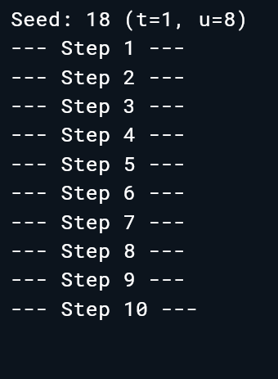
Step1:
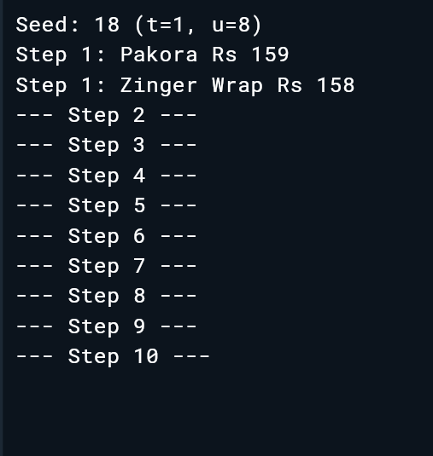
Step2:
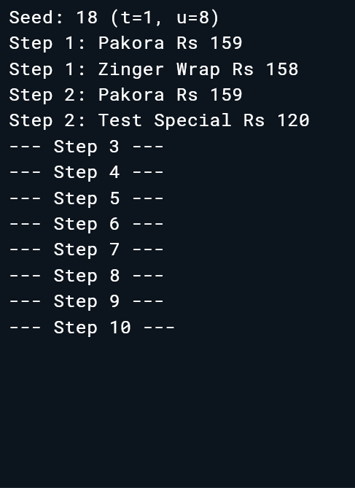
// price cannot be final because the constructor may change it because of pricefloor
Step3:
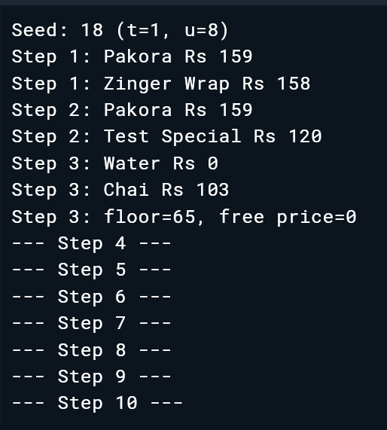
The floor logic did not run because free() is a separate named constructor;
it directly initializes price to 0 and does not execute the main constructor body.
Step4:
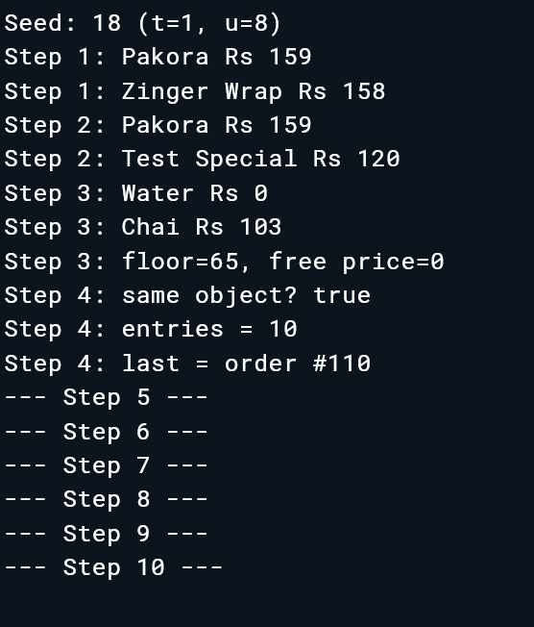
/* The underscore makes _instance and _internal private to this library. Without it, outside code could access them directly and bypass the factory.*/
Step05:
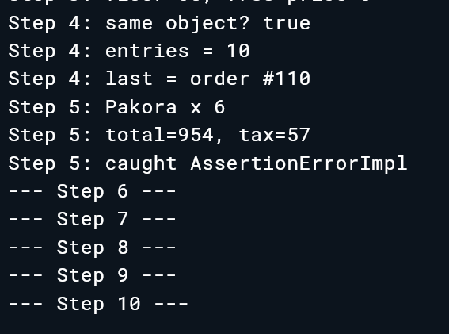
/*Answer : An initializer list cannot read another instance field because the object is not fully initialized yet.*/
Use this: total = item.price * qty,
tax = (item.price * qty) * taxPercent ~/ 100,
Step06
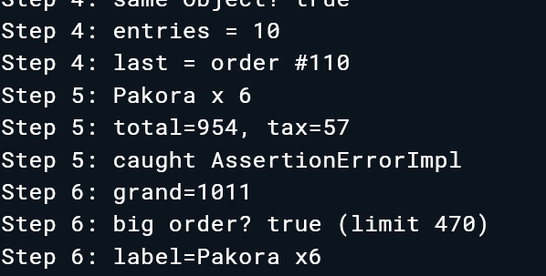
Answer: /* Answer: ->line.grand = 5 fails because grand has only a getter, so it can be
-> read but not changed. To make assignment legal, we would need to add
-> a setter for grand.*/
Step07
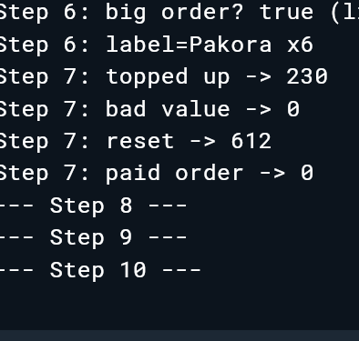
/*Answer For an invalid value, a setter could throw an exception or show an error
message instead of silently changing the value.*/
Step08
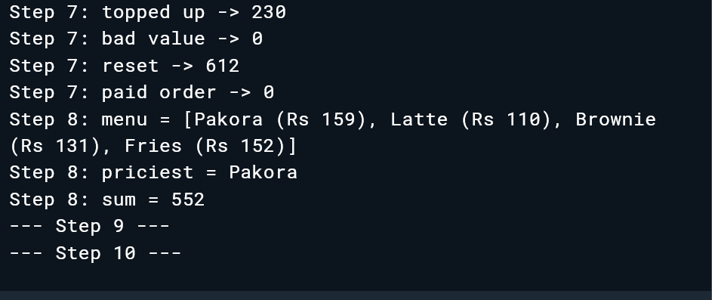
Step09:
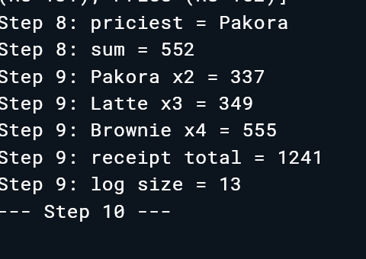
Step10:
