CS442 | Mobile Application Development
Setup:
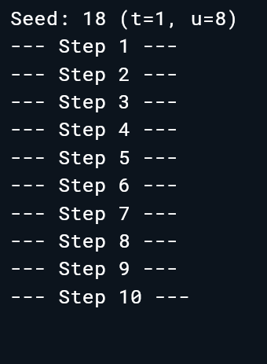
Step1:
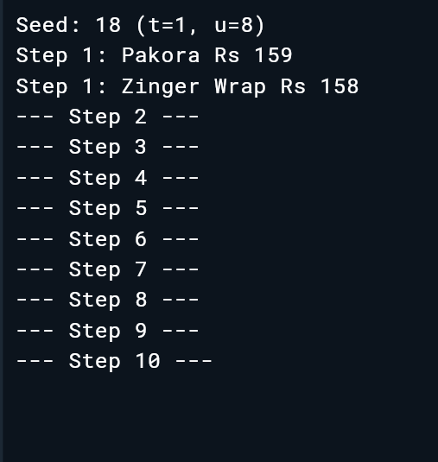
Step2:
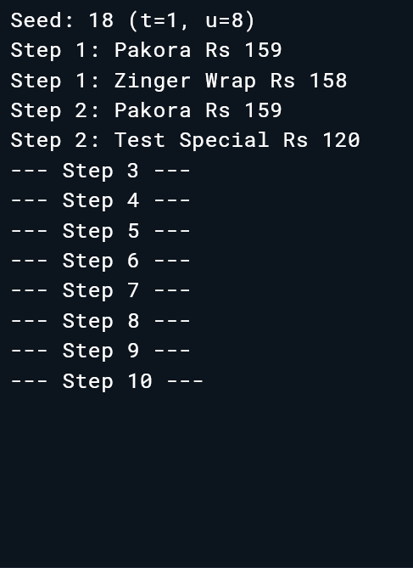
// price cannot be final because the constructor may change it because of pricefloor
Step3:
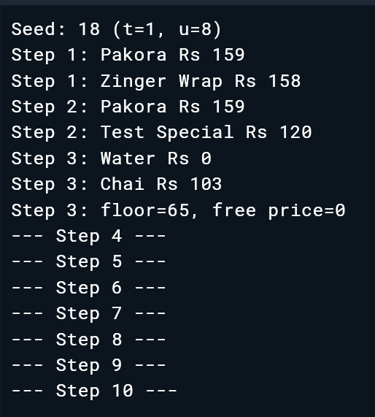
The floor logic did not run because free() is a separate named constructor;
it directly initializes price to 0 and does not execute the main constructor body.
Step4:
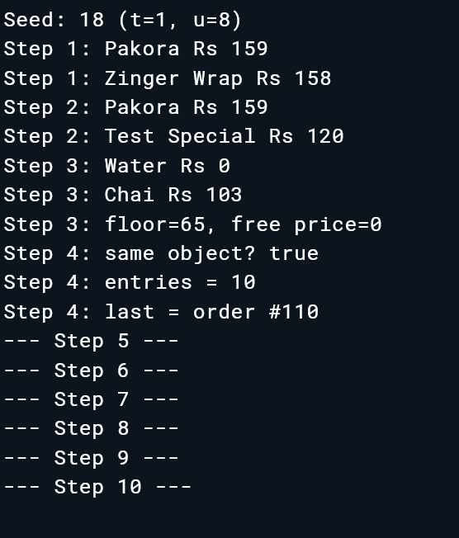
/* The underscore makes _instance and _internal private to this library.Without it, outside code could access them directly and bypass the factory.*/

