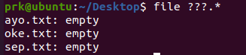

15. file ???.*



20. echo ”$SHEL”

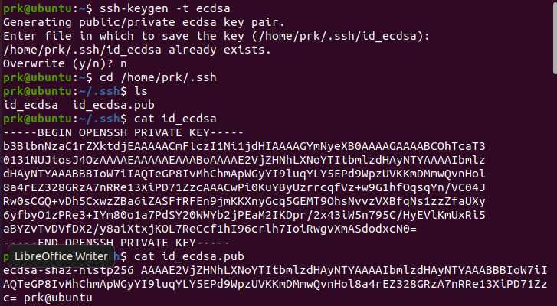

1.ssh-keygen –t ecdsa

NAR22-1

NAR22-1

Cd /home/prk/.ssh

Ls

Cat id_ecdsa

Cat id_ecdsa.pub

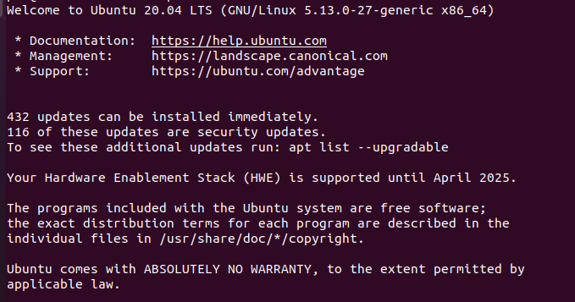

2.sudo apt get update

sudo apt install openssh-server

sudo systemctl status ssh

ip a

ssh prk@[ip]

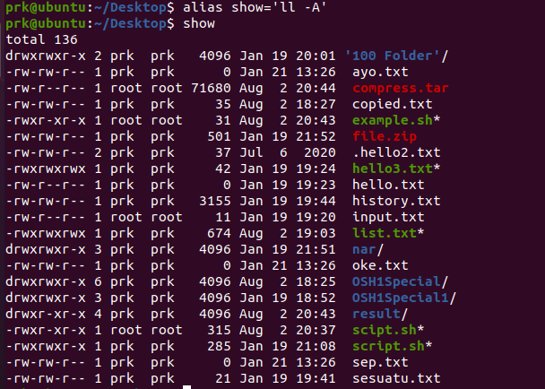

16.alias show=”ls -A”

13.

