Human Emotion Recognition Using CNN

Project Overview
This project implements a Human Emotion Recognition System using a Convolutional Neural Network (CNN) trained on facial images. The model classifies human emotions into five categories: Angry, Fear, Happy, Sad, and Surprise. The trained model is later used for real-time emotion detection through a webcam.

Objectives
- Train a CNN model to recognize facial emotions
- Use grayscale facial images for efficient computation
- Prevent overfitting using early stopping
- Deploy the model for real-time emotion recognition

Dataset Description
Data set link Human Face Emotions
Total images: ~59,000
Image size: 496x96 pixels
Color format: Grayscale
Classes: 5 emotion categories

Data Preprocessing
Images are resized to 48x48pixels, converted to grayscale, and normalized to values between 0 and 1. The dataset is split into 70% training, 20% validation, and 10% testing.

Model Architecture
Conv2D (32 filters) + MaxPooling
Conv2D (64 filters) + MaxPooling
Conv2D (128 filters) + MaxPooling
Flatten
Dense (128 neurons) + Dropout
Dense (5 neurons, Softmax)

Training Strategy
The model is trained for a maximum of 15epochs using EarlyStopping. Training automatically stops around epoch 14 when validation loss stops improving.

Performance
Training Accuracy: ~82%
Test Accuracy: ~77%
Validation Accuracy: ~81%
Optimal Epoch: ~14

Real-Time Emotion Detection
The trained model is used with a webcam to detect facial emotions in real time. Faces are detected, preprocessed, and classified frame by frame.

Technologies Used
Python 3.10
TensorFlow/Keras
OpenCV
NumPy
Matplotlib

Conclusion
This project demonstrates an effective CNN-based approach for human emotion recognition with reliable performance and real-time applicability.
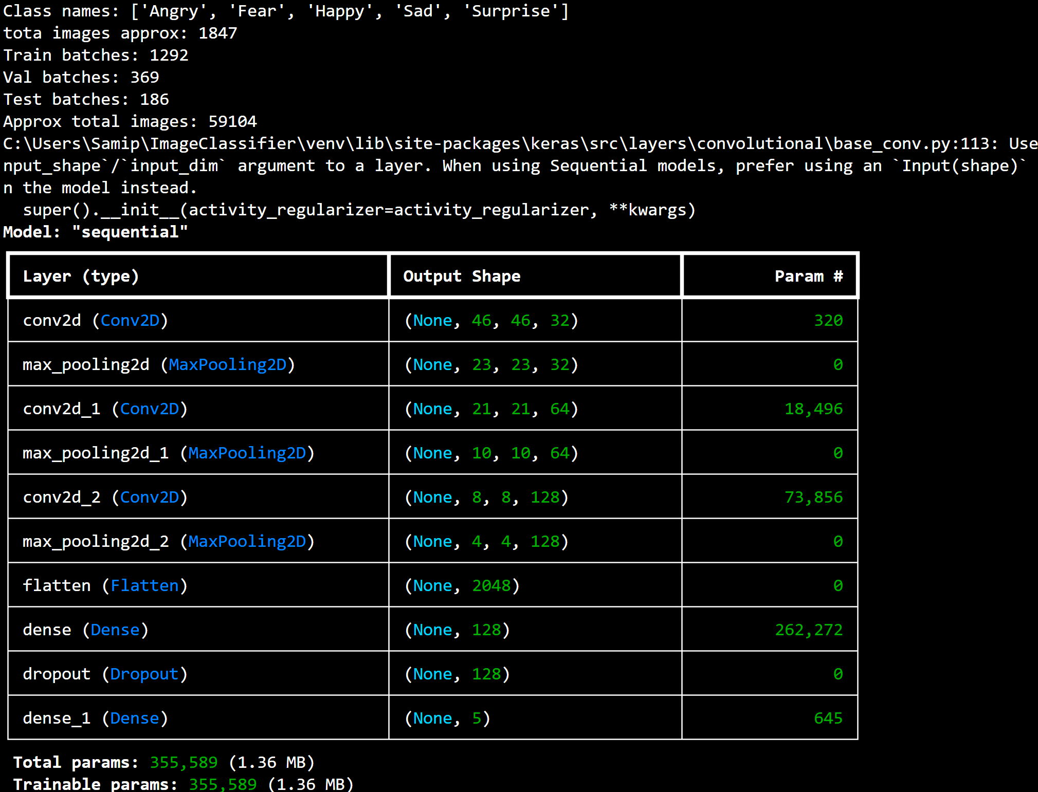

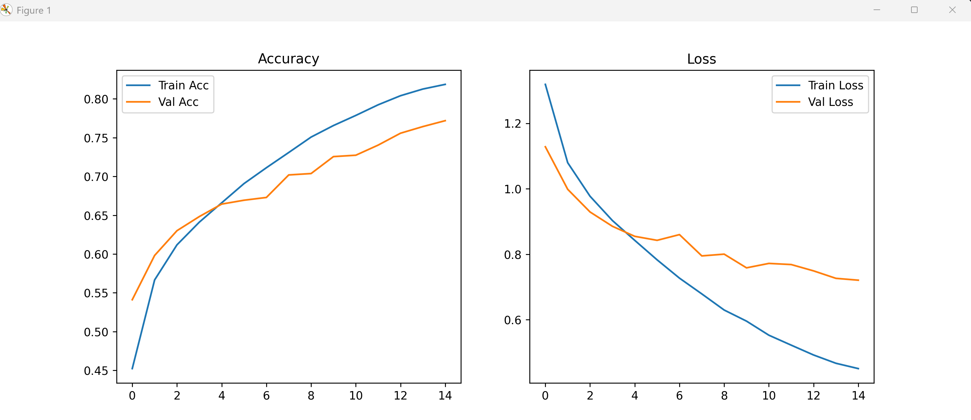
Test Accuracy: 0.7724

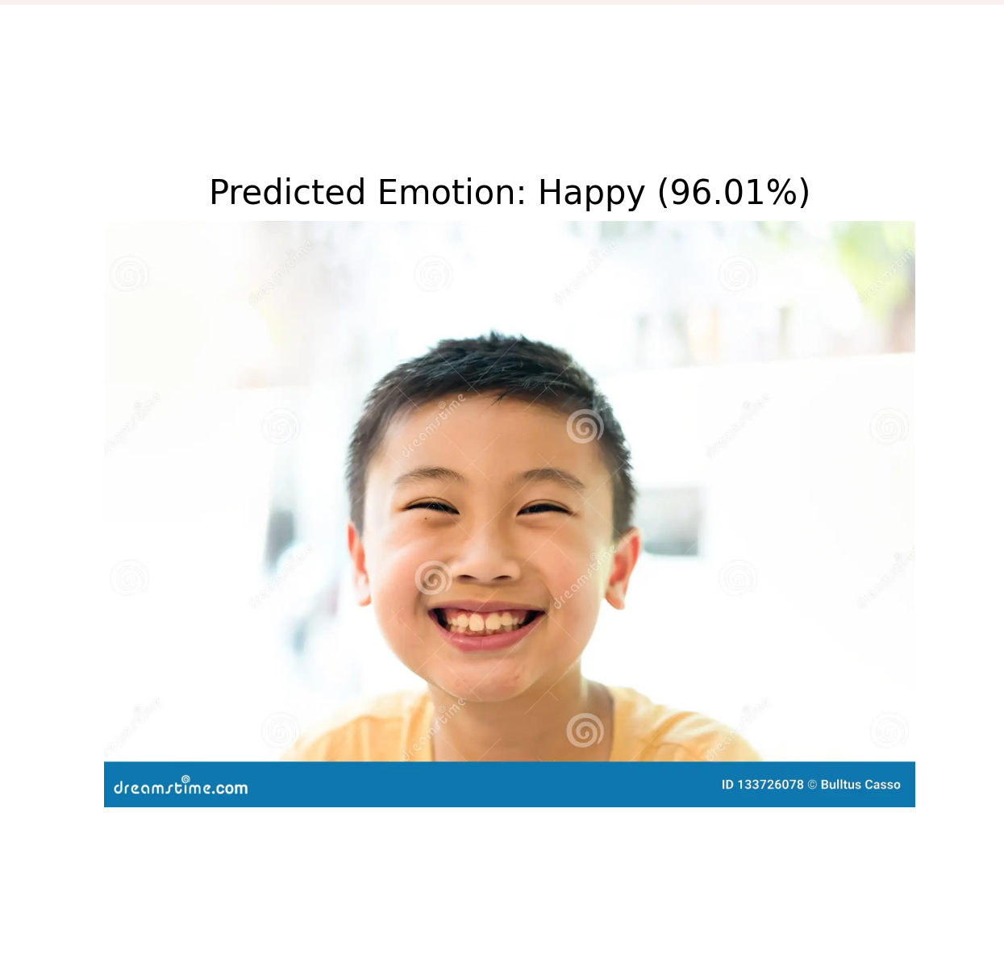
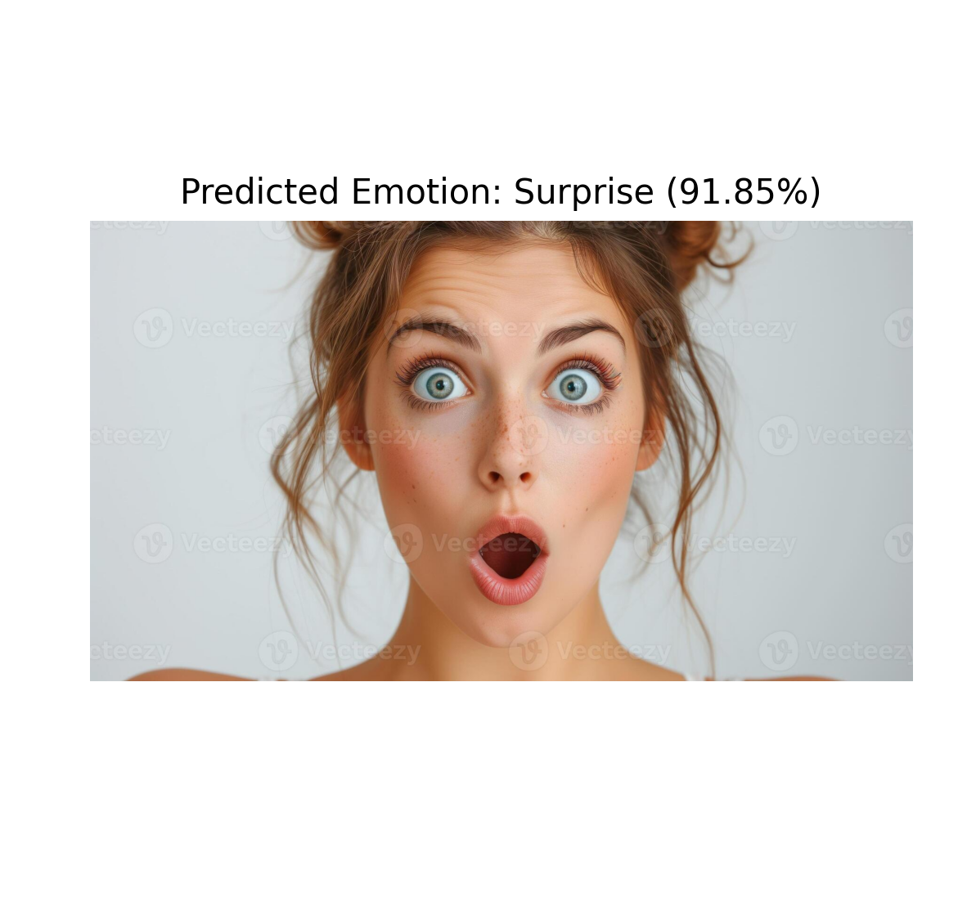Prediction probabilities:
Angry: 0.00%
Fear: 8.12%
Happy: 0.03%
Sad: 0.00%
Surprise: 91.85%

