HashMap-Documentation

Sami Simple HashMap
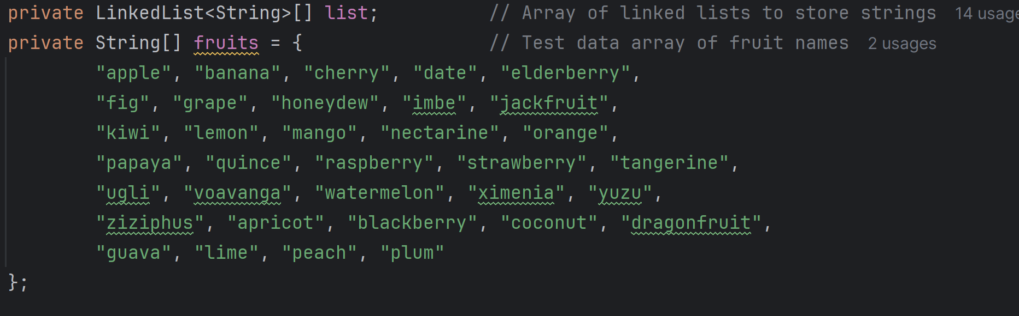
Constructor
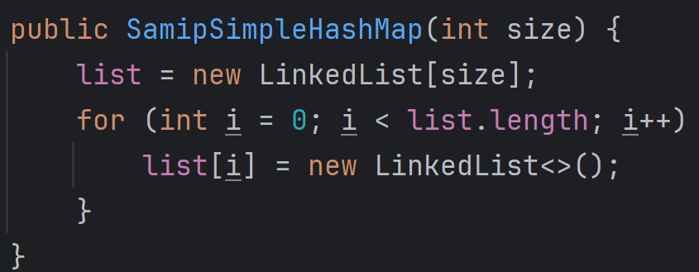
The constructor of the ‘SamipSimpleHashMap’ class initializes the hash map with a specified size. It creates an array of linked lists to store strings and initializes each linked list. This setup allows the hash map to efficiently store and retrieve strings based on their hash values.

#dumbHash Method
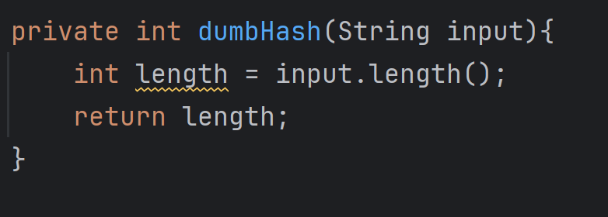
The ‘dumbHash’ method is a simple hash function that calculates the hash value of a string based on its length. It takes a string as input and returns its length as the hash value. This method is used to determine the index in the array for storing and retrieving strings, although it may lead to collisions if multiple strings have the same length.

#add Method
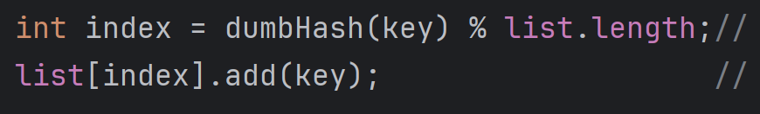
The ‘add’ method adds a string to the hash map. It calculates the index in the array using the `dumbHash` method and the modulo operation with the array length. The string is then added to the linked list at the calculated index. This method ensures that strings are stored in the hash map and can be retrieved later.

#contains Method
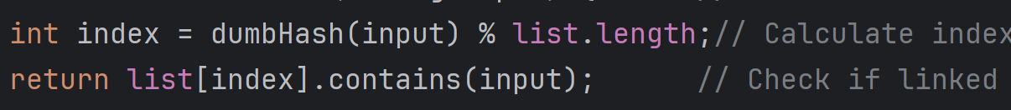
The ‘contains’ method checks if a string exists in the hash map. It calculates the index in the array using the ‘dumbHash’ method and the modulo operation with the array length. The method then checks if the linked list at the calculated index contains the input string and returns the result. This method is useful for verifying the presence of a string in the hash map.

#resize Method
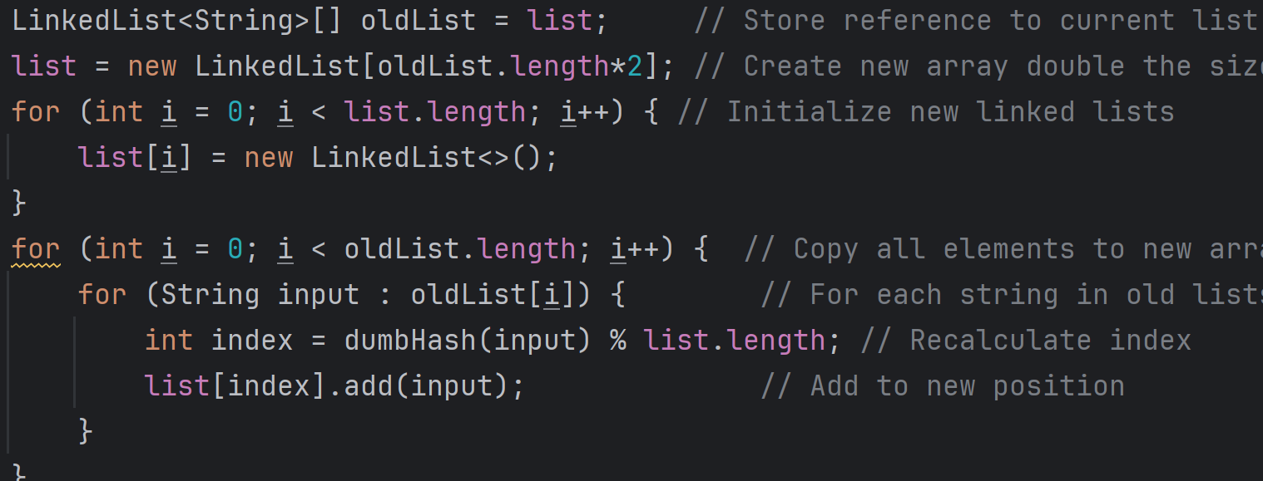
The ‘resize’ method doubles the size of the hash map and rehashes all existing elements to their new positions. It stores a reference to the current array of linked lists, creates a new array with double the size, and initializes each element as a new linked list. The method then iterates through the old array, rehashes each string to its new position in the new array, and adds it to the appropriate linked list. This method is essential for maintaining the efficiency of the hash map as it grows.

#runPerformanceTest Method
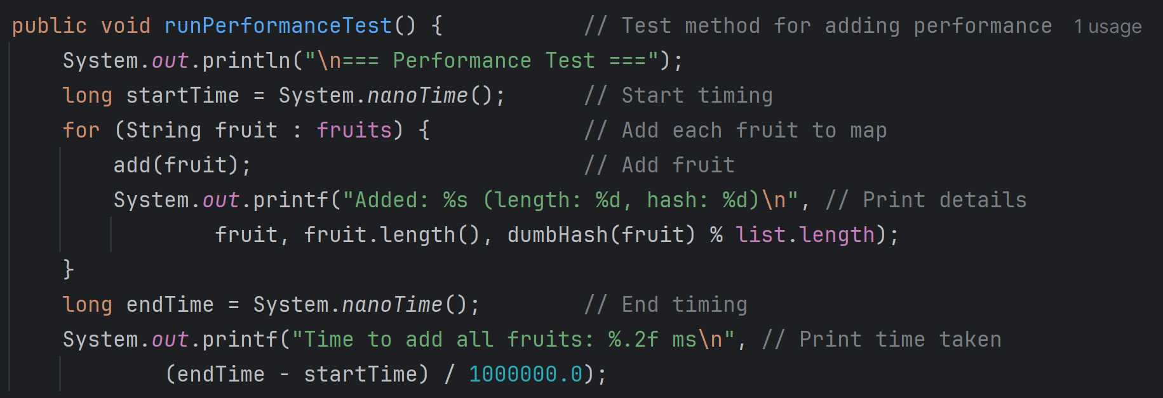
The ‘runPerformanceTest’ method tests the performance of adding strings to the hash map. It records the start time, iterates through the `fruits` array, and adds each fruit to the hash map. The method prints the details of each addition, including the fruit name, length, and hash value. It records the end time and prints the total time taken to add all fruits, providing insights into the performance of the `add` method.

#runSearchTest Method
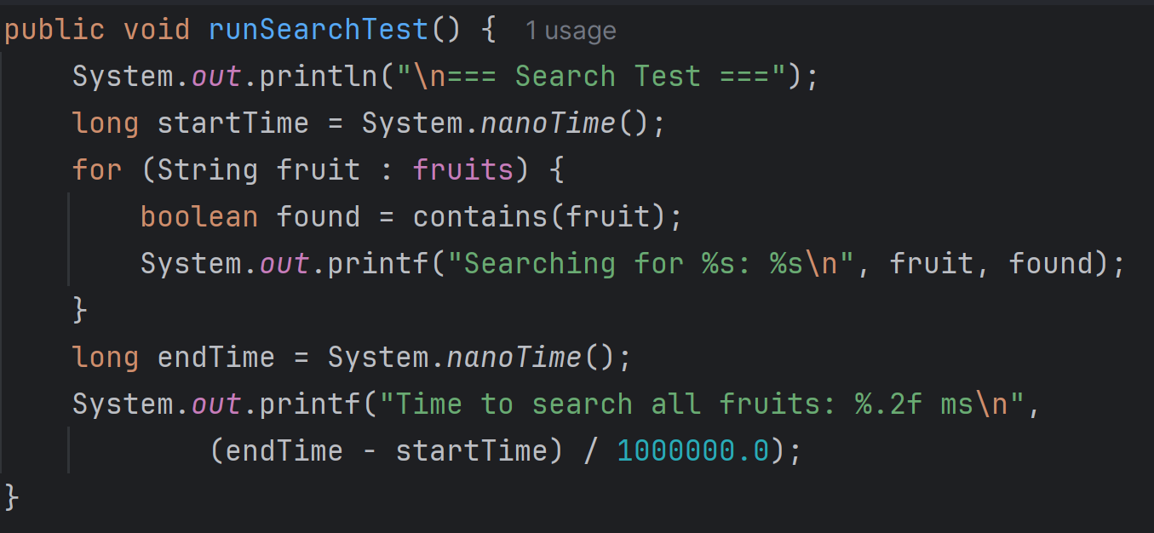
The ‘runSearchTest’ method tests the performance of searching for strings in the hash map. It records the start time, iterates through the `fruits` array, and checks if each fruit exists in the hash map. The method prints the result of each search and records the end time, printing the total time taken to search for all fruits. This method helps evaluate the efficiency of the ‘contains’ method.
Tester
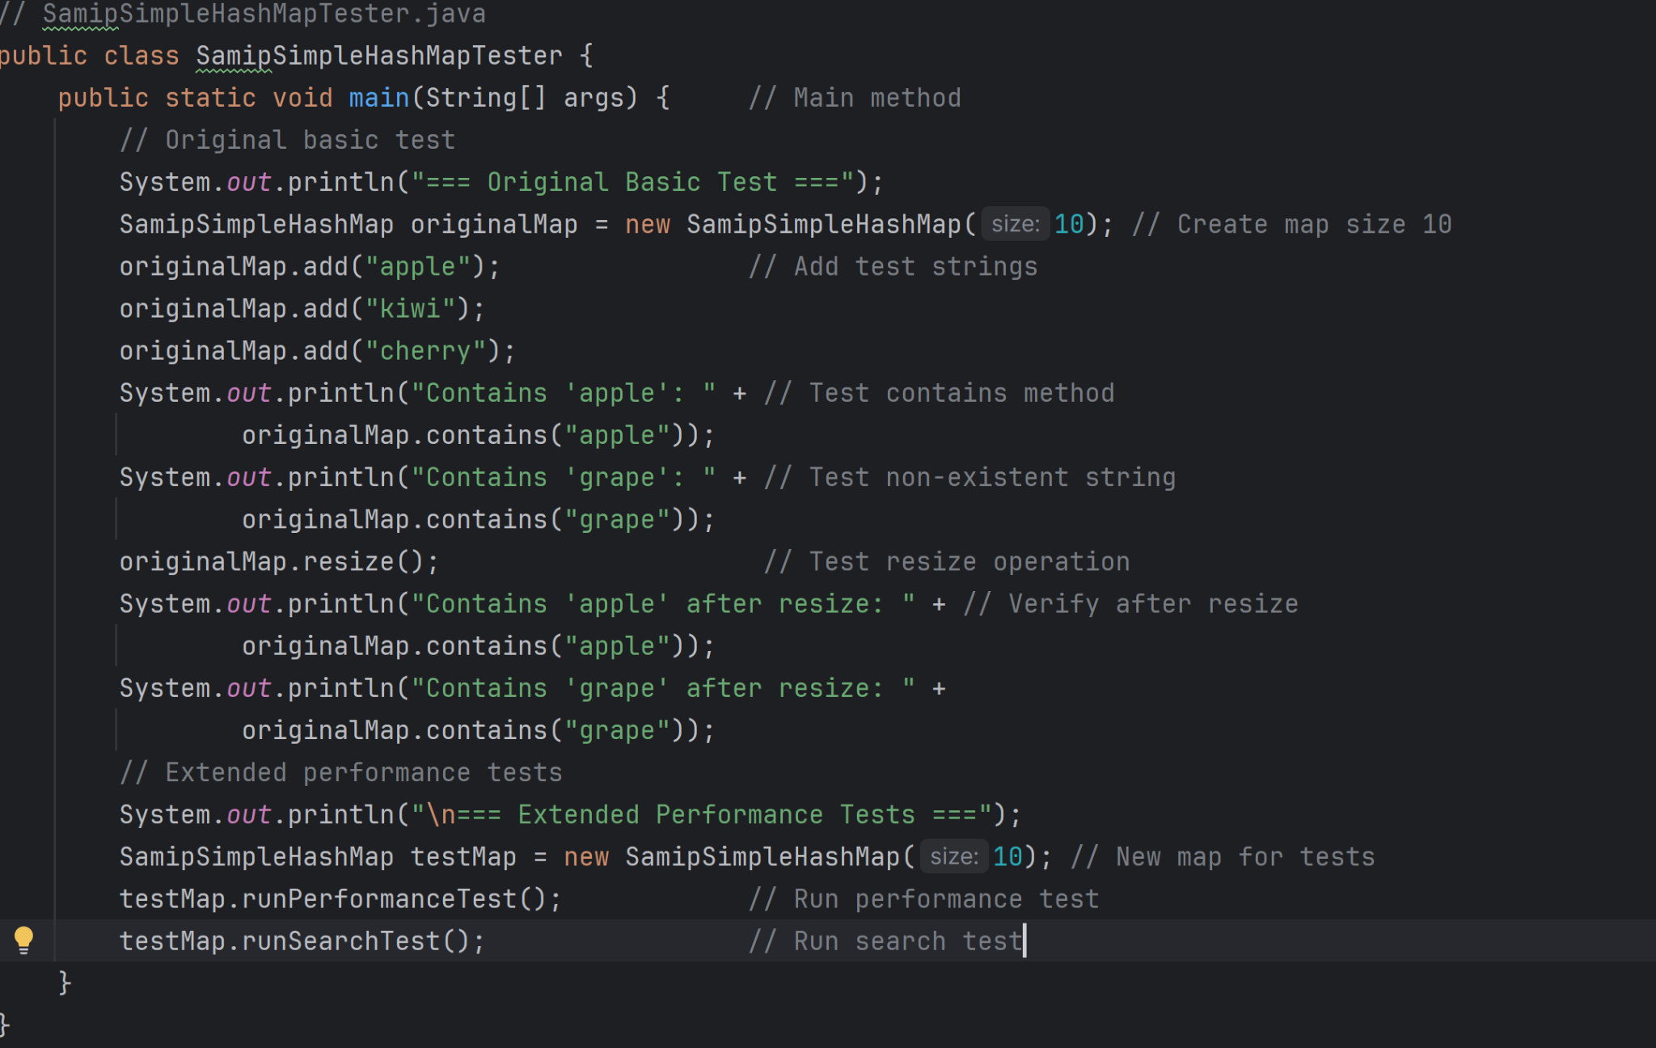
Output
=== Original Basic Test ===
Contains 'apple': true
Contains 'grape': false
Contains 'apple' after resize: true
Contains 'grape' after resize: false

=== Extended Performance Tests ===

=== Performance Test ===
Added: apple (length: 5, hash: 5)
Added: banana (length: 6, hash: 6)
Added: cherry (length: 6, hash: 6)
Added: date (length: 4, hash: 4)
Added: elderberry (length: 10, hash: 0)
Added: fig (length: 3, hash: 3)
Added: grape (length: 5, hash: 5)
Added: honeydew (length: 8, hash: 8)
Added: imbe (length: 4, hash: 4)
Added: jackfruit (length: 9, hash: 9)
Added: kiwi (length: 4, hash: 4)
Added: lemon (length: 5, hash: 5)
Added: mango (length: 5, hash: 5)
Added: nectarine (length: 9, hash: 9)
Added: orange (length: 6, hash: 6)
Added: papaya (length: 6, hash: 6)
Added: quince (length: 6, hash: 6)
Added: raspberry (length: 9, hash: 9)
Added: strawberry (length: 10, hash: 0)
Added: tangerine (length: 9, hash: 9)
Added: ugli (length: 4, hash: 4)
Added: voavanga (length: 8, hash: 8)
Added: watermelon (length: 10, hash: 0)
Added: ximenia (length: 7, hash: 7)
Added: yuzu (length: 4, hash: 4)
Added: ziziphus (length: 8, hash: 8)
Added: apricot (length: 7, hash: 7)
Added: blackberry (length: 10, hash: 0)
Added: coconut (length: 7, hash: 7)
Added: dragonfruit (length: 11, hash: 1)
Added: guava (length: 5, hash: 5)
Added: lime (length: 4, hash: 4)
Added: peach (length: 5, hash: 5)
Added: plum (length: 4, hash: 4)
Time to add all fruits: 13.65 ms

=== Search Test ===
Searching for apple: true
Searching for banana: true
Searching for cherry: true
Searching for date: true
Searching for elderberry: true
Searching for fig: true
Searching for grape: true
Searching for honeydew: true
Searching for imbe: true
Searching for jackfruit: true
Searching for kiwi: true
Searching for lemon: true
Searching for mango: true
Searching for nectarine: true
Searching for orange: true
Searching for papaya: true
Searching for quince: true
Searching for raspberry: true
Searching for strawberry: true
Searching for tangerine: true
Searching for ugli: true
Searching for voavanga: true
Searching for watermelon: true
Searching for ximenia: true
Searching for yuzu: true
Searching for ziziphus: true
Searching for apricot: true
Searching for blackberry: true
Searching for coconut: true
Searching for dragonfruit: true
Searching for guava: true
Searching for lime: true
Searching for peach: true
Searching for plum: true
Time to search all fruits: 3.59 ms

